Supervised protein language model embeddings improve GOF/LOF variant classification where evolutionary conservation fails

Abstract
Distinguishing gain-of-function (GOF) from loss-of-function (LOF) missense variants is central to clinical genomics, yet GOF variants often occur at conserved residues where zero-shot protein language model (PLM) predictors may break down. We benchmark three classification strategies on multiplexed assay of variant effect (MAVE) data for MC4R, HXK4/glucokinase, PTEN, and SRC: the zero-shot ESM2 log-likelihood ratio (LLR), a Random Forest on ESM2 embeddings trained by active learning (RF AL), and the same architecture trained with 5-fold cross-validation (RF 5 FOLD CV). RF 5 FOLD CV exceeds LLR for MC4R (AUC 0.773 vs. 0.690) and SRC (0.831 vs. 0.748), demonstrating that PLM embeddings encode GOF-relevant information beyond conservation. Domain-level analysis uncovers a qualitative LLR failure: in the MC4R extracellular domain, where activating variants cluster at ligand-contacting residues, conservation is strongly anti-correlated with function (r = −0.560) and classification is worse than random (AUC = 0.211), while supervised embeddings recover a positive signal. The same inversion appears in other allosteric hotspots including MC4R TM6. Active learning with eleven rounds remains below LLR on every protein, defining a clear gap for future work. Supervised PLM embeddings thus complement zero-shot conservation, and conservation-based scoring should be interpreted with caution at the functional hotspots where many clinically actionable variants reside.

1. Introduction
The ability to predict whether a missense variant will abolish or amplify protein function is foundational to clinical genomics, drug development, and mechanistic biology. The distinction matters beyond mechanism: loss-of-function (LOF) and gain-of-function (GOF) variants in the same gene routinely cause opposite diseases and call for opposite therapeutic strategies. MC4R LOF causes obesity, while GOF protects against it [1]. Glucokinase (GCK/HXK4) LOF causes maturity-onset diabetes of the young, while GOF causes congenital hyperinsulinism [2]. PTEN LOF drives cancer predisposition, while rare PTEN GOF variants have been described [3]. SRC GOF variants underlie malignant transformation [4]. Misclassifying a GOF variant as benign — or worse, recommending an agonist when an antagonist is needed — has direct clinical consequences. Despite this, computationally distinguishing GOF from LOF has lagged far behind general pathogenicity prediction [5–7].
Multiplexed assays of variant effect (MAVEs) have begun to close the experimental gap by delivering quantitative functional measurements for thousands of variants per protein [5–11]. Yet converting continuous assay scores into accurate, generalizable GOF/LOF classifiers remains non-trivial. The dominant computational paradigm leverages protein language models (PLMs): transformers trained on hundreds of millions of protein sequences that encode evolutionary constraint and structural context in high-dimensional embeddings [12–14]. Built on these models, the log-likelihood ratio (LLR) — comparing the probability a PLM assigns to the mutant versus wildtype amino acid in context — has become the de facto zero-shot variant effect score [15, 16]. The LLR requires no task-specific training, generalizes across proteins, and has been broadly adopted for missense pathogenicity assessment.
The LLR rests on an implicit assumption: that evolutionary improbability predicts functional disruption. For LOF variants this logic usually holds, because substitutions at conserved residues tend to be damaging. For GOF variants, the assumption can fail in an insidious way. Activating mutations frequently occur at residues that are evolutionarily conserved precisely because they control receptor or enzyme activation — any perturbation is rare, but a subset of substitutions can tip the protein toward constitutive activity. Conservation-based scoring penalizes all changes at conserved sites, conflating “constrained” with “deleterious” and flagging activating substitutions as damaging. Recent critical assessments have documented systematic failures of PLM-based LLRs, including this conflation of site-level conservation with substitution-specific effects [17], but the magnitude, structural distribution, and mechanistic origin of these failures for GOF variants have not been systematically characterized. Nor has it been established whether supervised classifiers built on the same PLM embeddings can recover the signal that the LLR obscures.
Here we address this gap through a systematic benchmark on four proteins selected for their diversity of structural class, disease biology, and — critically — the public availability of quantitative GOF data: the class A GPCR MC4R [1, 8], the metabolic enzyme HXK4/GCK [2, 9], the lipid phosphatase tumor suppressor PTEN [3, 11], and the non-receptor tyrosine kinase SRC [4, 10]. These proteins are among the few for which MAVE data include meaningful GOF coverage, making them uniquely suited for benchmarking classifiers that require both functional categories in training and evaluation. We compare three strategies: (i) the zero-shot ESM2 LLR; (ii) a Random Forest classifier on ESM2 embeddings trained by active learning over eleven rounds (RF AL); and (iii) the same Random Forest trained with 5-fold cross-validation on the full labeled dataset (RF 5 FOLD CV), which establishes a data-usage upper bound for the embedding-based architecture.
We find that RF 5 FOLD CV exceeds LLR for MC4R and SRC, demonstrating that PLM embeddings encode GOF-relevant information beyond what LLR extracts when adequate training data is available. Domain-level analysis reveals the structural origin of LLR’s failures: conservation signals are not merely weaker but actively inverted in ligand-contacting and allosterically critical regions where GOF variants cluster, and supervised embeddings partially recover the lost signal. RF AL with eleven rounds falls below LLR on all four proteins, even though the same architecture trained on full cross-validation data (RF 5 FOLD CV) exceeds LLR on MC4R and SRC. This directly quantifies the labeling bottleneck: the model has sufficient capacity, but eleven active learning rounds do not provide enough labeled examples to reach it. Together, these results reframe PLM-based LLR as a powerful but regionally unreliable predictor and supervised embedding classifiers as a complementary tool especially valuable where conservation breaks down.

2. Methods

2.1 MAVE datasets and functional scoring
MAVE datasets for MC4R, HXK4/GCK, PTEN, and SRC were obtained from published sources. The MC4R dataset was derived from high-resolution deep mutational scanning of the melanocortin-4 receptor [8]. The HXK4 dataset was obtained from a comprehensive map of human glucokinase variant activity [9]. The SRC dataset was derived from an integrated characterization of the regulatory mechanism coupling Src’s kinase activity, localization, and phosphotransferase-independent functions[10]. The PTEN dataset was obtained from a study integrating thousands of PTEN variant activity and abundance measurements. [11]. Functional scores were derived from multiplexed deep mutational scanning assays specific to each protein: Gαs pathway basal signaling z-scores for MC4R [8], yeast complementation-based enzymatic activity for GCK [9], phosphotransferase-linked yeast growth scores for SRC [10], and lipid phosphatase activity scores for PTEN [11]. GOF and LOF thresholds were defined per protein. For MC4R, HXK4, and SRC, published functional criteria were used. For PTEN, thresholds were set at 10% above (GOF) and 10% below (LOF) the wildtype assay score — pragmatic cutoffs chosen to exclude variants within the likely technical noise range of the assay while ensuring labeled examples are confidently non-wildtype. Variants exceeding the GOF threshold were labeled GOF; variants below the LOF threshold were labeled LOF. Variants between thresholds were treated as functionally neutral and excluded from strict binary classification.

2.2 ESM2 embeddings and log-likelihood ratios
ESM2 (esm2_t33_650M_UR50D) was used to generate per-residue embeddings and masked-marginal log-likelihood ratios (LLRs). For a substitution from wildtype amino acid wt to mutant amino acid mut at position i:
LLR(i) = log P(mut | context) − log P(wt | context)
where context denotes the protein sequence with the amino acid at position i masked, and P(a | context) is the probability the model assigns to amino acid a at position i given the rest of the sequence. Natural logarithms were used throughout. Both LLR and assay scores were z-score normalized for analyses comparing model output to functional measurements. Per-residue embeddings were mean-pooled into fixed-length protein-level feature vectors for supervised models.

2.3 Model architectures
LLR (zero-shot baseline). ESM2 LLR values were used directly as prediction scores. No training was performed.
RF AL (Random Forest with active learning). A Random Forest classifier was trained on mean-pooled ESM2 embeddings using an active learning strategy adapted from Jiang et al. [18], which demonstrated that this setup is effective at identifying GOF variants. Active learning proceeded for eleven rounds, with the initial labeled pool seeded by a small random subset; subsequent rounds used a greedy acquisition strategy. We sampled 16 variants in the first round and 50 variants in each subsequent round, for ≤516 total labels after eleven rounds. Mean prediction scores and standard deviations over five independent simulation runs are reported.
RF 5 FOLD CV (Random Forest with 5-fold cross-validation). The identical Random Forest architecture was trained on the full labeled dataset via stratified 5-fold cross-validation, providing a data-usage upper bound for the embedding-based classifier. Cross-validated prediction scores were used for evaluation.

2.4 Evaluation metrics
ROC AUC. Area under the receiver operating characteristic curve was computed for binary GOF/LOF classification; AUC = 0.5 indicates random performance and AUC = 1.0 perfect discrimination. For RF AL, values are reported as mean ± standard deviation across the five simulation runs; LLR and RF 5 FOLD CV are deterministic.
Mean signed error (MSE). MSE was computed as the mean of (prediction score − assay score) across variants in a domain, with positive values indicating systematic over-prediction and negative values under-prediction. MSE values are reported as mean ± standard deviation across RF AL simulation runs.
Optimal Youden index. J = sensitivity + specificity − 1, evaluated at the optimal classification threshold, reports the best achievable separation at a single operating point.

2.5 Domain-level analysis
Structural domain boundaries were defined from published structural annotations: MC4R — extracellular domain (ECD), seven transmembrane helices (TM1–TM7), intracellular loops (ICL1–ICL4), extracellular loops (ECL2–ECL3), C-terminal tail; HXK4 — small domain, Hinge 1 and 2, Large domain N-lobe and C-lobe, C-terminal tail; PTEN — phosphatase domain, linker, C2 domain, C-terminal tail; SRC — SH3, SH2, kinase domains. AUC, MSE, and position-averaged correlations were computed separately for variants mapping to each domain.

2.6 Label generation strategies
Five labeling schemes were compared to evaluate sensitivity to label definition: (i) GOF/LOF strict — binary labels from published functional criteria (in the case of PTEN activity greater than 10% of wild type was labeled GOF and activity less than 10% of wild type was labeled LOF), excluding intermediate variants; (ii) GOF_10% — top 10% of assay scores labeled GOF, others negative; (iii) GOF_20% — top 20% labeled GOF; (iv) LOF_10% — bottom 10% labeled LOF, others positive; (v) LOF_20% — bottom 20% labeled LOF. All labeling comparisons used the RF AL model.

3. Results

3.1 Supervised PLM embeddings exceed the zero-shot LLR baseline for MC4R and SRC
The central benchmark compares three strategies — zero-shot LLR, active-learning–trained RF AL, and full-data RF 5 FOLD CV — using strict labels across the four proteins (Figure 1). RF 5 FOLD CV exceeds LLR for MC4R (AUC 0.773 vs. 0.690) and SRC (0.831 vs. 0.748), approaches LLR for HXK4 (0.755 vs. 0.772), and remains below LLR for PTEN (0.741 vs. 0.844). The SRC improvement of +0.083 AUC is particularly notable: it indicates that the ESM2 embedding space encodes discriminative information about kinase activation that evolutionary conservation does not fully capture. Together, the MC4R and SRC results establish that the RF + ESM2 embedding architecture has sufficient representational capacity to surpass the zero-shot baseline when adequate training data are provided.
RF AL, using the same architecture but limited to at most 516 labels acquired over eleven rounds, consistently underperforms LLR across all four proteins: MC4R (0.601 vs. 0.690), HXK4 (0.564 vs. 0.772), PTEN (0.619 vs. 0.844), and SRC (0.638 vs. 0.748). The gap between RF AL and RF 5 FOLD CV — most pronounced for SRC (0.638 vs. 0.831) and MC4R (0.601 vs. 0.773) — quantifies the untapped potential of the embedding-based classifier that eleven rounds of active learning have not yet realized. This dissociation between architecture capacity and active-learning coverage motivates the remainder of the analysis: where can the supervised approach deliver value today, and what is the structural topography of its strengths and weaknesses?

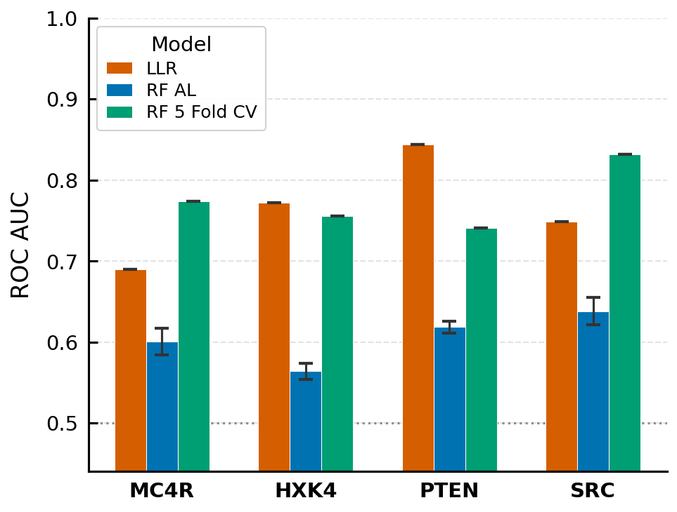
Figure 1. Summary of final model performance by protein and model (LLR, RF AL, RF 5 FOLD CV) using strict GOF/LOF labels.

3.2 Active learning improves monotonically but has not converged on the full-data ceiling
RF AL starts at AUC = 0.50 in round 1 (consistent with random initialization) and improves steadily across the eleven rounds of active learning on every protein under strict GOF/LOF labeling (Figure 2). For most proteins the largest AUC gains occur in early rounds, with diminishing returns later — but the curves have not plateaued below the LLR baseline, nor have they approached the RF 5 FOLD CV ceiling.
By round 11, LLR still exceeds RF AL across all four proteins: MC4R (+0.153 AUC), HXK4 (+0.224), PTEN (+0.250), and SRC (+0.162), with all margins substantially larger than the RF AL standard deviation. The standard deviations themselves are informative: the narrow RF AL spread for PTEN (±0.007) indicates that a larger labeled pool reduces sampling variability despite class imbalance, whereas MC4R (±0.017) and SRC (±0.017) show moderate run-to-run variation. The combination of monotonic improvement, unexhausted gains at round 11, and a large RF AL → RF 5 FOLD CV gap indicates that additional rounds or larger acquisition batches — not architectural changes — are the primary lever for closing the gap to LLR and beyond.
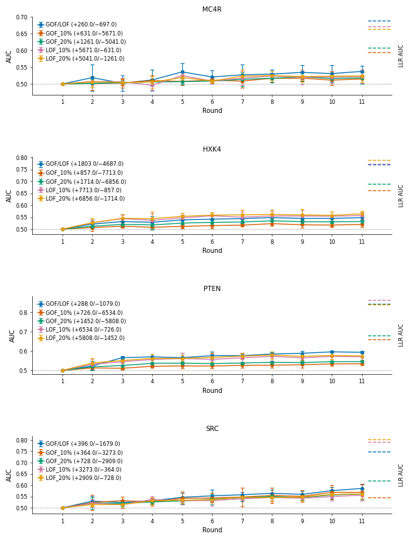Figure 2. Active learning convergence curves for RF AL (solid lines) versus LLR baseline (dashed horizontal lines) across eleven rounds. Each panel corresponds to one protein (MC4R, HXK4, PTEN, SRC) with strict GOF/LOF labels. Shaded bands indicate ± one standard deviation across simulation runs.

3.3 Classification performance is profoundly heterogeneous across structural domains
Protein-level AUC collapses a great deal of biological structure. To resolve where each model succeeds or fails, we computed AUC separately for each annotated structural domain (Supplementary Figure S1) and complemented this with the directional bias of RF AL predictions via mean signed error (MSE; Supplementary Figure S2).
MC4R. The most striking domain-level result occurs in the extracellular domain (ECD). RF AL achieves AUC = 0.505 ± 0.097 while LLR achieves only 0.211 — an LLR value well below random, indicating that evolutionary conses5rvation signals in the ECD are not merely uninformative but are inverted relative to the GOF/LOF axis. RF AL’s above-chance AUC in the same region, though modest, shows that ESM2 embeddings partially retain discriminative information that the LLR discards. Outside the ECD, performance is mixed. ECL3 shows RF AL = 0.573 ± 0.184 vs. LLR = 1.000, but the 10 GOF / 2 LOF variant count and the wide RF AL standard deviation caution against overinterpretation. ICL2 similarly favors LLR (1.000) over RF AL (0.500 ± 0.162) on only 3 GOF / 6 LOF variants. TM6 and TM7 are near-random for RF AL (0.498 ± 0.050 and 0.499 ± 0.075, respectively); LLR is also near-random in TM6 (0.502) but moderate in TM7 (0.619).
HXK4. LLR consistently outperforms RF AL across all HXK4 domains, though performance is relatively balanced. Hinge 2 is RF AL’s best domain (0.617 ± 0.030), while Hinge 1 strongly favors LLR (0.805 vs. 0.529 ± 0.071). The C-terminal tail favors LLR (0.765 vs. 0.555 ± 0.027), and the Large domain N-lobe shows below-chance RF AL performance (0.474 ± 0.035), implying that embedding-based features fail to capture functional constraints as well as evolutionary conservation in this region.
PTEN. LLR dominates every PTEN domain. The Linker region shows the largest gap (LLR = 0.986 vs. RF AL = 0.654 ± 0.126, with variability reflecting the small variant count: 5 GOF / 29 LOF). The C-terminal tail is particularly challenging for RF AL (AUC = 0.406 ± 0.042, well below chance), identifying this intrinsically disordered region as the single most difficult region for the embedding-based classifier. The C2 and phosphatase domains also favor LLR (0.876 and 0.753 vs. RF AL 0.569 ± 0.018 and 0.593 ± 0.021).
SRC. Only the kinase domain contained sufficient labeled variants for domain-level analysis, where RF AL (0.586 ± 0.017) fell below LLR (0.748) with high run-to-run consistency.
MSE analysis reveals that domain-level AUC failures are often accompanied by systematic directional biases in RF AL score predictions. Within MC4R, ECL3 shows the most negative MSE (−1.068 ± 0.119, under-prediction) and ECL2 the most positive (+0.816 ± 0.153, over-prediction); TM7 also shows positive bias (+0.655 ± 0.060). Every PTEN domain has negative MSE (−0.168 to −0.888), directly reflecting that RF AL systematically under-predicts PTEN assay scores across structural categories, mirroring its depressed AUC. The SRC kinase domain shows near-zero MSE (0.066 ± 0.045), indicating approximately unbiased predictions with tight run-to-run consistency. In HXK4, Hinge 1 shows the most negative MSE (−0.728 ± 0.183) and Hinge 2 the most positive (+0.272 ± 0.131), while remaining domains cluster near zero.
The domain-level picture is thus regime-dependent: LLR and RF AL each dominate in specific structural contexts, and their failure modes — inverted conservation signal for LLR (MC4R ECD), directional prediction bias and chance-level performance for RF AL (PTEN C-terminal tail) — are mechanistically distinct.

3.4 Position-level landscape reveals that evolutionary conservation is inverted at GOF hotspots
To understand why LLR fails so dramatically in certain structural regions, we examined the continuous position-level relationship between model predictions and assay scores. Supplementary Figures S3 and S4 map position-averaged assay scores with position-averaged prediction scores across each protein, and Figures 3 and 4 quantify the Pearson correlation at protein and domain levels, respectively.
Figure 3. Pearson correlation between position-averaged assay score and model prediction score. At the protein level, LLR outperforms RF AL on HXK4 (r = 0.610 vs. 0.327) and PTEN (0.589 vs. 0.309), while RF AL modestly outperforms LLR on SRC (0.463 vs. 0.425) and MC4R (0.437 vs. 0.311). RF 5 FOLD CV achieves the highest correlation across all proteins (MC4R: 0.862, HXK4: 0.920, PTEN: 0.846, SRC: 0.914), consistent with the AUC benchmark and confirming that full-data training extracts additional signal available in the embedding space.
Figure 4. Domain-level Pearson correlation between position-averaged assay score and prediction score. Breaking the correlation down by structural domain exposes the mechanism behind LLR’s MC4R ECD failure. The LLR–assay correlation in the MC4R ECD is strongly negative (r = −0.560): evolutionary conservation is inversely related to functional activity in this region. GOF variants in MC4R cluster in the N-terminal extracellular segment, which makes direct contact with melanocortin peptide ligands. These residues are evolutionarily conserved because they control normal signaling, but many are permissive to substitutions that shift the receptor toward constitutive activity. LLR penalizes any substitution at conserved positions regardless of functional direction, so both GOF and LOF variants receive negative scores — meaning the LLR signal aligns with LOF detection but is systematically misleading for GOF. The net result is not a loss of signal but an inversion of it, producing the near-chance classification AUC of 0.211 observed in Section 3.3. In the same region, RF AL achieves a clearly positive correlation, demonstrating that ESM2 embeddings partially retain the assay-relevant variation that LLR discards.
The same inversion logic appears in MC4R TM6 (LLR r = −0.209; RF AL r = 0.100), a helix that undergoes the large outward displacement characteristic of class A GPCR activation. Substitutions that facilitate this motion can appear evolutionarily unusual while being functionally activating, again inverting the conservation signal. Two further patterns emerge. First, PTEN’s C-terminal tail shows a moderate RF AL correlation (r = 0.425), exceeding LLR in the same region (r = 0.226), suggesting that learned embeddings partially capture functional variation in this intrinsically disordered region despite post-translational modification contexts that are invisible to sequence-only models [19]. Second, the SRC kinase domain shows only a modest LLR → RF AL improvement in the kinase region (r = 0.427 → 0.463), indicating that learned embeddings provide limited additional signal over evolutionary conservation for allosteric relationships governing kinase activity.
The landscape, figures S3 and S4, also reports the functional distribution of residue positions. For PTEN and HXK4, mean assay scores across positions lie predominantly below the LOF threshold, reflecting high sensitivity to perturbation and functional intolerance to most substitutions. SRC contains a larger fraction of GOF-range positions, consistent with its oncogenic activation potential, while MC4R positions span the broadest functional range, reflecting this receptor’s bidirectional GOF/LOF biology. The combination of biased position-level distributions with structurally localized conservation inversions explains why protein-level benchmarks alone understate the stakes: a classifier that is correct “on average” can still be catastrophically wrong precisely where actionable variants cluster.

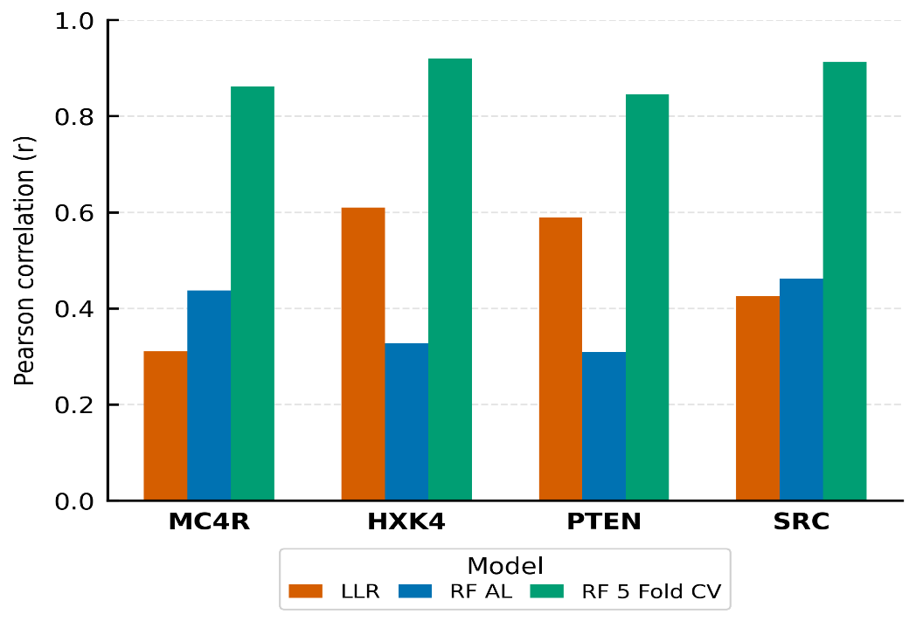
Figure 3. Pearson correlation between position-averaged assay score and model prediction score.

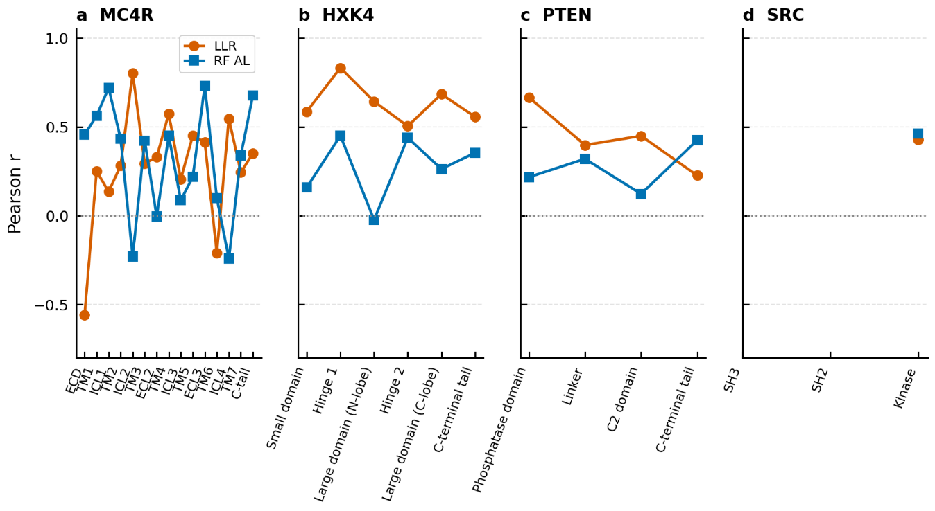
Figure 4. Domain-level Pearson correlation between position-averaged assay score and prediction score.

3.5 Strict functional labels generally outperform percentile-based labels
Finally, we examined whether the choice of label definition influences the RF AL benchmark (Figure 2). Strict GOF/LOF labels produced the highest round-11 RF AL AUC for MC4R (0.537 ± 0.017), PTEN (0.594 ± 0.007), and SRC (0.586 ± 0.017). For HXK4, LOF-anchored percentile labels narrowly outperformed strict labels (LOF20%: 0.564 ± 0.012; LOF10%: 0.557 ± 0.015; GOF/LOF strict: 0.548 ± 0.010), suggesting that for this enzyme the LOF signal is more coherently captured by percentile-based thresholds. For PTEN, strict labels also outperformed LOF percentile labels (0.594 ± 0.007 vs. 0.575 ± 0.021 and 0.571 ± 0.025), though confidence intervals overlap.
Domain-level RF AL AUC under the alternative labeling strategies was generally lower than under strict labels across most proteins and domains (Supplementary Figure S5). Percentile-based labels, which include a larger pool of intermediate-effect variants near the decision boundary, produce more ambiguous classification targets and degrade training performance relative to strict labels that enforce clear functional separation. The PTEN result is especially informative: the GOF percentile methods performed worst overall, which is biologically consistent because assigning the top 10–20% of the assay distribution as “GOF” for a tumor suppressor conflates truly activating variants with those that are merely less severely damaging, creating a noisy and biologically ambiguous positive class. LOF percentile methods for PTEN performed better than GOF percentile methods, consistent with PTEN’s LOF-dominated biology, but still carried higher variance (±0.021–0.025) than strict labels (±0.007), indicating that borderline variants near percentile cutoffs inject run-to-run instability. The strict-label advantage is notable because the strict PTEN GOF class is small (288 GOF vs. 1,079 LOF); the biologically validated threshold evidently provides a cleaner and more consistent training signal than any percentile cutoff.

4. Discussion

4.1 Supervised PLM embeddings can exceed zero-shot conservation, but active learning needs more rounds
Our central finding is that the ESM2 embedding-based Random Forest classifier, when trained on the full labeled dataset via 5-fold cross-validation, exceeds the zero-shot LLR baseline for MC4R (0.773 vs. 0.690) and SRC (0.831 vs. 0.748). This directly demonstrates that the RF + ESM2 architecture has sufficient representational capacity to surpass the zero-shot baseline when adequate training data are available — the embedding space contains discriminative information about receptor activation and kinase regulation that evolutionary conservation alone does not surface. The SRC result in particular suggests that allosteric couplings governing kinase activity leave a learnable signature in PLM embeddings.
Eleven rounds of active learning, acquiring up to 516 labels, are insufficient to realize this capacity. RF AL remains below LLR on all four proteins, consistent with recent critiques of PLM-based supervised variant effect prediction under limited data [17]. The large RF AL → RF 5 FOLD CV gap — most pronounced for SRC (0.638 vs. 0.831) and MC4R (0.601 vs. 0.773) — quantifies the unrealized potential of this approach. The monotonic AUC improvements across rounds (Figure 2), without plateauing, are consistent with this diagnosis: the supervised classifier has not yet saturated. Closing this gap by expanded active-learning protocols (more rounds, larger acquisition batches, alternative acquisition functions) is the most immediate priority for making this approach practically useful.

4.2 Evolutionary conservation is actively misleading at GOF hotspots
The domain-level analyses expose a qualitative failure mode of zero-shot LLR that is obscured by protein-level averages. In the MC4R ECD, LLR’s classification AUC is 0.211 — substantially worse than random — and the underlying position-level correlation is −0.560. This is not a lack of signal but an inverted signal: conservation-based scoring systematically mislabels activating variants at ligand-contacting residues as damaging, while correctly labeling LOF variants as damaging, which produces an anti-predictive score for the GOF/LOF distinction.
This inversion is a structural phenomenon, not a statistical artifact. Activating GPCR mutations frequently occur at residues that are conserved precisely because they are functionally critical; the wildtype is selected because it maintains correct signaling, yet specific substitutions can tip the receptor toward constitutive activation. Conservation-based models cannot distinguish between these two regimes, because they encode only which residue is improbable, not which direction of functional effect a given substitution produces. The same logic explains the negative LLR–assay correlation in MC4R TM6 (r = −0.209), where mutations facilitating the activating outward-helical motion appear evolutionarily unusual but are functionally activating. These observations concretize the broader class of failure modes recently documented in PLM-based variant effect prediction [17] — conflation of site-level conservation with substitution-specific effects — and demonstrate that the failure is strongest precisely where clinical stakes are highest: at the ligand-binding and allosteric hotspots where many actionable GOF variants cluster.
That supervised RF AL recovers a positive, if modest, signal in the same MC4R ECD region (AUC = 0.505 ± 0.097) is biologically meaningful. It demonstrates that the ESM2 embeddings retain some assay-relevant information beyond what the LLR extracts, even though the overall protein-level benchmark favors LLR for MC4R. Domain-level advantages of this kind are obscured in protein-level summaries, and they motivate ensemble strategies that combine the zero-shot and supervised signals according to regional reliability — LLR where conservation is well-aligned with function, supervised embeddings where conservation is inverted.

4.3 PTEN exposes a representational limit, not merely a data limit
For PTEN, both RF AL (0.619) and RF 5 FOLD CV (0.741) underperform LLR (0.844), with the RF 5 FOLD CV gap (+0.103 for LLR) smaller than the RF AL gap (+0.225) but still substantial. The high LLR performance likely reflects strong evolutionary conservation of catalytically critical residues in the phosphatase and C2 domains, making conservation-based scores reliable LOF predictors, and the exceptional LLR Linker performance (0.986) is consistent with the known regulatory importance and strong conservation of this segment. However, the small sample size for this region makes this conclusion questionable.
Critically, because RF 5 FOLD CV accesses the full labeled dataset and still fails to match LLR, the PTEN shortfall is not primarily a data-quantity problem. Two additional factors likely contribute. First, GOF variants for PTEN are rare and functionally heterogeneous; the strict label set contains only 288 GOF vs. 1,079 LOF variants, a moderate imbalance that complicates training regardless of data volume. Second, PTEN’s C-terminal tail (residues 352–403) is largely intrinsically disordered and subject to extensive post-translational regulation, making sequence-based embeddings less predictive than for structured domains [19]. The below-chance RF AL AUC in this region (0.406 ± 0.042) directly supports this interpretation. Together, these observations suggest that the PTEN challenge reflects a fundamental representational limitation of sequence-only ESM2 embeddings for proteins whose functional output is shaped by disordered regions and post-translational modifications — not a problem additional active-learning rounds will resolve.
The PTEN labeling-strategy comparison further reinforces this picture. Strict GOF/LOF labels produced both the highest RF AL AUC and the lowest run-to-run variance, outperforming all percentile-based schemes. The GOF percentile methods performed worst — biologically expected for a tumor suppressor where assigning the top 10–20% of the assay distribution as “GOF” conflates truly activating variants with less severely damaging ones, creating an ambiguous positive class. The steady monotonic improvement of PTEN GOF/LOF convergence across rounds (0.524 at round 2 → 0.585 at round 8 → 0.594 at round 11), versus more irregular trajectories under percentile labels, confirms that biologically validated thresholds provide a more learnable objective than arbitrary distributional cutoffs even when the resulting positive class is small.

4.4 Structural heterogeneity demands structurally informed evaluation
The dramatic variation in classification performance across structural domains establishes that protein-level AUC is an insufficient summary for PLM-based variant classifiers. Different domains require different modeling strategies, and aggregate metrics can mask both large failure modes (the MC4R ECD inversion) and genuine model advantages (RF AL’s positive signal in the same region).
Several domain-level observations have direct biological interpretations. The near-random RF AL performance in MC4R TM6 and TM7 (both ≈0.50) indicates that functional outcomes in these conformationally dynamic helices depend on subtle structural context that neither sequence-level embeddings nor conservation captures — LLR is also near-random in TM6 (0.502), confirming this as a fundamental challenge for sequence-based approaches rather than a specific weakness of either method. The below-chance RF AL AUC in the PTEN C-terminal tail (0.406 ± 0.042) and HXK4 Large domain N-lobe (0.474 ± 0.035) indicates that embeddings are not merely uninformative but actively mis-aligned with function in these regions; for the PTEN tail, despite a moderate position-level correlation (r = 0.425), the below-chance AUC may reflect misalignment between the embedding signal and the binary GOF/LOF boundary in this post-translationally regulated region [19]. The SRC kinase domain shows a higher RF AL position-correlation (r = 0.463 vs. LLR r = 0.427), though the advantage over LLR is modest, suggesting that allosteric relationships in the kinase domain are only partially imprinted in the embedding space beyond single-site conservation.
The high LLR performance in small MC4R domains (ICL2: 1.000 on 3 GOF / 6 LOF; ECL3: 1.000 on 10 GOF / 2 LOF) should be treated with caution. The wide RF AL standard deviations in these regions (±0.162, ±0.184) confirm that small-domain estimates are unstable across runs, and LLR’s apparent perfection reflects the small sample sizes as much as genuine discrimination. Future benchmarks should adopt minimum-sample thresholds for reporting domain-level AUC.

4.5 Label strategy has practical implications for MAVE-based training
The general superiority of strict GOF/LOF labels over percentile-based labels (for MC4R, PTEN, and SRC) has practical consequences for MAVE data analysis pipelines. Percentile labels describe the extremes of the assay distribution but conflate biologically distinct categories — a 90th-percentile variant may be slightly above neutral rather than a true gain of function — and the inclusion of these ambiguous variants as positives degrades classifier training.
The HXK4 exception, where LOF percentile strategies (LOF_20%: 0.564 ± 0.012) narrowly outperformed strict labels (0.548 ± 0.010), likely reflects that although the strict HXK4 GOF label set is numerically large (1,803 variants), it spans a wide spectrum of functional severity — from strongly activating to marginally above threshold. Because the classifier treats all GOF variants as equivalent positives, weakly activating variants near the decision boundary dilute the training signal. The magnitude of the difference (0.016 AUC) is small and overlaps with run-to-run variability, so this should be interpreted as a cautionary note about label granularity rather than a general prescription to favor percentile labels.

4.6 Limitations and future directions
Four limitations bear emphasis. First, our active learning implementation used eleven rounds; the large RF AL → RF 5 FOLD CV gap demonstrates that substantially more rounds or larger acquisition batches are required to realize the architecture’s full potential, consistent with the literature on supervised models underperforming zero-shot baselines at limited sample sizes [17]. Second, RF 5 FOLD CV exceeds LLR for MC4R and SRC but falls short for PTEN even with full dataset access, indicating that data quantity alone is insufficient for proteins where disordered regions and post-translational regulation dominate function — structure- or disorder-aware features will likely be required. Third, small-domain AUC estimates carry high standard deviations, and future work should adopt minimum-variant thresholds for reporting domain-level metrics. Fourth, PTEN GOF and LOF thresholds were defined pragmatically (assay score >1.1 and <0.9, respectively) rather than from published functional criteria; the ±10% margins exclude likely assay noise but the precise cutoff is arbitrary, and validation against ClinVar pathogenicity annotations is an important next step — though the observed superiority of strict labels over percentile labels provides indirect support that the chosen thresholds define a coherent, learnable signal.
Three directions follow naturally. First, ensemble approaches combining LLR with RF AL predictions could exploit the complementary strengths we document — for instance LLR in the PTEN Linker (0.986) with RF AL in the MC4R ECD (0.505 vs. LLR 0.211). Second, alternatives to mean pooling (attention pooling, per-residue feature concatenation, domain-specific pooling) could preserve information currently lost in the fixed-length representation. Third, integrating structural features (e.g., from AlphaFold2), explicit conservation scores, and functional annotations with ESM2 embeddings should improve performance in challenging regions such as intrinsically disordered tails. Most immediately, increasing active-learning rounds and batch sizes for data-rich proteins such as HXK4 and SRC may allow RF AL to approach the RF 5 FOLD CV ceiling, converting the architectural capacity we document into practical classification performance.

5. Conclusions
We benchmark three computational strategies for gain- and loss-of-function missense variant classification across four clinically relevant proteins. The ESM2 embedding-based Random Forest, when trained on the full labeled dataset, outperforms the zero-shot ESM2 LLR baseline for MC4R (0.773 vs. 0.690) and SRC (0.831 vs. 0.748), establishing that supervised PLM embeddings can exceed zero-shot conservation when adequate training data are available. Active learning with eleven rounds remains below LLR on every protein, and the gap to full-data performance quantifies the clear path forward for supervised PLM approaches. Domain-level analysis uncovers a qualitatively distinct failure of the zero-shot baseline: in the MC4R extracellular domain, where activating variants cluster at ligand-contacting residues, evolutionary conservation is strongly anti-correlated with function (r = −0.560) and classification is worse than random (AUC = 0.211), while supervised embeddings recover a positive discriminative signal. The same inversion appears in MC4R TM6 and in other allosteric hotspots — a regime-specific failure mode that protein-level benchmarks obscure and that has direct clinical implications for the many GOF variants that occur at evolutionarily constrained positions. Together, these findings position zero-shot LLR and supervised PLM-embedding classifiers as complementary tools whose regional reliabilities are structurally predictable, and provide a concrete blueprint — expanded active-learning coverage, structure-aware features, and ensemble combination — for delivering clinical-grade GOF/LOF classification from MAVE data.

Acknowledgements
We thank Vivek Kanpa for help with downloading and scrubbing the MAVE data.

Data and Code Availability
All data supporting this study are available at [URL]. Code is available at [GitHub URL].

Supplementary Material
Supplementary Figures S1–S5.

References
- Lotta LA, et al. Human gain-of-function MC4R variants show signaling bias and protect against obesity. Cell. 2019;177(3):597–607.e9.
- Gloyn AL. Glucokinase (GCK) mutations in hyper- and hypoglycemia: maturity-onset diabetes of the young, permanent neonatal diabetes, and hyperinsulinemia of infancy. Hum Mutat. 2003;22(5):353–362.
- Yehia L, Eng C. PTEN-opathies: from biological insights to evidence-based precision medicine. J Clin Invest. 2022;132(1):e154618.
- Boerner JL, Bhatt D, Bhatt NJ. Role of SRC in human carcinomas and breast cancer: decade of advances. Front Biosci. 2004;9:1483–1500.
- Fowler DM, Fields S. Deep mutational scanning: a new style of protein science. Nat Methods. 2014;11(8):801–807.
- Starita LM, et al. Variant interpretation: functional assays to the rescue. Am J Hum Genet. 2017;101(3):315–325.
- Weile J, Roth FP. Multiplexed assays of variant effects contribute to a growing genotype-phenotype atlas. Hum Genet. 2018;137(9):665–678.
- Howard CJ, Abell NS, Osuna BA, et al. High-resolution deep mutational scanning of the melanocortin-4 receptor enables target characterization for drug discovery. eLife. 2025. PMCID: PMC11981609.
- Gersing S, Cagiada M, Gebbia M, et al. A comprehensive map of human glucokinase variant activity. Genome Biol. 2023;24(1):93. PMCID: PMC10131484.
- Ahler E, Register AC, Chakraborty S, et al. An integrated approach reveals a regulatory mechanism coupling Src’s kinase activity, localization, and phosphotransferase-independent functions. Mol Cell. 2019;74(2):393–408.e20. PMCID: PMC6474823.
- Matreyek KA, Stephany JJ, Ahler E, Fowler DM. Integrating thousands of PTEN variant activity and abundance measurements reveals novel variant subgroups and new dominant negatives in cancers. Genome Med. 2021;13(1):165. PMCID: PMC8518224.
- Rives A, et al. Biological structure and function emerge from scaling unsupervised learning to 250 million protein sequences. Proc Natl Acad Sci USA. 2021;118(15):e2016239118.
- Elnaggar A, et al. ProtTrans: toward understanding the language of life through self-supervised learning. IEEE Trans Pattern Anal Mach Intell. 2022;44(10):7112–7127.
- Lin Z, et al. Evolutionary-scale prediction of atomic-level protein structure with a language model. Science. 2023;379(6637):1123–1130.
- Fraternali F, et al. EVE: machine learning-based variant effect prediction for human disease. Nat Commun. 2021;12(1):6969.
- Meier J, et al. Language models enable zero-shot prediction of the effects of mutations on protein function. Adv Neural Inf Process Syst. 2021;34:29287–29303.
- Wilke C. Protein language models are bad at mutational effect prediction. Genes, Minds, and Machines. 2026. https://blog.genesmindsmachines.com/p/protein-language-models-are-bad-at
- Jiang K, et al. Rapid in silico directed evolution by a protein language model with EVOLVEpro. Science. 2025;387(6732):eadr6006.
- Shenoy SS, et al. PTEN C-terminal tail is an autoinhibitory element and a degron that tunes protein stability and activity. Proc Natl Acad Sci USA. 2022;119(48):e2208007119.

