Supplementary Figures

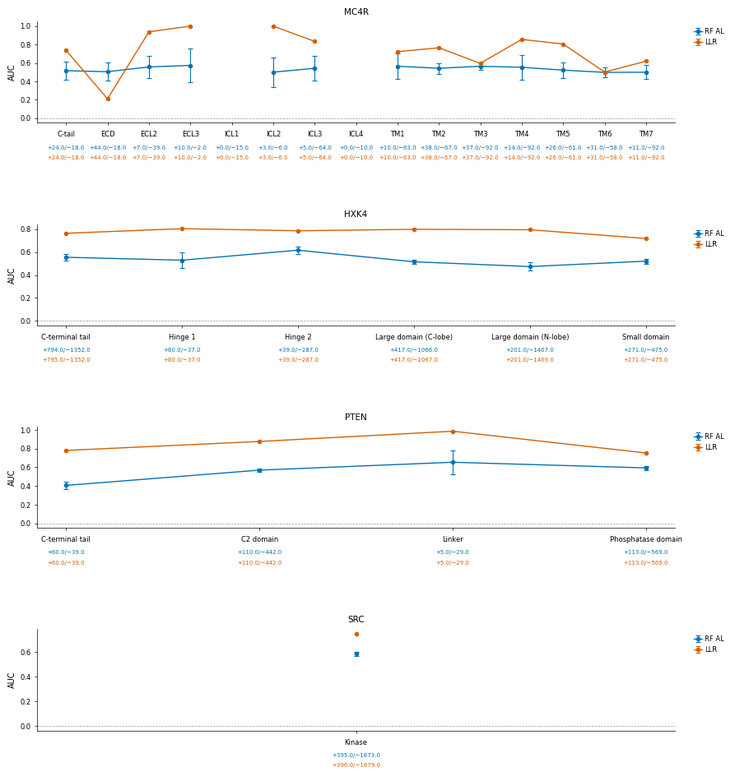
Supplementary Figure S1. Graph of domain-level ROC AUC for RF AL and LLR models (strict GOF/LOF labels) for each protein. Error bars indicate ± one standard deviation across simulation runs for RF AL; LLR is deterministic.
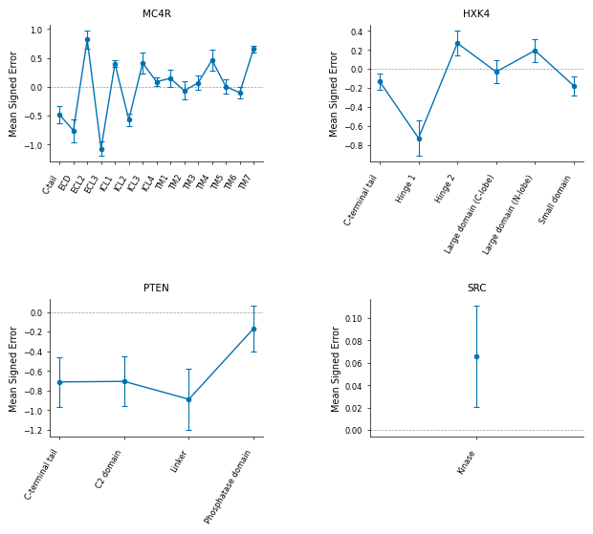
Supplementary Figure S2. RF AL mean signed error (MSE) by domain. Positive values indicate the model over-predicts functional scores on average; negative values indicate under-prediction. Values near zero indicate predictions are approximately unbiased for that domain. Error bars indicate ± one standard deviation across simulation runs.

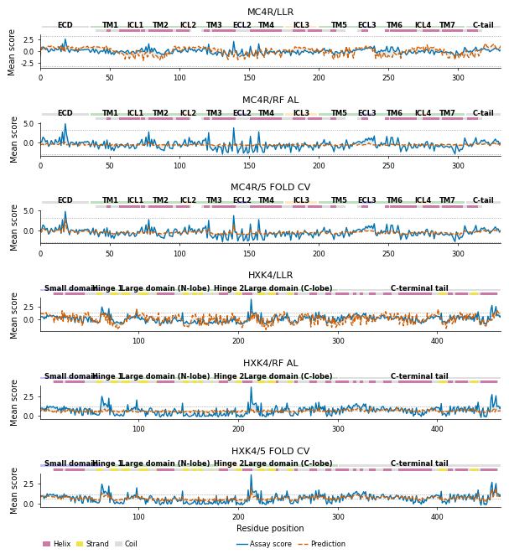
Supplementary Figure S3. Position-averaged assay scores and prediction scores for every residue in MC4R and HXK4 for different models. Dashed grey lines represent the GOF and LOF thresholds.

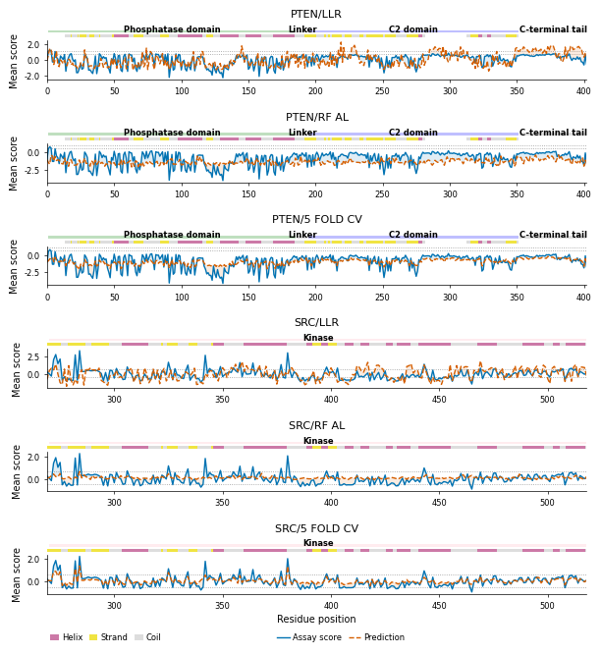

Supplementary Figure S4. Position-averaged assay scores and prediction scores for every residue in PTEN and SRC for different models. Dashed grey lines represent the GOF and LOF thresholds.

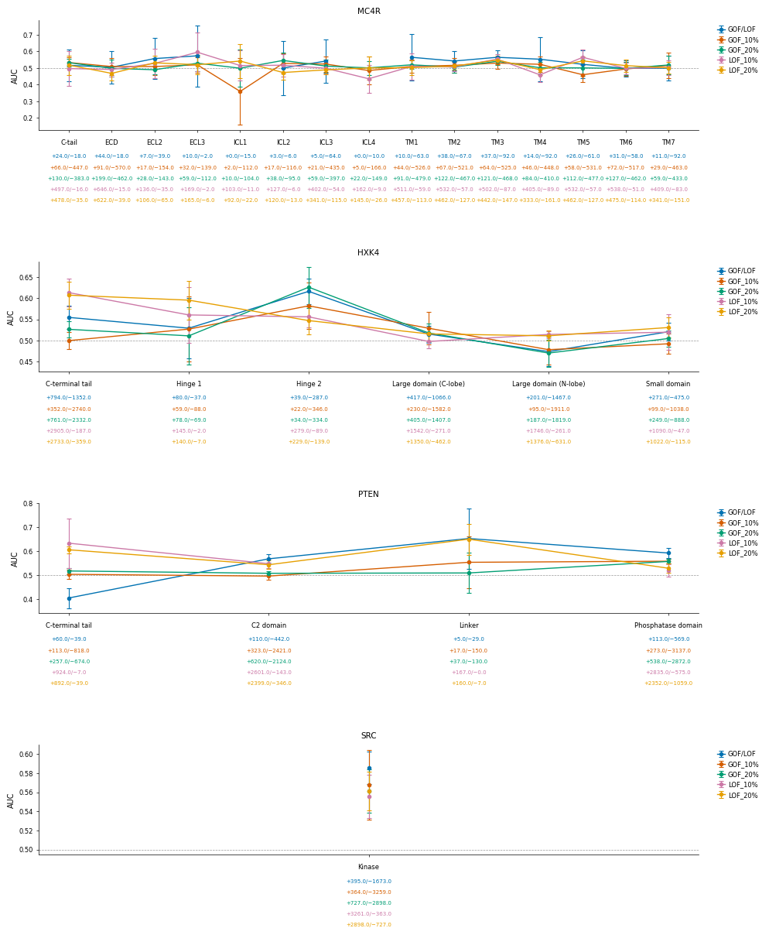
Supplementary Figure S5. Domain-level RF AL AUC comparison between strict GOF/LOF and percentile labels. The number of positive and negative labels for each domain for each labeling strategy is also shown. Error bars indicate ± one standard deviation across simulation runs.

