**Geo-spatial analysis of the association of vitamin A deficiency and stunted growth in children in Uganda**

Paddy Ssentongo, MD, MPH1,2 Tongyao Fan MPH2, MPH, Jeff D. Yanosky, ScD2, Andrew Whalen, PhD1, Steven J. Schiff, MD, PhD1, Ming Wang, PhD2, Vernon Chinchilli, PhD2

1Center for Neural Engineering, Department of Engineering, Science and Mechanics, The Pennsylvania State University, University Park, PA, USA

2Department of Public Health Sciences, Penn State College of Medicine, Hershey, PA, USA

**Introduction**

Globally, vitamin A deficiency (VAD) is estimated to affect over 127 million preschool-aged children1, and is associated with approximately 2.5 million preventable deaths from associated diarrheal, respiratory and immune diseases,2,3 with most of these deaths occurring in sub-Saharan Africa and South East Asia.1 Furthermore, VAD is associated with growth failure. However, studies looking at the association between VAD and deficits in linear (height) or ponderal (weight) growth have often yielded inconsistent results, with some studies reporting VAD to be associated with linear growth in Indonesia4,5, gender-specific ponderal growth 6 or no association at one year of follow-up in China7 and India8. None of these studies were conducted in Africa, where both VAD and growth failure are endemics. Evidence from animal models show that VAD affects linear growth9, and that growth could be restored by vitamin A supplementation10,11.

There are however no population-based studies to assess the association of growth failure and VAD in sub-Saharan Africa (SSA). Furthermore, the effect of environmental determinants of stunted growth are not explored. We hypothesized that the distribution of VAD and stunted growth could be modified by environmental factors including rainfall and elevation. Therefore the primary object if this study is to estimate and predict stunted growth using vitamin A status and environmental determinants. Second objective is to explore the spatial variations of stunted growth that cannot be explained by VAD and environmental covariates.

**METHODS**  
**Data and procedures**

Data were from the latest (2016) Uganda Demographic and Health Survey (UDHS). The data was collected between June 20, 2015 and December 16, 2016 by the Uganda Bureau of Statistics (UBOS) in collaboration with the Ministry of Health (MOH) and coordinated by ICF in Rockville, Maryland, USA. Financial support was provided by the United States Agency for International Development (USAID), Government of Uganda, the United Nations Children’s Fund (UNICEF), and the United Nations Population Fund (UNFPA). The survey collected nationally representative health to monitor and evaluate population health, and nutrition programs. Data collection used a multistage stratified sampling design. First, Uganda was divided into 15 regions. Within these regions, populations were stratified by urban and rural areas of residence. Within these stratified areas, a random selection of 696 enumeration areas or primary sampling units (PSUs) were drawn. In Uganda, an EA is a geographic area that covers an average of 130 households. PSUs were selected on the basis of a probability that was proportional to the population size. Next, in the second stage of sampling, all households within a PSU were listed from the most- recent population census (2014) and ~30 households per PSU were randomly selected for an interview with the use of equal probability systematic sampling. In total, a representative sample of 20,880 households was selected for the 2016 UDHS. For each sampled household, household members were listed, and women who were eligible for a more-detailed interview were identified. These women were between the ages of 15 and 49 y. Height and weight information was also collected from eligible women and men, as well as children age 0-59 months. Blood samples were collected from children age 6-59 months for laboratory testing of serum retinal binding protein, a surrogate marker for vitamin A concentration. Data collection was approved by the ICF Macro International Institutional Review Board and by the Ugandan MOH. Oral informed consent for the interview was obtained from each participants, their parents or guardians.

**Statistical analysis**

Values were presented as means (SD) for the continuous variable and counts (%) for the categorical variables to describe the population characteristic. T-tests or Chi-square testes were used to examine differences between cases and controls.

*Generalized Additive Mixed-effect Model (GAMM)*

To account for the random effects of the regions, clusters and households, we ran a GAMM.

The outcome of interested was stunting (Height-for-age z-score below 2 standard deviation from the WHO growth standards). The principal predictor of interest was VAD. We added the following covariates geographical coordinates, annual rainfall and temperature, slope (m), vegetation index and age. First we created the predicted values of stunting using the above mentioned covariates using logit link respectively.

**Geospatial interpolation**

To maintain participant confidentiality, the DHS randomly displaces GPS locations, with displacement diameters varying by urban (up to 2 km) and rural (up to 5 km, with 1% up to 10km) location. Such multilevel analyses have been used previously in the literature with DHS data to account for the inherent nesting structure and multistage sampling design of the data**.** We spatially interpolated the predicted values onto a grid using the penalized spline interpolation approaches. The grid was of 0.1o by 0.1o resolution covering the entire country of Uganda. The significance level for all the analyses was set at α=0.05. Interaction terms were tested and left in the model if were significant at α=0.05. All analyses were done with R package mgcv.

**Results**

A total of 4805 participants with 1308 cases were included in our project. Detailed descriptive results were presented in Table 1.

**Table 1 Demographic and covariates table**

|  |  |  |  |  |
| --- | --- | --- | --- | --- |
| **Variables** | **All participants**  **N=4805** | **Stunted**  **N=1308** | **No stunted**  **N=3497** | **P-values** |
| **Age, m** | 32.5 (15.4) | 33.0 (14.5) | 32.3 (15.8) | 0.16 |
| **Female, N (%)** | 2384 (49.6) | 614 (46.9) | 1770 (50.6) | **0.025** |
| **Vitamin A, ug/dl** | 26.4 (10.5) | 25.7 (9.9) | 26.7 (10.7) | **0.002** |
| **Height-for-Age-Z scores, SD** | -1.2 (1.4) | -2.8 (0.7) | 0.6 (1.1) | **<.0001** |
| **Rainfall_2010, mm** | 1359.79 (217.0) | 1361.3 (245.2) | 1359.2 (205.4) | 0.80 |
| **Temperature_2015,0C** | 23.3 (1.7) | 23.2 (1.7) | 23.3 (1.8) | **0.006** |
| **Slope, degrees** | 1.4 (1.4) | 1.7 (1.6) | 1.3 (1.3) | **<.0001** |
| **Vegetation index_2015, mean(SD)** | 3865.6 (675.2) | 3942.9 (696.6) | 3836.6 (664.7) | **<.0001** |
| **Proximity to water, m** | 43903.2 (39107.7) | 49468.0 (42296.7) | 41827.9 (37646.2) | **<.0001** |
| **Smoking status (%)** | 650 (13.5) | 200 (15.3) | 450 (12.9) | **0.03** |
| **Altitude, m** | 1202.8 (233.3) | 1237.0 (250.9) | 1189.9 (225.1) | **<.0001** |

The mean HAZ was -1.2 (1.4) and was higher among the non-stunted children (mean=0.6, SD=1.1) compared to the stunted children (mean=-2.8, SD=0.7). There was no age difference between stunted growth and controls children. However, those who are stunted were more likely to have a lower blood concentration of Vitamin A compared to the non-stunted children. Furthermore, temperature, slope, vegetation index, and altitude were meteorological and geographical factors associated with stunting. Smoking prevalence was higher in the households that were stunted compared to non-stunted households (15.3% vs. 12.9%).

**GAMM model using HAZ as the outcome variable.**

The final penalized spline model contained 8 variables (**Table 3**). Penalized spline models (**Figure 2**) indicated that with the exception of age and vitamin A concentrations, other covariates did not deviate from linearity assumption. Therefore, only geographical coordinates, vitamin A concentration and age were modeled as penalized splines. There was a non-linear association between vitamin A concentration and HAZ (effective degrees of freedom (edf) = 2.3, reference degrees of freedom (rdf) =2.3, F=4.0, p=0.014). HAZ increases linearly with increasing blood Vitamin A levels up to1.5 µg/dl, at which point the association plateaus. Likewise, age had a non-linearly association with HAZ (edf=8.8, rdf =2.3, F=14.0, p<0.0001). Lowest HAZ was observed at 19 months, but started rising again until 20 – 30 months and which point the association levelled off. Land surface temperature was the only fixed effect term significantly associated with HAZ. Per 0.07oC increase in the land surface temperature was associated with one z-score increase in HAZ. The adjusted R2 for the final parsimonious model was 8%.

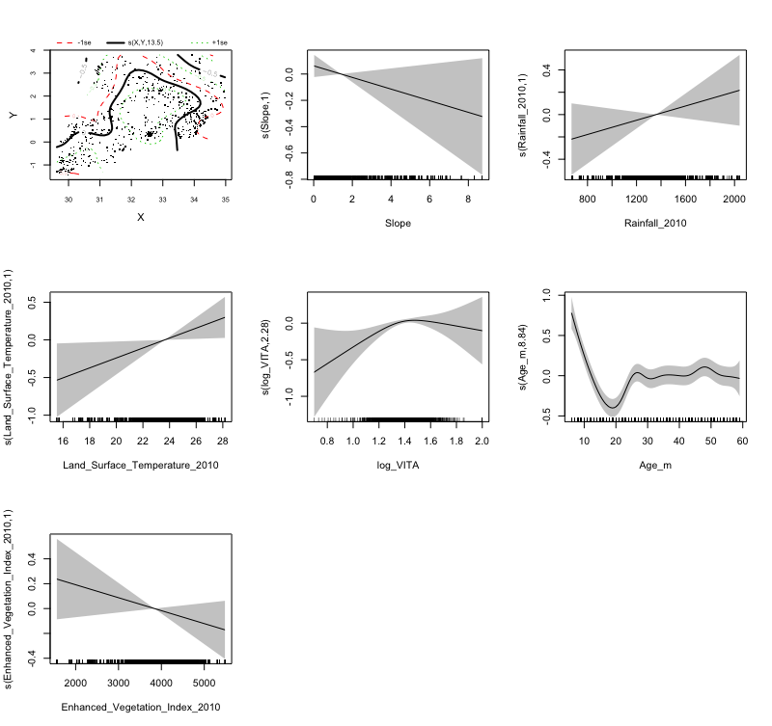

Figure 2: **Exposure-response penalized spline term graphs** Associations between HAZ and geographical coordinates (edf = 13, p = 0.012, slope (edf = 1, p = 0.14), rainfall (edf = 1, p = 0.17), temperature (edf = 1, p = 0.02), vitamin A (edf = 2, p = 0.01), age (edf = 9, p <0.0001) and vegetation index (edf = 1, p = 0.14). (Shaded grey band denote 95% CIs).

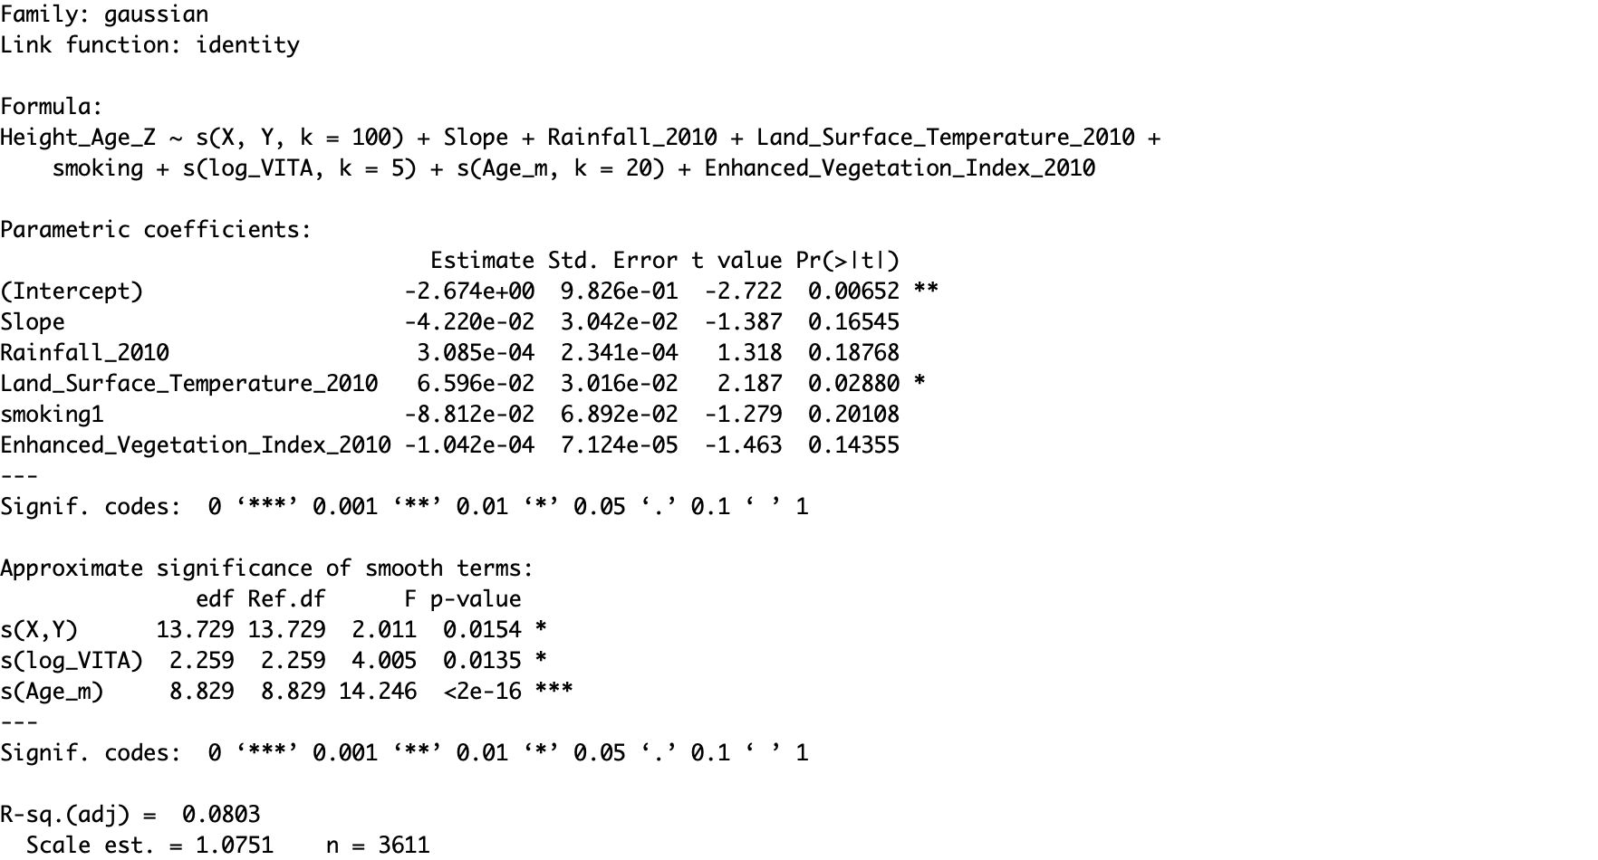

Table 3: Regression coefficient results for the final GAMM model

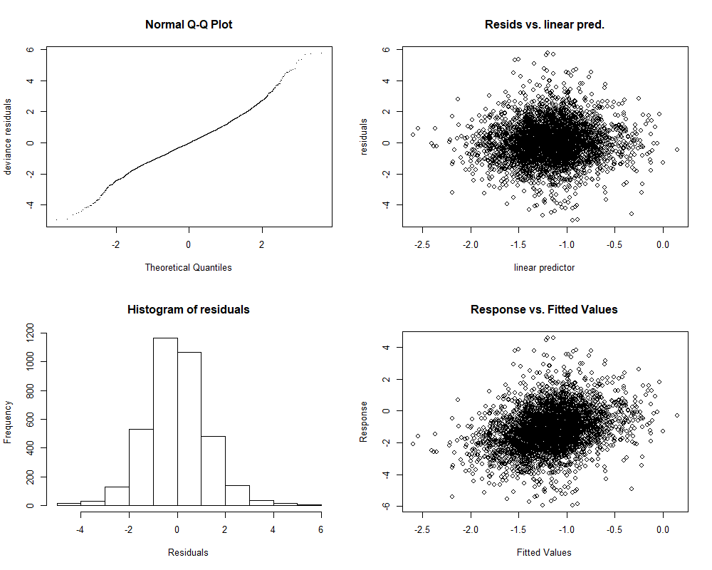

Figure 3: GAM Model diagnostics: Plots show normality of residuals.

The next step of the model is for visualization purpose, with spatially interpolated predicted values. Displayed in **Figure 4** are the spatially interpolated predicted (left) and observed (right) values of HAZ. The distribution of HAZ is consistent in both images. The north-eastern and western region of Uganda had the lowest HAZ (**Figure 5**). Finally, when the predicted and raw values were dichotomized into stunted (<-2 HAZ SD) and normal growth (≥2 HAZ SD), and plotted as jittered points, the distribution of the stunted cases is consistent with spatially interpolated predicted values of HAZ (**Figure 6**).

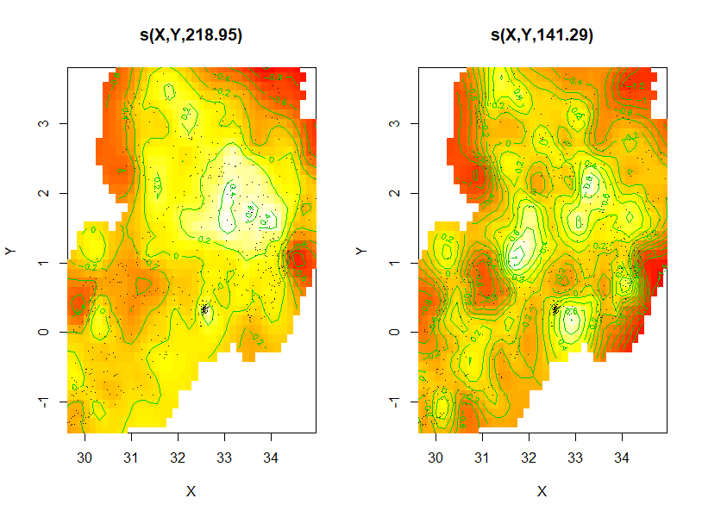

Figure 4: Maps of predicted and observed HAZ values

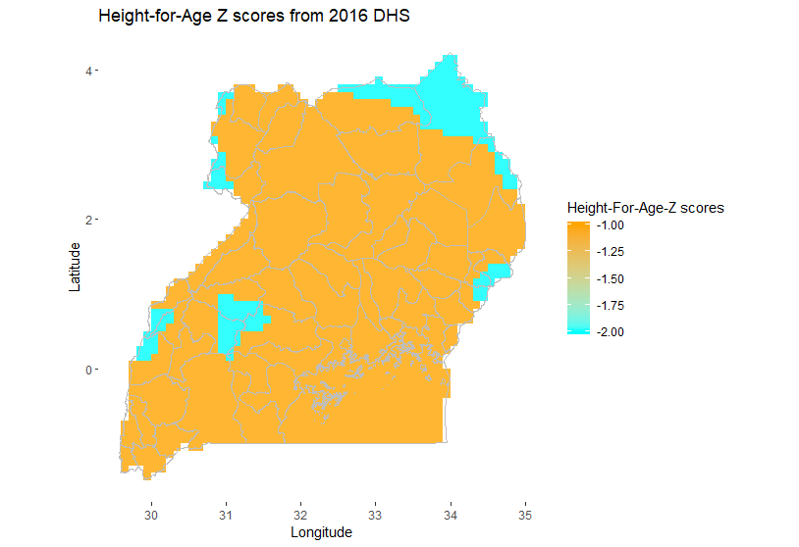

Figure 5: Spatially interpolated HAZ using GAM

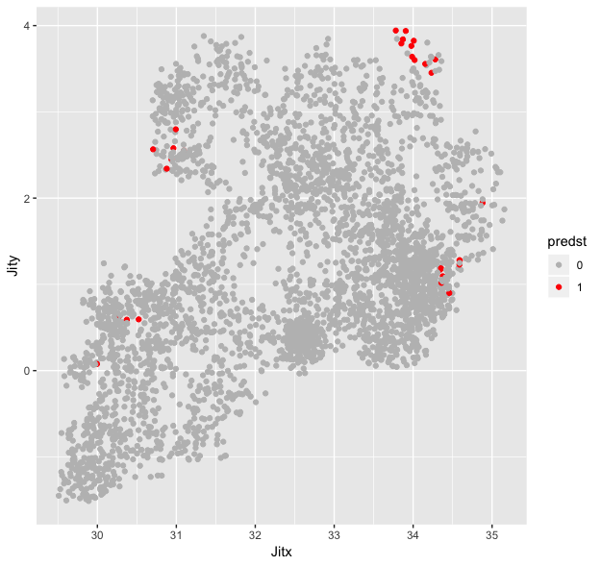

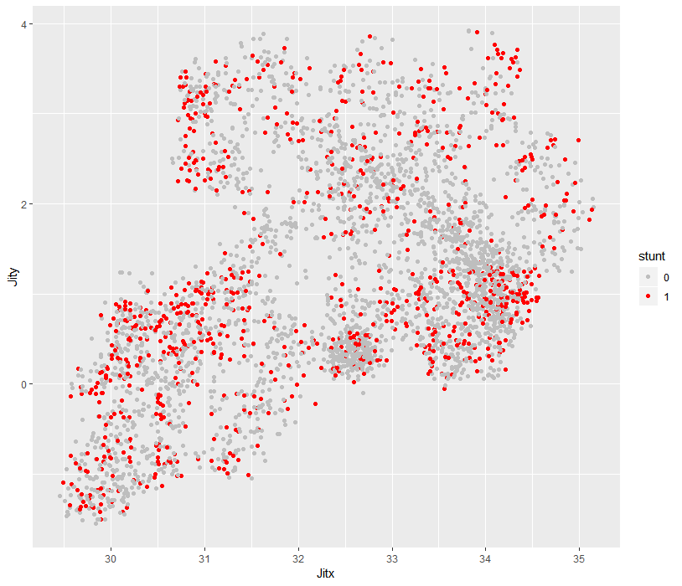

Figure 6: Point maps of predicted (left) and raw (right) HAZ dichotomized into stunted (HAZ<-2SD) and normal growth (HAZ ≥2 SD): Red are stunted children and grey are children with normal growth.

**Discussion**

Spatial variation in stunting continue to persist among low- and middle- income countries, and targeting spatial pockets of low HAZ or stunting will be critical for future health interventions. A nuanced understanding of how geographic micro-nutrient access influences malnutrition care at a very fine spatial resolution will be key to identify and reduce these inequalities and alleviate nutrition access gaps. Here, we have highlighted the emergent spatial patterns of HAZ resulting from geographic variation at a high-resolution scale, and presented probabilities of being stunted for given vitamin A concentration at the sub-national level. The spatial patterns revealed have important policy implications for informing allocation of future intervention efforts to target improved micro-nutrient supplementation to the most at-risk population of malnutrition. As these analyses highlight geographical areas with children with micro-nutrient deficiency, the presented results could help target not only sub-regional intervention but, but also village level or parish -level finer scale (with a 10 km by 10 km) resolution.

Overall, we found that disparities exist in obtaining stunted growth across wealth, education, gender, altitude, house hold smoking, temperature, and levels of rurality, and that proximity to eater and degree of the slope resulted in the higher association with stunting (Table 1). These findings are in line with previous studies, further establishing the risk of stunted growth is highest in those with lower SES, reduced access to water .Regionally, Karamoja and Mbarara had the strongest patterns of spatial heterogeneity in the observed outcomes and generally higher probabilities of stunted growth. Conversely, we found central region and eastern to have generally lower probabilities of stunted growth as compared to western and Karamoja. This trend could be due in part to the lower rainfall amount.

**Risk factors**

Stunting has been associated with vitamin A deficiency as well as smoking and age12. Our findings are consistent with what has been published in literature, in which the children at around 18 months of age are at increased risk of stunting, vitamin A deficiency and other micronutrient deficiencies such anemaia.13 This is not surprising since in Uganda, due to the short preceding birth interval (the length of the preceding birth interval measured as the number of months between the birth of the child under study (index child) and the immediately preceding birth to the mother)14, women tend to become expectant approximately 18 months after previous birth. As result, attention and food are diverted from one child to carter for the expectant mother or their newborn babies.

Uganda is principally an agricultural country and depends on the abundance of rain and temperature for crop growth. As thus, it was not surprising to see a linear association between rainfall, temperature and HAZ. However, the negative association of the amount of crop cover (vegetation index) was surprising. On the hand, the negative association of slope and HAZ could be explained, in part, by the available of water to grow crops at the less steep lands compared to the regions at higher slopes. The steeper the slope, the more likely the run off of water leading to poor crop growth.

**Strength and Limitation**

Our analyses were limited temporally by survey availability. We used temperature, rainfall and vegetation indexes for 2010, even when the study was conducted in 2016. This is differences in temporal association could have affected the results since these meteorological variables change over time. However, these changes are not drastic over a short period of time. The strength of our study is the use of GAMM models which are more robust because they accounted for the non-linearity of the geo-spatial variations and the random effects of the clustered data.

In conclusion, data that has geo-spatial variations should best presented using penalized splines to account for the non-linearly inherent in such data. Therefore, GAMM models are superior to other geostatistical tools and should be used more often in environmental and meteorological predictors of diseases. In addition, they account for the random effects of the clustered data.

**References**

1 West, J. K. P. Extent of Vitamin A Deficiency among Preschool Children and Women of Reproductive Age. *The Journal of Nutrition* **132**, 2857S-2866S, doi:10.1093/jn/132.9.2857S (2002).

2 Semba, R. D. *et al.* Abnormal T-cell subset proportions in vitamin-A-deficient children. *The Lancet* **341**, 5-8, doi:<https://doi.org/10.1016/0140-6736(93)92478-C> (1993).

3 Semba, R. D. *et al.* Depressed Immune Response to Tetanus in Children with Vitamin A Deficiency. *The Journal of Nutrition* **122**, 101-107, doi:10.1093/jn/122.1.101 (1992).

4 Muhilal, Permeisih, D., Idjradinata, Y. R., Muherdiyantiningsih & Karyadi, D. Vitamin A-fortified monosodium glutamate and health, growth, and survival of children: a controlled field trial. *The American Journal of Clinical Nutrition* **48**, 1271-1276, doi:10.1093/ajcn/48.5.1271 (1988).

5 Hadi, H. *et al.* Vitamin A supplementation selectively improves the linear growth of Indonesian preschool children: results from a randomized controlled trial. *The American Journal of Clinical Nutrition* **71**, 507-513, doi:10.1093/ajcn/71.2.507 (2000).

6 West, J. K. P. *et al.* Vitamin A supplementation and growth: a randomized community trial. *The American Journal of Clinical Nutrition* **48**, 1257-1264, doi:10.1093/ajcn/48.5.1257 (1988).

7 Lie, C., Ying, C., Wang, E. L., Brun, T. & Geissler, C. Impact of large-dose vitamin A supplementation on childhood diarrhoea, respiratory disease and growth. *Eur J Clin Nutr* **47**, 88-96 (1993).

8 Ramakrishnan, U., Latham, M. C. & Abel, R. Vitamin A Supplementation does not Improve Growth of Preschool Children: A Randomized, Double-Blind Field Trial in South India. *The Journal of Nutrition* **125**, 202-211, doi:10.1093/jn/125.2.202 (1995).

9 WOLBACH, S. B. VITAMIN-A DEFICIENCY AND EXCESS IN RELATION TO SKELETAL GROWTH. *The Journal of Bone and Joint Surgery* **29**, 171-192 (1947).

10 McGuire, G., Lewis, J. M., Falk, K. G. & Bodansky, O. Vitamin A Requirements in the Rat. The Relation of Vitamin A Intake to Growth and to Concentration of Vitamin A in the Blood Plasma, Liver and Retina: Two Figures. *The Journal of Nutrition* **23**, 351-363, doi:10.1093/jn/23.4.351 (1942).

11 Gil, A., Mackinney, G., Briggs, G. M. & Typpo, J. Vitamin A Requirement of the Guinea Pig. *The Journal of Nutrition* **96**, 359-362, doi:10.1093/jn/96.3.359 (1968).

12 Ong, K. K., Preece, M. A., Emmett, P. M., Ahmed, M. L. & Dunger, D. B. Size at birth and early childhood growth in relation to maternal smoking, parity and infant breast-feeding: longitudinal birth cohort study and analysis. *Pediatric research* **52**, 863 (2002).

13 Yang, W. *et al.* Anemia, malnutrition and their correlations with socio-demographic characteristics and feeding practices among infants aged 0–18 months in rural areas of Shaanxi province in northwestern China: a cross-sectional study. *BMC Public Health* **12**, 1127 (2012).

14 Rutstein, S. O. Effects of preceding birth intervals on neonatal, infant and under‐five years mortality and nutritional status in developing countries: evidence from the demographic and health surveys. *International Journal of Gynecology & Obstetrics* **89**, S7-S24 (2005).