My first paper with Rmarkdown
Claudio Fronterrè
19 July 2018

Analysis
During this practical I will be using the iris dataset in R.
summary(iris$Sepal.Length)
## Min. 1st Qu. Median Mean 3rd Qu. Max.
## 4.300 5.100 5.800 5.843 6.400 7.900
mean(iris$Sepal.Length)
## [1] 5.843333
I can also include inline R code. The average sepal length is 5.84.

Including Plots
It is extremely easy to include plots.
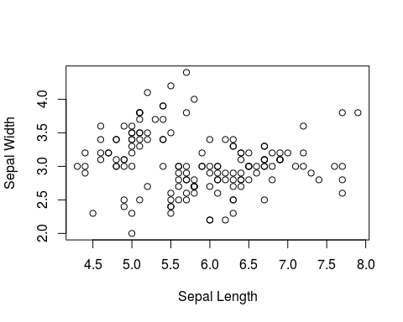
To add a caption it is enough to specify the fig.cap argument in the R chunk header.
Scatterplot of sepal length and sepal width.
You can change the height and widht and decide to align the figure in a different way.
You can also plot two figure side by side.

Including tables
To generate well formatted tables you can use the kable function from the knitr package. An extensive list of features can be found here.
Species | Mean | Sd
setosa | 1.462 | 0.1736640
versicolor | 4.260 | 0.4699110
virginica | 5.552 | 0.5518947
Let's customise our table a little bit.
Species | Petal Mean | Petal Sd
setosa | 1.46 | 0.17
versicolor | 4.26 | 0.47
virginica | 5.55 | 0.55
Summary table.
Adding the output from a model as a table.

Math equations
Inline LaTeX equations can be written in a pair of dollar signs using the LaTeX syntax, e.g. . Math expressions of the display style can be written in a pair of double dollar signs, e.g.

Citations
Lee and Mitchell (2013) shows that .... (Lee and Mitchell 2013). More about bibliography and citations can be found here.

Refrences
Lee, Duncan, and Richard Mitchell. 2013. “Locally Adaptive Spatial Smoothing Using Conditional Auto-Regressive Models.” J. R. Stat. Soc. C 62 (4): 593–608.

