p templates

{{p templates}}

p templates | manual_line_breaks

p templates | manual_line_breaks }

Apresentou erro

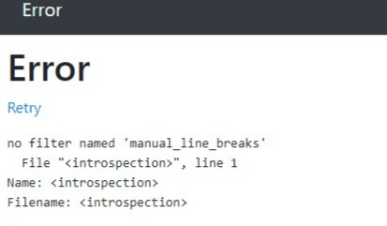

The default behavior of docassemble is the original setting, where you need to write r the_text | markdown

{{r templates | markdown }}

If you set new markdown to docx to True in your Configuration (which is recommended), the markdown filter assumes that you are inserting one or more paragraphs, so you need to write:

p the_text | markdown

{{p templates | markdown }}

If you have set new markdown to docx but you want to insert Markdown-formatted text within a paragraph, you can use the inline_markdown filter:

r the_text | inline_markdown

{{r templates | inline_markdown }}

Note that according to the [Markdown](https://daringfireball.net/projects/markdown/) standard, a single newline does not break a paragraph; you need two newlines to break a paragraph. If you want to convert single newlines into paragraphs breaks, there is another [Jinja2](http://jinja.pocoo.org/docs/2.9/) filter that can help. Instead of writing the_text | markdown, write the_text | paragraphs | markdown. The paragraphs filter runs the text through the [single_to_double_newlines()](https://docassemble.org/docs/functions.html#single_to_double_newlines) function.

{{p templates | paragraphs | markdown }}

Another way to insert formatted text using [Jinja2](http://jinja.pocoo.org/docs/2.9/) is to use the “rich text” feature of [python-docx-template](https://docxtpl.readthedocs.io/en/latest/). The RichText [Jinja2](http://jinja.pocoo.org/docs/2.9/) filter allows you to include line breaks inside of variable text:

The swift brown r animal | RichText jumped over the lazy dog.

Using this filter, any newline (\n) in animal will be converted into a manual line break and any \a character will be converted into a paragraph break. When using RichText, you must always use the r prefix,

{{r templates | RichText }}