SAMPLE SHOW PERFIS WITH ANGULAR AND NODEJS

1 – Installation
1.1 – Download it from github:
1.2 – Run npm install inside the api_node folder
1.3 – Run “node server.js” inside the api_node folder

2 – Use in WEB
2.1 – Put the application in a server like apache
2.2 – open “localhost/profiles-app”
2.3 – Scroll the page to see more profiles
2.4 – Click on Delete to delete a profile, after delete a new profie will be loaded automatically

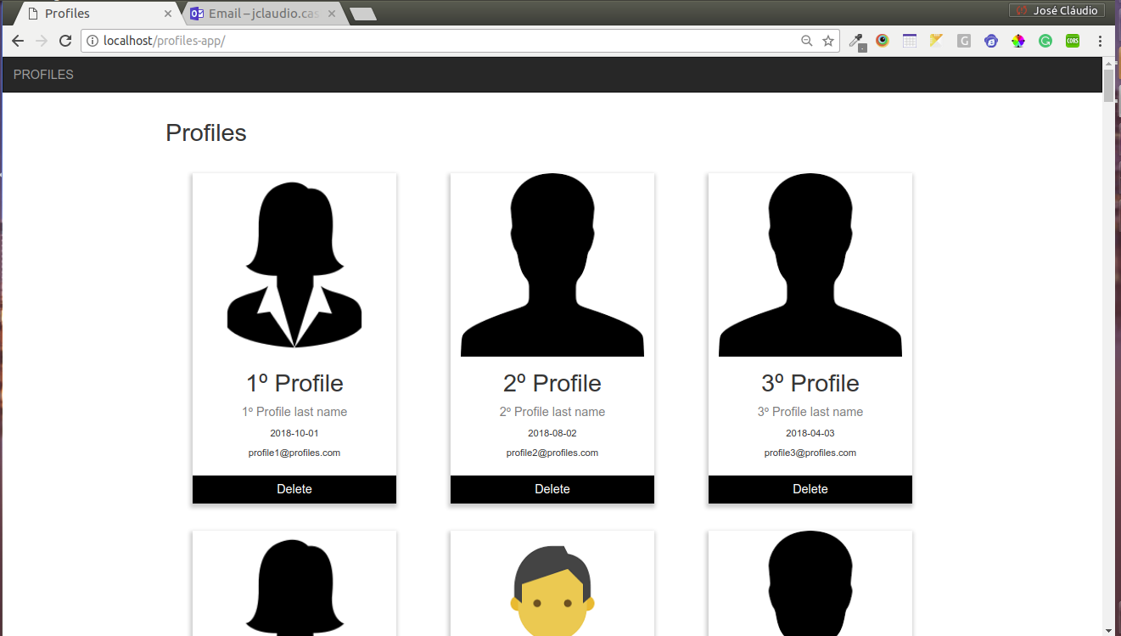
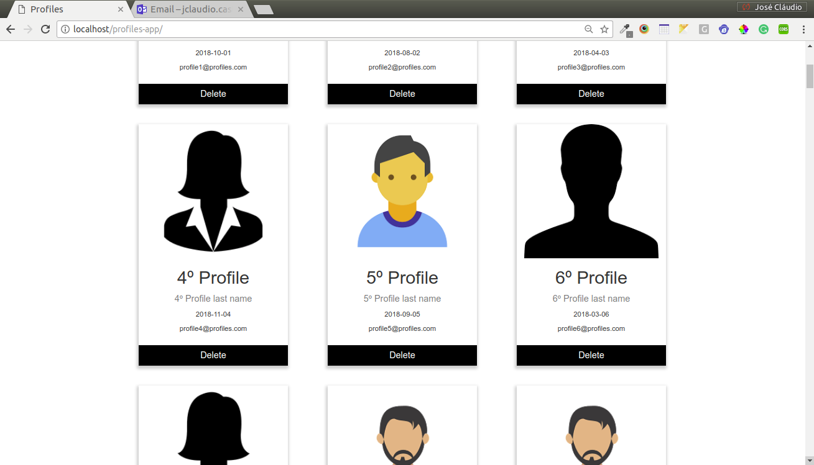

3 – Use in API

3.1 – Start the server
3.2 – call “localhost:3000/profiles/getAll” to get all the profiles
3.2.1 – you can pass an integer parameter to say that you want to start searching from, and another integer parameter to say that you want to stop in:
EX“localhost:3000/profiles/getAll/0/6” will bring the first 6 profiles.

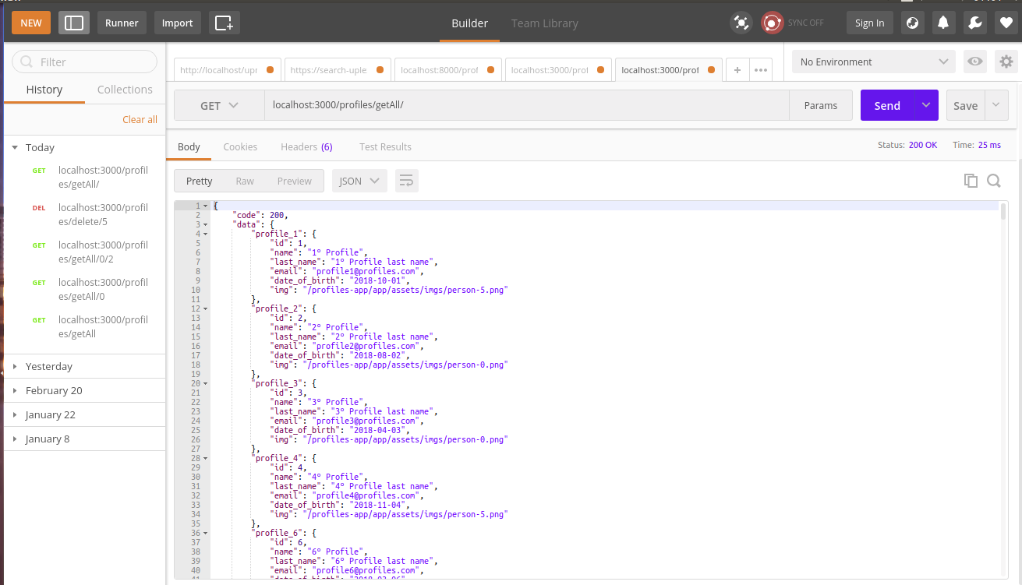

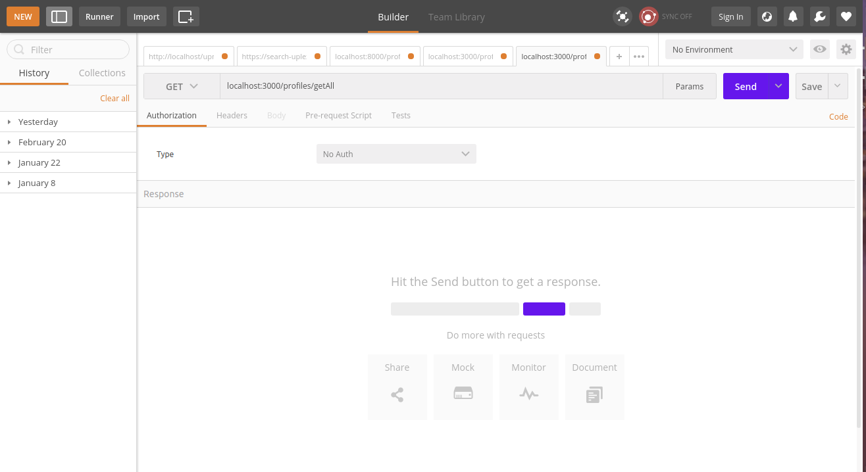
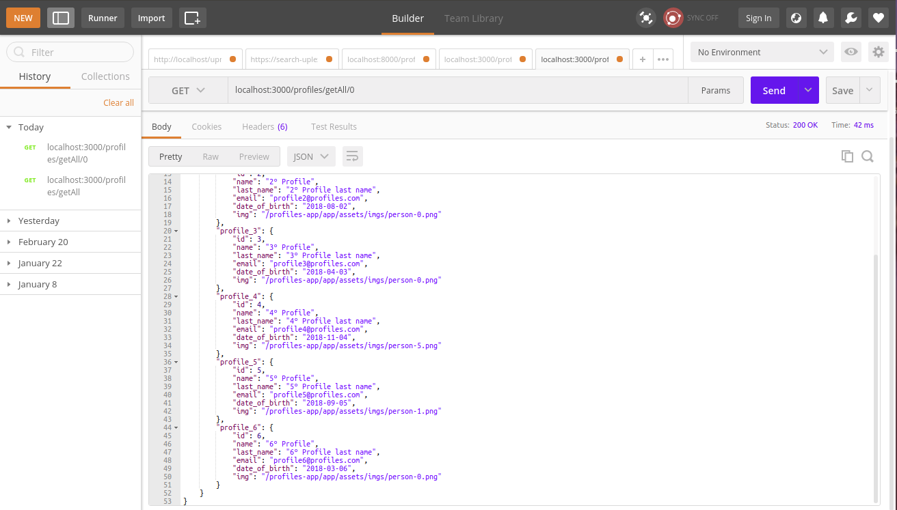

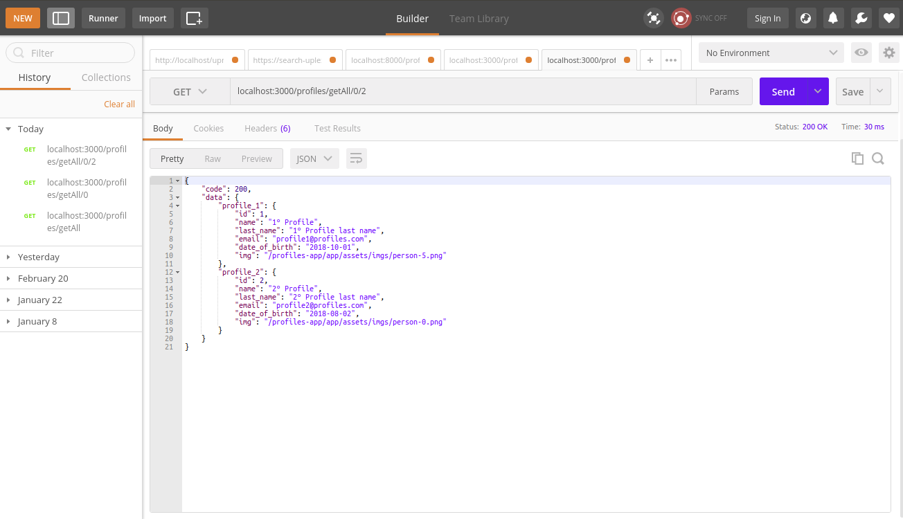

3.3 – call “localhost:3000/profiles/delete/:id” (:id = profile id), to delete a profile

