# Define the project

## Who?

* For an agency that needs a Newsletter form

## What

Business goal

* Create a signup form for this coding agency so that the users can enter their emails and claim the free trial
* Also this will have a note for the actual price

User Goal

* A form where the users can enter thei credentials and Claim a free trial for a software

## Target

* 18-35 male/female, who want to learn how to code

# Plan the project

## Content

* Provided by customer

## Sections

* 1 section

## Personality

* Startup

# Layout and components

Provided by customer

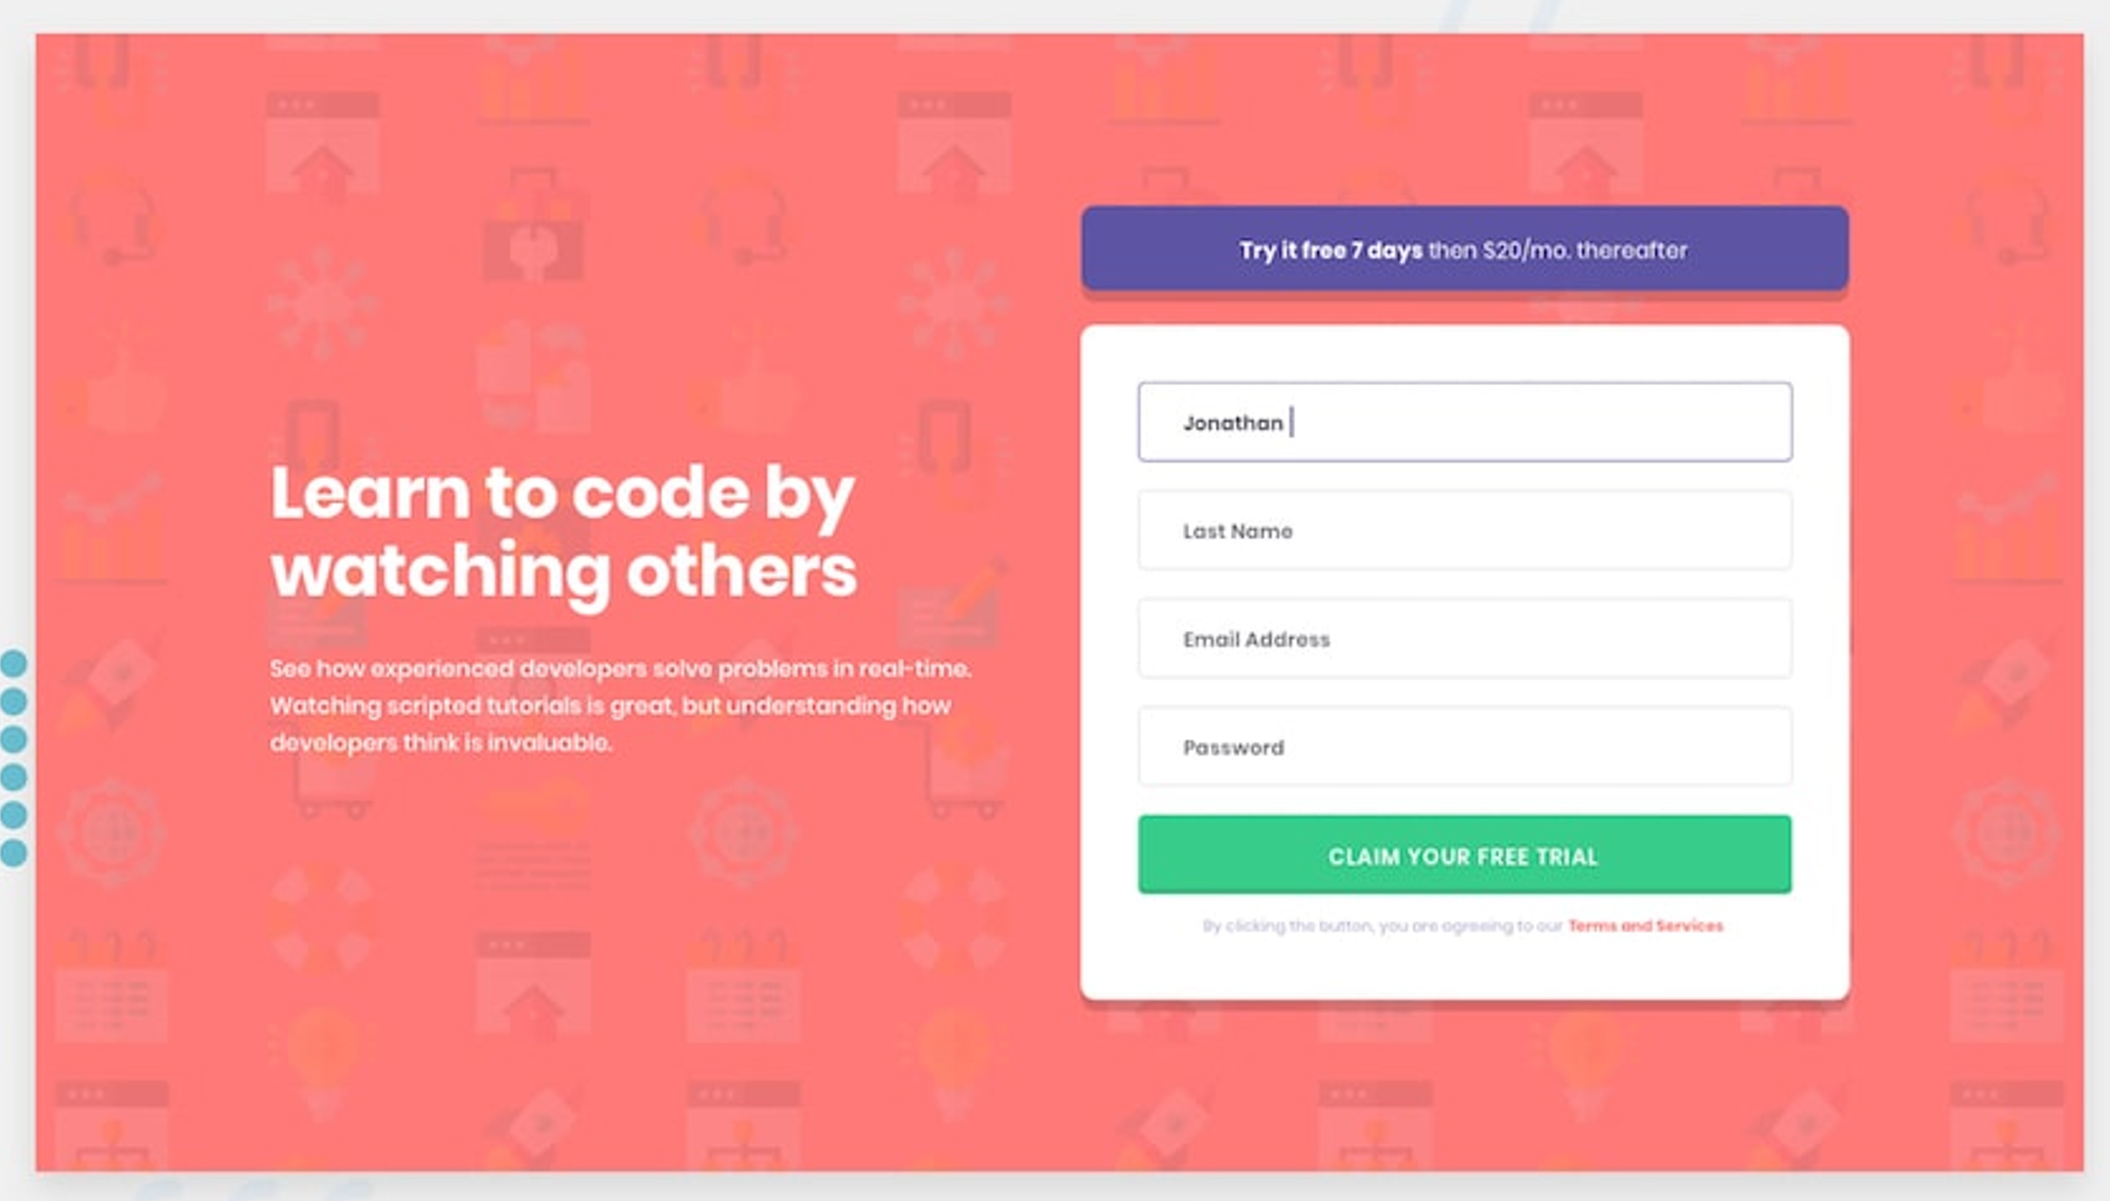

## Elements

* H1
* A paragraph
* 1 component with the price
* Card with the form
* 4 input fields
* 1 cta button
* Term and conditions text

## Components

* 1 grid / 2 columns
* Header + paragraph
* Paragraph with price/month
* The form
  + 4 input fields: First name, last name, email address, password
  + Cta button
* Term and conditions text

# Build the design

# What have I’ve learned

* Grid and grid 2 cols
* The form does not need flex
* How to use label and input
* Style the form
* A bit of JS behind the form

# Duration

* 3 hours