Water Mains Of Vancouver

Term Project Report – by Chris Lavell - 20422

**Introduction**

To look at the data in different ways quickly tableau is being used to create many different visualizations. This was mainly chosen due to familiarity with the platform and the powerful tools that come with it. However, tableau doesn’t have a way of manipulating the data in the way that I want, so two javascript scripts were used along with d3 in a server and also one small command using geojson-merge package from npm to process the data (Find details of that process in the dataset documentation). Mainly, this added information to the watermains data about whether a particular installation was abandoned or still in use and which neighbourhood in town the pipe was located.

The dataset for this exploration comes from the City of Vancouver website. It is a combination of some of the data from their water management systems and their neighbourhood boundaries. I chose this data mainly from an interest in systems and wanting to know where if not where the water that I drink comes from, then at least what is in contact with it during the journey from source to tap.

**Story**

Water mains are a pretty standard part of a city that people take for granted most of the time, however, there has to be some thought put into the materials that are used in the pipes. How does the location of the pipe affect what material was used? How does the material used in the installation of new pipes change throughout time? What pipes are most often abandoned? Which region of the city has the most pipe installed? Which region has had the most pipe replaced?

Here is a screenshot of the overview of the dashboard:

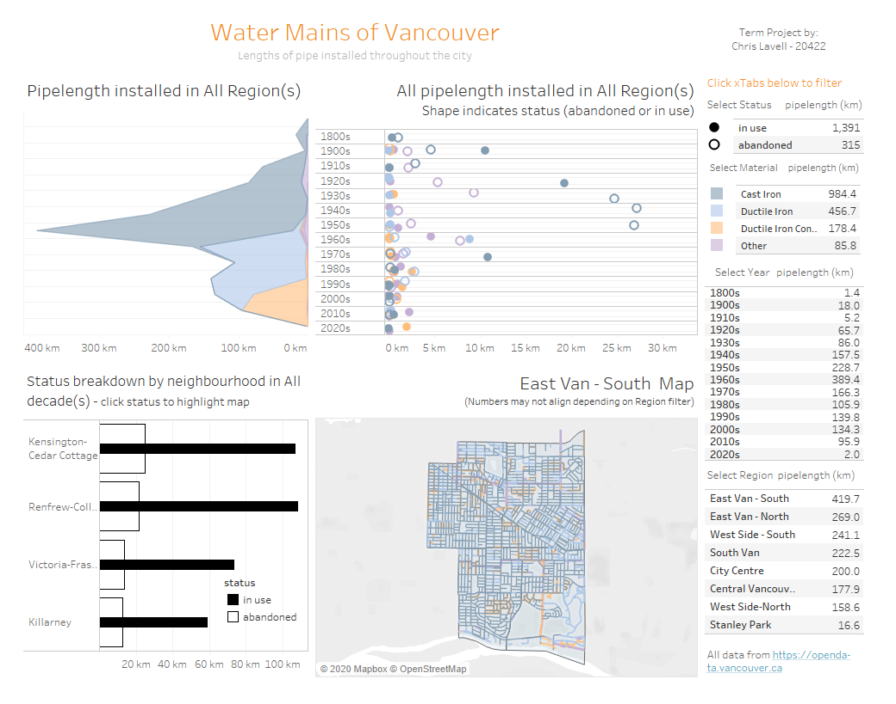

Keep in mind that the bottom two charts (dedicated to location data) do not ever show a whole picture as it is much too cluttered.

To answer the question about why a material is chosen, it seems that mosty time decides. This can be seen in the top left pane. Here it is with its legend:

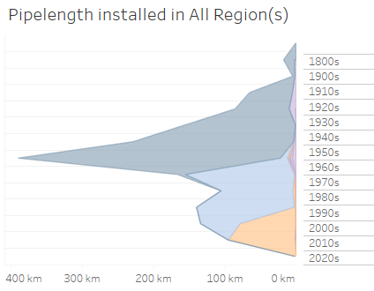 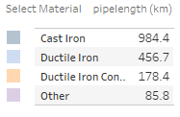

This shows cast iron used in the early 20th century, ductile iron (with cement lining) and ductile iron with concrete lining used from the mid-20th century up till now.

To see regional variations we can look at the lower half of the dashboard. Right now it is showing the southern part of East Vancouver.

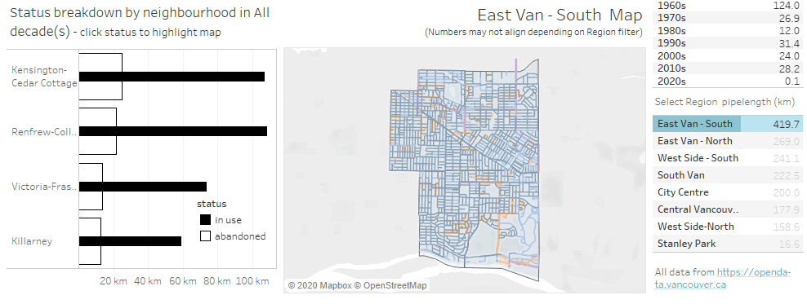

In this part of the dashboard we can look and see the proportions of abandoned to compared inuse water mains. By clicking on the status legend we can highlight the mains in the map based on status (abandoned or in use)

In use:

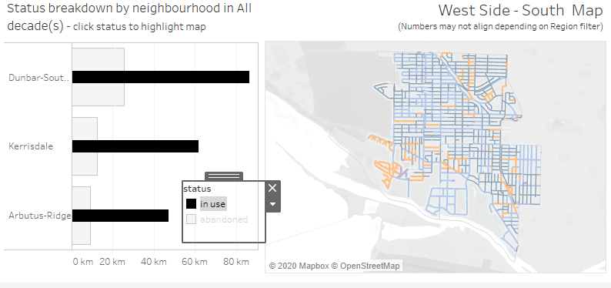

Abandoned:

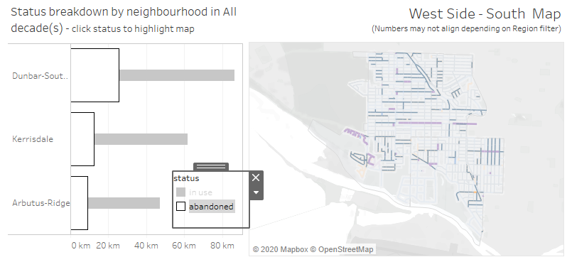

Throughout this, the status in the crosstab is highlighted with total numbers for the selected region:

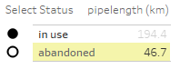

The map can be hovered over to see more info in the tooltip:

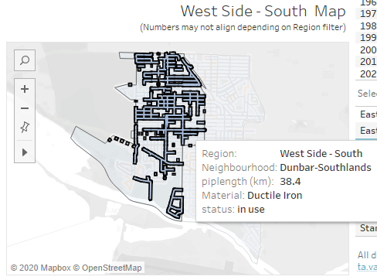

By looking around we can check out in more detail the “other” category shown in purple, which gives us insight on little things that the city tried and gave up on.

The material that has survived, shown by the chart in the upper right and the crosstabs tends to be the ductile iron, while a large part of the cast iron is no longer in use and “other” materials are mostly gone.

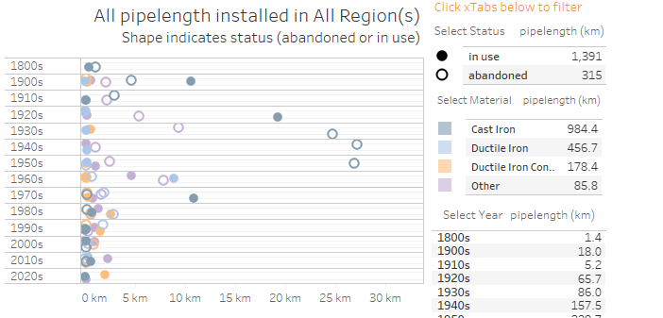

We also see the anomaly of a lot of cast iron pipes being abandoned that were installed from the 1930s to the 1950s, but from the 1900s and 1910s decades we see more of the cast iron pipes surviving than not.

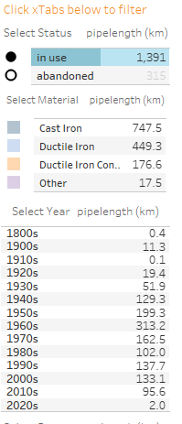 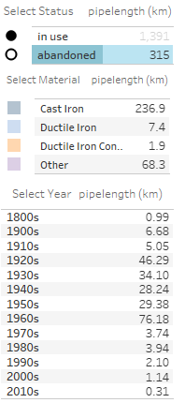

Overall in the water mains of vancouver we see a trend of three mostly successful materials whose preference was changed out over time along with some other fairly transient materials (such as steel and asbetos concrete) that did not stand the test of time, with the cast iron material being the most abandoned of the big three.

It was originally intended to look at how the “pressure zone” from another dataset might affect the choice of materials in pipes, however, that was outside the scope of this small dashboard. It might be interesting to see in a future project. Unfortunately in this dashboard the only overarching regional data that can be viewed in the dashboard can be done with the bottom crosstab, which could maybe be overcome with a link to another dashboard with just one or two views to expand the map and the bar in bar graphs across the screen. Also, it might be interesting to drill down into the lesser used materials to see which ones are still being used today.

Here is a link to the video presentation:

<https://youtu.be/d--naK9wRGg>