Drew Claver

Card sorting Lab

Week 7

For this card sorting lab, I had 2 friends volunteer. The instructions for this experiment was to sort the cards into categories. Before having my friends volunteer, I sorted the cards myself two times. The cards have city names, activities in specific cities, and languages spoken in specific cities on the cards. Here are the two types of card sorts that I would expect with Persona A and Persona B: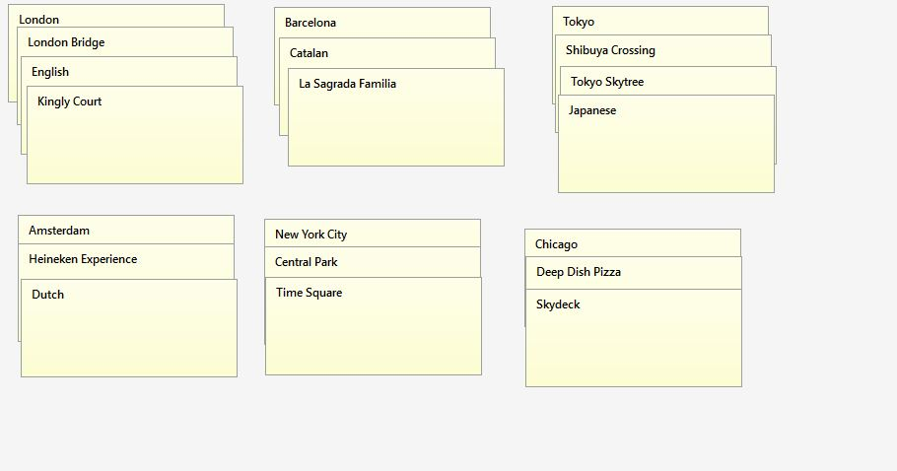Persona A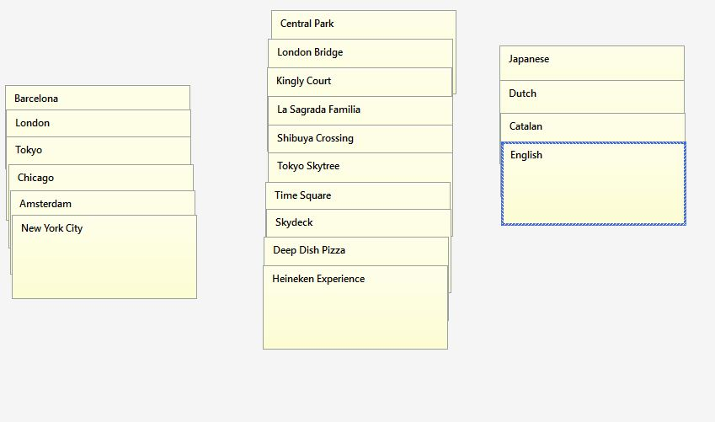Persona B

I would expect persona A to categorize the cards based on the city, the activities in that city, and language spoken in that city. I would expect persona B to categorize based on cities, activities, and languages.

Dan and Alexis volunteered to participate in this card sorting lab. Both are 22 years old, seniors at Michigan State University, and have a slight technical background. Dan has some experience travelling internationally, while Alexis has never left The USA/Canada.

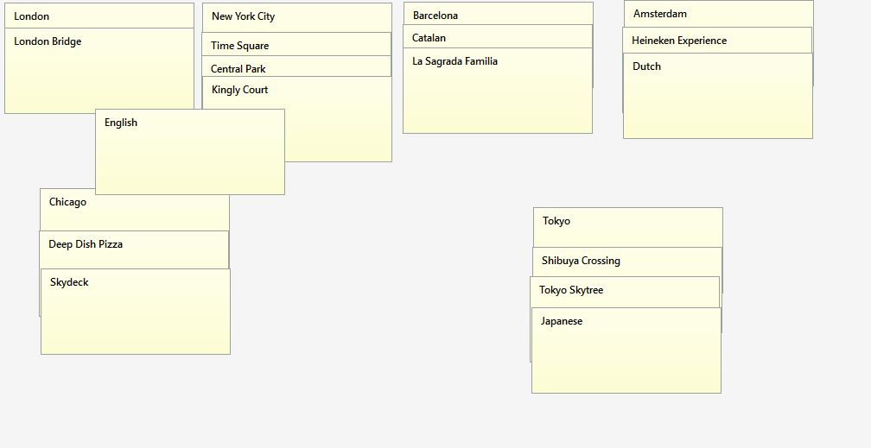 Dan Card Sorting

Dan sorted the cards based on Cities, and activities and languages spoken on those cities. When asked why he overlapped “English” with 3 stack, he said because “English is spoken in all 3 cities. Dan has travelled and has been to every city listed, except Barcelona. (Kingly Court was listed under New York City, but it’s actually a popular area in downtown London).

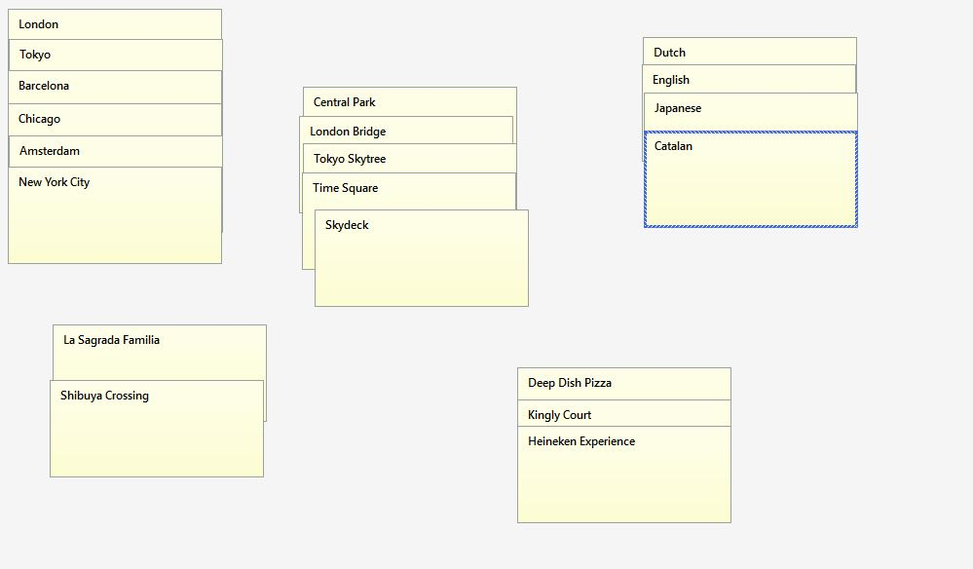 Alexis Card Sorting

Alexis sorted the cards based on cities, activities, and languages. She also added another stack for food/drinks. ‘La Sagrada Familia’ and ‘Shibuya Crossing’ were miscellaneous, but I later explained that ‘La Sagrada Familia’ is a large cathedral in Barcelona, and ‘Shibuya crossing’ is a famous crosswalk in Tokyo.

To conclude the findings for this Lab. Dan and Alexis, match up with expected persona A and persona B. Dan who is a more experienced traveler can identify most of the landmarks and languages for certain cities. Alexis, knows the names of cities, knows the names of most landmarks, but categorizes them based on whether or not it’s a city, activity, language, food/restaurant, or miscellaneous.