  - YOUR SEOUL, IN ONE POCKET

Seoul Pocket
  - An iPhone-first travel companion
with an offline-first foundation.
The app should remember your plans, food ideas, Korean phrases and accommodation essentials. Naver should handle live navigation. A weak connection should not stop you from opening information you already saved.

The recommended product
An installable web app on Cloudflare Pages, organized into five tabs: Today, Saved, Speak, Tools and Trip. Local saves are the default. Online search, reference rates and future group sharing are enhancements, not prerequisites to opening the trip. Pages supports the small Functions backend needed for these integrations. [S1–S4]

What has actually been built
Delivered | Still a release gate
Responsive five-tab app; editable food/place finds, links, photos and priorities | Installed-iPhone persistence, restart and recovery tests
Encrypted local stay vault, backup/export and non-overwriting restore | Live Cloudflare deployment and provider credentials
28 phrase drafts, phonetic hints, show-cards and device speech fallback | Reviewed offline pronunciation recordings
Currency converter, Naver handoff and optional server proxy code | Genuine multiuser authentication and conflict-safe sync
This is a substantial working local starter, not a deployed or certified trip-ready group service. The app says when a feature is unconnected or unverified.

How to use the package
Read this blueprint for the product decisions. Give Codex the entire repository and CODEX_START_HERE.md. The detailed product, UX, security, implementation and testing contracts are in the numbered Markdown documents inside docs/.
  - 01 / EXPERIENCE

Five tabs. One coherent trip.
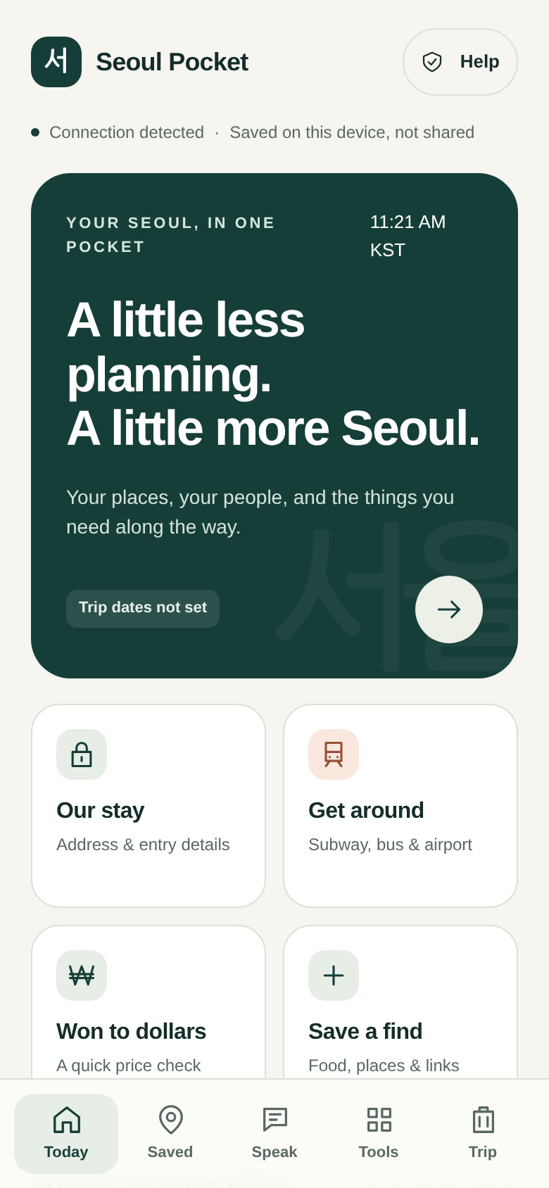 | 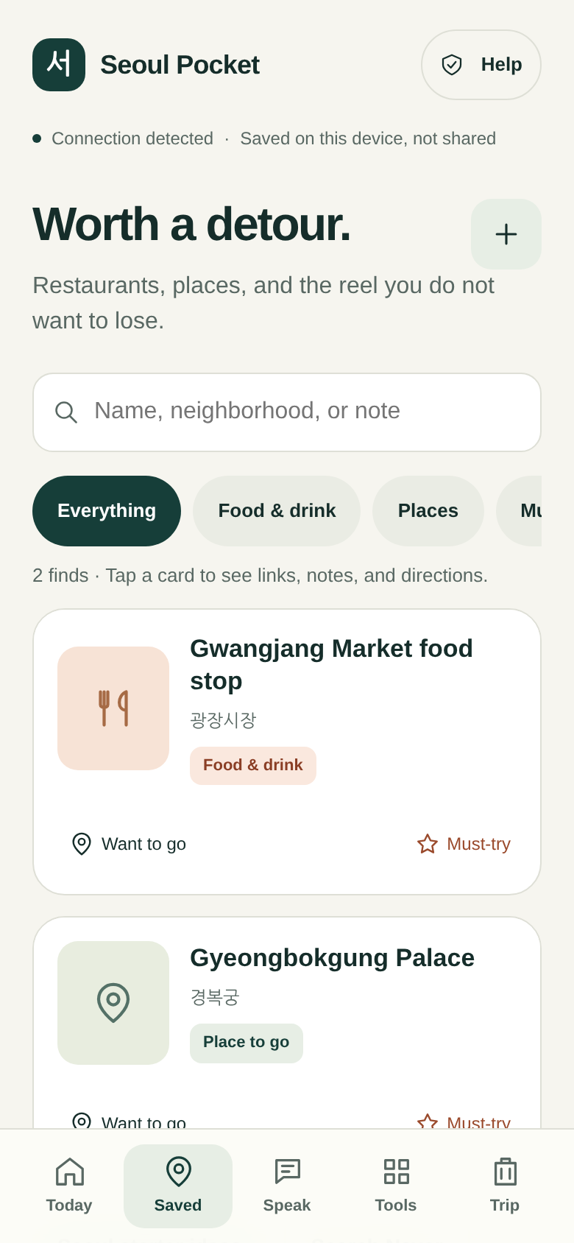 | 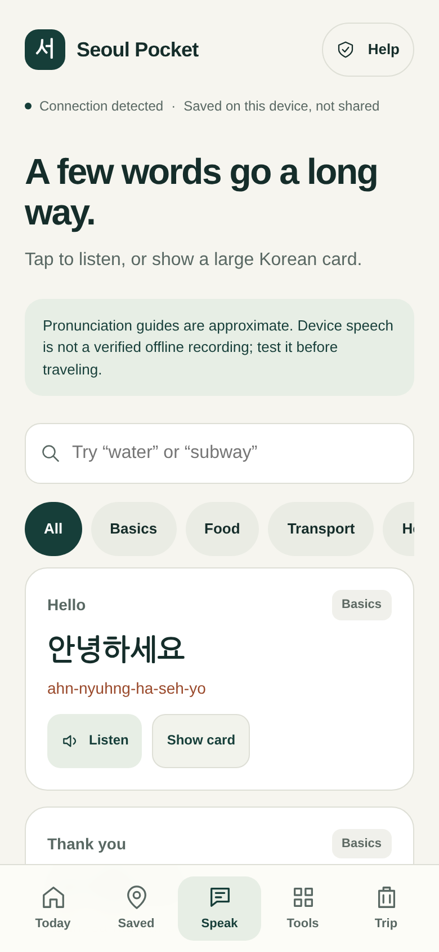
Actual application rendering at an iPhone-sized viewport, with explicit test adapters. Contents are illustrative; these are not screenshots of an already deployed trip.
Tab | Primary job
Today | Seoul date/time, today’s stops, stay shortcut and quick tools.
Saved | One collection for restaurants, dishes and destinations. Search, prioritize, plan and mark visited.
Speak | English meaning, Hangul, approximate phonetics, audio action and large show-card.
Tools | KRW/USD converter, transit guide, Naver search, emergency help and offline readiness.
Trip | Dates, private stay vault, backups and clear sharing status.
A must-try checklist is a filtered view of Saved, not a second list to maintain. Today also uses those same records. This avoids three conflicting copies of a restaurant or destination.
  - 02 / PLACES, FOOD & NAVER

Save the idea. Keep the context.

One find can begin with very little
A name is enough. Add an English/display name, Korean name, neighborhood, road address, notes, up to eight links, one local cover photo, must-try priority and visit state. A date/time and coordinates are optional. A dish such as mandu is valid without inventing a restaurant or reservation.

Photos and social links
The implemented workflow saves Reels, TikTok and other HTTP/S links as external references. Add a photo or screenshot locally for the visual reminder. JPEG, PNG and WebP uploads are resized and re-encoded; HEIC is not decoded by this starter. The app does not download a linked social video or rely on embedded feeds.

What Naver can provide
The supplied Local Search adapter imports basic listing metadata through a server-side proxy. It does not promise a full restaurant profile with photos, reviews, menus, bookings or verified hours. Naver Search, the Maps product and native app links are different integration surfaces. Credentials and current account-product compatibility still need testing. [S5–S9]
Every saved place offers Naver app search and browser fallback. With valid coordinates, it can hand off walking or public-transit routing. Copying a Korean address remains an independent fallback. The app never sends an entry PIN to a mapping service. [S7]

What “top destinations” should mean here
The starter includes 12 opt-in place/dish ideas, not a fabricated ranking or booked itinerary. Your personal must-try choices become the checklist. Before committing, verify operating days, reservation requirements, last admission/order and the exact location for your travel dates.
Useful next addition | Why it matters
Reservation cards | Separate an idea from a confirmed booking.
Neighborhood grouping | Keep nearby food and activities together.
An indoor alternative per day | Keep the plan flexible without automatic rescheduling.
Airport and return-home cards | Put the highest-friction journeys within easy reach.
  - 03 / OFFLINE & PRIVATE INFORMATION

Reliability is a behavior, not a badge.

Protect the stay separately
The Korean address, door PIN, room, host contact, Wi-Fi and access notes live in an encrypted local vault. A separate long passphrase unlocks it; the building PIN must not be used as that passphrase. The PIN has its own reveal action. The driver card and print fallback omit entry codes and Wi-Fi passwords.
The implementation uses authenticated Web Crypto encryption and locks the vault on close, background and inactivity. This protects the stored envelope, not an already unlocked screen or compromised application code. Ordinary finds/photos are not encrypted locally. There is no password-reset service. [S13–S14]

Offline is divided into specific promises
Available from the saved copy | Still depends on something else
Find text, locally stored photos, written phrases and the stay envelope | Live Naver routes/search, social videos and fresh rates require connectivity.
Conversion using a previously saved or manual reference | The estimate is not the final card-provider or exchange-booth price.
Cached app files, with a check of expected assets | Browser cache presence does not prove survival after eviction or app restart.
Audio action using device speech when available | Dependable offline pronunciation requires reviewed local files and device tests.

Recovery is part of the product
Encrypted exports include the saved collection and local photos. Restore imports new copies rather than replacing existing finds or an existing stay. The original stay passphrase is still required. Current dates/rate are preserved; re-enter them when restoring into a fresh app. The current file limit is 20 MB.
Browser storage is not guaranteed permanent, even with a persistence request. Each phone needs an independent saved backup and a minimal fallback outside the browser. Install and test the Home Screen copy itself, then try a real airplane-mode cold reopen. [S10–S11]
  - 04 / TRAVEL TOOLS

Korea-specific decisions that matter.

Transit: distinguish Tmoney from bank-card tapping
MobileTmoney now advertises an international-user flow and Apple Pay top-ups. Its current publisher notes name Mastercard, American Express, UnionPay and JCB; Visa is not listed there. Test the actual iPhone, card and region rather than assuming every wallet setup works. A Tmoney transit card in Apple Wallet is not the same as direct acceptance of a foreign bank card at every gate. [S16]
Keep a physical transit-card/cash fallback until the digital setup is proven. Seoul’s published open-loop rollout is phased, and pass coverage is date dependent. Do not hardcode an airport or Climate Card recommendation before the dates and routes are known. [S17–S19]

Getting around
Use Naver for live route selection. Keep the Korean destination, useful station exit and a screenshot of the last checked route. Tap when entering and leaving subway gates, and when boarding and getting off buses. Before a late outing, check the specific last route home and retain the address for a taxi fallback. [S20–S21]
Save the arrival terminal and chosen airport transfer. AREX Express and All Stop are different services; confirm the appropriate ticket and final connection on the official site. [S22]

Phrases, help and currency
The app includes 28 phrase drafts, approximate phonetic hints and large Korean show-cards. Reviewed recordings are still missing; device speech is only a fallback. Medical or allergy-specific cards need separate competent review and should never imply that a dish has been confirmed safe.
Emergency numbers: 112 for police, 119 for ambulance/fire. The 1330 tourist helpline provides travel/language support; check its current hours and online options. A data-only SIM may not provide ordinary calling. [S23]
The converter works in both directions and labels the rate source/date. A saved rate remains usable when refresh fails. Frankfurter provides a reference, not the exact amount a particular card issuer or merchant will settle. [S15]
  - 05 / TECHNICAL FOUNDATION

A small stack with explicit boundaries.
Layer | Current implementation
Frontend | Semantic HTML, CSS and native ES modules. No runtime dependencies.
Local data | IndexedDB: places, photos and metadata. Revision-checked local writes.
Offline shell | Generated service worker with content-derived version and explicit first-party assets.
Privacy | Native AES-GCM/PBKDF2 stay encryption; encrypted backups; no stored vault passphrase.
Cloudflare | Pages static build plus narrow Functions for health, rates and Naver.
Group storage | D1 schema and conflict reducer supplied; private R2 is a proposed addition, not wired.

No destructive shortcut to synchronization
The current sync endpoint deliberately returns 501 after authentication. Completing it means per-member access, an atomic local outbox, server versions, idempotent mutations, tombstones, a durable change cursor and explicit conflict handling. “Newest timestamp wins” is not the proposed design.
A server acknowledgement must not clear a newer local edit. A retry after a lost response must not create a duplicate. A revoked member cannot be promised remote erasure of information already downloaded to an offline phone. These conditions are specified in document 03 and need actual two-device tests.

Deployment shape
Build with npm run build, publish dist/ and keep functions/ at the repository root. Use a supported Pages Git or Wrangler workflow; uploading static files alone does not establish that Functions are working. Configure real provider credentials only as server secrets. Keep staging and production separate. [S2–S4]
The current owner-managed proxy token is only a temporary development control. It is not the proposed member-session system. Rate limits, deployed headers, actual account eligibility and private object authorization must be verified before a production shared release.
  - 06 / IMPLEMENTATION PLAN

The Codex completion sequence.
Order | Required outcome
1 · Reproduce | Run the existing tests and the real-origin browser smoke script. Validate actual IndexedDB and worker behavior.
2 · Stabilize iPhone | Test Home Screen installation, keyboard, password manager, copy address, native Naver handoff and recovery.
3 · Finish audio | Supply permitted recordings for all 28 phrases, review them, rebuild and test every clip offline.
4 · Wire staging | Set up Pages, provider secrets, rate limits and real responses. Preserve manual fallbacks.
5 · Complete sharing | Implement sessions, authorization, shared encryption, versioned outbox sync and private photo transfer.
6 · Prove the release | Run two-phone failure tests, restore a real backup, freeze the build and deploy production.

Minimum phone acceptance tests
From the installed production app, force-close, enable airplane mode and reopen. Read a find, open its photo, unlock the stay, convert a price and play a reviewed phrase. Restore a backup on another phone. Test an expired session with pending edits and simultaneous offline changes before describing the trip as shared.

A near-departure fallback must be explicit
When there is not enough time to validate collaboration, use a consciously accepted local-only release and provision each phone with a reviewed backup. Subsequent edits are independent. This is a fallback scope, not synchronization. The same principle applies to accepting written phrases without a verified audio pack.

Before the flight
Confirm actual dates and airport transfer; validate the transit-card setup; verify the Korean address and entry procedure; save the rate; run airplane-mode tests on each phone; export an independent backup. Avoid unnecessary software updates during the trip.
  - 07 / DELIVERY STATUS

Evidence, limits and the handoff.
Executed | Result
Syntax + JSON checks | Passed.
Node unit/contract tests | 41 passed: domain/content, native Web Crypto, mocked API/auth and generated-worker logic.
UI browser harness | 12 passed: selected real DOM flows with in-memory test adapters.
Production build | Passed; approximately 107 KB before user media or future recordings.
Reviewed offline audio gate | Expected failure: no reviewed audio pack is supplied.
The available Chromium browser blocked localhost navigation through an administrative policy. That policy was not changed. UI screenshots therefore use a page-content harness with explicit adapters. They do not prove real-origin IndexedDB persistence, browser service-worker behavior or iPhone compatibility. The real-origin smoke script is supplied for Codex, not claimed as passed.

The starter is not deployed
No Cloudflare project, GitHub repository, production database or live URL has been created. Live Naver credentials, deployed reference-rate refresh, actual D1/R2 behavior, group sharing, native Korean review and physical-device recovery remain unverified or unfinished.

Start locally
Use Node.js 22 or later. No dependency installation is needed for these commands:
npm run verify
npm run preview
Open http://localhost:4173. The preview server serves the app but does not execute Cloudflare Functions. Read CODEX_START_HERE.md for integration setup.

Owner inputs still needed
Travel dates, number of travelers/editing roles, iPhone versions, accommodation neighborhood, dietary/accessibility needs, Cloudflare account/domain and Naver account availability. Enter the actual door PIN inside the app, not in source code or a public fixture.
  - 08 / REFERENCE

Documents and primary sources.

Full specifications in the repository
File | Purpose
01-PRODUCT-SPEC.md | Requirements, scope, acceptance criteria and useful additions.
02-UX-AND-CONTENT.md | Layouts, critical flows, state language and accessibility.
03-ARCHITECTURE-AND-SECURITY.md | Local storage, encryption, proposed sync protocol and threat model.
04-CODEX-IMPLEMENTATION-PLAN.md | Ordered tickets, deployment and device release gates.
05-SEOUL-FIELD-GUIDE.md | Travel preparation, transit and content guidance.
06-TEST-REPORT.md | Executed evidence, untested behavior and limitations.
SOURCES.md | Complete primary-source register and recheck triggers.

Selected source links
S1–S4 · Cloudflare Pages and deployment documentation
S5–S9 · Naver Local Search API
S7 · Naver Maps native URL integration
S10–S11 · WebKit storage policy
S13–S14 · OWASP cryptographic storage guidance
S15 · Frankfurter reference-rate API
S16 · MobileTmoney publisher listing
S17–S19 · KTO transit-card guidance
S23 · Visit Seoul safety and emergency information
Research date: 7 September 2026. Source IDs refer to the full register in docs/SOURCES.md. Recheck account eligibility, transit payment support and pass rules for the actual travel dates. The product choices are design recommendations, not claims made by these providers.

