March 5, 2026
Ref: IIH/MD/2026/03/005

His Excellency,
The Executive Governor of Kwara State,
Government House,
Ahmadu Bello Way,
GRA, Ilorin, Kwara State

Your Excellency Sir,

REQUEST FOR APPROVAL TO RELEASE FUNDS FOR PAYMENT OF KWARA STATE GOVERNMENT GOOGLE WORKSPACE EMAIL & COLLABORATION TOOLS FOR
PERIOD JAN 2026 - MAY 2027

I write to request the funds for renewal of the Google Workspace Collaboration Tools email addresses for Kwara State Government Principal officers for the period of Jan 2026 – May 2027.

SN | DESCRIPTION | QTY | RATE | DURATION | PRICE ($) | PRICE (N)*
 | Kwara State .gov Email
1 | Google Workspace Business Edition | 80 users | $12/user | 17 months  Jan 2026-May 2027 | 16,320 | 22,568,438
2 | Service Charge + VAT 20%** |  |  |  |  | 4,513,688
 | GRAND TOTAL |  |  |  |  | 27,082,126

* This conversion was done at the current market rate of USD1 = NGN1382.87 as at March 5, 2026

I kindly request prompt approval for release of the required funds.

Yours sincerely,
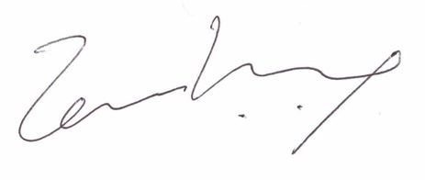
Temi Kolawole
Managing Director

