Here is the model I’m simulating:

The trait is birth rate, and it is involved in a trade-off with predator attack rate such that as *b* increases, so does the death rate of prey due to predation. I am specifically assuming the following functional form, which produces an ESS: .

Assuming a QG model for the evolution of *b*, I have:

The eco-evolutionary equilibrium is the following:

To produce different equilibria, I varied between 0.0005 and 0.004 in increments of 0.0005. The other parameters were held constant at . This produces a trait eco-evolutionary equilibrium of .

I initialized the system at a different place for each value to try (mostly unsuccessfully, as you will see) to limit the number of stochastic extinctions. The higher is, the lower the equilibrium, but the higher the innate tendency to fluctuate (the larger the imaginary part of the eigenvalues). Specifically, the initial conditions varied between (at to (at .

In all cases, I initialized the birth rate at , with an initial coefficient of variation of 0.2 and an of 0.85.

The number of replicates varied between 40 and 160, depending on the value (the higher the , the more replicates I initialized to try to get more that could actually make it to the eco-evolutionary equilibrium).

In the subsequent plots, I will give the expected eco-evolutionary equilibrium values, the total number of replicates and the initial conditions, the realized eco-evolutionary outcome (the mean prey, predator, and trait values across the replicates that made it for 200 time steps), and the TEA if the realized eco-evolutionary outcome is different from the QG prediction.

Note that the TEA is given by:

which implies that the more the predator suppresses the prey, the higher the TEA.

Parameter set #1:

Expected eco-evolutionary equilibrium:

Number of replicates: 40

Initial conditions:

Realized eco-evolutionary outcome (average of the mean *C*, *P*, and *b* [across the replicates] over the last 20 time steps):

TEA:

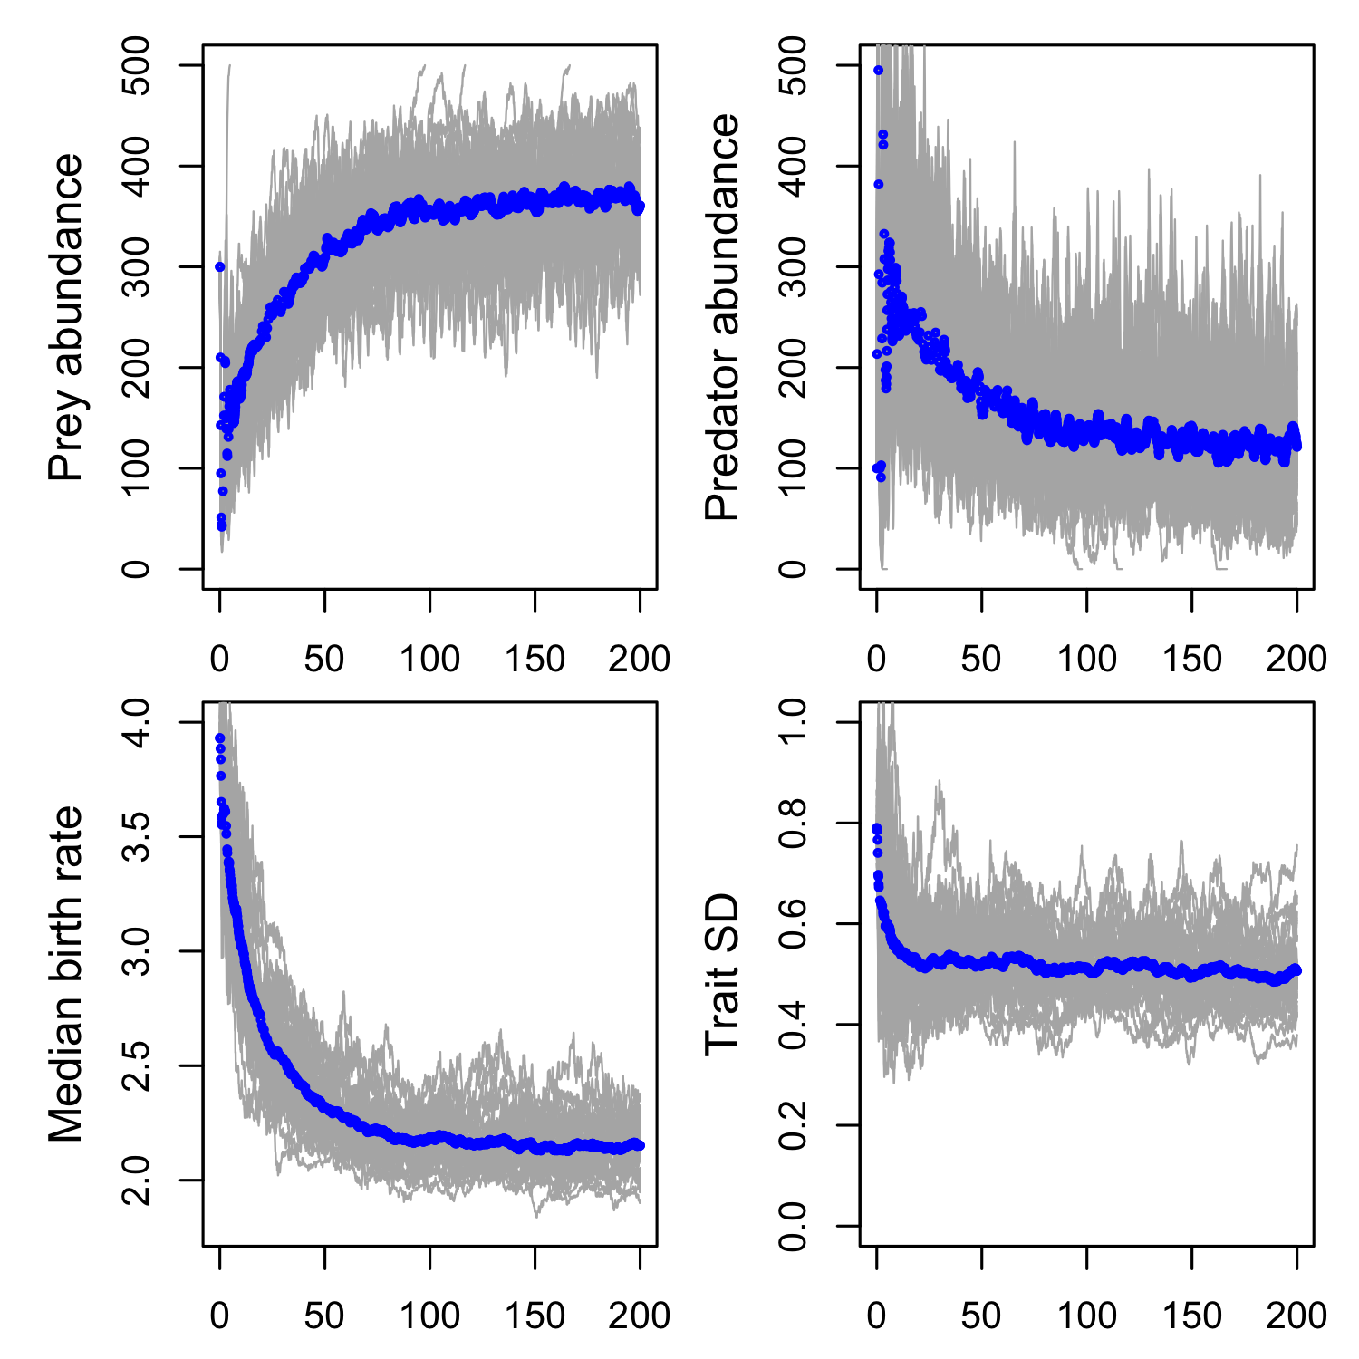

Parameter set #2:

Expected eco-evolutionary equilibrium:

Number of replicates: 40

Initial conditions:

Realized eco-evolutionary outcome (average of the mean *C*, *P*, and *b* [across the replicates] over the last 20 time steps):

TEA:

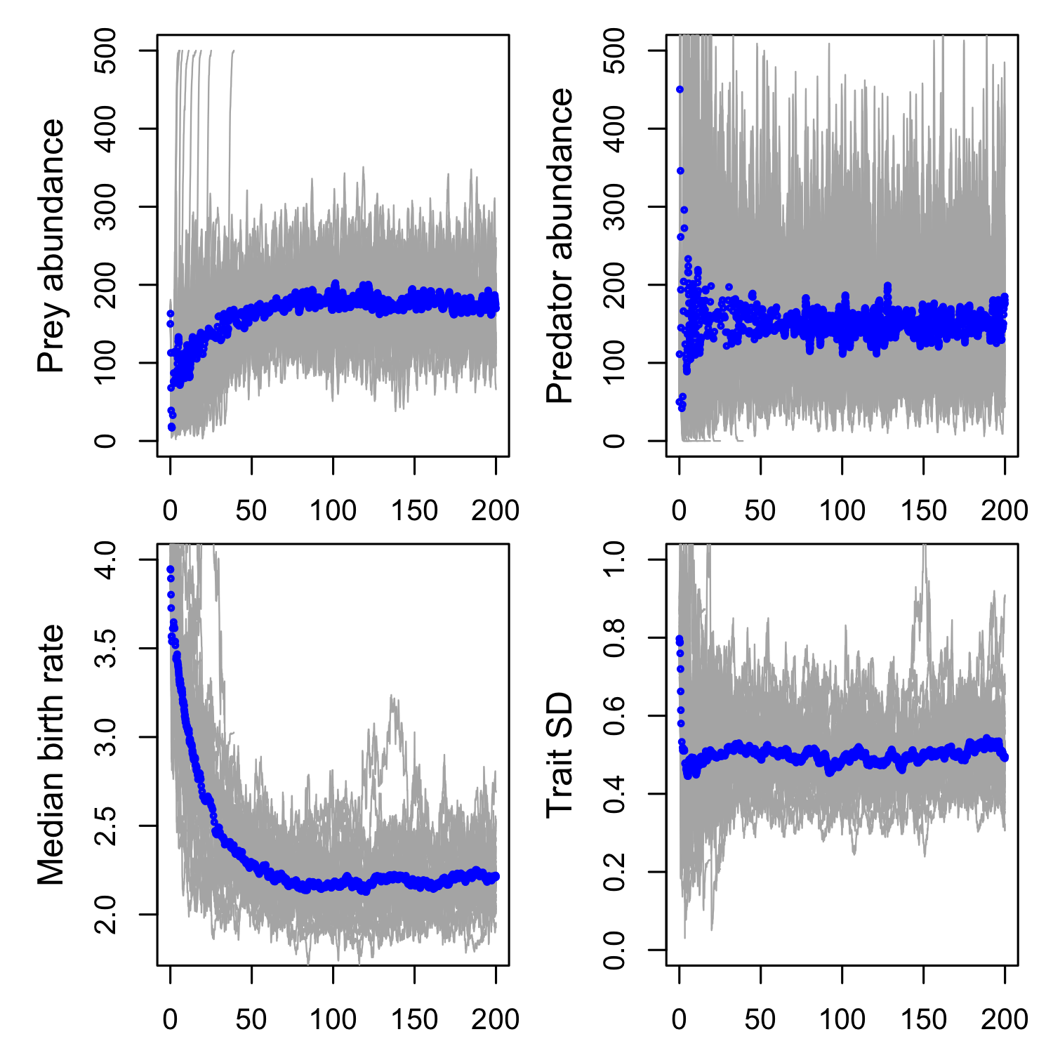

Parameter set #3:

Expected eco-evolutionary equilibrium:

Number of replicates: 60

Initial conditions:

Realized eco-evolutionary outcome (average of the mean *C*, *P*, and *b* [across the replicates] over the last 40 time steps):

TEA:

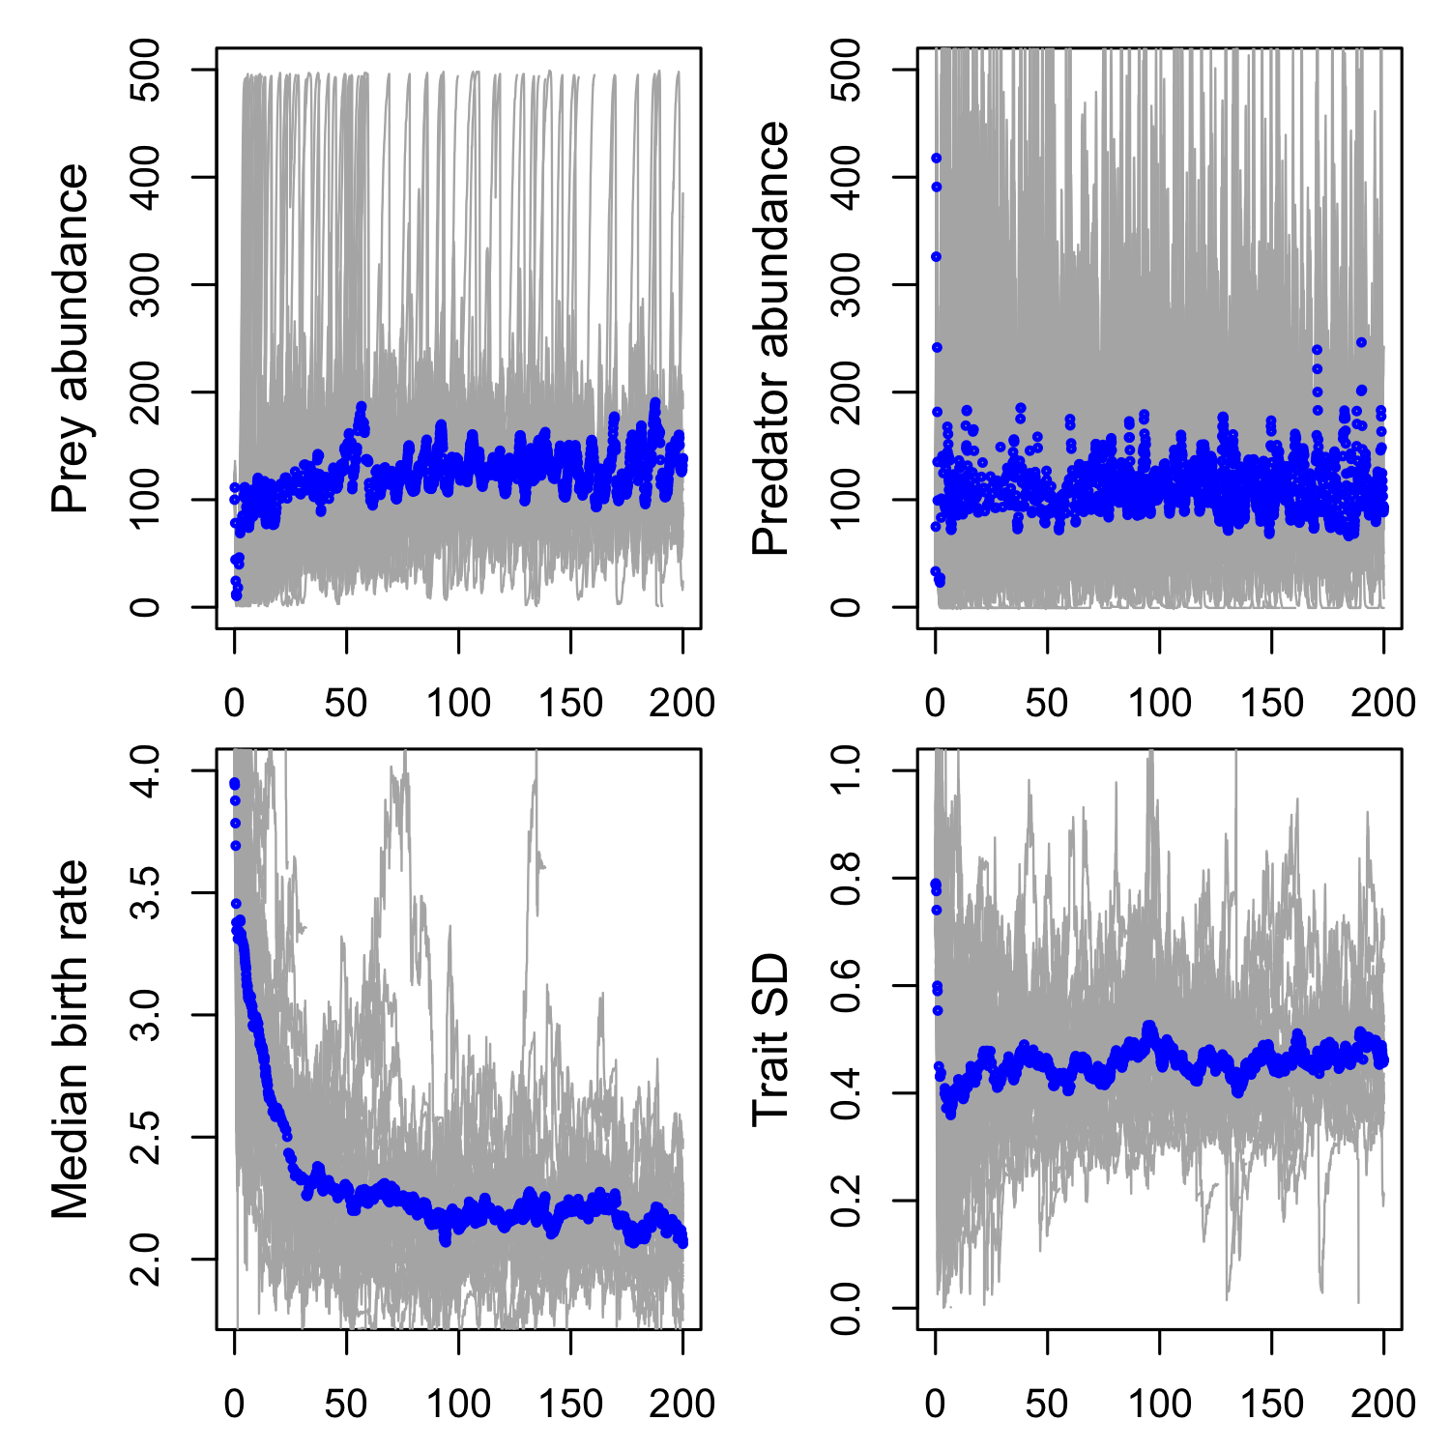

Parameter set #4:

Expected eco-evolutionary equilibrium:

Number of replicates: 80

Initial conditions:

Hard to see much here, as basically everything went extinct. I either need to simulate far more replicate runs to get more that survive, or I need to modify the initial conditions.

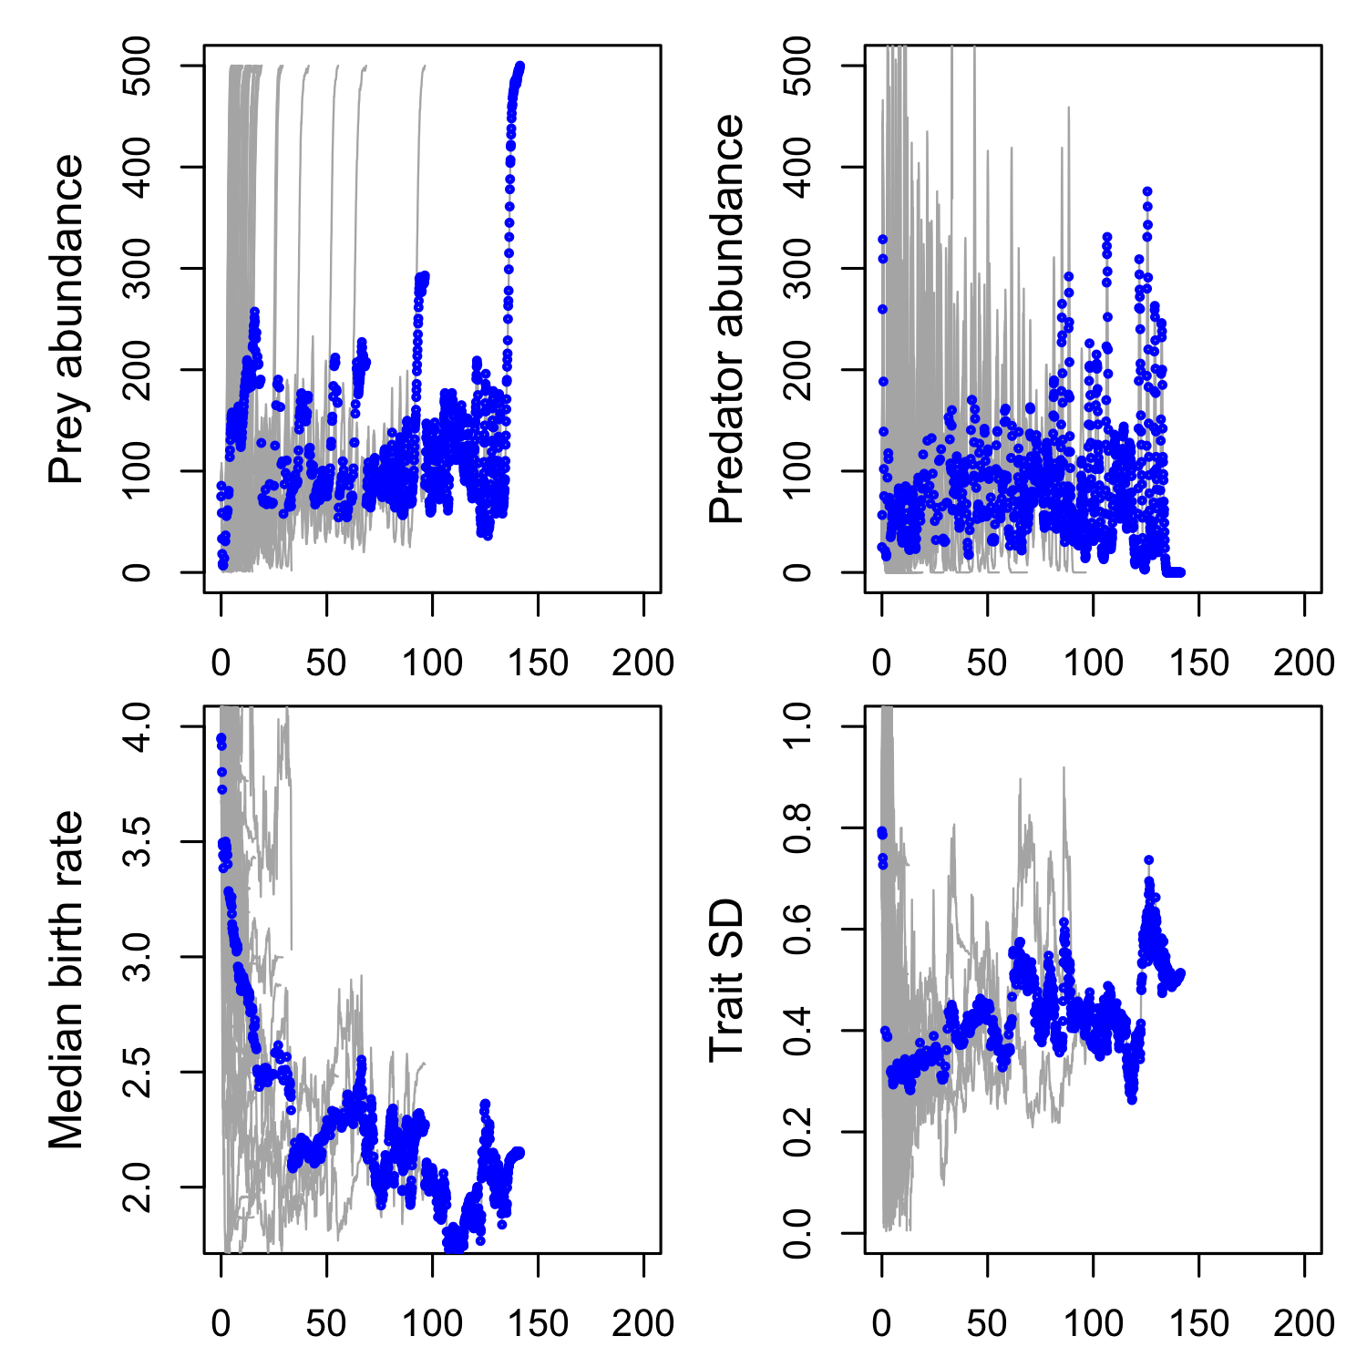

Extinction was an even bigger problem for values above 0.002. Here is the plot for , which is basically what they all look like:

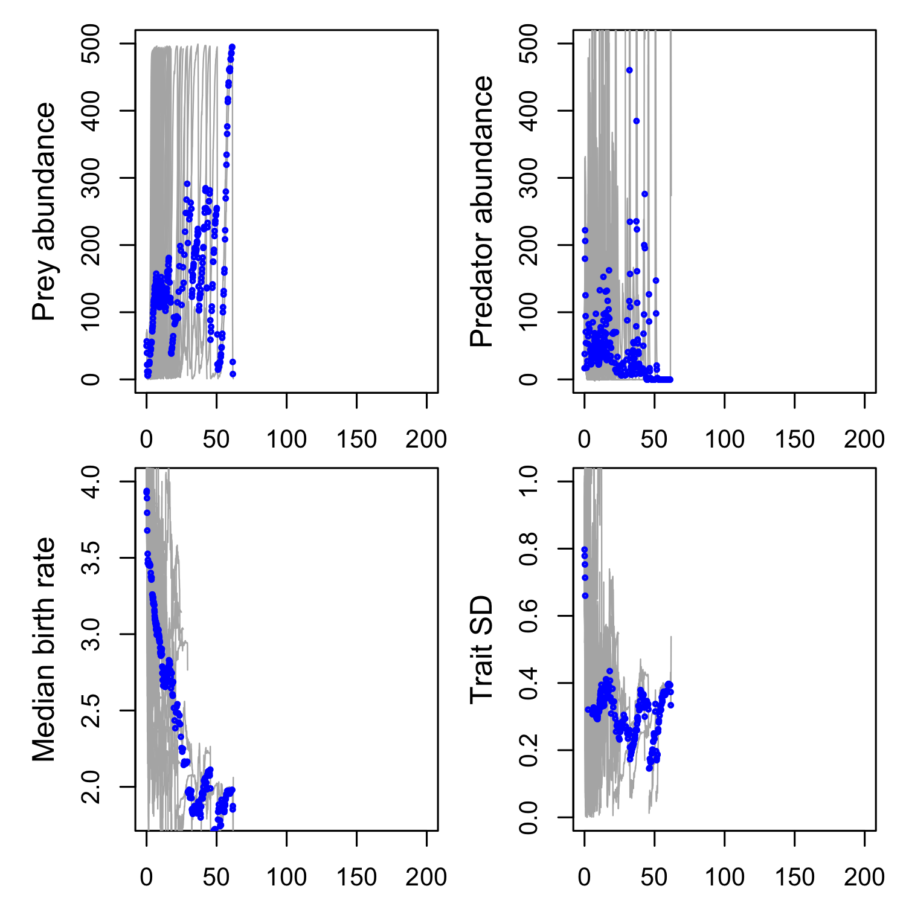

One way to resolve this problem, I think, is to start from a different parameter set, one that has less tendency to oscillate. I am doing some analytical exploration to find such a parameter set, and then I will rerun to see if we can get anything more easily understandable. From the results so far, though, I think there is reason to be optimistic that the TEAs might be exist!