**Metamorphosis and the evolution of genome size [working title]**

**Abstract**

A long-standing question in genome biology is the extent to which life-history variation exerts significant evolutionary influence over genome size. A growing body of work documents that genomes expand by largely neutral processes, which may be counterbalanced by downard selective pressure or constraints on large size. Indeed, many studies have found that genome size is correlated with life history variation, with metamorphosis presenting one of the most radical life-history shifts in the ontogeny of animals. However, the connection between life-history variation on genome size evolution remains unclear, with the relative influences of expansive and constraining forces on their evolutionary dynamics yet to be assessed. We modeled genome size evolution across salamanders, the vertebrate clade with the largest variation in genome size across animals as well as the full range of metamorphic life history variation. Against a background of TE accumulation, we found that salamander lineages that undergo metamorphosis without feeding evolve under the strongest constraint for small genome size, that feeding metamorphs and direct developers are evolving under weak stabilizing selection to possibly different optima, and that paedomorphic salamanders are evolving in a biased random walk with the loss of constraint to the largest genome sizes across animals. We discuss the inference of adaptation and constraint in the evolution of genome size. Or something like that

**Introduction**

Genome expansion across diverse lineages is driven by transposable element (TE) accumulation, a process that is largely neutral at the cellular and organismal levels (Pellicer, Hildago, Dodsworth and Leitch 2018)(Kapusta, Such, and Feschotte 2017)(Mueller 2015; Mueller and Jockusch 2018). Yet, correlations exist between overall genome size and several cell- and organismal-level traits including cell size (positive correlation) and rate of development (negative correlation), suggesting that this largely neutral process can, at times, affect phenotype. (Kapusta et al, 2017; Waltari and Edwards 2002)(Wake and Marks 1993; Gregory 2002; Sessions 2008; Bonett, et al. 2020) The mechanisms by which the evolution of such trait shapes TE accumulation and genome size remain incompletely understood, and few empirical examples have been identified .

Metamorphosis is a life history trait that has been hypothesized to shape TE accumulation and genome size evolution because of the effects that genome/cell size have on the rate of development . Metamorphosis is a radical transformation of morphology during the life cycle that produces strikingly different larval and adult forms. To achieve the adult form, metamorphosing animals undergo a second period of body plan patterning, separated from the first — embryogenesis — by a larval growth stage. Both embryogenesis and metamorphosis reflect coordination of the developmental cellular processes of cell division, differentiation, migration, and apoptosis (Alberch 1989). The dynamics of these cellular processes are affected by genome size and cell size; as genome/cell sizes increase, developmental rates throughout ontogeny ⎯ from embryogenesis through metamorphosis ­⎯ slow down (Horner and Macgregor 1983; Jockusch 1997). In turn, the duration of developmental stages ­becomes longer. Because metamorphosis can be a vulnerable part of the life cycle, its duration has been proposed as a target of natural selection in some taxa, which would indirectly select for faster development, smaller cells, and smaller genomes . The mechanisms underlying this proposed relationship remain unclear.

Amphibians — the vertebrate clade that includes frogs, salamanders, and caecilians — are a model taxon for studying TE accumulation and genome size evolution because the clade includes multiple independent examples of genome expansion to enormous sizes . In addition, amphibians are a model taxon for studying the evolution of metamorphosis (Hanken 1992; Johnson and Voss 2013; Rose 2014; San Mauro, et al. 2014). Within amphibians, the largest genomes are found in the salamanders, with sizes ranging from 15 Gb – 120 Gb across the 743 extant species (Gregory 2020). Because genome size is strongly correlated with cell size, salamanders have enormous cells . In addition, metamorphosis has been lost from the life-cycle numerous times in salamanders by different mechanisms, producing high life-history diversity (Mueller, et al. 2004; Bonett, et al. 2014; AmphibiaWeb 2020). In paedomorphic species, some or all stages of metamorphic repatterning are lost, and organisms reach sexual maturity retaining largely larval traits. In direct-developing species, the larval growth stage is eliminated, and embryogenesis and metamorphosis are integrated into a single sequence of developmental events that takes place inside the egg (Alberch 1989; Rose 2014). Metamorphosis has also been regained within salamanders from both paedomorphic and direct-developing ancestors . This diversity in both genome size and metamorphic strategy makes salamanders an excellent study system for connecting life history and genome size evolution.

Several studies have demonstrated a link between genome size and life history in salamanders, with smaller (albeit still enormous) genome sizes associated with metamorphosis (Wake and Marks 1993; Gregory 2002; Sessions 2008; Bonett, et al. 2020). This pattern has been interpreted as a constraint on genome/cell size expansion imposed by the requirement to develop fast enough to undergo metamorphosis and survive. This interpretation hinges on metamorphosis being a particularly vulnerable stage of the life cycle. In frogs, diverse studies suggest that metamorphosis is, in fact, a vulnerable time. Metamorphosing frogs experience higher predation levels because they can neither swim nor hop effectively (Wassersug and Sperry 1977; Arnold and Wassersug 1978). In addition, frogs are unable to feed during metamorphosis, and their energetic requirements can be twice as high while metamorphosing as immediately prior (Orlofske and Hopkins 2009; Wright, et al. 2011). These data are consistent with the hypothesis that natural selection likely acts to shorten the duration of metamorphosis in frogs (Szarski 1957).

In salamanders, however, metamorphosis is different ⎯ and less dramatic ⎯ than it is in frogs, despite being homologous and retaining broad similarities at the transcriptomic, hormonal, and organismal levels (Sanchez, et al. 2018). More specifically, metamorphosing salamanders are not more vulnerable to predation, are not universally unable to feed, and do not have higher energetic requirements compared to non-metamorphosing individuals of the same species (Deban and Marks 2002; Landberg and Azizi 2010; Vladimirova, et al. 2012). Although data on metamorphic duration are limited, the process takes much longer in salamanders than it does in frogs; timescales are on the order of weeks to months rather than days (Norman 1985; Downie, et al. 2004; Vladimirova, et al. 2012; Sanchez, et al. 2018). Given these differences between frogs and salamanders, it remains unclear whether metamorphosis is a vulnerable time for salamanders and, in turn, whether it would impose a constraint on developmental rate, cell size, and genome size expansion .

Salamanders’ enormous genomes result from unusually high levels of TE accumulation . Most animals have robust mechanisms for TE control that minimize functional or regulatory disruption associated with TE mutations. These control mechanisms also prevent the accumulation of TEs. In contrast, salamander TE control is characterized by low TE deletion rates, potentially less comprehensive TE silencing, and overall decreases in TE mutational hazard (Sun, Arriaza, et al. 2012; Sun, Shepard, et al. 2012; Sun and Mueller 2014; Frahry, et al. 2015; Madison-Villar, et al. 2016; Mohlhenrich and Mueller 2016). These properties result in clade-wide genomic gigantism. However, TEs are deleted as well as inserted, producing genome size decreases as well as increases. Overall, the processes of TE insertion and deletion are stochastic, but overall mutation pressure in salamanders appears biased towards TE accumulation.

In this study, we test the hypothesis that metamorphic repatterning imposes evolutionary constraints on genome/cell size expansion in salamanders. We predict that the degree of constraint differs based on characteristics of metamorphic repatterning: does it happen inside the egg (as part of direct development) or in a free-living organism? Is the metamorphosing animal able to feed? We use genome size data, life cycle data that includes the ability or inability to feed during metamorphosis, and a phylogeny for salamanders (Rose 1995c, a, b, 1996; Deban and Marks 2002; Bonett, et al. 2014; Rose 2014; Gregory 2020). We apply phylogenetic comparative methods to quantify/estimate the relative contributions of stochastic and deterministic processes in shaping the evolution of quantitative traits. With these tools, we evaluate the roles of mutation pressure towards genome expansion (i.e. TE accumulation) and metamorphosis-associated selection to constrain this expansion in shaping the 8-fold range of gigantic genome sizes across the salamander clade. More generally, we demonstrate the flexibility of stochastic models of trait evolution, expanding their use beyond classic scenarios of adaptive evolution.

END OF INTRO

[Because genome size is strongly correlated with cell size, salamanders have enormous cells, which, in turn, alter the dynamics of the developmental system and decrease developmental rates throughout ontogeny, from embryogenesis through metamorphic repatterning (Horner and Macgregor 1983; Sessions and Larson 1987; Jockusch 1997; Lertzman-Lepofsky, et al. 2019; Womack, et al. 2019).]

**Methods**

*Taxon Sampling, Genome Size, and Phylogeny*

Genome size data were available for 106 species of salamanders (out of a total of 739 currently named extant species), encompassing all ten salamander families and 35 of the 67 genera (Supplemental Table 1) (AmphibiaWeb 2020, Gregory 2020), and are included here. Our sample includes representatives with diverse life histories: direct development, paedomorphosis, and metamorphosis (with varying degrees of morphological remodeling affecting the ability to feed). Several lineages are facultative paedomorphs, which retain the ability to undergo metamorphosis, but do not always do so. We coded these taxa as metamorphic, a decision supported by recent work examining the evolutionary impacts of facultative paedomorphosis (cite Bonnet 2020). We transformed the data with natural logarithms prior to analysis.

The tree topology was obtained from previously published work (Mueller, et al. 2008; Pyron and Wiens 2011; Vieites, et al. 2011; Zheng, et al. 2011). Branch lengths were obtained by fixing the topology and estimating substitutions per site for two mitochondrial genes ⎯ cytochrome-b and 16S. Cyt-b and 16S sequences were obtained from GenBank when available or were generated using both conserved and species-specific primers and standard PCR conditions (Supplemental Table XX). For each gene, alignment was performed using MUSCLE and the best-fitting model of nucleotide substitution was selected using AIC implemented in ModelTest 3.6 (Posada and Crandall 1998; Edgar 2004); cyt-b was partitioned by codon position. Branch lengths were estimated for each gene individually using RAxML and averaged, weighted by gene length (Stamatakis 2006). The resulting tree was ultrametricized using penalized likelihood implemented in r8s with the truncated Newton algorithm and cross validation to select the optimal smoothing parameter value (from 10-100) (Sanderson 2003).

*Models of Genome Size Evolution*

Hypotheses connecting life history and genome size were tested using both Brownian motion (BM) and Ornstein-Uhlenbeck (OU) models of evolution (Hansen 1997; Butler and King 2004; O'Meara, et al. 2006; Beaulieu, et al. 2012). Under the BM model, as lineages diverge from a common ancestor, their traits engage in independent random walks, so that the expected variance between the two lineages will be proportional to the time since divergence and the value of a stochastic noise intensity parameter, σ. The multiple-rate BM model, introduced by O’Meara et al (2006), allows different σ values across different portions of a phylogenetic tree.

OU models include the stochastic terms of the BM model, but also include a deterministic component of trait evolution. Mathematically, the model for trait evolution is

$dX(t)=α(θ(t)-X(t))+σdB(t)$,

where $θ(t)$ is the deterministic equilibrium for the trait at time *t* and $α$ is the *strength of the deterministic pull (e.g. selection)* towards that equilibrium along a branch of a tree. Whereas θ represents an equilibrium value of the evolutionary process, σ and α are generally interpreted as evolutionary rates. Hypotheses regarding trait evolution are specified by painting “regimes” on the tree to indicate where these parameters are expected to shift. The simplest OU models allow multiple equilibria, with the evolutionary process leading to differences in mean phenotype across regimes. Further model extensions also allow the strength of the deterministic pull and the stochastic noise intensity to vary across regimes (Beaulieu, et al. 2012). Although these simple stochastic models typically are used to fit alternative scenarios for the dynamics of adaptive evolution, they are extremely flexible and can be interpreted in different ways. Here, we demonstrate how they can be used to model stochastic evolution under varying levels of constraint.

Consider how different metamorphic strategies might translate into the parameters of the BM and OU models for genome size. It is tempting to suggest that high TE accumulation resulting from relaxed TE control would be fit by a large value for noise intensity $σ$. However, mutation pressure biased towards genome expansion predicts more TE insertions than deletions, whereas the BM process would predict equal levels of insertions and deletions because there is no bias in the random walk. Therefore, a better model for lineages accumulating TEs freed from constraint on genome size imposed by metamorphic repatterning might be one with weak deterministic pull toward a very large equilibrium and moderate stochastic noise intensity (i.e. a biased random walk). For lineages with metamorphic repatterning, the constraints imposed on genome size/TE accumulation by evolutionary pressure to complete development within a certain timeframe may be better modeled by smaller equilibrium values with moderate deterministic pull and stochastic noise. The equilibrium value, in this case, represents the balance between biased mutation pressure driving genome size up and a constraint imposing an upper bound. In the absence of metamorphic repatterning, TE accumulation would approach some upper limit imposed by other constraints such as maintenance of cell function in the face of decreasing surface-area-to-volume ratio as cell size increases [cite].

To explore these ideas more fully, we considered three life histories: metamorphic, direct-developing, and paedomorphic. Within the metamorphic life history, we further distinguished between those in which the animals can feed throughout metamorphosis and those where the animals are unable to feed. The latter includes only the family Plethodontidae, which undergo a more synchronous metamorphosis with replacement of cartilaginous elements that underlie the change from suction to projectile feeding (Rose 1995b; Deban and Marks 2002).

We formed five hypotheses describing how these life histories could constrain genome size evolution in salamanders, given the backdrop of relaxed TE control:

1. *Brownian motion* (1 regime): Life history variation does not constrain genome size variation, which evolves by purely stochastic evolutionary processes of TE accumulation and deletion.
2. *metamorphosis-other* (2 regimes): Variation in genome size can be explained by a constraint on TE accumulation facing all metamorphosing salamanders.
3. *meta-paed-dd* (3 regimes): All metamorphosing salamanders face a similar constraint on TE accumulation/genome size, whereas direct developers and paedomorphs each face distinct constraints.
4. *meta-nf-other* (3 regimes): Feeding and non-feeding metamorphosis impose distinct constraints, and all non-metamorphosing salamanders face a third constraint on TE accumulation/genome size.
5. *meta-nf-paed-dd* (4 regimes): feeding metamorphic species, non-feeding metamorphic species, paedomorphic species, and direct-developing species each experience a different level of constraint on TE accumulation/genome size.

To these hypotheses, we fit BM and OU models allowing single or multiple parameters. In the case of multiple-parameter models, we painted multiple $θ$, $σ$, and/or $α$ according to the regimes above to capture different possible interactions between stochastic and deterministic forces under each hypothesized set of constraints (outlined below, and summarized in Table 1):

1. Stochastic noise intensity *σ* is uniform across the entire tree (BM1: this is the classic BM model of Felsenstein);
2. Noise intensity varies with life history according to hypotheses (2-5) above (BMS: this is the multiple-rate BM model of O’Meara et al. 2006);
3. Noise intensity and deterministic pull strength $α$ are uniform across the tree, but equilibrium genome size $θ$ varies with life history according to hypotheses (2-5) above (OUM: this is the classic OU model of Butler and King 2004);
4. Noise intensity is uniform across the three, but deterministic pull and equilibrium genome size vary with life history according to hypotheses (2-5) above (OUMA: this is the multiple- $α$ model of Beaulieu et al. 2012).
5. Deterministic pull is uniform across the three, but noise intensity and equilibrium genome size vary with life history according to hypotheses (2-5) above (OUMV: this is the multiple- $σ$ model of Beaulieu et al. 2012).
6. Deterministic pull, noise intensity, and equilibrium genome size vary with life history according to hypotheses (2-5) above (OUMVA: this is the full model of Beaulieu et al. 2012).

We also refit all of the above models with the ancestral plethodontid lineage defined as direct-developing (Bonett, et al. 2014) rather than metamorphosing. In Appendix B, we show that this choice has no effect on the evolutionary conclusions we draw here.

*Model Comparison and Parameter Estimation*

We used the software package OUwie to implement the models (Beaulieu, et al. 2012), and compared the multiple optimum OU models with results fitted in OUCH (Butler and King, 2004; King and Butler 2009), both written in the R statistical computing environment (R Core Team 2020). We compared model fit using AICc values for each model. We then performed model selection bootstrap analysis (Boettiger et al. 2012) by simulating 500 datasets with the best-fit parameter estimates for each model and re-fitting all of the competing models to the simulated data. By creating distributions of AICc values under different generating models, we can see how extreme our observed model fits are, as well as quantify the strength of the support for the best model versus the alternatives, allowing us to test specific hypotheses. In particular:

1. Comparing *metamorphosis-other* to BM quantifies the support for metamorphic life histories imposing a constraint on TE accumulation/genome size evolution;
2. Comparing *meta-paed-dd* to *metamorphosis-other* quantifies the support for the hypothesis that there are distinct constraints imposed by the different non-metamorphosing strategies, direct development and paedomorphosis.
3. Comparing *meta-nf-other* to *metamorphosis-other* quantifies the support for the hypothesis that non-feeding metamorphosis imposes a distinct constraint from feeding metamorphosis.
4. Comparing *meta-nf-paed-dd* to *meta-paed-dd* and to *meta-nf-other* quantifies the support for the hypothesis that all four life histories impose unique constraints on TE accumulation/genome size evolution.

This model selection bootstrap analysis is necessary because AICc differences can favor more complicated models, even when a simpler model is correct (Boettiger, et al. 2012). We used the Phylogenetic Monte Carlo approach described in Boettiger et al. (2012) to calculate distributions of the test statistic

*δ* = –2 (log *L*0 – log *L*1)

where *L*0 is the likelihood of the simpler model and *L*1 is the likelihood of the more complex model. We computed this test statistic for each of the pairwise model comparisons described above and an additional one that compared the *meta-nf-paed-dd* models with variable versus uniform *σ* values; these were the two best-fitting models, and the comparison quantifies the support for the hypothesis that different life histories experience different stochastic noise intensities.

Determining whether the observed value of *δ* is significant requires an approximate *p-*value -- the probability of observing this *δ* value if the simpler model were true. To approximate this probability, we simulated 500 datasets using the simpler model at its MLE parameter estimates; we then fit the simpler and more complex models to each of these simulated datasets and computed the values of *δ.* This produced a null distribution of *δ* under the simpler model. We compared the observed value of *δ* to this null distribution to calculate an approximate *p*-value.

Determining the power of this test requires computing the probability of rejecting the simpler model when the data are generated by the more complex model. To approximate this probability, we simulated 500 datasets using the more complex model at its MLE parameter estimates; we then fit the simpler and more complex models to each of these simulated datasets and computed the values of *δ.* The fraction of these *δ* values that are greater than the 95% quantile of the null distribution calculated above gives an estimate of power.

We note here that OUwie has different options for dealing with the root state, *X*(0). In the BM model above, this value is estimated, and early OU approaches (Hansen 1997, Butler and King 2004) did this as well. However, it is often the case that this parameter is very difficult to estimate (Cressler et al. 2015). One alternative is to assume that the value of *X*(0) is distributed according to the stationary distribution of an OU process, which eliminates this parameter by absorbing the variance into the covariance matrix implied by the phylogeny itself (Ho and Ane 2013). However, OUwie does not currently support this approach for OU models with multiple $α$ or $σ$ parameters. Instead, the default option in OUwie is to eliminate this parameter by absorbing its weight into the regime of the root. Because this option (specified in OUwie by setting root.station=FALSE) is available for all of the models of interest, we used it for all model fitting. However, as we show in Appendix C, the parameter estimates of a single- $α$, single- $σ$ OU model fit assuming the root is in the stationary distribution (by setting root.station=TRUE) are very different from the parameter estimates we report here, although the conclusions about which model fits the data best hold. This large difference in the parameter values reinforces a general point in phylogenetic comparative hypothesis testing, which is that parameter estimation is often more fraught than hypothesis testing, and as such, parameter estimates should be interpreted with caution (Beaulieu et al. 2012, Ho and Ane 2013, 2014, Cressler et al. 2015, Cooper et al. 2016).

However, despite the limited conclusions we can draw from point estimates for these poorly-defined parameters, we can explore their combined effect on the phenotype. For example, recognizing that a low value of α (weak deterministic pull) will act in opposition to extreme equilibrium values (high θ) in the model, it is more informative to determine their overall combined effect on trait evolution. To this end, we calculated the value of $α(\bar{X}-θ)$ for each life-history regime to estimate the overall deterministic trend imposed by the best-fitting model, where $\bar{X}$ is the average genome size of species in that regime at the end of the evolutionary process. The goal here is to evaluate whether the analysis suggests a deterministic trend towards either larger or smaller genome size. In the context of salamander genome size evolution, such trends could be influenced by both directional selection and the biased stochastic evolutionary force of TE activity.

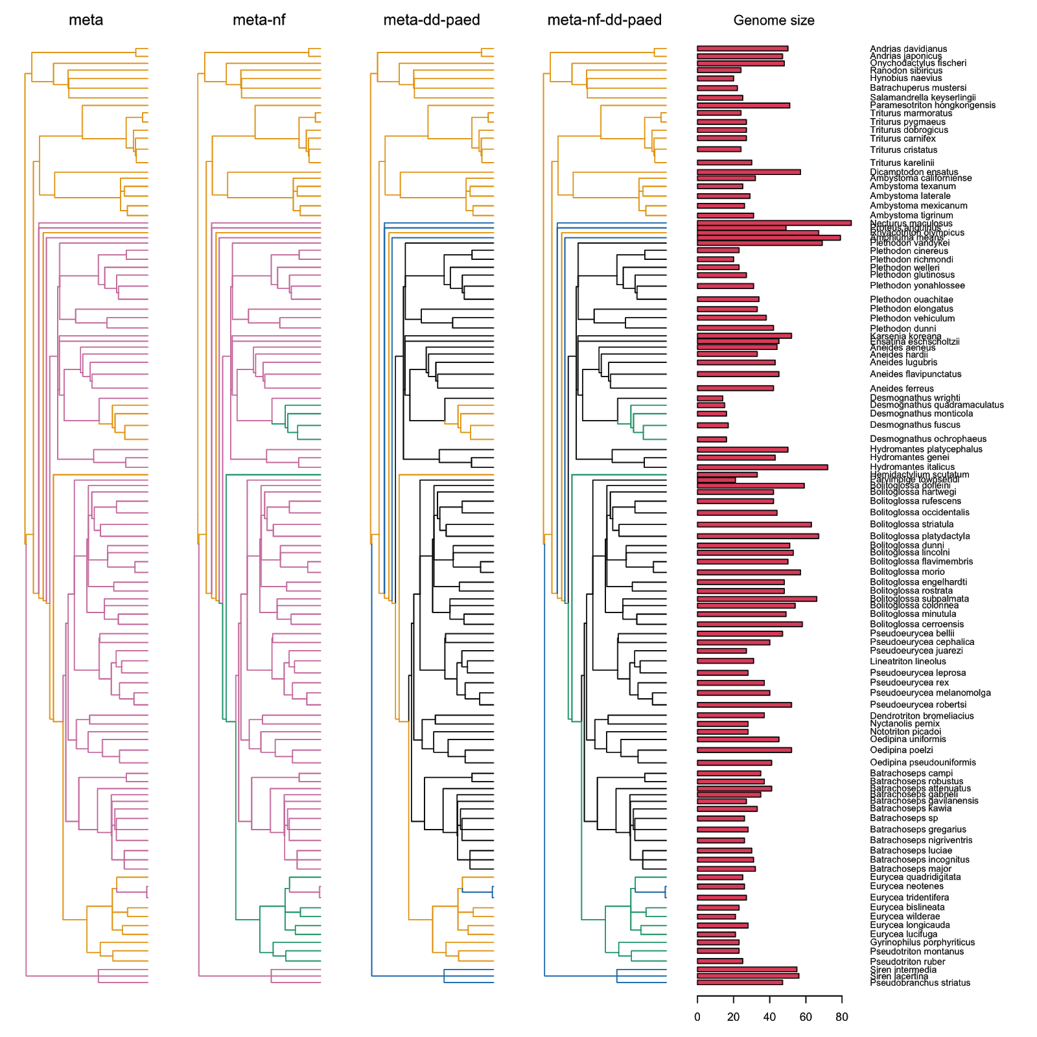

Figure 1. Evolutionary hypotheses for genome size. xx = Direct development, xx = Metamorphosis, xx = non-feeding metamorphosis, xx = Paedomorphosis, Cyan = non-metamorphosis (i.e. direct development or paedomorphosis). Genome sizes are shown on the right.

**Results**

The best-fitting hypothesis for salamander genome size evolution accounted for both non-feeding and feeding metamorphosis, paedomorphosis, and direct development (*meta-nf-paed-dd*; Table 1) under an OU model that allowed both equilibrium genome size (θ) and noise intensity (σ) to vary across the regimes (Table 1). However, fitting only a single noise intensity to the same regimes fit nearly as well (Fig. 2e; Table 4.5). Additionally, the *meta-nf-other* hypothesis with multiple $θi and multiple σ$ also fit nearly as well (Fig. 2f; Table 4.6). These three models were far superior to the remaining models. Overall, the addition of multiple α values resulted in poorer model fit relative to a uniform α value, whereas the addition of multiple σ values relative to a single σ both improved and worsened model fit, depending on the hypothesis (Table 1, Figure 2).

Table 1. Model comparison statistics. The “Model” column gives name of the ‘model’ option provided to OUwie: BM1 = Brownian motion; BMS = Brownian motion with multiple noise intensities; OUM = OU model with multiple equilibria; OUMV = OU model with multiple equilibria and multiple noise intensities; OUMA = OU model with multiple equilibria and multiple selection strengths; OUMVA = OU model with multiple equilibria, noise intensities, and selection strengths.

|  |  |  |  |  |  |  |
| --- | --- | --- | --- | --- | --- | --- |
| ΔAICc | Model | | | | | |
| OU Models | | | | BM Models | |
| Hypotheses | $$θi,σi,α$$ | $θi,σ,α$ | $$θi,σi,αi$$ | $$θi,σ,αi$$ | $$σi$$ | $$σ$$ |
| *meta-nf-dd-paed* | **0** | 1.1 | 7.5 | 8.1 | 12.9 |  |
| *meta-nf-other* | 1.4 | 3.6 | 6.1 | 8.1 | 11.1 |  |
| *meta-dd-paed* | 6.0 | 3.4 | 10.7 | 7.9 | 11.4 |  |
| *Metamorphosis-other* | 5.8 | 4.1 | 8.0 | 6.3 | 9.5 |  |
| Brownian motion |  |  |  |  |  | 31.8 |
| average | 3.3 | 3.05 | 8.075 | 7.6 | 11.225 | 31.8 |

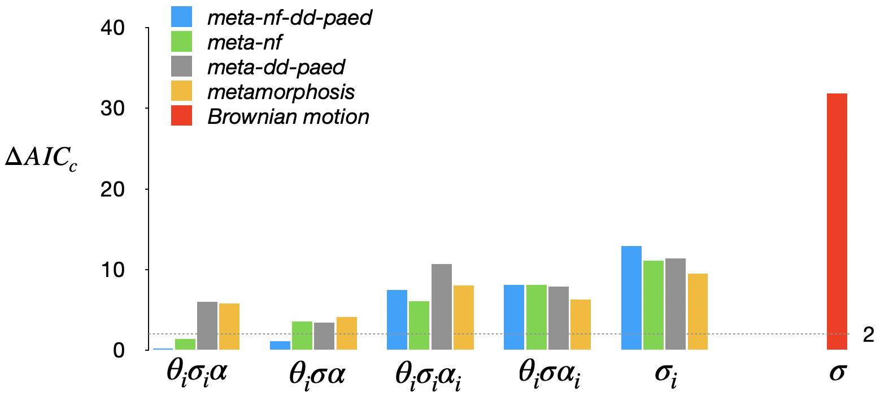

Figure 2: AICc values for OU models fit to the four life history hypotheses, as well as the Brownian motion model.

Table 4 and Figure 2 summarize the results of the pairwise model comparisons quantifying support for specific hypotheses. Fig. 2 shows the bootstrap distributions of the test statistic *δ* = –2 (log *L*0 – log *L*1) when the data is created by simulation of the simpler or more complex model for each comparison. Overall, the results show that we can reject any purely stochastic hypothesis for genome size evolution. A model that allows for separate equilibrium values for metamorphosers was far superior to any purely neutral model (Fig. 2A; Table 4). Specifying distinct equilibrium values for non-feeding and feeding metamorphosis substantially improves the explanatory power of any model (Fig. 2C, E). A model specifying distinct equilibrium values imposed by direct development and paedomorphosis receives weaker support (Fig. 2B, D), as does a model specifying separate noise intensities across life histories (Figure 2F).

Table 4. Model comparisons quantifying support for specific hypotheses.

|  |  |  |
| --- | --- | --- |
| **Comparison** | ***p-*value** | **Power** |
| 1. *metamorphosis-other* vs. BM: does metamorphosis impose constraints on genome size evolution (Fig. 2A)? | 0.016 | 0.69 |
| 2. *meta-paed-dd* vs. *metamorphosis-other*: do different non-metamorphosing strategies impose unique constraints on genome size evolution (Fig. 2B)? | 0.096 | 0.39 |
| 3. *meta-nf-other* vs. *metamorphosis-other*:does the inability to feed during metamorphosis impose a distinct constraint on genome size evolution (Fig. 2C)? | 0.032 | 0.80 |
| 4. *meta-nf-paed-dd* vs. *meta-paed-dd*: does the inability to feed during metamorphosis impose a distinct constraint on genome size evolution, after accounting for differences in non-metamorphosing strategies (Fig. 2D)? | 0.030 | 0.88 |
| 5. *meta-nf-paed-dd* vs. *meta-nf-other*: do different non-metamorphosing strategies impose unique constraints on genome size evolution after accounting for differences between feeding and non-feeding metamorphosis (Fig. 2E)? | 0.102 | 0.54 |
| 6. *meta-nf-paed-dd* (OUMV) vs. *meta-nf-paed-dd* (OUM): does allowing for separate drift intensities for each regime significantly improve the fit of the model (Fig. 2F)? | 0.088 | 0.67 |

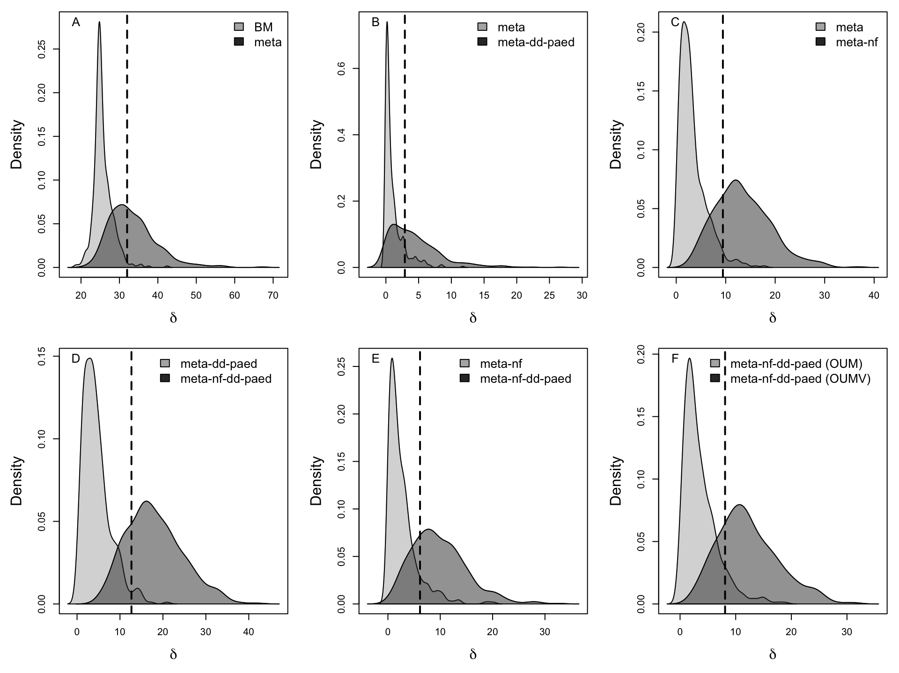Figure 2. The distributions of *δ* values calculated by generating 500 datasets under a specified model at its MLE parameter estimates, fitting the two models, and computing *δ*. Light gray is the simpler model and dark gray is the more complex model. The dashed line gives the observed value of *δ* from fitting the actual data on genome size.

The *p-*value is given by the fraction of the light gray distribution that lies to the right of the observed *δ*; the power is given by the fraction of the dark gray distribution that lies to the right of the 95th percentile of the light gray distribution. These values are reported in Table 4.

Parameter values for each regime estimated under the best-fitting model are presented in Table 2. Direct-developers, non-feeding metamorphosers, paedomorphs, and feeding metamorphosers have broadly overlapping stochastic noise intensity (σ) values. Deterministic pull strength (α) takes an extremely small value, and the equilibrium values (θ) take extreme values both large and small. In Appendix C, we show that these extreme values are a consequence of the handling of the root state and reiterate that they should be interpreted with caution.

Table 2: Maximum likelihood parameter estimates and parametric bootstrap confidence intervals for the best-fitting model (*meta-nf-dd-paed $θi,σi,α$:* separate equilibrium values and noise intensities for lineages in the four selection regimes: dd = direct development, meta-nf = non-feeding metamorphosis, meta = feeding metamorphosis, paed = paedomorphosis).

|  |  |  |  |
| --- | --- | --- | --- |
| **Parameter** |  | **MLE** | **95% CI** |
| Deterministic pull strength | $$α$$ | 1.05e-7 | (1.01e-7, 1.7) |
| Stochastic noise intensity | $$σdd$$ | 0.365 | (0.308, 0.545) |
|  | $$σmeta_{}nf$$ | 0.355 | (0.252, 0.525) |
|  | $$σmeta$$ | 0.187 | (0.108, 0.283) |
|  | $$σpaed$$ | 0.249 | (0.112, 0.464) |
| Equilibrium value | $$θdd$$ | -3.77e5 | (-2.67e6, 1.99e6) |
|  | $$θmeta_{}nf$$ | 3.62 | (3.32, 3.90) |
|  | $$θmeta$$ | -5.55e6 | (-7.62e6, 3.28) |
|  | $$θpaed$$ | 4.41e6 | (3.96, 6.29e6) |

Values for the overall deterministic trend $α(\bar{X}-θ)$ calculated from the best-fitting model parameter estimates for each regime are reported in Table 3. There is evidence of a deterministic trend towards small genome size in salamanders that undergo metamorphosis without feeding as well as a trend towards large genome size in paedomorphic salamanders. In contrast, genome size in direct developing and metamorphosing salamanders show no such trends. The range of values for the strength of the overall deterministic trend (Table 3) is much greater than the range of values for stochastic noise intensity (Table 2).

Table 3: Estimates of the deterministic trend in the best-fitting model for lineages evolving in each regime, based on the average genome size (log-scale) of salamanders in each regime.

|  |  |  |
| --- | --- | --- |
| **Regime** | **Average log genome size $\bar{X}$** | **Deterministic trend $α(θ-\bar{X})$** |
| Direct development | 3.66 (38.9pg) | -0.0396 |
| Feeding metamorphosis | 3.46 (31.8pg) | 1.68e-8 |
| Non-feeding metamorphosis | 3.07 (21.5pg) | -0.583 |
| Paedomorphosis | 3.89 (48.9pg) | 0.463 |

**Discussion**

*Life history evolution and genome size in salamanders.⎯* Evolution of genome size in salamanders is well-described by a model with weak deterministic pull strength $α$, strong noise parameter(s) $σ$, and separate equilibria θ for each life history, consistent with a recent related analysis (cite Bonnet 2020). We interpret these results to mean that the 8-fold variation in genome size across the gigantic genomes of salamanders can be explained by biased stochastic TE accumulation under several different constraints imposed by life history. Accounting for constraints imposed by metamorphosis is far superior to any purely stochastic model; in a targeted pairwise comparison, metamorphosis-other is a significantly better fit to the data than BM (Table 4, Figure 2A). In addition, the non-feeding metamorphic strategy imposes a distinct and very strong added constraint limiting genome expansion, even causing a deterministic trend towards smaller genome sizes; in targeted pairwise comparisons, metamorphosis-non-feeding-other significantly improves upon metamorphosis-other, and meta-nf-paed-dd significantly improves upon meta-paed-dd (Table 4, Figure 2C, D). Accounting separately for the paedomorphic and direct developing strategies has less of an impact on model fit; in targeted comparisons, *meta-paed-dd* improves upon *metamorphosis-other* and *meta-nf-paed-dd* improves upon *meta-nf-other*, but neither effect is significant (Table 4, Figure 2B, E). When we allow multiple noise parameters across regimes (Table 1), the addition of the paedomorphic and direct-developing regimes has an even smaller effect on model fit. However, the strength of the deterministic trend towards genome expansion for paedomorphs is roughly the same as the strength of the deterministic trend towards genome reduction for non-feeding metamorphosers; both are an order of magnitude stronger than the trend for direct-developers. Non-feeding metamorphosers have no deterministic trend (Table 3). Taken together, these results suggest that each life-history strategy receives some support as exerting a unique influence on genome size, but that the metamorphosing and non-feeding metamorphosing strategies exert the strongest influences.

To our knowledge, our study is the first to identify non-feeding metamorphosis, which occurs in the family Plethodontidae, as a distinct life-history constraint shaping genome size evolution in salamanders. The deterministic trend toward smaller genome sizes within this regime is consistent with selection towards genome size reduction to shorten the duration of metamorphosis; the inability to feed during weeks of differentiation and body-plan repatterning does appear to create vulnerability. Recent work suggests that non-feeding metamorphosis in plethodontids evolved several times within the clade from direct-developing ancestors. Under this scenario, in the direct-developing ancestral lineage(s), metamorphic repatterning steps were retained as part of the longer sequence of developmental events that occurred inside the egg. The larval growth phase was eliminated. These changes were likely mediated by evolutionary changes in the timing of thyroid hormone (TH) activity and individual tissue-level TH responses . The re-evolution of metamorphosis from this direct-developing ancestor(s) reflected the insertion of a larval growth phase back into ontogeny, followed by the synchronous occurrence of metamorphic repatterning events in the free-living organism after the larval growth phase. The repatterning of the feeding apparatus is different in plethodontids than in other salamanders; the ceratobranchials, which are cartilaginous components of the tongue skeleton, are replaced by new structures in the adult rather than remodeled from existing larval structures . This replacement underlies the transition from larval suction feeding to adult projectile feeding and explains plethodontids’ inability to feed during repatterning . In contrast, under the classical scenario of life history evolution, non-feeding metamorphosis evolved from feeding metamorphosis at the base of the plethodontid clade, associated with a synchronization of metamorphic repatterning events and the more drastic remodeling of feeding structures including ceratobranchial replacement . Our results are consistent with either scenario, suggesting that selection has acted to decrease genome size and shorten the duration of non-feeding metamorphosis in plethodontid salamanders, irrespective of the immediate ancestral state.

The mechanisms by which selection favors genome reduction are incompletely understood . Variation in genome size is introduced into a population by TE insertions and deletions. Selection could, in principle, sort between genome size variants produced stochastically by individuals with the same overall TE control machinery, although the fitness consequences of individual TE loci are typically miniscule . In addition, selection could sort between differences in TE control machinery including the pathways that underlie silencing and deletion, which could yield variants with greater differences in TE composition and fitness . Given the strong deterministic trend towards genome size reduction identified here, salamanders that undergo non-feeding metamorphosis are a powerful model system to distinguish between these possibilities and understand, more generally, how selection on life history traits translates into changes in genome size. We note, however, that we cannot rule out the possibility that the deterministic trend towards genome size reduction reflects mutation bias towards TE deletion rather than selection, although we consider this less likely.

Paedomorphic salamanders show a deterministic trend in the opposite direction ⎯ towards genome expansion. This trend is consistent with TE accumulation proceeding to higher overall levels, unchecked by any constraints imposed by metamorphic repatterning. However, we do not suggest that genome size is free from all constraints in paedomorphs. The impacts of decreased surface-area-to-volume ratio that accompany increased cell size likely impose an upper limit on cell function that salamanders may well have reached; their cells are among the largest found in animals. In addition, the duration of embryogenesis may well have an upper bound that constrains genome expansion at the extremely high end. We cannot rule out the possibility that the deterministic trend towards huge genomes/cells in paedomorphs has been driven by selection, although we consider this less likely. In the past, huge cells have been proposed as adaptive because they coincide, at broad taxonomic levels, with low metabolic rates; salamanders and lungfishes have the lowest metabolic rates and the largest genomes/cells within vertebrates. This correlation led to the proposal that selection shaped an adaptive “frugal metabolic strategy” in these taxa . More recent analyses of the relationship between genome/cell size and metabolic rate, however, have failed to find the predicted relationship within amphibians. Thus, empirical evidence that huge genomes are a product of directional selection is currently lacking, although it remains an important target of future research.

Lineages that undergo metamorphosis, but are able to feed throughout the process, show no deterministic trend in genome size evolution. Rather, trait evolution in these lineages is described by moderate stochastic noise around an equilibrium value that we interpret as a balance between upwardly biased TE accumulation and an upper constraint imposed by metamorphosis. Metamorphosing salamanders have higher mean genome sizes than non-feeding metamorphosing salamanders (XX vs XX, include ranges). Although the ability to feed removes a key vulnerability from metamorphosis, there are other ways in which fitness can still be lower during the transition from the larval to adult form in salamanders; for example, metamorphosing individuals are less able to exploit stream habitat refugia than either larvae or adults, which increases their mortality (Lowe, et al. 2019). Thus, relative to non-feeding metamorphosis, we infer that metamorphosis imposes a less severe constraint on genome size that is permissive to a higher degree of TE accumulation, and that the constraint is mediated by vulnerabilities other than depletion of energetic stores.

Lineages that undergo direct development have larger average genome sizes than either metamorphosing regime, but smaller than paedomorphs; they show a weak deterministic trend towards genome size reduction. In direct-developing lineages, some or all of the developmental steps of metamorphic repatterning occur inside the egg at the end of embryogenesis. Because they are occurring in an embryo rather than a free-living organism that has undergone a growth period, the repatterning happens to a smaller number of cells in a smaller overall mass of tissue compared with metamorphosing lineages. Thus, the energetic requirements for comparable developmental steps are lower in direct developers than in metamorphosers. On the other hand, the energy to fuel these steps comes from yolk stores which, although plentiful in direct developers, are still finite. Thus, we infer that direct development imposes a less severe constraint on genome size that is permissive to a higher degree of TE accumulation than does metamorphosis. We infer that this constraint is mediated by the potential for depletion of energy stores if the duration of metamorphic repatterning during embryogenesis is too long. Although we modeled all direct developing lineages as a single regime, there is variation across these lineages in metamorphic repatterning. In some cases, the total sequence of developmental events is shortened because the formation of larval structures is lost from ontogeny. In other cases, most or all events of embryogenesis and metamorphosis occur inside the egg (which allows for the possibility of re-evolution of metamorphosis). We would predict more severe constraints in these latter lineages. Although we treated both scenarios as a single category for simplicity, these two types of direct development may be different in their effects on genome size evolution and warrant more detailed study.

*Model complexity to capture the evolutionary process.⎯* It is almost paradoxical that the best model includes a deterministic pull parameter ⎯ typically interpreted as selection, although here we interpret it to reflect the processes of upward mutation pressure, constraint, and selection ⎯ when the magnitude of $α$ is miniscule. One might wonder why it is needed at all? Yet its importance is clear: the models with deterministic pull provided a huge improvement over any purely stochastic model. One of the challenges of an OU model with a weak deterministic component is that the model parameters will be poorly defined (Cressler et al., 2015). Intuitively, if the $α$ is important but close to zero, the equilibrium $θi$ can take on a wide range of values in combination with a range of values for the stochastic parameter $σ$ and explain the phenotypic distribution equally as well. For example, even with α close to zero, a trend to larger genome size in paedomorphic salamanders is modeled by an extremely large value for $θpaed$, the genome size equilibrium. The difference between a purely stochastic (BM) model and one that has any degree of deterministic pull is that the variance of a BM model will grow unbounded over time, whereas the variance in a model with deterministic pull will not. The phenotype may explore a wide range of values, but it will be bounded. For paedomorphs, a weak deterministic pull allows the mean to wander, while a far-away equilibrium value captures a deterministic trend toward increase. In OU models, increasing deterministic pull strength influences the approach to the equilibrium, but also will tend to dampen stochastic effects (apart from the influence of $σ$), so weak deterministic pull allows greater noise in the stochastic process. This analysis demonstrates that deterministic pull can exert an important evolutionary influence, even if the magnitude of alpha is weak.

But how complex a model of deterministic pull is necessary? We found no evidence for a rate shift in deterministic pull; all multiple alpha models performed poorly. This is consistent with extensive simulation results showing that, among the three basic parameters of the OU model, alpha is most poorly defined (ref?). Thus, even if a rate shift in alpha existed, there is probably little power to detect it. In this study, a lack of rate shift in alpha is not surprising as there are multiple free parameters and weak deterministic pull throughout the system. We can readily capture shifts in the evolutionary process with variable theta and perhaps sigma over the tree, with stronger deterministic trends accomplished by moving theta to more extreme values. Thus, a shift in alpha is superlative, as these variations (rate shift in alpha, more extreme values of theta) are not independently identifiable. Aside from this case where the system overall experiences weak deterministic pull, this may be a general problem for all comparative studies. We do not know of a case as of yet where a multiple alpha model was superior.

*Exploring evolutionary constraints with the comparative method.⎯* Constraint can be described as an evolutionary limit on the range of possible phenotypes, and its role in shaping evolution has long been debated. The study of constraint has benefitted from increasing conceptual clarification and input from multiple disciplines. For example, Arnold (1992) laid out four major categories of constraint ⎯ genetic, selective, developmental, and functional ⎯ that may shape lineages’ explorations of phenotypic space. Work on genetic constraints has focused on the form of covariances of multivariate characters (i.e. G matrices; refs). ~~(Revell et al., 2007, many more).~~ Evolutionary developmental biology (evo-devo) has explored the limits on phenotypic variation that are inherent in developmental systems (Wagner 1988, Wagner and Altenberg 1996). Comparative studies in deep time have explored functional constraints, typically in the form of a tradeoff or negative correlation between two or more phenotypes across species (). In this study, we explore a selective constraint in which a trait value (genome size) becomes a target of selection only when it crosses a threshold value. This is conceptually different from the canonical view of adaptation, where unbounded phenotypic variants that differ in fitness are sorted by natural selection toward an optimum. In contrast, evolution shaped by constraint can unfold as stochastic changes producing functionally equivalent variants within limits. In salamanders, this scenario is best illustrated by metamorphosers, which show no deterministic trend, but rather stochastic variation within bounds. With the evolution of non-feeding metamorphosis, the constraint on genome size became more severe, driving the range of acceptable genome sizes lower. These two views of phenotypic evolution ⎯ canonical adaptation and constraint ⎯ can be conceptualized as two ends of a continuum, one dominated by a strong pull toward an optimum with weak stochastic variation and the other dominated by strong stochastic variation with boundaries. OU models, which model both the change in the mean as well as variance of the phenotype, can be used to distinguish among these alternatives. Phylogenetic comparative methods have largely focused on explaining shifts in mean phenotype, and have thus lent themselves well to studying adaptation, convergent evolution, and parallelism. We show here that these methods can also be used to identify the action of evolutionary constraints, shining additional light on the full range of forces shaping phenotypic evolution.

---------

Alberch P. 1989. Development and the evolution of amphibian metamorphosis. In: Splechtna/Hilgers, editor. Trends in Vertebrate Morphology. Stuttgart: Gustav Fischer Verlag. p. 163-173.

AmphibiaWeb: Information on amphibian biology and conservation [Internet]. 2020. Berkeley, California. Available from <http://amphibiaweb.org/>.

Arnold SJ, Wassersug RJ. 1978. Differential predation on metamorphic anurans by garter snakes (thamnophis): Social behavior as a possible defense. Ecology 59:1014-1022.

Arnold SJ. 1992. Constraints on phenotypic evolution. The American Naturalist 140:S85-S107.

Beaulieu JM, Jhwueng D-C, Boettiger C, O’Meara BC. 2012. Modeling stabilizing selection: expanding the Ornstein-Uhlenbeck model of adaptive evolution. Evolution 66:2369-2383.

Boettiger C, Coop G, Ralph P. 2012. Is your phylogeny informative? Measuring the power of comparative methods. Evolution 66:2240-2251.

Bonett RM, Hess AJ, Ledbetter NM. 2020. Facultative transitions have trouble committing, but stable life cycles predict salamander genome size evolution. Evol Biol 47:111-122.

Bonett RM, Steffen MA, Robison GA. 2014. Heterochrony repolarized: a phylogenetic analysis of developmental timing in plethodontid salamanders. EvoDevo 5:27.

Budzik KA, Żuwała K, Kerney R. 2016. Tongue and taste organ development in the ontogeny of direct-developing salamander Plethodon cinereus (Lissamphibia: Plethodontidae). J Morph 277:906-915.

Butler MA, King AA. 2004. Phylogenetic comparative analysis: a modeling approach for adaptive evolution. The American Naturalist 164:683-695.

Deban SM, Marks SB. 2002. Metamorphosis and evolution of feeding behaviour in salamanders of the family Plethodontidae. Zool J Linn Soc 134:375-400.

Downie JR, Bryce R, Smith J. 2004. Metamorphic duration: an under-studied variable in frog life histories. Biol J Linn Soc 83:261-272.

Edgar RC. 2004. MUSCLE: multiple sequence alignment with high accuracy and high throughput. Nucleic Acids Research 32:1792-1797.

Gregory TR. 2002. Genome size and developmental complexity. Genetica 115:131-146.

Gregory, T. R. Animal Genome Size Database (<http://www.genomesize.com>) [Internet]. 2020.

Hanken J. 1992. Life history and morphological evolution. J Evol Biol 5:549-557.

Hansen TF. 1997. Stabilizing selection and the comparative analysis of adaptation. Evolution 51:1341-1351.

Hansen TF, Martins EP. 1996. Translating between microevolutionary process and macroevolutionary patterns: the correlation structure of interspecific data. Evolution 50:1404-1417.

Harmon L. 2019. Phylogenetic Comparative Methods: CreateSpace Independent Publishing Platform.

Horner HA, Macgregor HC. 1983. C value and cell volume: their significance in the evolution and development of amphibians. Journal of Cell Science 63:135-146.

Jockusch EL. 1997. An evolutionary correlate of genome size change in plethodontid salamanders. Proceedings of the Royal Society of London, Series B: Biological Sciences 264:597.

Kapusta, A., Suh, A., Feschotte, C. 2017. Dynamics of genome size in birds and mammals. Proceedings of the National Academy of Sciences 114(8) E1460-E1469. <https://doi.org/10.1073/pnas.1616702114>

Johnson CK, Voss SR. 2013. Salamander paedomorphosis: Linking thyroid hormone to life history and life cycle evolution. In: Shi Y-B, editor. Current Topics in Developmental Biology: Academic Press. p. 229-258.

Kerney RR, Blackburn DC, Müller H, Hanken J. 2012. Do larval traits re-evolve? Evidence from the embryogenesis of a direct-developing salamander, Plethodon cinereus. Evolution 66:252-262.

Kerney RR, Hanken J, Blackburn DC. 2018. Early limb patterning in the direct-developing salamander Plethodon cinereus revealed by sox9 and col2a1. Evol Dev 20:100-107.

King AA, Butler MA. 2009. ouch: Ornstein-Uhlenbeck models for phylogenetic comparative hypotheses (R package). <http://ouch.r-forge.r-project.org>.

Knight CA, Molinari NA, Petrov DA. 2005. The large genome constraint hypothesis: evolution, ecology, and phenotype. Annals of Botany 95:177-190. doi:10.1093/aob/mci011

Landberg T, Azizi E. 2010. Ontogeny of escape swimming performance in the spotted salamander. Functional Ecology 24:576-587.

Lertzman-Lepofsky G, Mooers AØ, Greenberg DA. 2019. Ecological constraints associated with genome size across salamander lineages. Proc Roy Soc B 286:20191780.

Lowe WH, Swartz LK, Addis BR, Likens GE. 2019. Hydrologic variability contributes to reduced survival through metamorphosis in a stream salamander. Proceedings of the National Academy of Sciences 116:19563.

Moran NA. 1994. Adaptation and constraint in the complex life cycles of animals. Ann Rev Ecol Syst 25:573-600.

Mueller RL, Gregory TR, Gregory SM, Hsieh A, Boore JL. 2008. Genome size, cell size, and the evolution of enucleated erythrocytes in attenuate salamanders. Zoology 111:218-230.

Mueller RL, Macey JR, Jaekel M, Wake DB, Boore JL. 2004. Morphological homoplasy, life history evolution, and historical biogeography of plethodontid salamanders inferred from complete mitochondrial genomes. Proceedings of the National Academy of Sciences, USA 101:13820-13825.

Norman MF. 1985. A practical method for staging metamorphosis in the tiger salamander Ambystoma tigrinum. Anatom Rec 211:102-109.

O'Meara BC, Ané C, Sanderson MJ, Wainwright PC. 2006. Testing for different rates of continuous trait evolution using likelihood. Evolution 60:922-933.

Orlofske SA, Hopkins WA. 2009. Energetics of metamorphic climax in the pickerel frog (Lithobates palustris). Comparative Biochemistry and Physiology Part A: Molecular & Integrative Physiology 154:191-196.

Parichy DM. 1998. Experimental analysis of character coupling across a complex life cycle: Pigment pattern metamorphosis in the tiger salamander, Ambystoma tigrinum tigrinum. J Morph 237:53-67.

Pellicer J, Hidalgo O, Dodsworth S, Leitch IJ. 2018. Genome size diversity and its impact on the evolution of land plants. Genes 9(11) <https://doi.org/10.3390/genes9020088>

Posada D, Crandall KA. 1998. MODELTEST: testing the model of DNA substitution. Bioinformatics 14:817-818.

Pyron AR, Wiens JJ. 2011. A large-scale phylogeny of Amphibia including over 2800 species, and a revised classification of extant frogs, salamanders, and caecilians. Molecular Phylogenetics and Evolution 61:543-583.

R Core Team. 2020. R: A language and environment for statistical computing. R Foundation for Statistical Computing, Vienna, Austria. https://www.R-project.org/.

Revell LJ, Harmon LJ, Langerhans RB, Kolbe JJ. 2007. A phylogenetic approach to determining the importance of constraint on phenotypic evolution in the neotropical lizard Anolis cristatellus. Evolutionary Ecology Research 9:261-282.

Rose CS. 1996. An endocrine-based model for developmental and morphogenetic diversification in metamorphic and paedomorphic urodeles. Journal of Zoology 239:253-284.

Rose CS. 2014. The importance of cartilage to amphibian development and evolution. International Journal of Developmental Biology 58:917-927.

Rose CS. 1995a. Skeletal morphogenesis in the urodele skull:1. Postembryonic development in the hemidactyliini (amphibia: Plethodontidae). J. Morph. 223:125-148.

Rose CS. 1995b. Skeletal morphogenesis in the urodele skull: Ii. Effect of developmentalstage in thyroid hormone-induced remodeling. J. Morph. 223:149-166.

Rose CS. 1995c. Skeletal morphogenesis in the urodele skull: Ill. Effect of hormone dosage in th-induced remodeling. J. Morph. 223:243-261.

San Mauro D, Gower DJ, Müller H, Loader SP, Zardoya R, Nussbaum RA, Wilkinson M. 2014. Life-history evolution and mitogenomic phylogeny of caecilian amphibians. Mol Phylogen Evol 73:177-189.

Sanchez E, Küpfer E, Goedbloed DJ, Nolte AW, Lüddecke T, Schulz S, Vences M, Steinfartz S. 2018. Morphological and transcriptomic analyses reveal three discrete primary stages of postembryonic development in the common fire salamander, Salamandra salamandra. J Exp Zool B: 330:96-108.

Sanderson MJ. 2003. r8s: inferring absolute rates of molecular evolution and divergence times in the absence of a molecular clock. Bioinformatics 19:301-302.

Sessions SK. 2008. Evolutionary cytogenetics in salamanders. Chromosome Research 16:183-201.

Sessions SK, Larson A. 1987. Developmental correlates of genome size in plethodontid salamanders and their implications for genome evolution. Evolution:1239-1251.

Stamatakis A. 2006. RAxML-VI-HPC: maximum likelihood-based phylogenetic analyses with thousands of taxa and mixed models. Bioinformatics 22:2688-2690.

Szarski H. 1957. The origin of larva and metamorphosis in amphibia. The American Naturalist 91:283-301.

ten Brink H, de Roos AM, Dieckmann U. 2019. The evolutionary ecology of metamorphosis. The American Naturalist 193:E116-E131.

Vieites DR, Rom·n SN, Wake MH, Wake DB. 2011. A multigenic perspective on phylogenetic relationships in the largest family of salamanders, the Plethodontidae. Molecular Phylogenetics and Evolution 59:623-635.

Vladimirova IG, Kleimenov SY, Alekseeva TA. 2012. Dynamics of body mass and oxygen consumption in the ontogeny of the Spanish ribbed newt (Pleurodeles waltl): 2. Larval stage. Biology Bulletin 39:10-14.

[Wagner GP. 1988.](https://github.com/mbutler808/Macroevolution/blob/master/25.Wagner1988.pdf) The significance of developmental constraints for phenotypic evolution by natural selection. Pp. 222-229 in G. de Jong (ed.) Population Genetics and Evolution, Springer-Verlag, Berlin.

[Wagner, GP, Altenberg L. 1996](https://github.com/mbutler808/Macroevolution/blob/master/38.WagnerAltenberg1996.pdf) Perspective: Complex adaptations and the evolution of evolvability. Evolution 50(3):967-967.

Wake DB, Marks SB. 1993. Development and evolution of plethodontid salamanders: a review of prior studies and a prospectus for future research. Herpetologica 49:194-203.

Wake DB, Roth G. 1989. The linkage between ontogeny and phylogeny in the evolution of complex systems. In: Wake DB, Roth G, editors. Complex Organismal Functions: Integration and Evolution in Vertebrates. Chichester: John Wiley & Sons. p. 361-377.

Waltari E, Edwards SV. 2002. Evolutionary dynamics of intron size, genome size, and physiological correlates in Archosaurs. American Naturalist 160(5): 539-552.

Wassersug RJ, Sperry DG. 1977. The relationships of locomotion to differential predation on pseudacris triseriata (anura: Hylidae). Ecology 58:830-839.

Womack MC, Metz MJ, Hoke KL. 2019. Larger genomes linked to slower development and loss of late-developing traits. The American Naturalist 194:854-864.

Wright ML, Richardson SE, Bigos JM. 2011. The fat body of bullfrog (Lithobates catesbeianus) tadpoles during metamorphosis: Changes in mass, histology, and melatonin content and effect of food deprivation. Comp. Biochem. Phys. A 160:498-503.

Zheng Y, Peng R, Kuro-o M, Zeng X. 2011. Exploring patterns and extent of bias in estimating divergence time from mitochondrial DNA sequence data in a particular lineage: a case study of salamanders (Order Caudata). Molecular Biology and Evolution 28:2521-2535.