**Metamorphosis imposes variable constraints on genome expansion through effects on development**

**Article type:** Original Research

**Keywords**: genome size, metamorphic vulnerability, developmental system, comparative methods, life history, salamander

**Abstract**

Genome size varies ~ 100,000-fold across eukaryotes and has long been hypothesized to be influenced by metamorphosis in animals. Transposable element accumulation has been identified as a major driver of increase, but the nature of constraints limiting the size of genomes has remained unclear, even as traits such as cell size and rate of development co-vary strongly with genome size. Salamanders, which possess diverse metamorphic and non-metamorphic life histories, have the largest vertebrate genomes ¾ 3 to 40 times that of humans ¾ as well as the largest range of variation in genome size. We tested 13 biologically-inspired hypotheses exploring how the form of metamorphosis imposes varying constraints on genome expansion in a broadly representative phylogeny containing 118 species of salamanders. We show that metamorphosis during which animals undergo the most extensive and synchronous remodeling imposes the most severe constraint against genome expansion, with the severity of constraint decreasing with reduced extent and synchronicity of remodeling. More generally, our work demonstrates the potential for broader interpretation of phylogenetic comparative analysis in exploring the balance of multiple evolutionary pressures shaping phenotypic evolution.

**Introduction**

Across the tree of life, few traits exhibit the tremendous scale of variation shown by genome size, which encompasses a ~100,000-fold range across eukaryotes alone (Gregory 2022). Decades of research have explored the question of whether this variation has a cohesive evolutionary explanation, revealing two traits that consistently covary with large genome size: cell division rate slows down and cell size increases (Gregory 2001, 2005). However, whether genome size evolves by adaptation or constraint, and what drives these processes, have been challenging questions to answer, in part because the organismal features involved have been unclear. For example, genome size co-varies in a context-dependent manner with metabolic rate, showing an association within some vertebrate clades, but not others, and shows no correlation across vertebrates as a whole (Licht and Lowcock 1991; Gregory 2002a; Smith, et al. 2013; Wright, et al. 2014; Kapusta, et al. 2017; Uyeda, et al. 2017; Gardner, et al. 2020). Genome size has also been associated with developmental rate or complexity (Gregory 2002b), temperature (Hessen, et al. 2013), invasiveness (Pandit, et al. 2014), and speciation and extinction rates (Vinogradov 2004; Jeffery, et al. 2016). As these associations vary in their generality, the explanation may not lie in a single overarching factor. Rather, genome size variation may reflect the balance of multiple evolutionary pressures. Thus, to disentangle the forces affecting genome size requires close consideration of the interaction of ecology and organismal biology (Gregory 2004; Roddy, et al. 2019).

The association between genome size and metamorphosis has been repeatedly noted across ectotherms (salamanders: Larson 1984; Wake and Marks 1993; Gregory 2002b; Sessions 2008; fish and insects: Gregory 2002b). It has long been proposed that natural selection acts to shorten the duration of metamorphosis (Szarski 1957) to limit exposure to potentially lethal stresses during transformation, termed "metamorphic vulnerabilities" (Gregory 2002b; Lowe, et al. 2021). Salamanders have received special focus because they have the largest genomes among vertebrates (9 Gb – 120 Gb per haploid genome; the vast majority are diploid), as well as exceptional diversity in life history across the 798 extant species (Decena-Segarra, et al. 2020; AmphibiaWeb 2022; Gregory 2022). Metamorphosis has been lost, modified, and regained throughout the clade’s evolutionary history leading to metamorphosers, paedomorphs, and direct developers among extant salamanders. These three life history types vary widely in the degree and duration of transformation, as well as many other organismal features that have important consequences for natural selection. Metamorphosers undergo a morphological transformation from an aquatic larval to terrestrial adult form, paedomorphs retain the aquatic larval morphology throughout life, and direct developers hatch from terrestrial eggs as miniature versions of the adults (Rose 1996; Rose 1999; Chippindale, et al. 2004; Mueller, et al. 2004; Wiens, et al. 2005; Bonett, et al. 2014).

The observation that metamorphosis is linked to smaller genome size (Wake and Marks 1993; Gregory 2002b; Sessions 2008; Bonett, et al. 2020), and larger genome size is linked to an overall slow-down of developmental rates, led to the hypothesis of time-limited metamorphosis as a constraint on genome expansion (Gregory 2002b). An evolutionary constraint is broadly defined as a limit to phenotypic variation (Arnold 1992) that can arise from non-adaptive sources or from selection on a correlated trait indirectly shaping the focal trait (e.g., Savell, et al. 2016); it is this latter definition that we apply here. For example, because the rate of development is an emergent property of complex cellular processes that are slowed down by large genome/cell sizes (Horner and Macgregor 1983; Jockusch 1997), selection to shorten metamorphosis should limit the sizes that genomes can attain, resulting in a constraint on genome size. There has been some ecological confirmation of the time-limited metamorphosis hypothesis in salamanders, with species in ephemeral habitats possessing smaller genomes (Lertzman-Lepofsky, et al. 2019). However, large-scale phylogenetic comparative analysis has both rejected (Liedtke, et al. 2018) and confirmed the classical association between genome size and life history (Bonett, et al. 2020). A key difference in the latter was partitioning life history diversity to better reflect how developmental complexity influences genome size. Combining lineages with the ability to metamorphose at all ¾ even if only occasionally, as seen in facultative paedomorphs ¾ and separating them from lineages that are obligate paedomorphs was key to finding any association between genome size and life history (Bonett, et al. 2020).

Although this was a big step forward, there was no clear best model; a model that separated direct developers from paedomorphs and a model that grouped them as non-metamorphosers explained the data nearly equally well. This result is surprising if developmental remodeling is a primary factor influencing genome size because direct developers undergo some metamorphic remodeling inside the egg, whereas paedomorphs have lost much (or all) metamorphic remodeling from their larval stage {Kerney, 2012 #647;Marks, 2000 #751;Wake, 1996 #690}{Rose, 1999 #749}. We hypothesize that this result may be explained by the models not yet considering natural diversity across salamander lineages in the synchronicity and extent of developmental remodeling during metamorphosis, as well as the associated vulnerabilities. Thus, the relevant features of metamorphosing organisms, and the evolutionary pressures they exert on genome size, likely remain incompletely understood.

In vertebrates, genome size is strongly shaped by transposable elements (TEs), sequences that replicate and spread throughout host genomes, increasing genome size (Sotero-Caio, et al. 2017; Shao, et al. 2019). TEs can be deleted by errors in replication, recombination, and DNA repair (Michael 2014; Vu, et al. 2017). TE activity can be nearly neutral, largely missing functional genomic regions and therefore resulting in negligible fitness consequences (Arkhipova 2018). Salamanders are particularly prone to stochastic increases in genome size through TE accumulation (Sun, et al. 2012; Keinath, et al. 2015; Nowoshilow, et al. 2018) because they possess low TE deletion rates and incomplete TE silencing (Sun and Mueller 2014; Frahry, et al. 2015; Madison-Villar, et al. 2016){J, 2023 #846}.

In this study, we explore how metamorphosis constrains genome size, expanding the consideration of life history diversity to include natural variation in developmental complexity during metamorphosis and associated metamorphic vulnerabilities. We inform stochastic models of genome size evolution with life history data and the molecular mechanisms of biased stochastic genome expansion. We detail how OU model-based comparative methods can be used to explore constraint on genome size and, by extension, other traits that also may not be shaped exclusively by adaptive evolution. Whereas OU models have been used widely to study adaptive significance (Hansen 1997; Butler and King 2004), some traits such as extremely large genome size have no known fitness benefit, which is at odds with an interpretation of adaptive evolution. Indeed, these general models can be interpreted in multiple ways, and rather than evolutionary “optima,” the phenotypic locations predicted by the models may be better envisioned as “equilibria” to reflect a balance of forces such as upwardly-biased mutation pressure opposed by a constraint set by selection acting on other correlated aspects of organismal biology. The sigma term, describing the intensity of random fluctuations of the evolutionary process, has received much less attention, but in combination with the other parameters may be helpful in diagnosing release from constraint.

**Methods**

*Metamorphic Vulnerabilities Associated With Life History Regimes*

Metamorphosis is a radical morphological transformation often coordinated in a short window of time, and thus subject to multiple risks. During metamorphosis, animals undergo rapid cell division, differentiation, migration, and apoptosis (Alberch 1989), as they remodel their skin and glands, blood, gut, teeth, and musculoskeletal, excretory, and immune systems (Rose 1999). Accordingly, metamorphosing animals can experience three classes of vulnerabilities: 1) Performance and physiological handicap. Animals can suffer reductions in performance in escaping predation or accessing food and shelter; or reductions in physiological tolerance to environmental swings during transformation. 2) Energetic limitations imposed when resorbing or remodeling larval structures and forming adult structures (Wassersug and Sperry 1977; Orlofske and Hopkins 2009; Enriquez-Urzelai, et al. 2019; Lowe, et al. 2019; Lowe, et al. 2021). 3) Random developmental errors resulting from developmental system perturbation, which can become more likely with both increased developmental complexity and reduced cell numbers when remodeling occurs at earlier embryonic stages (Hanken 1984; Gregory 2002b; Rose 2003).

In addition to the ancestral form of metamorphosis, a derived mode that differs markedly in timing and extent of remodeling, reflecting an abrupt increase in thyroid hormone level, has evolved within the salamander clade Plethodontidae (Alberch, et al. 1985; Rose 1999, 2003; Beachy, et al. 2017). In contrast to previous studies, we therefore differentiate four life history regimes for the evolution of genome size: Paedomorphosis, Direct Development, and two forms of metamorphosis: Gradual Progressive Metamorphosis and Abrupt Synchronous Metamorphosis {names draw from Rose, 1999 #749}. Because they account for < 2% of salamander species, we did not include viviparous and ovoviviparous life histories.

*Paedomorphosis:* Individuals do not undergo metamorphosis, instead reaching sexual maturity retaining largely larval traits without any radical developmental remodeling (Gould 1977; Rose 1996). Paedomorphosis has evolved at least eight times within salamanders (Rose 1999). Paedomorphs experience no metamorphic vulnerabilities and are thus predicted to be free from any related constraints on genome expansion.

*Direct development:* The larval growth stage is eliminated, and metamorphosis is integrated with embryogenesis into a single sequence of developmental events that takes place much earlier in ontogeny, inside the egg (Alberch 1989; Rose 2014). Thus, metamorphic remodeling occurs, but the events involve small amounts of tissue and few cells. Direct development has likely evolved at least twice within salamanders (Bonett, et al. 2014). Direct developers may experience the metamorphic vulnerabilities of energetic limitation and developmental error due to decreased cell numbers. Thus, direct developers are predicted to have intermediate levels of constraint on genome size associated with metamorphosis.

*Gradual, progressive metamorphosis:* This type of metamorphosis is likely ancestral for salamanders (Rose 1999), and involves remodeling events happening sequentially and over relatively long timeframes in a free-living, aquatic organism in preparation for transition to a terrestrial habitat (Rose 1996). In contrast to frogs, these salamander larvae are able to feed throughout the process, as well as use larval energy stores (Semlitsch, et al. 1988; Deban and Marks 2002), alleviating energetic limitations. Furthermore, the timing of metamorphic onset is flexible and can be delayed when larval food resources are limited (Beachy, et al. 2017). Gradual metamorphosers experience the metamorphic vulnerabilities of decreased performance and physiological tolerance and are thus predicted to have intermediate levels of constraint on genome size associated with metamorphosis.

*Abrupt, synchronous metamorphosis:* This form of metamorphosis differs markedly from gradual, progressive metamorphosis in that remodeling events are more radical, occur simultaneously, and begin at a fixed time point in larval development, irrespective of larval size (Alberch, et al. 1985; Rose 1999, 2003; Beachy, et al. 2017). Organisms undergo a more extensive remodeling of the feeding apparatus and consequently transform with reduced feeding performance (Deban and Marks 2002). This type of metamorphosis has evolved approximately three times within salamanders, all within the Plethodontidae (Bonett, et al. 2014). Abrupt metamorphosers experience the metamorphic vulnerabilities of decreased performance and physiological tolerance, energetic demand, and developmental error due to increased complexity and are thus predicted to have the most extreme levels of constraint on genome expansion associated with metamorphosis.

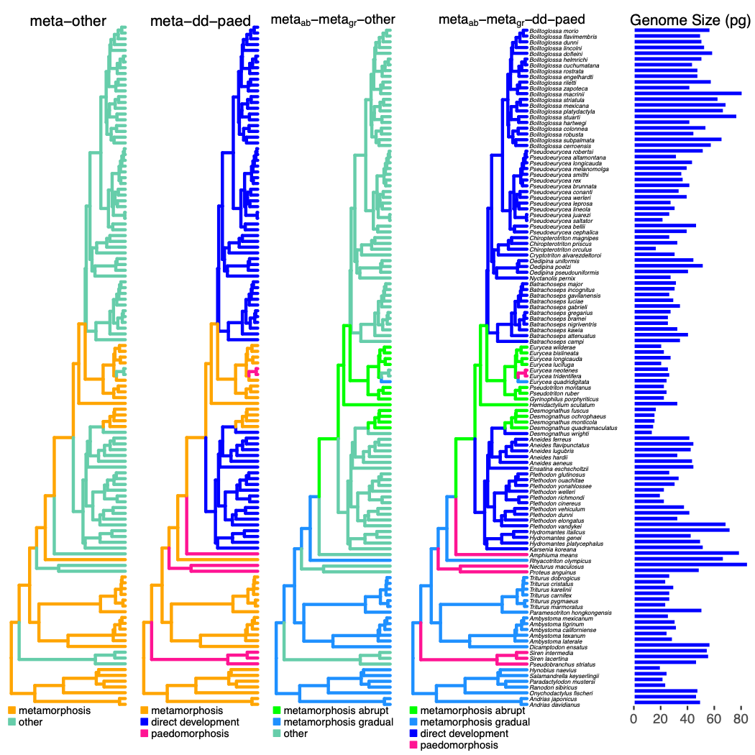

Figure 1. Alternative hypotheses for constraints imposed by development on genome size evolution in salamanders. On each phylogeny (www.vertlife.org), alternative life history regimes are painted in different colors as indicated in each legend (see text). Haploid genome sizes are shown on the right in pg (1 pg = 978 Mb).

*Taxon Sampling, Genome Size, and Phylogeny*

We analyzed haploid genome size data for 118 species of salamanders (all of which are diploid), including all ten families and 33 of 68 genera, and representing all four life-history regimes (Supplemental Table 1) (AmphibiaWeb 2022). We excluded miniaturized taxa (mean SVL < 35 mm), as miniaturization is associated with decreased genome size independent from any selection imposed by metamorphosis; this meant excluding 20 miniaturized, direct-developing species (Decena-Segarra, et al. 2020). The interaction between miniaturization and life history is an important target for future research. Several lineages are facultative paedomorphs; we coded these taxa as metamorphic, as they retain the ability to successfully (albeit occasionally) metamorphose (Bonett, et al. 2020). The two species of *Andrias* were coded as metamorphic, despite missing several morphogenetic remodeling events {Rose, 1996 #643}.

The dataset includes all non-miniature species that are represented in the Animal Genome Size Database (www.genomesize.com) and the VertLife database for phylogeny subsampling (www.vertlife.org) (Jetz and Pyron 2018; Gregory 2022). We took the mean genome size where estimates were reported from multiple studies, and natural-log transformed the data to better conform with assumptions of Gaussian errors. We excluded one study that reported consistently higher values than all others (Bachmann 1970). We obtained the 118-species phylogeny by sampling 1,000 ultrametric trees from the pseudo-posterior distribution of the VertLife database (Jetz and Pyron 2018) and computing mean branch lengths using the consensus.edges function in the R package phytools v 0.7-90 (Revell 2012) (Fig. 1). All analyses were conducted in the R statistical computing environment (R Core Team 2020).

*Models of Genome Size Evolution*

We modeled genome size evolution using both Brownian motion (BM) and OU models of evolution (Hansen 1997; Butler and King 2004; O'Meara, et al. 2006; Beaulieu, et al. 2012). The BM model is the simplest stochastic model with a single rate parameter σ for *stochastic noise intensity* describing the magnitude of the independent random walks of the trait evolving along the branches of the phylogeny. The multiple-rate BM model allows σ to vary across a phylogeny (O'Meara, et al. 2006).

OU models generalize the BM model by allowing the mean to shift and the variance to narrow. They include a deterministic component of trait evolution that models the tendency to move toward an equilibrium. In contrast to previous work, and to more closely reflect our hypothesis that salamander genome size evolves in response to a balance of deterministic forces such as mutation pressure and selection on a correlated trait imposing constraint, we generalize the notion of “selective optima" to "*deterministic equilibria*", which can encompass both adaptive and non-adaptive forces affecting the equilibrium ($θ(t)$). Similarly, we generalize "selection" to "*deterministic pull"* such that it also encompasses non-selective, but directional, evolutionary forces ($α$; e.g., biased mutation pressure and constraint). Mathematically, the model for trait evolution expressed as a differential equation is

$dX(t)=α(θ(t)-X(t))+σdB(t)$,

where $θ(t)$ is the *deterministic equilibrium* for the trait at time *t* and $α$ is an evolutionary rate describing the *strength of the deterministic pull* towards that equilibrium. The simplest multi-regime OU models allow equilibria to vary across the tree, reflecting the evolution of differences in mean phenotype across regimes (Hansen 1997; Butler and King 2004). Further model extensions also allow the strength of the deterministic pull and the stochastic noise intensity to vary across regimes (Beaulieu, et al. 2012).

We formalized five hypotheses for the influence of biased mutation pressure and metamorphic constraints on genome size evolution: (1) *random evolution*: stochastic evolutionary processes may be sufficient to explain genome size evolution, as represented by BM. The remaining four hypotheses propose different groupings of constraint against biased genome expansion fit with OU models. (2) *metamorphosis-other*: Metamorphosis imposes a constraint on genome expansion distinct from all remaining life histories, grouped as "other". (3) *meta-paed-dd*: This hypothesis refines (2) by dividing the "other" category into direct developers and paedomorphs, allowing each to impose distinct constraints on genome size evolution. (4) *metaabrupt-metagradual-other*: Alternatively, we may refine (2) by keeping the "other" category of non-metamorphosers, but differentiating the two groups of metamorphosers, recognizing that abrupt (*metaabrupt*) and gradual (*metagradual*) metamorphosis each impose distinct constraints on genome size evolution. (5) *metaabript-metagradual-paed-dd*: Each category imposes distinct constraints on genome expansion (Fig. 1).

We tested 21 models that varied in the number of parameters used to explore these five biologically-inspired hypotheses. The simplest model allows the equilibria to vary with life history regime while modeling a single stochastic noise intensity (σ) and deterministic pull strength ($α$) across all species. Additional sub-hypotheses fit evolutionary models with separate stochastic noise intensities (*i*) for each regime (Table 1). More complex models with multiple deterministic pull strengths (*i*) produced fitting errors or nonsensical parameter estimates or likelihoods, so we did not consider them further (see Supplementary Information; Table 2). We fit the remaining 13 models with the ancestral plethodontid node assigned to be either metamorphosing or direct-developing (Bonett, et al. 2014) and found that the choice made no qualitative difference (Supplementary Information). Model fitting and parameter estimation were carried out using OUwie (Beaulieu, et al. 2012).

Table 1. BM and OU models with single or multiple parameters used to fit the data. Numbers in parentheses specify (1) model parameters and notation, (2) parameters that remain constant across the phylogeny, (3) parameters that vary with shifts in life history regime, (4) OUwie model notation, and (5) notes for the model implementations and citations.

|  |  |  |  |  |
| --- | --- | --- | --- | --- |
| **Models** | **Uniform** | **Multiple with Regime** | **OUwie Notation** | **Notes** |
| (1) | (2) | (3) | (4) | (5) |
| Single noise intensity *σ* | *σ* |  | BM1 | Classic BM model of (Felsenstein 1985) |
| Multiple noise intensities *σi* |  | *σi* | BMS | Multiple-rate BM model of O’Meara et al. (2006) |
| Multiple equilibria $θ_{i},σ,α$ | *σ* | *i* | OUM | OU model of Hansen (1997) and Butler and King (2004) |
| Multiple equilibria and deterministic pull strengths $θ_{i},σ,α_{i}$ | *σ* | *i*  *I* | OUMA | Multiple- $α$ model of Beaulieu et al. (2012) |
| Multiple equilibria and noise intensities $θ_{i},σ_{i},α$ | $$α$$ | *σi*  *i* | OUMV | Multiple- $σ$ model of Beaulieu et al. (2012) |
| Multiple equilibria, noise intensities, and deterministic pull strengths $θ_{i},σ_{i},α_{i}$ |  | *σi*  *i*  *i* | OUMVA | Full model of Beaulieu et al. (2012) |

*Model Comparison*

We compared the fit of each of the models using the Akaike Information Criterion corrected for small sample size (AICc). Because AICc differences can favor more complex models even when a simpler one is correct, we performed model selection bootstrap analysis (phylogenetic Monte Carlo; (Boettiger, et al. 2012). We additionally evaluated the support for hypotheses in six pairwise comparisons (Fig. 2) which assess and progressively refine the strength of evidence for successive levels of increased model complexity as well as the power to detect differences in model support. Support for the more complex model in each pair implies:

(A) *BM vs. metamorphosis-other:* metamorphosis imposes a constraint on genome expansion;

(B) *meta-other vs. meta-dd-paed:* distinct constraints are imposed by the different non-metamorphosing strategies, direct development and paedomorphosis;

(C) *meta-other vs. abrupt-gradual-other:* abrupt metamorphosis imposes a distinct constraint from gradual metamorphosis;

(D) *meta-dd-paed vs. abrupt-gradual-dd-paed:* abrupt metamorphosis imposes a distinct constraint from gradual metamorphosis, after accounting for differences in non-metamorphosing strategies;

(E) *abrupt-gradual-other vs. abrupt-gradual-dd-paed:* non-metamorphosing strategies impose unique constraints, after accounting for differences between abrupt and gradual metamorphosis;

(F) after identifying *metaabrupt-metagradual-paed-dd* as the best-fitting hypothesis, we further explored the power to discriminate between multiple versus single stochastic noise intensity parameters.

For each comparison, we computed the observed likelihood difference,

*δ*obs = –2 (log *L*0 – log *L*1),

where *L*0 is the likelihood of the simpler model and *L*1 is the likelihood of the more complex model. We used these parameters and stochastic simulation to compute approximate *p-*values and power.

Determining whether *δ*obs is significantly different from a null expectation requires an approximate *p-*value ¾ the probability of observing *δ*obs *if the simpler model were true*. That is, we need to compare the value *δ*obs to the distribution of *δ* values under the simpler model. To create this distribution, we generated 500 datasets by simulating the simpler model at its MLE parameter estimates; we then fit both the simpler and more complex models to each simulated dataset and computed the values of *δ*, producing a null distribution of *δ* assuming the simpler model. We compared the observed value of *δ* to this null distribution to calculate an approximate *p*-value.

Power conveys the (desirable) probability of rejecting the simpler model when the more complex model is true. To estimate power, we generated 500 datasets by simulating the more complex model at its MLE parameter estimates; we then fit the two models and computed the values of *δ.* The fraction of these *δ* values that are greater than the 95% quantile of the distribution generated under the simpler model (described above) gives an estimate of power. All data and code necessary to carry out the analysis in this manuscript can be found at <https://github.com/claycressler/genomesize> and in Supplemental Material.

**Results**

The best-fitting model for salamander genome size evolution accounted for four regimes: both abrupt and gradual metamorphosis, paedomorphosis, and direct development (*metaabrupt -metagradual -paed-dd*; Table 2) under an OU model that allowed both equilibrium genome size and noise intensity to vary across these regimes (qi, si, a, Table 2). The three-regime *metaabrupt -metagradual -other* (qi, si, a) and *meta-dd-paed* (qi, si, a) hypotheses also had marginal support ($Δ$ AICc 3).

Several authors have recommended parametric and model selection bootstraps to assess OU models, as model selection tends to be robust while parameters can be difficult to estimate accurately (Boettiger, et al. 2012; Ho and Ané 2013; Ho and Ané 2014; Cressler, et al. 2015). We found no evidence of identifiability issues; AICc values correspond with parametric bootstrap results, and parameter estimates and confidence intervals are well-behaved (Table 3, Fig. 2,3). We furthermore avoid interpreting point estimates of parameters, limiting our discussion to features of the best models, relative rankings of parameter estimates across regimes bolstered by AICc-derived confidence intervals, and comparison of variation across models.

We reject a purely stochastic hypothesis for genome size evolution based on both the results of model fitting and interrogation by parametric bootstrap (Table 2, Fig. 2). The BM model had the highest AICc, and a model that accounts for metamorphosis vs. others with separate equilibrium and noise intensity values was far superior to a purely neutral model (Table 2; Fig. 2a). Models that separate non-metamorphosing strategies into direct development and paedomorphosis (comparing *metamorphosis-other* to *meta-dd-paed*;Fig. 2b) or separate metamorphosing strategies into gradual and abrupt metamorphosis (comparing *metamorphosis-other* to *metaabrupt-metagradual-other*; Fig. 2c) had only moderate power to reject the simpler *metamorphosis-other* hypothesis. However, models that included all four selective regimes (*metaabrupt-metagradual-dd-paed*) had high power to reject any three-regime hypothesis (Fig. 2d,e). These model selection bootstrapping results support our conclusion, based on the AICc values obtained from fitting the real data, that these life history regimes have different deterministic equilibria (Table 3), and moreover, allowing noise intensity to vary among regimes is strongly supported (Fig. 2f). Therefore, we have compelling evidence that observed differences in genome size between abrupt metamorphosers, gradual metamorphosers, direct developers, and paedomorphs (Fig. 3) reflect differences in the balance of evolutionary forces shaping genome size in each regime. We emphasize that our results only reveal the best-fitting model among the ones we specified, which differ in life history regimes, as this is the trait we hypothesize to have shaped genome size evolution. The lineages within these regimes also differ in many other ways, and we cannot formally rule out the possibility that these unmodelled differences are driving the pattern we identify, particularly if one such difference is present in a large clade (e.g. if one of the clades of direct developers also evolved a different trait that shaped genome size in the direction consistent with our predictions) {Uyeda, 2018 #844}.

Table 2. Model comparison statistics. Best model (interrogated by bootstrap, Fig. 2) indicated in bold. Model parameterizations are indicated by: s = Brownian motion; s*i* = Brownian motion with multiple noise intensities; q*i,* s*,* a = OU model with multiple equilibria; q*i,* s*i,* a = OU model with multiple equilibria and multiple noise intensities.

|  |  |  |  |  |  |  |
| --- | --- | --- | --- | --- | --- | --- |
|  | ΔAICc (-Log-likelihood, # parameters) | | | | | |
| OU Models | | | BM Models | | |
| Hypotheses | $$θi,σi,α$$ | $θi,σ,α$ | $$σi$$ | | $$σ$$ |
| *metaabrupt -metagradual -paed-dd* | **0 (-3.43, 9)** | 7.6  (-10.7, 6) | 7.7  (-11.9, 5) | |  |
| *metaabrupt -metagradual -other* | 2.4  (-6.94, 7) | 7.3  (-11.6, 5) | 9.6  (-13.9, 4) | |  |
| *meta-paed-dd* | 3.3  (-7.4, 7) | 9.1  (-12.5, 5) | 5.6  (-10.3, 4) | |  |
| *metamorphosis-other* | 4.5  (-10.3, 5) | 7.8  (-13.0, 4) | 7.9  (-14.1, 3) | |  |
| Brownian motion |  |  |  | | 15.8  (-19.1, 2) |

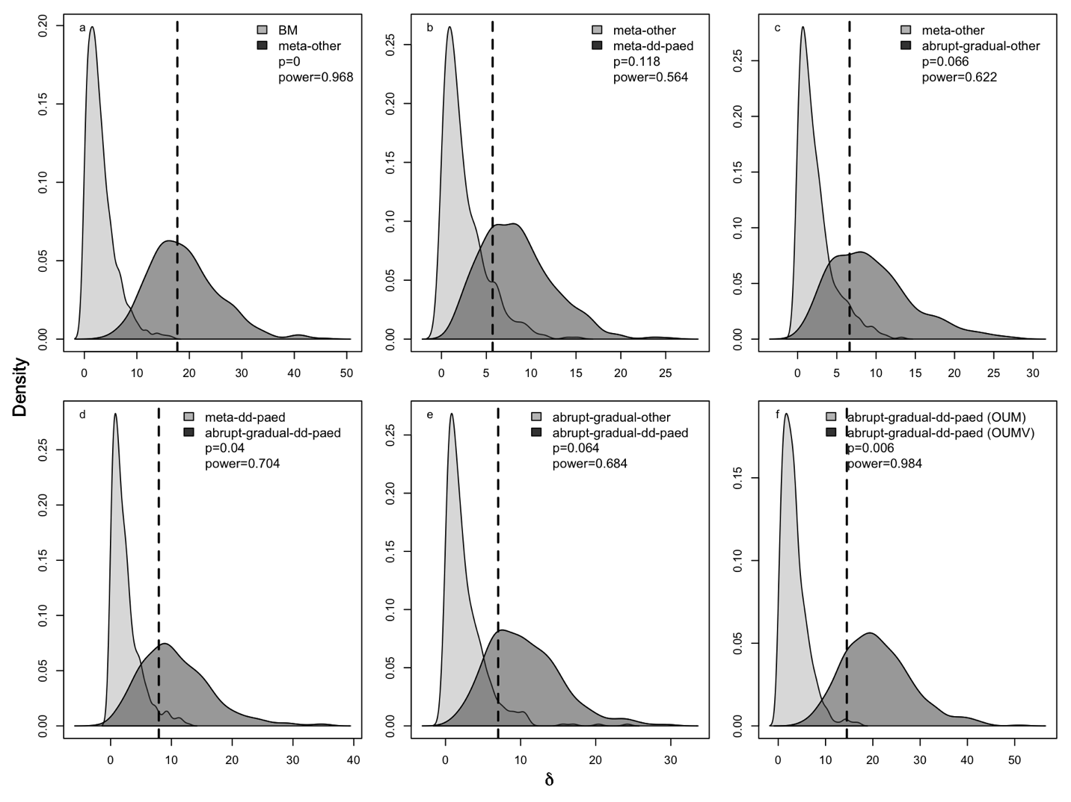Figure 2. The power to discriminate among competing life-history regime models. Each panel evaluates the support for a different, more complex, hypothesis relative to a simpler one (panel keys). Pairwise bootstrap distributions of the likelihood difference (*δ*)calculated by generating 500 datasets under each of two competing life history regime models at their MLE parameter estimates, refitting the two models, and computing *δ*. All comparisons are between multiple equilibria, multiple noise intensity models. Assuming the simpler model is the truth, the probability density of *δ* is in light gray, while the density of the likelihood difference assuming the complex model is in dark gray. The dashed line gives the observed value (*δ*obs)from fitting the actual genome size data. The reported *p-*value is the fraction of the light gray distribution that lies to the right of *δ*obs; the power is the fraction of the dark gray distribution that lies to the right of the 95th percentile of the light gray distribution.

Parameter estimates for the best-fitting model are presented in Table 3. Abrupt metamorphosers have the smallest genome size equilibrium, gradual metamorphosers and direct developing salamanders are intermediate, and paedomorphic salamanders have the largest (Table 3), with multiple categories of stochastic noise intensity. To help visualize what this best-fitting model tells us about genome size evolution, we compared the distribution of observed genome sizes for species in each regime to the expected stationary distribution, given the model estimates of *θ*, *α*, and *σ* for each regime (Fig. 3). In particular, (Ho and Ané 2013) showed that the stationary distribution of an OU process will be a normal distribution with mean *θ* and variance $σ^{2}/(2α)$, providing a useful way to visualize the model fit that captures aspects of all parameters. In the direct-developing regime (which is the most common across the tree), the expected distribution completely overlaps the observed (Fig. 3c). The observed and expected distributions of genome size for gradual metamorphosers are broadly overlapping, although the mean of the expected distribution is slightly higher than the observed (Fig. 3b); similar patterns are observed for paedomorphs (Fig. 3d). In contrast, the expected mean is smaller than almost all abrupt metamorphosing salamander genome sizes (Fig. 3a). Furthermore, this best-fit model predicts that the variance of the trait distribution for each regime is well-predicted by $σ^{2}/(2α)$, which varies by regime because of differences in the noise parameter *σi.* Direct developers have larger stochastic noise in genome size than abrupt metamorphosers or paedomorphs, with gradual metamorphosers intermediate (Table 3, Fig. 3).

Table 3: Maximum likelihood parameter estimates and parametric bootstrap confidence intervals for the best-fitting model (*metaabrupt-metagradual-dd-paed $θi,σi,α$:* separate equilibrium values and noise intensities for lineages in the four life history regimes: dd = direct development, meta*abrupt* = abrupt metamorphosis, meta*gradual* = gradual metamorphosis, paed = paedomorphosis)

|  |  |  |  |  |
| --- | --- | --- | --- | --- |
| **Parameter** | **Abrupt**  **Metamorphosis** | **Gradual**  **Metamorphosis** | **Direct**  **Development** | **Paedomorphosis** |
| Deterministic pull ($α$) | 1.29 | | | |
| 95% CI | (0.40, 3.93) | | | |
|  |  | | | |
| Equilibrium value ($θ_{i}$) | 2.69 | 3.66 | 3.73 | 4.30 |
| 95% CI | (1.07, 3.44) | (3.39, 3.93) | (2.93, 4.63) | (3.87, 5.19) |
|  |  |  |  |  |
| Stochastic  noise intensity ($σ_{i}$) | 0.60 | 0.37 | 0.84 | 0.36 |
| 95% CI | (0.40, 0.90) | (0.21, 0.52) | (0.73, 1.08) | (0.14, 0.63) |

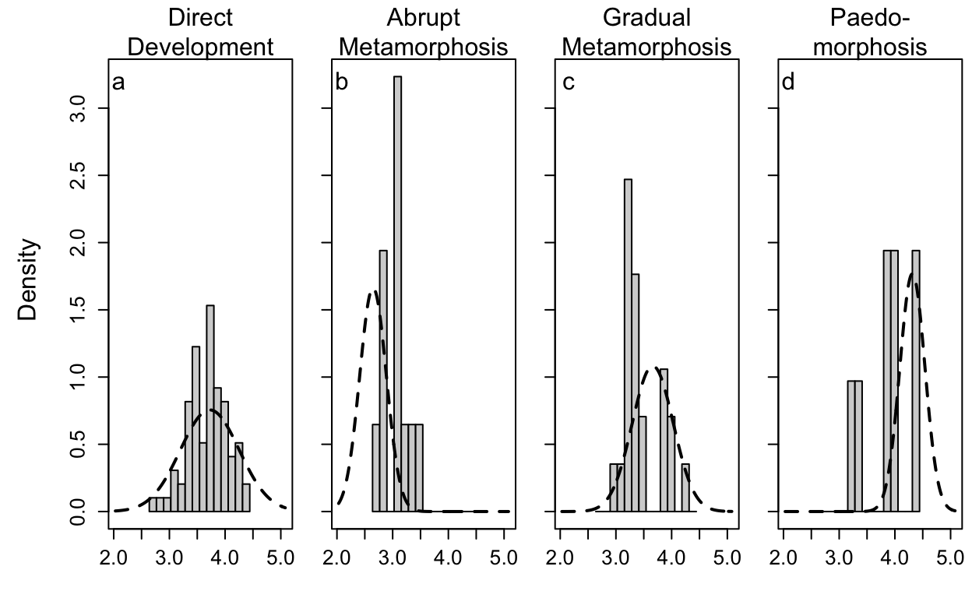

Figure 3. Comparison of the observed distribution of genome sizes for salamanders in each regime (bars) against the stationary distribution predicted by the best-fitting parameter set (dotted lines, Table 3) if the ancestral value is at the deterministic equilibrium. The stationary distribution is normal with mean $θ$ and variance $σ^{2}/(2α)$, where the values of $θ$ and $σ$ vary across regimes. The x-axis is natural-log transformed genome size.

**Discussion**

*Genome Size Evolution Across Different Life Histories*

Genome size differs among metamorphic life history strategies in salamanders. Salamanders that undergo abrupt metamorphosis are experiencing deterministic pull downward, suggesting that abrupt metamorphosis is driving the evolution of smaller genome size (smaller equilibrium value than observed, Figure 3a). Gradual metamorphosers and direct developers reach larger genome sizes than abrupt metamorphosers, but we see little evidence from the best-fit model of any tendency towards either genome size contraction or expansion (Fig. 3b,c). When metamorphic remodeling is largely removed from life history, genomes are expected to be unconstrained and permissive to biased stochastic TE accumulation, consistent with our finding that paedomorphic lineages are experiencing deterministic pull toward genome expansion (Fig. 3d); this also suggests that models of stochastic evolution with a directional trend are an interesting target for future research {Gill, 2016 #845}. Although metamorphosis has been suggested to influence the evolution of genome size, this hypothesis has rarely been demonstrated in a broadly comparative manner, and the relevant features of metamorphosing organisms that exert evolutionary pressure on genome size have been understudied (but see Gregory 2002b; Bonett, et al. 2020). We discuss how three classes of metamorphic vulnerabilities or their interaction may constrain biased TE accumulation and, thus, shape genome size diversity across life history regimes in salamanders: (1) performance and physiological handicap, (2) energetic limitation, and (3) developmental error during metamorphosis. We track the influence of these evolutionary pressures in qualitative form in Table 4.

*Performance and Physiological Handicap*

Performance handicaps are expected based on the classic and widely-cited work on frogs; metamorphosing individuals can neither hop nor swim effectively and are subject to increased predation (Wassersug and Sperry 1977; Arnold and Wassersug 1978). In contrast, metamorphosing salamanders do not suffer locomotor handicaps (Landberg and Azizi 2010). However, some metamorphosing salamanders (*Gyrinophilus porphyriticus*) do suffer a performance handicap in accessing shelter during critical environmental fluctuations; their decreased ability to exploit stream habitat refugia during extremely high or low flow rates increases mortality (Lowe, et al. 2019). In addition, several species of salamanders have decreased critical thermal maxima during metamorphosis (*Ambystoma tigrinum*, *Notophthalmus viridescens*)(Hutchison 1961; Delson and Whitford 1973). Thus, decreased performance and physiological tolerance likely contribute to the increased mortality experienced by salamanders during metamorphosis (Peterson, et al. 1991), selecting for rapid metamorphosis and constraining genomes and cells to smaller sizes. However, these vulnerabilities apply to all metamorphosers, accounting for their smaller genome sizes relative to direct developers and paedomorphs, but not for the differences between abrupt and gradual metamorphosers (Table 4).

*Energetic Limitation*

Vulnerability of metamorphosing individuals to energetic limitation is important despite low overall metabolic rates across salamanders (Gatten, et al. 1992), and furthermore affects the metamorphic strategies differently. The most strongly affected are abrupt, synchronous metamorphosers. There is evidence that these larvae are food-limited in nature; individuals grow more slowly in the field than those fed *ad libitum* in the lab (Beachy 1995). In addition, the timing of the onset of abrupt metamorphosis is fixed, irrespective of food availability, larval growth rate, or body size (Beachy, et al. 2017; Beachy 2018). Thus, these animals lack the flexibility to delay metamorphosis until they reach an optimal size ¾ unlike metamorphosing frogs, arthropods, and salamanders that undergo gradual metamorphosis ¾ resulting in the possibility that transformation is forced at a smaller body size with lower energy reserves, yielding reduced fitness (Wilbur and Collins 1973; Beachy, et al. 2017). Once abrupt metamorphosis begins, feeding ceases, although there are mixed anecdotal reports of transforming organisms feeding or attempting to feed in the lab (Deban and Marks 2002). Metamorphosis itself does not increase energetic demand, as evidenced by gradually metamorphosing salamanders, in which metabolic rate remains unchanged during the transformation (Vladimirova, et al. 2012). However, the transformation is more extensive in abrupt metamorphosing salamanders, and frogs experience elevated metabolic rates during their extensive metamorphosis (Orlofske and Hopkins 2009; Wright, et al. 2011). Thus, abrupt metamorphosers are at risk of initiating a costly sequence of developmental events with sub-optimal energy reserves and impaired capacity to feed (Deban and Marks 2002; Vladimirova, et al. 2012; Beachy, et al. 2017). In contrast, gradual metamorphosers are not vulnerable energetically, as they can feed throughout metamorphosis as well as delay its onset. In direct-developing lineages, some or all of the developmental steps of metamorphic remodeling occur inside the egg at the end of embryogenesis, in sequences that deviate from those of metamorphosers to varying degrees (Alberch 1989; Wake and Hanken 1996; Marks 2000; Rose 2003; Kerney, et al. 2012). The energy to fuel metamorphic repatterning comes from yolk stores which, although relatively large in direct developers, are still finite (Wake and Hanken 1996; Gregory 2002b), suggesting the potential for some energetic vulnerability. However, direct developers do not have smaller genome size equilibria than gradual metamorphosers, suggesting that any constraint imposed by energetic limitation in direct developers is weak or absent. Abrupt metamorphosers have the smallest genome size equilibrium, consistent with energetic limitation exerting the strongest selection for rapid metamorphosis and therefore the strongest constraint on genome size (Table 4).

*Developmental Error*

Abrupt and gradual metamorphosers differ in both metamorphic synchronicity and extent of transformation, leading to differential vulnerability to developmental errors. Abrupt metamorphosis entails the synchronous execution of a large number of developmental events, e.g.: the chondrification and ossification of the nasal capsule, dermal bones of the skull, upper jaw, and palate; remodeling of the skin; and gill resorption. The internal organs are likely also abruptly remodeled because they are under the same hormonal control (Rose 1996; Rose 1999, 2003). Some systems undergo a more radical transformation altogether; larval elements undergo cell death, and adult structures form *de novo* rather than being remodeled from larval elements. For example, the hyobranchial apparatus (i.e. tongue skeleton) in abrupt metamorphosers transforms this way, enabling the formation of projectile and, in some species, ballistic tongues (Alberch, et al. 1985; Alberch and Gale 1986). These transformations require precise spatial coordination of the cell-autonomous programs and cell-cell interactions that drive cell death, growth, and differentiation, often in very close proximity (Alberch, et al. 1985; Schreiber, et al. 2009; Ishizuya‐Oka 2011). Temporal organization is also critical; induction events (e.g. epithelial-mesenchymal interactions) that occur out of sequence result in developmental anomalies (Hanken and Hall 1993). The evolution of abrupt metamorphosis increased the complexity of spatiotemporal coordination of cell-cell interactions relative to gradual metamorphosers. We found that abrupt metamorphosers have distinctly smaller genome sizes, consistent with more intense vulnerability to developmental error (Table 4). This result is broadly consistent with a similar pattern in insects, where holometabolous lineages (i.e. those that undergo a complete metamorphosis) have smaller genome sizes than hemimetabolous lineages (i.e. those that undergo incomplete metamorphosis), which has been interpreted as evidence for stronger constraint on genome size with greater developmental complexity (Gregory 2002b; Alfsnes, et al. 2017). We note that the pattern in insects is also consistent with the other metamorphic vulnerabilities (i.e. predation, energetic limitation) acting to limit duration of metamorphosis to different degrees in holo- versus hemimetabolous lineages.

Direct developers undergo repatterning at a developmental stage involving much less tissue and fewer cells, therefore requiring less spatiotemporal cell-cell coordination. Although this simplifies the overall developmental process, it also introduces the potential for error because stochastic noise in developmental processes (e.g. cell migration) can have larger phenotypic effects when each cell represents a larger proportion of an incipient structure. One of the best illustrations of the mechanistic consequences of low cell numbers on development is the salamander genus *Thorius,* characterized by large genomes, small bodies, and thus low cell numbers. Skeletal and cartilaginous elements in the limbs and skull form embryonically from precartilage condensations, which are tight aggregates of mesenchymal cells. Up to 70% of *Thorius* individuals show left-right asymmetry in the arrangement of carpal or tarsal elements in the limbs and/or anterior elements in the skull, and similar variation exists among individuals (Hanken 1982; Hanken 1984). This degree of variability demonstrates that the outcome of precartilage condensation is subject to stochastic noise in the cellular processes involved in cell aggregation (i.e. cell movement, cell-cell adhesion, cell-extracellular matrix interaction) (Chatterjee, et al. 2020; Glimm, et al. 2020).

More generally, vulnerability to stochastic noise is expected to impose stronger constraints on genome expansion when developmental sequences are more complex. Limited data from direct developers are consistent with this hypothesis. In *Bolitoglossa subpalmata*, the formation of larval hyobranchial apparatus components has been lost from ontogeny, leading to a simpler developmental sequence in which adult structures are formed without larval precursors (Alberch 1989; Wake and Hanken 1996). Other taxa (e.g. *Desmognathus aeneus* and *Plethodon cinereus*) retain a more complex developmental sequence with more of the larval and metamorphorphic stages of hyobranchial development (Wake and Hanken 1996; Marks 2000; Kerney, et al. 2012); as predicted, they have smaller genome sizes (~15 Gb estimated for *D. aeneus* based on measurements of conspecifics, ~29 Gb for *P. cinereus*, ~65 Gb for *B. subpalmata*) {Gregory, 2023 #2;Itgen, 2022 #759}. Much more empirical data collection is required for a full test of this hypothesis, including from members of the genus *Plethodon*; the 8 species in the western clade (~45 million years divergent from *P. cinereus*) have a mean genome size of ~50 Gb, and one (*P. idahoensis*) reaches 67 Gb {Kumar, 2017 #784}{Itgen, 2022 #759}{Gregory, 2023 #2}.

Both direct developers and abrupt metamorphosers experience risks for developmental error, but direct developers have a larger genome size equilibrium (Table 3), consistent with weaker developmental error constraints (Table 4). In addition, direct developers have the largest expected variance in genome size, which presents a new hypothesis — that diverse developmental sequences within this life history regime also differ in vulnerability to error and, thus, impose different constraints on genome expansion that our models did not capture. However, all being equal, the larger number of lineages within the direct-developing regime would also result in larger variance. Thus, this hypothesis warrants further investigation.

*Paedomorphosis and the Loss of Metamorphic Constraints*

Despite their freedom from metamorphosis-induced constraints, paedomorphs may still face other evolutionary pressures that prevent their genomes from reaching ever-larger sizes. The decreased surface-area-to-volume ratio that accompanies increased cell size imposes a functional limit that salamanders may well have reached (Chan and Marshall 2010), as their cells are among the largest in animals (Horner and Macgregor 1983). In addition, the rate at which adult salamanders regenerate limbs and organs ⎯ and in some cases, their ability to do so at all ⎯ declines dramatically in paedomorphs with the largest genomes, suggesting another fitness consequence of extreme genome expansion (Scadding 1977; Sessions and Wake 2021).

In the past, huge cells have been proposed as adaptive because salamanders and lungfishes have the lowest metabolic rates and the largest genomes/cells among vertebrates. This correlation led to the “frugal metabolic strategy” hypothesis (Szarski 1983; Olmo, et al. 1989), under which paedomorphs would show the greatest degree of adaptation for this trait. However, more recent studies failed to find a clear relationship between genome or cell size and metabolic rate, both within salamanders (Licht and Lowcock 1991) and more generally (Uyeda, et al. 2017; Gardner, et al. 2020). Rather than adaptation towards larger genome size, our results support the idea that loss of metamorphosis has released constraints against biased stochastic genome expansion in paedomorphs.

| Table 4. Mutation pressure and metamorphic vulnerabilities shaping genome size in different life history regimes | | | | | |
| --- | --- | --- | --- | --- | --- |
| Evolutionary Pressure | Effect on Genome Size | Abrupt  Metamorphosers | Gradual  Metamorphosers | Direct  Developers | Paedomorphs |
| TE  accumulation bias | ↑ | ✓a | ✓ | ✓ | ✓ |
| Performance or Physiological Handicap | ↓ | ✓ | ✓ |  |  |
| Energetic  Limitation | ↓ | ✓✓ |  | ✓ |  |
| Developmental Error | ↓ | ✓✓ | ✓ | ✓ |  |

aA single checkmark vs. two checkmarks indicates a difference in the intensity of a metamorphic vulnerability across life history regimes.

*Summary of* *Metamorphic Vulnerabilities and Genome Size Evolution*

Abrupt metamorphosers are challenged with every metamorphic vulnerability: decreased performance and physiological tolerance, energetic limitation, and developmental error, providing the explanation for their smallest genome sizes (Table 4). In contrast, paedomorphs are free from all of these vulnerabilities and have the largest genome sizes (Table 4). Direct developers have a similar genome size equilibrium to gradual metamorphosers, but with larger variation (Table 3), which we hypothesize reflects diversification of direct developmental pathways. Gradual metamorphosers avoid developmental error at the cost of decreased performance and physiological tolerance whereas direct developers avoid performance handicap at the cost of some susceptibility to stochastic noise in development. More generally, these results illustrate how genome size may be shaped by different constraints across taxa that are important to assess in order to understand the major drivers of genome size evolution across the tree of life (Knight, et al. 2005; Carta and Peruzzi 2016; Alfsnes, et al. 2017; Roddy, et al. 2019).

*OU Models Evaluate the Balance of Evolutionary Forces*

While we have no model tailored to biased evolutionary increase opposed by constraining forces, the OU class of models (of which BM is a subset) is a powerful tool that can differentiate among biologically-motivated, nuanced hypotheses. While it is widely recognized that OU models provide deterministic components that allow modeling evolutionary shifts in the means of phenotypes, it is less appreciated that they also provide a way to model the information content in the variances. The difference between a purely stochastic (BM) model and one that has any degree of deterministic pull (OU) is that the variance of a BM model will grow unbounded over time, whereas the variance in a model with deterministic pull will not (Hansen and Martins 1996; Butler and King 2004). Along these lines, our finding that allowing both stochastic noise intensities and equilibria to vary across regimes produces a model with substantially better fit than either set of parameters alone is very biologically informative. While we have three broad categories of genome size equilibria, with abrupt metamorphosers distinctly smaller and paedomorphs larger (Table 3), the metamorphic categories also differ substantially in stochastic noise intensity. The smaller equilibrium value and noise intensity of abrupt metamorphosers suggests that this regime is experiencing strong deterministic pull downward, even in comparison to gradual metamorphosers (Table 3, Fig. 3a vs. b). Direct developers have the highest estimated noise intensity, suggesting that the evolution of diverse developmental sequences resulted in a range of vulnerabilities to error and, thus, variable constraints on genome expansion that our models do not yet capture (compare confidence intervals in Table 3, Fig. 3c vs. d). Thus, both the mean and variance of the evolutionary process shed light on the balance of forces acting on genome size across life histories.

In general, OU models are conceptualized as models for stabilizing selection, with the $θ$ parameters interpreted as trait optima towards which individual species are evolving. However, this interpretation does not fit well with the biology of genome size. As the variability in genome size is strongly determined by the quantity of nearly-neutral noncoding DNA, the notion of an "optimal" genome size has little meaning (but see Cavalier-Smith 2005). More realistically, there is a range of permissible values within which species can vary.

We propose that the strong support for OU models in our analysis reflects a balance between the biased stochastic forces driving genome size upward and evolutionary constraints acting to limit genome size. That is, rather than interpreting Fig. 3b as evidence that gradual metamorphosing salamanders have genomes near their "optimal" sizes, we interpret it as showing that these salamanders have settled on a genome size distribution that is balanced between stochastic TE dynamics tending to bias genome size upward and selection on correlated metamorphic traits imposing evolutionary constraint against further size increase. Paedomorphs have the largest genome size equilibria of all, and our model indicates that they are evolving with a deterministic pull toward even larger size. There is no compelling adaptive interpretation for this genome size "optimum" larger than all other vertebrates, although some have tried (see above); rather, we interpret it as a balance between upwardly-biased TE accumulation and functional constraints not considered here (e.g. an upper limit on cell size). This is a novel way of interpreting the results of comparative analysis, but one that is supported by our understanding of the biology of the system. Our results thus suggest that OU models can potentially be used to detect other evolutionary processes beyond adaptation towards an optimum, which broadens their applicability to the study of traits that do not evolve in response to strong selection by a single factor.

Literature Cited

Alberch P. 1989. Development and the evolution of amphibian metamorphosis. In: Splechtna/Hilgers, editor. Trends in Vertebrate Morphology. Stuttgart: Gustav Fischer Verlag. p. 163-173.

Alberch P, Gale EA. 1986. Pathways of cytodifferentiation during the metamorphosis of the epibranchial cartilage in the salamander *Eurycea bislineata*. Dev Biol 117:233-244.

Alberch P, Lewbart G, Gale EA. 1985. The fate of larval chondrocytes during the metamorphosis of the epibranchial in the salamander, *Eurycea bislineata*. J Embryol Exp Morph 88:71-83.

Alfsnes K, Leinaas HP, Hessen DO. 2017. Genome size in arthropods; different roles of phylogeny, habitat and life history in insects and crustaceans. Ecol Evol 7:5939-5947.

AmphibiaWeb: Information on amphibian biology and conservation [Internet]. 2022. Berkeley, California. Available from <http://amphibiaweb.org/>.

Arkhipova IR. 2018. Neutral theory, transposable elements, and eukaryotic genome evolution. Mol Biol Evol 35:1332-1337.

Arnold SJ. 1992. Constraints on phenotypic evolution. Am Nat 140:S85-S107.

Arnold SJ, Wassersug RJ. 1978. Differential predation on metamorphic anurans by garter snakes (*Thamnophis*): Social behavior as a possible defense. Ecology 59:1014-1022.

Bachmann K. 1970. Feulgen slope determinations of urodele nuclear DNA amounts. Histochemie 22:289-293.

Beachy CK. 2018. Effects of growth rate and temperature on metamorphosis in *Eurycea wilderae* (Caudata, Plethodontidae, Hemidactyliinae, Spelerpini; blue ridge two-lined salamander). Southeast Nat 17:423-432.

Beachy CK. 1995. Effects of larval growth history on metamorphosis in a stream-dwelling salamander (*Desmognathus ochrophaeus*). J Herp:375-382.

Beachy CK, Ryan TJ, Bonett RM. 2017. How metamorphosis is different in plethodontids: Larval life history perspectives on life-cycle evolution. Herpetologica 73:252-258.

Beaulieu JM, Jhwueng D-C, Boettiger C, O’Meara BC. 2012. Modeling stabilizing selection: Expanding the Ornstein–Uhlenbeck model of adaptive evolution. Evolution 66:2369-2383.

Boettiger C, Coop G, Ralph P. 2012. Is your phylogeny informative? Measuring the power of comparative methods. Evolution 66:2240-2251.

Bonett RM, Hess AJ, Ledbetter NM. 2020. Facultative transitions have trouble committing, but stable life cycles predict salamander genome size evolution. Evol Biol 47:111-122.

Bonett RM, Steffen MA, Robison GA. 2014. Heterochrony repolarized: a phylogenetic analysis of developmental timing in plethodontid salamanders. Evo Devo 5:27.

Butler Marguerite A, King Aaron A. 2004. Phylogenetic comparative analysis: A modeling approach for adaptive evolution. Am Nat 164:683-695.

Carta A, Peruzzi L. 2016. Testing the large genome constraint hypothesis: plant traits, habitat and climate seasonality in Liliaceae. New Phytol. 210:709-716.

Cavalier-Smith T. 2005. Economy, speed and size matter: evolutionary forces driving nuclear genome miniaturization and expansion. Ann Bot 95:147-175.

Chan Y-HM, Marshall WF. 2010. Scaling properties of cell and organelle size. Organogenesis 6:88-96.

Chatterjee P, Glimm T, Kaźmierczak B. 2020. Mathematical modeling of chondrogenic pattern formation during limb development: Recent advances in continuous models. Math Biosci 322:108319.

Chippindale PT, Bonett RM, Baldwin AS, Wiens JJ. 2004. Phylogenetic evidence for a major reversal of life-history evolution in plethodontid salamanders. Evolution 58:2809-2822.

Cressler CE, Butler MA, King AA. 2015. Detecting adaptive evolution in phylogenetic comparative analysis using the Ornstein–Uhlenbeck model. Syst Biol 64:953-968.

Deban SM, Marks SB. 2002. Metamorphosis and evolution of feeding behaviour in salamanders of the family Plethodontidae. Zool J Linn Soc 134:375-400.

Decena-Segarra LP, Bizjak-Mali L, Kladnik A, Sessions SK, Rovito SM. 2020. Miniaturization, genome size, and biological size in a diverse clade of salamanders. Am Nat 196:634-648.

Delson J, Whitford WG. 1973. Critical thermal maxima in several life history stages in desert and montane populations of *Ambystoma tigrinum*. Herpetologica:352-355.

Enriquez-Urzelai U, Sacco M, Palacio AS, Pintanel P, Tejedo M, Nicieza AG. 2019. Ontogenetic reduction in thermal tolerance is not alleviated by earlier developmental acclimation in *Rana temporaria*. Oecologia 189:385-394.

Felsenstein J. 1985. Phylogenies and the comparative method. Am Nat 125:1-15.

Frahry MB, Sun C, Chong R, Mueller RL. 2015. Low levels of LTR retrotransposon deletion by ectopic recombination in the gigantic genomes of salamanders. J Mol Evol 80:120-129.

Gardner JD, Laurin M, Organ CL. 2020. The relationship between genome size and metabolic rate in extant vertebrates. Philos Trans R Soc B 375:20190146.

Gatten REJ, Miller K, Full RJ. 1992. Energetics at rest and during locomotion. In: Feder ME, editor. Environmental Physiology of the Amphibians. Chicago: University of Chicago Press. p. 314-377.

Glimm T, Bhat R, Newman SA. 2020. Multiscale modeling of vertebrate limb development. Wiley Interdiscip Rev: Syst Biol Med 12:e1485.

Gould SJ. 1977. Ontogeny and Phylogeny. Cambridge, MA: Harvard University Press.

Gregory TR. 2002a. A bird's eye view of the c-value enigma: genome size, cell size, and metabolic rate in the class Aves. Evolution 56:121-130.

Gregory TR. 2001. Coincidence, coevolution, or causation? DNA content, cell size, and the C-value enigma. Biol Rev Camb Philos Soc 76:65-101.

Gregory TR. 2005. The Evolution of the Genome. San Diego, CA: Academic Press.

Gregory TR. 2002b. Genome size and developmental complexity. Genetica 115:131-146.

Gregory, T. R. Animal Genome Size Database (<http://www.genomesize.com>) [Internet]. 2022.

Gregory TR. 2004. Macroevolution, hierarchy theory, and the C-value enigma. Paleobiology 30:179-202.

Hanken J. 1982. Appendicular skeletal morphology in minute salamanders, genus *Thorius* (Amphibia: Plethodontidae): growth regulation, adult size determination, and natural variation. J Morph 174:57-77.

Hanken J. 1984. Miniaturization and its effects on cranial morphology in plethodontid salamanders, genus Thorius (Amphibia: Plethodontidae). I. Osteological variation. Biol J Linn Soc 23:55-75.

Hanken J, Hall BK. 1993. Mechanisms of skull diversity and evolution. In: Hanken J, Hall BK, editors. The Skull, Volume 3: Functional and Evolutionary Mechanisms. London: University of Chicago Press.

Hansen TF. 1997. Stabilizing selection and the comparative analysis of adaptation. Evolution 51:1341-1351.

Hansen TF, Martins EP. 1996. Translating between microevolutionary process and macroevolutionary patterns: The correlation structure of interspecific data. Evolution 50:1404-1417.

Hessen DO, Daufresne M, Leinaas HP. 2013. Temperature-size relations from the cellular-genomic perspective. Biol Rev 88:476-489.

Ho LST, Ané C. 2013. Asymptotic theory with hierarchical autocorrelation: Ornstein-Uhlenbeck tree models. Ann Statist 41:957-981.

Ho LST, Ané C. 2014. Intrinsic inference difficulties for trait evolution with Ornstein-Uhlenbeck models. Methods Ecol Evol 5:1133-1146.

Horner HA, Macgregor HC. 1983. C value and cell volume: their significance in the evolution and development of amphibians. J Cell Sci 63:135.

Hutchison VH. 1961. Critical thermal maxima in salamanders. Physiol Zool 34:92-125.

Ishizuya‐Oka A. 2011. Amphibian organ remodeling during metamorphosis: Insight into thyroid hormone‐induced apoptosis. Develop Growth Diff 53:202-212.

Jeffery NW, Yampolsky L, Gregory TR. 2016. Nuclear DNA content correlates with depth, body size, and diversification rate in amphipod crustaceans from ancient Lake Baikal, Russia. Genome 60:303-309.

Jetz W, Pyron RA. 2018. The interplay of past diversification and evolutionary isolation with present imperilment across the amphibian tree of life. Nature Ecol Evol 2:850-858.

Jockusch EL. 1997. An evolutionary correlate of genome size change in plethodontid salamanders. Proc Royal Soc B: Biol Sci 264:597.

Kapusta A, Suh A, Feschotte C. 2017. Dynamics of genome size evolution in birds and mammals. Proc Nat Acad Sci 114:E1460-E1469.

Keinath MC, Timoshevskiy VA, Timoshevskaya NY, Tsonis PA, Voss SR, Smith JJ. 2015. Initial characterization of the large genome of the salamander *Ambystoma mexicanum* using shotgun and laser capture chromosome sequencing. Sci Rep 5:16413.

Kerney RR, Blackburn DC, Müller H, Hanken J. 2012. Do larval traits re-evolve? Evidence from the embryogenesis of a direct-developing salamander, *Plethodon cinereus*. Evolution 66:252-262.

Knight CA, Molinari NA, Petrov DA. 2005. The large genome constraint hypothesis: evolution, ecology and phenotype. Ann Bot 95:177-190.

Landberg T, Azizi E. 2010. Ontogeny of escape swimming performance in the spotted salamander. Funct Ecol 24:576-587.

Larson A. 1984. Neontological inferences of evolutionary pattern and process in the salamander family Plethodontidae. Evol Biol 17:119-217.

Lertzman-Lepofsky G, Mooers AØ, Greenberg DA. 2019. Ecological constraints associated with genome size across salamander lineages. Proc Roy Soc B 286:20191780.

Licht LE, Lowcock LA. 1991. Genome size and metabolic rate in salamanders. Comp Biochem Physiol B: Comp Biochem 100:83-92.

Liedtke HC, Gower DJ, Wilkinson M, Gomez-Mestre I. 2018. Macroevolutionary shift in the size of amphibian genomes and the role of life history and climate. Nat Ecol Evol 2:1792-1799.

Lowe WH, Martin TE, Skelly DK, Woods HA. 2021. Metamorphosis in an era of increasing climate variability. Trends Ecol Evol.

Lowe WH, Swartz LK, Addis BR, Likens GE. 2019. Hydrologic variability contributes to reduced survival through metamorphosis in a stream salamander. Proc Natl Acad Sci USA 116:19563.

Madison-Villar MJ, Sun C, Lau N, Settles M, Mueller RL. 2016. Small RNAs from a big genome: the piRNA pathway and transposable elements in the salamander species *Desmognathus fuscus*. J Mol Evol 83:126-136.

Marks SB. 2000. Skull development in two plethodontid salamanders (genus *Desmognathus*) with different life histories. In. The Biology Of Plethodontid Salamanders: Springer. p. 261-276.

Michael TP. 2014. Plant genome size variation: bloating and purging DNA. Brief Funct Genom 13:308-317.

Mueller RL, Macey JR, Jaekel M, Wake DB, Boore JL. 2004. Morphological homoplasy, life history evolution, and historical biogeography of plethodontid salamanders inferred from complete mitochondrial genomes. Proc Natl Acad Sci USA 101:13820-13825.

Nowoshilow S, Schloissnig S, Fei J-F, Dahl A, Pang AWC, Pippel M, Winkler S, Hastie AR, Young G, Roscito JG, et al. 2018. The axolotl genome and the evolution of key tissue formation regulators. Nature 554:50-55.

O'Meara BC, Ané C, Sanderson MJ, Wainwright PC. 2006. Testing for different rates of continuous trait evolution using likelihood. Evolution 60:922-933.

Olmo E, Capriglione T, Odierna G. 1989. Genome size evolution in vertebrates: Trends and constraints. Comp Biochem Phys B: Comp Biochem 92:447-453.

Orlofske SA, Hopkins WA. 2009. Energetics of metamorphic climax in the pickerel frog (*Lithobates palustris*). Comp Biochem Phys A: Molec Integ Phys 154:191-196.

Pandit MK, White SM, Pocock MJO. 2014. The contrasting effects of genome size, chromosome number and ploidy level on plant invasiveness: a global analysis. New Phytol 203:697-703.

Peterson CL, Wilkinson RF, Moll D, Holder T. 1991. Premetamorphic survival of *Ambystoma annulatum*. Herpetologica:96-100.

R Core Team. 2020. R: A language and environment for statistical computing. Vienna, Austria: R Foundation for Statistical Computing.

Revell LJ. 2012. phytools: an R package for phylogenetic comparative biology (and other things). Methods Ecol Evol 3:217-223.

Roddy AB, Théroux-Rancourt G, Abbo T, Benedetti JW, Brodersen CR, Castro M, Castro S, Gilbride AB, Jensen B, Jiang G-F, et al. 2019. The scaling of genome size and cell size limits maximum rates of photosynthesis with implications for ecological strategies. Int J Plant Sci 181:75-87.

Rose CS. 2003. The developmental morphology of salamander skulls. In: Heatwole H, editor. Amphibian Biology: Osteology. Chipping Norton: Surrey Beatty & Sons. p. 1684-1781.

Rose CS. 1996. An endocrine-based model for developmental and morphogenetic diversification in metamorphic and paedomorphic urodeles. J Zool 239:253-284.

Rose CS. 1999. Hormonal control in larval development and evolution—amphibians. In. The Origin And Evolution Of Larval Forms: Elsevier. p. 167-VI.

Rose CS. 2014. The importance of cartilage to amphibian development and evolution. Int J Dev Biol 58:917-927.

Savell KRR, Auerbach BM, Roseman CC. 2016. Constraint, natural selection, and the evolution of human body form. Proc Nat Acad Sci 113:9492-9497.

Scadding SR. 1977. Phylogenic distribution of limb regeneration capacity in adult Amphibia. J Exp Zool 202:57-67.

Schreiber AM, Mukhi S, Brown DD. 2009. Cell–cell interactions during remodeling of the intestine at metamorphosis in *Xenopus laevis*. Dev Biol 331:89-98.

Semlitsch RD, Scott DE, Pechmann JH. 1988. Time and size at metamorphosis related to adult fitness in *Ambystoma talpoideum*. Ecology 69:184-192.

Sessions SK. 2008. Evolutionary cytogenetics in salamanders. Chromosome Res 16:183-201.

Sessions SK, Wake DB. 2021. Forever young: Linking regeneration and genome size in salamanders. Dev Dyn 250:768-778.

Shao F, Han M, Peng Z. 2019. Evolution and diversity of transposable elements in fish genomes. Sci Rep 9:15399.

Smith JDL, Bickham JW, Gregory TR. 2013. Patterns of genome size diversity in bats (order Chiroptera). Genome 56:457-472.

Sotero-Caio CG, Platt RN, II, Suh A, Ray DA. 2017. Evolution and diversity of transposable elements in vertebrate genomes. Genome Biol Evol 9:161-177.

Sun C, Mueller RL. 2014. Hellbender genome sequences shed light on genome expansion at the base of crown salamanders. Genome Biol Evol 6:1818-1829.

Sun C, Shepard DB, Chong RA, Arriaza JL, Hall K, Castoe TA, Feschotte C, Pollock DD, Mueller RL. 2012. LTR retrotransposons contribute to genomic gigantism in plethodontid salamanders. Genome Biol Evol 4:168-183.

Szarski H. 1983. Cell size and the concept of wasteful and frugal evolutionary strategies. J Theor Biol 105:201-209.

Szarski H. 1957. The origin of larva and metamorphosis in amphibia. Am Nat 91:283-301.

Uyeda JC, Pennell MW, Miller ET, Maia R, McClain CR. 2017. The evolution of energetic scaling across the vertebrate tree of life. Am Nat 190:185-199.

Vinogradov AE. 2004. Genome size and extinction risk in vertebrates. Proc Roy Soc B 271:1701-1705.

Vladimirova IG, Kleimenov SY, Alekseeva TA. 2012. Dynamics of body mass and oxygen consumption in the ontogeny of the Spanish ribbed newt (*Pleurodeles waltl*): 2. Larval stage. Biol Bull 39:10-14.

Vu GTH, Cao HX, Reiss B, Schubert I. 2017. Deletion-bias in DNA double-strand break repair differentially contributes to plant genome shrinkage. New Phytol 214:1712-1721.

Wake D, Hanken J. 1996. Direct development in the lungless salamanders: what are the consequences for developmental biology, evolution and phylogenesis? Int J Dev Biol 40:859-869.

Wake DB, Marks SB. 1993. Development and evolution of plethodontid salamanders: a review of prior studies and a prospectus for future research. Herpetologica 49:194-203.

Wassersug RJ, Sperry DG. 1977. The relationships of locomotion to differential predation on *Pseudacris triseriata* (anura: Hylidae). Ecology 58:830-839.

Wiens JJ, Bonett RM, Chippindale PT. 2005. Ontogeny discombobulates phylogeny: paedomorphosis and higher-level salamander relationships. Syst Biol 54:91-110.

Wilbur HM, Collins JP. 1973. Ecological aspects of amphibian metamorphosis: nonnormal distributions of competitive ability reflect selection for facultative metamorphosis. Science 182:1305-1314.

Wright ML, Richardson SE, Bigos JM. 2011. The fat body of bullfrog (*Lithobates catesbeianus*) tadpoles during metamorphosis: Changes in mass, histology, and melatonin content and effect of food deprivation. Comp Biochem Phys A 160:498-503.

Wright NA, Gregory TR, Witt CC. 2014. Metabolic ‘engines’ of flight drive genome size reduction in birds. Proc Roy Soc B: Biol Sci 281:20132780.