We fit the following models using ouch: BM, OU1, meta, mpd, mpdMpleth. We used OUwie to fit multiple σ models where each of the selective regimes specified by meta, mpd, or mpdMpleth has a unique σ value. The table below gives AIC and AIC_{c} values for each of these models.

Model | AIC | AIC_{c} | DF
mpdMpleth | 10.19 | 11.03 | 6
BM | 12.62 | 12.73 | 2
mpd | 12.89 | 13.49 | 5
meta | 13.94 | 14.34 | 4
meta.BMS | 14.50 | 14.74 | 3
mpd.BMS | 16.49 | 16.88 | 4
mpdMpleth.BMS | 17.10 | 17.70 | 5
OU1 | 20.09 | 20.33 | 3

We performed model selection bootstraps by simulating 1000 datasets using the best-fitting model at the MLE parameters and re-fitting all of the competing models. The fraction of the simulated datasets that supported each model (the given model had the lowest AIC_{c}) are given in the table below.

Model | Bootstrap %
mpdMpleth | 74%
mpd | 11.5%
BM | 7.5%
meta | 5%
meta.BMS | 2%
OU1 | 0%
mpdMpleth.BMS | 0%
mpd.BMS | 0%

However, AIC_{c} differences can favor more complicated models, even when the simpler model is correct (Boettiger et al. 2012). To address this problem, we follow Boettiger et al. 2012 by using “phylogenetic Monte Carlo” to calculate distributions of the test statistic
δ = –2 (log L₀ – log L₁)
where L₀ is the likelihood of the simpler model (BM) and L₁ is the likelihood of the more complex model (mpdMpleth). The observed value of δ in our study is 10.43.

To determine whether this value is significant, we would like to compute an approximate p-value, that is, to determine the probability of observing a value of δ this extreme if the simpler model were true. To approximate this probability, we simulated 1000 datasets using the BM model at its MLE parameter estimates; we then fit the BM and mpdMpleth models to each of these simulated datasets and computed the values of δ. This produces a null distribution of δ under the BM model. Comparing the observed value of δ to this null distribution, we calculate an approximate p-value of 0.042.

To determine whether the power of this test, we would like to compute the probability of rejecting the simpler model when the data are generated by the more complex model. To approximate this probability, we simulated 1000 datasets using the mpdMpleth model at its MLE parameter estimates; we then fit the BM and mpdMpleth models to each of these simulated datasets and computed the values of δ. The fraction of these δ values that are greater than the 95% quantile of the null distribution calculated above gives an estimate of power. For our data, the approximate power is 0.86. We can visualize both significance and power plotting the distributions of δ under each model and the observed δ value (Fig. 1).

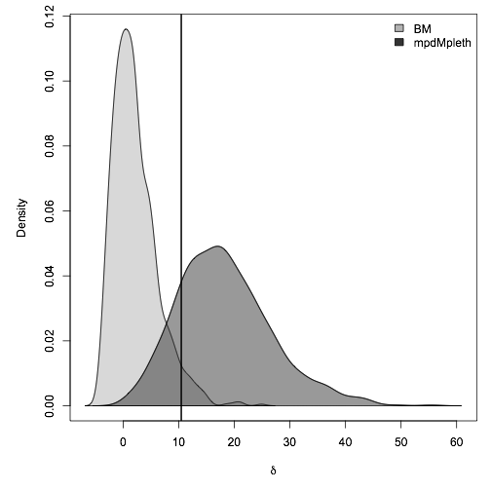
Fig. 1. The light gray shaded region shows the distribution of δ values calculated by generating 1000 datasets under the BM model at its MLE parameter estimates, fitting the BM and mpdMpleth models, and computing δ; the dark gray shaded region shows the distribution of AIC_{c} differences calculated by generating 1000 datasets under the mpdMpleth model at its MLE parameter estimates, fitting the BM and mpdMpleth models, and computing δ. The black line shows the observed δ. The observed δ value is much more likely under the mpdMpleth model.

