This first figure shows the epidemiological dynamics over time for different initial Th1:Th2 biases. Each panel shows the results for 50 stochastic simulations. Bias is generated by drawing the number of initial Th2 cells upon infection from a uniform distribution with a minimum varying between 200 and 750, and a maximum fixed at 800. The total number of immune cells are fixed at 1200. So if the initial Th2-ness was 250, then initial Th1-ness would be 950. Virulence is evolving over time in all simulations. Note the that duration of the simulations does vary somewhat across panels, which I will clean up before publication.

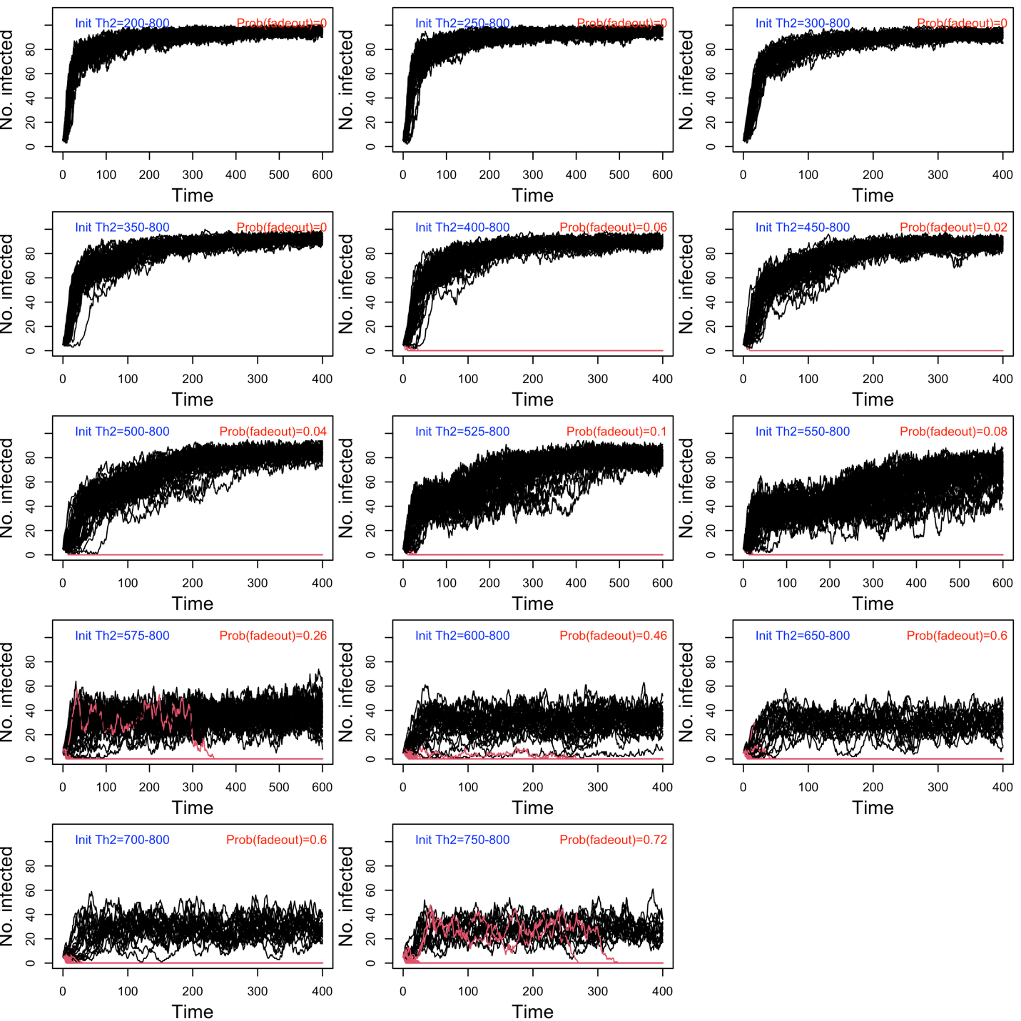

The second figure shows the evolutionary dynamics of virulence across Th1:Th2 biases. Red lines show the evolutionary dynamics for simulations that eventually went extinct.

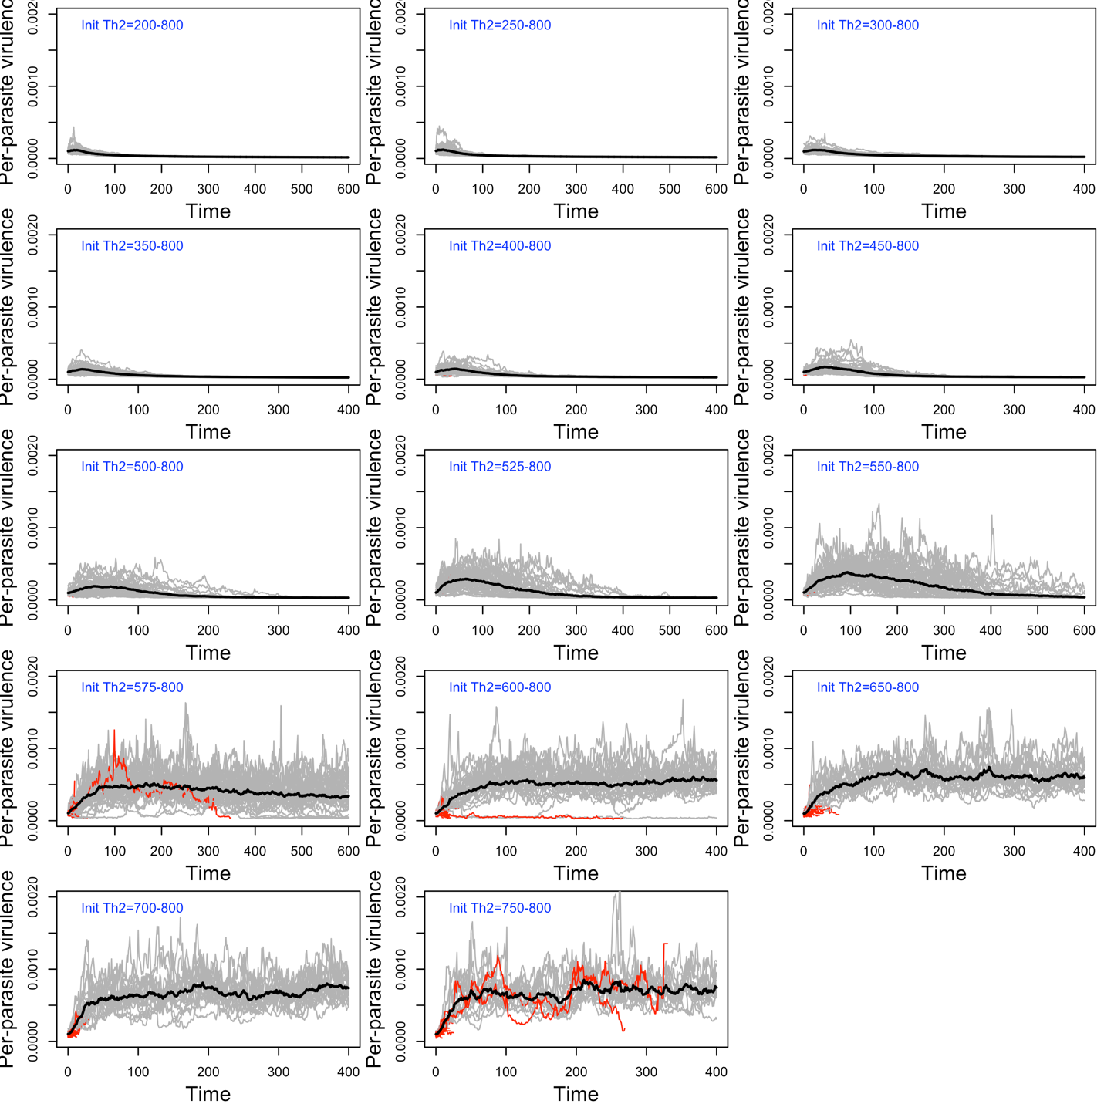

The third figure shows the average burden at each timestep across panels. Note that this is the average across infections of varying age, so it is not the same as the maximum burden for each individual infection.

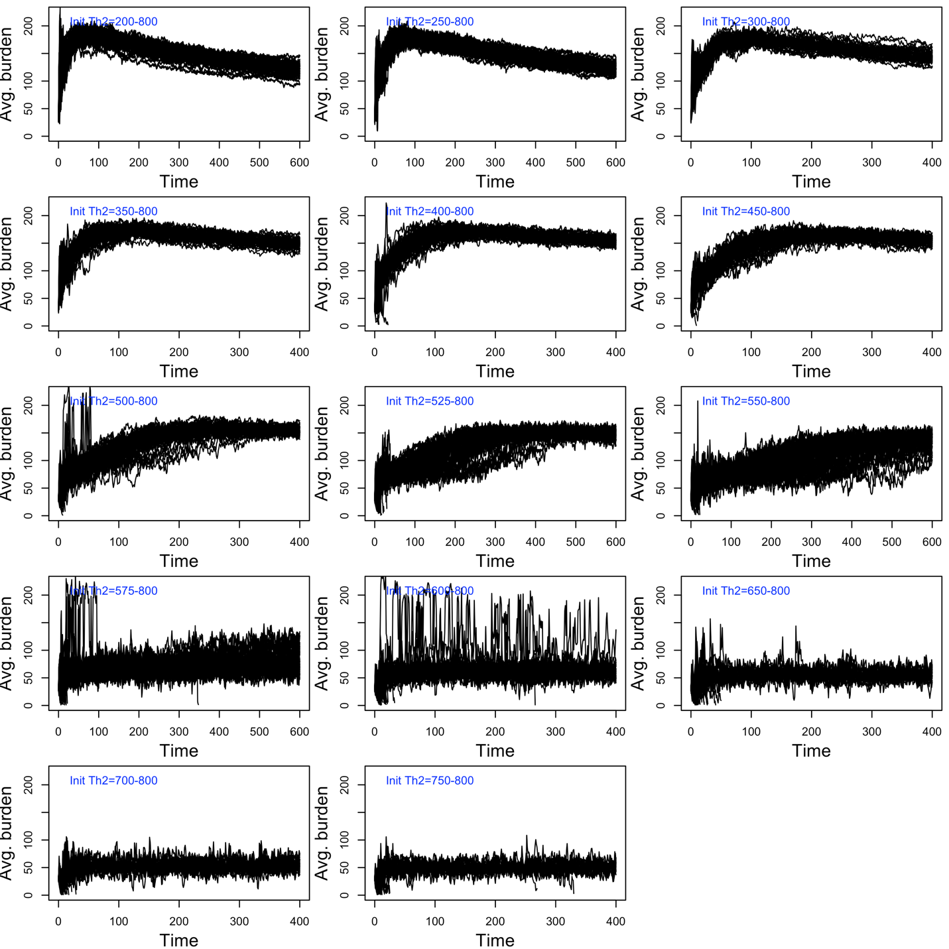

The next set of figures are all reporting information about individual outcomes, rather than population-level outcomes. For that reason, I have to “bin” individuals who are born within particular intervals to see how the evolution of virulence is modifying these individual-level outcomes. To increase the number of individuals within each interval, I analyze all 50 stochastic simulations at one time, rather than plotting separate trajectories for each simulation. This fourth figure shows how the mean infection duration changes over time. I used a standard survival analysis to compute this average, such that every infection either ends (due to clearance or death) or it doesn’t (because the infection is ongoing at the end of the simulation). Thus the data is right-censored, and I use the R package ‘survival’ to estimate the average infection duration.

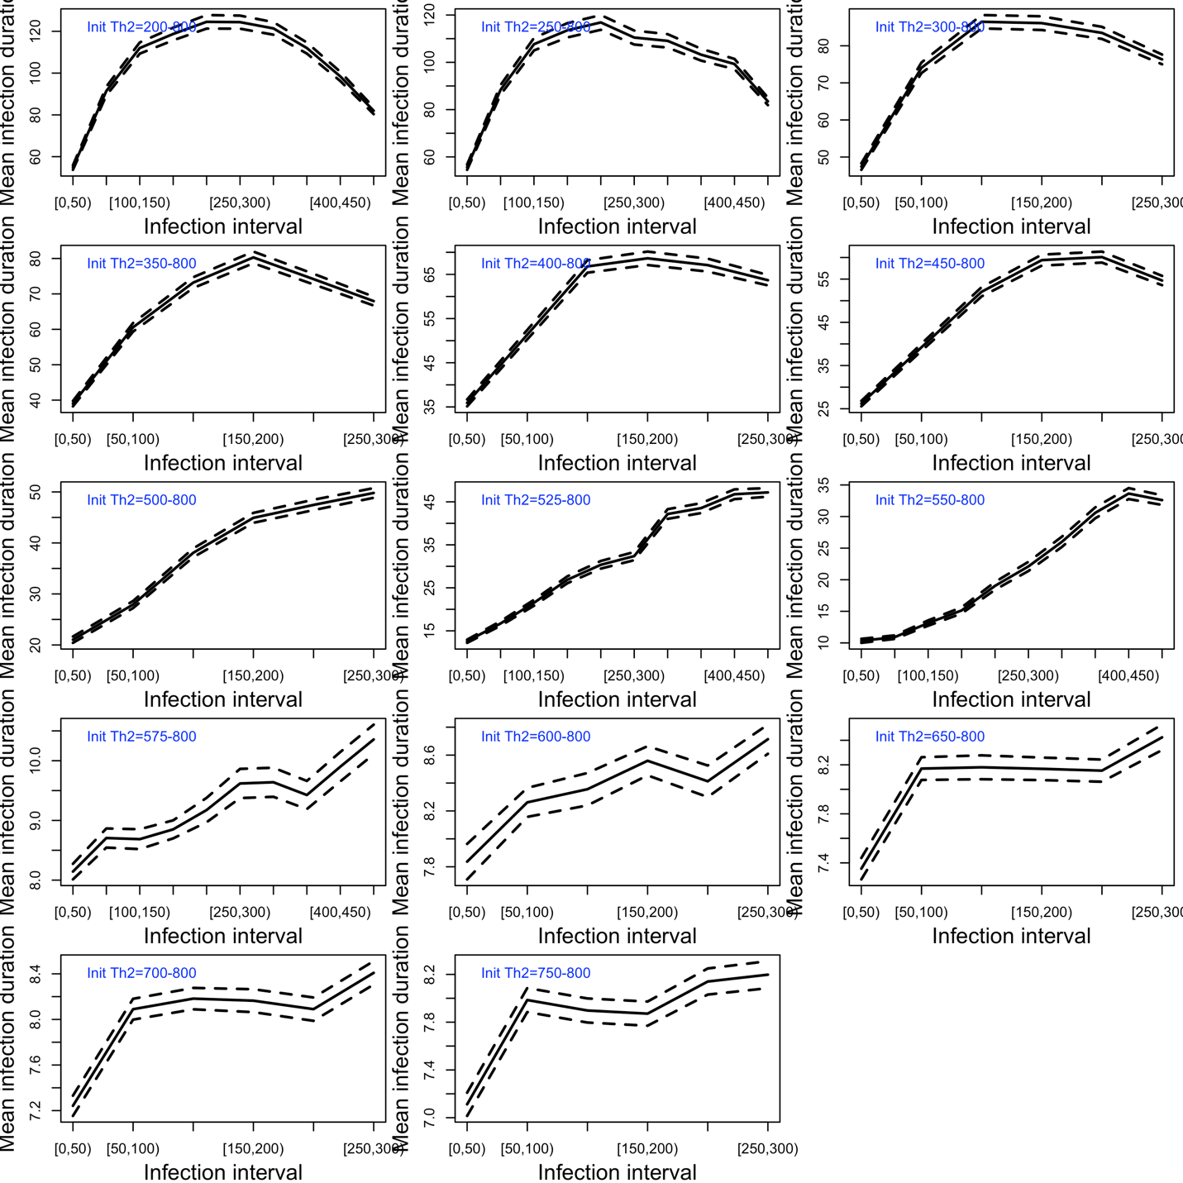

For this fifth figure, I separate out why the infections end. This must be analyzed in a slightly different way than infection duration because clearance and death are competing risks – once one happens, the other cannot. To estimate the probabilities of clearance and death at different infection ages, I estimated the cumulative incidence functions for clearance and death using the Aalen-Johansen estimator in the R package ‘cmprsk.’ However, rather than plotting the cumulative incidence functions themselves, I am showing the per-infection probability of clearance. Across all simulations, I observed that incidence function for clearance asymptotes very quickly: either the host clears the infection quickly or it becomes chronically infected and the probability of death typically increases through time, especially when virulence is evolving to be lower. Thus, the probability of clearance, combined with the average duration plot above, give a good sense of how virulence evolution and Th1:Th2 bias are impacting clearance versus death.
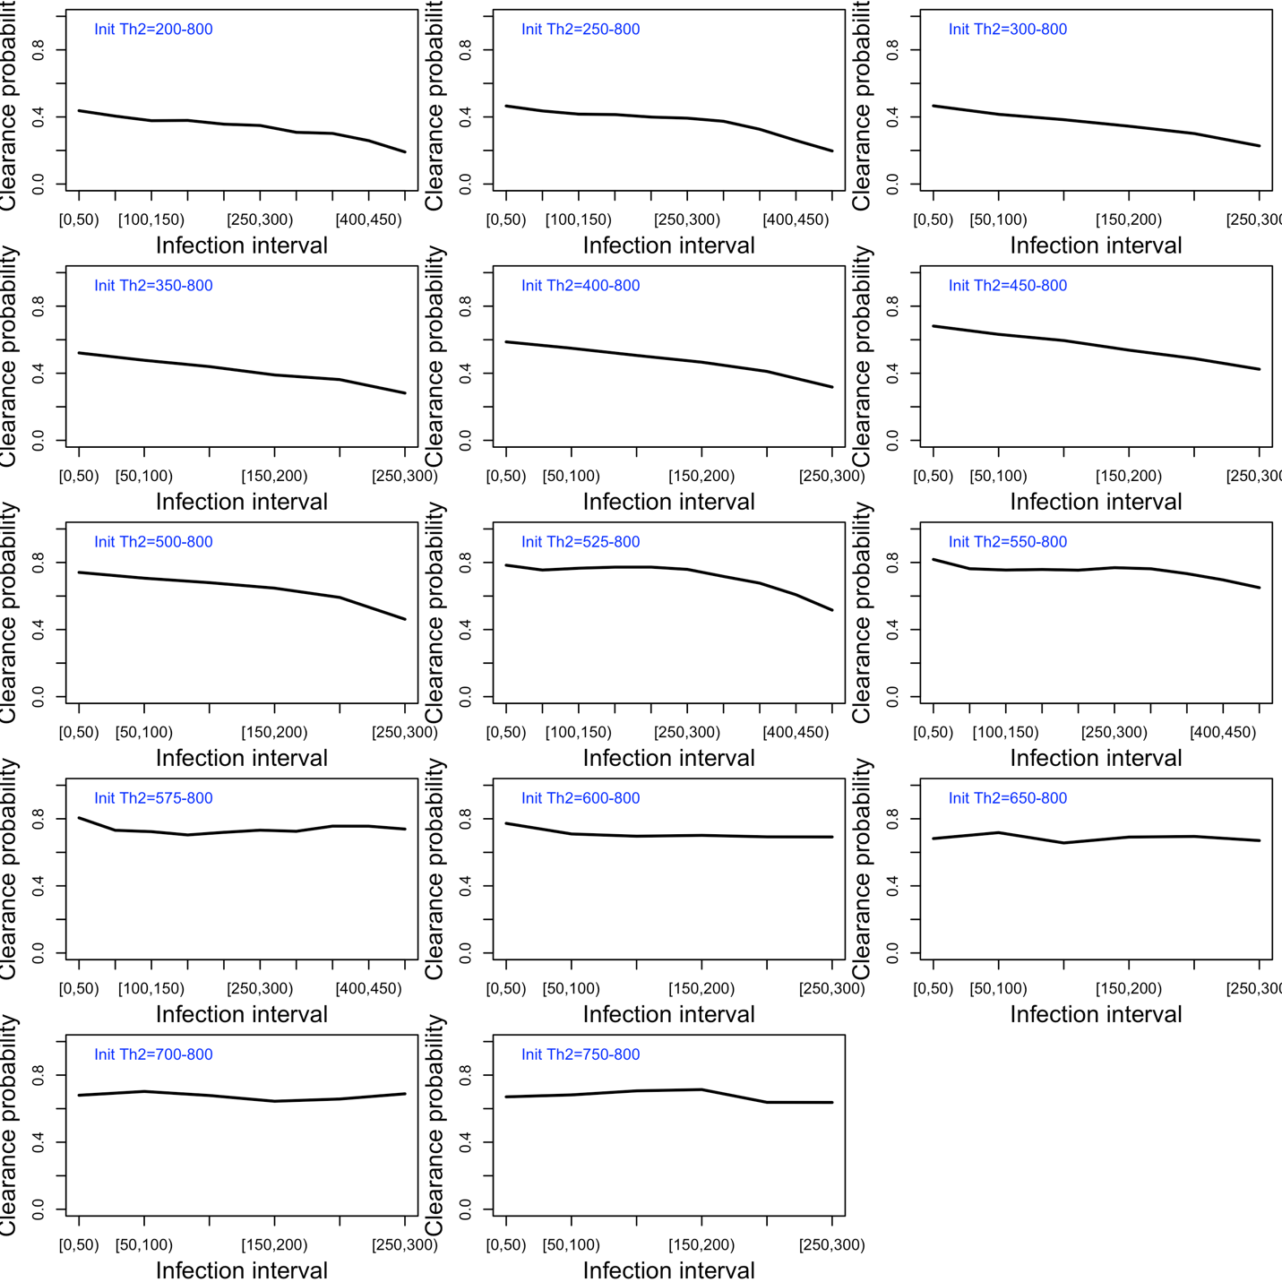
Finally, we can look at the mean peak burden reached by infections as virulence is evolving.

