Online Supplementary Information

To carry out an adaptive dynamics analysis (Geritz et al. 1998) of the simple epidemiological model (equation 3 in the main text), we first expand the model to consider the dynamics of a resident strain of parasite that causes acute ($I_{a,r}$) and chronic ($I_{c,r}$) infections and a mutant strain of parasite that also causes acute ($I_{a,m}$) and chronic ($I_{c,m}$) infections. The two strains differ in virulence ($v_{r}$ and $v_{m}$), which alters their transmission rates according to the function
$$β\left(v\right)=\frac{β_{0}v}{h+v}.$$

Thus the model is

$$\frac{dS}{dt}=b\left(S+I_{a,r}+I_{c,r}+I_{a,m}+I_{c,m}\right)\left(1-\frac{S+I_{a,r}+I_{c,r}+I_{a,m}+I_{c,m}}{K}\right)-μS-β\left(v_{r}\right)\left(I_{a,r}+I_{c,r}\right)S-β\left(v_{m}\right)\left(I_{a,m}+I_{c,m}\right)S+γ(I_{a,r}+I_{a,m})$$
$$\frac{dI_{a,r}}{dt}=pβ\left(v_{r}\right)\left(I_{a,r}+I_{c,r}\right)S-(v_{r}+γ+μ)I_{a,r}$$
$$\frac{dI_{c,r}}{dt}=\left(1-p\right)β\left(v_{r}\right)\left(I_{a,r}+I_{c,r}\right)S-(v_{r}+μ)I_{c,r}$$
$$\frac{dI_{a,m}}{dt}=pβ\left(v_{m}\right)\left(I_{a,m}+I_{c,m}\right)S-(v_{m}+γ+μ)I_{a,m}$$
$$\frac{dI_{c,m}}{dt}=\left(1-p\right)β\left(v_{m}\right)\left(I_{a,m}+I_{c,m}\right)S-(v_{m}+μ)I_{c,m}$$

Following a classic adaptive analysis approach, whether a mutant strain can invade and displace the resident is determined by the stability of the mutant-free equilibrium $\left(S,I_{a,r},I_{c,r},I_{a,m},I_{c,m}\right)=(\hat{S}, \hat{I_{a,r}}, \hat{I_{c,r}}, 0, 0)$. This is given by the eigenvalues of the Jacobian matrix evaluated at that equilibrium. Given that the resident would attain a stable equilibrium if the resident was not present (that is, if the system of equations did not include the resident at all), then whether the mutant can invade is given by the eigenvalues of the matrix
$$\left(\begin{matrix}pβ\left(v_{m}\right)\hat{S}-(v_{m}+μ+γ) & pβ\left(v_{m}\right)\hat{S} \\ (1-p)β\left(v_{m}\right)\hat{S} & \left(1-p\right)β\left(v_{m}\right)\hat{S}-(v_{m}+μ)\end{matrix}\right).$$

The eigenvalues of this matrix are difficult to interpret, but a more biologically interpretable expression for the invasion criterion can be used by applying the next generation theorem (Hurford et al. 2010) to the above matrix. This leads to the following condition for the mutant to be able to invade:
$$\frac{pβ\left(v_{m}\right)\hat{S}}{v_{m}+μ+γ}+\frac{\left(1-p\right)β\left(v_{m}\right)\hat{S}}{v_{m}+μ}>1,$$
which can be interpreted as the expected number of new infections caused by an acute infection plus the expected number of new infections caused by a chronic infection. If this quantity is greater than one, then the mutant parasite can spread among the susceptible hosts that are left over by the resident strain ($\hat{S}$). This means that the mutant is suppressing the number of susceptible hosts below the number where the resident can persist. That is, evolution will lead to the minimization of the number of susceptible (the so-called pessimization principle of adaptive dynamics).

Potential endpoints of evolution are found by finding the roots of the derivative of the above expression with respect to the evolving trait ($v_{m}$), that is, by solving the following equation for $v_{m}:$
$$\left(v_{m}+μ\right)\left(v_{m}+γ+μ\right)β\left(v_{m}\right)-\left(v_{m}+μ\right)\left(v_{m}+\left(1-p\right)γ+μ\right)β\left(v_{m}\right)-\left(v_{m}+γ+μ\right)\left(v_{m}+\left(1-p\right)γ+μ\right)β(v_{m})+\left(v_{m}+μ\right)\left(v_{m}+γ+μ\right)\left(v_{m}+\left(1-p\right)γ+μ\right)β^{'}\left(v_{m}\right)=0.$$

As long as $β(v)$ is an increasing, saturating function of virulence $v$, then any $v_{m}$ that satisfies the above equality will be evolutionarily and convergence stable (Geritz et al. 1998). Fig. 5 in the main text shows the ESS $v_{m}$ as the probability of an acute infection $p$ and the recovery rate $γ$ vary.

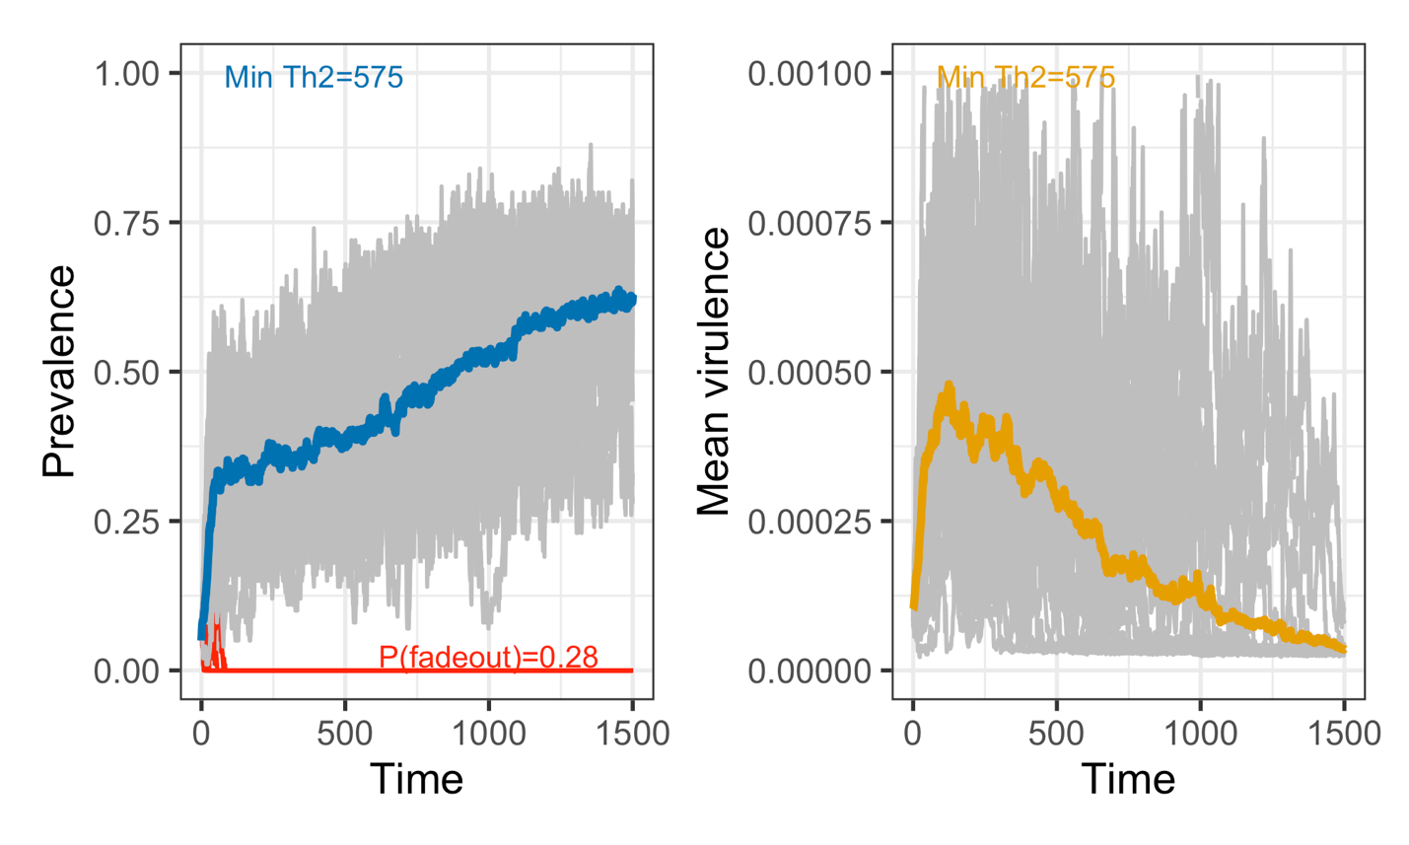
Figure S1. Eco-evolutionary dynamics of prevalence and virulence when the minimum initial Th2 is 575. This extends the timecourse shown in the lower left panels of Figs. 2 and 3, revealing that it takes a very long time for prevalence and virulence to reach an eco-evolutionary steady state.

References

Geritz, S. A. H., Kisdi, É., Meszéna, G., & Metz, J. A. J. (1998). Evolutionarily singular strategies and the adaptive growth and branching of the evolutionary tree. Evolutionary Ecology, 12, 35–57.

Hurford, A., Cownden, D., & Day, T. (2010). Next-generation tools for evolutionary invasion analyses. Journal of the Royal Society Interface, 7(45), 561–571.

