The eco-evolutionary dynamics of macroparasite virulence across stochastically heterogeneous host immune landscapes

Clayton E. Cressler¹, David A. Chang van Oordt², Andrea L. Graham², Daniel C. G. Metz³

1. School of Biological Sciences, University of Nebraska-Lincoln, Lincoln, NE, USA
2. Department of Ecology & Evolutionary Biology, Princeton University, Princeton, NJ, USA
3. Department of Biology, Franklin & Marshall College, Lancaster, PA, USA

Abstract
Recovery from infection is a key determinant of parasite fitness, yet classic epidemiological theory typically assumes that recovery rates are fixed and homogeneous among hosts. For parasites cleared by adaptive immunity, that assumption is unlikely to hold: recovery depends on the interaction between parasite growth and immune dynamics, and therefore on the immune state of the host at the time of infection. Here we embed a mechanistic within-host model of helper T-cell polarization and parasite growth into a stochastic susceptible–infected–susceptible epidemiological framework to ask how heterogeneity in host immune state alters parasite prevalence and virulence evolution. We show that stochastic variation in host immune state generates distinct population-level immune landscapes that strongly alter both epidemiological and evolutionary dynamics. Th1-biased landscapes favor chronic infection, high prevalence, and the evolution of low virulence, whereas Th2-biased landscapes favor acute infection, low prevalence, and the evolution of higher virulence. A simplified adaptive-dynamics analysis reveals that these differences are driven primarily by variation in the probability of recovery rather than by changes in recovery rate alone. More broadly, our results show that stochastic immunological heterogeneity can reshape eco-evolutionary dynamics by changing not only mean infection duration, but the distribution of infection fates across hosts.

Introduction
The recovery rate from an infection is a critical determinant of parasite fitness and thus both the epidemiological dynamics of an infectious disease and the evolution of key parasite traits like virulence (Greenhalgh & Day 2017). Classic epidemiological theory assumes that recovery rate at the population scale is constant; at the individual scale, this implies that the probability of recovery is constant throughout the course of infection, leading to infection durations that are exponentially distributed (Keeling and Rohani 2008). This assumption is often violated in nature.

In particular, for parasite and pathogens of vertebrates that are cleared by the adaptive immune response, there is likely a high probability of recovery early in infection, when stochastic extinction of small parasite population is likely, followed by a period of time where the probability of recovery is low because the parasite has established but the adaptive immune response has not yet been fully activated and tailored (Graham & Regoes, 2024). Whether recovery probability increases or decreases from that timepoint depends on the interaction between the adaptive immune response and the parasite population. Assuming an appropriate immune response is activated, the probability of recovery will increase with infection duration (Chi et al. 2024). On the other hand, if the parasite is able to successfully manipulate the immune response, either by misdirecting or suppressing it, the probability of recovery will actually decrease with infection duration (Maizels et al. 2018; Bancroft et al. 2019). Given that recovery depends on time since infection, the standard compartmental framework no longer fully captures the effective distribution of infection durations.

Although other authors have shown how to relax the assumption of a constant recovery rate within standard epidemiological frameworks (Lloyd 2001; Keeling & Rohani 2008; Greenhalgh & Day 2017), biologically, whether and when recovery occurs clearly depends on the interaction between parasites and the immune response, and models of the immune response reveal complex dynamics that are not easily captured by simplified assumptions about the distribution of infection durations (Yates et al. 2000; van den Ham & de Boer 2008; Cressler et al. 2024). Thus, we need tractable theory that is grounded in immunology. Here we extend an existing model of the within-host interaction between the immune system and parasites (Cressler et al. 2024) to assess how variation in immune state and potency of feedback loops affects infection clearance probability (and, thus, recovery rates), and hence parasite prevalence and evolved virulence. This model incorporates key immunological feedback loops that drive helper T-cell polarization towards either a T-helper 1 (Th1) or T-helper 2 (Th2) response (Yates et al. 2000; van den Ham & de Boer 2008; Schrom et al. 2020), appropriate for clearing intracellular microparasites or extracellular macroparasites, respectively. These feedbacks include self-activation, where activated T-helper cells producing signalling molecules that cause similar activation in naïve T-helper cells; cross-inhibition, where activated T-helper cells produce signalling molecules that prevent naïve T-helper cells from adopting the opposite phenotype (e.g., Th1 cells preventing the activation of Th2 cells); and parasite manipulation, where parasites produce signalling molecule mimics that induce the activation of an incorrect immune response. Operating together, these positive feedback loops cause the immune-parasite interaction to be multistable (Angeli et al. 2004), meaning that multiple equilibria, representing distinct immunological and parasitological outcomes, are simultaneously stable, including equilibria where the parasite is cleared by an appropriate immune response, and equilibria where the parasite infection becomes chronic due to an inappropriate immune response. Critically, which outcome is reached by the system depends on the state of the immune system upon infection and the size of the parasite dose (Cressler et al. 2024). That is, within-host immune feedback mechanisms convert a fixed recovery rate into a host immune-state dependent probability of recovery. Given that initial parasite dose likely varies stochastically among hosts due to random differences in exposure, and initial immune state likely varies stochastically among hosts due to differences in immune history, for example, due to differences in prior exposure to commensal or pathogenic microbes, then the epidemiological consequences for prevalence and selection on virulence may differ sharply due simply to stochasticity.

To explore these consequences of immunological heterogeneities, we nest the within-host immune-parasite model into a simple SIS epidemiological framework and simulate the model as a stochastic individual-based model via a Gillespie algorithm (DeLong & Cressler 2023). We consider the evolution of an extracellular parasite (e.g., a gastrointestinal helminth parasite) that would be cleared by a Th2 immune response, but can potentially manipulate the host into mounting a Th1 response (Else et al. 1992; Bancroft et al. 2001; Maizels et al. 2018). Critically, we allow each host’s immune state upon infection to be drawn from a probability distribution. This reflects heterogeneity in immune history among individual hosts, but creates the potential for distinct immune landscapes for the parasite due entirely to stochasticity in immunity. To vary the population-level immune landscape the parasite is experiencing, we vary the probability distribution for the immune state, varying it from being Th1-biased to Th2-biased.

At the same time, we allow parasite virulence to evolve, to understand how the immune landscape creates distinct epidemiological and evolutionary outcomes. We show that Th1-biased landscapes lead to high prevalence and the evolution of very low virulence as parasites evolve to maximize infection duration, whereas Th2-biased landscapes lead to low prevalence and the evolution of high virulence as parasites evolve to maximize parasite abundance and transmission. Finally, we use a simplified adaptive dynamics analysis to show that the key evolutionary driver of these differences is the probability of recovery. Taken together, these results suggest that host immunological heterogeneity and within-host interactions can alter both epidemic outcomes and the evolution of virulence by altering not just mean infection duration, but the distribution of infection fates (acute vs chronic) across hosts.

Methods
To study the epidemiological and evolutionary consequences of stochasticity in host immune state, we nest a within-host model of the interaction between an extracellular parasite, such as a gastrointestinal helminth, and the adaptive immune system (Cressler et al. 2024) into a simple susceptible-infected-susceptible (SIS) epidemiological model. The SIS framework is appropriate for such parasites, as some hosts become chronically infected and recovery does not typically lead to long-lasting immunity, such that reinfection is common (Grencis 2015). We use a Gillespie algorithm to stochastically simulate coupled within-host and between-host dynamics, leading to a stochastic, individual-based model with an underlying deterministic skeleton (DeLong and Cressler 2023). The underlying deterministic within-host model we consider is:

$$\frac{dT_{1}}{dt}=\underset{\begin{aligned}External \\ activation\end{aligned}}{\underbrace{b_{1}}}+\underset{\begin{aligned}Parasite \\ activation\end{aligned}}{\underbrace{\frac{c_{1}P}{C_{1}+P}}}+\underset{\begin{aligned}Self- \\ activation\end{aligned}}{\underbrace{\left(\frac{s_{1}T_{1}^{2}}{S_{1}^{p}+T_{1}^{2}}\right)}}\underset{\begin{aligned}Cross- \\ inhibition\end{aligned}}{\underbrace{\left(\frac{I_{12}}{I_{12}+T_{2}}\right)}}-\underset{Apoptosis}{\underbrace{mT_{1}}}$$  $$\frac{dT_{2}}{dt}=b_{2}+\frac{c_{2}P}{C_{2}+P}+\frac{s_{2}T_{2}^{2}}{S_{2}^{2}+T_{2}^{2}} \frac{I_{21}}{I_{21}+T_{1}}-mT_{2}$$  $$\frac{dP}{dt}=\underset{Parasite growth}{\underbrace{r\left(\frac{v}{V_{0}+v}\right)P\left(1-\frac{P}{K_{p}}\right)}}-\underset{Parasite expulsion}{\underbrace{aPT{}_{2}}}$$ | (1)

Full details and analysis of this model can be found in Cressler et al. 2024, but briefly, the model considers the interaction between subpopulations of helper T-cells ($T_{1}$ and $T_{2}$) and parasite biomass (P). The T-helper cell populations expand due to T-cell activation that is independent of either the focal parasite or immune feedbacks ($b_{i}$), parasite-induced activation (controlled by parameters $c_{i}$ and $C_{i}$) and self-activation (controlled by parameters $s_{i}$ and $S_{i}$). Self-activation is cross-inhibited by T-helper cells of the other subpopulation (controlled by parameter $I_{ij}$). The self-activation and cross-inhibition functions phenomenologically capture the cytokine-dependent interactions that occur between Th1 and Th2 cells (Yates et al. 2000, van den Ham and de Boer 2008, Schrom et al. 2020). Parasite biomass increases through density-dependent growth at a maximum rate $r$, scaled by the per-parasite virulence, $v$, and the half-saturation constant $V_{0}$ that determines how sensitive biomass growth rate is to changes in virulence. Parasite biomass growth is inhibited due to the action of Th2 cells at a maximum per-T-cell rate of $a$. The positive feedback loops created by self-activation, cross-inhibition, and the parasite’s ability to induce both Th1 and Th2 responses make the dynamics of this system multistable: the ultimate outcome of the interaction depends on both the parameters of the model and the initial starting conditions. In particular, Cressler et al. (2024) showed that acute infection, where the immune system polarizes towards a Th2 response and clears the infection quickly, and chronic infection, where the immune system polarizes towards a Th1 response and the parasite cannot be cleared, were both stable outcomes of this model. Table 1 gives the baseline parameters we use for this study. Note that these parameters are not derived for any particular system, but were chosen because of the rich and biologically plausible outcomes they produce (see Fig. 1).

The epidemiological model we consider is:
$$\frac{dS}{dt}=b\left(S+I\right)\left(1-\frac{S+I}{K}\right)-p\left(P\right)cSI+γ\left(P\right)I$$  $$\frac{dI}{dt}=p\left(P\right)cSI-μ\left(v,P\right)I-γ\left(P\right)I$$ | (2)

We assume that the host population grows logistically in the absence of infection. Infected and susceptible hosts come into contact at a per-capita rate $c$, but the probability of infection given contact, $p(P)$ depends on the parasite biomass in the infected host, $P$, and thus on the within-host interaction. In particular, in the IBM implementation of this model, the initial parasite biomass in the new host is drawn from a Poisson distribution. For simplicity, we assume that the mean and variance of this distribution are set to one-tenth of the infected host’s parasite biomass at the time of infection. If the drawn dose is equal to zero, then transmission fails. The infection-induced mortality rate, $μ(v,P)$, varies among infected hosts; for infected individual $i$ this is equal to $v_{i}P_{i}(t)$, where $v_{i}$ is the per-parasite virulence of that individual’s infection and $P_{i}(t)$ is its burden at time $t$. Finally, the recovery rate from infection, $γ(P)$, also varies among infected individuals. An individual will recover from infection if parasite burden ever drops to zero, which depends on the within-host interaction between parasite growth and the immune response.

Note that $p(P)$, $γ(P)$, and $μ(v,P)$ are not actually defined at the population level (that is, we cannot write down a function for, e.g., $p(P)$ because parasite biomass varies across infected individuals). Rather, at each step in our Gillespie algorithm, we compute the rates of each process in the within-host model (denoted by the underbraces in Eq. 1) for every infected individual based on its current within-host state; we compute the parasite-induced mortality rate for every infected individual based on its current parasite biomass; we compute the population-level host birth rate; and we compute a population-level contact rate. The Gillespie algorithm then updates the time based on the total rate of all possible processes and stochastically chooses which process is occurring. If the chosen process was a change in a within-host variable ($T_{1}, T_{2}$, or $P$) of an infected host, the algorithm updates the appropriate variable accordingly. If this causes $P=0$, the infected individual recovers, increasing the number of susceptible hosts ($S$) and decreasing the number of infected hosts ($I$) by one. If the chosen process was parasite-induced mortality, we remove the chosen infected host and decrease the number of infected hosts by one. If the chosen process was a host birth, we increase the number of susceptible hosts by one. Finally, if the chosen process was a contact between a susceptible and infected host, we choose an infected host at random and draw the initial parasite biomass from a Poisson distribution. If the initial parasite biomass is greater than zero, we create a new infected individual with that initial parasite biomass and with an initial immune state ($T_{1},T_{2}$) drawn from a probability distribution as described below.

As shown in Cressler et al. (2024) and in Fig. 1, the outcome of the within-host interaction described by Eq. 1 depends critically on both the initial parasite biomass (resulting from the infection process described above) and the initial immune state. Rather than fixing the initial immune state of every individual upon infection, we assume that it varies stochastically, reflecting that every individual’s immune state upon infection would depend on its history of past exposures to parasitic, commensal, and mutualistic symbionts and thus would vary tremendously from one individual to another. Across different simulation runs, we vary the immune landscape the parasite faces by altering the initial Th2 bias of the immune system. In particular, we hold the maximum number of initial Th2 cells fixed at 800 and vary the minimum number of cells; we then draw the initial number of Th2 from a uniform distribution. We also fix the total immune cell population at 1200, so the random draw determines both the initial Th1 and Th2 cell numbers. Thus, when the minimum number of Th2 cells is very small (e.g., 200), the initial immune state is likely to be Th1-biased, whereas when the minimum number of Th2 cells is very large (e.g., 700), the initial immune state is Th2-biased.

We start each simulation with a small population of infected individuals, each with a per-unit biomass virulence of $v=0.0001$. When contact between an infected and a susceptible host results in a new infection, the virulence of this infection is drawn from a lognormal distribution with mean equal to the virulence of the infecting host and a standard deviation equal to half the mean. With this model of inheritance, virulence evolution emerges out of the stochastic processes of infection, death, and recovery (Doebeli et al. 2017).

Results

Figure 1 shows how variation in the initial number of Th2 cells (from 200-800) and variation in the initial parasite dose (from 1 to 40) interact to shape the outcome of infection, in particular whether an infection is cleared or is chronic, at the within-host level. The per-parasite virulence, v, is held constant at its initial value, $v=0.0001$. Fig. 1A shows the results of deterministic simulations of the within-host model (Eq. 1); Fig. 1B shows the results of stochastic simulations of the model using a Gillespie algorithm. For each set of initial conditions, we simulated the stochastic model 100 times and then report the probability of an acute infection. The deterministic model predicts that there are three possible equilibria, depending on the initial number of Th2 cells and the initial parasite dose: a high Th1, low Th2, high parasite equilibrium corresponding to a chronic infection (red); a high Th1, high Th2, low parasite (but non-zero) equilibrium (gray); and a low Th1, high Th2, zero parasite equilibrium corresponding to recovery (black). Stochasticity eliminates the high Th1, high Th2 equilibrium; instead, we see a probabilistic outcome where the probability of recovery varies between 0 and 1 for Th2 between 400-600.

With this intuition developed, we can consider the epidemiological and evolutionary dynamics that result from different immunological landscapes, specified by varying the minimum Th2 of the probability distribution from which the initial immune state is drawn for each new infection. Fig. 2 shows the epidemiological dynamics that occur as the parasite is evolving. In general, we observe a decrease in prevalence as we increase the minimum number of Th2 cells upon infection (main panel), reflecting an increase in the probability of infection clearance with a higher initial Th2 (Fig. 1; Fig. 4A). The blue points and top left panel show the epidemiological dynamics when the immune system is very likely to be Th1-biased (minimum Th2=200). We observed no epidemic fadeouts and prevalence is nearly 100%. Conversely, the green points and bottom left panel show the epidemiological dynamics when the immune system is Th2-biased (minimum Th2=700). Epidemic fadeouts are common; meanwhile, in those populations where the infection becomes endemic, prevalence reaches an approximate steady state around 25%. The orange points and middle left panel show the epidemiological dynamics when there is moderate Th2 bias (minimum Th2=575). Here we observe much more variability in the final prevalence across simulations and it is also clear that we have not yet reached a steady state; this is because the eco-evolutionary dynamics are still occurring (Fig. 3). At this intermediate Th2 bias, the eco-evolutionary dynamics do not reach a steady state, even after 1500 timesteps and there is considerable variation between stochastic replicate simulations (Supplementary Figure S1).

Evolutionarily, we see that when the immune system is Th1-biased (minimum Th2=200; top left panel of Fig. 3), virulence evolves to be very low as chronic infections are very likely. Conversely, when the immune system is Th2-biased (minimum Th2=700; bottom left panel of Fig. 3), virulence evolves to be high as acute infections are very likely. When there is moderate Th2 bias (minimum Th2=575), the evolutionary outcomes are highly variable; overall, most simulations are evolving towards lower virulence, but many have maintained very high virulence throughout the entire simulation run, implying that virulence evolution is much less predictable. For moderate Th2 bias, this variability can persist for a long time; although most simulations have reached low virulence by 1500 timesteps, there are still multiple replicates with higher-than-expected virulence (Supplementary Fig. S1). Overall, as the immune system becomes more Th2-biased and acute infections are more likely, parasite virulence evolves to be higher (Fig. 3, main panel).

Figure 4 visualizes how evolution of virulence across different immune landscapes has modified parasite fitness components. We examine only the first 500 timesteps of each simulation to avoid issues with right-censoring of infection duration. When the initial immune state is likely Th1-biased (that is, when the initial number of Th2 cells is low), parasite evolution reduces the probability of recovery, whereas the probability of recovery remains relatively fixed over eco-evolutionary time when the immune state is likely Th2-biased (compare the red lines [Th1-biased] to the blue lines [Th2-biased] in Fig. 4A). Note, however, that the probability of recovery remains positive, indicating that not all infections are chronic even in the most Th1-biased immune landscapes. Unsurprisingly, as recovery probability declines in Th1-biased immune landscapes, infection duration increases (red lines in Fig. 4B). More surprisingly, given the fact that virulence is increasing in Th2-biased landscapes (Fig. 3), infection duration remains relatively constant (blue lines in Fig. 4B), a point we return to in the Discussion. Finally, evolution of reduced virulence in Th1-biased landscapes leads to lower peak parasite biomass, whereas evolution of increased virulence in Th2-biased landscapes leads to higher peak parasite abundance (Fig. 4C). Combining the insights from Figs. 2−4, we see that Th1-biased immune landscapes lead to the evolution of reduced virulence, which reduces recovery probability and increases infection duration, leading to high prevalence of infection within the host population. Th2-biased immune landscapes lead to the evolution of increased virulence, which increases peak parasite abundance, thereby increasing transmission, but without reducing the high recovery probability, which leads to low prevalence of infection.

Finally, to confirm that it is the acute versus chronic infection probability that is driving the evolutionary and epidemiological outcomes, we consider the evolution of virulence in a greatly simplified system:

$$\frac{dS}{dt}=b\left(S+I_{a}+I_{c}\right)\left(1-\frac{S+I_{a}+I_{c}}{K}\right)-μS-β\left(v\right)\left(I_{a}+I_{c}\right)S+γI_{a}$$  $$\frac{dI_{a}}{dt}=pβ(v)(I_{a}+I_{c})S-(v+γ+μ)I_{a}$$  $$\frac{dI_{c}}{dt}=\left(1-p\right)β\left(v\right)\left(I_{a}+I_{c}\right)S-(v+μ)I_{c}$$ | (3)

In this model, infected hosts are either acutely infected ($I_{a}$) or chronically infected ($I_{c}$), with the probability of entering either infected class determined at infection ($p$), independent of the virulence of the parasite. Acutely infected hosts die from infection at a rate $v$ and recover at a rate $γ$. We assume a classic virulence-transmission trade-off, such that the transmission rate depends on virulence according to the function
$$β\left(v\right)=β_{0}\frac{v}{h+v}.$$
Note that this assumption is much simpler than our current system, where virulence influences transmission, recovery, and duration of infection.

We use an adaptive dynamics analysis to study the evolution of virulence $v$ as the probability of an acute infection, $p$, varies (Geritz et al. 1998; see details in Supplementary Information). This captures the key element of our stochastic individual-based simulations, that variation in initial immune state largely determines the probability that an infection will be acute or chronic. Figure 5A shows the ESS virulence, $\hat{v}$, as the probability of recovery $p$ increases, for different recovery rates, $γ$. Fig. 5B shows the ESS virulence as the recovery rate increases for $p=1$. Fig. 5B thus shows the classic virulence evolution prediction for a simple SIS model with a fixed recovery rate. Fig. 5A shows that the ESS virulence is very low when the probability of an acute infection is low; it remains low for a wide range of $p$ values and then accelerates to high virulence when the probability of an acute infection is high. Note that this pattern closely mirrors the pattern observed in Fig. 3, but does not mirror the pattern shown in Fig. 5B. In Fig. 5B, when all infections are acute, increasing the recovery rate causes virulence to increase rapidly. Thus, increasing the probability of an acute infection does not have the same evolutionary effect as increasing the recovery rate.

Discussion
Classic epidemiological theory assumes that recovery rates are fixed, rather than depending on the time since an infection began (Greenhalgh & Day 2017). It also assumes that every infected individual has an identical recovery rate, rather than depending on the immune state of the individual. These assumptions lead to the classic compartmental model of epidemiology that ignores within-host interactions between parasites and the immune system. This modeling framework has been foundational to predicting the epidemiological and evolutionary dynamics of infectious diseases (Anderson & May 1991; Keeling & Rohani 2008). However, neither of these assumptions are met by natural infections, where the probability of recovery depends on the time since infection and on the potency and history of the immune system of the infected individual. Thus, it is unclear whether classical predictions from virulence evolution theory will be met when we allow for variation in immunity among individuals and for infection outcomes to depend on the unfolding within-host dynamics of immunity and parasite growth. Here, we utilize an individual-based model to nest a simple, mechanistic model of Th1 and Th2 immunity into an epidemiological model. We show that the immunological landscape, that is, the variation in immunity that exists among the host population, shapes both the evolutionary and epidemiological dynamics of parasites. We show that, when the immunological landscape is Th1-biased, for example due to a recent viral epidemic (Ryan et al. 2022; Sanchez-Menedez et al. 2024), so that chronic infections are more likely, the parasite evolves towards lower virulence, further lowering the probability of recovery and extending infection durations (Fig. 2-4). On the other hand, when the immunological landscape is Th2-biased, for example due to frequent exposure to parasitic helminths (de Ruiter et al. 2020; Benos & Mutapi 2026), so that acute infections are more likely, the parasite evolves towards higher virulence, increasing parasite biomass and transmission rate (Fig. 2-4). Other factors, such as nutritional plane (Bourke et al. 2016) or co-circulation of different suites of parasites (Mabbott 2018) will also alter the population-level immunological landscape.

These results seemingly mirror a simple prediction of classic evolutionary epidemiology: as the recovery rate increases, virulence is expected to increase (Fig. 5B). However, our novel model lends new insight and nuance to this simple prediction. In particular, altering the immune landscape affects the probability of recovery (Fig. 4A) as well as the recovery rate (quantified as inverse of the duration of infection; Fig. 4B). The shape of the relationship between ESS virulence and the probability of recovery is very different from the shape of the relationship between ESS virulence and the rate of recovery (compare Fig. 3 and 5A to Fig. 5B). If there is even a moderate chance an infection will become chronic, parasite virulence evolves to be low (Fig. 3). This lower virulence further reduces the probability of recovery (Fig. 4A), prolonging infection duration (Fig. 4B) and maximizing the contribution of chronically infected hosts to parasite fitness.

As the probability of recovery increases, the ESS virulence increases rapidly (Fig. 3 and 5A). This does not actually increase the probability of recovery (Fig. 4A) or shorten infection duration (Fig. 4B) because the increased virulence also increases the peak parasite biomass in the host (Fig. 4C), which slows infection clearance but increases the host mortality rate. The reduced recovery rate and increased mortality rate approximately balance one another, causing recovery probability and infection duration to remain roughly constant over eco-evolutionary time (Fig. 4A-B). The benefits of an increased peak biomass are two-fold: it increases the probability of transmission when an infected host contacts a susceptible host and it increases the size of the initial parasite biomass upon transmission, which helps to slow clearance and facilitates reaching high peak biomass. Compared to classic virulence evolution theory (Cressler et al. 2016), our results therefore better capture the eco-evolutionary dynamics of heterogeneous, chronic infections such as exhibited by helminth parasites in natural host populations.

An important benefit of using an individual-based modeling approach is that it allows us to examine the transient eco-evolutionary dynamics and to compare stochastic replicate simulations to gain insight into how immune variation impacts the speed and variability of eco-evolutionary trajectories (Doebeli et al. 2017; DeLong & Cressler 2023). When the immune landscape is highly Th1-biased (e.g., a minimum Th2 of 200; top left panel of Figs. 2 and 3), all the simulations quickly evolve towards low virulence and high infection prevalence. When the immune landscape is highly Th2-biased (e.g., a minimum Th2 of 700; bottom left panel of Figs. 2 and 3), the simulations quickly evolve towards high virulence and low infection prevalence, although there is considerably more variability than in the Th1-biased case. Conversely, at moderate Th2-bias (e.g., a minimum Th2 of 575; middle left panel of Figs. 2 and 3), there is tremendous variation between stochastic replicates. Although eventually all of the populations evolve towards low virulence (Fig. S1), by the final timestep in Fig. 3 (timestep 700), there are replicates with virulence as high as in the Th2-biased simulations, and replicates with virulence as low as in the Th1-biased simulations. Compare that against the highly biased simulations, which reached relatively stable virulence and prevalence within the first 50 timesteps. This implies that virulence evolution may be very unpredictable in the short- and even medium-term, a nuance that is missed by simpler equilibrium-based evolutionary analyses like adaptive dynamics.

The reason why the eco-evolutionary dynamics are so much slower is revealed by Fig. 1B, which shows how the outcome of the within-host dynamics depends on the initial Th2-ness of the immune system and the initial parasite biomass. At moderate Th2 bias (e.g., a minimum initial Th2 of 550-600), it is clear from Fig. 1B that almost all infections will be cleared by the immune response, a fact that creates selection for increased virulence to maximize transmission. However, there are rare occasions where the parasite infects a host that has an initial immune state with a low number of Th2 cells. These infections are much more likely to become chronic. Notice also that when the initial number of Th2 cells is approximately 550, there is a strong influence of the initial parasite biomass on the infection outcome, with lower initial biomasses being more likely to cause a chronic infection (Fig. 1B). These chronic infections are so valuable to parasite fitness that, over the long term, parasites evolve towards low virulence even though low virulence combined with a high likelihood of encountering a Th2-biased immune response leads to a probability of recovery that is actually higher at moderate Th2 bias than high Th2 bias (compare the purple to the blue lines in Fig. 4A), and a peak biomass that is lower (Fig. 4C).

A comparison of Fig. 1A and B also helps to understood why an equilibrium that is predicted by the deterministic model is never observed in nature. Specifically, both Fig. 1A and Cressler et al. (2024) suggested that one possible outcome of infection is a high Th1 response, a high Th2 response, and a low (but non-zero) parasite biomass. This outcome is not observed experimentally, but Fig. 1B suggests that adding demographic stochasticity is sufficient to cause that equilibrium to disappear. That is, within-host trajectories that start in the gray region of Fig. 1A will stochastically “walk” into the basin of attraction for either the Th1-polarized equilibrium (red) or the Th2-polarized equilibrium (blue), leading to the probabilistic outcomes observed in Fig. 1B (compare the gray region of Fig. 1A to the gradient color region of Fig. 1B).

Although considerable insight can be gained from these results, we have made a number of simplifying assumptions that could be relaxed in future studies. First, we have assumed that the host immune state upon infection is drawn randomly from a fixed distribution. This assumption was meant to reflect the fact that every individual has a unique set of immune challenges, so that it is hard to predict the immune state for any individual. A more realistic assumption would be to extend the within-host model to include the action of regulatory T-cells (which might dampen both Th1 and Th2 responses; McGuirk & Mills 2002), which would both allow for another axis of manipulation for parasites (Maizels et al. 2018) and would allow for more explicit modeling of within-host immunity in recovered individuals. This would allow, for example, for an individual’s probability of reinfection to depend on how long it has been since their last infection; an individual who recently recovered from infection would still have a Th2-biased immune response, making it less likely for them to be infected.

Second, we have assumed that the size of the immune system is fixed across all individuals, so that all that varies among them is the fraction of immune cells that are Th1- versus Th2-biased. Cressler et al. (2024) showed that the total number of T-cells also affects the number of within-host equilibria and the likelihood of approaching each (see Fig. 2 of that paper). In general, in that study, reducing the number of T-cells made the immune system less reactive, allowing parasites to establish without provoking a strong immune response, an outcome we did not observe here. Thus, allowing the number of T-cells to vary among individuals might capture aspects of immune reactivity as well as immune bias that could influence the evolution of parasite traits.

Although here we have considered the dynamics of a macroparasite infection that is cleared by a Th2 response, the model is readily applied to microparasitic infections. All that would be changed is which immune response is more strongly provoked by the pathogen and a reconceptualization from parasite biomass to pathogen load (e.g., viremia, bacteremia). Otherwise, all the mechanistic immunological detail included in the within-host model applies to pathogenic infections just as well as it applies to parasitic infections (Yates et al. 2000; van den Ham & de Boer 2008; Schrom et al. 2020; Cressler et al. 2024).

Here we show that incorporating a mechanistic within-host model into an epidemiological model allows for a rich set of eco-evolutionary outcomes, even when all the parameters of both models are fixed. This reveals that the immunological landscape—the variability in immune states both within hosts over the course of infection and across hosts in the population — can drastically alter the trajectory of virulence evolution and infection prevalence. This has important implications for predicting how parasites will evolve. In particular, we have shown that, if there is even a small chance that an infection can become chronic, parasites evolve to low virulence. This may help explain why parasitic infections, such as gastrointestinal helminths, that can become chronic tend to have very low virulence and high prevalence, whereas pathogenic infections that are always acute tend to have high virulence and low prevalence.

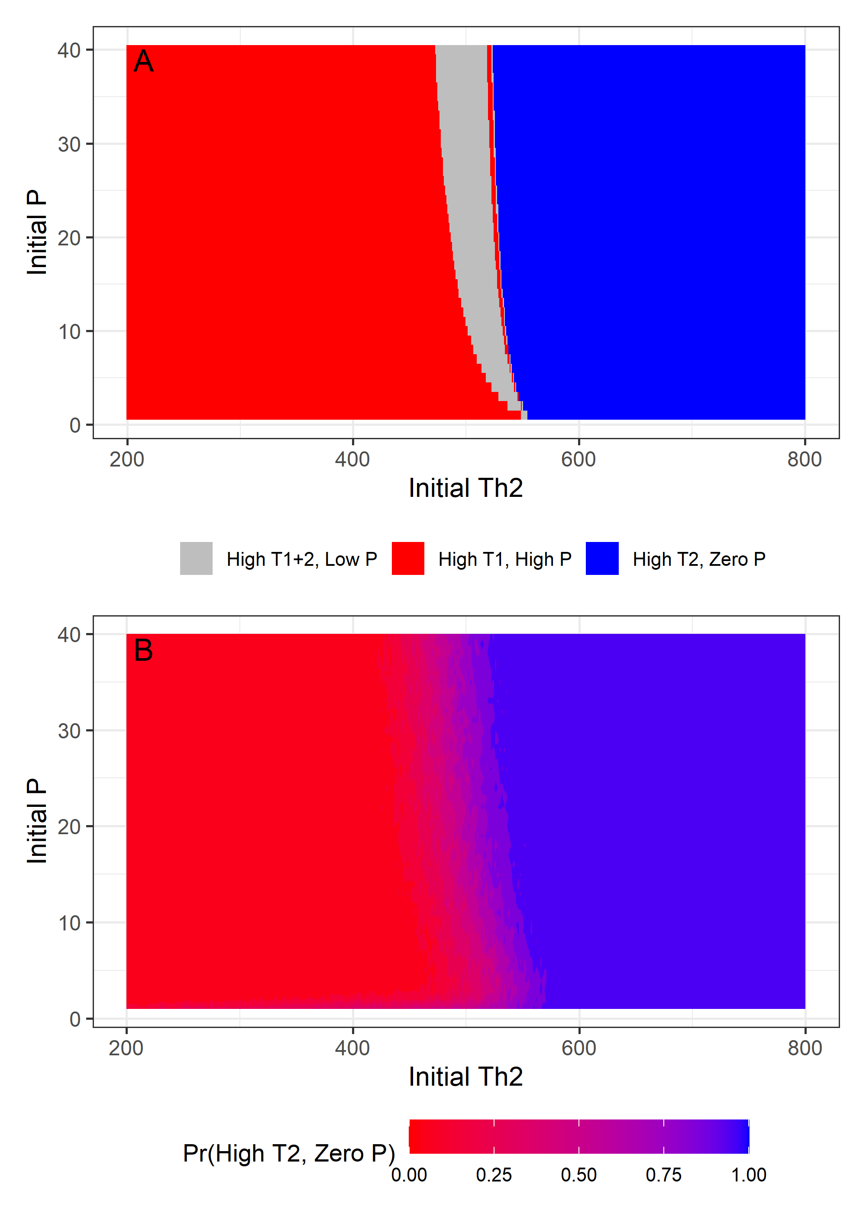
Figure 1. Outcomes of the deterministic (A) and stochastic (B) version of the within-host model as the initial number of Th2 cells and the initial parasite biomass vary. For the parameter values in Table 1, the deterministic model has three multistable equilibria representing a Th1-biased immune response and a chronic, high biomass parasite (red); a Th2-biased immune response and zero parasite biomass (blue); and an immune response with high Th1 and high Th2 and a low, but non-zero, parasite biomass (grey). In the stochastic model, this last equilibrium is not observed and instead the probability of reaching the Th1-biased or Th2-biased equilibrium depends on the initial conditions.
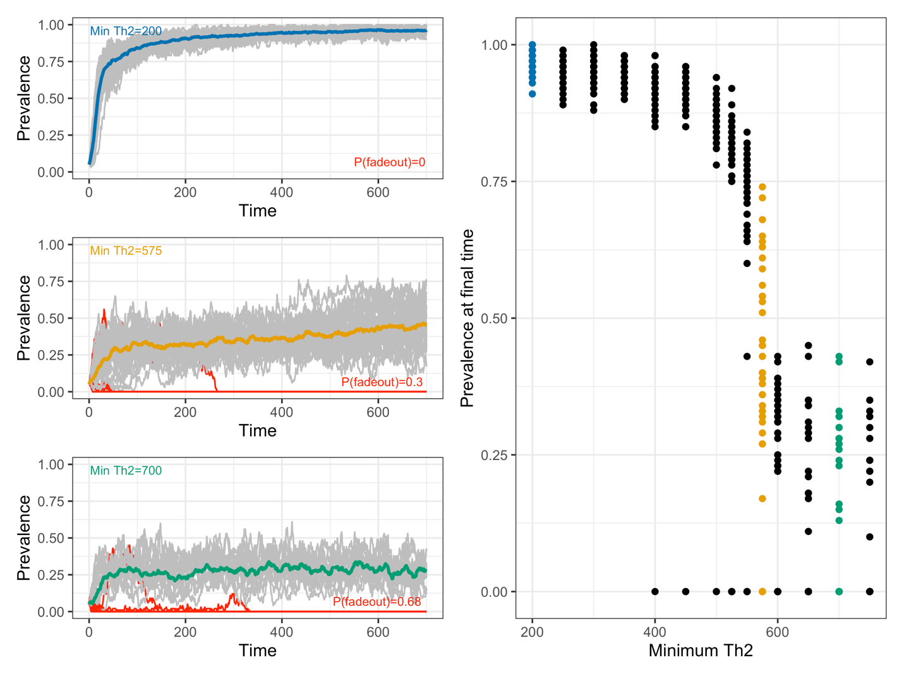
Figure 2. Eco-evolutionary equilibrium prevalence as the minimum number of Th2 cells upon infection varies. Low minimum Th2 leads to a highly Th1-biased immune landscape, whereas high minimum Th2 leads to a highly Th2-biased immune landscape. The right panel shows that prevalence is high in Th1-biased landscapes, but drops quickly as Th2-bias increases. The left panels show the observed eco-evolutionary dynamics of prevalence in each stochastic replicate (gray lines) and the mean across replicates (solid line) for low (blue), moderate (orange), and high (green) minimum Th2. Red lines show the dynamics of replicates where the epidemic faded out.

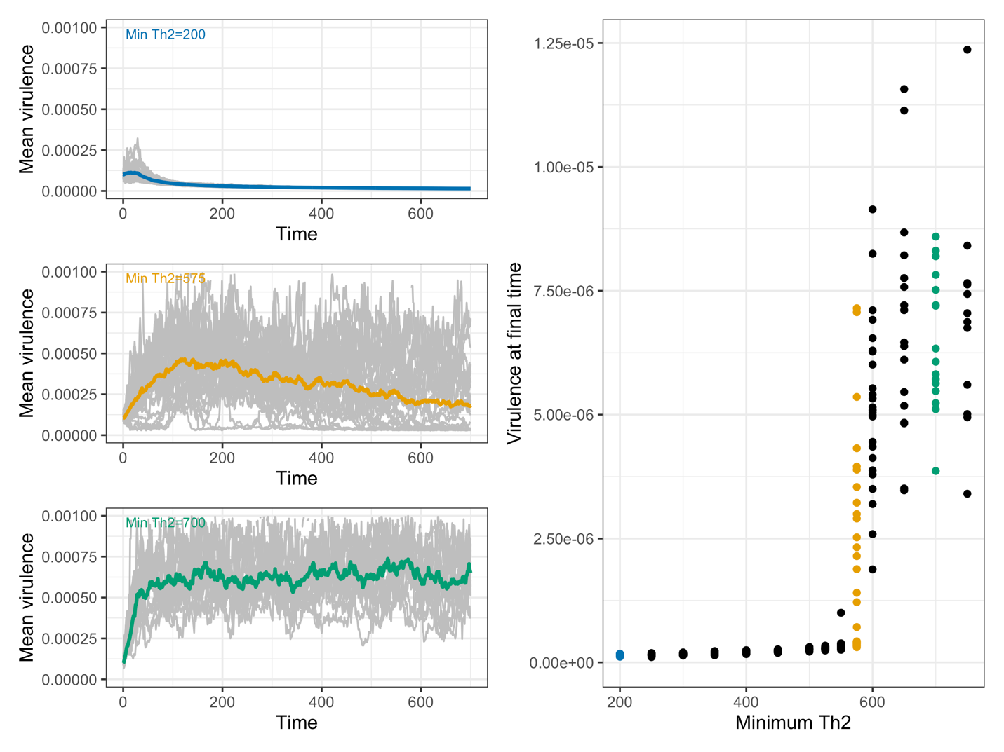
Figure 3. Eco-evolutionary equilibrium prevalence as the minimum number of Th2 cells upon infection varies. The right panel shows that virulence is low in Th1-biased landscapes, but increases rapidly as Th2-bias increases. The left panels show the observed eco-evolutionary dynamics of virulence in each stochastic replicate (gray lines) and the mean across replicates (solid line) for low (blue), moderate (orange), and high (green) minimum Th2.

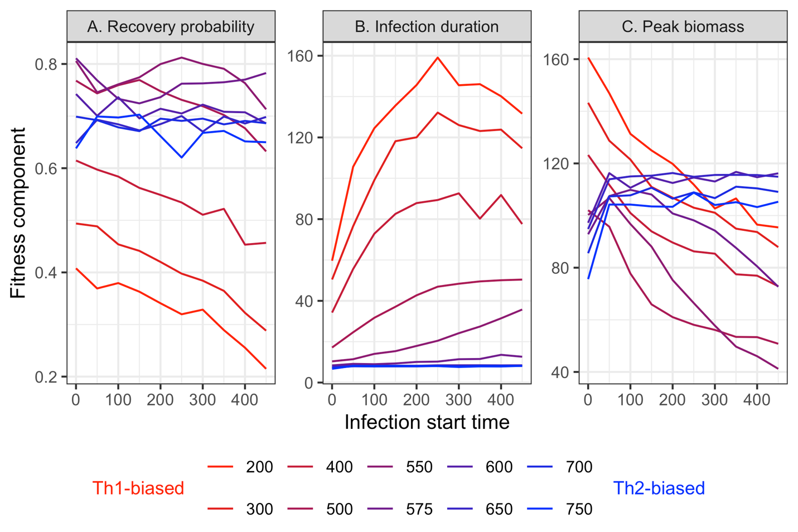
Figure 4. Components of parasite fitness as the immune landscape shifts from Th1-biased (red lines; low minimum Th2 cells) to Th2-biased (blue lines; high minimum Th2 cells), for infections starting at different times. This shows how parasite virulence evolution is affecting the different components of parasite fitness (recovery probability [A], infection duration [B], and peak parasite biomass [C]).

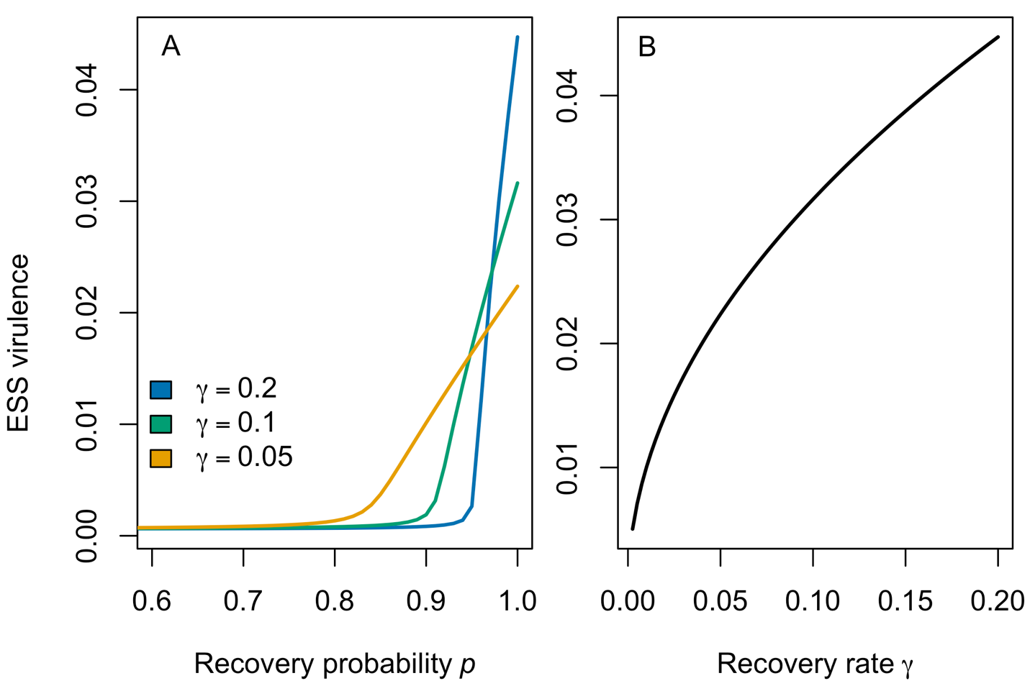

Figure 5. Evolutionarily stable virulence strategies for epidemiological model (3). (A) Evolutionary stable virulence as the probability of recovery, $p$, increases for different values of the recovery rate $γ$. (B) Evolutionarily stable virulence as the recovery rate increases when the probability of recovery is fixed at $p=1.$ Baseline parameters for epidemiological model (3) are $h=0.1$ and $μ=3.65×{10}^{-5}$ (see Supplementary Information for more details).

Table 1: Model parameters
Parameter | Parameter interpretation | Value
$$b_{i}$$ | External activation rate of Th-$i$ response | $$b_{1}=b_{2}=0.1$$
$$c_{i}$$ | Maximum parasite biomass-induced activation rate of Th-$i$ response | $$c_{1}=50,$$  $$c_{2}=130$$
$$C_{i}$$ | Half-saturation constant of parasite biomass-induced activation function | $$C_{1}=C_{2}=50$$
$$s_{i}$$ | Maximum self-activation rate of Th-$i$ response | $$s_{1}=s_{2}=2000$$
$$S_{i}$$ | Half-saturation constant of immune self-activation function | $$S_{1}=S_{2}=1000$$
$$I_{ij}$$ | Half-saturation constant of immune cross-inhibition function | $$I_{12}=I_{21}=10,000$$
$$m$$ | Immune cell apoptosis rate | $$m=0.9$$
$$r$$ | Maximum parasite biomass growth rate | $$r=8$$
$$V_{0}$$ | Half-saturation constant for the virulence—growth function | $$V_{0}=0.0001$$
$$K_{P}$$ | Maximum parasite biomass | $$K_{P}=300$$
$$a$$ | Per-Th2 cell biomass inhibition rate | $$a=0.004$$
$$b$$ | Maximum birth rate of new hosts | $$b=0.1$$
$$K$$ | Host carrying capacity | $$K=100$$
$$c$$ | Per-host contact rate | $$c=0.003$$
$$v$$ | Per-parasite virulence | Evolving: $v(0)=0.0001$
$$v_{CV}$$ | Coefficient of variation in virulence | $$v_{CV}=0.0001$$

References

Anderson, R. M., & May, R. M. (1991). Infectious Diseases of Humans: Dynamics and Control. Oxford University Press.

Angeli, D., Ferrell Jr, J. E., & Sontag, E. D. (2004). Detection of multistability, bifurcations, and hysteresis in a large class of biological positive-feedback systems. Proceedings of the National Academy of Sciences, 101(7), 1822-1827.

Bancroft, A. J., Else, K. J., Humphreys, N. E., & Grencis, R. K. (2001). The effect of challenge and trickle Trichuris muris infections on the polarisation of the immune response. International Journal for Parasitology, 31(14), 1627–1637

Bancroft, A. J., Levy, C. W., Jowitt, T. A., Hayes, K. S., Thompson, S., Mckenzie, E. A., ... & Grencis, R. K. (2019). The major secreted protein of the whipworm parasite tethers to matrix and inhibits interleukin-13 function. Nature Communications, 10(1), 2344.

Benos, E. J., & Mutapi, F. (2026). The human immunome in the post-schistosomiasis mass drug administration era. PLoS Neglected Tropical Diseases, 20(3), e0014084.

Bourke, C. D., Berkley, J. A., & Prendergast, A. J. (2016). Immune dysfunction as a cause and consequence of malnutrition. Trends in Immunology, 37(6), 386-398.

Chi, H., Pepper, M., & Thomas, P. G. (2024). Principles and therapeutic applications of adaptive immunity. Cell, 187(9), 2052-2078.

Cressler, C. E., McLeod, D. V., Rozins, C., Van Den Hoogen, J., & Day, T. (2016). The adaptive evolution of virulence: a review of theoretical predictions and empirical tests. Parasitology, 143(7), 915-930.

DeLong, J. P., & Cressler, C. E. (2023). Stochasticity directs adaptive evolution toward nonequilibrium evolutionary attractors. Ecology, 104(1), e3873.

de Ruiter, K., Jochems, S. P., Tahapary, D. L., Stam, K. A., König, M., van Unen, V., ... & Yazdanbakhsh, M. (2020). Helminth infections drive heterogeneity in human type 2 and regulatory cells. Science Translational Medicine, 12(524), eaaw3703.

Doebeli, M., Ispolatov, Y., & Simon, B. (2017). Towards a mechanistic foundation of evolutionary theory. Elife, 6, e23804.

Else, K. J., Hültner, L., & Grencis, R. K. (1992). Cellular immune responses to the murine nematode parasite Trichuris muris. II. Differential induction of TH-cell subsets in resistant versus susceptible mice. Immunology, 75(2), 232–237.

Geritz, S. A. H., Kisdi, É., Meszéna, G., & Metz, J. A. J. (1998). Evolutionarily singular strategies and the adaptive growth and branching of the evolutionary tree. Evolutionary Ecology, 12, 35–57.

Graham, A. L., & Regoes, R. R. (2024). Dose-dependent interaction of parasites with tiers of host defense predicts “wormholes” that prolong infection at intermediate inoculum sizes. PLoS Computational Biology, 20(12), e1012652.

Grencis, R. K. (2015). Immunity to helminths: resistance, regulation, and susceptibility to gastrointestinal nematodes. Annual Review of Immunology, 33(1), 201-225.

Hurford, A., Cownden, D., & Day, T. (2010). Next-generation tools for evolutionary invasion analyses. Journal of the Royal Society Interface, 7(45), 561–571.

Keeling, M. J., & Rohani, P. (2008). Modeling Infectious Diseases in Humans and Animals. Princeton University Press.

Lloyd, A. L. (2001). Realistic distributions of infectious periods in epidemic models: changing patterns of persistence and dynamics. Theoretical population biology, 60(1), 59-71.

Mabbott, N. A. (2018). The influence of parasite infections on host immunity to co-infection with other pathogens. Frontiers in Immunology, 9, 2579.

Maizels, R. M., Smits, H. H., & McSorley, H. J. (2018). Modulation of host immunity by helminths: The expanding repertoire of parasite effector molecules. Immunity, 49(5), 801–818.

McGuirk, P., & Mills, K. H. (2002). Pathogen-specific regulatory T cells provoke a shift in the Th1/Th2 paradigm in immunity to infectious diseases. Trends in Immunology, 23(9), 450-455.

Ryan, F. J., Hope, C. M., Masavuli, M. G., Lynn, M. A., Mekonnen, Z. A., Yeow, A. E. L., ... & Lynn, D. J. (2022). Long-term perturbation of the peripheral immune system months after SARS-CoV-2 infection. BMC Medicine, 20(1), 26.

Sanchez-Menendez, C., De La Calle-Jiménez, O., Mateos, E., Vigon, L., Fuertes, D., Murciano Antón, M. A., ... & Coiras, M. (2024). Different polarization and functionality of CD4+ T helper subsets in people with post-COVID condition. Frontiers in Immunology, 15, 1431411.

Schrom, E. C., Levin, S. A., & Graham, A. L. (2020). Quorum sensing via dynamic cytokine signaling comprehensively explains divergent patterns of effector choice among helper T cells. PLoS Computational Biology, 16(7), e1008051.

van den Ham, H.-J., & de Boer, R. J. (2008). From the two-dimensional Th1 and Th2 phenotypes to high-dimensional models for gene regulation. International Immunology, 20(10), 1269–1277.

Yates, A., Bergmann, C., Van Hemmen, J. L., Stark, J., & Callard, R. (2000). Cytokine-modulated regulation of helper T cell populations. Journal of Theoretical Biology, 206(4), 539–560.

Online Supplementary Information

To carry out an adaptive dynamics analysis of the simple epidemiological model (equation 3 in the main text), we first expand the model to consider the dynamics of a resident strain of parasite that causes acute ($I_{a,r}$) and chronic ($I_{c,r}$) infections and a mutant strain of parasite that also causes acute ($I_{a,m}$) and chronic ($I_{c,m}$) infections. The two strains differ in virulence ($v_{r}$ and $v_{m}$), which alters their transmission rates according to the function
$$β\left(v\right)=\frac{β_{0}v}{h+v}.$$

Thus the model is

$$\frac{dS}{dt}=b\left(S+I_{a,r}+I_{c,r}+I_{a,m}+I_{c,m}\right)\left(1-\frac{S+I_{a,r}+I_{c,r}+I_{a,m}+I_{c,m}}{K}\right)-μS-β\left(v_{r}\right)\left(I_{a,r}+I_{c,r}\right)S-β\left(v_{m}\right)\left(I_{a,m}+I_{c,m}\right)S+γ(I_{a,r}+I_{a,m})$$
$$\frac{dI_{a,r}}{dt}=pβ\left(v_{r}\right)\left(I_{a,r}+I_{c,r}\right)S-(v_{r}+γ+μ)I_{a,r}$$
$$\frac{dI_{c,r}}{dt}=\left(1-p\right)β\left(v_{r}\right)\left(I_{a,r}+I_{c,r}\right)S-(v_{r}+μ)I_{c,r}$$
$$\frac{dI_{a,m}}{dt}=pβ\left(v_{m}\right)\left(I_{a,m}+I_{c,m}\right)S-(v_{m}+γ+μ)I_{a,m}$$
$$\frac{dI_{c,m}}{dt}=\left(1-p\right)β\left(v_{m}\right)\left(I_{a,m}+I_{c,m}\right)S-(v_{m}+μ)I_{c,m}$$

Following a classic adaptive analysis approach, whether a mutant strain can invade and displace the resident is determined by the stability of the mutant-free equilibrium $\left(S,I_{a,r},I_{c,r},I_{a,m},I_{c,m}\right)=(\hat{S}, \hat{I_{a,r}}, \hat{I_{c,r}}, 0, 0)$. This is given by the eigenvalues of the Jacobian matrix evaluated at that equilibrium. Given that the resident would attain a stable equilibrium if the resident was not present (that is, if the system of equations did not include the resident at all), then whether the mutant can invade is given by the eigenvalues of the matrix
$$\left(\begin{matrix}pβ\left(v_{m}\right)\hat{S}-(v_{m}+μ+γ) & pβ\left(v_{m}\right)\hat{S} \\ (1-p)β\left(v_{m}\right)\hat{S} & \left(1-p\right)β\left(v_{m}\right)\hat{S}-(v_{m}+μ)\end{matrix}\right).$$

The eigenvalues of this matrix are difficult to interpret, but a more biologically interpretable expression for the invasion criterion can be used by applying the next generation theorem (Hurford et al. 2010) to the above matrix. This leads to the following condition for the mutant to be able to invade:
$$\frac{pβ\left(v_{m}\right)\hat{S}}{v_{m}+μ+γ}+\frac{\left(1-p\right)β\left(v_{m}\right)\hat{S}}{v_{m}+μ}>1,$$
which can be interpreted as the expected number of new infections caused by an acute infection plus the expected number of new infections caused by a chronic infection. If this quantity is greater than one, then the mutant parasite can spread among the susceptible hosts that are left over by the resident strain ($\hat{S}$). This means that the mutant is suppressing the number of susceptible hosts below the number where the resident can persist. That is, evolution will lead to the minimization of the number of susceptible (the so-called pessimization principle of adaptive dynamics).

Potential endpoints of evolution are found by finding the roots of the derivative of the above expression with respect to the evolving trait ($v_{m}$), that is, by solving the following equation for $v_{m}:$
$$\left(v_{m}+μ\right)\left(v_{m}+γ+μ\right)β\left(v_{m}\right)-\left(v_{m}+μ\right)\left(v_{m}+\left(1-p\right)γ+μ\right)β\left(v_{m}\right)-\left(v_{m}+γ+μ\right)\left(v_{m}+\left(1-p\right)γ+μ\right)β(v_{m})+\left(v_{m}+μ\right)\left(v_{m}+γ+μ\right)\left(v_{m}+\left(1-p\right)γ+μ\right)β^{'}\left(v_{m}\right)=0.$$

As long as $β(v)$ is an increasing, saturating function of virulence $v$, then any $v_{m}$ that satisfies the above equality will be evolutionarily and convergence stable. Fig. 5 in the main text shows the ESS $v_{m}$ as the probability of an acute infection $p$ and the recovery rate $γ$ vary.

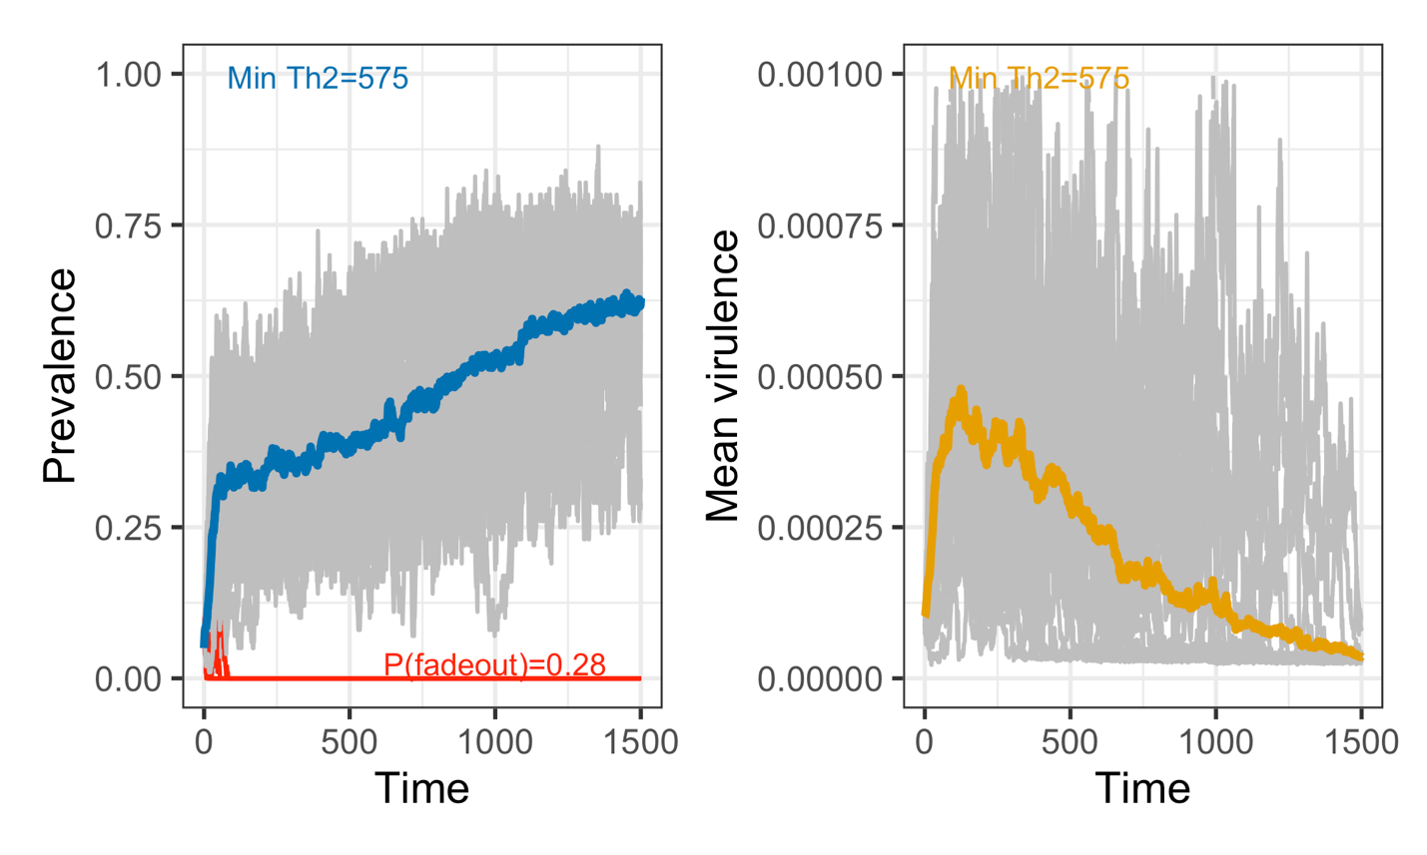
Figure S1. Eco-evolutionary dynamics of prevalence and virulence when the minimum initial Th2 is 575. This extends the timecourse shown in the lower left panels of Figs. 2 and 3, revealing that it takes a very long time for prevalence and virulence to reach an eco-evolutionary steady state.

