Methods
To study the epidemiological and evolutionary consequences of stochasticity in host immune state, we nest a within-host model of the interaction between parasites and the adaptive immune system (Cressler et al. 2024) into a simple susceptible-infected (SI) epidemiological model. We use a Gillespie algorithm to stochastically simulate coupled within-host and between-host dynamics, leading to a stochastic, individual-based model with an underlying deterministic skeleton (DeLong and Cressler 2023). The underlying deterministic within-host model we consider is:

$$\frac{dT_{1}}{dt}=\underset{\begin{aligned}External \\ activation\end{aligned}}{\underbrace{b_{1}}}+\underset{\begin{aligned}Parasite \\ activation\end{aligned}}{\underbrace{\frac{c_{1}P}{C_{1}+P}}}+\underset{\begin{aligned}Self- \\ activation\end{aligned}}{\underbrace{\left(\frac{s_{1}T_{1}^{2}}{S_{1}^{p}+T_{1}^{2}}\right)}}\underset{\begin{aligned}Cross- \\ inhibition\end{aligned}}{\underbrace{\left(\frac{I_{12}}{I_{12}+T_{2}}\right)}}-\underset{Apoptosis}{\underbrace{mT_{1}}}$$  $$\frac{dT_{2}}{dt}=b_{2}+\frac{c_{2}P}{C_{2}+P}+\frac{s_{2}T_{2}^{2}}{S_{2}^{2}+T_{2}^{2}} \frac{I_{21}}{I_{21}+T_{1}}-mT_{2}$$  $$\frac{dP}{dt}=\underset{Parasite growth}{\underbrace{r\left(\frac{v}{V_{0}+v}\right)P\left(1-\frac{P}{K_{p}}\right)}}-\underset{Parasite expulsion}{\underbrace{aPT{}_{2}}}$$ | (1)

Full details and analysis of this model can be found in Cressler et al. 2024, but briefly, the model considers the interaction between subpopulations of helper T-cells ($T_{1}$ and $T_{2}$) and parasite biomass (P). The T-helper cell populations expand due to external activation ($b_{i}$), parasite-induced activation (controlled by parameters $c_{i}$ and $C_{i}$) and self-activation (controlled by parameters $s_{i}$ and $S_{i}$). Self-activation is cross-inhibited by T-helper cells of the other subpopulation (controlled by parameter $I_{ij}$). The self-activation and cross-inhibition functions phenomenologically capture the cytokine-dependent interactions that occur between Th1 and Th2 cells (Yates et al. 2004, can den Ham and de Boer 2008, Schrom et al. 2020). Parasite biomass increases through density-dependent growth at a maximum rate $r$, scaled by the per-parasite virulence, $v$, and parasite biomass growth is inhibited due to the action of Th2 cells at a maximum per-T-cell rate of $a$. The positive feedback loops created by self-activation, cross-inhibition, and the parasite’s ability to induce both Th1 and Th2 responses make the dynamics of this system multistable: the ultimate outcome of the interaction depends on both the parameters of the model and the initial starting conditions (Cressler et al. 2024). Table 1 gives the baseline parameters we use for this study. Note that these parameters are not derived for any particular system, but rather were chosen because of the rich but biologically plausible outcomes they produce (see Fig. 1).

The epidemiological model we consider is:
$$\frac{dS}{dt}=b\left(S+I\right)\left(1-\frac{S+I}{K}\right)-p\left(v,P\right)cSI$$  $$\frac{dI}{dt}=p\left(P\right)cSI-μ\left(v,P\right)I-γ\left(v,P,T_{1},T_{2}\right)I$$ | (2)

We assume that the host population grows logistically in the absence of infection. Infected and susceptible hosts come into contact at a per-capita rate $c$, but whether a contact results in infection depends on the parasite burden in the infected host. In particular, in the IBM implementation of this model, the infectious dose is drawn from a Poisson distribution with mean and variance set to one-tenth of the infected host’s parasite burden at the time of infection. If the drawn dose is equal to zero, then transmission fails. The infection-induced mortality rate experienced by infected individual $i$ is equal to $v_{i}P_{i}(t)$, where $v_{i}$ is the per-parasite virulence of that individual’s infection and $P_{i}(t)$ is its burden at time $t$. Finally, the parasite recovers from infection if parasite burden ever drops to zero, which depends on the within-host interaction between parasite growth and the immune response.

As shown in Cressler et al. (2024) and in Fig. 1, the outcome of this within-host interaction depends critically on both the initial parasite dose (resulting from the infection process described above) and the initial immune state. Rather than fixing the initial immune state of every individual upon infection, we assume that it varies stochastically, reflecting that every individual’s immune state upon infection would depend on its history of past exposures to parasitic, commensal, and mutualistic symbionts and thus would vary tremendously from one individual to another. In our simulations, we vary the range of variation in the initial number of Th2 cells and assume that the initial immune state is drawn from a uniform distribution with a specified minimum and maximum. In particular, we hold the maximum fixed at 800 and vary the minimum. The total immune cell population is fixed at 1200, so the random draw determines both the initial Th1 and Th2 cell numbers.

We start each simulation with a small population of infected individuals, each with a per-parasite virulence of $v=0.0001$. When an infected host contacts a susceptible host, the virulence of the new infection is drawn from a lognormal distribution with mean equal to the virulence of the infecting host and a standard deviation equal to half the mean. With this model of inheritance, virulence evolution emerges out of the stochastic processes of infection, death, and recovery (Doebeli et al. 2017).

Results

Figure 1 shows how variation in the initial number of Th2 cells (from 200-800) and variation in the initial parasite dose (from 1 to 40) interact to shape the outcome of infection at the within-host level. The per-parasite virulence, v, is held constant at its initial value, $v=0.0001$. Fig. 1A shows the results of deterministic simulations of the within-host model (Eq. 1); Fig. 1B shows the results of stochastic simulations of the model using a Gillespie algorithm. For each set of initial conditions, we simulated the stochastic model 100 times and then report the probability of an acute infection. The deterministic model predicts that there are three possible equilibria, depending on the initial number of Th2 cells and the initial parasite dose: a high Th1, low Th2, high parasite equilibrium corresponding to a chronic infection (red); a high Th1, high Th2, low parasite (but non-zero) equilibrium (gray); and a low Th1, high Th2, zero parasite equilibrium corresponding to clearance (black). Stochasticity eliminates the high Th1, high Th2 equilibrium; instead, we see a probabilistic outcome where the probability of clearance varies between 0 and 1 for Th2 between 400-600.

With this intuition developed, we can consider the epidemiological and evolutionary dynamics that result from different immunological landscapes, specified by varying the minimum Th2 of each infection. Fig. 2 shows the epidemiological results.

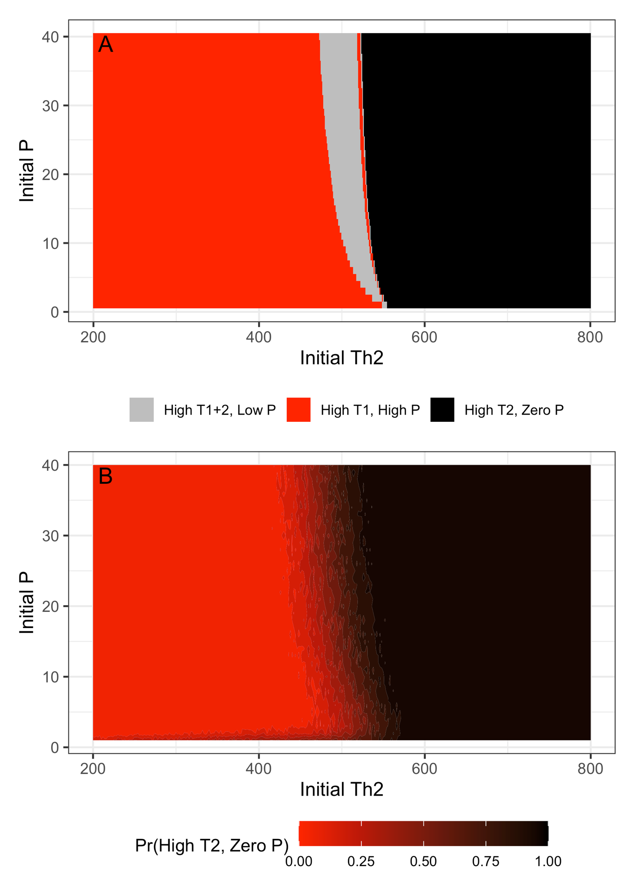

Table 1: Model parameters
Parameter | Parameter interpretation | Value
$$b_{i}$$ | External activation rate of Th-$i$ response | $$b_{1}=b_{2}=0.1$$
$$c_{i}$$ | Maximum parasite biomass-induced activation rate of Th-$i$ response | $$c_{1}=50,$$  $$c_{2}=130$$
$$C_{i}$$ | Half-saturation constant of parasite biomass-induced activation function | $$C_{1}=C_{2}=50$$
$$s_{i}$$ | Maximum self-activation rate of Th-$i$ response | $$s_{1}=s_{2}=2000$$
$$S_{i}$$ | Half-saturation constant of immune self-activation function | $$S_{1}=S_{2}=1000$$
$$I_{ij}$$ | Half-saturation constant of immune cross-inhibition function | $$I_{12}=I_{21}=10,000$$
$$m$$ | Immune cell apoptosis rate | $$m=0.9$$
$$r$$ | Maximum parasite biomass growth rate | $$r=8$$
$$V_{0}$$ | Half-saturation constant for the virulence—growth function | $$V_{0}=0.0001$$
$$K_{P}$$ | Maximum parasite biomass | $$K_{P}=300$$
$$a$$ | Per-Th2 cell biomass inhibition rate | $$a=0.004$$
$$b$$ | Maximum birth rate of new hosts | $$b=0.1$$
$$K$$ | Host carrying capacity | $$K=100$$
$$c$$ | Per-host contact rate | $$c=0.003$$
$$v$$ | Per-parasite virulence | Evolving: $v(0)=0.0001$
$$v_{CV}$$ | Coefficient of variation in virulence | $$v_{CV}=0.0001$$

