Introduction
The recovery rate from an infection is a critical determinant of parasite fitness and thus both the epidemiological dynamics of an infectious disease and the evolution of key parasite traits like virulence. Classic epidemiological theory assumes that recovery rate is fixed, implying that the probability of recovery is constant throughout the course of infection. This assumption is often violated in nature.

In particular, for parasite and pathogens of vertebrates that are cleared by the adaptive immune response, there is likely a high probability of recovery early in infection, when stochastic extinction of small parasite population is likely, followed by a period of time where the probability of recovery is low because the parasite has established but the adaptive immune response has not yet been activated. Whether infection probability increases or decreases from that timepoint depends on the interaction between the adaptive immune response and the parasite population. Assuming an appropriate immune response is activated, the probability of recovery will increase with infection duration. On the other hand, if the parasite is able to successfully manipulate the immune response, either by misdirecting or suppressing it, the probability of recovery will actually decrease with infection duration. However, once recovery depends on time since infection, the standard compartmental framework no longer fully captures the effective distribution of infection durations.

To understand how relaxing the assumption of a constant recovery rate affects both the epidemiological and evolutionary dynamics of infectious disease, we need tractable theory that is grounded in immunology. Here we extend an existing model of the within-host interaction between the immune system and parasites. This model incorporates key immunological feedbacks that drive helper T-cell polarization towards either a T-helper 1 or T-helper 2 response, appropriate for clearing intracellular or extracellular parasites, respectively. These feedbacks include self-activation, where activated T-helper cells producing signalling molecules that cause similar activation in naïve T-helper cells; cross-inhibition, where activated T-helper cells produce signalling molecules that prevent naïve T-helper cells from adopting the opposite phenotype (e.g., Th1 cells preventing the activation of Th2 cells); and parasite manipulation, where parasite produce signalling molecule mimics that induce the activation of an incorrect immune response. Operating together, these positive feedback loops cause the immune-parasite interaction to be multistable, meaning that multiple equilibria, representing distinct immunological and parasitological outcomes, are simultaneously stable, including equilibria where the parasite is cleared by an appropriate immune response, and equilibria where the parasite infection becomes chronic due to an inappropriate immune response. Critically, which outcome is reached by the system depends on the state of the immune system upon infection and the size of the parasite dose. That is, within-host immune feedbacks and stochasticity convert a fixed recovery rate into a host immune-state dependent probability of recovery. Given that initial immune state likely varies tremendously among hosts due to differences in immune history, for example, due to differences in prior exposure to commensal or pathogenic microbes, then the epidemiological consequences for prevalence and selection on virulence may differ sharply across immune landscapes.

To explore these consequences, we nest a within-host immune-parasite model into a simple SIS epidemiological framework and simulate the model as a stochastic individual-based model via a Gillespie algorithm. We consider the evolution of an extracellular parasite (e.g., a gastrointestinal helminth parasite) that would be cleared by a Th2 immune response, but can potentially manipulate the host into mounting a Th1 response. Critically, we allow each host’s immune state upon infection to be drawn from a probability distribution. This reflects heterogeneity in immune history among hosts, but creates distinct immune landscapes for the parasite. To vary the immune landscape the parasite is experiencing, we vary the probability distribution for the immune state, varying it from being Th1-biased to Th2-biased. At the same time, we allow parasite virulence to evolve on this landscape to understand how the immune landscape creates distinct epidemiological and evolutionary outcomes. We show that Th1-biased landscapes lead to high prevalence and the evolution of very low virulence as parasites evolve to maximize infection duration, whereas Th2-biased landscapes lead to low prevalence and the evolution of high virulence as parasites evolve to maximize parasite abundance and transmission. Finally, we use a simplified adaptive dynamics analysis to show that the key evolutionary driver of these differences is the probability of clearance. Taken together, these results suggest that host immunological heterogeneity and within-host interactions can alter both epidemic outcomes and the evolution of virulence by altering not just mean infection duration, but the distribution of infection fates (acute vs chronic) across hosts

Methods
To study the epidemiological and evolutionary consequences of stochasticity in host immune state, we nest a within-host model of the interaction between an extracellular parasite, such as a gastrointestinal helminth, and the adaptive immune system (Cressler et al. 2024) into a simple susceptible-infected-susceptible (SIS) epidemiological model. The SIS framework is appropriate for such parasites, as some hosts become chronically infected and recovery does not typically lead to long-lasting immunity. We use a Gillespie algorithm to stochastically simulate coupled within-host and between-host dynamics, leading to a stochastic, individual-based model with an underlying deterministic skeleton (DeLong and Cressler 2023). The underlying deterministic within-host model we consider is:

$$\frac{dT_{1}}{dt}=\underset{\begin{aligned}External \\ activation\end{aligned}}{\underbrace{b_{1}}}+\underset{\begin{aligned}Parasite \\ activation\end{aligned}}{\underbrace{\frac{c_{1}P}{C_{1}+P}}}+\underset{\begin{aligned}Self- \\ activation\end{aligned}}{\underbrace{\left(\frac{s_{1}T_{1}^{2}}{S_{1}^{p}+T_{1}^{2}}\right)}}\underset{\begin{aligned}Cross- \\ inhibition\end{aligned}}{\underbrace{\left(\frac{I_{12}}{I_{12}+T_{2}}\right)}}-\underset{Apoptosis}{\underbrace{mT_{1}}}$$  $$\frac{dT_{2}}{dt}=b_{2}+\frac{c_{2}P}{C_{2}+P}+\frac{s_{2}T_{2}^{2}}{S_{2}^{2}+T_{2}^{2}} \frac{I_{21}}{I_{21}+T_{1}}-mT_{2}$$  $$\frac{dP}{dt}=\underset{Parasite growth}{\underbrace{r\left(\frac{v}{V_{0}+v}\right)P\left(1-\frac{P}{K_{p}}\right)}}-\underset{Parasite expulsion}{\underbrace{aPT{}_{2}}}$$ | (1)

Full details and analysis of this model can be found in Cressler et al. 2024, but briefly, the model considers the interaction between subpopulations of helper T-cells ($T_{1}$ and $T_{2}$) and parasite biomass (P). The T-helper cell populations expand due to T-cell activation that is independent of either the focal parasite or immune feedbacks ($b_{i}$), parasite-induced activation (controlled by parameters $c_{i}$ and $C_{i}$) and self-activation (controlled by parameters $s_{i}$ and $S_{i}$). Self-activation is cross-inhibited by T-helper cells of the other subpopulation (controlled by parameter $I_{ij}$). The self-activation and cross-inhibition functions phenomenologically capture the cytokine-dependent interactions that occur between Th1 and Th2 cells (Yates et al. 2004, van den Ham and de Boer 2008, Schrom et al. 2020). Parasite biomass increases through density-dependent growth at a maximum rate $r$, scaled by the per-parasite virulence, $v$, and the half-saturation constant V0 that determines how sensitive biomass growth rate is to changes in virulence. Parasite biomass growth is inhibited due to the action of Th2 cells at a maximum per-T-cell rate of $a$. The positive feedback loops created by self-activation, cross-inhibition, and the parasite’s ability to induce both Th1 and Th2 responses make the dynamics of this system multistable: the ultimate outcome of the interaction depends on both the parameters of the model and the initial starting conditions (Cressler et al. 2024). Table 1 gives the baseline parameters we use for this study. Note that these parameters are not derived for any particular system, but rather were chosen because of the rich and biologically plausible outcomes they produce (see Fig. 1).

The epidemiological model we consider is:
dSdt=bS+I1-S+IK-pv,PcSI+γv,P,T1,T2I  dIdt=pPcSI-μv,PI-γv,P,T1,T2I | (2)

We assume that the host population grows logistically in the absence of infection. Infected and susceptible hosts come into contact at a per-capita rate $c$, but the probability of infection given contact, p(P) depends on the parasite biomass in the infected host, P, and thus on the within-host interaction. In particular, in the IBM implementation of this model, the initial parasite biomass in the new host is drawn from a Poisson distribution. For simplicity, we assume that the mean and variance of this distribution are set to one-tenth of the infected host’s parasite biomass at the time of infection. If the drawn dose is equal to zero, then transmission fails. The infection-induced mortality rate, μ(v,P), varies among infected hosts; for infected individual $i$ this is equal to $v_{i}P_{i}(t)$, where $v_{i}$ is the per-parasite virulence of that individual’s infection and $P_{i}(t)$ is its burden at time $t$. Finally, the recovery rate from infection, γ(P), also varies among infected individuals. An individual will recover from infection if parasite burden ever drops to zero, which depends on the within-host interaction between parasite growth and the immune response.

Note that p(P), γ(P), and μ(v,P) are not actually defined at the population level (that is, we cannot write down a function for, e.g., p(P) because parasite biomass varies across infected individuals). Rather, at each step in our Gillespie algorithm, we compute the rates of each process in the within-host model (denoted by the underbraces in Eq. 1) for every infected individual based on its current within-host state; we compute the parasite-induced mortality rate for every infected individual based on its current parasite biomass; we compute the population-level host birth rate; and we compute a population-level contact rate. The Gillespie algorithm then updates the time based on the total rate of all possible processes and stochastically chooses which process is occurring. If the chosen process was a change in a within-host varible (T1, T2, or P) of an infected host, the algorithm updates the appropriate variable accordingly. If this causes P=0, the infected individual recovers, increasing the number of susceptible hosts (S) and decreasing the number of infected hosts (I) by one. If the chosen process was parasite-induced mortality, we remove the chosen infected host and decrease the number of infected hosts by one. If the chosen process was a host birth, we increase the number of susceptible hosts by one. Finally, if the chosen process was a contact between a susceptible and infected host, we choose an infected host at random and draw the initial parasite biomass from a Poisson distribution. If the initial parasite biomass is greater than zero, we create a new infected individual with that initial parasite biomass and with an initial immune state (T1,T2) drawn from a probability distribution as described below.

As shown in Cressler et al. (2024) and in Fig. 1, the outcome of the within-host interaction described by Eq. 1 depends critically on both the initial parasite biomass (resulting from the infection process described above) and the initial immune state. Rather than fixing the initial immune state of every individual upon infection, we assume that it varies stochastically, reflecting that every individual’s immune state upon infection would depend on its history of past exposures to parasitic, commensal, and mutualistic symbionts and thus would vary tremendously from one individual to another. Across different simulation runs, we vary the immune landscape the parasite faces by altering the initial Th2 bias of the immune system. In particular, we hold the maximum number of initial Th2 cells fixed at 800 and vary the minimum number of cells; we then draw the initial number of Th2 from a uniform distribution. We also fix the total immune cell population at 1200, so the random draw determines both the initial Th1 and Th2 cell numbers. Thus, when the minimum number of Th2 cells is very small (e.g., 200), the initial immune state is likely to be Th1-biased, whereas when the minimum number of Th2 cells is very large (e.g., 700), the initial immune state is Th2-biased.

We start each simulation with a small population of infected individuals, each with a per-unit biomass virulence of $v=0.0001$. When a contact between an infected and susceptible results in a new infection, the virulence of this infection is drawn from a lognormal distribution with mean equal to the virulence of the infecting host and a standard deviation equal to half the mean. With this model of inheritance, virulence evolution emerges out of the stochastic processes of infection, death, and recovery (Doebeli et al. 2017).

Results

Figure 1 shows how variation in the initial number of Th2 cells (from 200-800) and variation in the initial parasite dose (from 1 to 40) interact to shape the outcome of infection at the within-host level. The per-parasite virulence, v, is held constant at its initial value, $v=0.0001$. Fig. 1A shows the results of deterministic simulations of the within-host model (Eq. 1); Fig. 1B shows the results of stochastic simulations of the model using a Gillespie algorithm. For each set of initial conditions, we simulated the stochastic model 100 times and then report the probability of an acute infection. The deterministic model predicts that there are three possible equilibria, depending on the initial number of Th2 cells and the initial parasite dose: a high Th1, low Th2, high parasite equilibrium corresponding to a chronic infection (red); a high Th1, high Th2, low parasite (but non-zero) equilibrium (gray); and a low Th1, high Th2, zero parasite equilibrium corresponding to clearance (black). Stochasticity eliminates the high Th1, high Th2 equilibrium; instead, we see a probabilistic outcome where the probability of clearance varies between 0 and 1 for Th2 between 400-600.

With this intuition developed, we can consider the epidemiological and evolutionary dynamics that result from different immunological landscapes, specified by varying the minimum Th2 of each infection. Fig. 2 shows the epidemiological results, highlighting some particularly interesting. In general, we observe a decrease in prevalence as we increase the minimum number of Th2 cells upon infection (main panel), reflecting an increase in the probability of an acute infection with a higher initial Th2 (Fig. 1). The blue points and top left panel show the epidemiological dynamics when the immune system is very likely to be Th1-biased (minimum Th2=200). We observed no epidemic fadeouts and prevalence is nearly 100%. Conversely, the green points and bottom left panel show the epidemiological dynamics when the immune system is Th2-biased (minimum Th2=700). Epidemic fadeouts are common and prevalence reaches an approximate steady state around 25%. The orange points and middle left panel show the epidemiological dynamics when there is moderate Th2 bias (minimum Th2=575). Here we observe much more variability in the final prevalence across simulations and it is also clear that we have not yet reached a steady state; this is because the eco-evolutionary dynamics are still occurring (Fig. 3).

Evolutionarily, we see that when the immune system is Th1-biased (minimum Th2=200; top left panel of Fig. 3), virulence evolves to be very low as chronic infections are very likely. Conversely, when the immune system is Th2-biased (minimum Th2=700; bottom left panel of Fig. 3), virulence evolves to be high as acute infections are very likely. When there is moderate Th2 bias (minimum Th2=575), the evolutionary outcomes are highly variable; overall, most simulations are evolving towards lower virulence, but many have maintained very high virulence throughout the entire simulation run, implying that virulence evolution is much less predictable. Overall, as the immune system becomes more Th2-biased and acute infections are more likely, parasite virulence evolves to be higher (Fig. 3, main panel).

Figure 4 visualizes how evolution of virulence across different immune landscapes has modified parasite fitness components. When the initial immune state is likely Th1-biased, parasite evolution reduces the probability of clearance, whereas the probability of clearance remains relatively fixed over eco-evolutionary time when the immune state is likely Th2-biased (Fig. 4A). Note, however, that even when the immune system is strongly Th1-biased the probability of clearance remains positive, indicating that not all infections are chronic. Unsurprisingly, as clearance probability declines in Th1-biased immune landscapes, infection duration increases. More surprisingly, given the fact that virulence is increasing in Th2-biased landscapes (Fig. 3), infection duration remains relatively constant (Fig. 4B). Finally, evolution of reduced virulence in Th1-biased landscapes leads to lower peak parasite abundance, whereas evolution of increased virulence in Th2-biased landscapes leads to higher peak parasite abundance (Fig. 4C). Combining the insights from Figs. 2−4, we see that Th1-biased immune landscapes lead to the evolution of reduced virulence to reduce clearance probability and increase infection duration, which leads to high prevalence of infection within the host population. Th2-biased immune landscapes lead to the evolution of increased virulence to increase peak parasite abundance, thereby increasing transmission, but the high clearance probability leads to low prevalence of infection.

Finally, to confirm that it is the acute versus chronic infection probability that is driving the evolutionary and epidemiological outcomes, we consider the evolution of virulence in a greatly simplified system:

$$\frac{dS}{dt}=b\left(S+I_{a}+I_{c}\right)\left(1-\frac{S+I_{a}+I_{c}}{K}\right)-μS-β\left(v\right)S\left(I_{a}+I_{c}\right)+γI_{a}$$  $$\frac{dI_{a}}{dt}=pβ(v)S(I_{a}+I_{c})-(v+γ+μ)I_{a}$$  $$\frac{dI_{c}}{dt}=\left(1-p\right)β\left(v\right)S\left(I_{a}+I_{c}\right)-(v+μ)I_{c}$$ | (3)

In this model, infected hosts are either acutely infected ($I_{a}$) or chronically infected ($I_{c}$), with the probability of entering either infected class determined at infection ($p$), independent of the virulence of the parasite. Acutely infected hosts die from infection at a rate $v$ and recover at a rate $γ$. We assume a classic virulence—transmission trade-off, such that the transmission rate depends on virulence according to the function
$$β\left(v\right)=β_{0}\frac{v}{h+v}.$$
Note that this is much simpler than our current system, where virulence influences transmission, recovery, and duration of infection.

We use an adaptive dynamics analysis to study the evolution of virulence $v$ as the probability of an acute infection, $p$, varies (Geritz et al. 1997; see details in Supplementary Information). This captures the key element of our stochastic individual-based simulations, that variation in initial immune state largely determines the probability that an infection will be acute or chronic. Figure 5 shows the ESS virulence, $\hat{v}$, as the probability of clearance increases, for different recovery rates, $γ$. What this figure reveals is that the ESS virulence declines very quickly as the probability of clearance declines, and then is relatively stable over a wide range of $p$ values. The implication here is that, if there is even a moderate chance that an infection will become chronic, parasite virulence evolves to be lower to maximize the contribution of chronically infected hosts to parasite fitness.

Discussion

Our modeling framework naturally relaxes the assumption of classic epidemiological theory that recovery rate is fixed. This assumption has several implications that are difficult to justify biologically. First, it implies that the instantaneous probability of recovery is identical at every timepoint in infection. In reality, the probability of recovery changes over the course of infection as either an appropriate adaptive immune response is activated, leading to an increasing probability of clearance with infection duration, or an inappropriate response is activated, leading to a decreasing probability of clearance with infection duration. By allowing the initial immune response to vary among infected individuals, the model accommodates this heterogenei

which implies that infection duration is exponentially distributed with a mean equal to the inverse of the recovery rate. The assumption of a fixed recovery rate also impliesmeaning that the instantaneous probability of recovery is constant throughout the course of infection. That assumption leads to a number of While this assumption is rarely met in practice, it can be a reasonable simplification in a heterogeneous population.

Unfortunately, the assumption that recovery
I have lots of ideas here, but I would love to hear your thoughts independently to see what aspects of these results you found the most interesting, controversial, or thought-provoking.

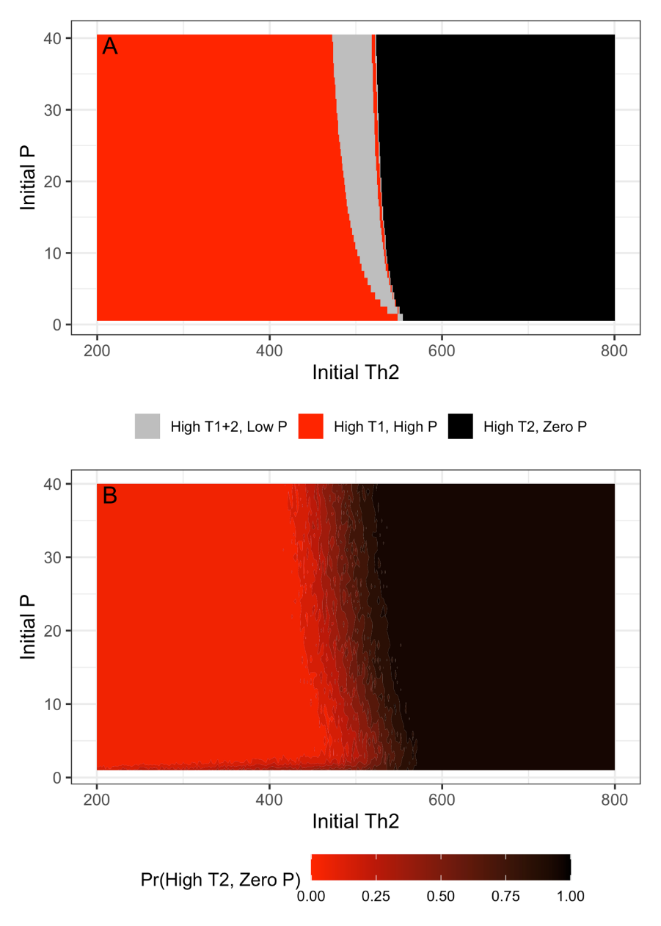
Figure 1.
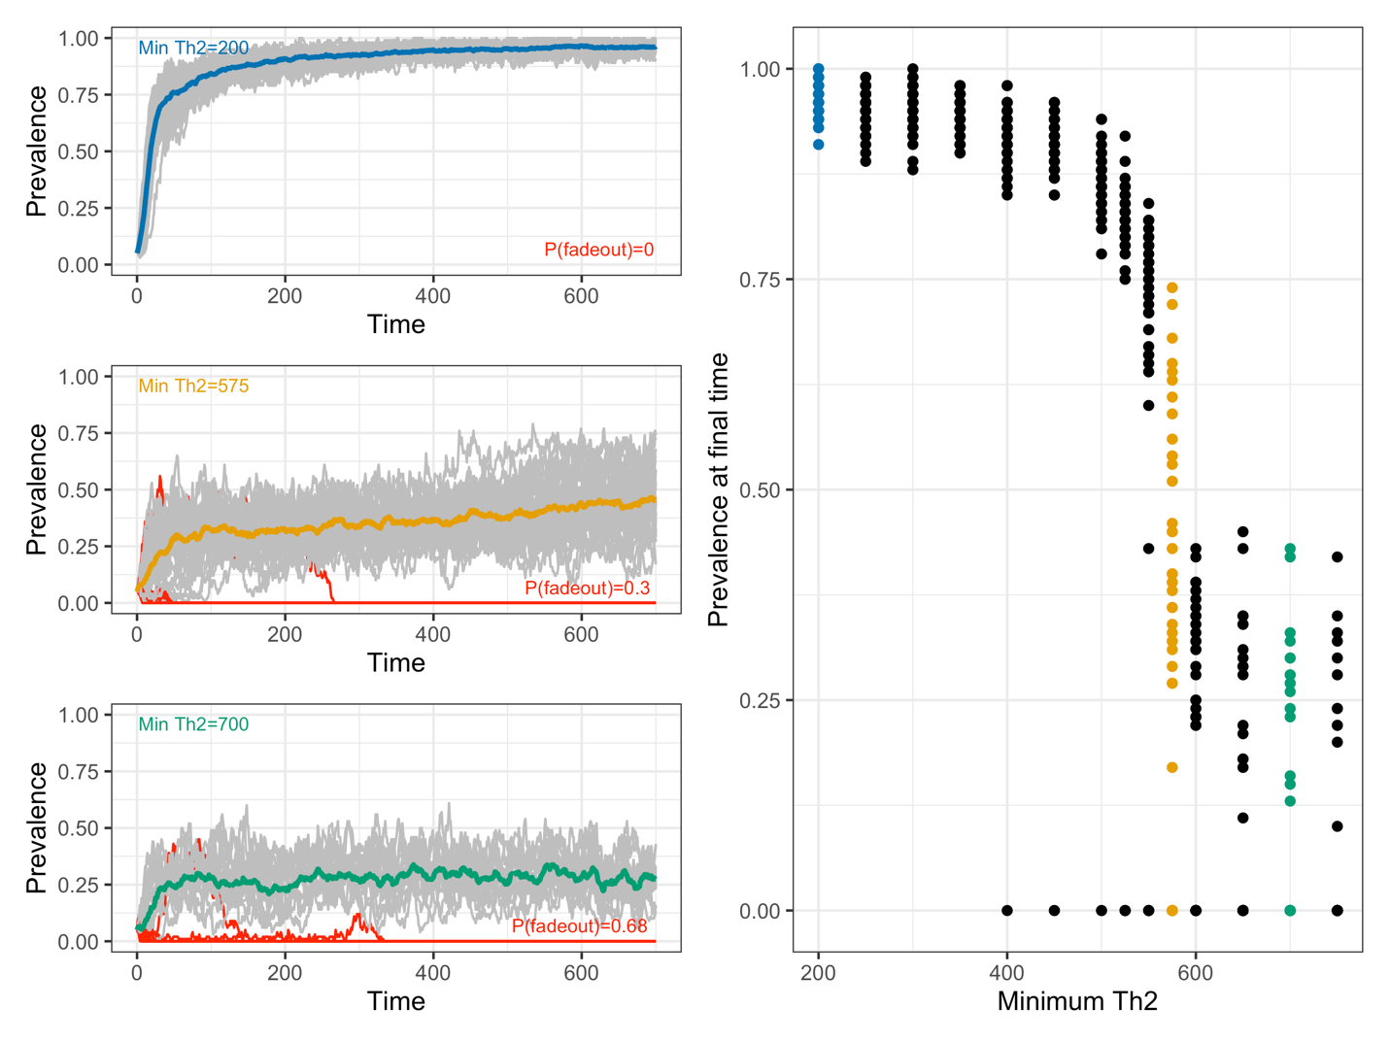
Figure 2.

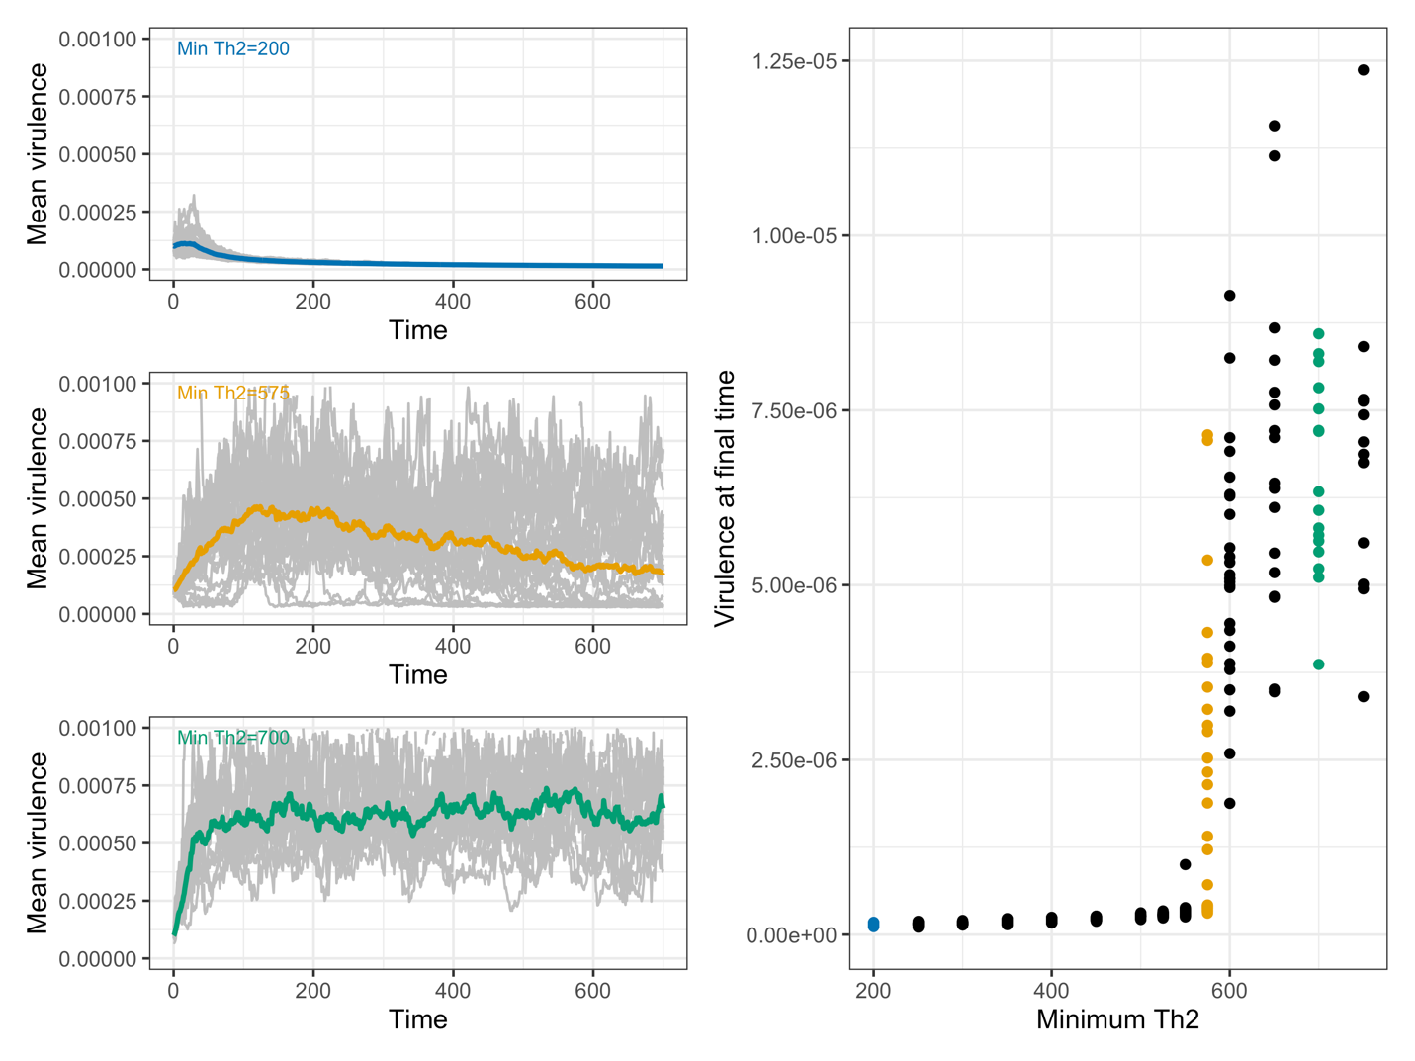
Figure 3.

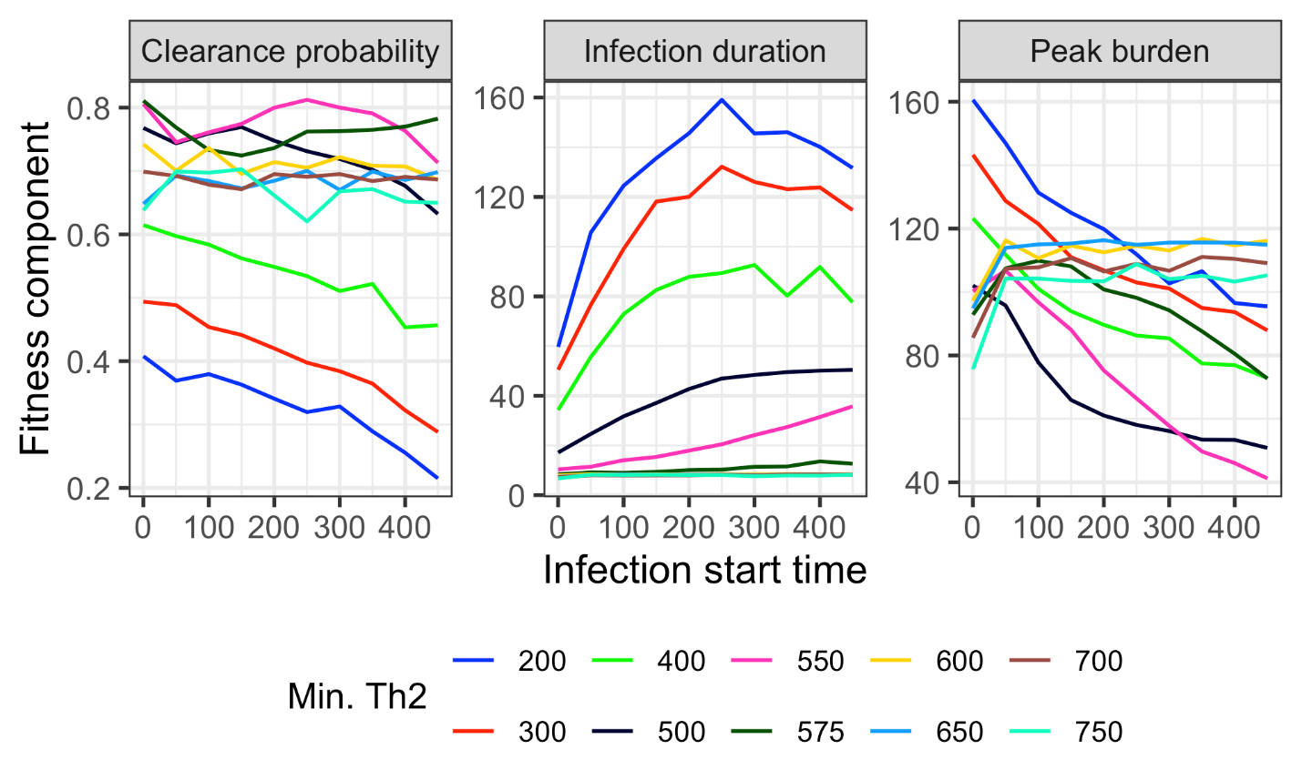
Figure 4.

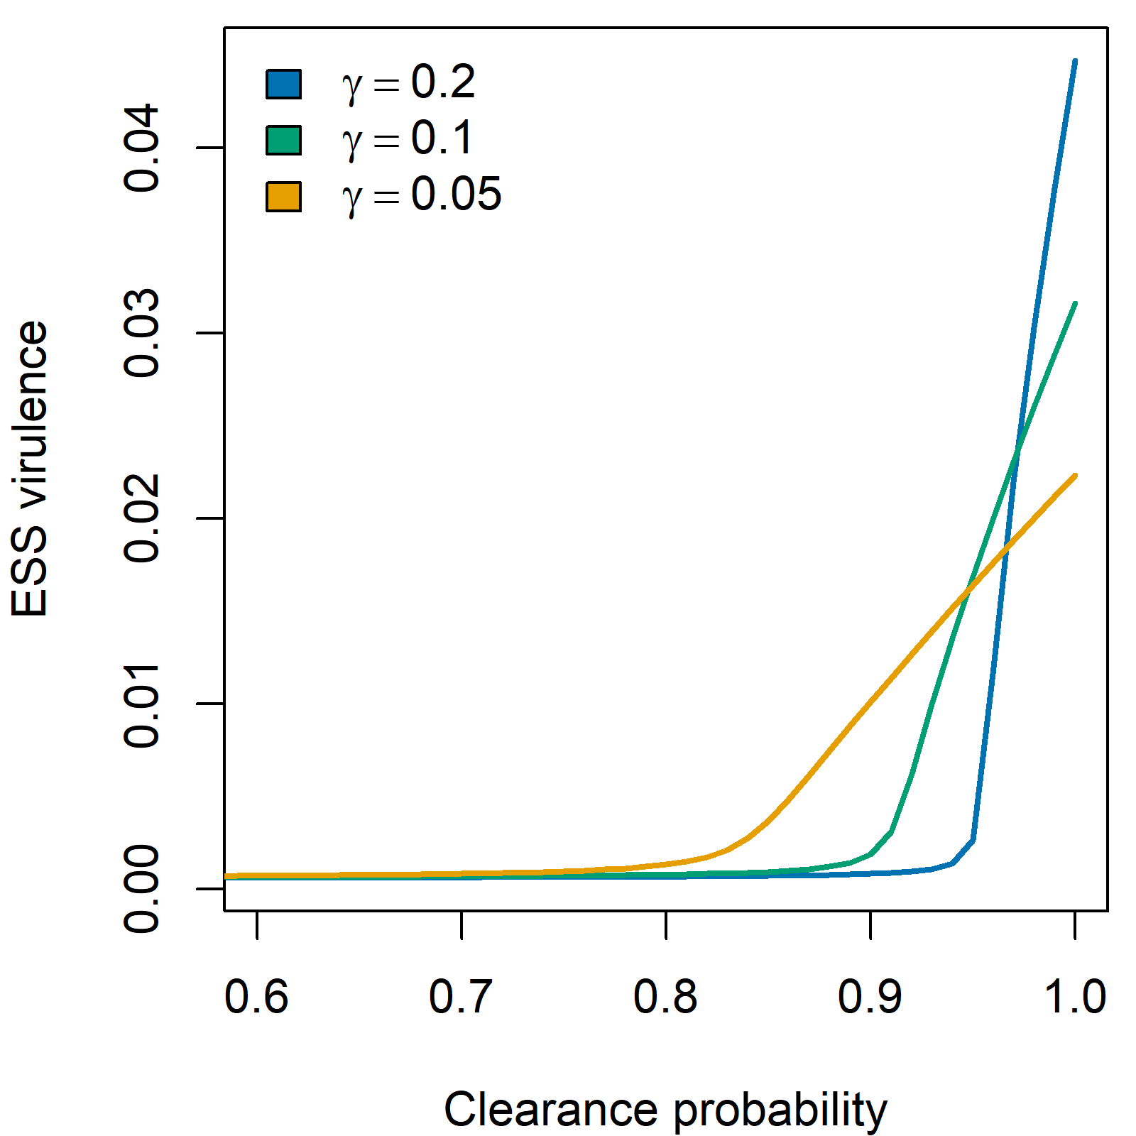
Figure 5.

Table 1: Model parameters
Parameter | Parameter interpretation | Value
$$b_{i}$$ | External activation rate of Th-$i$ response | $$b_{1}=b_{2}=0.1$$
$$c_{i}$$ | Maximum parasite biomass-induced activation rate of Th-$i$ response | $$c_{1}=50,$$  $$c_{2}=130$$
$$C_{i}$$ | Half-saturation constant of parasite biomass-induced activation function | $$C_{1}=C_{2}=50$$
$$s_{i}$$ | Maximum self-activation rate of Th-$i$ response | $$s_{1}=s_{2}=2000$$
$$S_{i}$$ | Half-saturation constant of immune self-activation function | $$S_{1}=S_{2}=1000$$
$$I_{ij}$$ | Half-saturation constant of immune cross-inhibition function | $$I_{12}=I_{21}=10,000$$
$$m$$ | Immune cell apoptosis rate | $$m=0.9$$
$$r$$ | Maximum parasite biomass growth rate | $$r=8$$
$$V_{0}$$ | Half-saturation constant for the virulence—growth function | $$V_{0}=0.0001$$
$$K_{P}$$ | Maximum parasite biomass | $$K_{P}=300$$
$$a$$ | Per-Th2 cell biomass inhibition rate | $$a=0.004$$
$$b$$ | Maximum birth rate of new hosts | $$b=0.1$$
$$K$$ | Host carrying capacity | $$K=100$$
$$c$$ | Per-host contact rate | $$c=0.003$$
$$v$$ | Per-parasite virulence | Evolving: $v(0)=0.0001$
$$v_{CV}$$ | Coefficient of variation in virulence | $$v_{CV}=0.0001$$

