20 July 2015

To the NIH Ruth L. Kirschstein Individual Postdoctoral Fellowship Review Committee:

I am writing this letter in enthusiastic support of Dr. Sarah Budischak’s application. Dr. Budischak has proposed an ambitious, innovative, and important research program that will enhance our understanding of the complex interaction between host nutrition and infection with helminthic parasites. This research seeks to determine (i) how host nutrition jointly affects immune function, parasite development, and their interaction, (ii) the nutritional, immunological, and parasitic factors that establish and disrupt the ‘negative spiral’ of malnutrition and disease common to helminth infections, and (iii) how host nutritional status can shift host defense between strategies of resistance or tolerance. For this work, Dr. Budischak will integrate detailed physiological experiments with a novel, resource budget-based mathematical framework, allowing her to disentangle the complex interactions at the heart of these questions.

The integration of mathematical models with empirical data is an invaluable tool for grappling with the complexity of disease systems. Host nutrition has well-known effects on immune function, but helminthic parasites rely on hosts for their own nutrition as well. Moreover, helminthic parasites manipulate both host nutrition and immune function. The complexity of these interactions makes the mathematical framework proposed by Dr. Budischak an essential component of this proposal. Using this framework to guide experimental design and then challenging the framework with experimental data will increase the impact of this research and demonstrate the utility of the resource budget framework for studying disease systems.

My role in this project will be to help develop and analyze this mathematical framework. This mentorship will provide Dr. Budischak with training in how to use mathematical models to rigorously test biological hypotheses and to guide experimental design. This will be a valuable skillset as she transitions to her independent research career, positioning her to collaborate more broadly with both empiricists and theoreticians and to tackle challenging, integrative questions.

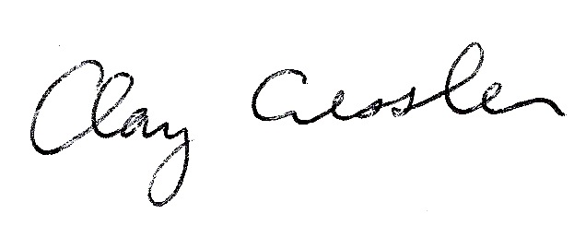There is clear evidence that the global health problems of malnutrition and helminthic parasites are linked. Despite this, we lack the understanding of this linkage necessary to successfully manage these problems to promote human flourishing. The research program laid out in this proposal is an important step towards that understanding. I am thrilled at the opportunity to lend my expertise to help support that program.

Sincerely,

Clayton E. Cressler, Asst. Professor, University of Nebraska