**3. APPROACH**

Giving UAS pilots a better view of the airspace around their vehicle will mitigate any UAVS from infringing on the paths of other aircraft that could potentially cause a mid-air collision. UAS Alert creates a safer environment for UAS operators by giving them a greater awareness of air traffic in the airspace surrounding the UAV. Alerts are displayed on the ground station when any ADS-B OUT signal is received by the on-board module.

UAS Alert consists of multiple subsystems in order to collect information received on the on-board module and aggregate it with information imported from an online source. This will provide a more complete mapping of surrounding aircraft in order to provide alerts to the user. Figure 3.1 shows a high-level overview of UAS Alert and external subsystems that interact with it.

System overview.png

**Figure 3.1 UAS Alert overview.**

**3.1. Hardware**

UAS Alert will incorporate hardware components to make a sufficient and user-friendly system. This subsection will discuss the main hardware components. Each component with alternative options has a discussion on the pros and cons for each option along with reasons for final decisions.

**3.2.1. Power Source and Requirements**

The on-board module must last 1 hour under normal battery draw conditions. The average flight time of the most popular consumer drone is 45 minutes; so by making our design last an hour, we are insuring that the drone operator has ADS-B coverage throughout the duration of their flight. Taking a summation of the current drawn from the Raspberry Pi, the two software-defined radios (SDRs), and the RF module, an equation can be made on what the power source capacity should be. The Raspberry Pi 3 Model B requires a 5 V input and draws around 400 mA with nothing attached to it. The XBee 900 draws a maximum current of 215 mA at 3.3V when it is transmitting. Both SDRs require a maximum of 290 mA-hr to operate which adds to 580 mA-hr. By adding the current draw of each device, it is found that a total of 1,195 mA or 1.195 A is needed for 1 hour. The product of the total current being drawn per hour and the voltage that is required will yield the needed watt hours needed to power UAS Alert. A formulated description is given of the power source capacity needed for UAS Alert in equation (1).

Capacity = (5V \* 400mAhr) + (3.3V \* 215mAhr) + 2 \* (5V \* 290mAhr) = 5.61 Whr (1)

The operation time will be in a maximum range to give a safe estimate. The battery will be rechargeable through a USB connection. Rechargeable lithium-ion and lithium-polymer batteries are being considered for the power source. The three main battery considerations were lithium-ion AA batteries, lithium-ion flat cell batteries, and lithium polymer flat cell batteries.

Due to the weight restrictions on our prototype, the AA lithium-ion batteries proved to be an inappropriate power source. These batteries have added weight contained in the casing of each battery. The requirement of multiple 1.5V batteries to achieve the 5V power needs of the raspberry pi compounded the weight issue, and this added nuisance made this battery option unusable.

Of the remaining battery options, after some research, it was discovered that lithium-polymer batteries have a much greater capacity. The lithium-polymer batteries have been the main focus for UAS systems for a few years due to the freedom with which the chemical composition of the batteries can be manipulated[1]. This situation has led to greater strides being made in the lithium-polymer market. Since our system will require greater power consumption with a limited weight, the lithium polymer flat cell batteries were the obvious choice due to their power capacity at more conservative payload weight.

**3.2.2. Software-Defined Radio**

The on-board module attached to the drone will use two SDRs in order to receive information from aircraft broadcasting on 978 MHz and 1090 MHz. High-gain 978 MHz and 1090 MHz antennas will attach to the SDRs. SDRs were a clear choice for this design due to the low price, small size, and simplicity in operating at any frequency. These radios perform signal processing and modulation/demodulation with the CPU of a computer instead of hardware. SDRs considered for this project are compared in Table 3.2.2.

**Table 3.2.2. Software-Defined Radios**

|  |  |  |  |  |  |
| --- | --- | --- | --- | --- | --- |
| **SDR** | **Frequency Range** | **Frequency Stability** | **Weight (gram)** | **Price** | **Choice** |
| NooElec NESDR SMArt | 25MHz-1700MHz | 0.5PPM | 29 | $21.95 (per SDR) |  |
| NooElec NESDR Nano 2+ | 25MHz-1750MHz | 0.5PPM | 6 | $22.95 (per SDR) | ✔ |
| RTL-SDR.com | 500kHz-1.7GHz | 1PPM | 31 | $24.95 (per SDR) |  |
| Stratux 1090ES & UAT Radio | 1090MHz & 978MHz | Unknown | 5 | $34.99 (both) |  |

All of the SDRs in table 3.2.2. use the R820T2 tuner IC and the RTL2832 USB interface IC. With all of the prices being somewhat similar, thorough documentation and specifications is a big factor in choosing an SDR. The NooElec NESDR Nano 2+ was chosen for this design for two main reasons; it has technical specifications and only weighs 6 grams. The Stratux SDRs were originally used and tested. The NooElec Nano 2+ SDRs have a very similar design to the Stratux SDRs but have a case to cover the hardware and PCB and have more technical documentation. The RTL-SDR.com SDR had a lower frequency stability and was too large to have two running side-by-side on our Raspberry Pi. This SDR is well documented and performs extremely well.

**3.2.3. Development Boards**

A single-board computer will be used for the on-board module. The purpose of the single-board computer is to interpret the information being received from the two SDRs and send it to the ground station via the transceiver.

Qualities that are needed are multiple USB inputs, Linux-based software, and the ability to support 1.2 amps. USB inputs are important because of the amount of power each port can provide in comparison to the GPIO pins that only provide small amounts of power. By using USB ports, information can be sent from the board and powered from the USB without extra power connections coming from the battery pack. The battery back can power the board and the board will power every device needed. Linux software must also be required because dump1090 only runs on Linux-capable devices. Also, 1.2 amps is the estimated current draw from the devices needed to run every device simultaneously [2].

Table 3.2.3. lists the features of the boards that were considered.

**Table 3.2.3. Development Boards**

|  |  |  |  |
| --- | --- | --- | --- |
| **Board** | **Picture** | **Description** | **Choice** |
| Raspberry Pi | Raspberry_Pi_3_1_of_4_711f1ffe-af5e-4923-aa7f-d80651396258_1024x1024.jpg | Open Source  Multiple USB 2.0 Inputs  45 Grams  2.5 Amps  Linux Based | ✔ |
| Arduino | Arduino-uno-perspective-transparent.png | Open Source  6 Digital & 6 Analog Inputs  25 Grams  0.7 Amps  Java/Linux Based |  |

From Table 3.2.3 the Raspberry Pi 3 is the ideal candidate for the intended purposes. The Raspberry Pi features multiple USB inputs that can supply 1.2 A or 500 mA each.

**3.2.4. 1090 MHz and 978 MHz Antennas**

This design will need two separate antennas to receive all of the necessary data from approaching planes and ADS-B ground stations. The antennas used need to be able to operate without a grounding plane. ADS-B signals are vertically polarized requiring a horizontal grounding plane if a monopole antenna was used. A horizontally oriented grounding plane could interfere with the control or video signals of the drone to the operator and would also increase the size of the on-board system. Because of this, dipole ADS-B antennas were chosen to avoid these issues. Table 3.2.4 shows the alternative options, a short description, and which component was chosen.

**Table 3.2.4. Antennas**

|  |  |  |  |
| --- | --- | --- | --- |
| **Antennas** | **Description** | **Price** | **Choice** |
| HUACAM HCM98 Antenna Kit | No Specifications | $16.99 |  |
| NooElec ADS-B Discovery 5dBi Antenna Bundle | High Gain, Documentation, Affordable | $16.95 | ✔ |
| NooElec ADS-B Discovery 3dBi Antenna Bundle | Documentation and Specs, Affordable | $12.95 |  |
| ADS-B High Gain Antenna DMURRAY14 Kit | Large Community use with Stratux Kits | $19.99 |  |

The NooElec ADS-B Discovery 5dBi Antenna Bundle was chosen for this design. The NooElec brand antennas had more technical documentation than the other antennas considered. While both NooElec ADS-B antennas would suit our design just fine, the 5dBi antennas offer superior range and directivity for better ADS-B signal reception. These antennas are sleeve dipole antennas and do not require grounding planes for good signal reception.

**3.2.5. RF Modules**

Table 3.2.1 compares the two RF Modules that were considered.

**Table 3.2.1 RF Modules**

|  |  |  |  |
| --- | --- | --- | --- |
| **RF Module** | **Picture** | **Description** | **Choice** |
| Xbee 900hp | Xbee.PNG | 128-bit AES Encryption  LOS Range: 6500 m (with 2.1 dB antennas)  Frequency: 900 Hz | ✔ |
| Synapse RF 266PC1 | Synapse.PNG | 128-bit AES Encryption  LOS Range: 1220 m  Frequency: 2.4 MHz |  |

The RF modules are a very important part of the design. These modules are used to send the aircraft position data collected and compiled by the onboard system to the ground station. These RF modules must have a large range in order for the UAS pilot to obtain a constantly updated version of the data required for accurate display of air traffic in the surrounding area. We considered two modules based on their higher data rates at greater line-of-sight (LOS) ranges.

These two RF modules were the Synapse RF 226PC1 and the XBee 900hp. Both of these RF modules boasted higher data rates than most competitor’s. At first glance, everything about the Synapse was much better than the XBee. The data rates and antenna Range were much better than the Xbee. However, after further inspection, the difference in LOS range could not be ignored. This difference is due to the ability to change the antenna on the Xbee from the standard wire antenna to a 2dB high gain antenna. This boosts the LOS range of the Xbee to 6500m at the maximum data rate. The synapse comes equipped with a chip antenna that cannot be easily removed from the module. The ability to enhance the Xbee LOS range without risk of damage to the module was the reason that we decided to use the Xbee RF module over the Synapse RF module.

**3.3. Software**

The software used for this project will be based upon elements of Dump1090, Dump978, and PiAware. This software is used to demodulate and decode 1090 Mode S messages and 978 UAT messages, respectively.

**3.3.1. Ground Station**

The UAS Alert ground station will offer services that allow the user to receive synthetically derived ADS-B positions of aircraft that are not ADS-B equipped. This is achievable through multilateration (MLAT). When the aircraft is detected by three or more receivers, the position of the aircraft is triangulated through time difference of arrival (TDOA). Multilateration will increase the accuracy of the data that UAS Alert provides the user. This MLAT data will be available through a TCP connection to MLAT servers, and is an added feature that will only be available when there are three or more receivers running the same MLAT server.

The ground station will be receiving the raw hex messages through the Xbee transceiver, and reading the data through the use of Pyserial. Pyserial is a popular Python library used for serial communication over a USB port. The output of the demodulation software will be redirected to the serial port file.

**3.3.2 Demodulation Software**

As mentioned above, dump1090 and dump978 are commonly used demodulator and decoder software for 1090 MHz Mode S and 978 MHz UAT messages, which are the common names for ADS-B messages sent on 1090 and 978 MHz. They are open source and feature single-bit error correction using 24-bit cyclic redundancy check (CRC). For the project’s purpose, only portions of dump1090 and dump978 will be used. Although dump1090 also decodes the message into a human-readable display of the data field (velocity, position, identification, among other things), the software for the device attached to the UAV will only need to send raw data in the hex format representation of the message to the ground station where it will be interpreted. Additionally, not all of the data fields are relevant to the purpose of the design and may be omitted before sending. This will reduce the data payload per message being sent to the ground station via the transceivers. No alternative software was found for SDR demodulators that dealt with ADS-B. In order to focus more on implementations, the team chose to use this open-source software instead of trying to fully design it on our own.

**3.3.3 Operating System**

In order to support our software choices, the operating system must be Linux based. Dump1090, dump978, and PiAware are all built to run on a linux-based machine. There is a version of dump1090 that is compatible with Windows. However, no such version exists for dump978. Raspian is a linux based operating system for the Raspberry Pi and will be what is used for this design due to the team’s previous experience with Raspbian and for compatibility purposes for all software involved.

**3.3.4 Device Drivers**

The device on the flight frame will incorporate software that will drive the transceivers and transmit the demodulated dump1090 data as mentioned above. This code will be written in C++ and Python due to the familiarity with these programming languages. Pyserial is a Python library that adds support for serial connections and will be crucial for the on-board’s functionality. With Pyserial, we will use this data to transmit the raw hexadecimal representation of the messages over the Xbee transceivers. These messages range from 14 to 28 bytes and will be sent with a start of frame and end of frame character to assist in parsing the data on the receiving end.

**3.3.5 Display and Alerts**

UAS Alert will feature a map overlay of all detected aircraft. This feature will be written in HTML and Javascript and will use the OpenLayers API to display the coordinates of the surrounding aircraft on a dynamic map view. OpenLayers is an open-source Javascript API that makes it easy to put positions on an accurate map in a web page. Alerts and simple advisories will be given to the user when the UAV is in danger of colliding with an approaching aircraft. These simple advisories will include directions to make maneuvers such as ascend or descend as needed.

**3.3.6. Use Case Scenarios**

A sunny day case scenario describes the optimal operation of UAS Alert. This case would be when the user attaches the on-board module to the UAV and the UAS pilot opens the user interface on the ground station. Once the UAV is near an ADS-B OUT equipped aircraft an ADS-B message is received and the user is notified of surrounding traffic. Figure 3.2 shows the ideal steps of implementing UAS Alert.

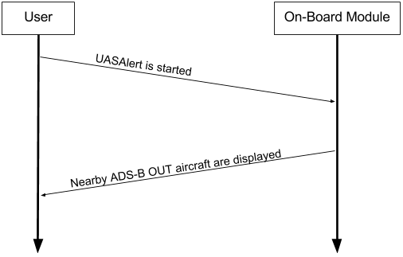

**Figure 3.2: Sunny Day Case Scenario.**

A rainy day scenario describes errors that could occur in the system. Figure 3.3 shows an example of one possible scenario where the RF module goes out of range during operation. The RF modules are limited to a range where data can be reliably transmitted to the ground station. A built-in feature allows the user to know the signal strength but errors can still occur if signal strength becomes too low.

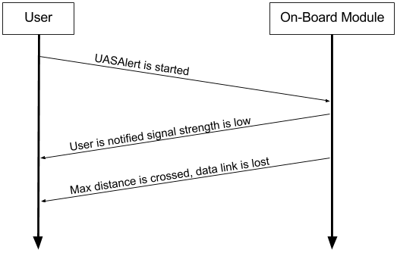

**Figure 3.3: Rainy Day RF module range case.**

Figure 3.4 shows a scenario where data packets are lost during operation. Packet loss could happen for multiple reasons such as other devices broadcasting on the same frequency or outside noise. The RF modules have a built-in feature that will give a notification that packet loss has happened, but this is not optimal performance.

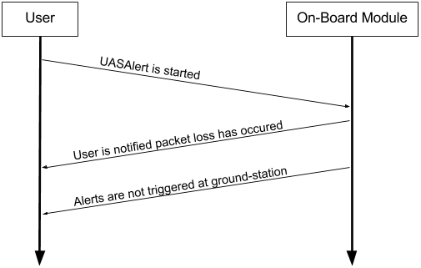

**Figure 3.4: RF module packet loss scenario.**

**References**

[1]Scottie.(2015, June 21). *Lithium Polymer vs Lithium-Ion batteries: What’s the deal?*[Online]. Available: https://scottiestech.info/2015/06/21/lithium-polymer-vs-lithium-ion-batteries-whats-the-deal/.

[2]"Raspberry Pi FAQs - Frequently Asked Questions", *Raspberry Pi*, 2016. [Online]. Available: https://www.raspberrypi.org/help/faqs/#power. [Accessed: 01- Nov- 2016].