## 3. Product Summary

## Product Description

UAS Alert is a battery powered situational awareness technology that will attach to a host UAV and transmit ADS-B messages it receives to the ground station software running on the user’s laptop. The module attached to the UAV consists of a GPS, two software-defined radios tuned for 978 MHz and 1090 MHz that intercept ADS-B messages being broadcast on those frequency bands, a transmitter to rebroadcast them to the ground station, and a single-board computer. The device assists the UAS operator in avoidance of aircraft by providing a map display of the aircraft in the vicinity. The user is visually alerted when their UAV is potentially in the path of another aircraft.

## Customer Needs and Benefits

Currently there are very few products that allow a UAV pilot to see the air traffic around their aircraft. UAS Alert will provide the first mid-flight UAV aircraft detection so that collisions can be minimized. Our device will provide an easy to understand display and simple startup for the user. Another benefit of UAS Alert is that it can be attached to any capable drone, and the user can swap our device from one machine to another with ease. Lastly, one of the greatest benefits is that our device is durable enough to last hundreds of flights reliably.

## Future Products

Once UAS Alert establishes itself in drone-to-aircraft collision avoidance technologies, we plan to create technologies for drone-to-drone collision avoidance. New, expensive drones like the DJI Phantom 4 have this technology implemented already in the form of sense-and-avoid. Our plan is to create a portable drone-to-drone alert system that is integrated with the drone-to-aircraft technology for any drone that does not already have sense-and-avoid.

## Competitive Comparison

Uavionix is a company that sells awareness and avoidance systems for UAVs. Their products are designed for specific UAVs and flight controllers. For this reason, their products do not operate with a wide range of UAVs. If a user who owns an unsupported UAV wished to have the functionality that Uavionix products offer, they would have to replace their own flight controller, which can be nontrivial for the average consumer, or buy a supported UAV such as the DJI Phantom 3 which sells for $499 or the Phantom 4 which sells for $949. UAS Alert offers the solution to this problem. Unlike Uavionix, UAS Alert provides a more platform independent solution. Any UAV that can fit the device will be able to make use of it. The device provides its own power source and does not rely on the host UAV’s flight controller. As such, UAS Alert is portable between UAVs and can be easily detached from one onto another.

With Uavionix, a customer may have to purchase a supported flight controller, if they wish to replace their own, of approximately $130, as well as an ADS-B receiver that ranges from $125 to $1200 depending on the functionality you want. If the customer is unable or unwilling to replace their flight controller, they would be required to buy a supported UAV for around $499. Alternatively, UAS Alert is able to supply the full awareness system for $199.

## 4. Market Summary

## 4.1 Market Analysis

UAS Alert will target both the commercial and hobbyist market. Once the business is stable, the company will seek to expand the functionality of products to work with other platforms such as mobile phones. This will make UAS Alert products easily accessible to the user.

## 4.2 Marketing Strategy

An online business strategy through Amazon will the be the simplest way to establish a storefront. There are also conventions UAS Alert will be involved with such as the New England Aviation Safety Expo that is organized by the FAA. The FAA also has the annual FAA UAS Symposium which is directly targeted at UAS integration with the National Airspace System (NAS).

Commercial sales will be a large part of our total sales due to the increasing use of UAVs in commercial applications. In fact, by 2021, commercial UAV use is projected to rise tenfold. For the commercial market, our company will approach businesses that use UAVs in their workforce such as airborne photographers, delivery services, and construction companies. We will inform them of the potential hazard of high flying UAVs as well as the potential legal responsibilities should they cause a collision. If sold to companies that sell UAVs, our company will offer them our product as a solution as well as a discounted price if they advertise our product as an additional package to be sold with their product.

In addition to the advertisement through potential commercial partnerships mentioned above, UAS Alert will seek to advertise through television and internet articles for UAV hobbyists. In these advertisements, we will give a description of our product as well as its necessity. We will reinforce our claims by listing any existing partnerships using our product, which will be mutually beneficial to us and the customers.

## 4.3 Sales Projection

The target price of our product will be $199, with a projected manufacturing cost of $100 per unit. Figure 4.1 shows the sales projections for the first 3 years of production. The first two years we are projected to sell 50 and 100 units respectively. The third year, the company is projected to sell 500 units. This large jump in expected sales is due to the enactment, in year 2020, of the ADS-B mandate requiring all aircraft operating in certain airspace classes to be equipped with ADS-B equipment as well as the increasing commercial UAV use.

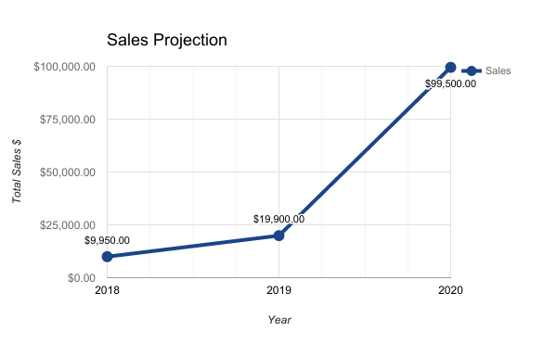

**Figure 4.1 Sales Projection for Years 2018-2020**

## 4.4 Manufacturing and Distribution Strategy

Assuming no significantly large orders of units are placed during the first two years, assembly by hand should be sufficient until order sizes bring profits high enough to implement an automated system. Since UAS Alert is compact and lightweight it can be easily mailed through typical mail services such as FedEx or UPS.