## 5. Organization Overview

## 5.1 Company Structure

To ensure that responsibility is spread out among the founders after startup, each member will be in charge of their field of expertise. Brian Joyner will be in charge of software development. Clayton Hudspeth will be the lead developer for UAS alert display and interface. Carter Long will be in charge of hardware development and assembly. Chase Abercrombie will head the packaging and durability department. Brady Wade will be the lead salesman and marketer.

Company Structure (1).png

**Figure 5.1 Company Structure**

## 5.2 Personnel Plan

UAS Alert will seek to employ personnel to strengthen any weaknesses we may encounter in the future as a company. Once a financial foundation has been set, the company would seek to employ an accountant as well as a marketing professional. Additional software developers would be hired to refine and add features to improve our product. Long term, the business would have several teams performing dedicated tasks such as maintaining existing products, reducing the bill of materials without compromising quality, developing new products, and marketing.

## 6. Financial Plan

## 6.1 Profit and Loss

The bill of materials can be considerably lowered by redesigning the product. With initial estimates, the device could be manufactured for $100 per unit, netting a profit of $100 per unit sold.Rent was listed as $0.00, as the company will be operating out of the apartment of an owner, and will not be coming out of the company funds. The owners do not expect a substantial amount of salary from the business for the first three years of operation, and will still be reliant on a full-time job during this time. $500 has been set aside for insurance in case of workplace injury, and $1000 for traveling expenses as we plan to advertise our product at conventions. An additional $3,000 will be used for advertising through online resources.

**Table 6.1 Profit and Loss**

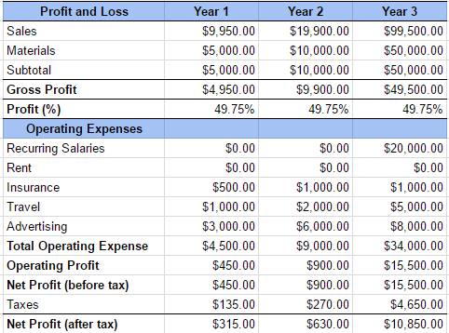

## 6.2 Projected Cash Flow

**Table 6.2 Projected Cash Flow**

## 

## 6.3 Projected Balance Sheet

**Table 6.1 Projected Balance**

