## 1. Plan Overview

## Mission

Our mission here at Unmanned Aerial System (UAS) Alert is to lead the aircraft detection sector in safety, reliability, and affordability. Our products will also adhere to the rules and regulations the Federal Aviation Administration (FAA) has in place for the safety of all aircraft. We plan to continuously develop new innovative technology for all aircraft to keep the skies safe for all aviation hobbyists. The unique advantage of UAS Alert is that our products will be available to a wide-range of Unmanned Aerial Vehicles (UAVs) and easily moveable from one airframe to the next.

## Objectives

UAS Alert’s primary company objective is to provide safer navigation for both aircrafts and UAVs. We plan to do this by making coordinates of the surrounding aircraft known by UAV operators to potentially reduce mid-air collisions. We aim to have 20% of UAV operators using our technology while flying their UAVs within 5 years after developing a fully operational product.

The product oriented objective of UAS Alert is to create an easily integratable and user-friendly product for UAS operator situational awareness and safety, with a simple yet feature rich display that will be ported to other operating systems and platforms in the future. This will improve the mobility of the product by eliminating the need to carry a laptop to the site. Another main objective for product improvement is to have drone-to-drone collision avoidance technology. As the popularity of both drones and our product increase, aircraft avoidance for drones equipped with our product will be a unique selling point of our product and will enhance the UAS Alert community.

## Keys to Success

An important key to success is becoming a favored brand name among commercial UAS operations. The UAS community will look to these companies and understand that our product is proven to work in the field. We should also strive to be an active member in the aviation community and all things related to the FAA. Specifically, convincing the FAA that our products will make their job easier. In order to provide a better product, we will make use of Failure Mode and Effects Analysis (FMEA), a strategy to identify the effects of failures on a system as well as to eliminate or reduce chances of failures.

## Competitive Advantage

Unlike other products on the market, UAS Alert is an independent system that does not rely on the inner workings of the airframe to which it is attached. Products offered by other companies inject themselves into the UAV and communicate with the UAV’s flight controller, while solutions made at UAS Alert do not interfere with the aircraft. Products from UAS Alert even provide their own battery and do not drain the host aircraft’s battery.

The portability of the devices from one airframe to another is advantageous for its user. The customer will not need to wait on a new line of products to be compatible should they wish to make a design change of their own, as the solutions offered at UAS Alert aim to be platform independent.

Our products aim to provide a reasonable level of customization among antennas. As different antennas can have different pros and cons, the decision as to which antenna best fits the job can be left to the customer.

## Target Market

UAS Alert aims to provide solutions for hobbyists and businesses alike. Our products may be used in any area that mandates or uses Automatic Dependent Surveillance Broadcast (ADS-B) transceivers in aircraft. In fact, the FAA has mandated the use of ADS-B out in all aircraft that already require a “Mode C” transponder by January 1, 2020. With increased use of ADS-B as well as an increasing number of regulations on drone usage, both companies and hobbyists will benefit from a safety system. The FAA predicts that total annual UAV sales will increase from 2.5 million in 2015 to 7 million in 2020 [1]. A larger number of UAVs in the sky will mean a higher risk of collision, further increasing the need for such a system.

## Basic Strategies

UAS Alert will at first look for investors by offering portions of the company’s equity equaling up to 15%. We will explain our business plan and the advantages over the current market to these potential investors. Other finances will be obtained through loans, and eventually look for contracts with companies to obtain a steady, flowing income. We will introduce our product to companies that use or sell UAVs by participating in aviation conventions. At the conventions, we will explain the benefits of our system with regard to the rules and regulations set forth by the FAA and other aviation safety agencies, as well as explain the risk posed by improper use of UAVs.

Once we have the funds for startup, we will look to find manufacturers and distributors. We will provide and discuss a full manufacturer's suggested retail price (MSRP) analysis and negotiate costs for manufacturing and distribution. To remain competitive and increase revenue, we will attempt to reduce the bill of materials when possible without risking the quality of the product. The company will seek to maintain our products, so that they do not become obsolete. We will provide bug fixes and updates as needed to please the customer.

After we have a stable business in the market, we will seek to expand our product to be compatible with a wider range of platforms and operating systems for phone and tablet devices, as well as improving functionality of our products outside the scope of UAVs, such as improvements that will make it more desirable in larger aircraft as well. Increased drone sales could also open up the market to benefit from a system that detects drones as well. This would help prevent collisions in populated areas where multiple users may be flying a UAV.

## 2. Company Summary

## Company Description

UAS Alert will choose the LLC path. The added benefits of limited liability fit the nature of the company and market UAS Alert will be a part of.

## Company Location and Facilities

UAS Alert will begin developing its products in Brian’s apartment in Starkville, MS. This location is affordable and close to Mississippi State University where there are numerous engineering facilities like the Maker Space, which is a space to develop and assist constructing our products. This location also makes it easier to recruit graduating engineers to the UAS Alert engineering team. Once enough money is made at this location, we will gradually grow into larger facilities to better support the needs of the growing drone market. We plan to go from Brian’s apartment to an office space rental, then eventually to a small warehouse for all the manufacturing and engineering offices.

## Company Strategy

Diving straight into the hobbyist market and expecting a grand return would be unrealistic. Commercial industry sets the playing field for anything safety and aviation related. Getting into the commercial side of the UAS field would be the only way to appeal to the average consumer, since they will want trusted products.. A well known and proven brand name is the best chance for success.

## Startup Costs

UAS Alert LLC is budgeting $1,000 in legal fees to pay the LLC cost for the state of Mississippi and website address. We estimate about $900 to fine tune and develop 3 prototypes. Each will cost $300 for parts. Our advertising will cost around $4,000 for shows, magazine ads, and online advertising. Insurance is to protect our product with patents which will cost $1,000 for fees. Our equipment needs for demonstrations are several UAV model drones which will equal $2,000. We expect to encounter around $1,000 in miscellaneous fees as well. We will start with a $15,000 balance with $2,000 in inventory for initial sales and startup production. This will bring our startup requirements to a total of $27,000. Each of the owners will be working other full-time jobs for the first three years to ensure financial stability while pursuing this business venture. For the first three years, each owner will invest a portion of their personal income into the company, starting with $5,000 per person in the first year. For the second and third years, each will invest $10,000.

**Table 2.1 Startup Expenses and Funding**

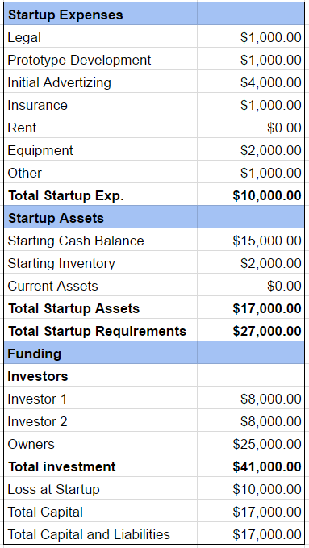

## 3. Product Summary

## Product Description

UAS Alert is a battery powered situational awareness technology that will attach to a host UAV and transmit ADS-B messages it receives to the ground station software running on the user’s laptop. The module attached to the UAV consists of a GPS, two software-defined radios tuned for 978 MHz and 1090 MHz that intercept ADS-B messages being broadcast on those frequency bands, a transmitter to rebroadcast them to the ground station, and a single-board computer. The device assists the UAS operator in avoidance of aircraft by providing a map display of the aircraft in the vicinity. The user is visually alerted when their UAV is potentially in the path of another aircraft.

## Customer Needs and Benefits

Currently there are very few products that allow a UAV pilot to see the air traffic around their aircraft. UAS Alert will provide the first mid-flight UAV aircraft detection so that collisions can be minimized. Our device will provide an easy to understand display and simple startup for the user. Another benefit of UAS Alert is that it can be attached to any capable drone, and the user can swap our device from one machine to another with ease. Lastly, one of the greatest benefits is that our device is durable enough to last hundreds of flights reliably.

## Future Products

Once UAS Alert establishes itself in drone-to-aircraft collision avoidance technologies, we plan to create technologies for drone-to-drone collision avoidance. New, expensive drones like the DJI Phantom 4 have this technology implemented already in the form of sense-and-avoid. Our plan is to create a portable drone-to-drone alert system that is integrated with the drone-to-aircraft technology for any drone that does not already have sense-and-avoid.

## Competitive Comparison

Uavionix is a company that sells awareness and avoidance systems for UAVs. Their products are designed for specific UAVs and flight controllers. For this reason, their products do not operate with a wide range of UAVs. If a user who owns an unsupported UAV wished to have the functionality that Uavionix products offer, they would have to replace their own flight controller, which can be nontrivial for the average consumer, or buy a supported UAV such as the DJI Phantom 3 which sells for $499 or the Phantom 4 which sells for $949. UAS Alert offers the solution to this problem. Unlike Uavionix, UAS Alert provides a more platform independent solution. Any UAV that can fit the device will be able to make use of it. The device provides its own power source and does not rely on the host UAV’s flight controller. As such, UAS Alert is portable between UAVs and can be easily detached from one onto another.

With Uavionix, a customer may have to purchase a supported flight controller, if they wish to replace their own, of approximately $130, as well as an ADS-B receiver that ranges from $125 to $1200 depending on the functionality you want. If the customer is unable or unwilling to replace their flight controller, they would be required to buy a supported UAV for around $499. Alternatively, UAS Alert is able to supply the full awareness system for $199.

## 4. Market Summary

## 4.1 Market Analysis

UAS Alert will target both the commercial and hobbyist market. Once the business is stable, the company will seek to expand the functionality of products to work with other platforms such as mobile phones. This will make UAS Alert products easily accessible to the user.

## 4.2 Marketing Strategy

An online business strategy through Amazon will the be the simplest way to establish a storefront. There are also conventions UAS Alert will be involved with such as the New England Aviation Safety Expo that is organized by the FAA. The FAA also has the annual FAA UAS Symposium which is directly targeted at UAS integration with the National Airspace System (NAS).

Commercial sales will be a large part of our total sales due to the increasing use of UAVs in commercial applications. In fact, by 2021, commercial UAV use is projected to rise tenfold. For the commercial market, our company will approach businesses that use UAVs in their workforce such as airborne photographers, delivery services, and construction companies. We will inform them of the potential hazard of high flying UAVs as well as the potential legal responsibilities should they cause a collision. If sold to companies that sell UAVs, our company will offer them our product as a solution as well as a discounted price if they advertise our product as an additional package to be sold with their product.

In addition to the advertisement through potential commercial partnerships mentioned above, UAS Alert will seek to advertise through television and internet articles for UAV hobbyists. In these advertisements, we will give a description of our product as well as its necessity. We will reinforce our claims by listing any existing partnerships using our product, which will be mutually beneficial to us and the customers.

## 4.3 Sales Projection

The target price of our product will be $199, with a projected manufacturing cost of $100 per unit. Figure 4.1 shows the sales projections for the first 3 years of production. The first two years we are projected to sell 50 and 100 units respectively. The third year, the company is projected to sell 500 units. This large jump in expected sales is due to the enactment, in year 2020, of the ADS-B mandate requiring all aircraft operating in certain airspace classes to be equipped with ADS-B equipment as well as the increasing commercial UAV use.

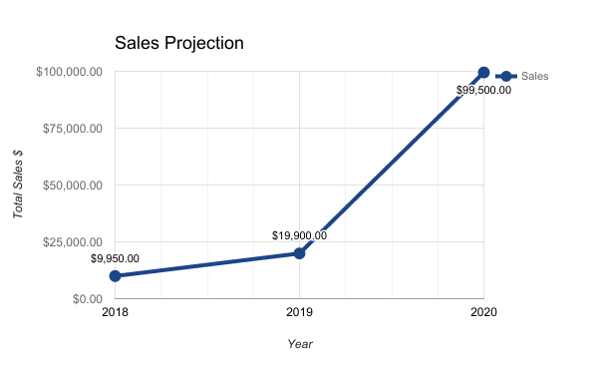

**Figure 4.1 Sales Projection for Years 2018-2020**

## 4.4 Manufacturing and Distribution Strategy

Assuming no significantly large orders of units are placed during the first two years, assembly by hand should be sufficient until order sizes bring profits high enough to implement an automated system. Since UAS Alert is compact and lightweight it can be easily mailed through typical mail services such as FedEx or UPS.

## 5. Organization Overview

## 5.1 Company Structure

To ensure that responsibility is spread out among the founders after startup, each member will be in charge of their field of expertise. Brian Joyner will be in charge of software development. Clayton Hudspeth will be the lead developer for UAS alert display and interface. Carter Long will be in charge of hardware development and assembly. Chase Abercrombie will head the packaging and durability department. Brady Wade will be the lead salesman and marketer.

Company Structure (1).png

**Figure 5.1 Company Structure**

## 5.2 Personnel Plan

UAS Alert will seek to employ personnel to strengthen any weaknesses we may encounter in the future as a company. Once a financial foundation has been set, the company would seek to employ an accountant as well as a marketing professional. Additional software developers would be hired to refine and add features to improve our product. Long term, the business would have several teams performing dedicated tasks such as maintaining existing products, reducing the bill of materials without compromising quality, developing new products, and marketing.

## 6. Financial Plan

## 6.1 Profit and Loss

The bill of materials can be considerably lowered by redesigning the product. With initial estimates, the device could be manufactured for $100 per unit, netting a profit of $100 per unit sold.Rent was listed as $0.00, as the company will be operating out of the apartment of an owner, and will not be coming out of the company funds. The owners do not expect a substantial amount of salary from the business for the first three years of operation, and will still be reliant on a full-time job during this time. $500 has been set aside for insurance in case of workplace injury, and $1000 for traveling expenses as we plan to advertise our product at conventions. An additional $3,000 will be used for advertising through online resources.

**Table 6.1 Profit and Loss**

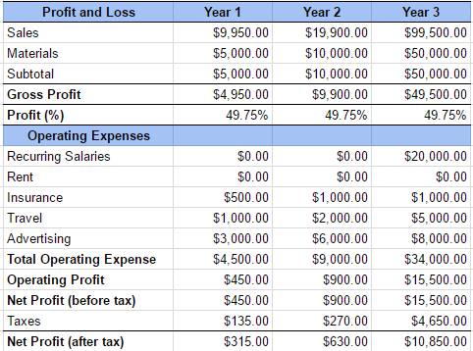

## 6.2 Projected Cash Flow

**Table 6.2 Projected Cash Flow**

## 

## 6.3 Projected Balance Sheet

**Table 6.1 Projected Balance**

