**4. EVALUATION**

The following section details the tests that were conducted on the components of UAS Alert to ensure that the design constraints stated in Table 4.1.1. are met.

**4.1. Test Specifications**

**Table 4.1.1. Technical Design Constraints**

|  |  |
| --- | --- |
| **Name** | **Description** |
| **Transmission** | The transceiver must remain within line-of-sight range for wireless communications. The maximum range of the transceiver must be longer than the signal range of the remote controller of the UAV. |
| **Device Weight** | The device must weigh under 300 grams. |
| **Battery Life** | The battery must be able to supply the on-board device with an hour of usage. |
| **Compact Design** | The airframe attachment must fit on a typical UAV. |
| **Response Time** | The total response time of the system must be no longer than 1 minute to give the user time to adjust the flight path. |

**4.2. Test Specification - Transmission**

Range tests were done with the Digi XTCU application. The Digi XTCU application is a graphical interface to set-up, configure, and test XBee RF modules [1]. Two members held laptops with the XTCU application and the XBee modules hooked up to the USB. A GPS distance measuring app was used to test the difference between members. The application showed the signal strength and the amount of transmitted, received, and lost packets during the test. Figures 4.2.1., 4.2.2., and 4.2.3. shows the test done at 280, 520, and 1200 feet.

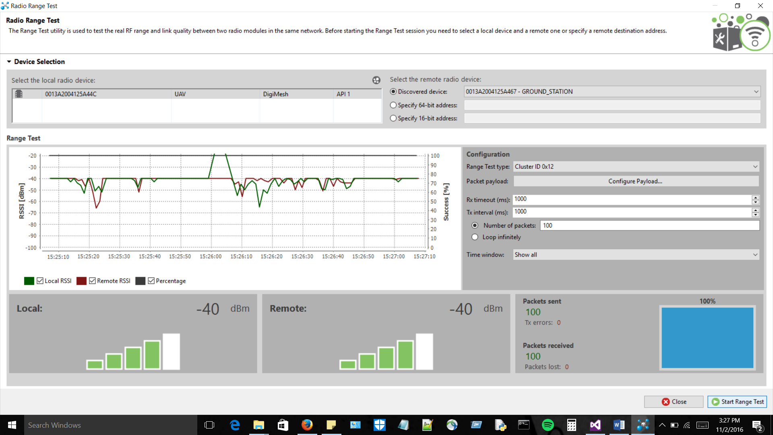

**Figure 4.2.1: Signal Strength at 280 ft**

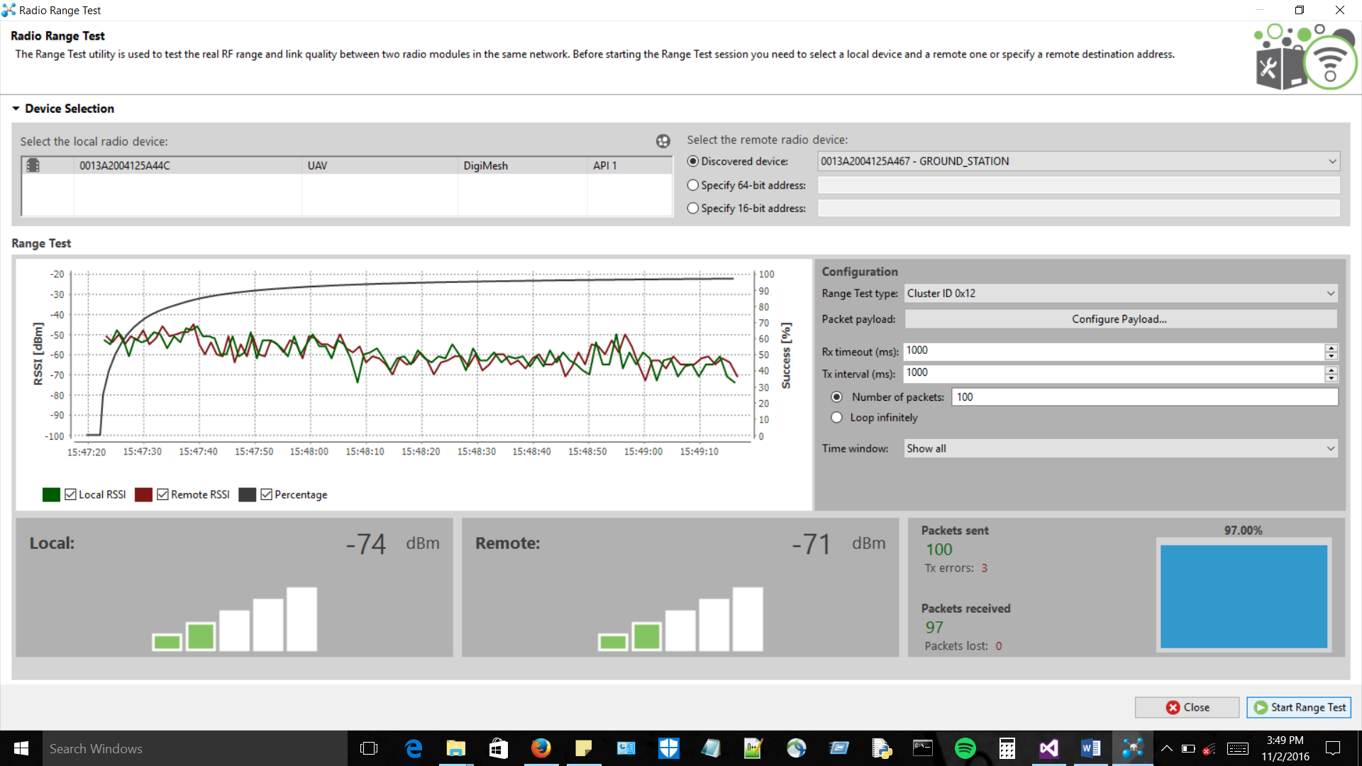

**Figure 4.2.2: Signal Strength at 520 ft**

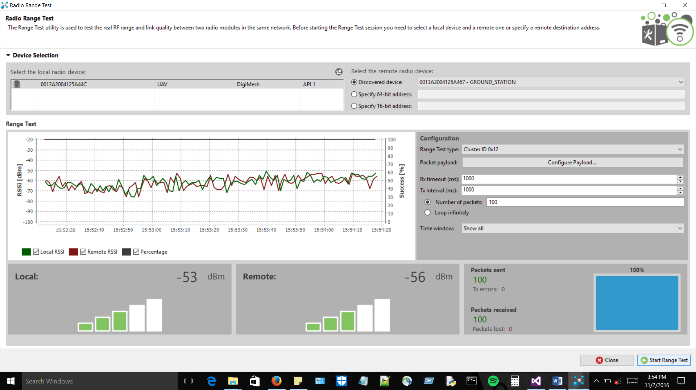

**Figure 4.2.3: Signal Strength at 1200 ft**

The above Figures 4.2.1-4.2.3 show the average dBm for their respective distances. These test were done with the default antennas that came with the XBee 900HP kit. A packet size of 50 bytes was the test packet size. Further testing is needed to decided if higher quality antennas are required.

**4.3. Test Specification - Device Weight**

The weight of the individual components was measured using a precise scale. Figure 4.3.1 shows the software-defined radios (SDRs), the adapter cables, and the 3dBi antennas. Figure 4.3.2 shows the weight of the Raspberry Pi 3 Model B with a case. The battery has not arrived yet but the weight of the combined components other than the battery is 118 grams. This leaves us with 182 grams for the battery pack to stay within our weight constraint.

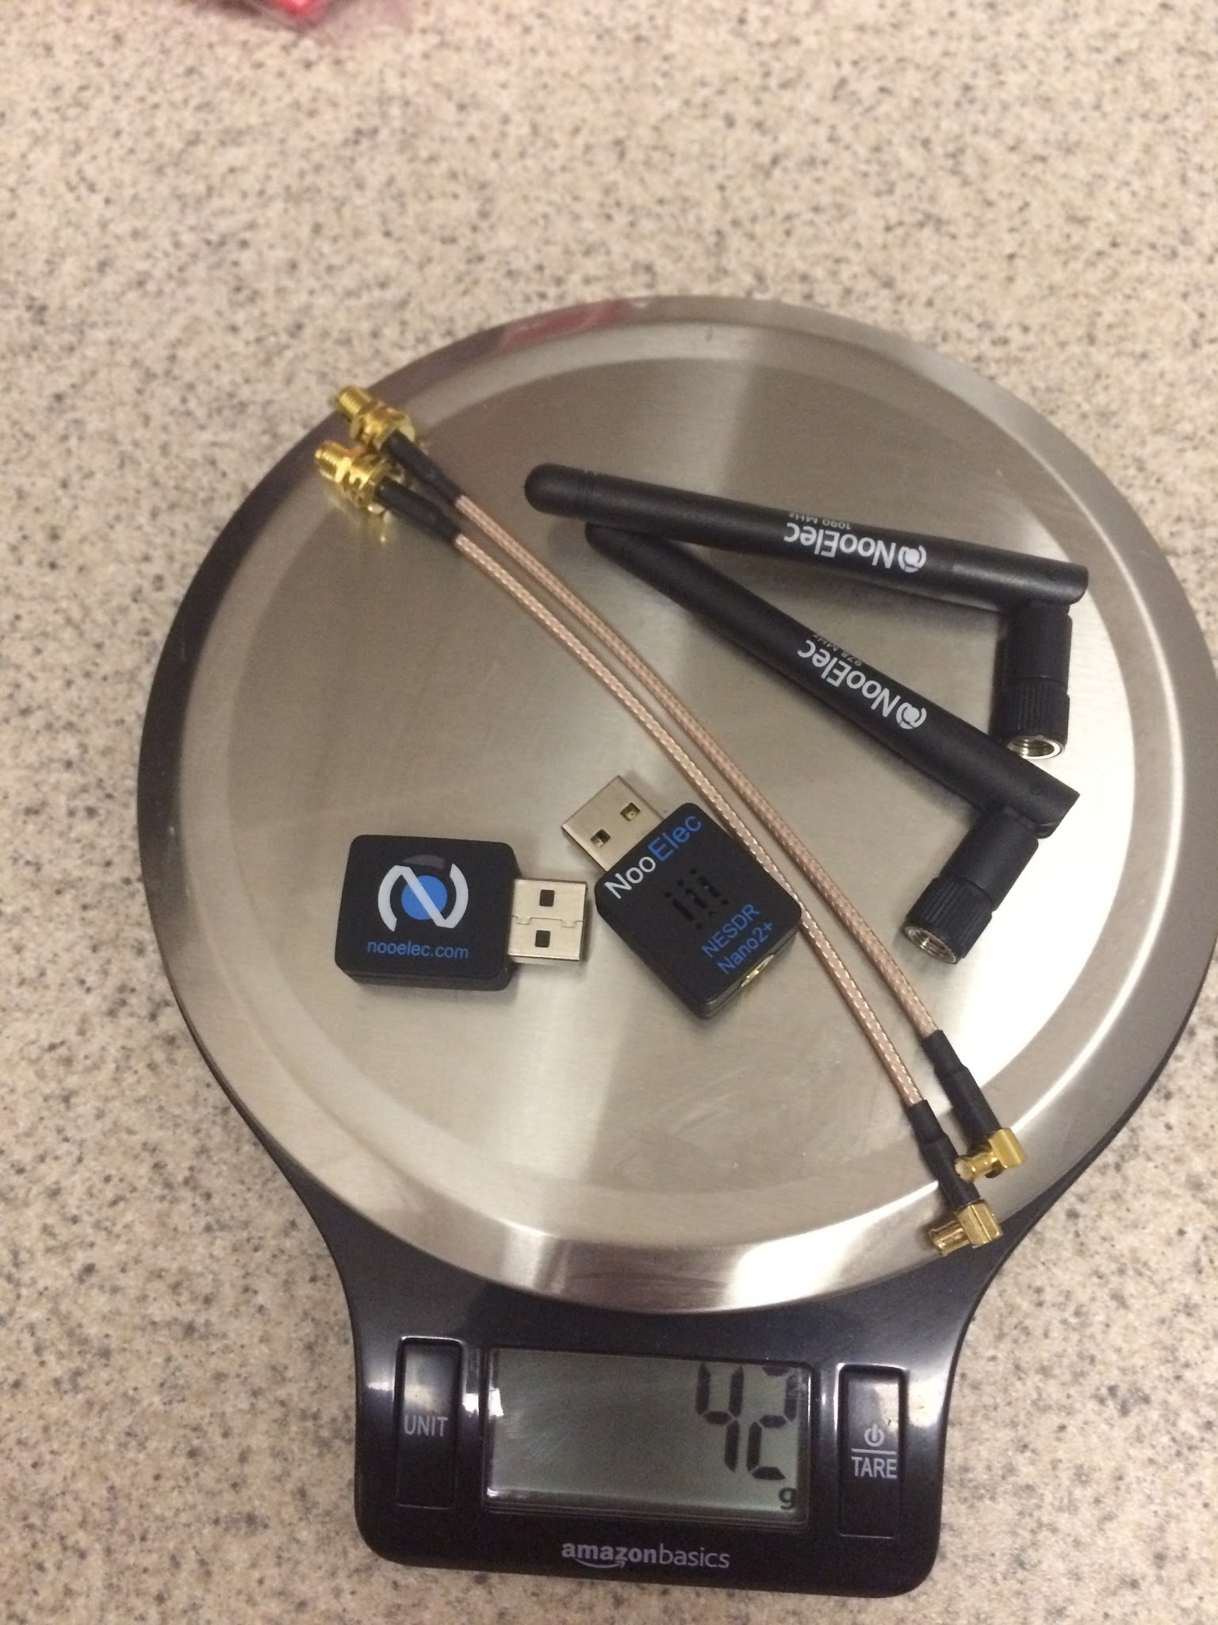

**Figure 4.3.1: Weight of SDRs, antennas, and adapter cables**

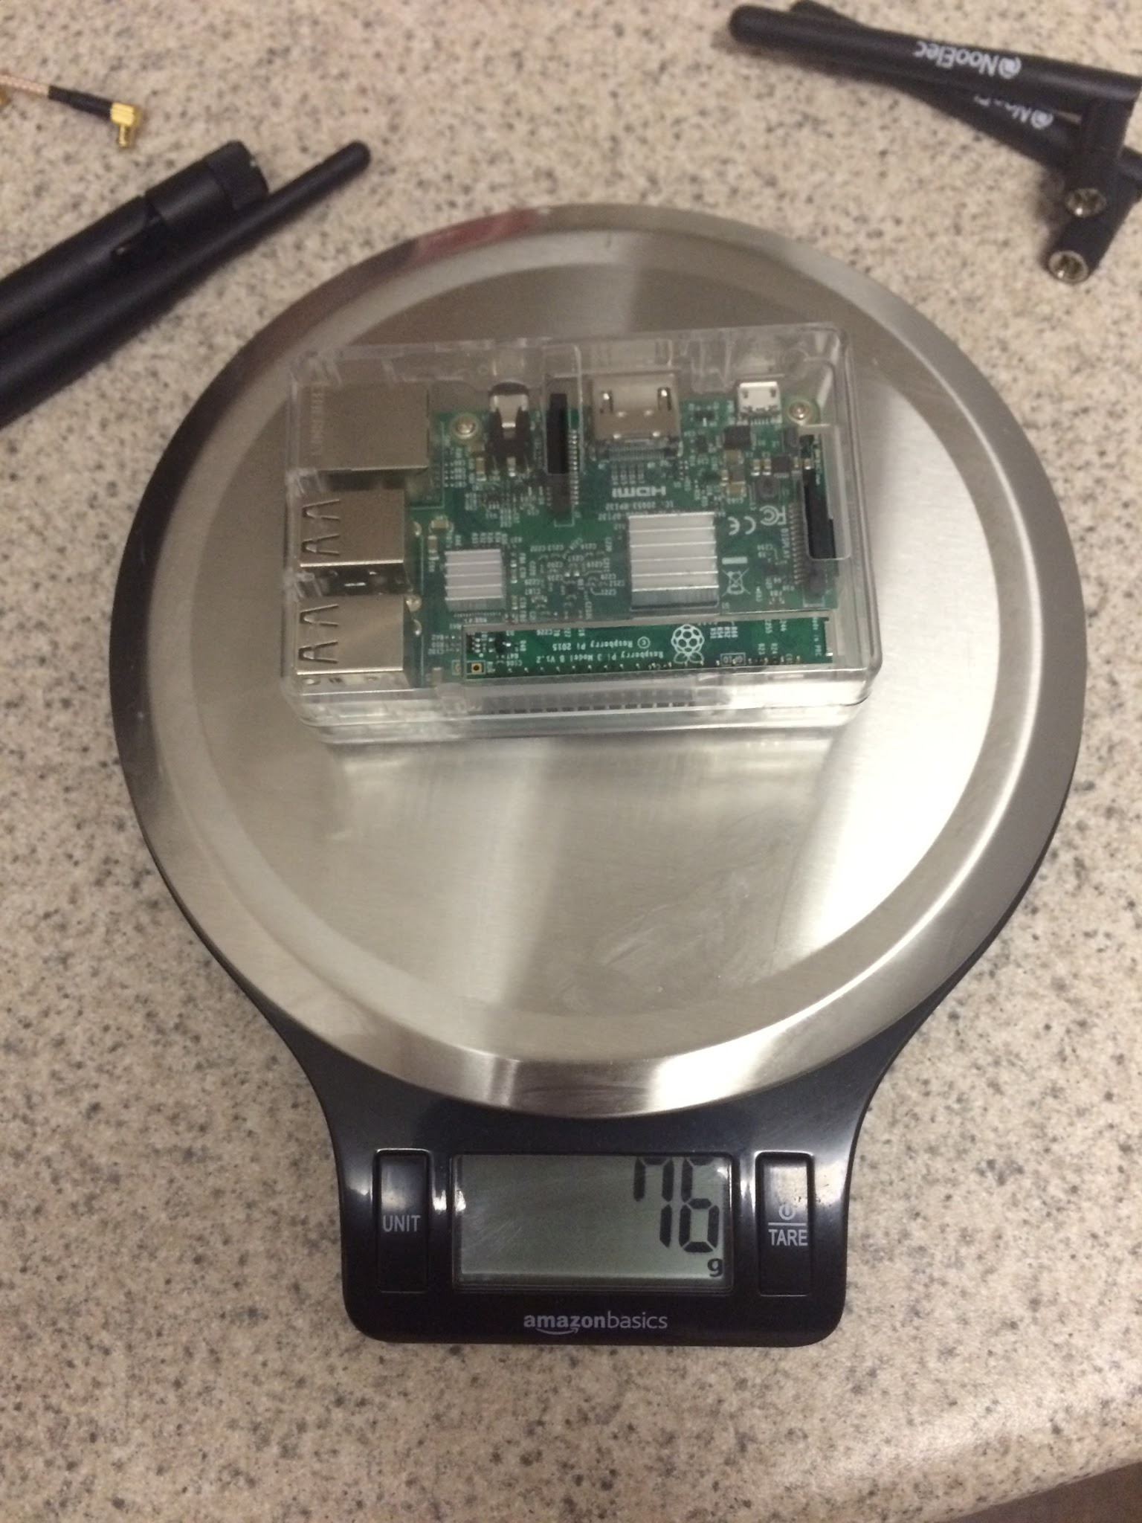

**Figure 4.3.2: Weight of Raspberry Pi**



**Figure 4.3.3: Weight of Battery Pack**

The gathered data and total weight calculations can be seen in Figure 4.3.4.

|  |  |
| --- | --- |
| Component Name | Weight (grams) |
| Raspberry Pi | 76 g |
| SDRs and accessories | 42 g |
| Battery Pack | ++ g |
| Total Weight | ++ g |

**Figure 4.3.4: Total Weight**

**4.4. Test Specification - Battery Life**

We established in one of our constraints that the battery must be able to sustain at least an hour of usage in order to provide services to the user for a full flight. We measured the individual current draw of each of the components. This was accomplished by using a usb inline ammeter.

Each of the SDRs were measured at a constant 250 mA draw regardless of the amount of traffic detected as shown in Figure 4.4.1. This is likely due to the constant sampling from the SDRs.

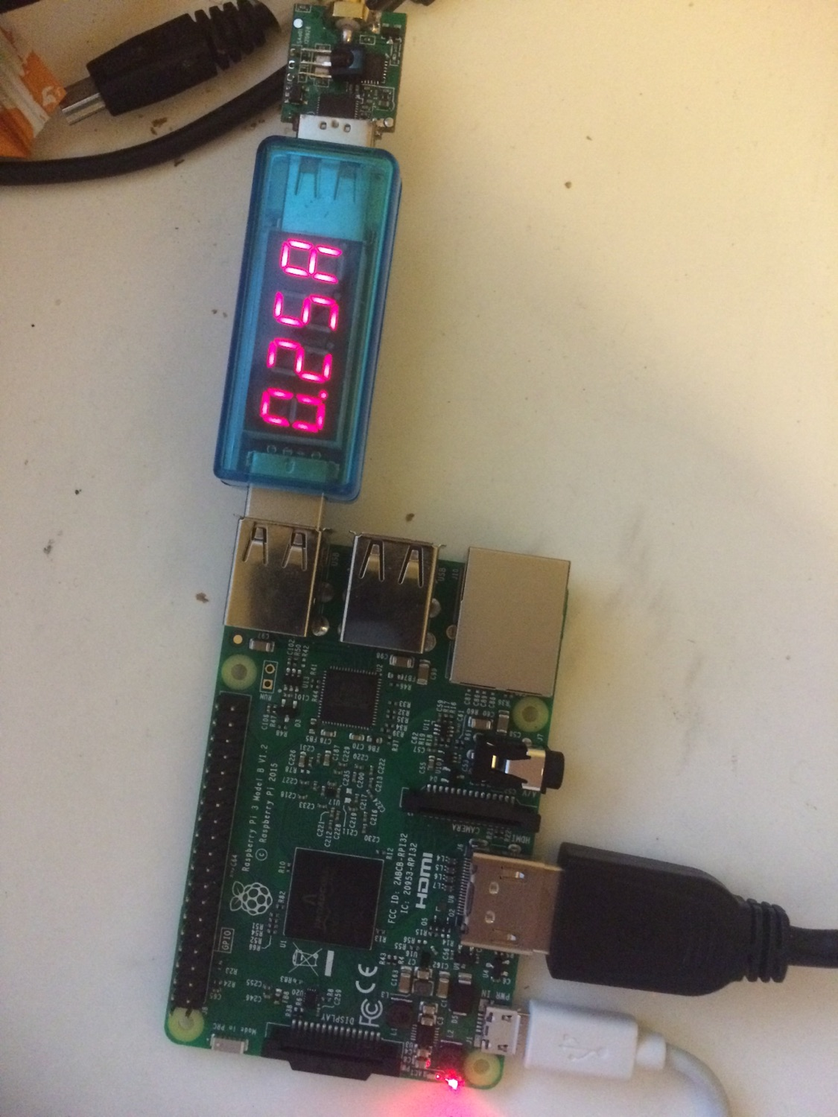

**Figure 4.4.1: Current Draw of SDR**

The current draw of the Raspberry pi system was measured at 400 mA, as shown in Figure 4.4.2. This will be the part of the UAS Alert system that will pull the maximum amount of draw. This is due to the fact that the Raspberry Pi is the basis of our system and runs the majority of processes enabling proper functionality.



**Figure 4.4.2: Current draw of Raspberry Pi**

The GPS systems which are used to establish UAS position allocation was then tested to be ++mA, shown in Figure 4.4.3. This subsystem maintains constant communication with satellites to retain accuracy of position data.



**Figure 4.4.3: Current Draw of GPS Module**

The Xbee 900hp, which is the RF module used for wireless communication from the on-board section of this system to the ground station, was measured to have a current draw of ++mA, displayed in Figure 4.4.4.



**Figure 4.4.4: Current Draw of Xbee 900hp**

To obtain the power needs required for proper operation of the system, we must account for all power consuming components that will rely on the battery pack. To obtain this measurement, we took the maximum measured current draw for each system and added them together. The information obtained can be found in

|  |  |  |  |
| --- | --- | --- | --- |
| Subsystem Name | Current Draw | Voltage(Avg.) | Total Power Draw |
| Raspberry Pi | ++ mA | 5V | ++ W |
| Software Defined Radios (SDRs) | 500mA  (2 x 250mA) | 5V | ++ W |
| GPS | ++ mA | 5V | ++ W |
| Xbee 900hp | ++ mA | 3.3V | ++ W |
| Total System Battery Consumption | ++ mA |  | ++ W |

**4.5. Test Specification - Compact Design**

The purpose of the compact design is to ensure that the device will be able to at least fit under a popular consumer UAV such as the DJI Phantom 3. The placement of the antennas was done so that they would cause minimal interference with the UAV and keep the on-board module within the size constraints.



**Figure 4.5.1: On-Board Module mounted on DJI Phantom 3**

**4.6. Test Specification - Response Time**

As the constraints stated the response time needs to fast enough so that there is a current and accurate position on the ground station display. To satisfy this constraint the map will be updated every second with current information. This test cannot be done yet due to the final design not being completed.



**Figure 4.6.1: System Response Time**

**References**

[1]"XCTU - Next Gen Configuration Platform for XBee/RF Solutions - Digi International", *Digi.com*, 2016. [Online]. Available: https://www.digi.com/products/xbee-rf-solutions/xctu-software/xctu#productsupport-utilities. [Accessed: 03- Nov- 2016].