**4. EVALUATION**

This section details the tests that were conducted on the components of UAS Alert to ensure that the design constraints stated in Table 4.1.1. are met.

**4.1. Test Specifications**

The design constraints that need to be tested can be found in table 4.1.1.

**Table 4.1.1: Technical Design Constraints**

|  |  |
| --- | --- |
| **Name** | **Description** |
| **Transmission** | The transceiver must be able to communicate at 1000 m when in line-of-sight. |
| **Device Weight** | The device must weigh under 300 g. |
| **Battery Life** | The battery must power the device for a minimum of 1 hr. |
| **Compact Design** | The airframe attachment must be at most 150x150x100 mm. |
| **Response Time** | The total response time of the system must be no longer than 1 min to give the user time to adjust the flight path. |

**4.2. Test Specification – Transmission**

Range tests were done with the Digi XTCU application, a graphical interface to setup, configure, and test XBee RF modules [14]. Two members held laptops with the XTCU application and the XBee modules hooked up to the USB. A GPS distance measuring app was used to test the difference between members. The application showed the signal strength and the amount of transmitted, received, and lost packets during the test. At all ranges tested the application reported a acceptable signal strength. Figures 4.2.1, 4.2.2, 4.2.3, and 4.2.4 show the test done at 280, 520, 1200, and 3800 ft (85.3, 158.5, 365.7, and 1158 m).

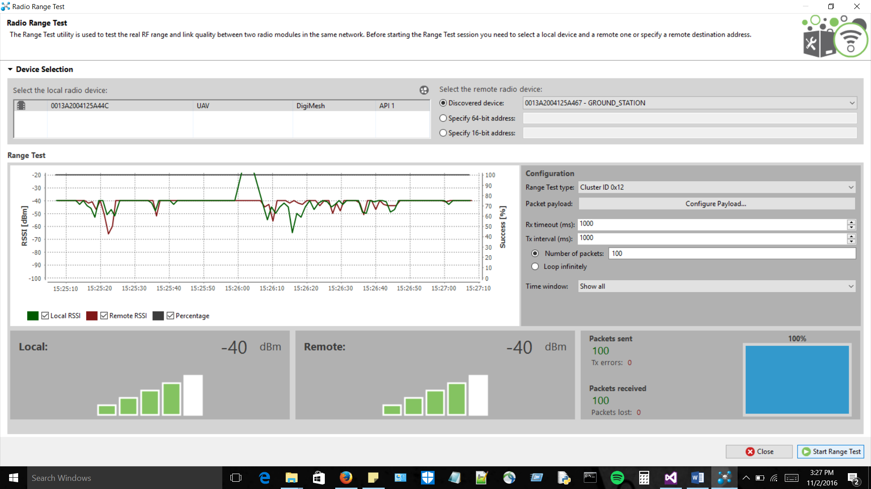

**Figure 4.2.1: Signal Strength at 280 ft**

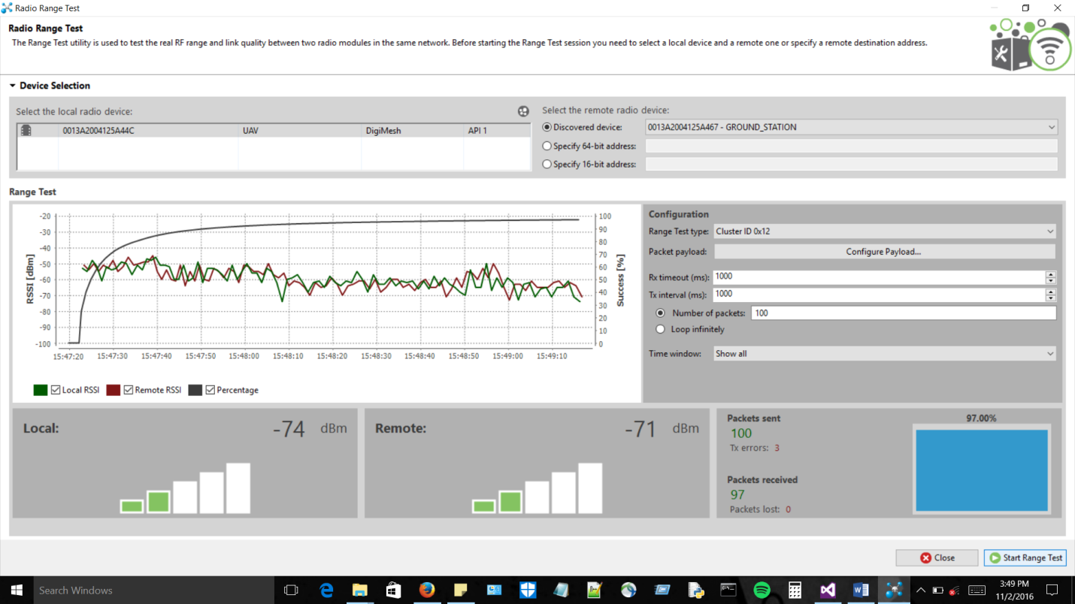

**Figure 4.2.2: Signal Strength at 520 ft**

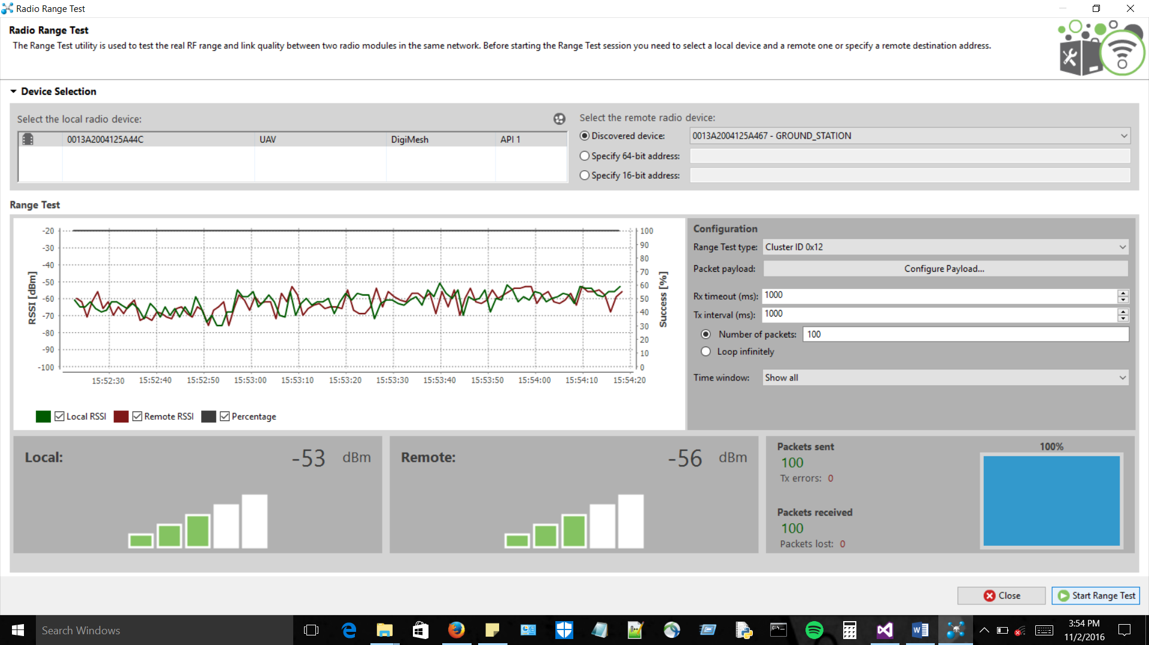

**Figure 4.2.3: Signal Strength at 1200 ft**

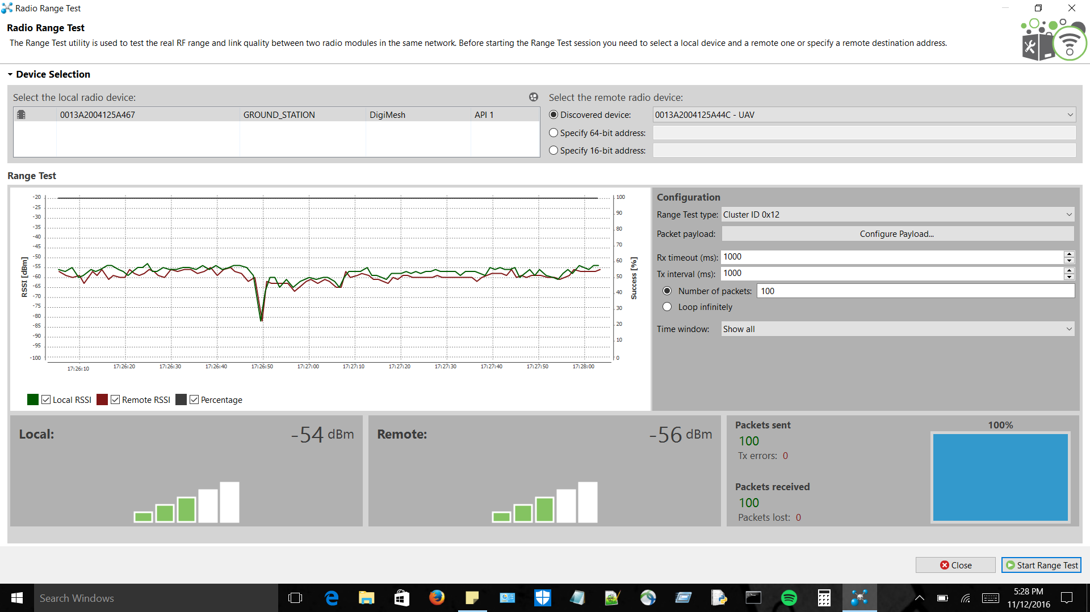

**Figure 4.2.4: Signal Strength at 3800 ft**

Figures 4.2.1-4.2.4 show the average dBm for their respective distances. These tests were done with the default antennas that came with the XBee 900HP kit. A packet size of 50 bytes was the test packet size. At all distances the signal strength had an average of -54 dBm which is well within the transceiver’s range of operation.

**4.3. Test Specification - Device Weight**

The weight of the individual components was measured using a precise scale. Figure 4.3.1 shows the software-defined radios (SDRs), the adapter cables, and the 3dBi antennas. Figure 4.3.2 shows the weight of the Raspberry Pi 3 Model B with a case.

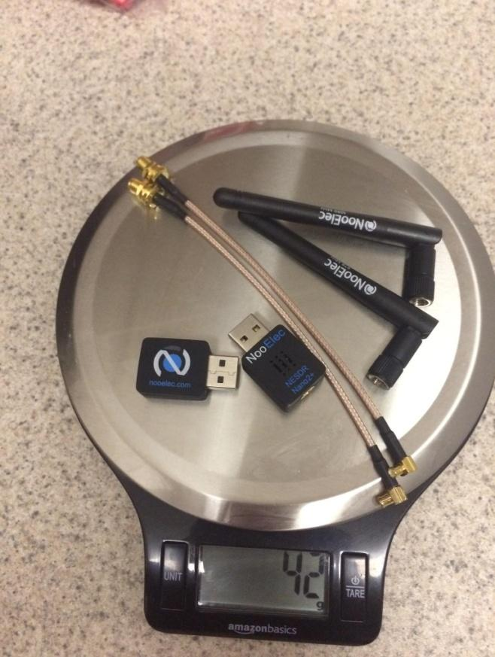

**Figure 4.3.1: Weight of SDRs, antennas, and adapter cables**

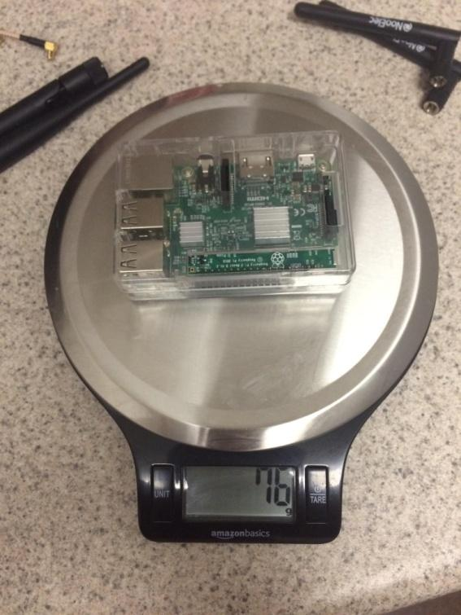

**Figure 4.3.2: Weight of Raspberry Pi**

The battery and buck converter together weigh 83 g and the transceiver weighs 36 g. The gathered data and total weight calculations can be seen in Table 4.3.4.

**Table 4.3.1: Total Weight**

|  |  |
| --- | --- |
| Component Name | Weight (grams) |
| Raspberry Pi 3 Model-B | 76 g |
| NooElec Nano 2 SDRs | 42 g |
| Xbee 900HP | 36 g |
| FlightPower FPRX 1600mAh | 68 g |
| UBEC DC-DC Converter | 15 g |
| Total Weight | 237 g |

**4.4. Test Specification - Battery Life**

We established in the power constraint that the battery must be able to sustain at least 1 hr of usage in order to provide services to the user for the full duration a flight. We measured the individual current draw of each of the components. This was accomplished by using a USB inline ammeter.

Each of the SDRs were measured at a constant 250 mA draw regardless of the amount of traffic detected as shown in Figure 4.4.1. This is likely due to the constant sampling from the SDRs.

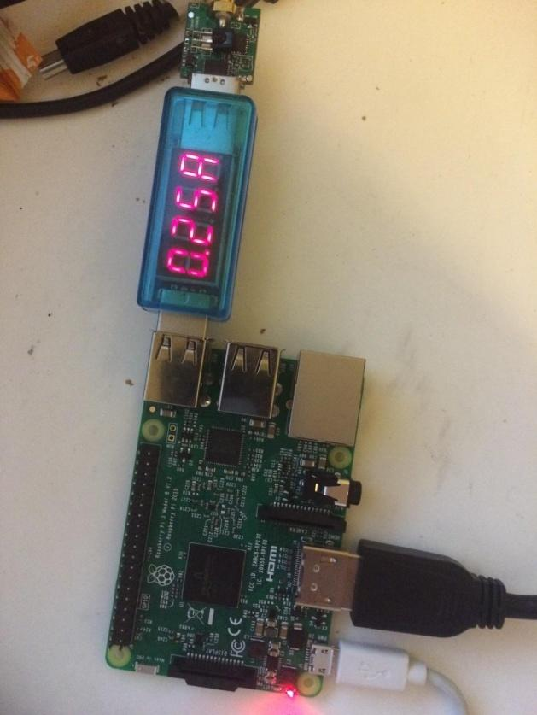

**Figure 4.4.1: Current Draw of SDR**

The current draw of the Raspberry Pi system was measured at 400 mA. This will be the part of the UAS Alert system that will pull the maximum amount of current. This is because the Raspberry Pi is the basis of our system and runs the majority of processes enabling proper functionality.

The Xbee 900hp, which is the RF module used for wireless communication from the on-board section of this system to the ground station, was measured to have a current draw of 215 mA. The total current draw with everything running is shown in Figure 4.4.2.

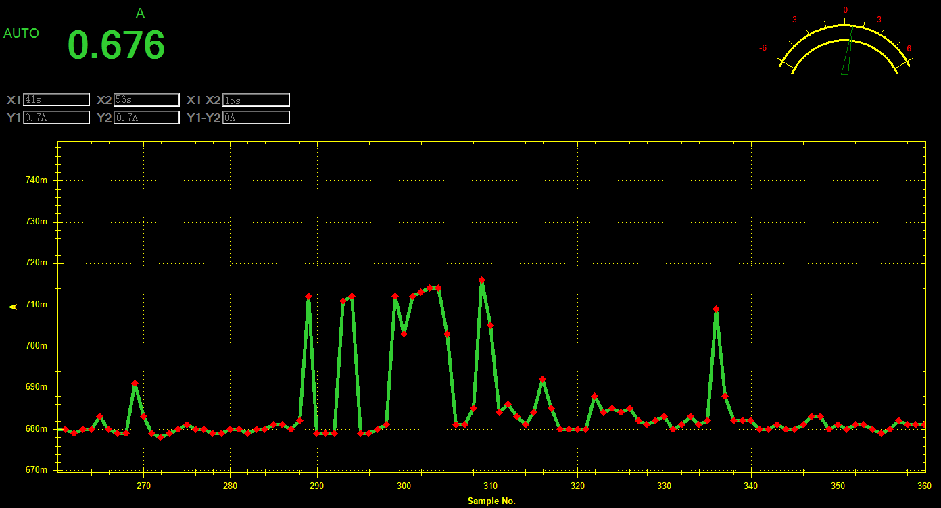

**Figure 4.4.2: Current Draw of Whole System**

To satisfy the power needs required for proper operation of the system, we must account for all power-consuming components that will rely on the battery pack. To obtain this measurement, we took the maximum measured current draw for each system and added them together. The information obtained can be found in Table 4.4.1.

**Table 4.4.1: Power Consumption**

|  |  |  |  |
| --- | --- | --- | --- |
| Subsystem Name | Current Draw | Voltage(Avg.) | Total Power Draw |
| Raspberry Pi | 400 mA | 5V | 2 W |
| Software Defined Radios (SDRs) | 580 mA  (2 x 290 mA) | 5V | 2.9 W |
| Xbee 900hp | 215 mA | 3.3V | 0.774 W |
| Total System Battery Consumption | 1.195 A |  | 5.975 W |

**4.5. Test Specification - Compact Design**

The purpose of the compact design is to ensure that the device will be able to at least fit under a popular consumer UAV such as the DJI Phantom 3. The placement of the antennas was done so that they would cause minimal interference with the UAV and keep the on-board module within the size constraints. As of now our design does fit within our constraints as long as the antennae are placed directly next to the onboard device. We were unable to test this with our device on a DJI Phantom 3 but we have measured the overall size and the dimensions were within the constraints.

**4.6. Test Specification - Response Time**

As the constraints stated, the response time needs to be fast enough so that there is a current and accurate position on the ground station display. We were only able to test the time difference between receiving the message on the on-board module until receiving it on the ground station to be decoded and placed on the map. Statements were placed in the code for the on-board module that timed when the message was received. This was also done on the ground station upon receiving and plotting the aircraft on the display. The difference was found to be less than 1 second, which satisfies this technical constraint. The figures below demonstrate one of the tests performed. Figure 4.6.1 shows the timing, in seconds, of the message being received on the on-board module. Figure 4.6.2 shows the message being received on the ground station. Before running the test. The time on both machines was printed to ensure that they were in sync. The ground-station’s time stamp was initially two seconds behind that of the on-board. This is reflected in the figures below.

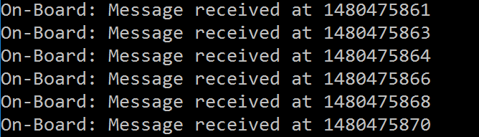

**Figure 4.6.1: On-board**

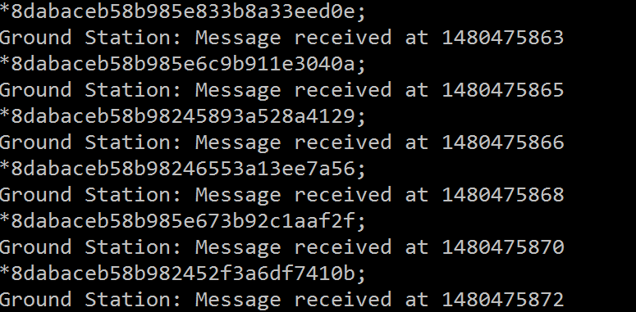

**Figure 4.6.2: Ground Station**

**4.7. Total System Test**

Lastly the entire system was tested. For this test the Xbees, SDRs, and Raspberry Pi were connected to the battery. Figure 4.7.1 shows the GPS coordinates, tail number, and type as it is received on the ground station.

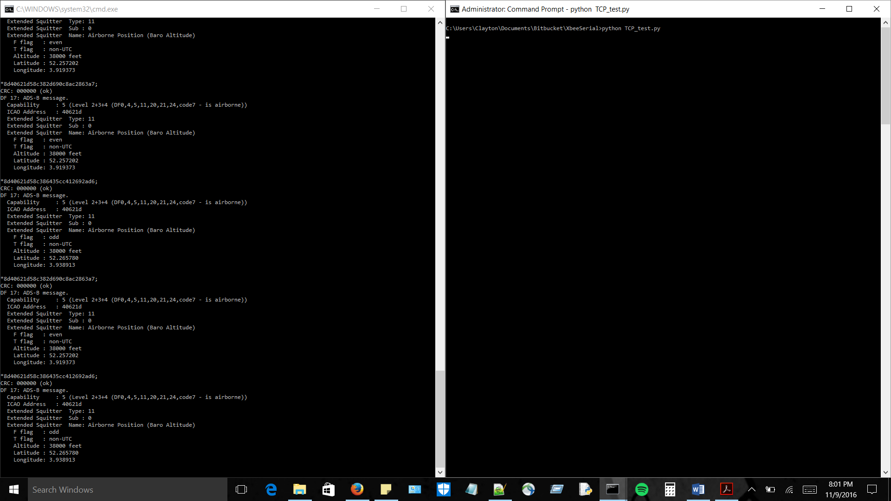

**Figure 4.7.1: Actual Coordinates, Tail Number, and Type**

Figure 4.7.2 shows a plane plotted on the display. Note that these figures are two distinct planes.

**Figure 4.7.2: Actual Mapping of Airplane Displayed on Ground Station**

**References**

[14]"XCTU - Next Gen Configuration Platform for XBee/RF Solutions - Digi International", *Digi.com*, 2016. [Online]. Available: https://www.digi.com/products/xbee-rf-solutions/xctu-software/xctu#productsupport-utilities. [Accessed: 03- Nov- 2016].