**Executive Summary**

Since UAV operation has been on the rise there is a large need to keep these UAVs and the aircraft around them safe. If a small UAV hits an engine of an aircraft, it could bring the entire craft down and cause human fatalities. Since the larger aircraft are unable to scan for all nearby UAVs it is the responsibility of the UAV operator to avoid collisions with large aircraft. UAS Alert is the solution to this problem by allowing UAVs of all types to monitor the skies for ADS-B aircraft around them to avoid possible mid-air collisions. By monitoring Mode S and UAT frequencies, UAS Alert will receive all nearby ADS-B transmissions and display aircraft on an easy to use display. Figure 1 gives a visual representation of UAS Alert.

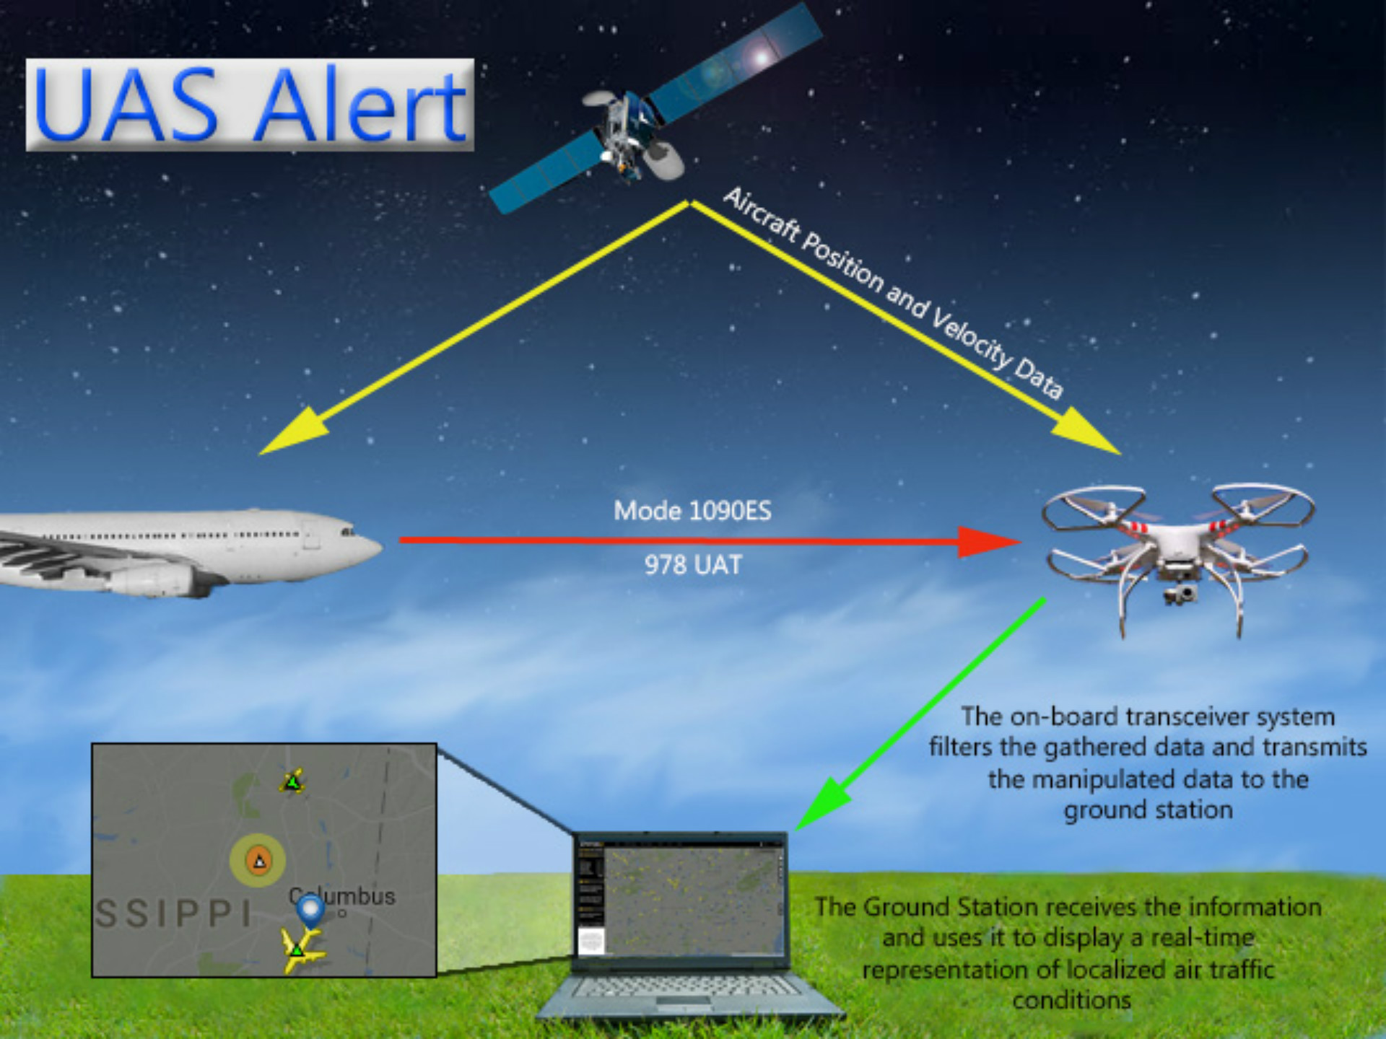

**Figure 1**: Overview of data flow for UAS Alert

In order to reliably and effectively collect all nearby ADS-B data there were several constraints put on our design. The ground station needs to be within line of sight range of the on-board module to receive accurate transmissions to display on the ground station. Also related to flight time is the battery life which needs to be longer than the UAVs flight time, which is approximately 1 hour, so that aircraft are protected at all times. The on-board module must also be small enough so that it will not block any normal functions of the UAV such as landing on flat surfaces. To make sure there is a steady flow of stable data we have decided to use Xbee 900hp which have a 6500m line-of-sight range with 2.1 dB antennas which is more than enough range for UAS Alert. The Xbees are also able to send enough packets fast enough to keep an accurate location of all nearby aircraft. When picking the most optimal components for the on-board device the weight was considered so that it would have a minimal impact on battery life.In order to meet the flight time requirements, the chosen battery has 1.2 times the capacity needed to power UAS Alert for over an hour when at maximum usage. Each component is also as small as possible to make sure the on-board module does not interfere with standard UAV functions.

UAS Alert is the first system that allows a UAV operator to see an accurate representation of the airspace around their UAV to avoid mid-air collisions. The on-board device will be attached on the top or bottom of the UAV so that any other devices needed for the flight can be attached in their optimal position. Another feature of UAS alert is that it will alert the operator when there is a potentially dangerous situation and may, in the future, recommend an evasive course of action.