**EXECUTIVE SUMMARY**

Since UAV operation has been on the rise, there is an increasing need to keep these UAVs, and the aircraft around them, safe. If a small UAV hits an engine of an aircraft, the collision could bring the entire craft down possibly resulting in human casualties. Since the larger aircraft are unable to scan for all nearby UAVs, it is the responsibility of the UAV operator to avoid collisions with large aircraft. UAS Alert aims to solve this problem by allowing UAV pilots to monitor the skies for ADS-B aircraft in the air-space surrounding them. By monitoring Mode S and UAT frequencies, UAS Alert will receive all nearby ADS-B transmissions and display aircraft on an easy-to-use display. Figure 1 gives a visual representation of UAS Alert.

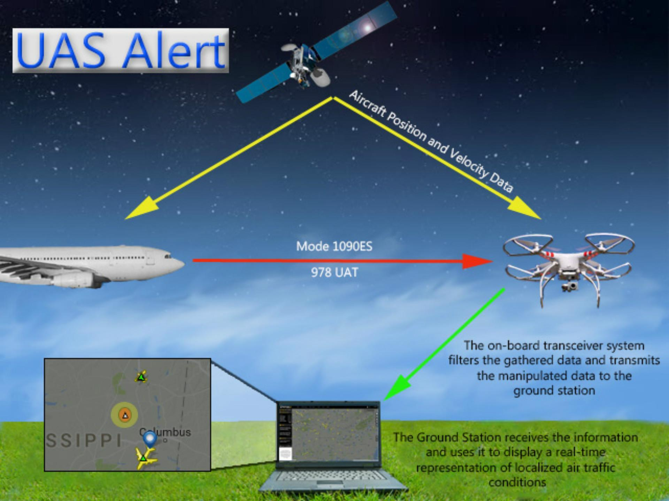

**Figure 1: Overview of data flow for UAS Alert**

In order to reliably and effectively collect all nearby ADS-B data, several constraints were placed on the design. The ground station must remain within line-of-sight range of the on-board module to facilitate the accurate reception of transmissions used to create the ground station display. Also, related to flight time, the battery life must be longer than 1 hr to provide aircraft protection at all times. The on-board module must also be small enough to avoid interruption of normal UAV operations, such as taking off or landing.

To ensure there is a steady flow of stable data, Xbees were chosen to transmit the data from the UAV to the ground station. The Xbees have a 6500 m line-of-sight range with 2.1 dBi antennas, which is more than enough range for UAS Alert. The Xbees are also able to send enough packets at a sufficient speed to keep an accurate location of all nearby aircraft. In order to meet the flight-time requirements, the chosen battery has 1.2 times the capacity needed to power UAS Alert when at maximum usage. Each component is also as small as possible to make sure the on-board module does not interfere with standard UAV functions.

UAS Alert is the first system that allows a UAV operator to see an accurate representation of the airspace around their UAV allowing avoidance of mid-air collisions. The on-board device will be affixed to the top or bottom of the UAV allowing for optimal placement of other peripheral devices. With the use of UAS Alert, UAV pilots will receive alerts and advisories. These alerts will give the user of existing or future dangers presented within range of the UAV.