Design Document for

UAS Alert

Bryan Jones, Ph.D.

ECE 4512 : Senior Design I

Department of Electrical and Computer Engineering

413 Hardy Road, Box 9571

Mississippi State University

Mississippi State, Mississippi 39762



November 29, 2016

prepared by:

Brady Wade, Carter Long, Brian Joyner, Chase Abercrombie, and Clayton Hudspeth

Faculty Advisor: Professor J. W. Bruce, Ph.D.

Department of Electrical and Computer Engineering

413 Hardy Road, Box 9571

Mississippi State University

Mississippi State, Mississippi 39762

email: {wbw103, acl331, jca69, ch1518, bcj162}@msstate.edu

|  |  |  |  |  |
| --- | --- | --- | --- | --- |
| **General Abbreviations:** | |  | **Measurement Abbreviations:** | |
| **ADS-B** | **Automatic Dependent Surveillance-Broadcast** |  | **A** | **Amperes** |
| **API** | **Application Program Interface** |  | **C** | **Celsius** |
| **CPU** | **Central Processing Unit** |  | **dB** | **decibels** |
| **CRC** | **Cyclic Redundancy Check** |  | **dBi** | **decibels isotropic** |
| **DC** | **Direct Current** |  | **dBm** | **decibel meters** |
| **FAA** | **Federal Aviation Administration** |  | **ft** | **feet** |
| **FCC** | **Federal Communications Commission** |  | **g** | **grams** |
| **GPIO** | **General Purpose Input/Output** |  | **GHz** | **GigaHertz** |
| **GPS** | **Global Positioning System** |  | **hr** | **hour** |
| **HTML** | **Hypertext Mark-up Language** |  | **m** | **meters** |
| **UAS** | **Unmanned Aircraft Systems** |  | **mA** | **milliAmperes** |
| **UAV** | **Unmanned Aerial Vehicles** |  | **mAhr** | **milliAmpere-hour** |
| **IC** | **Integrated Circuit** |  | **MHz** | **MegaHertz** |
| **LOS** | **line-of-sight** |  | **mi.** | **miles** |
| **MLAT** | **Multi-lateration** |  | **min.** | **minutes** |
| **PCB** | **Printed Circuit Board** |  | **mi/hr** | **miles per hour** |
| **RF** | **Radio Frequency** |  | **mm** | **millimeters** |
| **SDR** | **Software-Defined Radio** |  | **n.m.** | **nautical miles** |
| **TCP** | **Transmission Control Protocol** |  | **V** | **Voltage** |
| **TDOA** | **Time Difference of Arrival** |  | **W** | **Wattage** |
| **UAT** | **Universal Access Transceiver** |  | **Whr** | **Watt-hour** |
| **USB** | **Universal Serial Bus** |  |  |  |

**EXECUTIVE SUMMARY**

Since UAV operation has been on the rise, there is an increasing need to keep these UAVs, and the aircraft around them, safe. If a small UAV hits an engine of an aircraft, the collision could bring the entire craft down possibly resulting in human casualties. Since the larger aircraft are unable to scan for all nearby UAVs, it is the responsibility of the UAV operator to avoid collisions with large aircraft. UAS Alert aims to solve this problem by allowing UAV pilots to monitor the skies for ADS-B aircraft in the air-space surrounding them. By monitoring Mode S and UAT frequencies, UAS Alert will receive all nearby ADS-B transmissions and display aircraft on an easy-to-use display. Figure 1 gives a visual representation of UAS Alert.

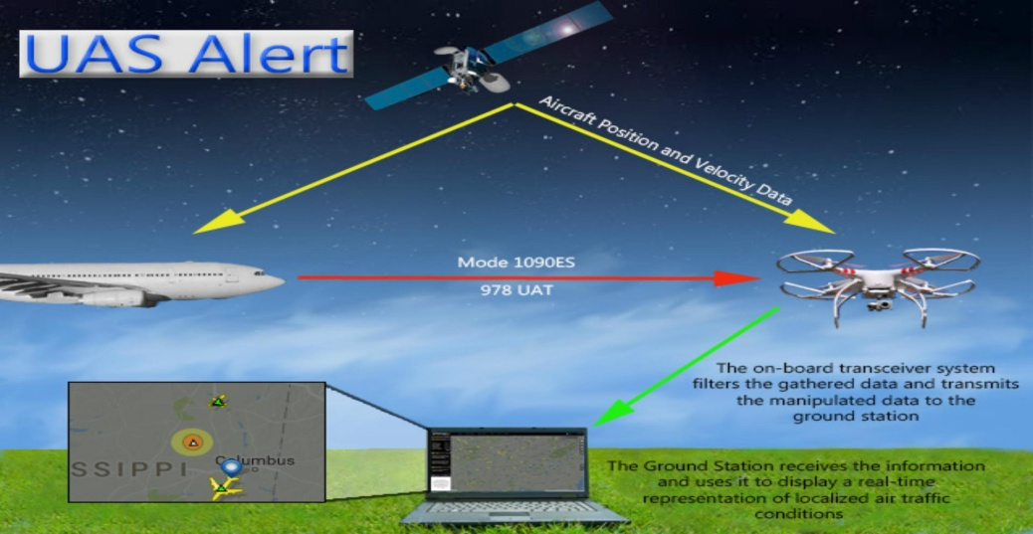

**Figure 1: Overview of data flow for UAS Alert**

In order to reliably and effectively collect all nearby ADS-B data, several constraints were placed on the design. The ground station must remain within line-of-sight range of the on-board module to facilitate the accurate reception of transmissions used to create the ground station display. Also, related to flight time, the battery life must be longer than 1 hr to provide aircraft protection at all times. The on-board module must also be small enough to avoid interruption of normal UAV operations, such as taking off or landing.

To ensure there is a steady flow of stable data, Xbees were chosen to transmit the data from the UAV to the ground station. The Xbees have a 6500 m line-of-sight range with 2.1 dBi antennas, which is more than enough range for UAS Alert. The Xbees are also able to send enough packets at a sufficient speed to keep an accurate location of all nearby aircraft. In order to meet the flight-time requirements, the chosen battery has 1.2 times the capacity needed to power UAS Alert when at maximum usage. Each component is also as small as possible to make sure the on-board module does not interfere with standard UAV functions.

UAS Alert is the first system that allows a UAV operator to see an accurate representation of the airspace around their UAV allowing avoidance of mid-air collisions. The on-board device will be affixed to the top or bottom of the UAV allowing for optimal placement of other peripheral devices. With the use of UAS Alert, UAV pilots will receive alerts and advisories. These alerts will give the user of existing or future dangers presented within range of the UAV.

|  |  |
| --- | --- |
| **TABLE OF CONTENTS** | |
| **1. PROBLEM STATEMENT** | Pg. 4 |
| **1.1 Historical Introduction** | Pg. 4 |
| **1.2 Market and Competitive Product Analysis** | Pg. 4 |
| **1.3 Concise Problem Statement** | Pg. 5 |
| **1.4 Implications of Success** | Pg. 5 |
| **2. DESIGN REQUIREMENTS/CONSTRAINTS** | Pg. 5 |
| **2.1. Technical Design Constraints** | Pg. 6 |
| **2.2. Practical Design Constraints** | Pg. 7 |
| **3. APPROACH** | Pg. 9 |
| **3.1. Hardware** | Pg. 10 |
| **3.2. Software** | Pg. 14 |
| **4. EVALUATION** | Pg. 18 |
| **4.2. Test Specification - Transmission** | Pg. 18 |
| **4.3. Test Specification - Device Weight** | Pg. 20 |
| **4.4. Test Specification – Battery Life** | Pg. 22 |
| **4.5. Test Specification – Compact Design** | Pg. 23 |
| **4.6. Test Specification – Response Time** | Pg. 24 |
| **4.7. Total System Test** | Pg. 25 |
| **5. SUMMARY AND FUTURE WORK** | Pg. 26 |
| **6. REFERENCES** | Pg. 28 |
| **7. APPENDIX: PRODUCT SPECIFICATION** | Pg. 30 |

**1. PROBLEM STATEMENT**

**1.1. Historical Introduction**

Unmanned aircraft systems (UASs) have been in use for over a century and a half. A UAS system includes everything needed to fly an aircraft remotely such as the airframe, controller, user, ground station, and extra application items. The first were used by the Austrian military in 1849 to attack Venice [1]. Since then, they have been used for many tasks ranging from military missions to filming movies.

Unmanned aerial vehicles (UAVs), which are the airframes used in a UAS, are used for many tasks including filmmaking, photography, and recreational activities. The main reason that UAVs are used for these tasks is because they are an inexpensive way to get great results. Because of the low market cost of UAVs more are being bought and flown by recreational users which means that there is a much larger risk of colliding with other aircraft. There were 764 recorded incidents from November 2014 to August 2015 that involved a UAV endangering another manned aircraft [2]. Many of these near misses are because the operators were not aware of their surroundings. There is not a device on the market that allows UAVs to be able to detect nearby aircraft to help avoid potentially harmful situations.

The ability to coordinate airplanes already exists through automatic dependent surveillance–broadcast (ADS-B), which was created by the Federal Aviation Administration (FAA) for the purpose of mapping planes by setting aside frequencies for air traffic communication [3]. ADS-B will also be required on all class A aircraft in 2020 [4]. UAS Alert will allow UAV users to monitor ADS-B frequencies and will provide a warning to assist in avoiding possibly fatal incidents.

**1.2. Market and Competitive Product Analysis**

The current selection of affordable avoidance systems for UAVs is limited, with the most notable systems for consumer use being collaborative work between Uavionix and companies such as DJI. They provide the hardware necessary to implement a detect and avoid system but do not provide the entire system. Uavionix sells small, lightweight ADS-B receivers and transceivers that have a price range of $125 to $1200, and currently support integration into the Pixhawk flight controller. In collaboration with DJI, Uavionix is also currently developing an ADS-B collision avoidance developer kit for DJI products; however, this kit is not yet available and is specifically for DJI products [5]. To construct their avoidance system, the consumer must incorporate the supported flight controllers in addition to the ADS-B equipment sold by Uavionix. This would require that the consumer replace their own flight controller and spend $100 to $130 dollars on the supported device. The alternative to this would be to buy a supported drone from DJI. The cheapest of these would currently be the DJI Phantom 3 which sells for $499, which doesn’t include the avoidance equipment from Uavionix.

UAS Alert will be attachable to any UAV that is capable of carrying it, and will not need to be connected directly to the UAS flight controller. Since the system is not dependent on being able to interface with a particular flight controller, it will be applicable to a wider range of consumers. The aviation community would benefit from a system like this, as an ADS-B system that is able to be equipped to a variety of UAVs would increase availability and help to provide a safer environment for other aircraft pilots. The anticipated selling price is system is approximately $250.

**1.3. Concise Problem Statement**

UAS Alert will give a visual representation of nearby aircraft which are displayed on the ground station by user-friendly interface. As mentioned above, recent data from the FAA concerning mid-air collisions with UAVs shows that the future landscape for UAVs in safe airspace is still being defined. Our product offers a part of the solution to minimizing mid-air collisions and creates a platform to connect with other FAA efforts in making safety a priority for human-operated aircraft. Without knowledge of FAA regulations among UAV pilots and the only warning for nearby aircraft being line-of-sight, lack of awareness becomes a dangerous issue.

UAS Alert, at its core, is awareness technology. The basic function of the UAS Alert is to give UAS pilots the best possible view of any near ADS-B OUT equipped system. Any aircraft considered to be close enough to compromise the safety of the aircraft will trigger an alert to be displayed on the ground station interface.

**1.4. Implications of Success**

UAS Alert enables, users will become more aware of their surroundings. This awareness should decrease the frequency of UAV intrusion into the immediate vicinity of aircraft and increase the safety of all aircraft, manned and unmanned, that share the same airspace. In the long term, the UAS could potentially save large sums of lives and money due to mid-air collisions caused by uneducated or unaware UAV pilots.

The use of a plug and play device coupled with a custom PC-based software installation will enable UAS Alert to have a low-cost. Due to this reduction in cost, UAS Alert will become a competitor in the UAV position tracking and collision avoidance markets.

There are other benefits that will also strengthen the marketability of the UAS Alert system. The appropriate use of clear advisories, audibly and visually represented, will open the system up for use in a wider market segment. Since the advisories will be presented in both of these mediums, deaf UAV pilots will be able to successfully implement the UAS Alert system into their flight sessions.

**2.0. DESIGN CONSTRAINTS**

Reducing the risk of mid-air collisions between UAVs and other aircraft is the primary focus of UAS Alert by ensuring the pilot is given the best possible awareness of nearby ADS-B Out equipped aircraft. UAS Alert is an awareness technology centered around safety and is targeted at the consumer and commercial UAS market. To do so, this product places one component attached to a UAV and the other component is a ground station for the UAV operator. Therefore, UAS Alert must support wireless communication from the UAV and the ground station in order to aggregate ADS-B data and provide information to the user. The two major subsections of this document highlight the technical and practical design constraints.

**2.1. Technical Constraints**

UAS Alert must function under the technical constraints listed in Table 2.1.

**Table 2.1: Technical Design Constraints**

|  |  |
| --- | --- |
| **Name** | **Description** |
| **Transmission** | The transceiver must be able to communicate at 1000 m when in line-of-sight. |
| **Device Weight** | The device must weigh less than 300 g. |
| **Battery Life** | The battery must power the device for a minimum of 1 hr. |
| **Compact Design** | The airframe attachment must be at most 150x150x100 mm. |
| **Response Time** | The total response time of the system must be no longer than 1 min to give the user time to adjust the flight path. |

**2.1.1. Transmission**

The wireless communication range must be at least 1000 m since this is the typical range of controllers for consumer UAVs [6]. Transmission of airspace information to the ground station must not interfere with the controls or video feed of the host UAV. Therefore, UAS Alert must avoid using the frequency bands of 2.4 GHz and 5.8 GHz commonly used for these purposes [7].

**2.1.2. Device Weight**

If the device attached to the flight-frame is too heavy, most small UAVs will be unable to carry it. The typical payload capacity of popular consumer UAVs is 300 g with some of the newer versions being able to reliably carry up to 500 g [6]. In order to reduce the excessive drain on the UAV’s battery life due to increased payload, the device’s weight must fall within this range.

**2.1.3. Battery Life**

UAS Alert will be able to operate independently of the host UAV’s flight controller and power source. Thus, the system will provide its own battery. Consumer UAVs generally have a flight time of between 20 to 45 min [7]. The battery must be able to supply power to the on-board system for a minimum of 1 hr in order to provide its services to the UAV operator during flight.

**2.1.4. Compact Design**

UAS Alert must be smaller than the UAV to which it is attached. A typical consumer UAV such as the DJI Phantom 3 has a center housing width/depth of 170 mm and a height of 100mm when landing gear is included [8]. Based on measurements made by the team, the height of the landing gear is approximately 110 mm. Therefore, UAS Alert must have a width/depth less than 150 mm and a height no greater than 100 mm based on the measurements above.

**2.1.5. Response Time**

The response time from the moment when the ADS-B signal is received by the on-board device to the moment when the airplane is displayed must be a maximum of 1 min. The stated response time ensures that the user has enough time to make adjustments to the UAV and navigate out of the way to avoid any potential conflict.For example, a plane moving at 288 mi/hr (250 knots) would have gone nearly 5 mi in the span of 1 min. What this example means is that UAS Alert must be able to detect a plane at least 5 mi away and warn the user in less than 1 min in order to allow the user to maneuver the UAV out of the flight path of the oncoming plane. ADS-B transmissions can be heard at a maximum range of 172 mi (150 n.m.) which at 288 mi/hr allows for over 35 min before the aircraft is near the UAV. [4] UAS Alert will take a very small fraction of this time to display the aircraft’s information to ensure worst case scenario.

**2.2. Practical Design Constraints**

UAS Alert must comply with practical design constraints listed in Table 2.2.

**Table 2.2: Practical Design Constraints**

|  |  |  |
| --- | --- | --- |
| **Name** | **Type** | **Description** |
| **Health and Safety** | **Safety** | UAS Alert must advise the user of nearby ADS-B Out equipped aircraft. |
| **Environmental** | **Temperature** | UAS Alert must work between 0℃ and 85℃. |
| **Economic** | **Viable Market** | The design cost must be under $250. |
| **Sustainability** | **Reliability** | UAS Alert must be able to withstand many flights in a row without repair. |
| **Political** | **Regulations** | The UAS Alert system must use advisories to inform the user of guidelines and advisories when infringing on FAA regulations.  UAS Alert must be designed in accordance with FAA and government regulations. |

**2.2.1. Health and Safety**

UAS Alert will improve situational awareness for UAV pilots by providing a map of the airspace surrounding the UAV. The display will assist in preventing mid-air collisions by providing proximity warnings so that the UAV pilot knows exactly how far away surrounding aircraft are from the UAV. However, improper design of an avoidance system could lead to a situation that gives the user a false sense of security during operation. If the user is completely reliant on the system for warnings, and for some reason a possible collision is not detected, the user may continue on the path into another aircraft. The product must properly address and minimize issues relating to false negatives and false positives being reported by the system. Each ADS-B message contains a 24-bit Cyclic Redundancy Check (CRC) used for error correction. This will assist in minimizing these issues.

**2.2.2. Environmental**

The on-board module of UAS Alert needs to stay between 0℃ and 85℃to function properly. If the on-board device reaches 85℃, the system’s maximum processing speed could suffer a 50% decrease [9]. Since the high-level processor releases a large amount of heat, the device needs to be able to stay cool throughout the duration of the flight. The device will stay cool by using vents and an optimal airflow design for heat dissipation. If the device gets colder than 0℃ in a humid outdoor environment, icing could occur on the components. This icing may result in packet loss or reduction in signal strength due to line-of-sight obstruction.

**2.2.3. Economic**

The design must cost less than $250 and would add to the total cost of the UAS. If the cost of UAS Alert heavily outweighs the cost of the UAV, the system becomes too exclusive. This price was selected in order to remain competitive in the current market. A full explanation of the competitive market analysis is available in section 1.2 of the problem statement. With safety as the primary concern, compromising quality for affordability will need to be analyzed with care.

**2.2.4. Sustainability**

UAS Alert must remain operational throughout the flight time of the UAV to which it is attached. UAVs on the market today can have flight times of up to 1 hr, and the UAS Alert system must be operational for the entire flight session. The UAS Alert system must be durable enough to withstand the normal wear and tear conditions of a UAV flight without failure. If the UAS Alert system fails, the mitigating factors produced by this system will no longer be active. This could result in damage, due to mid-air collision, to the UAV or other aircraft that may be sharing the same airspace.

**2.2.5. Political**

UAS Alert must not provide non-certified ADS-B Out services because UAS Alert does not require a license to broadcast on ADS-B frequencies [10]. Instead, it must provide its services to the user through a passive system without interrogating or broadcasting to other aircraft. In accordance with the Federal Communications Commission (FCC), the system must transmit its air traffic data to the ground station using unlicensed frequencies [11].

**3. APPROACH**

Giving UAS pilots a better view of the airspace around their vehicle will mitigate any UAVs from infringing on the paths of other aircraft that could potentially cause a mid-air collision. UAS Alert creates a safer environment for UAS operators by giving them a greater awareness of air traffic in the airspace surrounding the UAV. Alerts are displayed on the ground station when any ADS-B OUT signal is received by the on-board module.

UAS Alert consists of multiple subsystems in order to collect information received on the on-board module and aggregate it with information imported from an online source. This will provide a more complete mapping of surrounding aircraft in order to provide alerts to the user. Figure 3.1 shows a high-level overview of UAS Alert and external subsystems that interact with it.

System overview.png

**Figure 3.1: UAS Alert overview.**

**3.1. Hardware**

UAS Alert will incorporate hardware components to make a sufficient and user-friendly system. This subsection discusses the main hardware components. Each component with alternative options has a discussion on the pros and cons for each option along with reasons for final decisions.

**3.1.1. Power Source and Requirements**

The on-board module must last 1 hr under normal battery draw conditions. The average flight time of the most popular consumer drone is 45 minutes, so by making our design last an hour, we are ensuring that the drone operator has ADS-B coverage throughout the duration of the flight. Taking a summation of the current drawn from the Raspberry Pi, the two software-defined radios (SDRs), and the RF module, an equation can be derived to determine the size of the power source needed for UAS Alert. The Raspberry Pi 3 Model B requires a 5 V input and draws around 400 mA with nothing attached to it. The XBee 900 draws a maximum current of 215 mA at 3.3 V when it is transmitting. Both SDRs require a maximum of 290 mA-hr to operate, which sums to a total of 580 mA-hr. By adding the current draw of each device, it is determined that a total of 1,195 mA or 1.195 A is needed for 1 hr. The product of the total current being drawn per hour and the voltage that is required will yield the watt hours needed to power UAS Alert. A formulated description is given of the power source capacity needed for UAS Alert in equation (1).

Capacity = (5V \* 400mAhr) + (3.3V \* 215mAhr) + 2 \* (5V \* 290mAhr) = 5.61 Whr (1)

The operation time will be in a maximum range to give a safe estimate. The battery will be rechargeable through a USB connection. Rechargeable lithium-ion and lithium-polymer batteries are being considered for the power source. The three main battery considerations were lithium-ion AA batteries, lithium-ion flat cell batteries, and lithium polymer flat cell batteries.

Due to the weight restrictions on our prototype, the AA lithium-ion batteries proved to be an inappropriate power source. These batteries have added weight contained in the casing of each battery. The requirement of multiple 1.5V batteries to achieve the 5V power needs of the Raspberry pi compounded the weight issue, and this added nuisance made this battery option unusable.

Of the remaining battery options, after some research, it was discovered that lithium-polymer batteries have a much greater capacity. The lithium-polymer batteries have been the main focus for UAS systems for a few years due to the freedom with which the chemical composition of the batteries can be manipulated [12]. This situation has led to greater strides being made in the lithium-polymer market. Since our system will require greater power consumption with a limited weight, the lithium polymer flat cell batteries were the obvious choice due to their power capacity at more conservative payload weight.

**3.1.2. Software-Defined Radio**

The on-board module attached to the drone will use two SDRs in order to receive information from aircraft broadcasting on 978 MHz and 1090 MHz. High-gain 978 MHz and 1090 MHz antennas will attach to the SDRs. SDRs were a clear choice for this design due to the low price, small size, and simplicity in operating at any frequency. These radios perform signal processing and modulation/demodulation with the CPU of a computer instead of hardware. SDRs considered for this project are compared in Table 3.2.2.

**Table 3.2.2: Software-Defined Radios**

|  |  |  |  |  |  |
| --- | --- | --- | --- | --- | --- |
| **SDR** | **Frequency Range** | **Frequency Stability** | **Weight (gram)** | **Price** | **Choice** |
| NooElec NESDR SMArt | 25MHz-1700MHz | 0.5PPM | 29 | $21.95 (per SDR) |  |
| NooElec NESDR Nano 2+ | 25MHz-1750MHz | 0.5PPM | 6 | $22.95 (per SDR) | ✔ |
| RTL-SDR.com | 500kHz-1.7GHz | 1PPM | 31 | $24.95 (per SDR) |  |
| Stratux 1090ES & UAT Radio | 1090MHz & 978MHz | Unknown | 5 | $34.99 (both) |  |

All of the SDRs in Table 3.2.2. use the R820T2 tuner IC and the RTL2832 USB interface IC. With all of the prices being somewhat similar, thorough documentation and specifications is a big factor in choosing an SDR. The NooElec NESDR Nano 2+ was chosen for this design for two main reasons; it has technical specifications and only weighs 6 g. The Stratux SDRs were originally used and tested. The NooElec Nano 2+ SDRs have a very similar design to the Stratux SDRs but have a case to cover the hardware and PCB and have more technical documentation. The RTL-SDR.com SDR had a lower frequency stability and was too large to have two running side-by-side on our Raspberry Pi. This SDR is well documented and performs extremely well.

**3.1.3. Development Boards**

A single-board computer will be used for the on-board module. The purpose of the single-board computer is to interpret the information being received from the two SDRs and send it to the ground station via the transceiver.

Qualities that are needed are multiple USB inputs, Linux-based software, and the ability to support 1.2 A. USB inputs are important because of the amount of power each port can provide in comparison to the GPIO pins that only provide small amounts of power. By using USB ports, information can be sent from the board and powered from the USB without extra power connections. The battery back can power the board, and the board will power every device needed. Linux software must also be required because Dump1090 only runs on Linux-capable devices. The board must also supply 1.2 A, as determined in Section 3.2.1, to power all devices simultaneously [13].

Table 3.2.3 lists the features of the boards that were considered.

**Table 3.2.3: Development Boards**

|  |  |  |  |
| --- | --- | --- | --- |
| **Board** | **Picture** | **Description** | **Choice** |
| Raspberry Pi 3 | Raspberry_Pi_3_1_of_4_711f1ffe-af5e-4923-aa7f-d80651396258_1024x1024.jpg | * Open Source * Multiple USB 2.0 Inputs * 45 g * 2.5 A * Linux Based | ✔ |
| Arduino | Arduino-uno-perspective-transparent.png | * Open Source * 6 Digital & 6 Analog Inputs * 25 g * 0.7 A * Java/Linux Based |  |

From Table 3.2.3 the Raspberry Pi 3 is the ideal candidate for the intended purposes. The Raspberry Pi features multiple USB inputs that can supply 1.2 A or 500 mA each.

**3.1.4. 1090 MHz and 978 MHz Antennas**

This design will need two separate antennas to receive all of the necessary data from approaching planes and ADS-B ground stations. The antennas used need to be able to operate without a grounding plane. ADS-B signals are vertically polarized requiring a horizontal grounding plane if a monopole antenna was used. A horizontally oriented grounding plane could interfere with the control or video signals of the drone to the operator and would also increase the size of the on-board system. Because of this, dipole ADS-B antennas were chosen to avoid these issues. Table 3.2.4 shows the alternative options, a short description of each, and which component was chosen.

**Table 3.2.4: Antennas**

|  |  |  |  |
| --- | --- | --- | --- |
| **Antennas** | **Description** | **Price** | **Choice** |
| HUACAM HCM98 Antenna Kit | No Specifications | $16.99 |  |
| NooElec ADS-B Discovery 5dBi Antenna Bundle | High Gain, Documentation, Affordable | $16.95 | ✔ |
| NooElec ADS-B Discovery 3dBi Antenna Bundle | Documentation and Specs, Affordable | $12.95 |  |
| ADS-B High Gain Antenna DMURRAY14 Kit | Large Community Use with Stratux Kits | $19.99 |  |

The NooElec ADS-B Discovery 5dBi Antenna Bundle was chosen for this design. The NooElec brand antennas had more technical documentation than the other antennas considered. While both NooElec ADS-B antennas would suit our design, the 5 dBi antennas offer superior range and directivity for better ADS-B signal reception. These antennas are sleeve dipole antennas and do not require grounding planes for good signal reception.

**3.1.5. RF Modules**

Table 3.2.5 compares the two RF Modules that were considered.

**Table 3.2.5: RF Modules**

|  |  |  |  |
| --- | --- | --- | --- |
| **RF Module** | **Picture** | **Description** | **Choice** |
| Xbee 900hp | Xbee.PNG | 128-bit AES Encryption  LOS Range: 6500 m (with 2.1 dB antennas)  Frequency: 900 Hz | ✔ |
| Synapse RF 266PC1 | Synapse.PNG | 128-bit AES Encryption  LOS Range: 1220 m  Frequency: 2.4 MHz |  |

The RF modules are a very important part of the design. These modules are used to send the aircraft position data collected and compiled by the on-board system to the ground station. These RF modules must have a large range in order for the UAS pilot to obtain a constantly updated version of the data required for accurate display of air traffic in the surrounding area. We considered two modules based on their higher data rates at greater line-of-sight (LOS) ranges.

These two RF modules were the Synapse RF 226PC1 and the XBee 900hp. Both of these RF modules boasted higher data rates than most competitors. At first glance, all features of the Synapse were much better than the XBee. The data rates and antenna range were much better than the Xbee’s. However, after further inspection, the difference in LOS range could not be ignored. This difference is due to the ability to change the antenna on the Xbee from the standard wire antenna to a 2 dB high-gain antenna. This boosts the LOS range of the Xbee to 6500 m at the maximum data rate. The synapse comes equipped with a chip antenna that cannot be easily removed from the module. The ability to enhance the Xbee LOS range without risk of damage to the module was the reason that we decided to use the Xbee RF module over the Synapse RF module.

**3.2. Software**

The software used for this project will be based upon elements of Dump1090, Dump978, and PiAware. This software is used to demodulate and decode 1090 Mode S messages and 978 UAT messages, respectively.

**3.2.1. Ground Station**

The UAS Alert ground station will offer services that allow the user to receive synthetically derived ADS-B positions of aircraft that are not ADS-B equipped. This is achievable through multilateration (MLAT). When the aircraft is detected by three or more receivers, the position of the aircraft is triangulated through time difference of arrival (TDOA). Multilateration will increase the accuracy of the data that UAS Alert provides the user. This MLAT data will be available through a transmission control protocol (TCP) connection to MLAT servers and is an added feature that will only be available when there are three or more receivers running the same MLAT server.

The ground station will be receiving the raw hex messages through the Xbee transceiver and reading the data through the use of Pyserial. Pyserial is a popular Python library used for serial communication over a USB port. The output of the demodulation software will be redirected to the serial port file.

**3.2.2. Demodulation Software**

As mentioned above, Dump1090 and Dump978 are commonly used demodulator and decoder software for 1090 MHz Mode S and 978 MHz UAT messages, which are the common names for ADS-B messages sent on 1090 and 978 MHz. They are open source and feature single-bit error correction using 24-bit cyclic redundancy check (CRC). For the project’s purpose, only portions of Dump1090 and Dump978 will be used. Although Dump1090 also decodes the message into a human-readable display of the data field (velocity, position, identification, etc.), the software for the device attached to the UAV will only need to send raw data in the hex format representation of the message to the ground station where it will be interpreted. Additionally, not all of the data fields are relevant to the purpose of the design and may be omitted before sending. This will reduce the data payload per message being sent to the ground station via the transceivers. No alternative software was found for SDR demodulators that dealt with ADS-B. In order to focus more on implementations, the team chose to use this open-source software instead of trying to fully design it on our own.

**3.2.3. Operating System**

In order to support our software choices, the operating system must be Linux based. Dump1090, Dump978, and PiAware are all built to run on a Linux-based machine. There is a version of Dump1090 that is compatible with Windows. However, no such version exists for Dump978. Raspbian is a Linux-based operating system for the Raspberry Pi and will be used for this design due to the team’s previous experience with Raspbian and for compatibility purposes for all software involved.

**3.2.4. Device Drivers**

The device on the flight frame will incorporate software that will drive the transceivers and transmit the demodulated Dump1090 data as mentioned above. This code will be written in C++ and Python due to the familiarity with these programming languages. Pyserial is a Python library that adds support for serial connections and will be crucial for the on-board’s functionality. With Pyserial, we will use this data to transmit the raw hexadecimal representation of the messages over the Xbee transceivers. These messages range from 14 to 28 bytes and will be sent with a start of frame and end of frame character to assist in parsing the data on the receiving end.

**3.2.5. Display and Alerts**

UAS Alert will feature a map overlay of all detected aircraft. This feature will be written in HTML and Javascript and will use the OpenLayers API to display the coordinates of the surrounding aircraft on a dynamic map view. OpenLayers is an open-source Javascript API that makes it easy to put positions on an accurate map in a web page. Alerts and simple advisories will be given to the user when the UAV is in danger of colliding with an approaching aircraft. These simple advisories will include directions to make maneuvers such as ascend or descend as needed.

**3.2.6. Use Case Scenarios**

A sunny day case scenario describes the optimal operation of UAS Alert. This case would be when the user attaches the on-board module to the UAV and the UAS pilot opens the user interface on the ground station. Once the UAV is near an ADS-B OUT equipped aircraft, an ADS-B message is received, and the user is notified of surrounding traffic. Figure 3.2 shows the ideal steps of implementing UAS Alert.

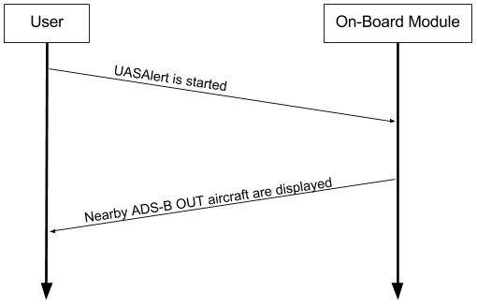

**Figure 3.2: Sunny Day Case Scenario.**

A rainy day scenario describes errors that could occur in the system. Figure 3.3 shows an example of one possible scenario where the RF module goes out of range during operation. The RF modules are limited to a range where data can be reliably transmitted to the ground station. A built-in feature allows the user to know the signal strength, but errors can still occur if signal strength becomes too low.

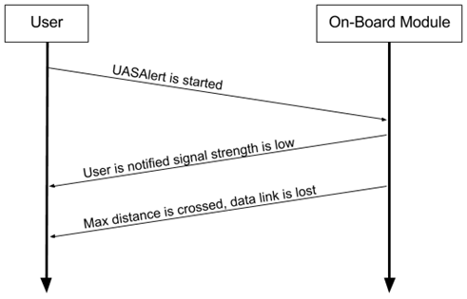

**Figure 3.3: Rainy Day RF module range case.**

Figure 3.4 shows a scenario where data packets are lost during operation. Packet loss could happen for multiple reasons such as other devices broadcasting on the same frequency or outside noise. The RF modules have a built-in feature that will give a notification that packet loss has happened, but this is not optimal performance.

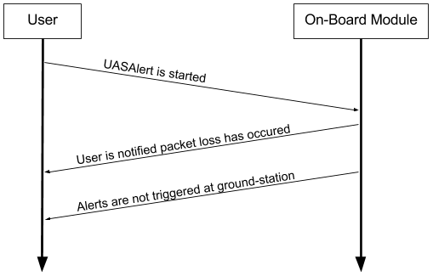

**Figure 3.4: RF module packet loss scenario.**

**4. EVALUATION**

This section details the tests that were conducted on the components of UAS Alert to ensure that the design constraints stated in Table 4.1.1. are met.

**4.1. Test Specifications**

The design constraints that need to be tested can be found in table 4.1.1.

**Table 4.1.1: Technical Design Constraints**

|  |  |
| --- | --- |
| **Name** | **Description** |
| **Transmission** | The transceiver must be able to communicate at 1000 m when in line-of-sight. |
| **Device Weight** | The device must weigh under 300 g. |
| **Battery Life** | The battery must power the device for a minimum of 1 hr. |
| **Compact Design** | The airframe attachment must be at most 150x150x100 mm. |
| **Response Time** | The total response time of the system must be no longer than 1 min to give the user time to adjust the flight path. |

**4.2. Test Specification – Transmission**

Range tests were done with the Digi XTCU application, a graphical interface to setup, configure, and test XBee RF modules [14]. Two members held laptops with the XTCU application and the XBee modules hooked up to the USB. A GPS distance measuring app was used to test the difference between members. The application showed the signal strength and the amount of transmitted, received, and lost packets during the test. At all ranges tested the application reported a acceptable signal strength. Figures 4.2.1, 4.2.2, 4.2.3, and 4.2.4 show the test done at 280, 520, 1200, and 3800 ft (85.3, 158.5, 365.7, and 1158 m).

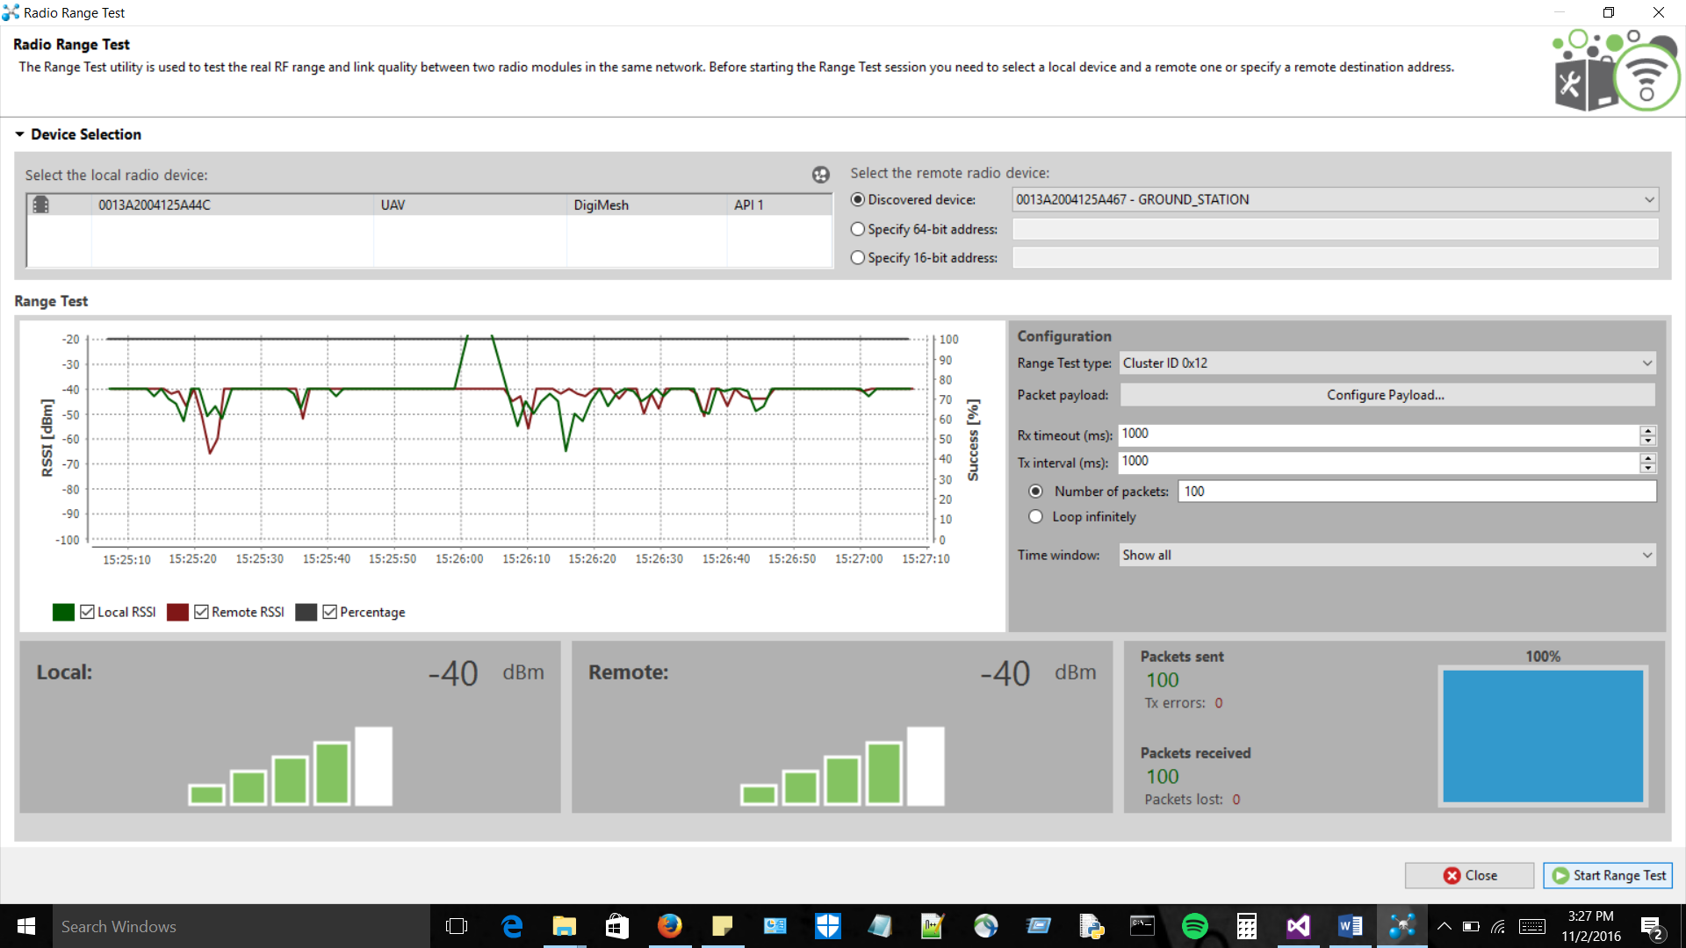

**Figure 4.2.1: Signal Strength at 280 ft**

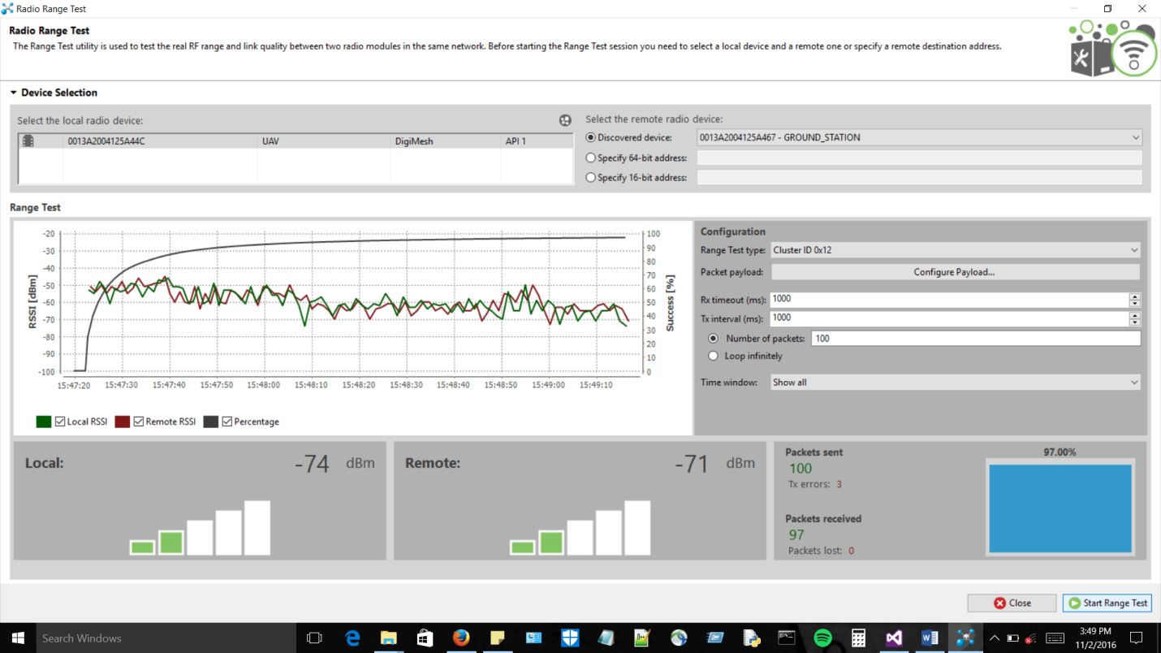

**Figure 4.2.2: Signal Strength at 520 ft**

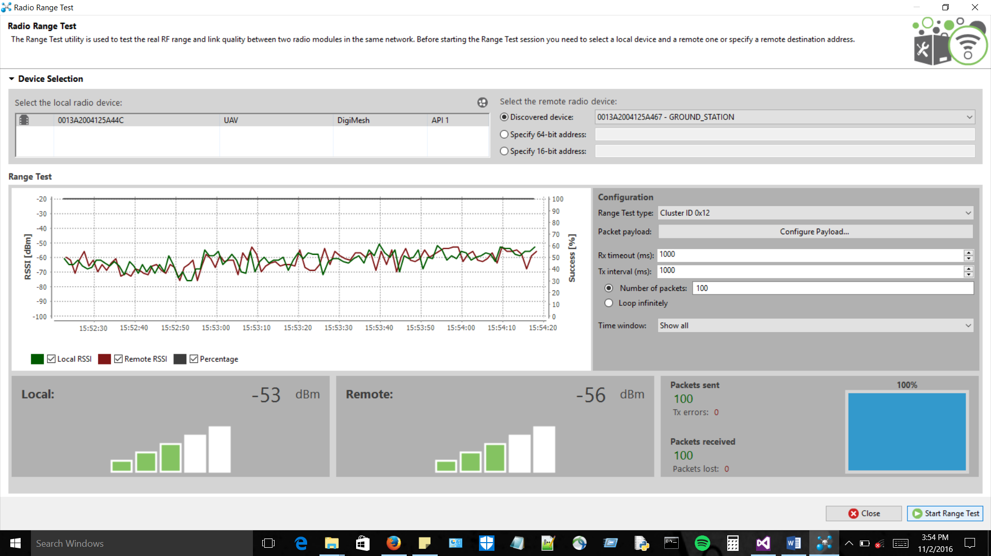

**Figure 4.2.3: Signal Strength at 1200 ft**

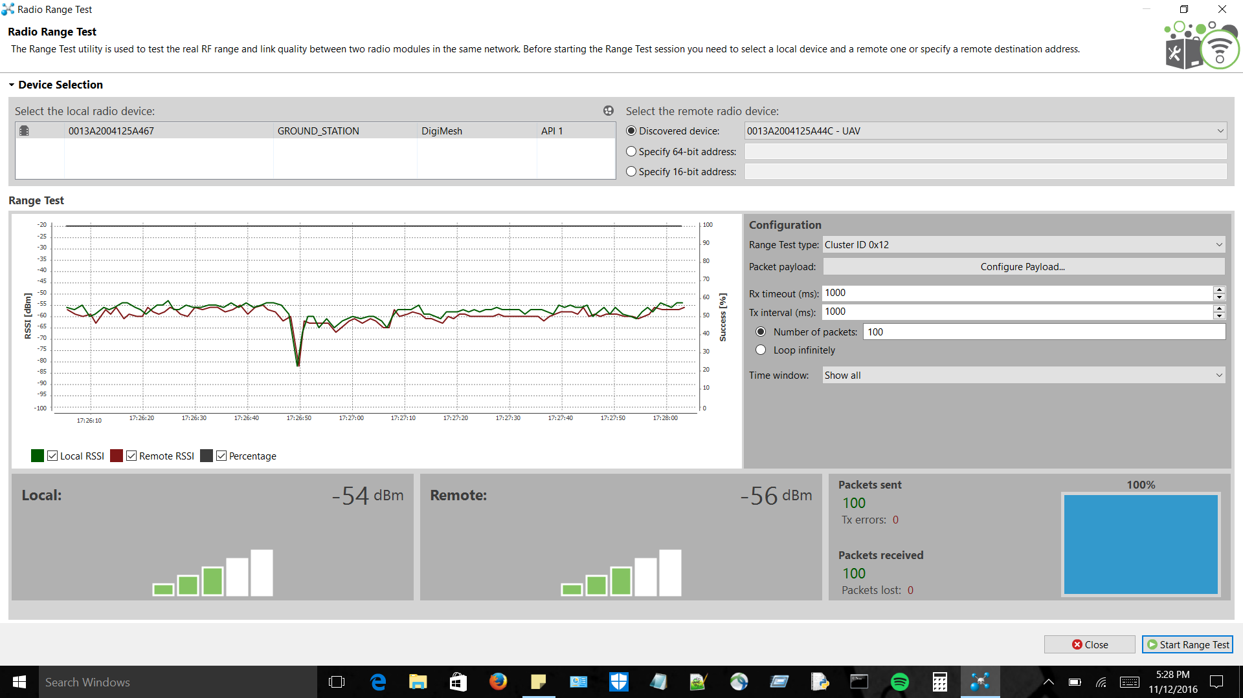

**Figure 4.2.4: Signal Strength at 3800 ft**

Figures 4.2.1-4.2.4 show the average dBm for their respective distances. These tests were done with the default antennas that came with the XBee 900HP kit. A packet size of 50 bytes was the test packet size. At all distances the signal strength had an average of -54 dBm which is well within the transceiver’s range of operation.

**4.3. Test Specification - Device Weight**

The weight of the individual components was measured using a precise scale. Figure 4.3.1 shows the software-defined radios (SDRs), the adapter cables, and the 3dBi antennas. Figure 4.3.2 shows the weight of the Raspberry Pi 3 Model B with a case.

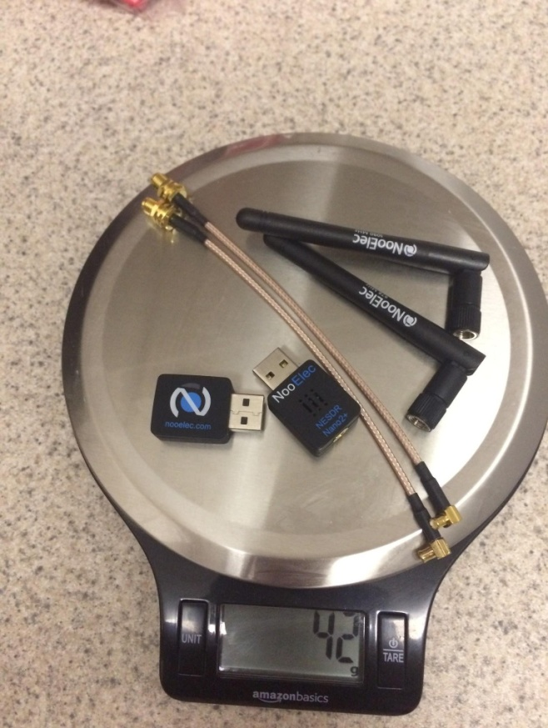

**Figure 4.3.1: Weight of SDRs, antennas, and adapter cables**

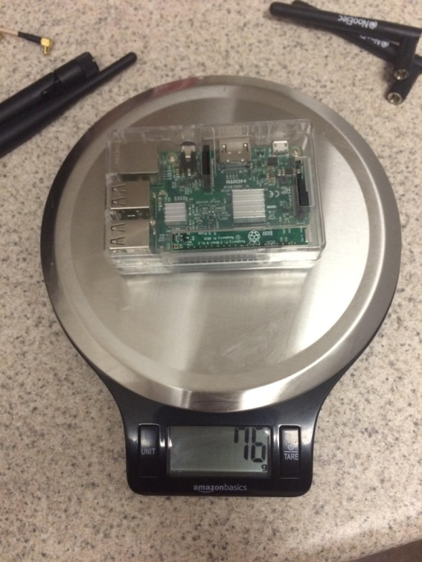

**Figure 4.3.2: Weight of Raspberry Pi**

The battery and buck converter together weigh 83 g and the transceiver weighs 36 g. The gathered data and total weight calculations can be seen in Table 4.3.4.

**Table 4.3.1: Total Weight**

|  |  |
| --- | --- |
| Component Name | Weight (grams) |
| Raspberry Pi 3 Model-B | 76 g |
| NooElec Nano 2 SDRs | 42 g |
| Xbee 900HP | 36 g |
| FlightPower FPRX 1600mAh | 68 g |
| UBEC DC-DC Converter | 15 g |
| Total Weight | 237 g |

**4.4. Test Specification - Battery Life**

We established in the power constraint that the battery must be able to sustain at least 1 hr of usage in order to provide services to the user for the full duration a flight. We measured the individual current draw of each of the components. This was accomplished by using a USB inline ammeter.

Each of the SDRs were measured at a constant 250 mA draw regardless of the amount of traffic detected as shown in Figure 4.4.1. This is likely due to the constant sampling from the SDRs.

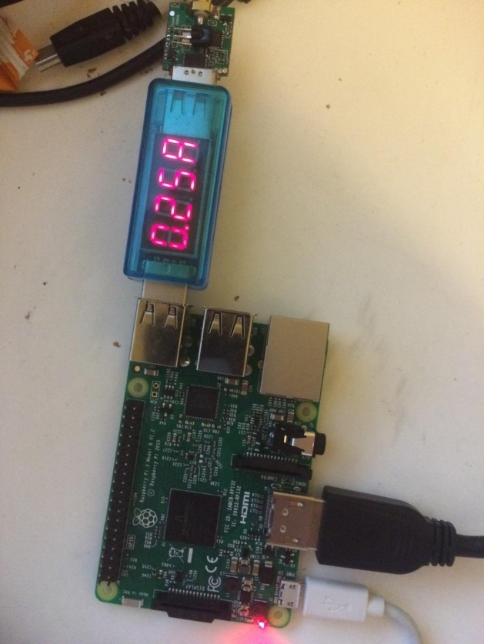

**Figure 4.4.1: Current Draw of SDR**

The current draw of the Raspberry Pi system was measured at 400 mA. This will be the part of the UAS Alert system that will pull the maximum amount of current. This is because the Raspberry Pi is the basis of our system and runs the majority of processes enabling proper functionality.

The Xbee 900hp, which is the RF module used for wireless communication from the on-board section of this system to the ground station, was measured to have a current draw of 215 mA. The total current draw with everything running is shown in Figure 4.4.2.

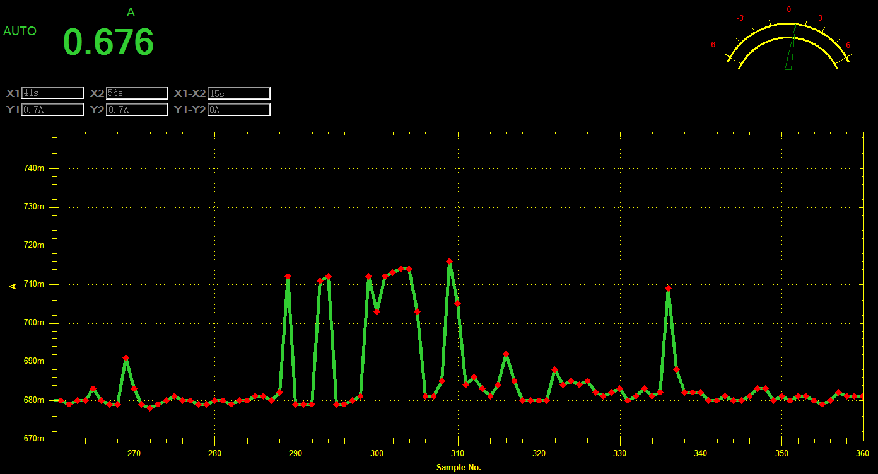

**Figure 4.4.2: Current Draw of Whole System**

To satisfy the power needs required for proper operation of the system, we must account for all power-consuming components that will rely on the battery pack. To obtain this measurement, we took the maximum measured current draw for each system and added them together. The information obtained can be found in Table 4.4.1.

**Table 4.4.1: Power Consumption**

|  |  |  |  |
| --- | --- | --- | --- |
| Subsystem Name | Current Draw | Voltage(Avg.) | Total Power Draw |
| Raspberry Pi | 400 mA | 5V | 2 W |
| Software Defined Radios (SDRs) | 580 mA  (2 x 290 mA) | 5V | 2.9 W |
| Xbee 900hp | 215 mA | 3.3V | 0.774 W |
| Total System Battery Consumption | 1.195 A |  | 5.975 W |

**4.5. Test Specification - Compact Design**

The purpose of the compact design is to ensure that the device will be able to at least fit under a popular consumer UAV such as the DJI Phantom 3. The placement of the antennas was done so that they would cause minimal interference with the UAV and keep the on-board module within the size constraints. As of now our design does fit within our constraints as long as the antennae are placed directly next to the onboard device. We were unable to test this with our device on a DJI Phantom 3 but we have measured the overall size and the dimensions were within the constraints.

**4.6. Test Specification - Response Time**

As the constraints stated, the response time needs to be fast enough so that there is a current and accurate position on the ground station display. We were only able to test the time difference between receiving the message on the on-board module until receiving it on the ground station to be decoded and placed on the map. Statements were placed in the code for the on-board module that timed when the message was received. This was also done on the ground station upon receiving and plotting the aircraft on the display. The difference was found to be less than 1 second, which satisfies this technical constraint. The figures below demonstrate one of the tests performed. Figure 4.6.1 shows the timing, in seconds, of the message being received on the on-board module. Figure 4.6.2 shows the message being received on the ground station. Before running the test. The time on both machines was printed to ensure that they were in sync. The ground-station’s time stamp was initially two seconds behind that of the on-board. This is reflected in the figures below.

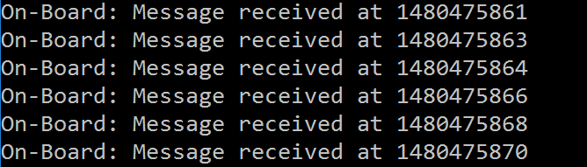

**Figure 4.6.1: On-board**

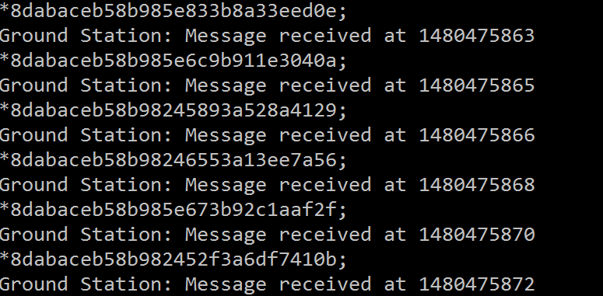

**Figure 4.6.2: Ground Station**

**4.7. Total System Test**

Lastly the entire system was tested. For this test the Xbees, SDRs, and Raspberry Pi were connected to the battery. Figure 4.7.1 shows the GPS coordinates, tail number, and type as it is received on the ground station.

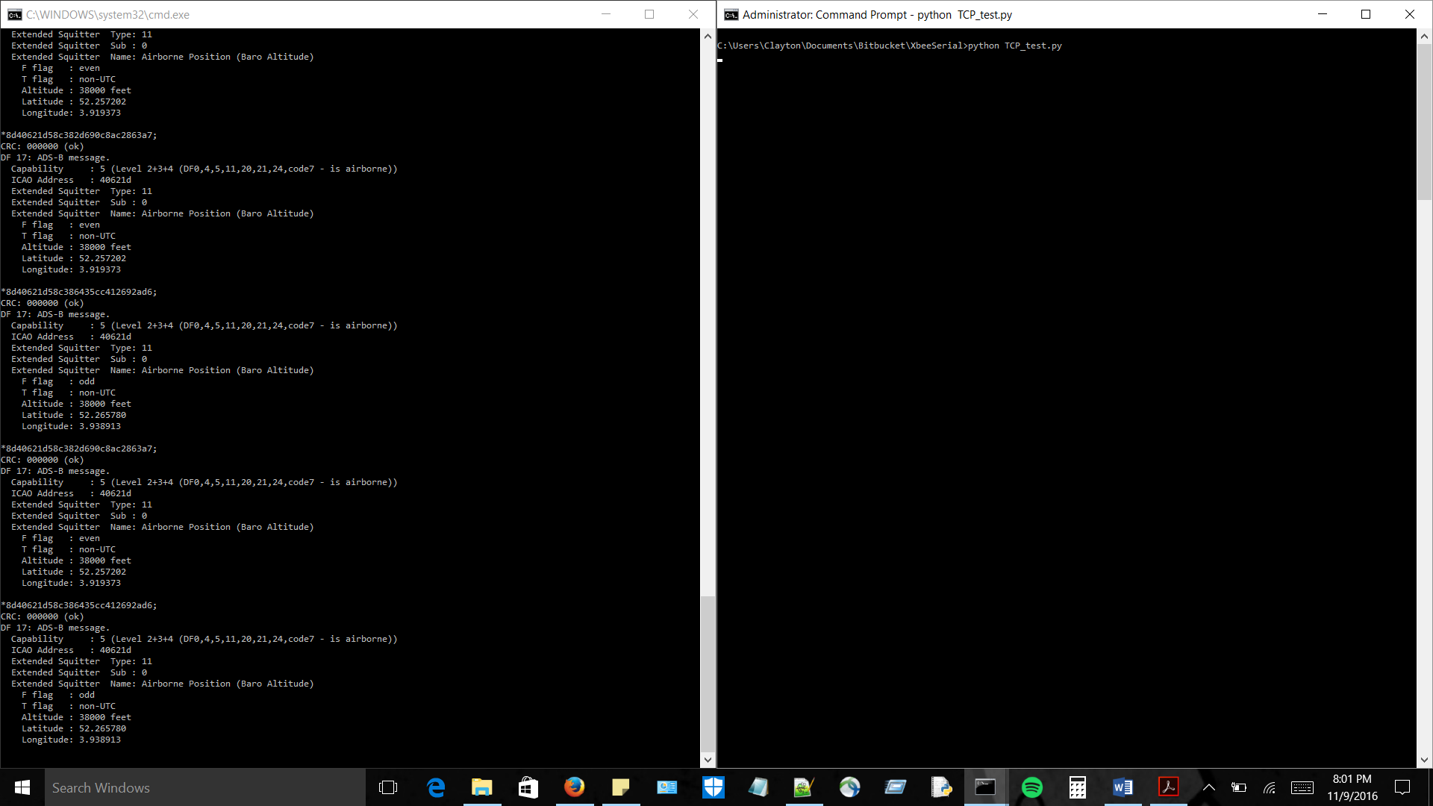

**Figure 4.7.1: Actual Coordinates, Tail Number, and Type**

Figure 4.7.2 shows a plane plotted on the display. Note that these figures are two distinct planes.

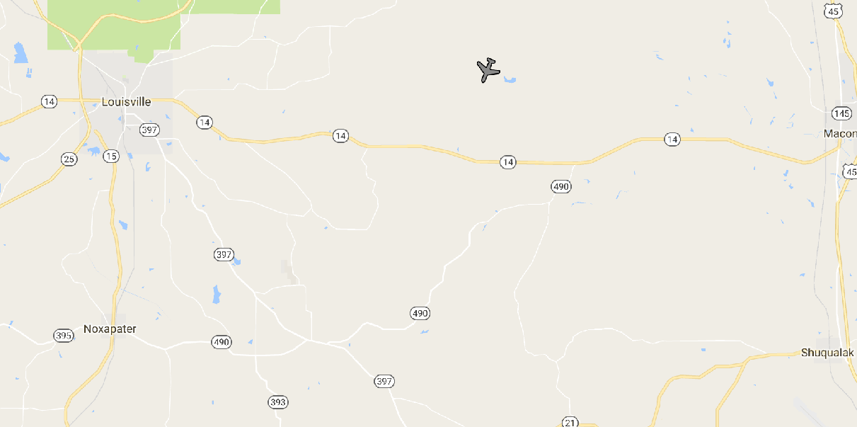**Figure 4.7.2: Actual Mapping of Airplane Displayed on Ground Station**

**5. SUMMARY AND FUTURE WORK**

UAS Alert is a situational awareness system that is designed to give UAV operators a map of aircraft near their UAV. The system will decrease the possibility for mid-air collisions between UAVs and ADS-B equipped aircraft. The result is an accurate map of the air space around the UAV on a ground station which will display nearby aircraft information for the UAV operator to view. UAS Alert uses a Raspberry Pi, SDRs, and Xbees to receive the ADS-B messages and send them to the ground station.

One issue the team had was that the FAA has many regulations we did not know about at the beginning of the project, however we adapted our project to stay within the legal boundaries of the FAA. There were also issues with the Google Maps API that part of the application was previously based on. The code had to be edited such that it would work for our specific application, although this was a temporary fix since Google Maps API grants a limited amount of free accesses. The current plan is to switch to openlayers3, a free and open-source API that provides the same functionality as google maps. Since there is a high power demand, the team decided to go with a higher voltage battery regulated, by a DC-DC converter, to the 5 V required for Raspberry Pi operation. The last problem the team ran into was that the original SDRs that were ordered were not optimal for our application due to temperature concerns. Therefore, we had to order new SDRs before we could start testing our system.

This semester we were able to receive ADS-B messages, send the message to the ground station, decode the message, and display the aircraft on a map. UAS Alert works best in outside areas where there are not many obstructions in the way. The device will also work reliably for approximately 1.2 times the amount of time it needs to be powered. There was a possibility that the Xbees would need larger antennae but the standard ones work very reliably at much further distances than anticipated.

The main goal for next semester is to make the design much more compact and faster. This will include making a PCB, designing a casing, re-writing some of the decoding software, and possibly switching to a Raspberry Pi Zero. The display will be redesigned so that proximity alerts can be provided for the operator of the UAV. The team also plans to provide the user with a secondary choice for display. This display will resemble a TCAS radar display. The PCB will have the DC-DC converter implemented on it as well as a second converter for 3.3 V if we switch to a Raspberry Pi Zero. PCBs will also be make for the Xbees to reduce the overall size of them. These mentioned modifications will make the design smaller and process messages faster for an even better awareness system for the UAV operator.

**6. REFERENCES**

[1] “Unmanned aerial vehicle”. Wikipedia.org, [Online]. Available: https://en.wikipedia.org/wiki/Unmanned\_aerial\_vehicle. [Accessed: 30-Aug-2016].

[2] "A320 collision heightens UAV safety concerns", Flightglobal.com, 2016. [Online]. Available: https://www.flightglobal.com/news/articles/a320-collision-heightens-uav-safety-concerns-424419/. [Accessed: 30-Aug-2016].

[3] “Automatic Dependent Surveillance-Broadcast (ADS-B)”. FAA.gov, [Online]. Available: http://www.faa.gov/nextgen/programs/adsb/. [Accessed: 30-Aug-2016].

[4] “ADS-B Frequently Asked Questions (FAQs)”. FAA.gov, [Online]. Available: https://www.faa.gov/nextgen/programs/adsb/faq/. [Accessed: 6-Sep-2016].

[5] “DJI and uAvionix to release ADS-B collision avoidance developer kit”, DJI NEWS, 2016. [Online]. Available: http://www.dji.com/newsroom/news/dji-and-uavionix-to-release-ads-b-collision-avoidance-developer-kit. [Accessed: 30-Aug-2016].

[7] “Phantom 3 Professional - Specs, FAQ, Tutorials, Downloads and DJI GO | DJI”, *dji.com*, 2015. [Online]. Available: http://www.dji.com/phantom-3-pro/info. [Accessed: 16-Sep-2016].

[8] “Phantom 3 size: Complete Measurements | Engabao.com”, *Engabao.com*, 2016. [Online]. Available: <http://www.engabao.com/phantom-3-size-complete-measurements/>. [Accessed: 14-Sep-2016].

[9] N. Heath, “No, your Raspberry Pi 3 won't overheat in everyday use, says its creator | ZDNet”, *ZDNet*, 2016. [Online]. Available: <http://www.zdnet.com/article/no-your-raspberry-pi-3-wont-overheat-in-everyday-use-says-its-creator/>. [Accessed: 16-Sep-2016].

[10] “ADS-B Ins and Outs”, *faa.gov*, 2016. [Online]. Available: https://www.faa.gov/nextgen/media/Safety%20Briefing%20ADS-B.pdf. [Accessed: 16-Sep-2016].

[11] “FCC Rules for Wireless Equipment operating in the ISM bands -www.afar.net”, *Afar.net*, 2016. [Online]. Available: http://www.afar.net/tutorials/fcc-rules. [Accessed: 16-Sep-2016].

[12]Scottie.(2015, June 21). “Lithium Polymer vs Lithium-Ion batteries: What’s the deal?”, [Online]. Available: https://scottiestech.info/2015/06/21/lithium-polymer-vs-lithium-ion-batteries-whats-the-deal/. [Accessed: 29-Nov-2016].

[13] “Raspberry Pi FAQs - Frequently Asked Questions”, *Raspberry Pi*, 2016. [Online]. Available: https://www.raspberrypi.org/help/faqs/#power. [Accessed: 01-Nov-2016].

[14] “XCTU - Next Gen Configuration Platform for XBee/RF Solutions - Digi International”, *Digi.com*, 2016. [Online]. Available: https://www.digi.com/products/xbee-rf-solutions/xctu-software/xctu#productsupport-utilities. [Accessed: 03-Nov-2016].

**7. APPENDIX: PRODUCT SPECIFICATION**

