Kalman Filter Noise Sweep
Figure Guide
  - HAOS Flight 403
How to interpret the figures and reproduce them from kf_samples.csv
This guide explains all eleven diagnostic figures from the 49-run Kalman filter sweep. Each figure is reproduced with a description of what it tells the reader, a concrete observation from this flight, and the calculation that connects it to the per-sample CSV.

What the results establish
Increasing the assumed acceleration noise from 0.05 g materially improves one-step agreement with the CSV observations, particularly during the selected maneuvers. Most of that improvement occurs before the top of the tested range. Changing position noise has a much larger effect on reported position uncertainty than on many prediction scores. At 5 and 10 seconds, forecast discrepancies grow substantially because every forecast still assumes constant velocity.
The comparisons measure agreement with the original CSV observations. They do not establish absolute accuracy against an independent truth trajectory. A smaller posterior residual can indicate closer measurement following, while a larger covariance can reflect a more conservative uncertainty assumption. Neither alone identifies the best filter.

The experiment in one view
Setting | Value
State | East, north, up, east velocity, north velocity, up velocity
Model and observations | Six-state constant-velocity KF; both position and velocity are observed
Acceleration std sweep | 0.05, 0.166667, 0.283333, 0.40, 0.516667, 0.633333, 0.75 g
Position std sweep | 5, 10, 20, 35, 50, 65, 100 m
Fixed velocity observation std | 1 m/s
Segment | HAOS_Flight_403_seg00; 2,071 records from 0 to 2,070 s
Evaluation | 2,070 updates; initialization excluded; no additional burn-in
Forecast origins | 2,060 common origins, from 1 through 2,060 s
Maneuver samples | 518 updates above a reference acceleration threshold of about 1.127 m/s²

How to read the figures
Heatmaps show all 49 settings. Increasing acceleration std moves upward; increasing position std moves rightward. Cells are evenly spaced visually even though the position values are not evenly spaced numerically. Each panel has its own color scale, so compare the printed values and units across panels.
Line plots show four corners only: blue = 0.05 g and 5 m; orange = 0.05 g and 100 m; green = 0.75 g and 5 m; red = 0.75 g and 100 m. The larger CSV tables retain every setting. The three event figures are numbered separately here, although their filenames all begin with 07.

Common data and calculations
The analysis script is analyze_kf_sweep.py. Its input is the large kf_samples.csv. Each row represents one sample in one segment for one noise pair. Group by segment_id, model_acceleration_std_g, and position_noise_std_m; then sort each group by sample_index. The script verifies that reference observations and timestamps match across runs.
CSV columns | Meaning
time_s and sample_index | Time within the segment and sequential sample number
observation_east, observation_north, observation_up | Reference position components in meters
observation_ve, observation_vn, observation_vu | Reference velocity components in m/s
x_prior_* and x_posterior_* | Predicted state before the current observation and corrected state after it
P_prior_*_* and P_posterior_*_* | All 36 covariance entries; suffixes name the row and column states
innovation_* and nis | Measurement-minus-prediction innovations and normalized innovation squared

Residuals and summaries
A prior residual is predicted state minus reference observation at the same time. A posterior residual substitutes the corrected state. For position, let d be the Euclidean length of the three component residuals: d = √(r_east² + r_north² + r_up²). For velocity, use ve, vn, and vu. The norm is nonnegative; the signed component means are separate bias statistics.
RMS = √mean(d²). P95 is the 95th percentile of d, so approximately 95% of evaluated distances lie at or below it. RMS is not the mean distance, and neither quantity is a confidence bound derived from P. The first row initializes the filter and is excluded from these summaries.

A common maneuver definition
Use the reference observation_ve, observation_vn, and observation_vu columns from one run, because they are identical across runs. Apply a centered five-second rolling mean to each velocity component, differentiate the smoothed components with respect to time_s using numpy.gradient, and take the three-dimensional acceleration norm. The 75th percentile over eligible updates is the threshold, approximately 1.127 m/s². Samples strictly above it form the common maneuver mask.
This is an offline, reference-based classification. It uses nearby future observations for smoothing and is not an online maneuver detector. It does not alter the KF states or forecasts. Below-threshold samples are called lower acceleration; they are not guaranteed to be truly constant velocity. Consecutive above-threshold samples form events, numbered in chronological order from zero.

How the two tuning parameters act
Position std is squared to build the position block of R, and also affects the initial position covariance in this implementation. Acceleration std is converted from g to m/s², squared, and mapped through G to form Q. The acceleration parameter changes uncertainty and measurement weighting; it does not add an acceleration state or a deterministic acceleration term to the constant-velocity forecast.
Implementation reference: reference_context builds common masks and forecast targets; residual_stats calculates distance summaries; covariance_summaries summarizes P; autocorrelation calculates the innovation ACF; draw_plots creates the figures. The supplied image labels and numerical examples correspond to the default analysis settings.

Figure 1 One step prediction comparison
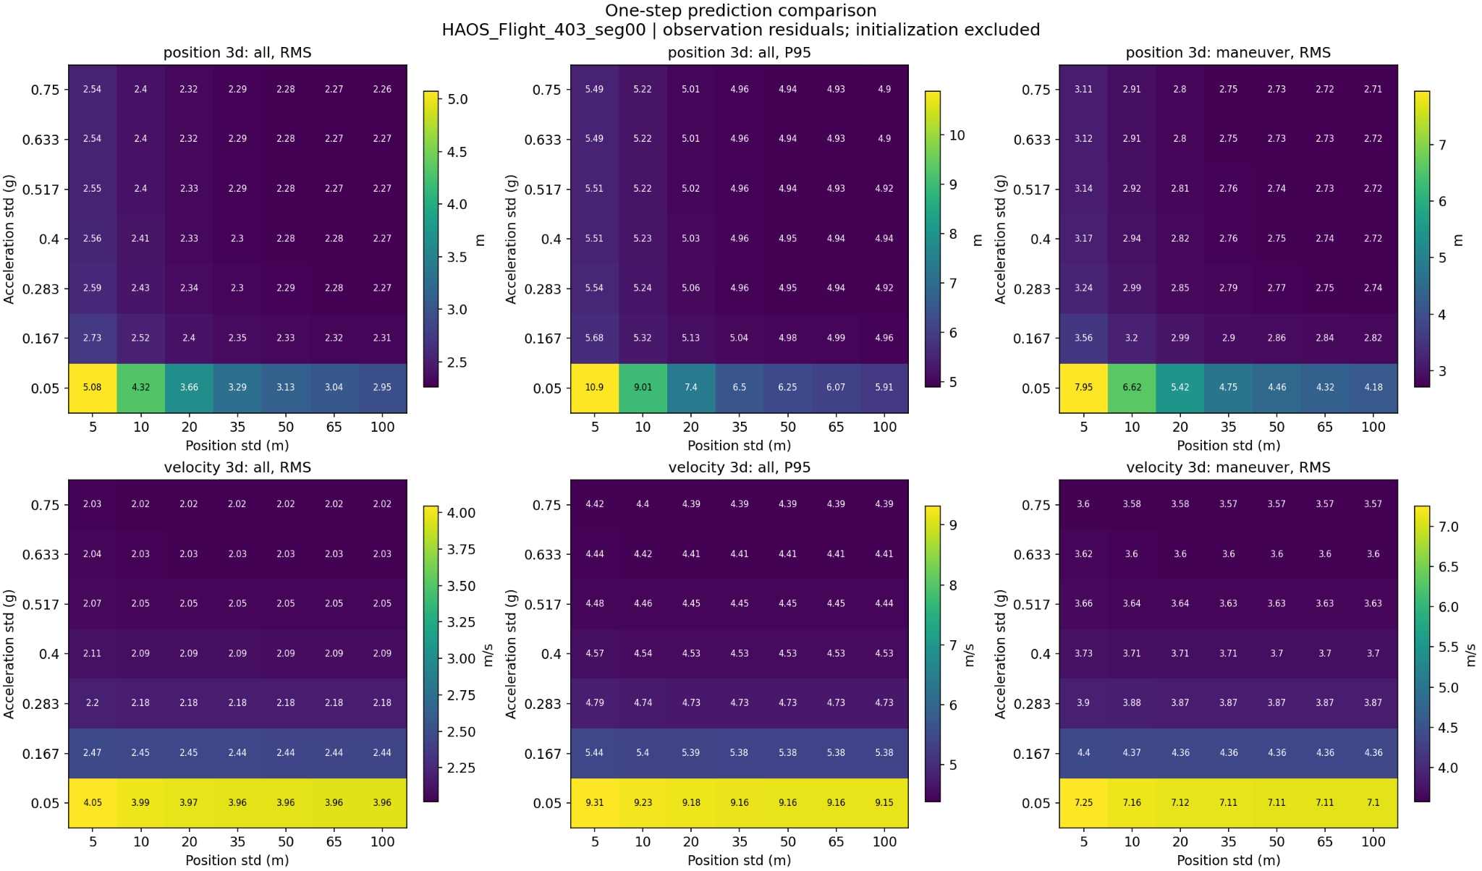
Figure 1. Prior position and velocity residual summaries over all updates and maneuver updates Source image: 01_prediction_heatmaps.png.
What it shows. The top row describes position prediction and the bottom row velocity prediction. The first column is whole-segment RMS, the second is whole-segment P95, and the third is RMS restricted to the common maneuver mask. Smaller numbers mean closer one-step agreement with the observations.
What this flight tells us. At 5 m position std, increasing acceleration std from 0.05 to 0.75 g reduces position RMS from 5.08 to 2.54 m and maneuver position RMS from 7.95 to 3.11 m. The velocity RMS falls from 4.05 to 2.03 m/s. Much of the improvement occurs between 0.05 and about 0.167–0.283 g; the upper rows show diminishing returns. Position noise also affects position residuals, but has little effect on velocity residuals at a fixed acceleration setting.
How it is generated. For each noise pair, subtract observation_east/north/up from x_prior_east/north/up and form the position norm. Repeat with ve/vn/vu for velocity. Exclude sample 0. Compute RMS and P95 over all remaining rows, then RMS over the shared maneuver rows. Pivot these values by the two noise parameters to make the six heatmaps.
Where to find the numbers. residual_metrics.csv, phase=prior; quantity=position_3d or velocity_3d; regime=all or maneuver. These are observed residual statistics, not covariance-based accuracy predictions.

Figure 2 Forecasts at one five and ten seconds
The figure on the following page asks a different question from the ordinary KF update: if new observations stopped now, how far would a constant-velocity forecast depart from the later CSV positions? Each row is a forecast horizon, and each column is either RMS or P95 position distance.

What this flight tells us
Longer horizons expose limitations that are barely visible in a trajectory overlay. At the high-noise corner, RMS grows from about 2.25 m at one second to 21.5 m at five seconds and 64.8 m at ten seconds. Ten-second P95 is about 153 m. These numbers describe forecasts evaluated against later observations, not a filter that continues receiving measurements during those ten seconds.
Horizon | 0.05 g and 5 m RMS | 0.75 g and 100 m RMS | 0.75 g and 100 m P95
1 second | 5.08 m | 2.25 m | 4.90 m
5 seconds | 28.5 m | 21.5 m | 48.3 m
10 seconds | 72.6 m | 64.8 m | 153 m
Increasing acceleration noise improves the velocity estimate used to launch a forecast, but the forecast itself remains a straight constant-velocity extrapolation. At ten seconds, changing position std makes little difference compared with the effect of elapsed prediction time. The nearly flat upper rows suggest limited benefit from further tuning within this range; they do not prove a universal optimum.

How it is generated from the CSV
At each eligible origin time t, read posterior position p(t) from x_posterior_east/north/up and posterior velocity v(t) from x_posterior_ve/vn/vu. For horizon τ, calculate forecast position p(t) + τ v(t). Compare it with observation_east/north/up at the exact timestamp t + τ, take the distance norm, and summarize with RMS and P95. No later update, fitted acceleration, or future observation enters the forecast.
All horizons and all settings use the same 2,060 launch times, 1 through 2,060 s. A launch is retained only if reference positions exist at all three target horizons. For this one-second dataset the target indices are direct time offsets. The general script matches timestamps within 10⁻⁶ s and does not interpolate.

Why its one second values differ from Figure 1
Figure 1 evaluates priors at times 1 through 2,070 s. The one-second row here evaluates forecasts launched at times 1 through 2,060 s, arriving at times 2 through 2,061 s. The constant-velocity prediction rule is the same, but the evaluated endpoints differ. This explains small differences such as 2.26 versus 2.25 m; they are not different filter algorithms.
Where to find the numbers. forecast_metrics.csv, quantity=position_3d, regime=all, horizon_s=1, 5, or 10. maximum_time_s identifies the target time; maximum_origin_time_s identifies the launch time.

Figure 2 Forecast heatmaps
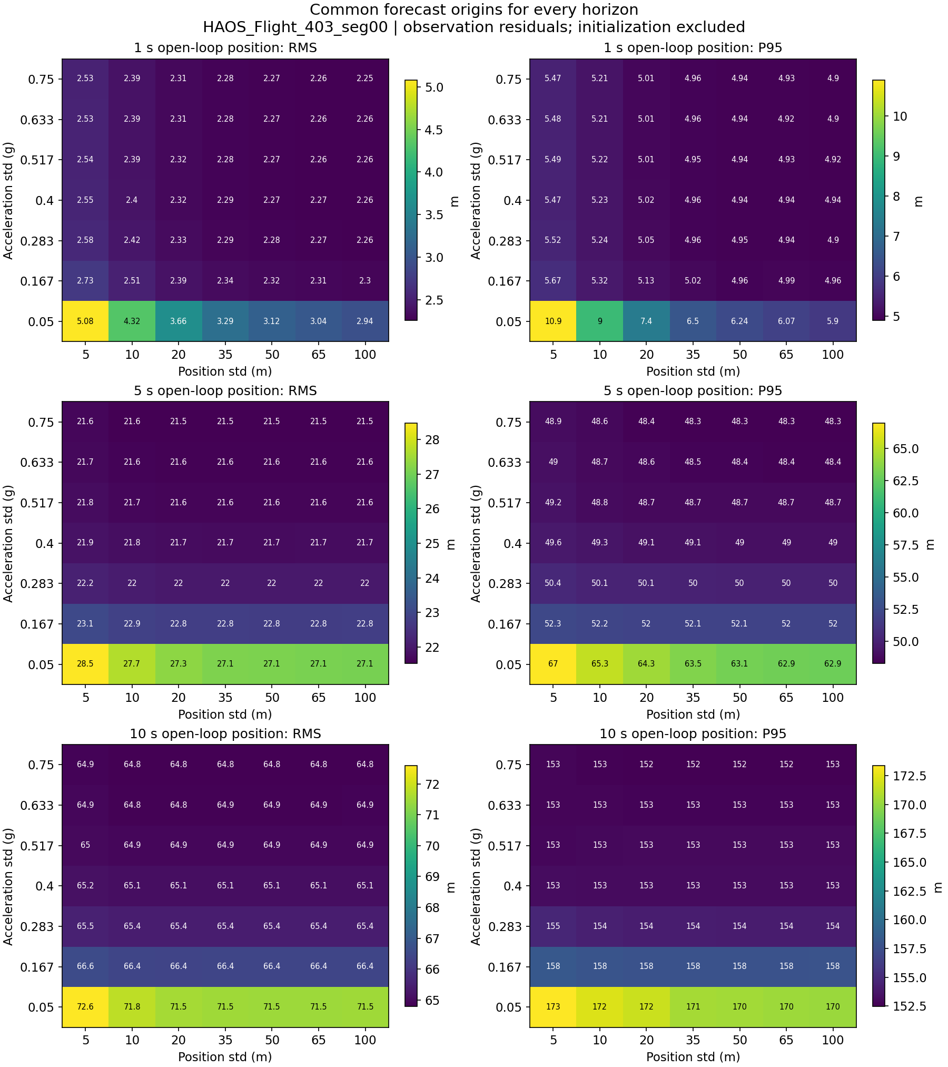
Figure 2. Open-loop position RMS and P95 at common forecast origins Source image: 02_forecast_heatmaps.png.

Figure 3 Reported covariance uncertainty
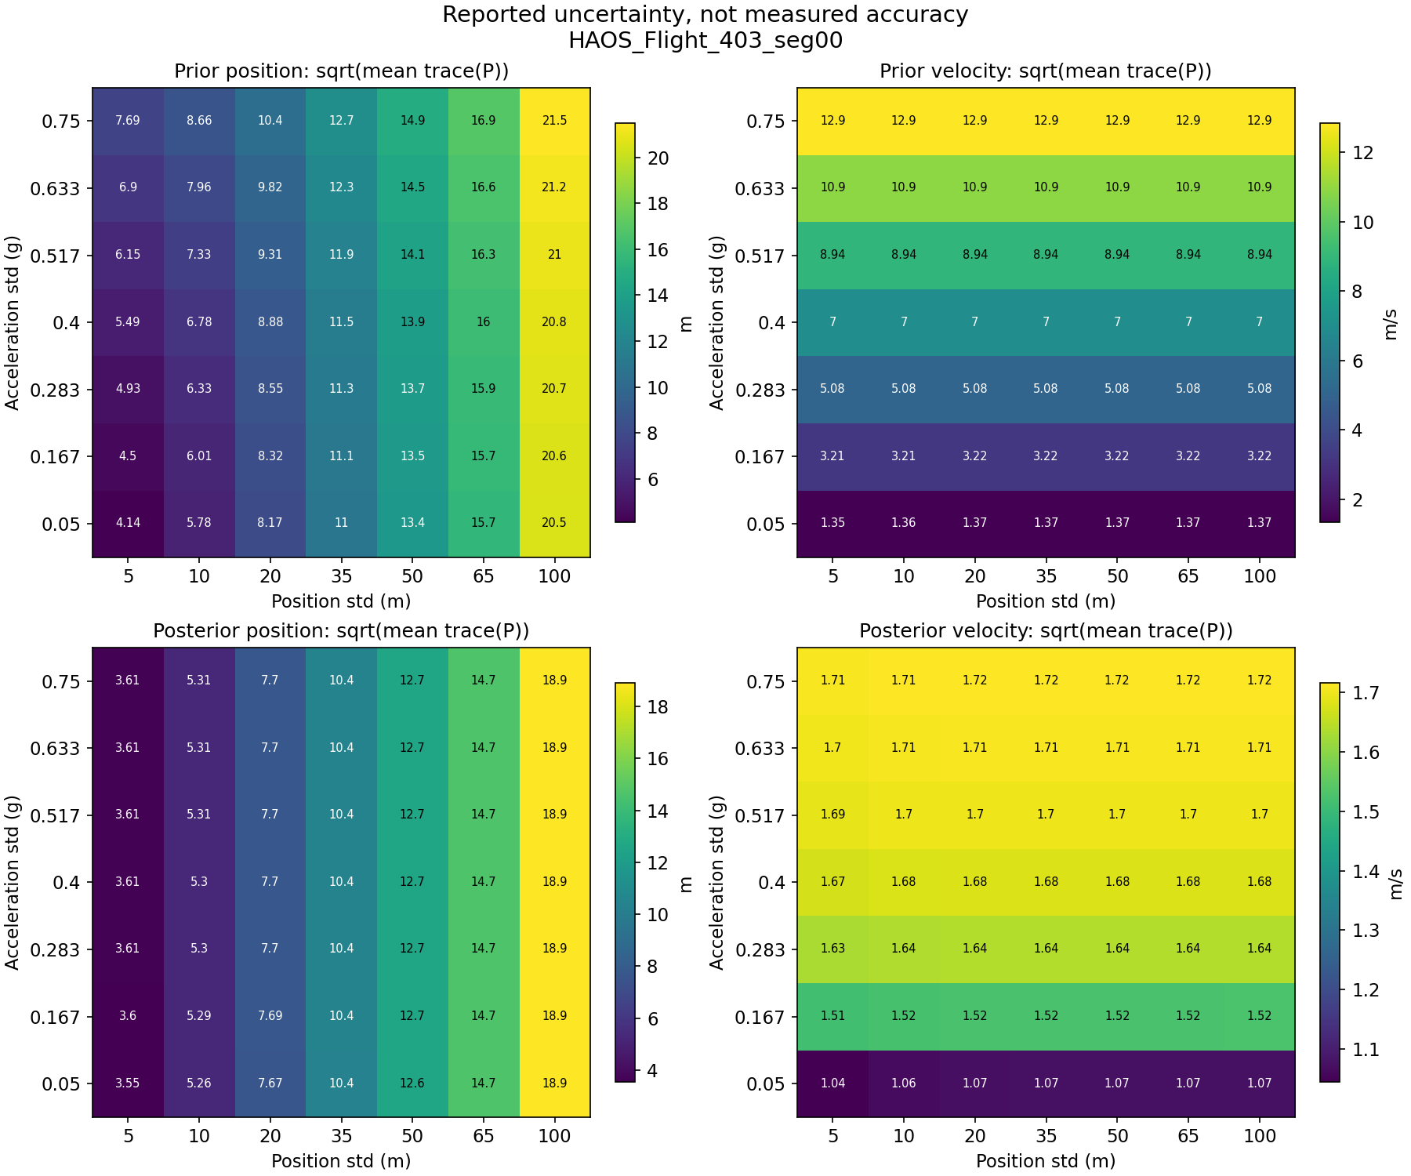
Figure 3. Model-implied position and velocity uncertainty before and after the observation Source image: 03_covariance_heatmaps.png.
What it shows. The top row uses prior covariance and the bottom row posterior covariance. Position and velocity are separate because their units differ. Each cell is √mean(trace(P_block)): the square root of the time-average sum of the three component variances. It is an RMS uncertainty magnitude under the filter model, not a 95% radius or a measured error.
What this flight tells us. Posterior position uncertainty grows from about 3.55 to 18.9 m as position std rises from 5 to 100 m, with relatively little change across acceleration settings. Prior velocity uncertainty grows strongly with acceleration std, from about 1.35 to 12.9 m/s. The measurement update reduces the high-acceleration posterior velocity uncertainty to about 1.71–1.72 m/s because velocity observations retain their fixed 1 m/s component uncertainty.
How it is generated. Sum the east/east, north/north, and up/up diagonal entries of P_prior for each eligible row, average over time, then take the square root. Repeat for P_posterior and for the ve/ve, vn/vn, vu/vu blocks. The order matters: √mean(trace(P)) is not mean(√trace(P)). Values are in covariance_metrics.csv, regime=all, column rms_uncertainty.
Interpretation limit. For prescribed F, Q, H, R and initialization, covariance depends on timestamps and matrix assumptions, not the observed trajectory values. These panels therefore describe uncertainty assigned by the model. A smaller value does not by itself establish a more accurate estimate.

Figure 4 Prediction and posterior fitting
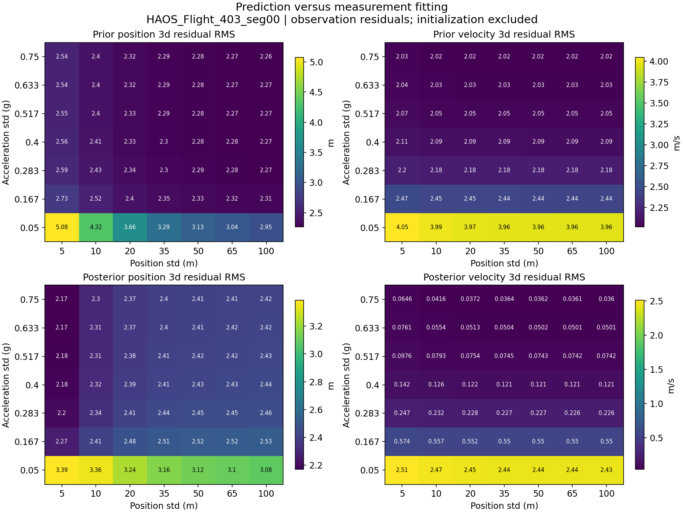
Figure 4. Residual RMS before and after assimilating the current observation Source image: 04_prior_posterior_heatmaps.png.
What it shows. The top row evaluates the prediction before the current observation is used. The bottom row evaluates the corrected estimate after it is used. Position is on the left and velocity on the right. Each value is a three-dimensional residual RMS against the same CSV observations.
What this flight tells us. At 0.75 g and 100 m, velocity RMS drops from about 2.02 m/s before the update to 0.036 m/s afterward. The posterior is following the velocity measurements closely. That tiny residual is not independent evidence of 0.036 m/s true velocity accuracy. At 0.75 g, increasing position std from 5 to 100 m improves prior position RMS from 2.54 to 2.26 m, while posterior position RMS increases from 2.17 to 2.42 m.
How it is generated. For each setting, form x_prior_* minus observation_* and x_posterior_* minus observation_* at the same time_s. Calculate position and velocity norms separately, exclude initialization, and take √mean(norm²). These are residual_metrics.csv rows with regime=all and phase=prior or posterior.
Why posterior position can be worse. The KF jointly updates all six state components, using position–velocity covariance and both observation types. Its correction is not constrained to reduce every position residual norm. It minimizes modeled expected estimation error, not every realized distance to the current observation. Compare posterior fitting alongside prediction performance, not as a replacement for it.

Figure 5 Residual distributions
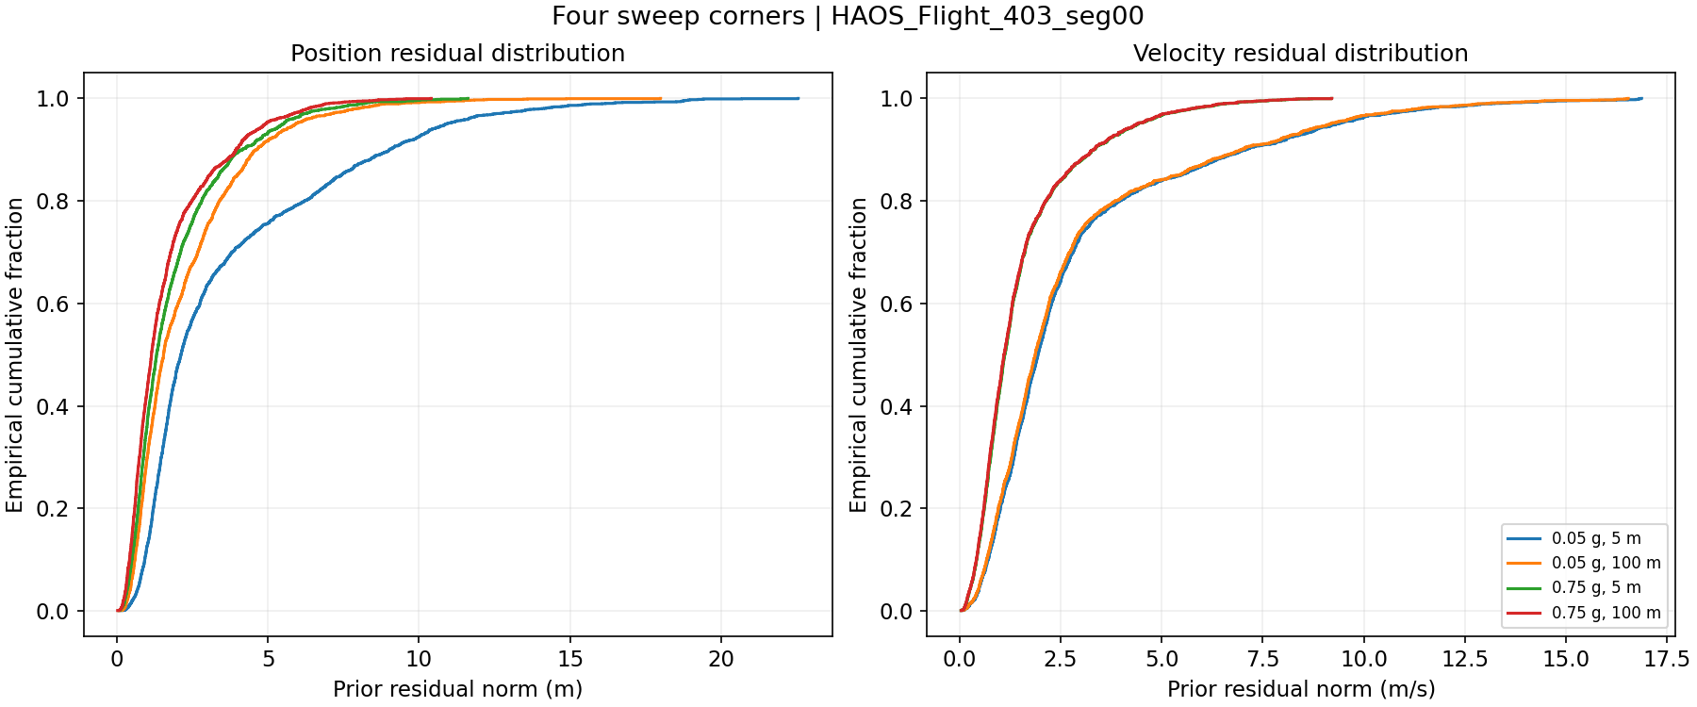
Figure 5. Empirical cumulative distributions of prior residual norms for the four sweep corners Source image: 05_residual_distributions.png.
What it shows. The horizontal axis is residual distance, in meters on the left and m/s on the right. The vertical axis is the fraction of evaluated updates with residual norm at or below that distance. At a fixed tolerance, a higher curve means more updates satisfy it. At a fixed percentile, a curve farther left means a smaller residual. The point at cumulative fraction 0.95 is the P95 distance.
What this flight tells us. The blue low-acceleration, low-position-noise configuration has the broadest position tail, reaching above 20 m. The higher-acceleration configurations concentrate more of the position residuals at small distances. In velocity, blue and orange nearly overlap, as do green and red. This supports the heatmap finding that acceleration tuning dominates velocity residual behavior, whereas position tuning has little influence on it.
How it is generated. Select the minimum and maximum values of each swept parameter, giving four runs. From x_prior_* and observation_*, calculate each eligible position and velocity residual norm. Sort each collection in ascending order. Plot the i-th sorted distance against i/N, for i=1 through N. The script uses a step plot, not a fitted Gaussian distribution or a histogram.
How to use it. Choose a meaningful tolerance and read the fraction below it, or choose a desired coverage such as 95% and read the corresponding distance. The curves show typical behavior and tails together. Crossing curves imply that a setting can be better at one percentile and worse at another; one average cannot capture that distinction.
Where to find the numbers. The distributions come directly from the per-sample CSV. residual_metrics.csv supplies their medians, P95 values, maxima, and fractions exceeding the configured tolerances. The example tolerances of 10 m and 2 m/s are adjustable, not validated requirements.

Figure 6 Residuals over the full flight
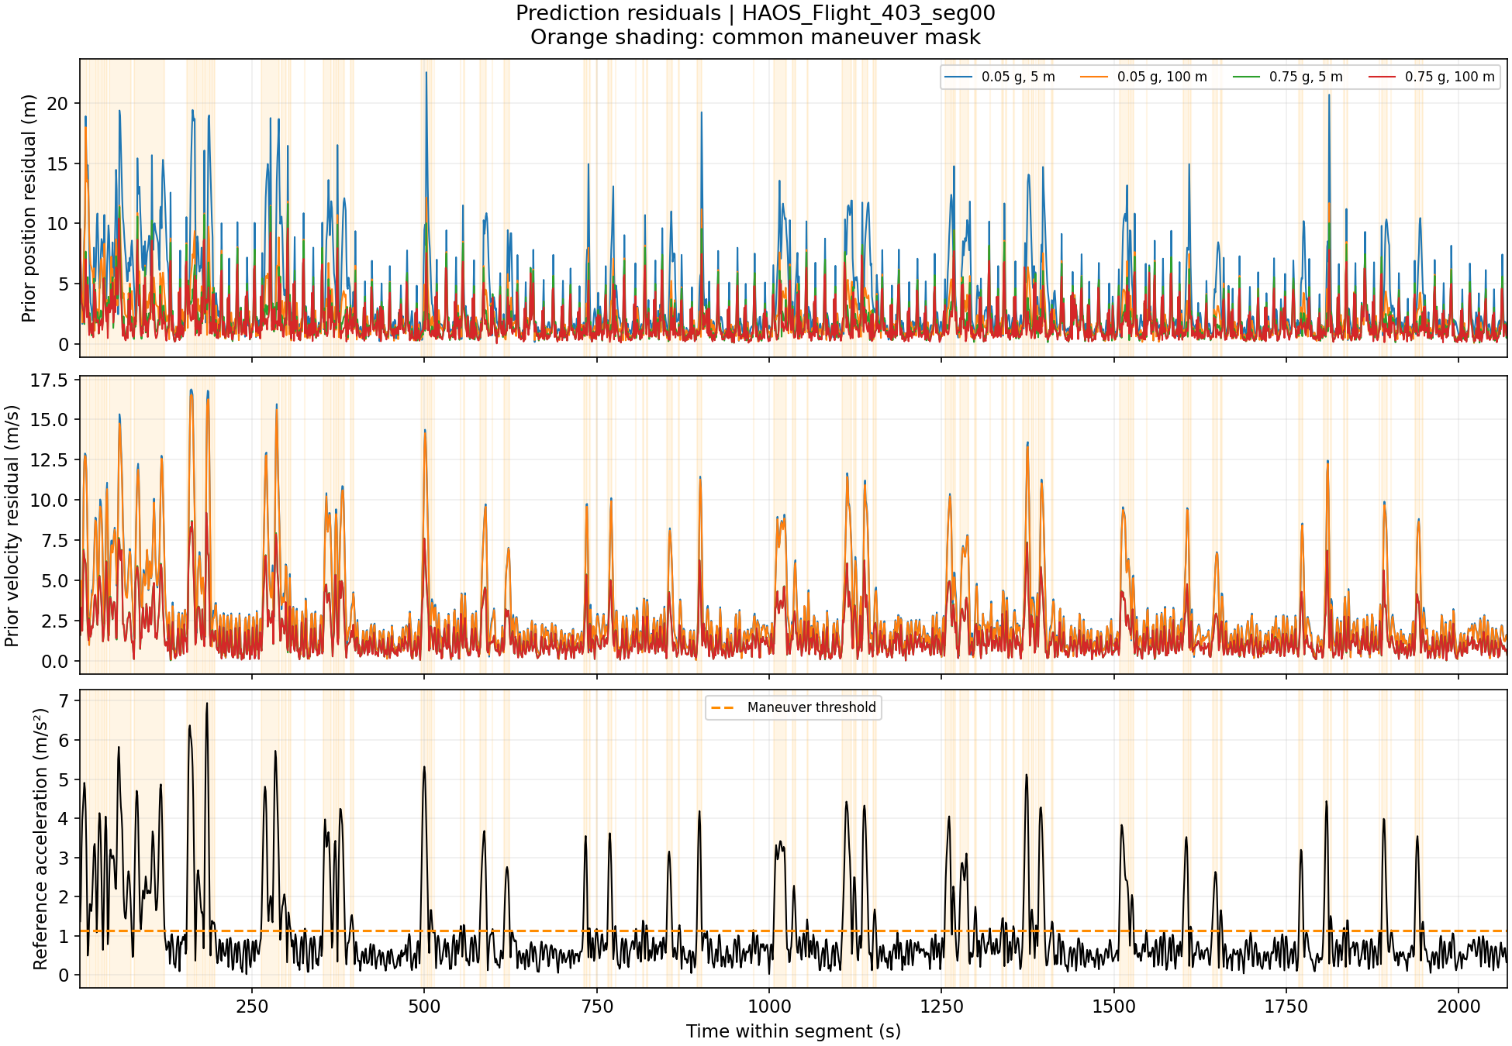
Figure 6. Time histories of prior residuals and common reference acceleration Source image: 06_residuals_over_time.png.
What it shows. The first panel is the three-dimensional prior position residual norm; the second is the prior velocity residual norm. The bottom panel is reference acceleration from the smoothed CSV velocity. Orange shading marks the common above-threshold maneuver samples. The four colored curves identify the four sweep corners.
What this flight tells us. Large excursions recur throughout the flight, rather than being confined to initialization. The blue position curve has particularly large excursions. In velocity, the two low-acceleration settings track each other closely, while the high-acceleration settings generally reduce the large excursions. Many excursions occur near acceleration events, although not every peak aligns exactly with a shaded sample.
How it is generated. For each corner run, compute the same prior position and velocity norms used in Figure 1, and plot them against time_s in original time order. Compute the reference acceleration and threshold once using observation_ve/vn/vu and the five-second smoothing method described earlier. Draw its acceleration trace, a horizontal threshold line, and the same maneuver shading on all three panels.
How to use it. Locate the times responsible for high RMS or P95, then inspect an event close-up. The full-flight plot is too compressed to measure response delays reliably. Smoothing, threshold crossings, and residual dynamics can shift peaks relative to the shading, so visual alignment alone is not a precise estimate of filter lag.

Figure 7 Strongest reference acceleration event
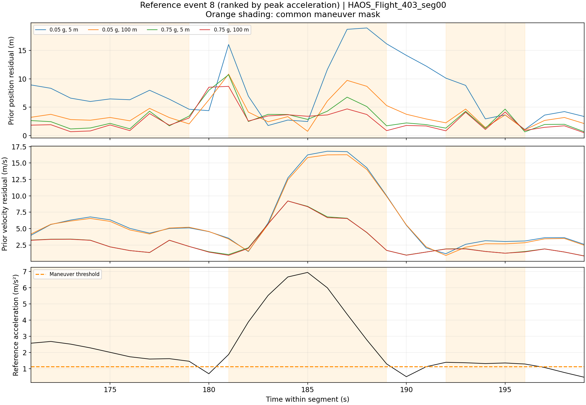
Figure 7. Close-up of reference event 8 and its surrounding updates Source image: 07_event_01.png.
What it shows. This is the same three-panel construction as Figure 6, restricted to about 171–199 s. The selected event spans 181–189 s and has the largest reference acceleration peak, about 6.94 m/s² near 185 s. Its first below-threshold recovery sample is at 190 s. Nearby orange regions belong to other events inside the display window.
What this flight tells us. Around 186–187 s, the low-acceleration velocity residual reaches roughly 16–17 m/s, while the high-acceleration curves are around 6–7 m/s. The blue position residual climbs to about 19 m, whereas the red curve remains much lower over that excursion. The difference is much clearer here than on a whole-trajectory overlay. This is consistent with the larger process-noise setting allowing quicker adaptation through measurement updates.
How it is generated. Build contiguous above-threshold intervals from the common reference acceleration mask. Rank events by their maximum reference acceleration and select the largest. Extend from the first event sample backward by ten seconds and from the last event sample forward by ten seconds. Plot the corner-run prior residual norms and reference acceleration in that window. The script does not rerun or reset the filter at the window boundary.
Selection and interpretation. The filename event_01 means first in peak-acceleration rank; the title event 8 is the original zero-based chronological identifier. Selection uses reference acceleration, not the largest KF error. The plot demonstrates local behavior, but neither the norm curves nor the smoothed acceleration alone establish an exact response-time delay.

Figure 8 Second strongest acceleration event
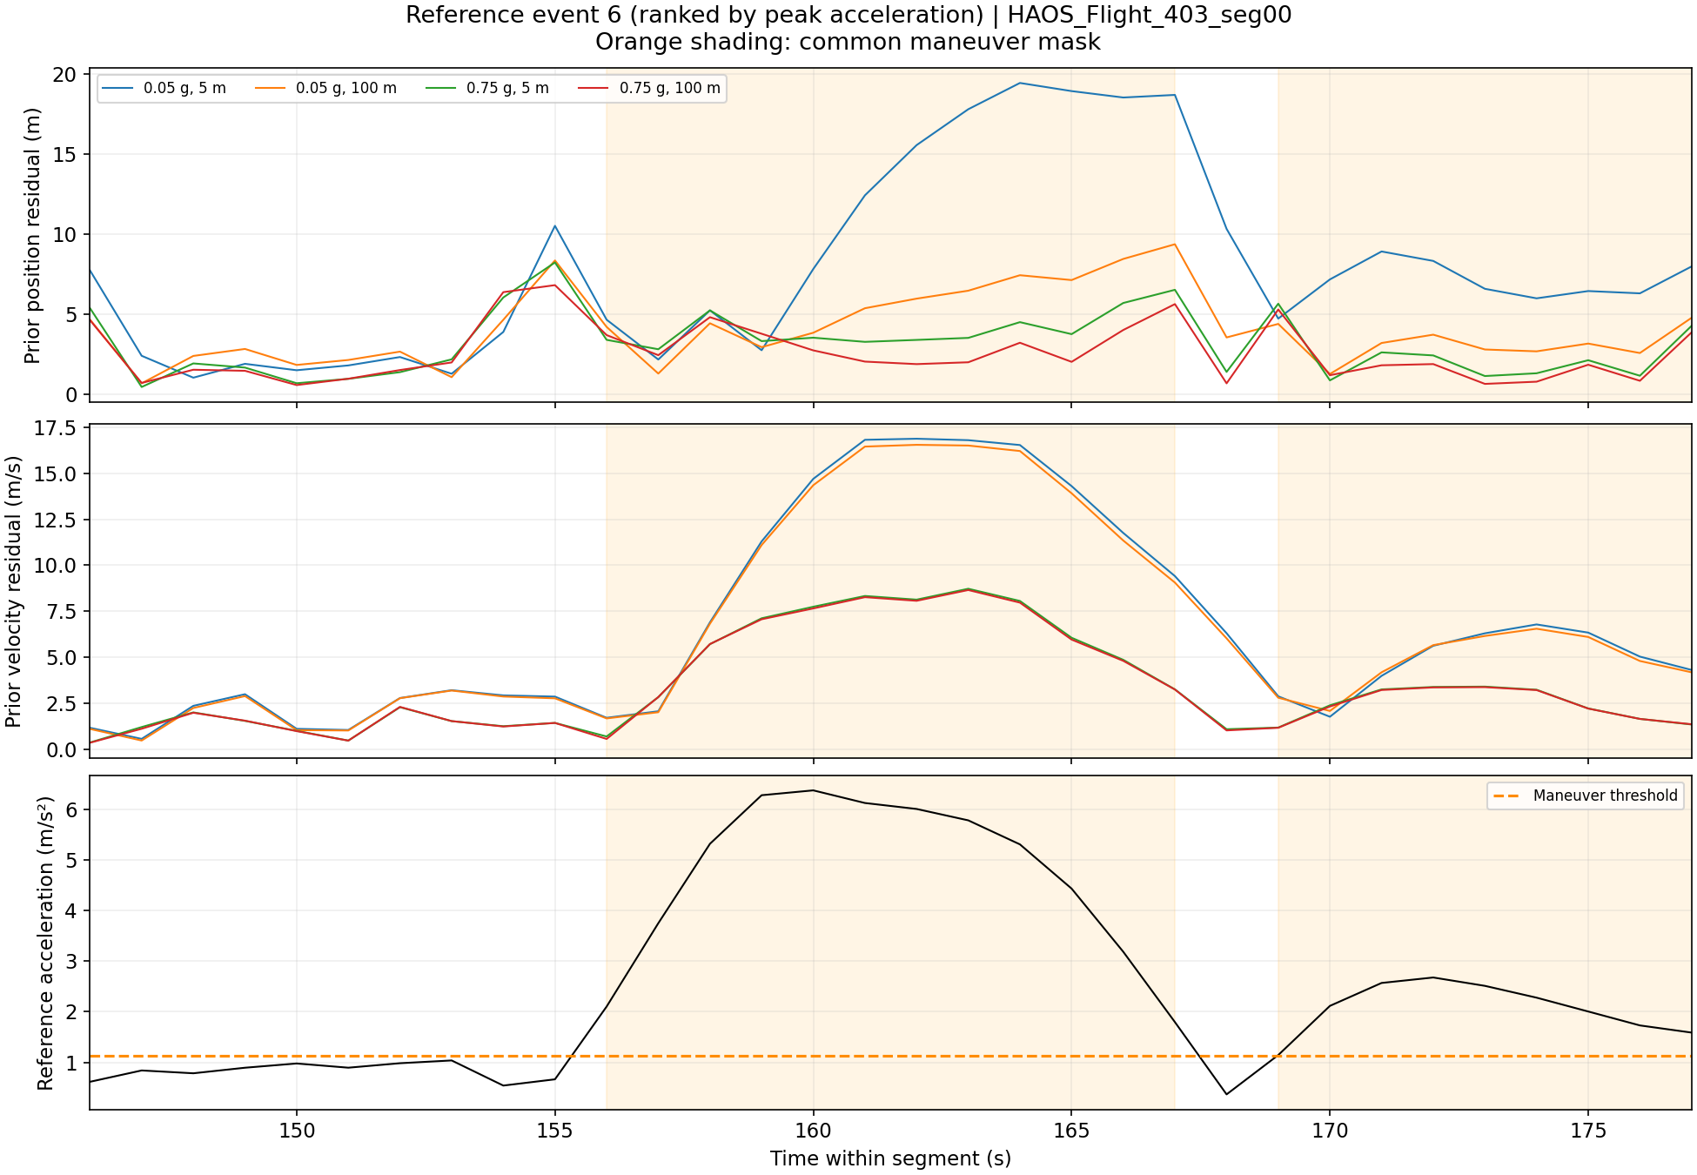
Figure 8. Close-up of reference event 6 and its surrounding updates Source image: 07_event_02.png.
What it shows. The display covers about 146–177 s. Event 6 spans 156–167 s and reaches approximately 6.37 m/s² near 160 s, making it the second-largest reference acceleration peak. Recovery begins at 168 s. The later shaded interval is a neighboring event, not a continuation of the selected event.
What this flight tells us. During about 161–164 s, the low-acceleration velocity residual stays near 16–17 m/s, while the high-acceleration residual is closer to 8–9 m/s. Blue and orange nearly coincide in velocity, again showing weak dependence on position noise there. Position behavior differs more: the blue curve rises toward 20 m and remains elevated for several samples, while green and red stay substantially lower during most of the event.
How it is generated. Use the identical reference acceleration series, threshold, and contiguous-event list used for Figure 7. Select the event with the second-highest acceleration peak and add the same ten-second margins. Select those time_s rows from each corner configuration, calculate x_prior_* minus observation_* norms, and display them without any new filtering.
How to use it. This second event checks whether the behavior seen in the strongest event repeats elsewhere. It supports a recurring association between low acceleration-noise tuning and larger maneuver residuals. It is still a selected-event comparison; the maneuver-wide RMS in Figure 1 summarizes all 518 above-threshold updates rather than only these close-ups.

Figure 9 Third strongest acceleration event
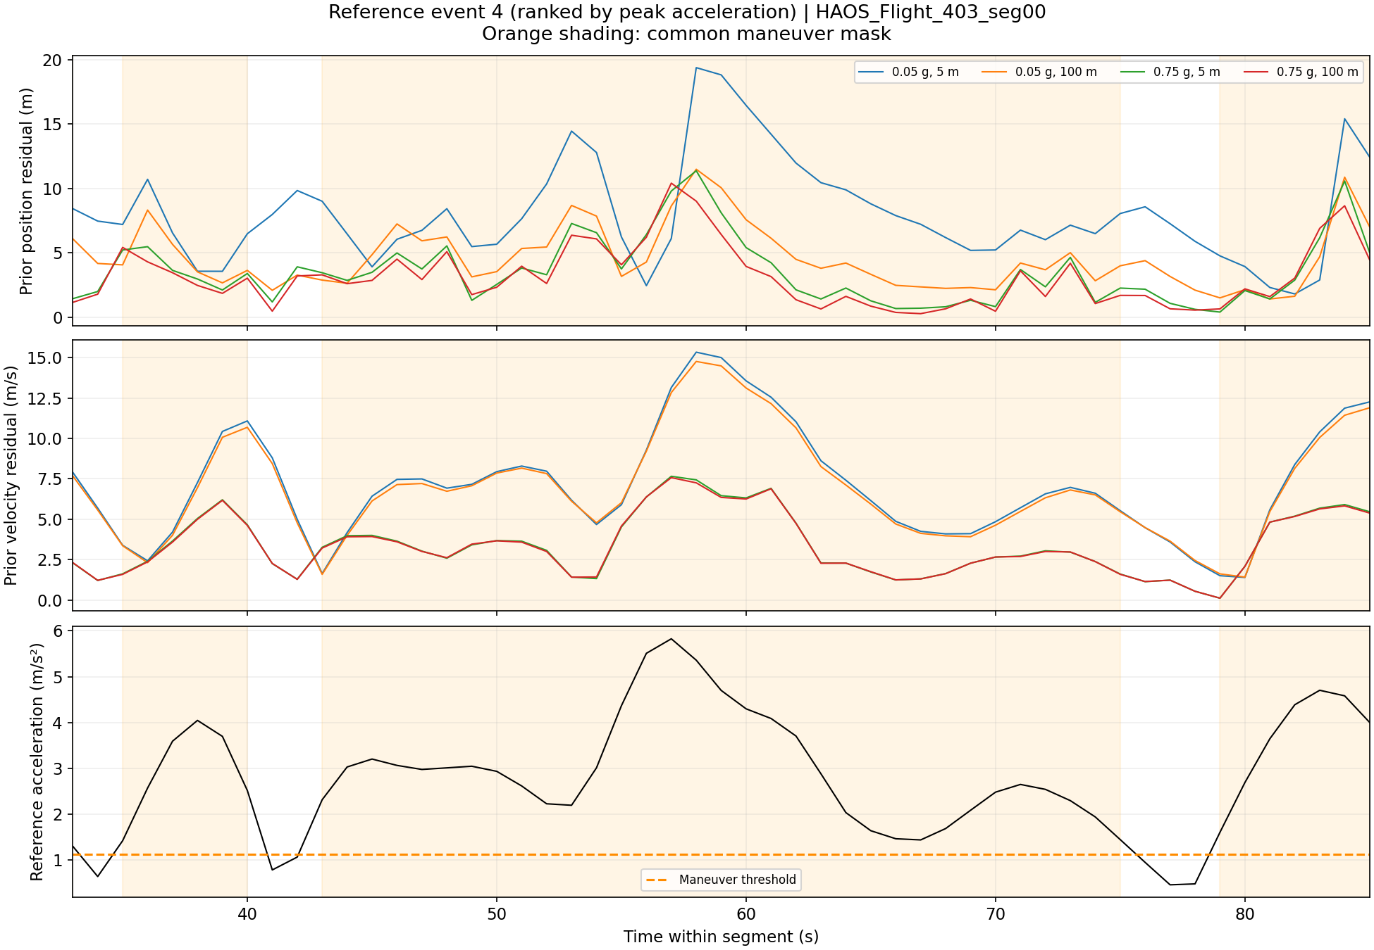
Figure 9. Close-up of the longer reference event 4 and neighboring events Source image: 07_event_03.png.
What it shows. The displayed window is about 33–85 s. Event 4 spans 43–75 s, with a peak near 5.82 m/s² around 57 s. Because it lasts longer than the other two selected events, the fixed ten-second margins produce a wider display window. Its first recovery sample is at 76 s.
What this flight tells us. Near 58–59 s, the low-acceleration velocity residual reaches about 15 m/s, compared with roughly 6–8 m/s for the high-acceleration settings. The blue position residual reaches nearly 20 m and decays over several subsequent samples. Green and red generally show smaller residuals, but occasional crossings show that no corner dominates at every individual update.
How it is generated. Rank the common reference events by peak acceleration and select the third. Extract the ten-second-expanded time window from the existing corner runs. Plot prior position and velocity residual norms, then add the shared reference acceleration and above-threshold shading. The event identifiers 8, 6, and 4 are not displayed in chronological order because ranking is by peak magnitude.
How to use it. This longer event helps distinguish sustained mismatch from a single isolated spike. Compare its pattern with the short events, then consult the all-maneuver metrics before selecting a parameter region. These panels visualize amplitude and evolution; the script does not calculate a formal settling time or causal lag estimate.

Figure 10 Innovation autocorrelation
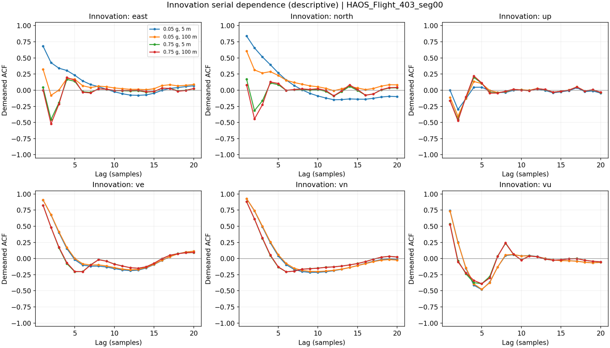
Figure 10. Serial dependence of each innovation component over lags of one through twenty samples Source image: 08_innovation_autocorrelation.png.
What it shows. Each panel is one innovation component: position east, north, up, then velocity ve, vn, vu. Positive ACF means deviations from the component mean tend to retain their sign at that lag; negative ACF means they tend to alternate. Lag is in samples, which equals seconds for this one-second dataset. This is a serial-dependence diagnostic, not an error-magnitude score.
What this flight tells us. The blue east and north position innovations retain strong positive correlation at short lags. Higher acceleration tuning reduces that initial persistence but produces negative correlation near lag two in those panels. Velocity innovations remain strongly correlated at short lags even with high acceleration noise. Smaller residual RMS therefore does not imply temporally white innovations.
How it is generated. Read each innovation_* column for eligible rows in each corner run. Subtract its sample mean to obtain d. At lag ℓ, calculate ACF(ℓ) = Σ d[k]d[k−ℓ] / Σ d[k]², using all available lagged pairs in the numerator and the full centered series in the denominator. Repeat for lags 1–20. This is the conventional biased sample ACF used by autocorrelation; detailed values are in innovation_acf.csv.
Interpretation limit. Innovation is observation minus prediction, the opposite sign of the residual used elsewhere. A uniform sign reversal does not change ACF. Correlation can reflect remaining model mismatch, the way reference velocities were derived, or other temporal structure. No significance bands or validated whiteness test are shown, and these plots cannot isolate the cause by themselves.

Figure 11 Normalized innovation squared
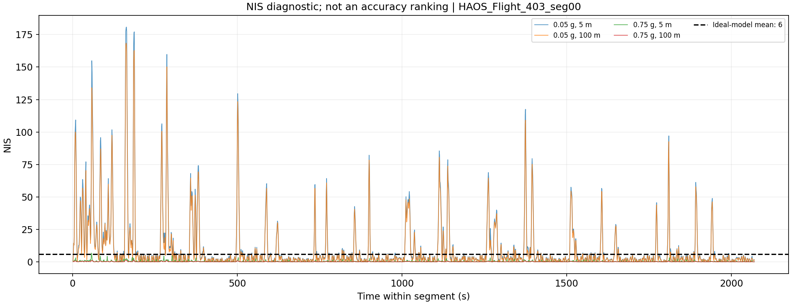
Figure 11. Time-resolved NIS for the four sweep corners with the ideal-model mean shown Source image: 09_nis_diagnostic.png.
What it shows. NIS measures innovation size relative to the covariance the filter assigns to that innovation. It is dimensionless and combines all six measured components. The dashed line at six is the expected mean under the ideal correctly specified six-dimensional measurement model. It is not an upper acceptance limit for individual updates.
What this flight tells us. The low-acceleration settings produce pronounced spikes, with the largest near 180. The high-acceleration curves are much closer to zero. Whole-flight mean NIS is about 10.75 for 0.05 g and 5 m, 9.63 for 0.05 g and 100 m, 0.302 for 0.75 g and 5 m, and 0.073 for 0.75 g and 100 m. The shared vertical scale hides much of the variation in the high-acceleration curves.

How it is generated from the CSV
The analysis figure simply reads the stored nis column, excludes initialization, selects the four corner runs, and plots against time_s. The underlying KF calculated innovation ν = z − Hx_prior, innovation covariance S = H P_prior Hᵀ + R, and NIS = νᵀ S⁻¹ν. It evaluated this using a linear solve rather than forming an explicit inverse.
For these runs H is the 6 × 6 identity. To recompute NIS, assemble the six innovation_* values, rebuild the full P_prior matrix from its 36 CSV entries, and add diagonal R with three copies of position_noise_std_m² and three copies of velocity_noise_std_mps². The CSV therefore contains what is needed to check the stored values. The routine uses nis_metrics.csv for descriptive summaries.

Why lower NIS is not automatically better
Increasing assumed uncertainty enlarges S and can reduce NIS even without a commensurate reduction in physical discrepancy. Small NIS can indicate conservative uncertainty assumptions; large spikes can indicate dynamics or noise not well represented by the model. Correlated or derived CSV velocities further limit ideal-model interpretation. Use this figure to question the stochastic assumptions, alongside prediction residuals and ACF, rather than to choose the smallest NIS.

Reading the figures together
Use Figures 1 and 2 to judge prediction agreement, Figures 5–9 to understand its distribution and timing, Figure 3 to inspect reported uncertainty, and Figures 4, 10, and 11 to understand fitting and diagnostic behavior. Together they suggest substantial benefit over the 0.05 g setting, diminishing gains at larger acceleration settings, and persistent long-horizon limitations of a constant-velocity model. The evidence supports comparison within this flight; choosing transferable tuning requires additional trajectories or independent truth.

