Combat ID Figure Supplement
  - Five figures with captions and suggested manuscript locations

Figure A Evaluation design
Suggested placement. Combat ID Model Comparison, after “How the test was run.”
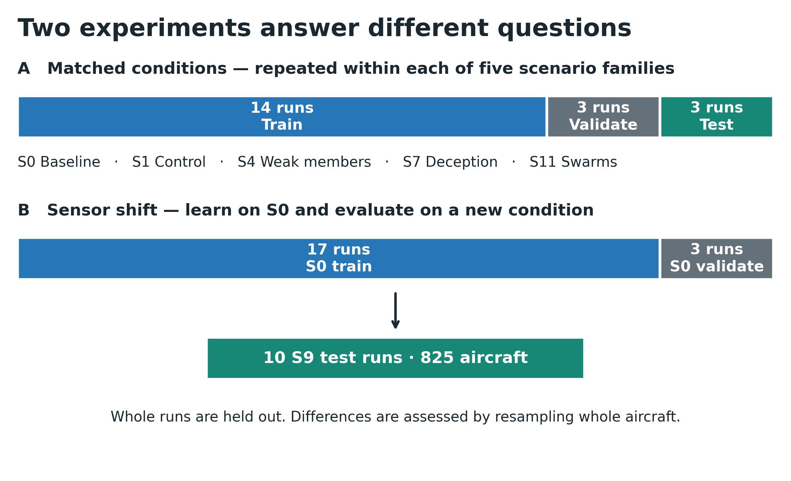
Caption. The main comparison holds out complete runs within each of five scenario families. The sensor-shift experiment instead trains on S0 and tests on 10 S9 runs containing 825 aircraft. Neural validation sets are used for early stopping and calibration. These experiments answer different generalization questions.
Interpretation note. The BN-oracle comparator is an explicit exception to independent test separation: its fitting includes test data. Aircraft resampling preserves within-aircraft snapshot dependence, but does not fully represent dependence within a scenario.
Source: Combat ID Model Comparison, How the test was run; Sensor-Shift Addendum, What was tested.

Figure B Accuracy across the five original scenarios
Suggested placement. Combat ID Model Comparison, after the balanced-accuracy table in “Overall accuracy.”
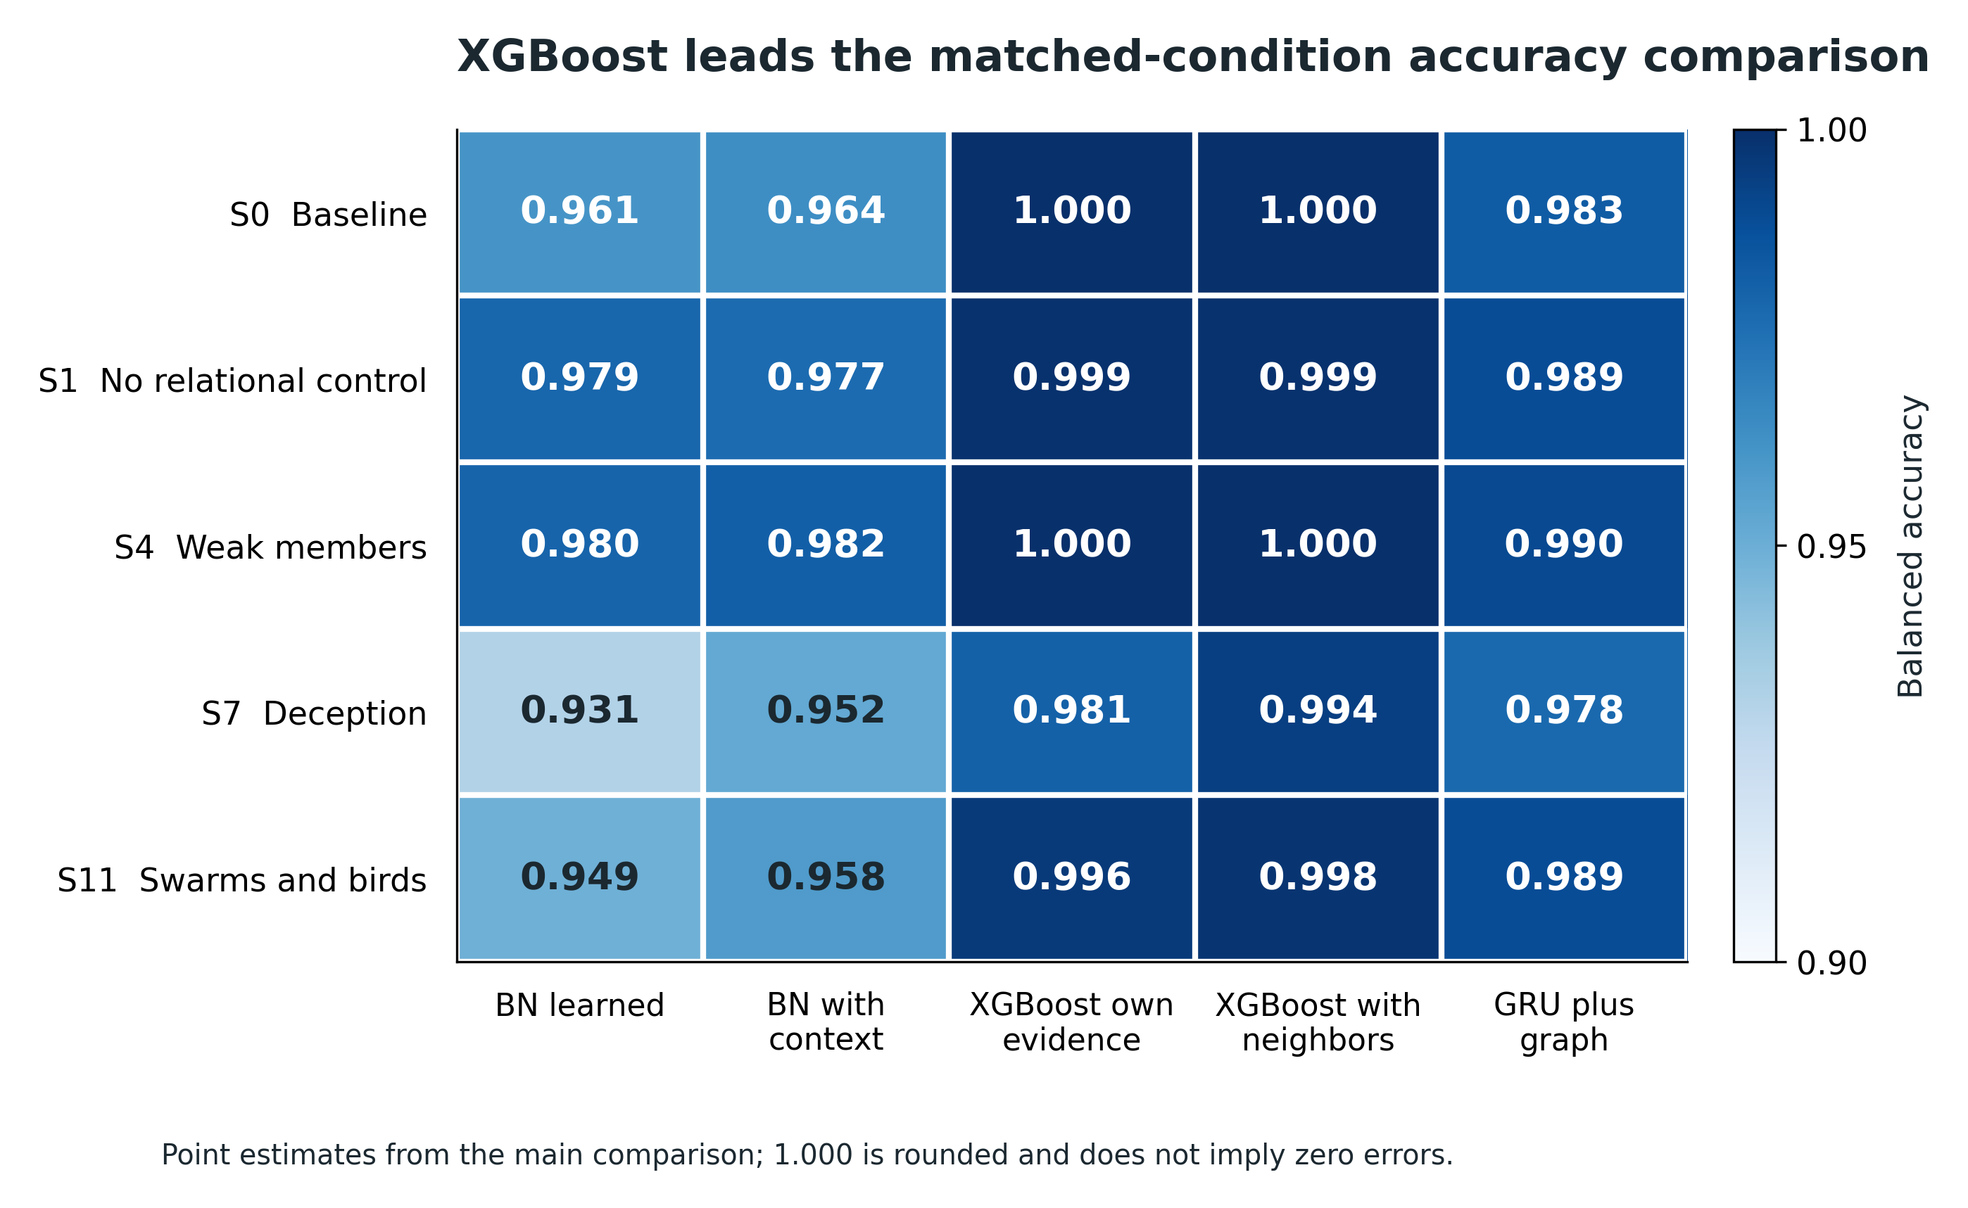
Caption. Balanced accuracy for representative Bayesian, tree, and temporal-graph models on the five matched-condition scenarios. XGBoost has the highest point estimates throughout. Adding neighbor summaries produces its largest improvement in S7 Deception. Values near one are rounded.
Interpretation note. This figure compares reported point estimates, not significance verdicts. It does not include a GRU-only row because those five-scenario results were still pending. The color scale begins at 0.90; values are printed in every cell.
Source: Combat ID Model Comparison, Results, Overall accuracy, Table 1.

Figure C Performance under sensor shift
Suggested placement. Sensor-Shift Addendum, after “How much each model degraded.”
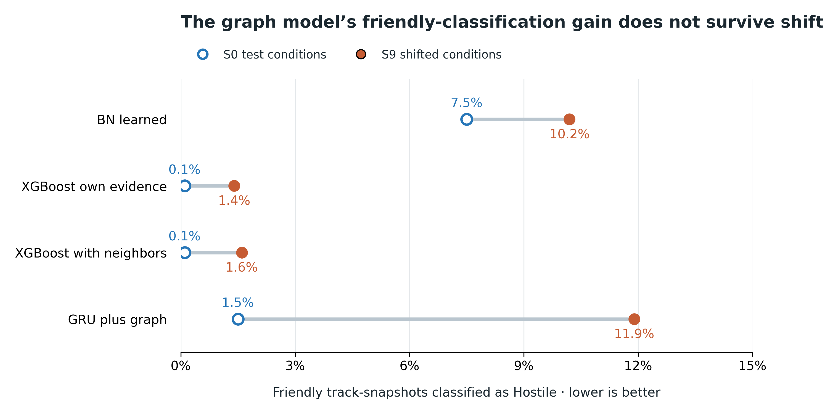
Caption. Friendly-as-hostile classification rates in the original S0 test and the S9 sensor-shift experiment. The temporal graph model’s rate increases from 1.5% to 11.9%; the corresponding BN-learned rates are 7.5% and 10.2%. Tree-model rates remain much lower. These percentages concern classification snapshots, not engagement outcomes.
Interpretation note. The S0 comparison uses 14 training and 3 test runs; the S9 comparison uses 17 S0 training runs and 10 S9 test runs. Connecting lines show descriptive changes across experiments, not paired observations from one unchanged fitted model. No uncertainty intervals for the cross-experiment changes are inferred.
Source: Sensor-Shift Addendum, How much each model degraded, Table 2.

Figure D Incremental contribution of the graph module
Suggested placement. Sensor-Shift Addendum, after “What the graph layers add.”
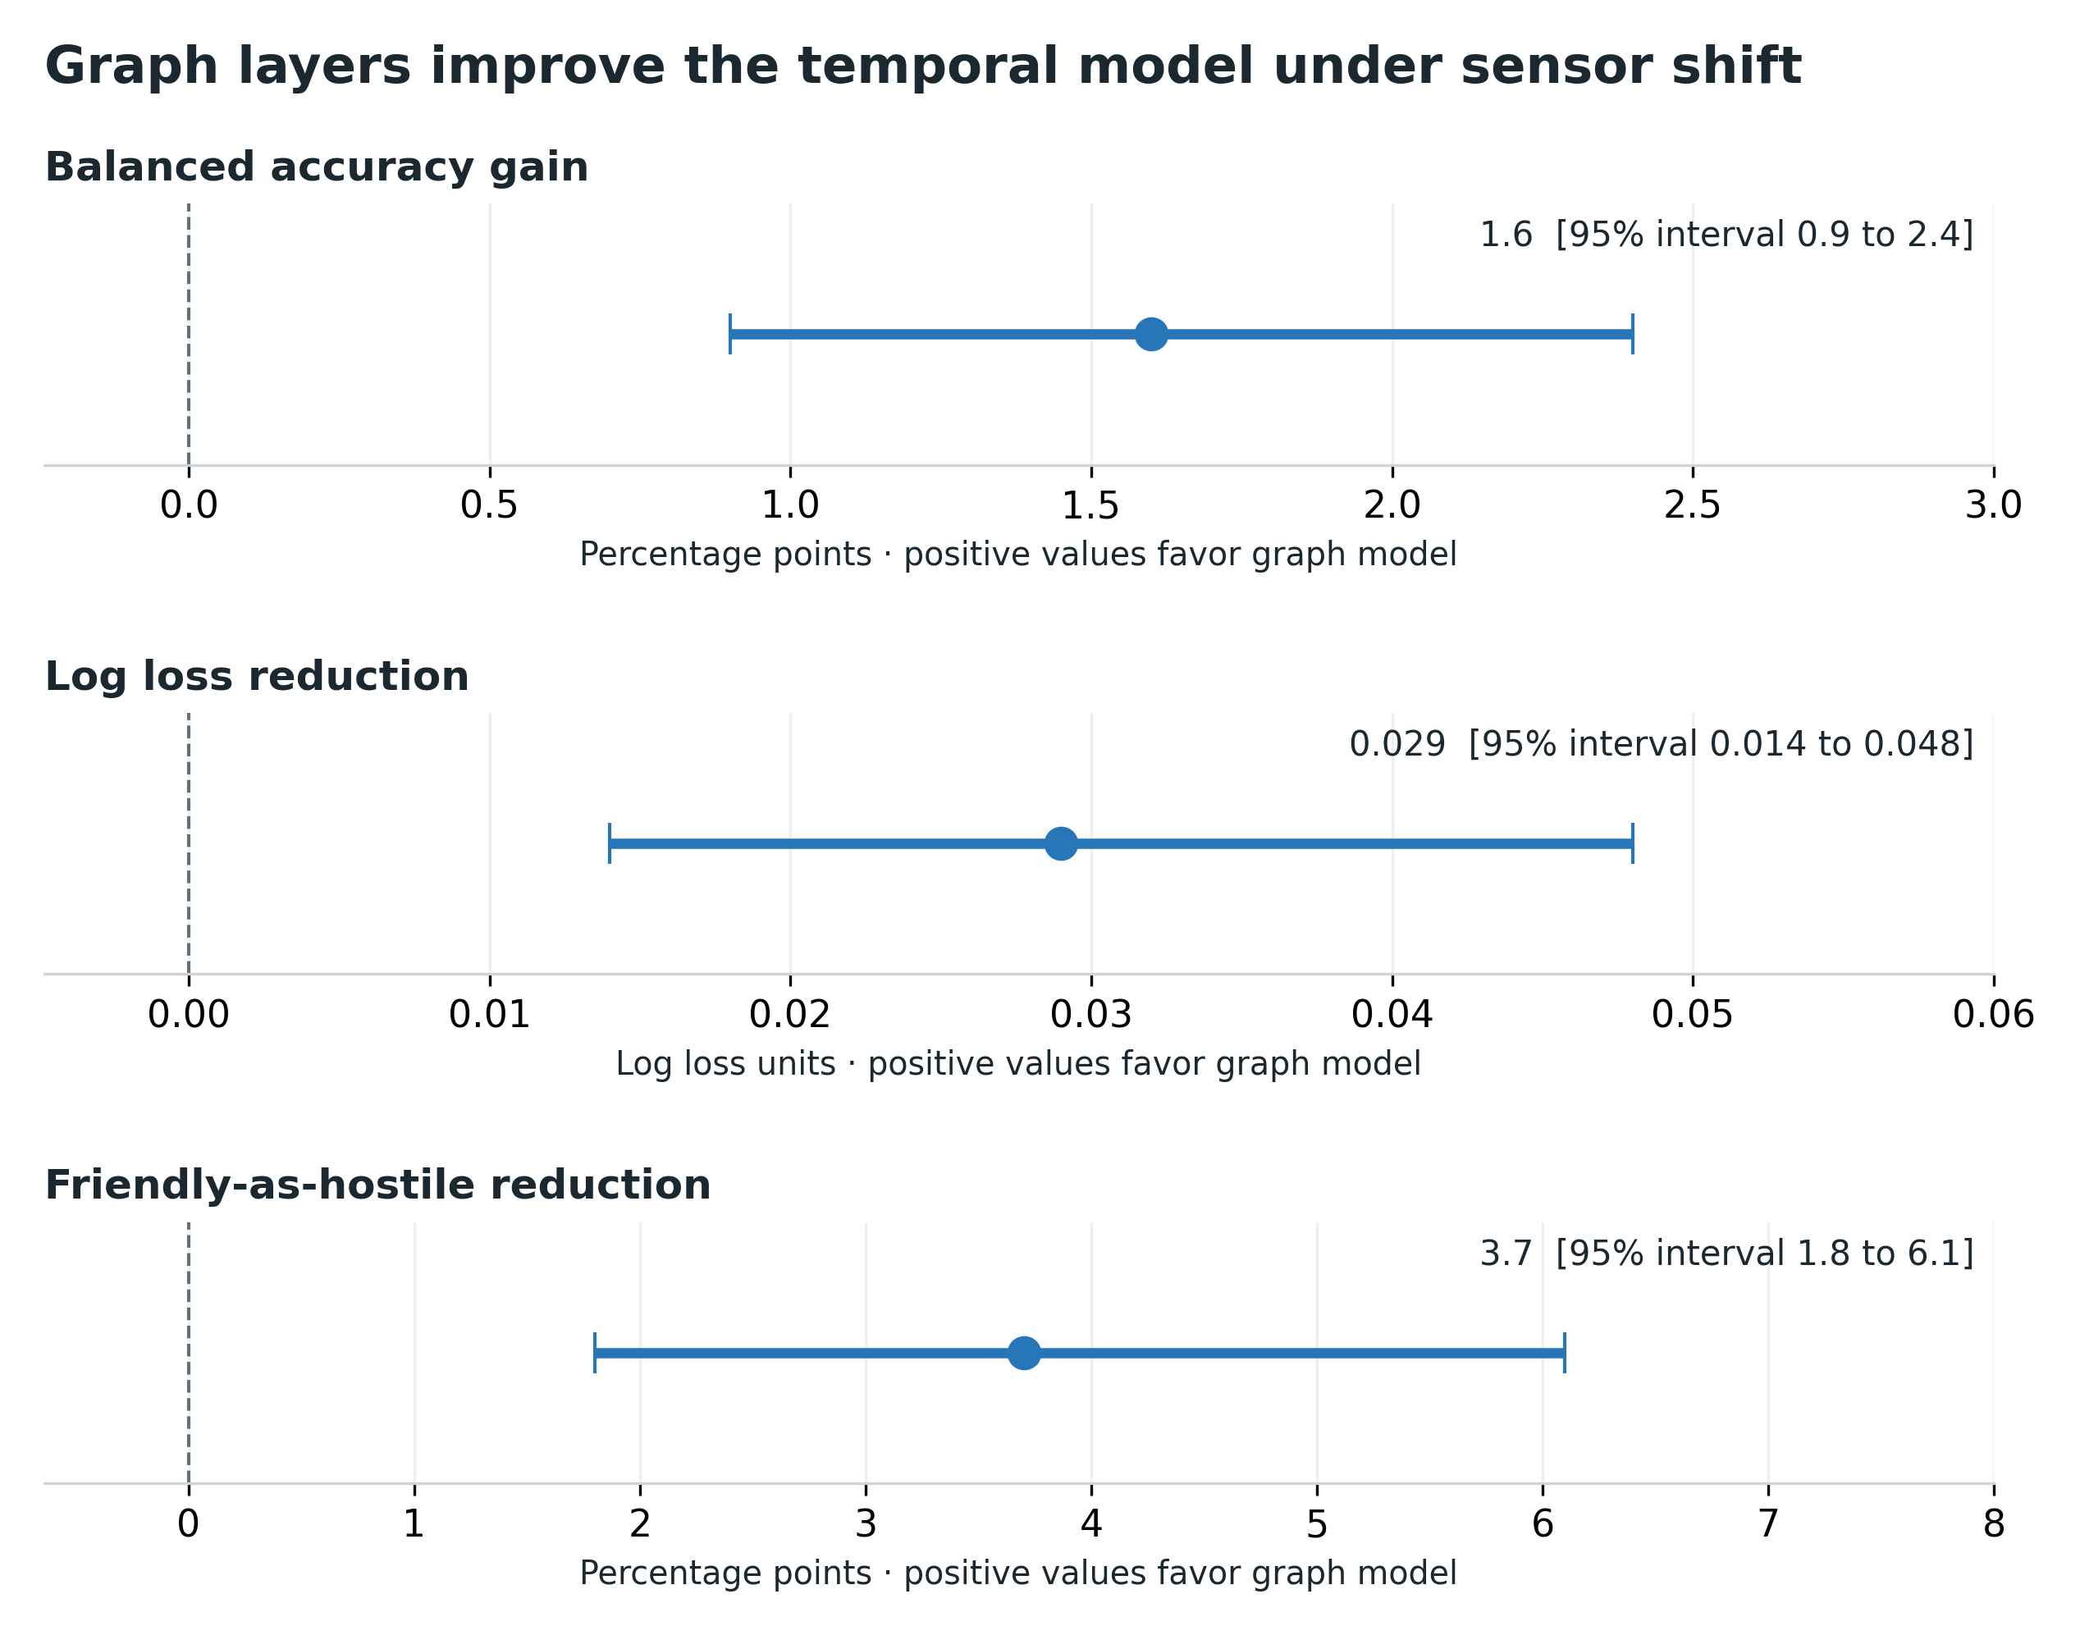
Caption. Adding the graph module to the GRU improves three reported measures in the S0-to-S9 experiment. Points and bars show the reported paired differences and 95% aircraft-bootstrap intervals. Signs are oriented so that positive values consistently favor the graph model. All three intervals exclude zero.
Interpretation note. The panels use different units and scales. This ablation removes the complete graph module and changes parameter count; it does not isolate GATv2 from GraphSAGE or establish which relationship type produces the improvement.
Source: Sensor-Shift Addendum, What the graph layers add, Table 3.

Figure E Where the friendly classification errors occur
Suggested placement. Sensor-Shift Addendum, after the table in “Why friendly drones fail.”
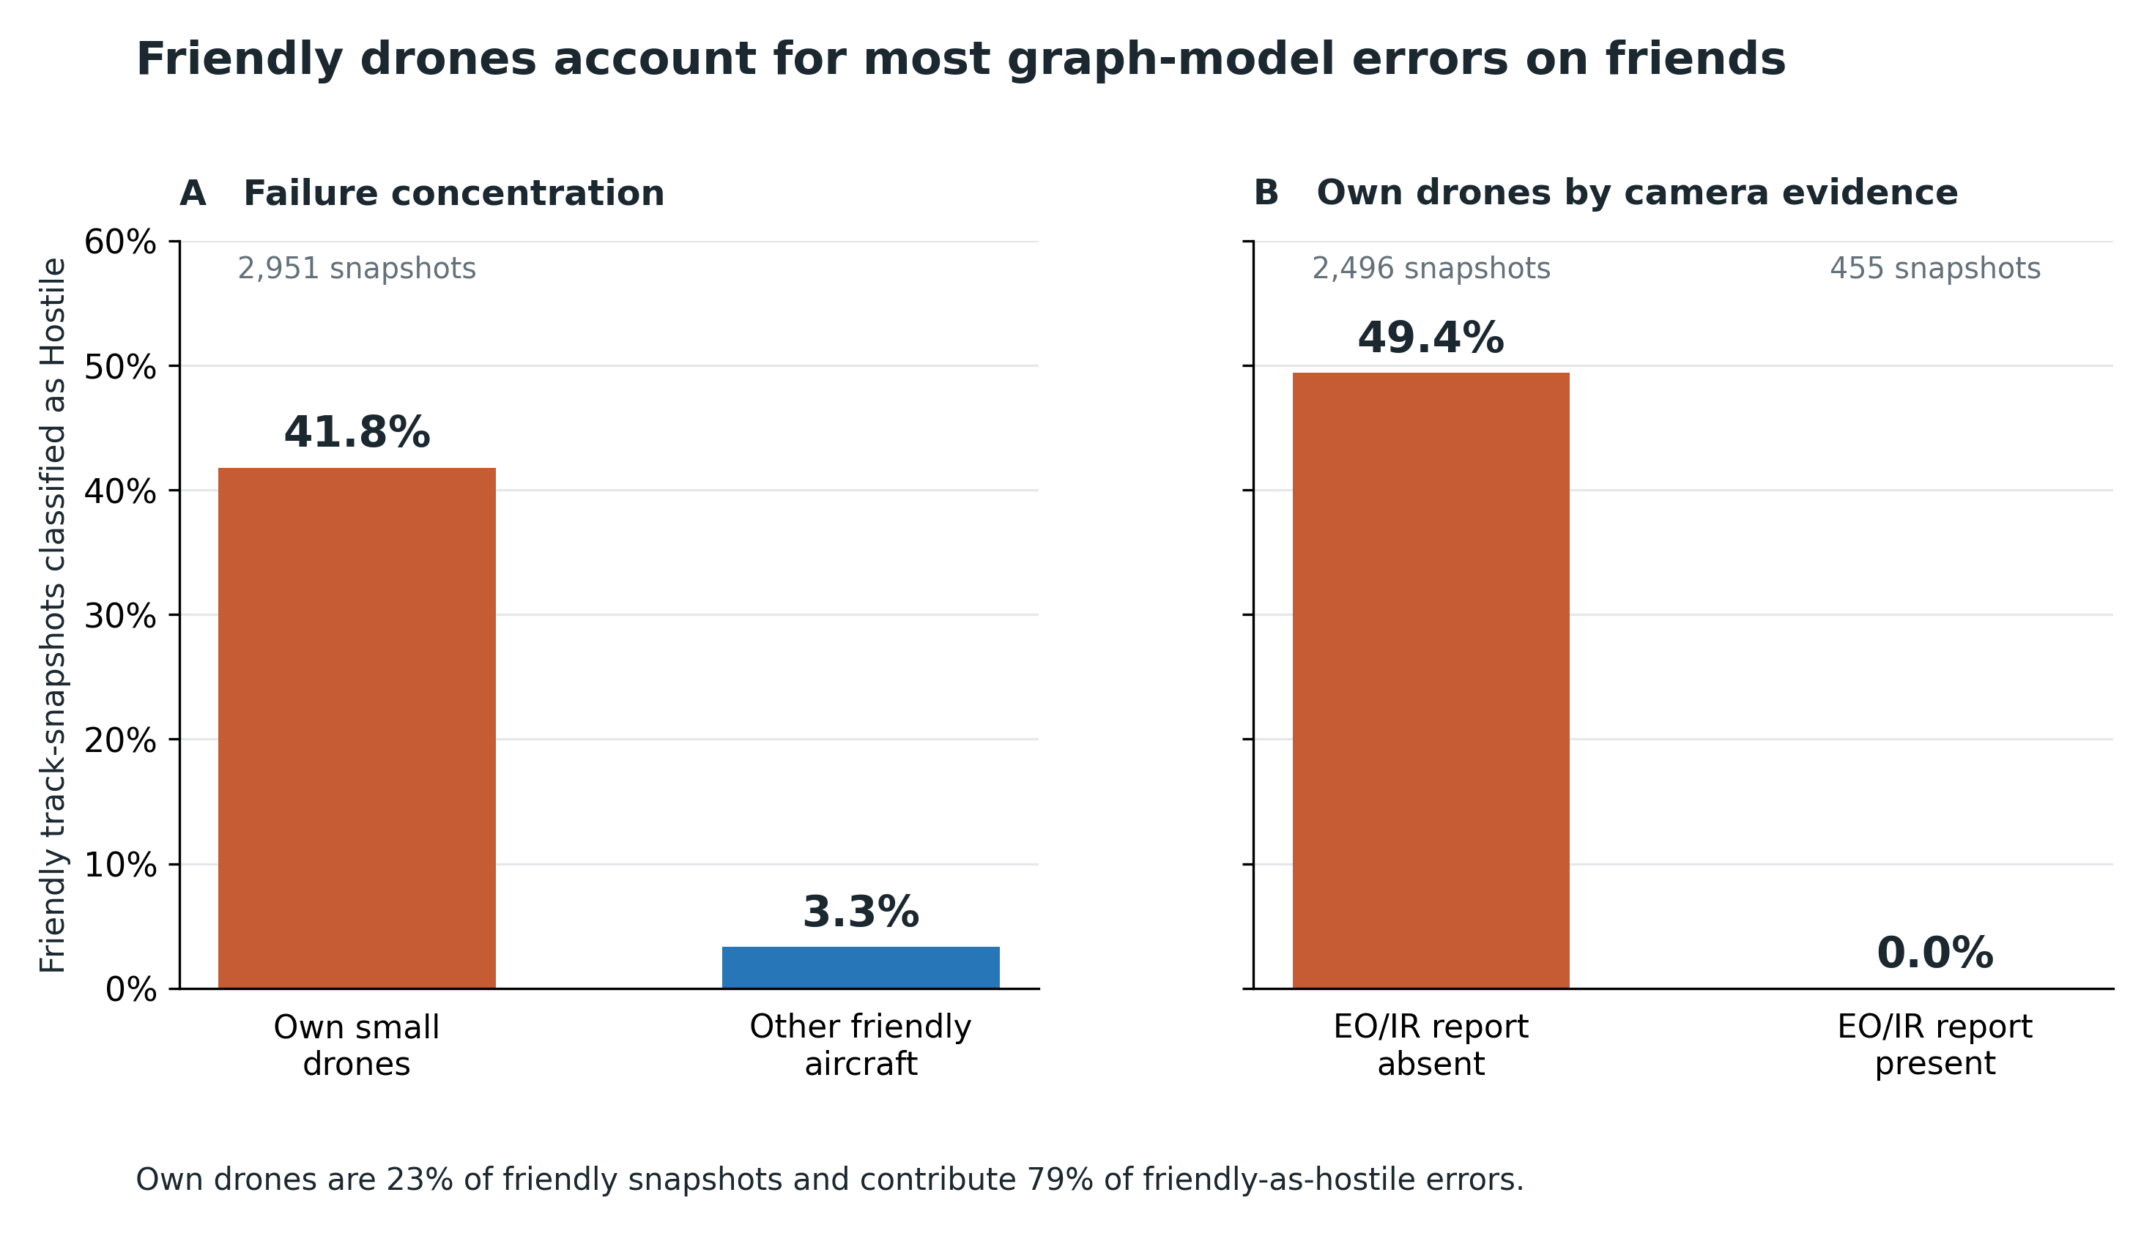
Caption. Under S9, the graph model classifies 41.8% of own-drone snapshots as hostile, compared with 3.3% for other friendly aircraft. Among own-drone snapshots, the rate is 49.4% without EO/IR reports and 0% with reports. Own drones account for 79% of friendly-as-hostile errors despite representing 23% of friendly snapshots.
Interpretation note. The camera subgroups are observational, not randomized. Their difference supports the proposed camera-reliance explanation without proving it: coverage, geometry, and other sensor conditions may differ. Snapshot counts are not counts of independent aircraft.
Source: Sensor-Shift Addendum, Tables 21–23 and the paragraph following Table 22.

