Threat Prioritization from Combat ID Likelihoods
cidgen v0.6.1. How the Friend / Neutral / Hostile likelihood vector feeds a ranked threat list, how each track's score is computed, and how the ranking is evaluated. All platform, sensor and doctrine parameters are notional.

1. Purpose
Combat ID answers who a track is. Threat prioritization answers which track matters most right now. At every update it ranks all visible tracks, most threatening first and confidently friendly last, so that an air defender's attention, and any engagement decision, goes to imminent threats first.
The ranking combines three questions that are kept deliberately separate:
- Identity: who is it? The likelihood vector P(Friend), P(Neutral), P(Hostile) from a Combat ID model.
- Threat: how dangerous is it now? Lethality of what it appears to be, multiplied by urgency against the defended assets.
- Eligibility: what are we allowed to do? Doctrine and rules of engagement, applied as explicit rules from an editable file, each with a stated reason.

2. From the likelihood vector to the threat list
The threat prioritization code consumes the Combat ID outputs produced earlier in the study. Nothing is retrained; every identity source is read from files already on disk.
Table 1. Where each identity source comes from
Identity source | Produced by | File read by run_tp.py
Truth (perfect Combat ID) | Generator labels | Run folders (labels table)
BN-learned, BN-context, XGB-own, XGB-own+nb, XGB-own+tq | compare --save-preds | allpred_<name> (test rows)
GNN and GRU variants (e.g. GNN-SD30-NOTQ) | train_gnn (test); train_gnn v0.5+ or predict.py (validation) | pred_<tag>_<name>.csv
Stacked ensemble, e.g. STACK:BN-learned+XGB-own+GNN-SD30-NOTQ | ensemble.Stacker, refitted inside run_tp on validation rows | allpred_, pred_ and valpred_ files

The neural probabilities in pred_ files are already temperature-calibrated: each is softmax(z / T) of the network's logits z, with T fitted on the S0 validation runs. predict.py was needed only for models trained before v0.5. It reloads a saved model, rebuilds its exact validation split and writes the valpred_ file, which the stacked ensemble needs because its weights are fitted on validation rows only.

2.1 What run_tp.py reads
- Run folders (--runs, e.g. the ten S9 test runs). For every track at every 10-second snapshot: the sensor-derived features, the track-to-asset geometry computed from radar tracks, the defended assets' values and radii, and the truth labels used only for scoring.
- Prediction folder (--preds and --name): the identity files in Table 1.
- Identity sources (--identity): which likelihood vectors to rank with. Each source is ranked separately.
- Doctrine files (--doctrine): one or more YAML files with the weapons-control state, lethality table, urgency settings and rules. Each file is scored separately so versions can be compared.
For each snapshot these are joined into a track picture: one row per track, the only input the prioritizer sees (Table 2). The prioritizer never reads truth columns, and it never modifies the picture it is given; it returns a new ranked table.
Table 2. The track picture: columns available to the prioritizer
Column | Meaning | Source
p_friend, p_neutral, p_hostile | Likelihood vector | Identity source
urgency_raw, ttg_s, cpa_m, asset_value, threatened_asset | Urgency against the most threatened asset, its time-to-go, closest approach and value | Radar track to asset geometry
asset_closure_mps, descending_closing | Closing speed on the nearest asset; descending (climb below −5 m/s) while closing faster than 20 m/s | Radar kinematics
obs_tier, speed, alt, rad_rcs_med30 | Observable size class (Tier 1 = under 60 m/s, under 1,500 m, RCS under −5 dBsm), kinematics, radar cross-section | Radar
iff_mode5_valid, iff_ever_valid, iff_mode3c | Current valid Mode 5 reply; any valid reply earlier in the track; Mode 3/C reply | IFF
airway_xtrack_m, airway_alt_inband, corridor_dist_m, threat_offset_deg | Distance from airway centreline, altitude within the airway band, distance from the friendly return corridor, angle from the threat axis | Map geometry

3. How each track's score is computed
At every update, every track in the picture goes through six steps. The default values quoted are those in configs/threat/doctrine_default.yaml.

Step 1. Urgency against each defended asset
For every defended asset a within edge range of the track, the radar track gives its time-to-go and its closest point of approach (CPA) on the current velocity. The track threatens asset a if it is already inside the asset's radius, or if it is closing and its CPA falls inside the radius:
u_{a} = v_{a} · exp(−TTG_{a} / τ) · 𝟙_{a} (1)
The track's urgency is that of its most threatened asset, with a small floor so that distant hostiles can still be ordered among themselves:
U = max( max_{a} u_{a} , U_{min} ) (2)

Step 2. Lethality from what can be observed
The prioritizer does not know the platform class, so lethality L is read from the first row of the doctrine's lethality table whose conditions the track meets: small UAS (observable Tier 1) 0.4; fast jet (at least 150 m/s) 0.8; low and slow, rotary-like (under 90 m/s and 3,000 m) 0.6; large and slow (RCS at least 20 dBsm, under 150 m/s) 0.3; anything else 0.6.

Step 3. Expected-threat score
The raw score is the probability-weighted threat, plus a term that lifts tracks whose identity is still unresolved:
S_{raw} = p_{H} · L · U + w · [ 1 − max(p_{F}, p_{N}, p_{H}) ] · L · U (3)
The second term matters when no class is likely: a track at P = (0.4, 0.3, 0.3) close to an asset should not wait for certainty before rising in the list.

Step 4. Doctrine rules
The rules in the doctrine file are applied in order. Each rule has conditions on picture columns (all must hold) and one or more actions. Unknown values never satisfy a condition. Every rule that fires attaches its reason to the track, so each position in the list can be explained.
multiply: S ← k · S floor: S ← max(S, f) cap: S ← min(S, c) (4)
Other actions place a track in a tier (protected, monitor or engage), block it from the engage tier, or set a flag. A sticky flag, such as declared_hostile, stays with the track for the rest of the scenario.

Step 5. Engagement tier
The weapons-control state decides which tracks may sit in the engage tier. Under weapons free, P(H) of at least 0.5 is enough. Under weapons tight, the default, P(H) must be at least 0.9 or the track must be declared hostile by a rule. Under weapons hold nothing is engage-eligible. A track a rule has protected or blocked is never engage-eligible.

Step 6. Smoothing and ordering
So that the list does not flicker with sensor noise, a score may rise immediately but decays no faster than a set rate between updates Δt apart:
S′_{t} = max( S_{t} , S̃_{t−Δt} · exp(−Δt / τ_{d}) ) (5)
Protected tracks are not smoothed. The list is then ordered by tier (engage, monitor, protected), then by smoothed score, then by raw score, then by P(Friend) ascending, which is the tie-break proposed at the start of this work.

Term definitions
Table 3. Every term in Equations 1 to 5
Symbol | Meaning | Default
p_{F}, p_{N}, p_{H} | Combat ID probabilities of Friend, Neutral, Hostile for the track | From the identity source
vₐ | Value of defended asset a | Primary 1.0; others 0.4 to 0.8
dₐ | Protection radius of asset a | Primary 5,000 m; others 3,000 m
TTGₐ | Time-to-go: range divided by closing speed; 0 inside the radius; undefined if not closing | From radar tracks
CPAₐ | Closest point of approach to asset a on the current velocity | From radar tracks
𝟙ₐ | 1 if the track is inside the radius, or closing with CPAₐ under m · dₐ; otherwise 0 | Margin m = 1.0
τ | Urgency time scale: urgency falls to 37% at TTG = τ | 300 s
U_{min} | Urgency floor | 0.02
L | Lethality of the observable class (Step 2) | 0.3 to 0.8
w | Weight on unresolved identity | 0.5
k, f, c | Multiplier, floor and cap set by a rule | Per rule (Table 4)
τ_{d} | Score decay time between updates | 30 s
S′_{t} | Smoothed score at update time t, used for ordering | Equation 5
Δt | Time since the previous update | 10 s in replay

4. The default doctrine
Table 4. Rules in configs/threat/doctrine_default.yaml, applied in this order
Rule | Conditions (all must hold) | Action | Stated reason
mode5_protected | Valid Mode 5 reply | Protected tier; score capped at 0; engage blocked | Valid Mode 5 reply: protected
mode5_history | Valid reply earlier in the track; P(F) ≥ 0.5 | Protected tier; score × 0.2; engage blocked | Probable IFF outage
friendly_corridor | Within 3 km of the return corridor; P(F) ≥ 0.3 | Score × 0.5 | In the friendly return corridor
civil_airway | Within 2 km of an airway, in its altitude band, Mode 3/C reply, not descending and closing | Score capped at 0.05; engage blocked | Conforming to an airway with a civil squawk
hostile_act | Descending and closing; TTG under 180 s; P(F) < 0.2 | Declared hostile (sticky); score at least 0.5 | Hostile act criteria met
threat_sector_ingress | Within 30° of the threat axis; closing faster than 50 m/s; P(H) ≥ 0.5 | Score × 1.3 | Inbound from the threat sector
imminent | TTG under 60 s; closing faster than 20 m/s; P(F) < 0.5 | Score at least 0.6; pop-up flag | Under 60 s and not identified friend

In v0.6.0 the imminent rule did not require the track to be closing. Own drones loitering inside an asset's radius have a time-to-go of zero, so a misidentified own drone was pushed to the top of the list. v0.6.1 adds the closing condition.
Event-driven updates. The list is recomputed at every full scan. Between scans, an update is triggered when a new track appears or any track's time-to-go drops under 60 s, so that a pop-up threat does not wait for the next scan.

5. Rankers compared
Table 5. The three rankers run for every identity source
Ranker | Score | Rules and tiers
P(Hostile) only | p_H, ties broken by P(Friend) ascending | None; engage tier if P(H) ≥ 0.5
Expected threat | Equation 3 with smoothing | Engage criteria only; no rules
Doctrine | Equation 3 with smoothing | All rules and engagement criteria

6. How the ranking is evaluated
The generator records a truth threat priority for every track at every snapshot, computed from the true position, velocity and platform class:
T = c_{class} · max_{a} v_{a} · exp(−TTG_{a,true} / τ) · 𝟙( CPA_{a,true} < d_{a} ) (6)
Here c is the platform's capability (strike aircraft 1.0, fighter and rotary wing 0.6, Group 2 UAS 0.5, larger UAS 0.4, Group 1 UAS and large military support aircraft 0.3, airliners, general aviation and birds 0), and T is zero for anything that is not hostile. The optimal list at a snapshot is every track sorted by T. A track with T of at least 0.05 counts as a real threat.
Table 6. Ranking measures reported by run_tp.py
Measure | Definition | Optimal
Threat captured in top 3 | Sum of T over the list's top 3 divided by the sum of T over the optimal top 3; snapshots with a real threat | 1
Rank of the top threat | Median and 90th-percentile rank of the single most dangerous track | 1
Order among threats (τ) | Kendall's τ between list order and T among real threats; snapshots with at least 3 | 1
NDCG at 10 | Discounted gain of the top 10 against the optimal order | 1
Never in top 3 | Share of real-threat episodes that never reached the top 3 | 0
Friend above the top threat | Share of snapshots where a friendly track is ranked above the most dangerous real threat | 0
Friends in engage tier | Share of friendly track-snapshots placed in the engage tier | 0
Airliner in top 3 | Share of snapshots with an airliner in the top 3 | 0
Top-5 changes per minute | Tracks entering or leaving the top 5 per minute: list stability | Low

One caution. The truth label and the urgency term share the same geometry, so measures of order partly reward the score for having the label's form. The measures driven by identity, friends above the top threat and friends in the engage tier, are the most informative comparisons between Combat ID models. The remaining gap between the perfect-identity ranking and the optimal list measures the cost of estimating threat from sensors: radar time-to-go instead of true time-to-go, and lethality from observable class instead of true platform.

7. Results
These results are from the v0.6.1 run on the ten S9 test runs (1,800 snapshots, 386 real-threat episodes), with every identity source trained on S0 only. The detailed lists are from S9 seed 3: 180 snapshots, about 47 tracks each, with a median of 8 and up to 25 real threats present at once.

7.1 Headline findings
- Ranking on P(Hostile) alone does not work, even with perfect identification. All hostiles tie near 1.0, so the list cannot tell a track 20 seconds from an asset from one 10 minutes away. It captures 33–42% of the optimal top-3 threat, and the most dangerous track sits around rank 11.
- The expected-threat score is the key step. Weighting identity by lethality and urgency lifts captured threat to 0.85–0.90 and brings the most dangerous track to a median rank of 2.
- With a good identity source, ranking is close to the perfect-identity limit. The stack and XGBoost lose under 1 point of captured threat against perfect identification. The GNN loses about 4 points and the BN about 5.
- The largest remaining loss is estimating threat, not identifying it. Even with perfect identification the ranking captures 0.90, not 1.0, because time-to-go comes from radar tracks and lethality from observable class rather than the true platform.
- Fratricide attention is decided by Combat ID quality. A friend is ranked above the most dangerous threat in 0.3% of snapshots with the stack, against 6–9% with the GNN or BN. The remaining cases are friends called hostile with high confidence, which no doctrine rule can catch without an IFF reply.
- The doctrine trades a little ordering for coverage. Real threats that never reach the top 3 fall from about 20% to 4–6%, at a cost of about 2 points of captured threat. After the v0.6.1 fix it also reduces fratricide attention.
- Weapons tight is the best of the three weapons-control states. Weapons free orders threats slightly better but puts up to twice as many friends in the engage tier; weapons hold loses 3–4 points of captured threat and ranks more friends above the top threat. The ambiguity weight has almost no effect in these scenarios (Section 7.7).

7.2 All identity sources and rankers
Table 7. Ranking results on the ten S9 test runs, default doctrine (weapons tight)
Identity | Ranker | Threat captured (top 3) | Top-threat rank (median / 90th %) | Order τ | Never top 3 | Friend above top threat | Friends in engage tier | Top-5 changes / min
Perfect ID | P(Hostile) only | 0.39 | 11 / 24 | -0.04 | 82.4% | 0.0% | 0.0% | 1.7
Perfect ID | Expected threat | 0.90 | 2 / 7 | 0.50 | 21.5% | 0.0% | 0.0% | 9.9
Perfect ID | Doctrine | 0.88 | 2 / 8 | 0.46 | 10.9% | 0.0% | 0.0% | 10.9
Stack | P(Hostile) only | 0.33 | 12 / 25 | -0.02 | 31.9% | 0.0% | 0.4% | 20.8
Stack | Expected threat | 0.89 | 2 / 7 | 0.49 | 20.0% | 0.4% | 0.3% | 12.1
Stack | Doctrine | 0.87 | 2 / 8 | 0.45 | 5.7% | 0.3% | 0.3% | 12.8
XGB-own | P(Hostile) only | 0.36 | 12 / 24 | -0.00 | 39.1% | 0.3% | 1.4% | 20.1
XGB-own | Expected threat | 0.89 | 2 / 7 | 0.49 | 20.2% | 1.1% | 0.7% | 12.3
XGB-own | Doctrine | 0.87 | 2 / 8 | 0.45 | 5.7% | 0.9% | 0.7% | 13.0
GNN-SD30-NOTQ | P(Hostile) only | 0.33 | 16 / 27 | -0.10 | 38.9% | 7.2% | 4.8% | 18.8
GNN-SD30-NOTQ | Expected threat | 0.86 | 2 / 9 | 0.46 | 19.2% | 7.2% | 3.7% | 12.9
GNN-SD30-NOTQ | Doctrine | 0.84 | 2 / 10 | 0.42 | 6.0% | 6.1% | 3.7% | 13.3
BN-learned | P(Hostile) only | 0.42 | 10 / 23 | -0.01 | 19.4% | 7.0% | 10.2% | 23.6
BN-learned | Expected threat | 0.85 | 2 / 14 | 0.43 | 20.5% | 9.3% | 4.9% | 15.5
BN-learned | Doctrine | 0.83 | 2 / 12 | 0.40 | 4.2% | 8.8% | 4.9% | 15.7
Threat captured, rank and τ are measured against the optimal list (tracks sorted by truth threat priority). For captured threat and τ, 1 is optimal; for rank, 1 is optimal; for the last four columns, lower is better.
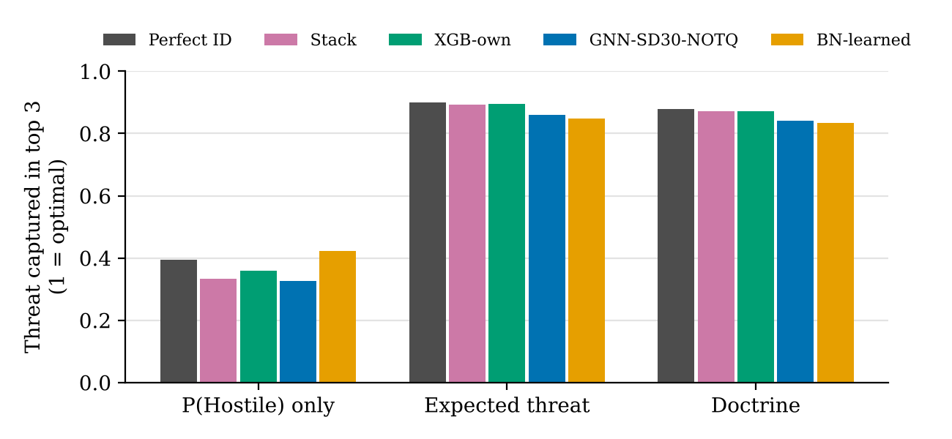
Figure 1. Threat captured in the top 3, as a share of the optimal top 3, for each identity source and ranker. The jump from P(Hostile) only to expected threat dominates; differences between identity sources are small by comparison.

7.3 Where the ranking loses against the optimal list
The gap between each ranking and the optimal list splits into two parts. The cost of estimating threat is what perfect identification still loses. The cost of identification is the further loss with a real Combat ID model.
Table 8. Threat captured in the top 3 (expected-threat ranker), split into its two losses
Identity | Threat captured | Lost to estimating threat | Lost to identification
Perfect ID | 0.899 | 0.101 | 0.000
Stack | 0.893 | 0.101 | 0.006
XGB-own | 0.894 | 0.101 | 0.005
GNN-SD30-NOTQ | 0.860 | 0.101 | 0.039
BN-learned | 0.847 | 0.101 | 0.052

For the stack and XGBoost almost all of the loss comes from estimating threat. The next gains for those models therefore lie in better time-to-go and lethality estimates, for example using the Bayes Net's platform-class posterior instead of the observable lethality table. For the GNN and BN, identification costs as much again.
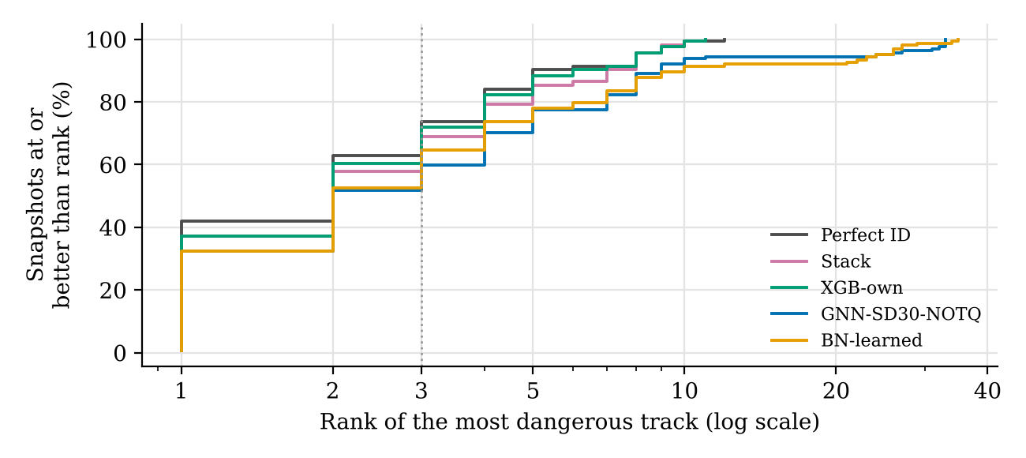
Figure 2. S9 seed 3, doctrine ranker: share of snapshots in which the most dangerous track is at or above each rank. The top threat is in the top 3 in 74% of snapshots with perfect identification, 72% with XGBoost, 69% with the stack, 65% with the BN and 60% with the GNN. The BN and GNN curves have long tails: in a few percent of snapshots the most dangerous track falls below rank 20.
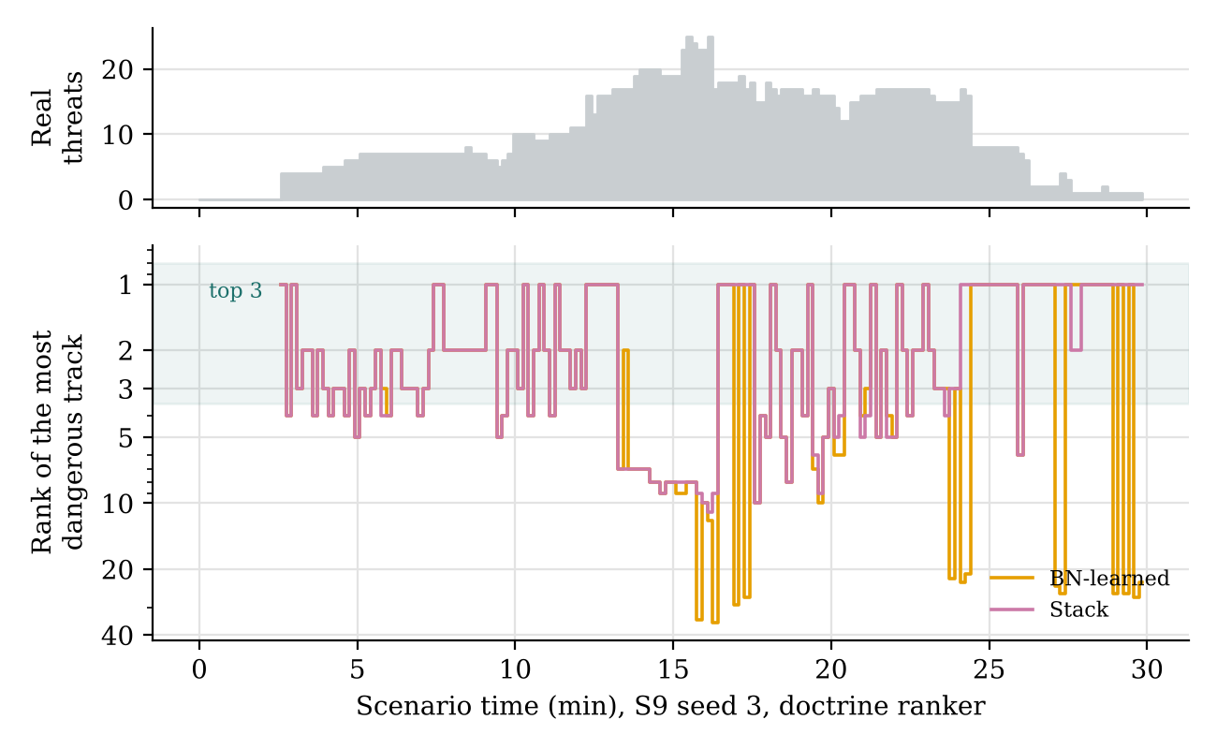
Figure 3. S9 seed 3, doctrine ranker. Top: real threats present. Bottom: rank of the most dangerous track over time with the stack and the BN (the BN line is hidden wherever the two agree). The BN loses the top threat several times, down to rank 20–40, during the busiest part of the raid and late in the scenario.

7.4 Fratricide attention and the v0.6.1 doctrine fix
In v0.6.0, the imminent rule raised any track with under 60 seconds to an asset that was not identified as friend. Own drones loitering inside an asset's radius have a time-to-go of zero, so whenever the BN or GNN misidentified one, it went to the top of the list. v0.6.1 requires the track to be closing.
Table 9. Friend ranked above the most dangerous threat, before and after the fix
Identity | Expected threat (no rules) | Doctrine v0.6.0 | Doctrine v0.6.1 | Friend in top 3 (v0.6.0 → v0.6.1) | Never top 3 (v0.6.0 → v0.6.1)
Perfect ID | 0.0% | 0.0% | 0.0% | 0.0% → 0.0% | 11.1% → 10.9%
Stack | 0.4% | 0.7% | 0.3% | 3.3% → 3.0% | 6.0% → 5.7%
XGB-own | 1.1% | 1.6% | 0.9% | 4.8% → 4.4% | 5.4% → 5.7%
GNN-SD30-NOTQ | 7.2% | 15.6% | 6.1% | 18.2% → 10.6% | 7.5% → 6.0%
BN-learned | 9.3% | 14.8% | 8.8% | 17.3% → 13.3% | 5.4% → 4.2%
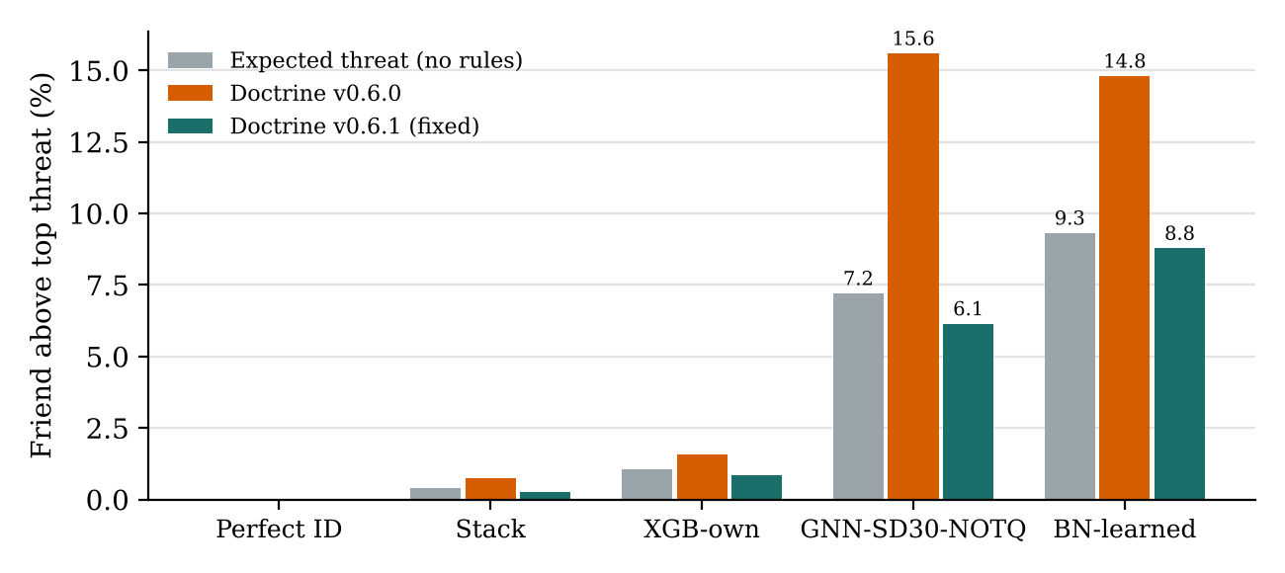
Figure 4. Share of snapshots with a friend ranked above the most dangerous real threat. The fix halved this for the GNN and BN, and the doctrine now does slightly better than the rules-free ranker for every identity source.
Table 10. Who the remaining friends ranked above the top threat are (S9 seed 3, doctrine ranker, count of track-snapshots)
Identity | Helicopters | Tactical return | Combat air patrol | Own drones | Median P(H)
Perfect ID | 0 | 0 | 0 | 0 | —
Stack | 0 | 0 | 0 | 0 | —
XGB-own | 0 | 3 | 0 | 0 | 0.94
GNN-SD30-NOTQ | 0 | 0 | 0 | 1 | 0.99
BN-learned | 7 | 4 | 3 | 0 | 0.94

Every remaining case is a friend that the identity source calls hostile with high confidence (median P(Hostile) 0.94–0.99): helicopters, the friendly tactical return and combat air patrol for the BN, the tactical return for XGBoost, and one own drone for the GNN. None replied validly on IFF at the time, so no doctrine rule could protect them. Reducing these errors is a Combat ID problem, which is why the stack's 0.3% is the best fratricide-attention result.

7.5 How the doctrine rules act
Table 11. How often each rule fires (S9 seed 3, stack identity, share of track-snapshots of each kind)
Rule (stated reason) | Real threats (n = 1790) | Friends (n = 1576) | Neutrals (n = 3150)
Inbound from the threat sector | 25.6% | 0.0% | 0.1%
Under 60 s to an asset and not identified friend | 16.4% | 0.0% | 0.5%
Descending and closing on an asset, under 3 minutes: hostile act criteria met | 0.3% | 0.0% | 0.0%
Replied validly earlier and looks friendly: probable IFF outage | 0.0% | 64.5% | 0.0%
Valid Mode 5 reply: protected | 0.0% | 56.3% | 0.0%
In the friendly return corridor | 0.0% | 17.4% | 0.0%
Conforming to an airway with a civil squawk | 0.0% | 0.0% | 19.5%

- Protection rules fire where they should. The Mode 5 and IFF-outage rules cover most friendly track-snapshots and never fire on a real threat. The civil-airway rule covers about a fifth of neutral track-snapshots and never fires on a threat.
- Escalation rules fire on threats, not friends. The threat-sector and imminent rules fire on a quarter and a sixth of real-threat snapshots respectively, and on essentially no friends or neutrals.
- The hostile-act rule rarely fires. Descending and closing within 3 minutes is met in well under 1% of real-threat snapshots in this scenario. Its criteria could be widened if declared-hostile status should come earlier.
- Why the doctrine costs a little ordering. The imminent floor of 0.6 and the 1.3 threat-sector multiplier lift several threats to similar scores, which flattens the order among them (τ falls by about 0.04) while ensuring each reaches the top 3 at some point.

7.6 Other observations
- Airliners in the top 3 rise under the doctrine (from 1.5–2.6% to 5–6.7% of snapshots), but this is harmless. Every case in seed 3 is a quiet snapshot with no real threat present, where the airliner's score is zero and it appears in the top 3 only because something must. The measure will be restricted to snapshots with a real threat.
- The list changes about 12–16 top-5 entries per minute, roughly 2 per 10-second update. A longer score decay time (decay_tau_s) would steady it; this is a tuning choice between stability and responsiveness.
- The delay before a real threat first reaches the top 3 (median 160–180 s) mostly reflects competition. With 8–25 concurrent threats, at most 3 can be in the top 3, so many wait their turn; captured threat and the top threat's rank are the better headline measures.

7.7 Doctrine variants
Three variants of the default doctrine were run on the same ten S9 runs, each changing a single setting: weapons free (P(Hostile) of at least 0.5 is engage-eligible), weapons hold (nothing is engage-eligible) and weapons tight with the ambiguity weight w set to 0. Table 12 gives the doctrine ranker for every identity source under each variant.
Table 12. Doctrine ranker under four doctrine variants (ten S9 runs)
Identity | Doctrine | Threat captured (top 3) | Top-threat rank, 90th % | Order τ | Never top 3 | Friend above top threat | Friends in engage tier
Perfect ID | Tight (default) | 0.878 | 8 | 0.46 | 10.9% | 0.0% | 0.0%
Perfect ID | Free | 0.882 | 8 | 0.46 | 10.9% | 0.0% | 0.0%
Perfect ID | Hold | 0.848 | 8 | 0.46 | 11.1% | 0.0% | 0.0%
Perfect ID | Tight, no ambiguity term | 0.878 | 8 | 0.46 | 10.9% | 0.0% | 0.0%
Stack | Tight (default) | 0.872 | 8 | 0.45 | 5.7% | 0.3% | 0.3%
Stack | Free | 0.876 | 8 | 0.45 | 5.4% | 0.4% | 0.4%
Stack | Hold | 0.843 | 8 | 0.46 | 6.0% | 0.9% | 0.0%
Stack | Tight, no ambiguity term | 0.871 | 8 | 0.45 | 6.0% | 0.3% | 0.3%
XGB-own | Tight (default) | 0.873 | 8 | 0.45 | 5.7% | 0.9% | 0.7%
XGB-own | Free | 0.876 | 8 | 0.45 | 5.4% | 1.7% | 1.4%
XGB-own | Hold | 0.839 | 8 | 0.46 | 6.0% | 3.8% | 0.0%
XGB-own | Tight, no ambiguity term | 0.873 | 8 | 0.45 | 5.7% | 0.7% | 0.7%
GNN-SD30-NOTQ | Tight (default) | 0.842 | 10 | 0.42 | 6.0% | 6.1% | 3.7%
GNN-SD30-NOTQ | Free | 0.851 | 9 | 0.43 | 6.2% | 7.1% | 4.8%
GNN-SD30-NOTQ | Hold | 0.818 | 8 | 0.45 | 7.2% | 8.4% | 0.0%
GNN-SD30-NOTQ | Tight, no ambiguity term | 0.842 | 10 | 0.42 | 6.0% | 6.1% | 3.7%
BN-learned | Tight (default) | 0.834 | 12 | 0.40 | 4.2% | 8.8% | 4.9%
BN-learned | Free | 0.845 | 9 | 0.44 | 4.4% | 10.4% | 10.2%
BN-learned | Hold | 0.808 | 9 | 0.45 | 6.0% | 12.0% | 0.0%
BN-learned | Tight, no ambiguity term | 0.835 | 12 | 0.40 | 4.4% | 8.6% | 4.9%
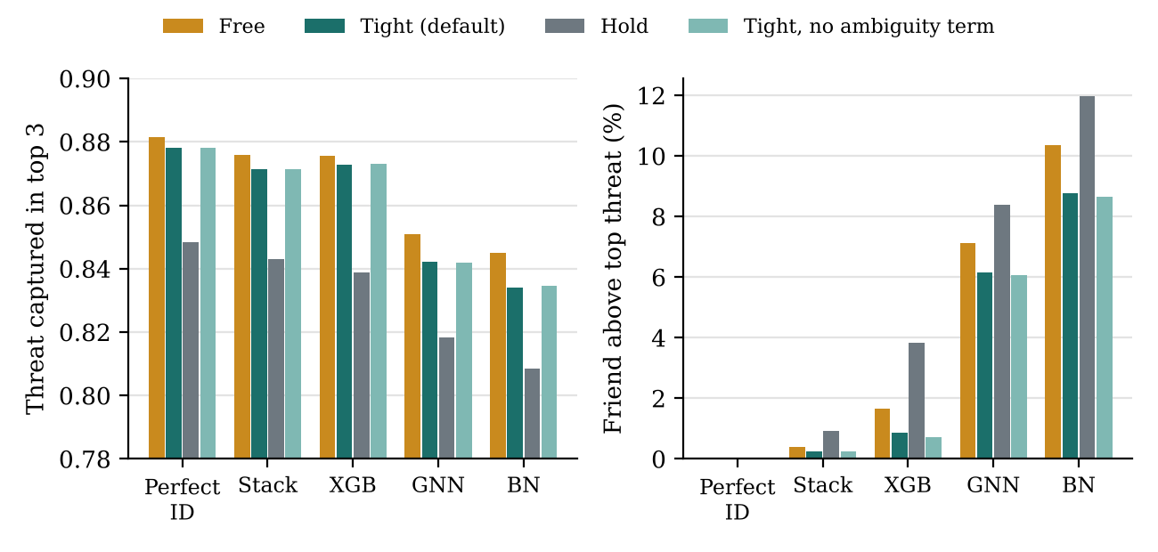
Figure 5. Doctrine ranker under each variant. Left: threat captured in the top 3 (axis starts at 0.78). Right: share of snapshots with a friend ranked above the most dangerous threat.
The weapons-control state changes the ranking, not only who may be engaged. Because the list is ordered by tier first, the engage tier acts as a sort key: tracks that meet the identity criteria rise above all others. The three states therefore produce different lists from identical scores.
- Weapons free orders threats slightly better (up to 1.1 points more captured threat, for the BN) because more hostiles reach the engage tier early. The cost falls on friends: with the BN, the share of friendly track-snapshots in the engage tier doubles from 4.9% to 10.2%, and with XGBoost from 0.7% to 1.4%. Friends ranked above the top threat also rise for every model source.
- Weapons hold is worst on both counts. With no engage tier, ordering falls back to score alone: captured threat drops 3 to 4 points and friends ranked above the top threat rise for every model (BN 8.8% to 12.0%, XGBoost 0.9% to 3.8%). Confidently hostile tracks no longer separate from moderately suspect friends that happen to be close to an asset.
- Weapons tight, the default, gives the best balance: within a point of weapons free on ordering, and the lowest friendly-fire attention and fewest friends in the engage tier for every identity source.
Table 13. Friend above the top threat with the rules-free ranker: the tier effect alone
Identity | Free | Tight | Hold
Stack | 0.5% | 0.4% | 1.1%
XGB-own | 1.6% | 1.1% | 3.7%
GNN-SD30-NOTQ | 8.4% | 7.2% | 9.8%
BN-learned | 11.3% | 9.3% | 14.8%

Table 13 isolates the tier effect: the expected-threat ranker has no rules, yet friends above the top threat still change with the weapons-control state, being lowest under weapons tight for every identity source. A design implication follows. Under weapons hold, the display could still sort by whether a track would meet the tight identity criteria, keeping that ordering benefit while engagement authority stays withheld; display tier and engagement authority need not be the same setting.
The ambiguity term has almost no effect here. Setting w to 0 changes captured threat by at most 0.001 and friends above the top threat by at most 0.2 points. The calibrated identity sources are rarely unresolved near an asset, so the term seldom matters. It is worth keeping as a safeguard for less confident identity sources and for pop-up tracks with little evidence, and a larger value could be tested.
Identity matters more than doctrine for fratricide attention. Across all four variants, friends above the top threat stay at 0.3–0.9% with the stack and 8.6–12.0% with the BN. The doctrine changes these by at most about 3 points; the choice of Combat ID model changes them by about 10.

7.8 Recommendations
- Use the stacked ensemble (or XGBoost) as the identity source. It brings ranking within 1 point of perfect identification and keeps fratricide attention under 1% in every doctrine tested.
- Keep weapons tight as the default, and decouple display ordering from engagement authority so that weapons hold does not lose the identity-confidence ordering.
- Improve threat estimation next. About 10 points of captured threat are lost even with perfect identification. Candidates: platform-class probabilities from the Bayes Net in place of the observable lethality table, and filtered time-to-go estimates.
- Tune the remaining doctrine settings with the same harness. The hostile-act rule rarely fires and could be widened; the imminent floor and threat-sector multiplier flatten ordering; the score decay time controls list stability.

