
A division of Data Access Technologies, Inc.
8605 Westwood Center Drive, Suite 505
Vienna, VA 22182

modelpro

design of a continuous integration build system with hudson
2 January 2008

Table of Contents
Section 1 Introduction 3
1.1 Purpose 3
1.2 Background 3
1.3 Related Documents 3
1.3.1 Placeholder 3
Section 2 QuickStart 4
Section 3 Linux Virtual Machine 4
3.1 Installing Eclipse 4
3.2 Installing ModelPro Plugin 4
3.3 Installing NetBeans 5
Section 4 Hudson Design 8
4.1 Launching Hudson 8
4.2 Hudson System Configuration 8
4.3 Adding a Hudson Project 9
4.4 Initializating the Hudson Project 15
4.5 Testing the Hudson Project 18
4.6 Adding the FindBugs Plugin 19
4.6.1 Install FindBugs 19
4.6.2 Add FindBugs Plugin to Hudson 19
Section 5 Building a Headless NetBeans Project 23
5.1 System-Specific Configuration 23
5.2 Headless Build 23
5.3 System-Specific Configuration 23
5.4 Workspace Save Issues 23
Section 6 Launching Glassfish v2 23
Section 7 Building the ModelPro Plugin 24
Section 8 Provisioning with A Headless Eclipse 24
8.1 SVN Checkout 24
8.2 Environment Variables 25
8.3 Eclipse Workspace for ModelPro 25
8.4 Eclipse Workspace for Provisioned Projects 25
8.5 Environment Variables 25
Section 9 Deploy a Web Service 25
Section 10 Test a Web Service 26
10.1 Glassfish Built-In Tester 26
Section 11 Phases 26

Table of Figures

Error! No table of figures entries found.

Table of Tables
Error! No table of figures entries found.

Introduction

Purpose
This document describes the design of a continuous integration build system for ModelPro.

Background

Related Documents

Placeholder

QuickStart

Starting Hudson
Open up VMWare console to 192.168.2.19 or open a SSH console.
Linux username: user
Linux password: user
Start Hudson with the following commands:
cd /home/user/continuous_integration/hudson
./hudson.sh
Start Glassfish with the following commands:
cd /home/user/continuous_integration/glassfish-v2ur2/bin
./asadmin start-domain
Open a web browser to the Hudson console at:
http://192.168.2.19:9090
Open a web browser to the Glassfish console at:
http://192.168.2.19:4848

Adding a Hudson Job

Linux Virtual Machine

The continuous integration application is run on a Linux VMWare virtual machine. The host machine is located at 192.168.2.230.

Installing Eclipse
To ensure the correct version of Eclipse is used, as well as to isolate it from the system-installed Eclipse which could be used for other development (with other incompatible plugins), an Eclipse dedicated for ModelPro is installed.
This Eclipse is the “Eclipse Modeling Tools” package for 32-bit Linux. The version is Ganymede SR1.
TBD: Is the host OS for VMWare a 32-bit or 64-bit machine?

Installing ModelPro Plugin
The ModelPro plugin without EKB package is installed.
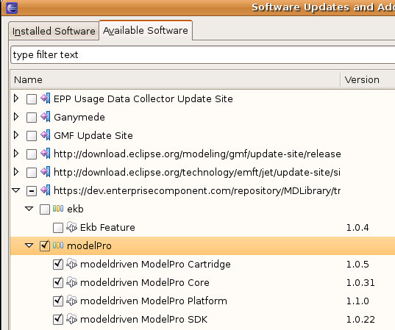

Installing NetBeans
The NetBeans 6.5 installer script for Linux was downloaded to /home/usr/continuous_integration. Launching this script (after chmod 755) brings up a graphical install wizard.
The following are installed with NetBeans 6.5:

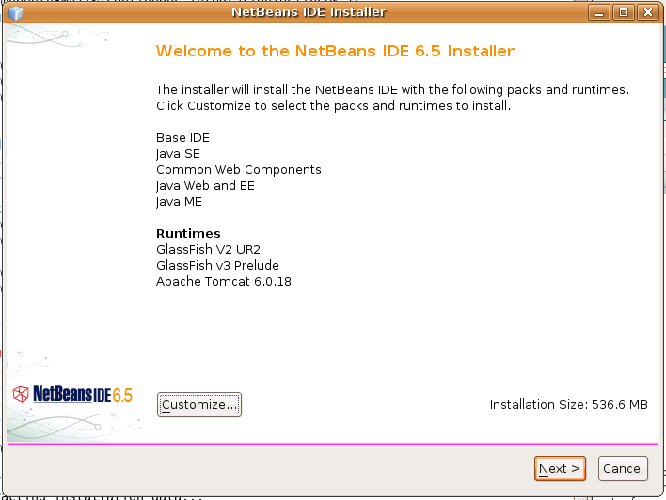

NetBeans 6.5 is installed in /home/usr/continuous_integration.
The GlassFish V2 UR2 install has the following properties:
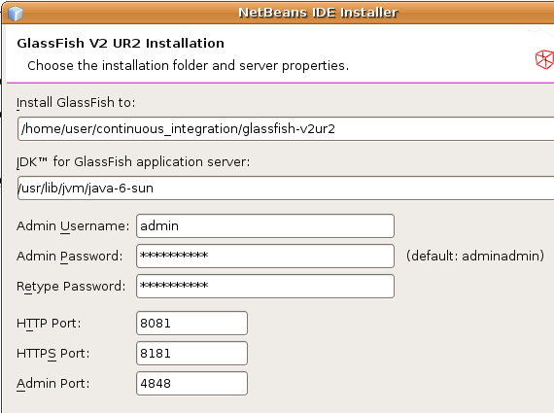

Following are the installation locations for the applications.

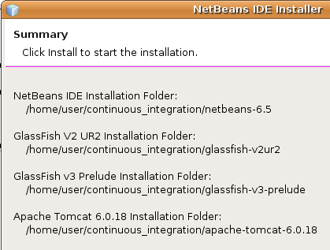

Hudson Design

Launching Hudson
Hudson is located in /home/user/continuous_integration/hudson. The environment variable HUDSON_HOME is set to /home/user/continuous_integration/hudson/data in the /home/user/.bashrc file.
The following command is used to launch hudson:
java –jar hudson.war
The web console is available at the following URL: http://192.168.2.19:8080

Hudson System Configuration
When Hudson is first run, the system configuration parameters must be set. To get to the configuration page, click on the “Manage Hudson” link. When the Manage Hudson page is displayed, click on the “Configure System” link.
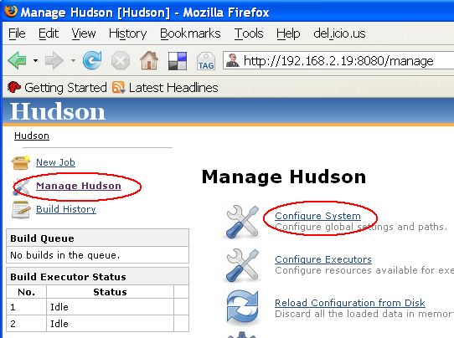
The JDK, Ant, and shell are configured for the Linux VM.
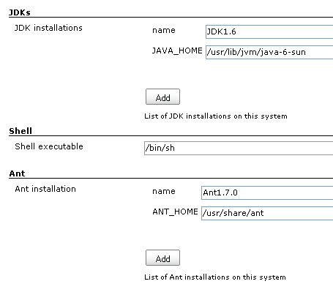

The email settings are configured for the Linux VM. Note that due to DNS issues, the IP address (not the hostname) is specified for the SMTP server.

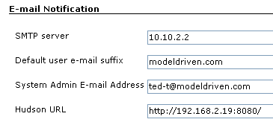
To test, click on the “Test configuration by sending e-mail to System Admin Address” link.

Adding a Hudson Project
To create a new job, start by clicking on the “New Job” link.
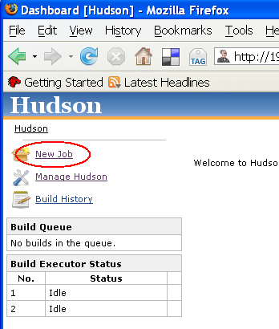
Select the “Build a free-style software project” radio button.
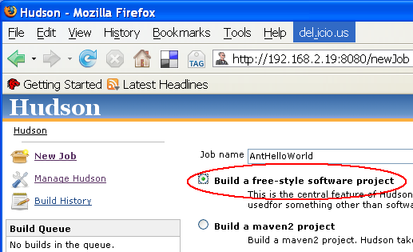
Specify that old builds are discarded and the last 5 builds are preserved.
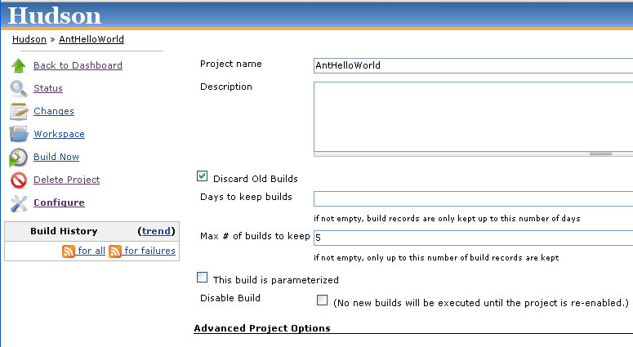

For Source Code Management, select None, since Hudson is not compatible with the MDS SVN server.
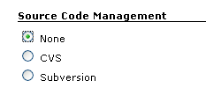
Set up a build trigger at the top of every hour. Click on the help icon (question mark symbol) for instructions on the cron format.
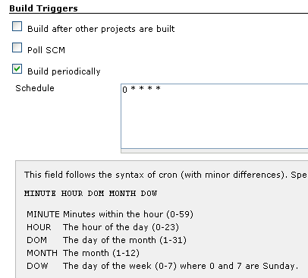
For the build steps, select the “Invoke Ant” option.
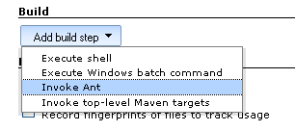
For the first build step, refresh the project from SVN.
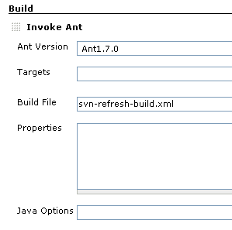
Create a second build step to run the project’s Ant script.
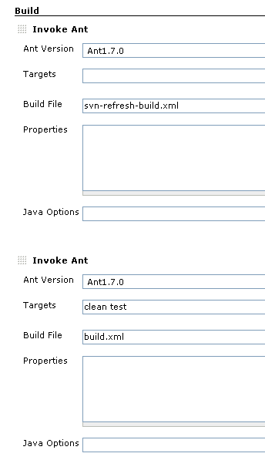
Configure archiving of artifacts so that the artifacts are available on the Hudson project web page.
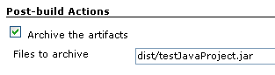
Note if this is configured before the project is ever built, then an error is displayed since the dist directory has not yet been created. This error will go away after the first build.
Configure the email notifications.
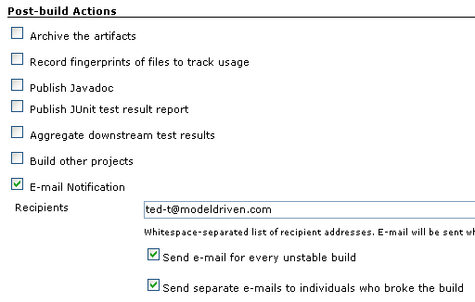
Press the Save button.

Initializating the Hudson Project
Click on the Build Now link to have Hudson set up the directory structure for this project. Note the build will fail.
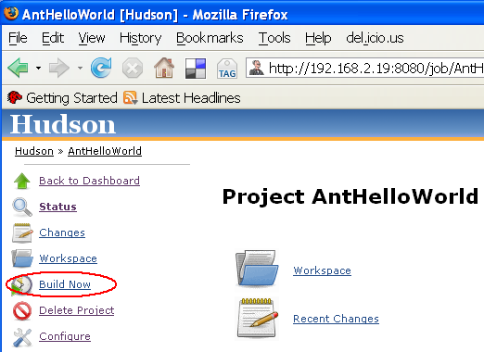
Hudson should have created a project directory under $HUDSON_HOME/jobs with the same name as the project. Under this project directory are two directories, one called “build” and one called “workspace”.
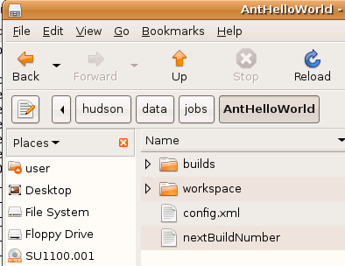
Because Hudson is not compatible with the MDS SVN repository, the first SVN checkout must be done manually in the directory called “workspace”.
Check out from SVN the project under the directory called workspace. For example, run the following Linux command in the $HUDSON_HOME/jobs/AntHelloWorld/workspace directory:
svn co https://dev.enterprisecomponent.com/repository/MDS/DAT-Technical/trunk/Projects/AntHelloWorld .
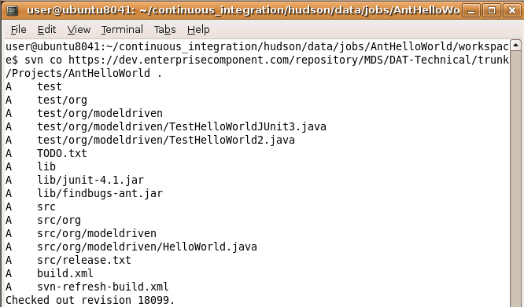
In the Linux file browser, the directory structure should look like the following.
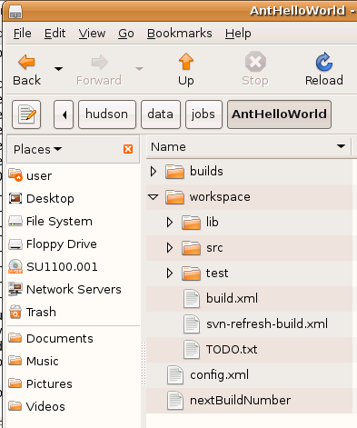

Testing the Hudson Project
To test, click the Build Now link in the web console.

Adding the FindBugs Plugin

Install FindBugs
FindBugs first must be installed on the Linux VM so that the FindBugs Ant task will run.
FindBugs is downloaded to /home/user/continuous_integration/findbugs. The environment variable FINDBUGS_HOME is set to this directory in ~/.bashrc.

Add FindBugs Plugin to Hudson
To add plugins, click on the Manage Hudson link and then the Manage Plugins link.
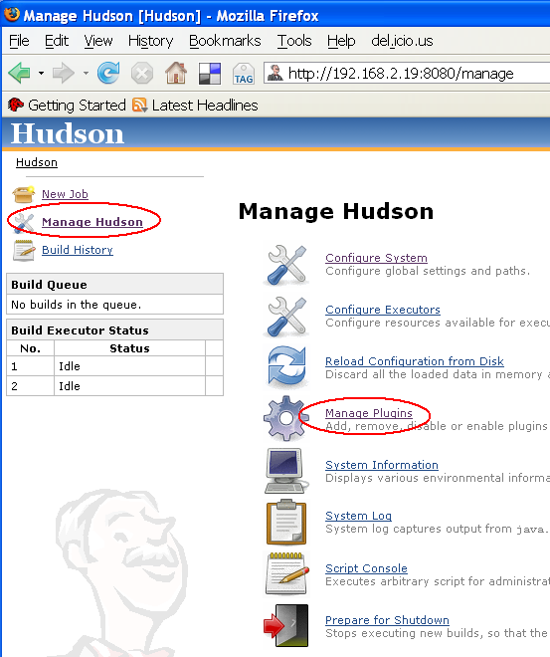

Click on the FindBugs plugin and press the Install button.
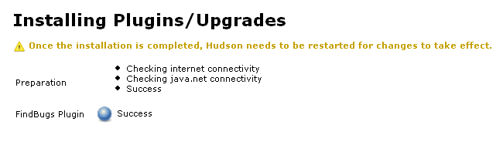
Restart Hudson after the plugin is installed.
Enable FindBugs for the project in the post-build actions.
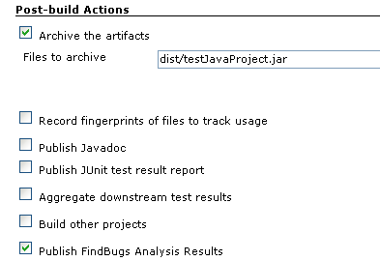

To view the results, click on the “FindBugs Warnings” link on the project page.
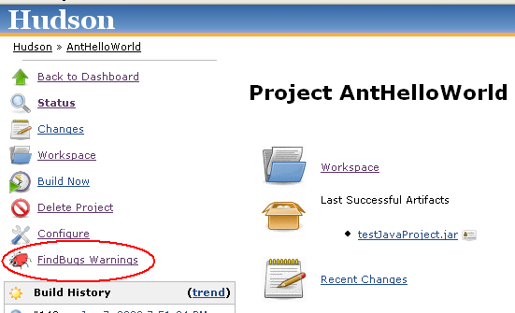

The FindBugs warnings are then displayed.

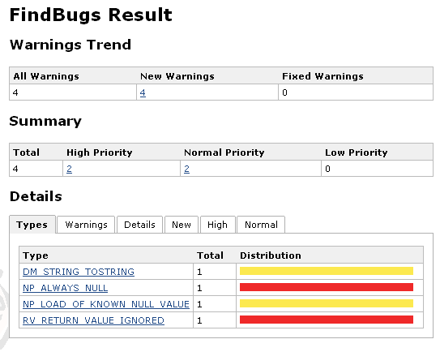

Building a Headless NetBeans Project

System-Specific Configuration
Although NetBeans projects use Ant, there are many jarfiles that are not part of the checked in project but rather part of the NetBeans installation that are referenced. Hence, to build a NetBeans project, one has to have NetBeans installed on the same system. To build such a project on the command line (i.e., headless), one has to configure the properties files to find the local NetBeans installation.
Because the properties file are specific to an install, and often these files are checked into SVN, NetBeans will detect a mismatch and display a “regenerate build-impl.xml” message when the project is opened. This action will regenerate various properties and build files so that the project will build on the new system.
For a continuous integration server, the system-specific build and properties files should be checked into SVN.
Once these system-specific files are correct, the project can be built using Ant on the command line.

Headless Build

System-Specific Configuration

Workspace Save Issues
To avoid issues with a workspace not being saved in headless mode, disable the automated builder for ModelPro. Also turn on automated saving of the workspace, though this may not apply to headless mode.
Specify argument “-clean” to headless build.

Launching Glassfish v2

To start Glassfish v2, run the following commands on the Linux CI system:
cd /home/user/continuous_integration/glassfish-v2ur2/bin
./asadmin start-domain
Verify the web console is up by opening http://localhost:4848. If on a different machine, open http://192.168.2.19:4848.
The username is “admin” and the password is “adminadmin”.
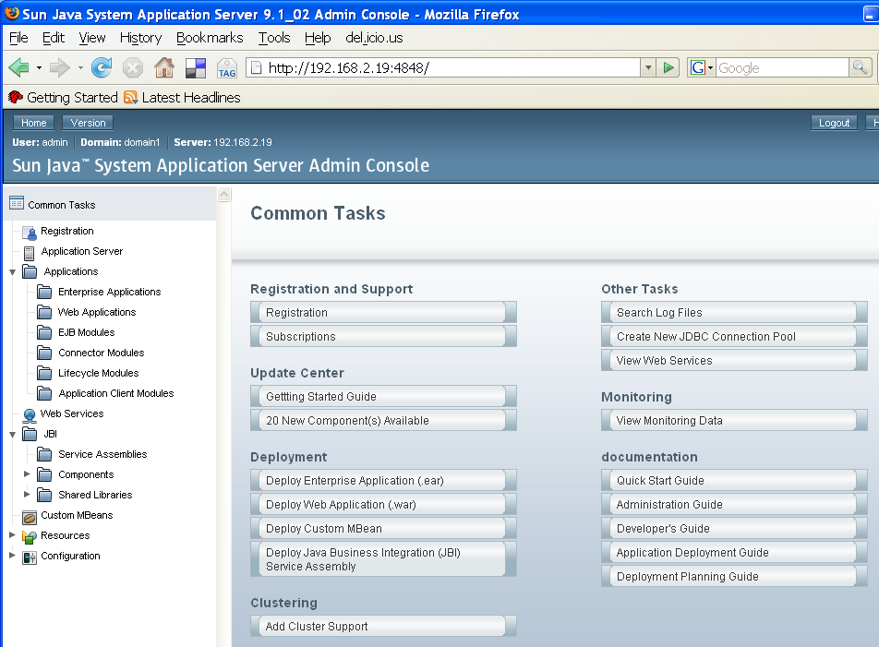

Building the ModelPro Plugin
This section defines how to build the ModelPro plugin.

Provisioning with A Headless Eclipse
This section defines how to use a headless Eclipse to provision an application from a model.

SVN Checkout
The Eclipse project requires the folder name to match the project name. As a result, checking out the code to Hudson’s workspace directory causes an error.
A workaround is to manually create a sub-directory under Hudson’s workspace with the name of the project, then check out the code into this sub-directory. This means that the build actions need to specify the location of the Ant script since it won’t be in the top level workspace directory.

Environment Variables
The following environment variables are used:
ECLIPSE_HOME
ECLIPSE_WORKSPACE

Eclipse Workspace for ModelPro
The Eclipse workspace for ModelProjects is located here:
/home/user/continuous_integration/workspace
The Eclipse workspace has to have the ModelPro project to build already opened before Eclipse can be invoked in a headless mode.
The project opened in the Eclipse workspace is the one checked out to the Hudson workspace, located in /home/user/continuous_integration/hudson/data/jobs/<projectName>/workspace.

Eclipse Workspace for Provisioned Projects
ModelPro seems to constantly provision its projects, so to avoid having ongoing provisioning while trying to build/deploy the provisioned projects, a second workspace is used which only contains the provisioned projects (in the gen~ folder), and not the ModelPro projects.
This workspace is located here:
/home/user/continuous_integration/workspace_provisioned

Environment Variables

Deploy a Web Service
This section defines how to deploy the provisioned web service application.
Once the NetBeans project is built, the ant target “run-deploy” is invoked.
There is an issue with the nbproject/build-impl.xml file. The “run-deploy” Ant target has an Ant task which is not on the classpath. This target is not needed to deploy the web service and is commented out.
The following fragment of the build-impl.xml file includes the Ant task, highlighted in yellow, that needs to be commented out.
<target depends="init,compile,compile-jsps,-do-compile-single-jsp,-pre-dist,-do-tmp-dist-with-manifest,-do-tmp-dist-without-manifest,-pre-run-deploy,-pre-nbmodule-run-deploy,-run-deploy-nb,-init-deploy-ant,-deploy-ant,-run-deploy-am,-post-nbmodule-run-deploy,-post-run-deploy" name="run-deploy">
<nbjpdaappreloaded/>
</target>

Test a Web Service
This section defines how to test the web service. This includes provisioning the web service client.

Glassfish Built-In Tester

Phases
This section defines the phasing of functionality.
- Hudson on the Linux VM
  - Configure Hudson - COMPLETE
  - Implement workaround for SVN incompatibility - COMPLETE
  - Test with AntHelloWorld – COMPLETE
  - Add plugins - TODO
- Manual build (provision app, build app, deploy app)
  - Provision Scott’s HelloWorld in Eclipse with plugin – COMPLETE
  - Build Scott’s HelloWorld in NetBeans – COMPLETE
  - Deploy Scott’s HelloWorld to Glassfish - COMPLETE
- Manual test (provision test app, build test app, deploy test app)
  - TODO: Create ModelPro app for test client under ModelPro/Applications
  - TODO: Reconfigure to use model in a different project
  - TODO: Code holes for JUnit
- Automate CI
  - TODO: Install Eclipse on Linux CI VM
  - TODO: Install NetBeans with Glassfish on Linux CI VM
  - TODO: Build headless NetBeans
- Update provision to use model files
- Manual build of plugin
- Automate CI of plugin

Issues:
- Can Eclipse ModelPro project be run in a directory not under workspace?

