xlsApp
xls Testopia Integration
USER’S MANUAL

October 8, 2010
Revision Sheet

Release No. | Date | Revision Description
1.0 | 8/10/2010 | Initial Revision

smb://sttky01/pvhome/Public/EngineeringPub/ForFukaya/xls-testopia/xlsApp-package-version7/
USER'S MANUAL

TABLE OF CONTENTS

Page #

1 GENERAL INFORMATION 1
1.1 1.1 System Overview 1
1 GETTING STARTED 1
1.1 Installing JDK1.6 or above 1
1.1.1 Starting the Application 1

1.0 GENERAL INFORMATION

GENERAL INFORMATION

1.1 System Overview

The xlsApp application is intended to assist the QA team to upload all the xls test cases into the testopia database. This application is developed using java and mysql database. It access the testopia bd tables using the login credentials. Hence the database security is not compromised.

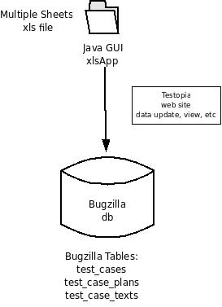

2.0 GETTING STARTED

GETTING STARTED
//sttky01/pvhome/Public/EngineeringPub/ForFukaya/xls-testopia/xlsApp-package-version7/
Copy the xlsApp-package-version7 which includes xlsApp.jar file.

Installing JDK1.6 or above

Starting the Application
Required library files should be inside the lib/ folder.
- jxl.jar
- log4j-1.2.16.jar
- mysql-connector-java.jar
- ojdbc14.jar
- postgresql-jdbc3.jar
- swing-layout-1.0.4.jar

run the xlsApp.jar using the shell script of by typing in the command line as follows:

#jre/bin/java -jar xlsApp.jar

Step 1: Give entry in to the Test Plan. Each of the Test Plan represents the name of the sheet of xls file. For a xls file with two sheets named FileOperation, mtpRecovery the required Test Case entries should be FileOperation and mtpRecovery.

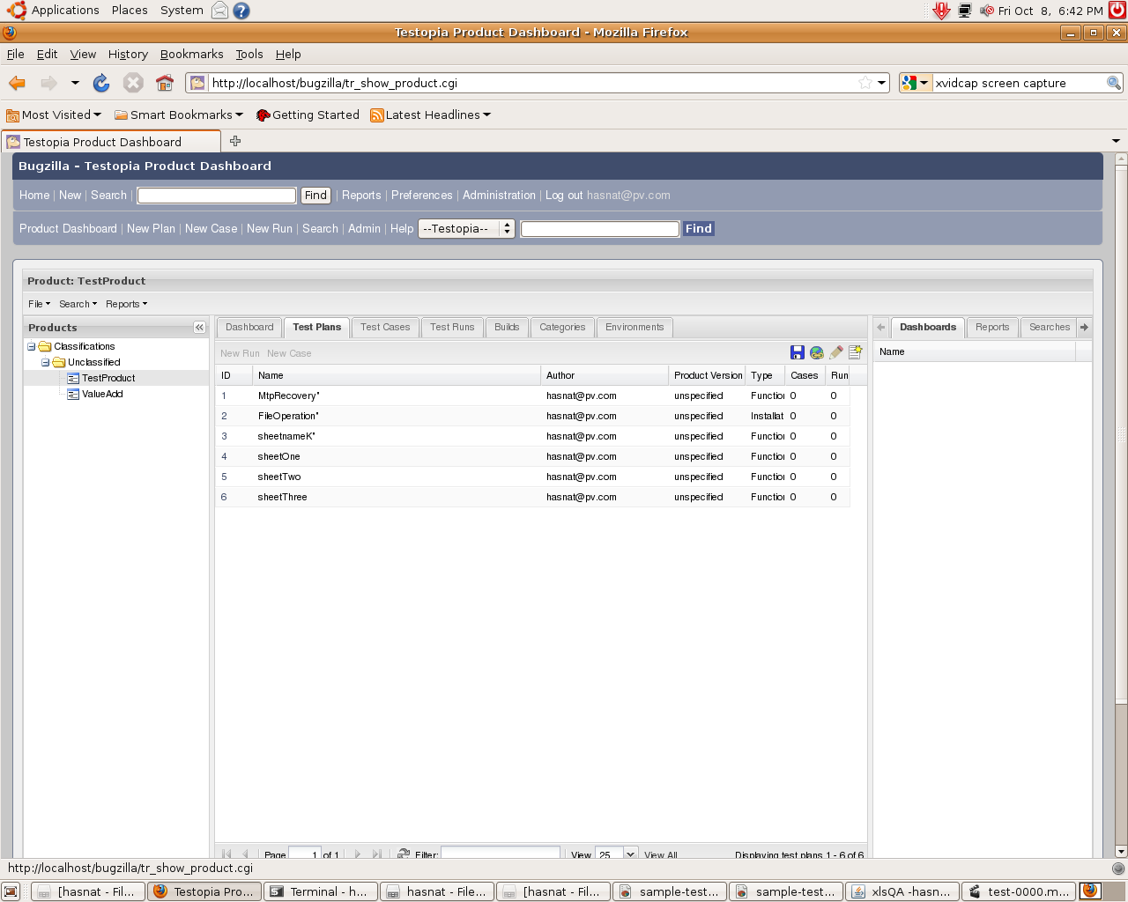

The testopia test case initially with out any test case entry.

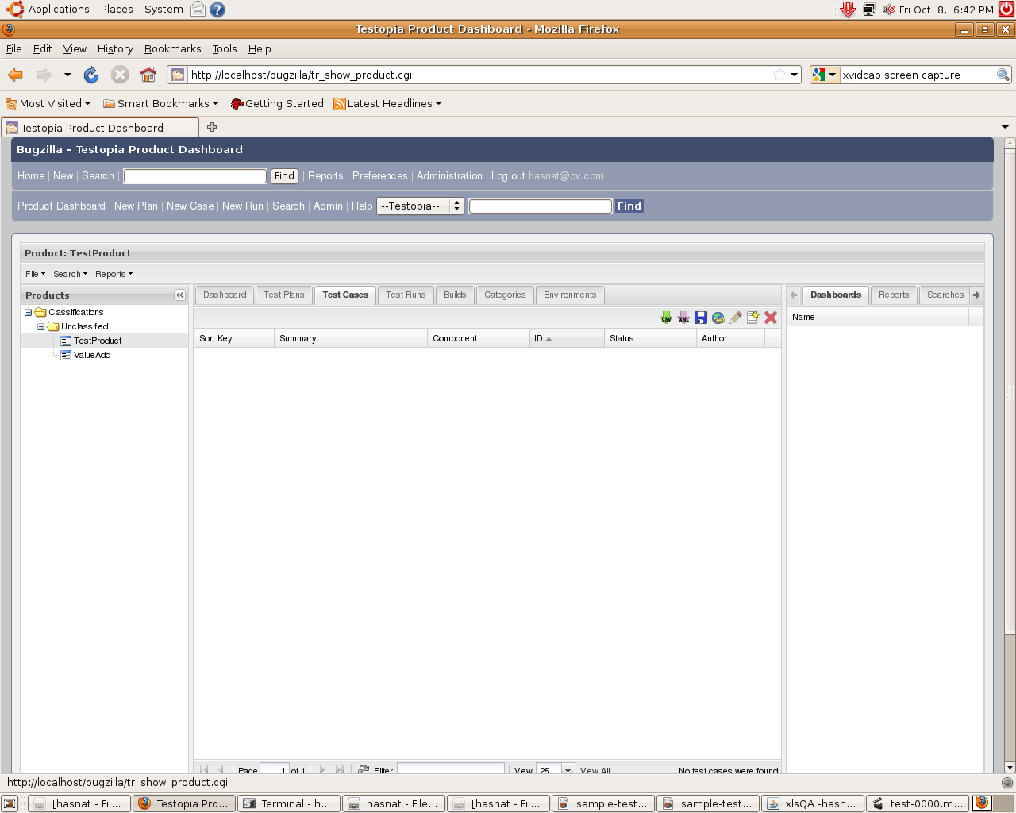

The latest release of the xlsApp.jar is runnabe by the shell script xlsApp or by typing from the command prompt as

java -jar xlsApp.jar

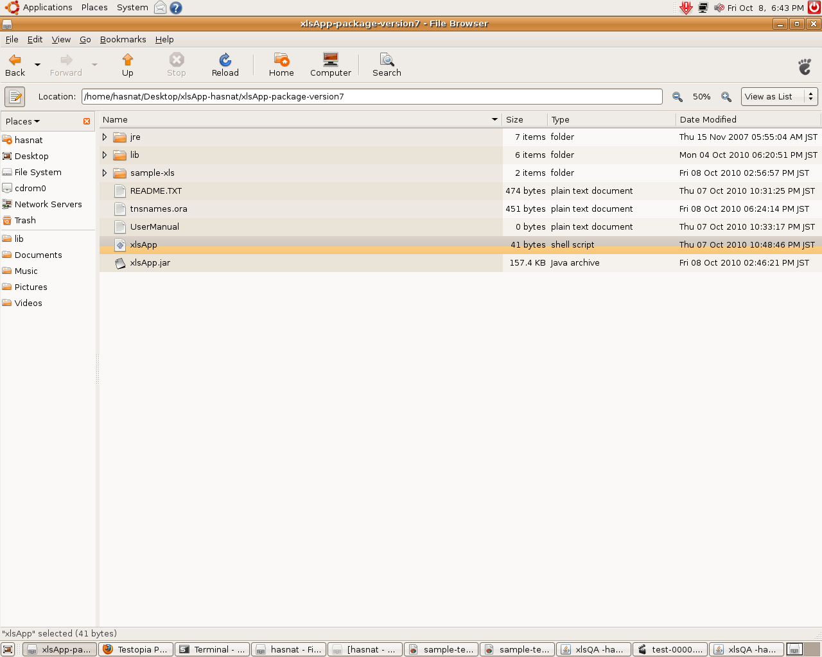

Run or run in terminal

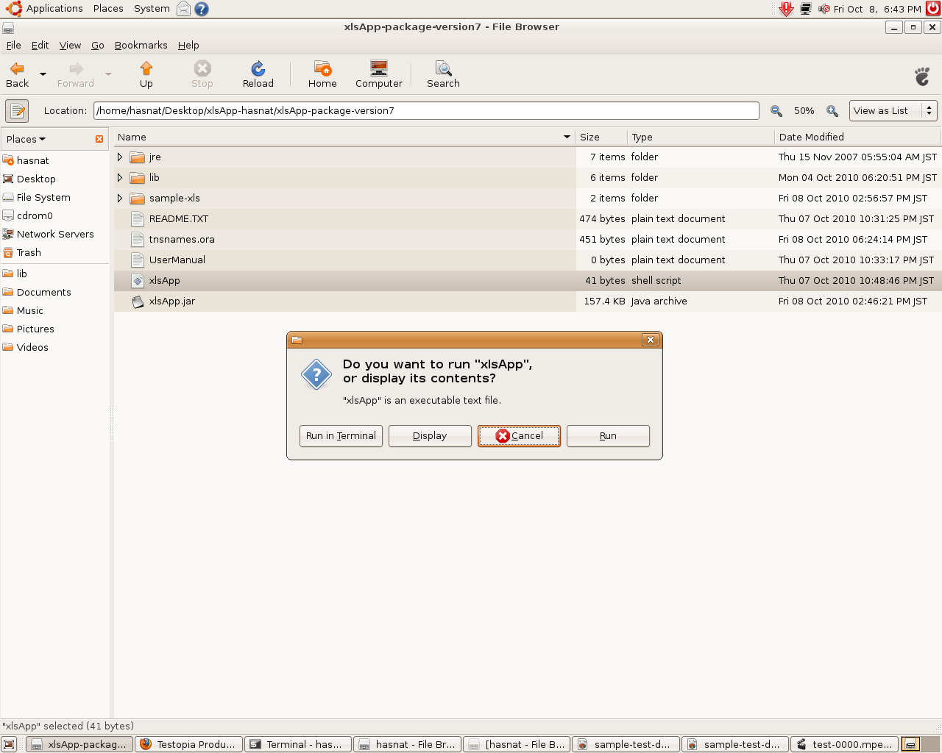

Please dont close the back ground terminal

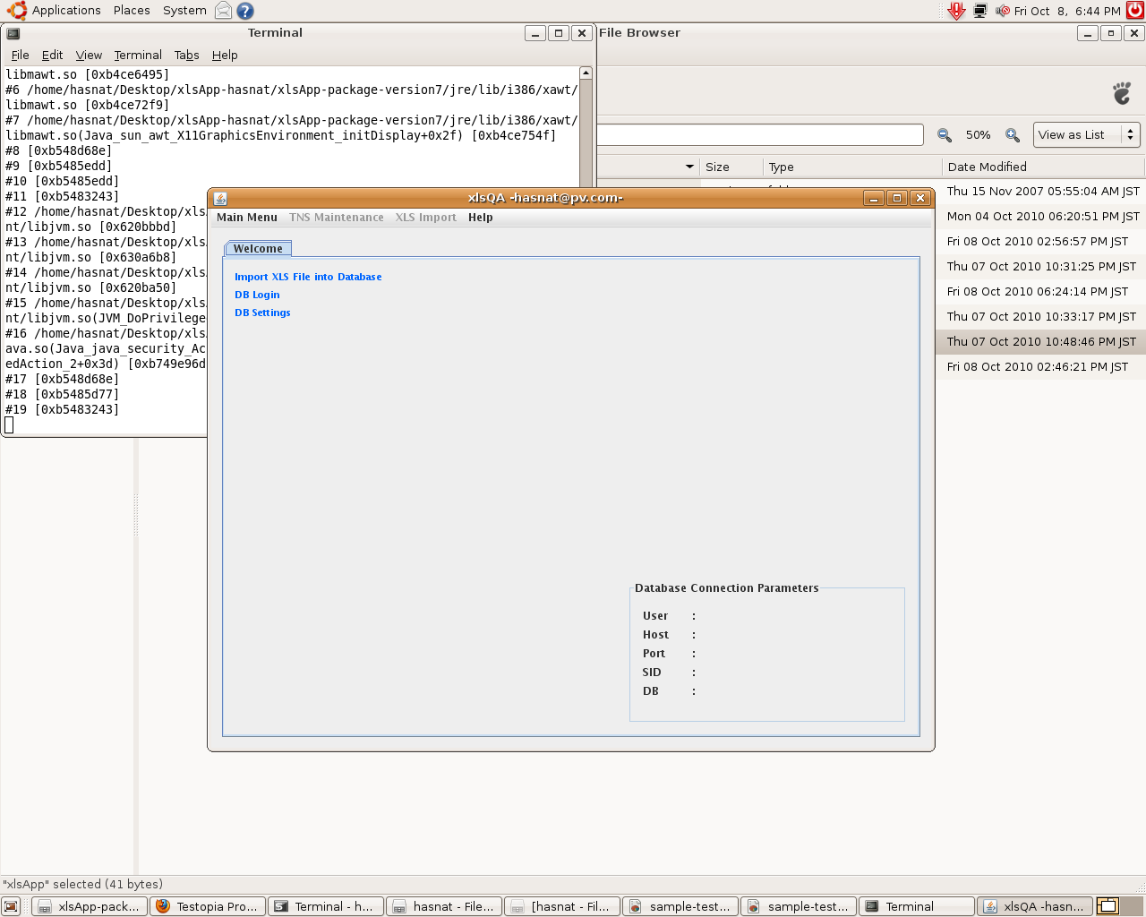

Click on DB Settings and then give entry for the data base credentials.
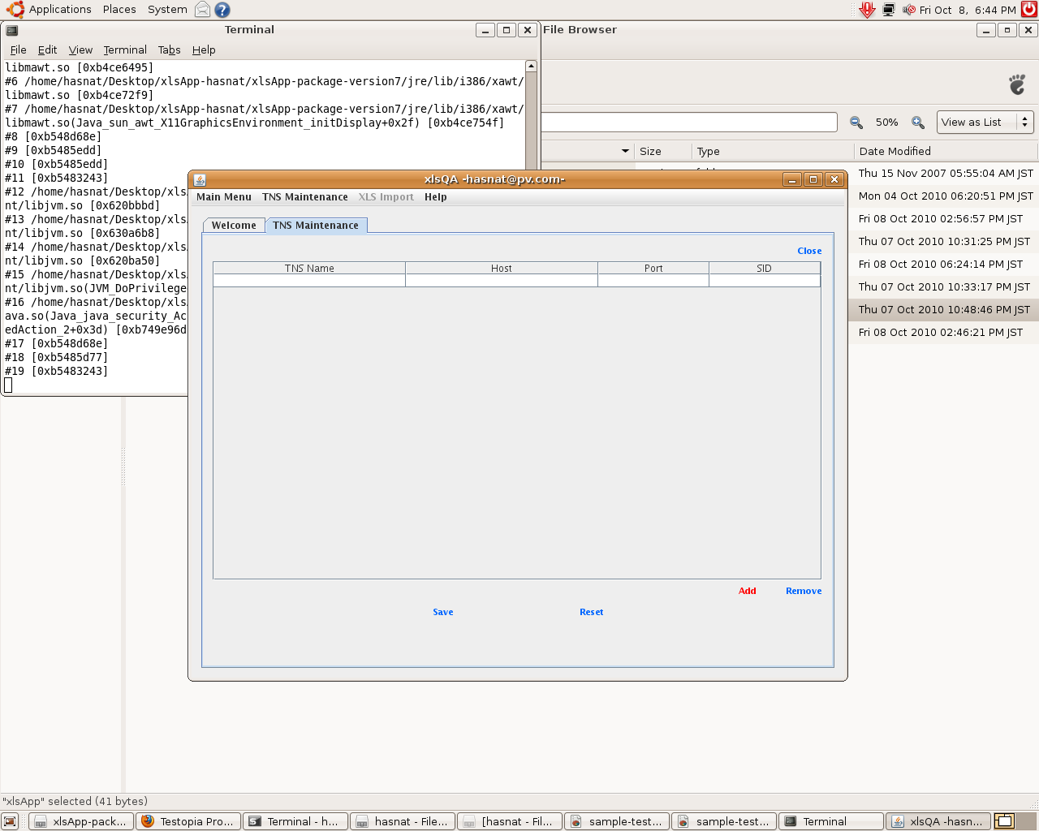

Click the save button for the database settings
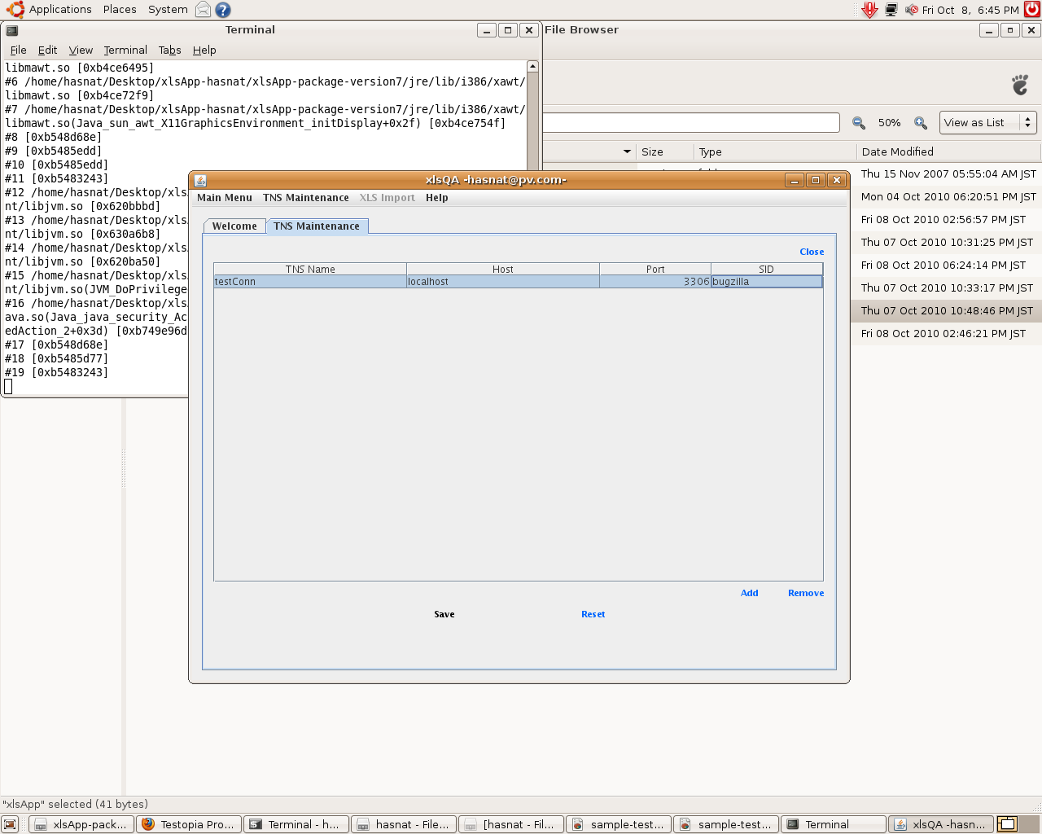

After saving the confirmation dialog box will be appeared.
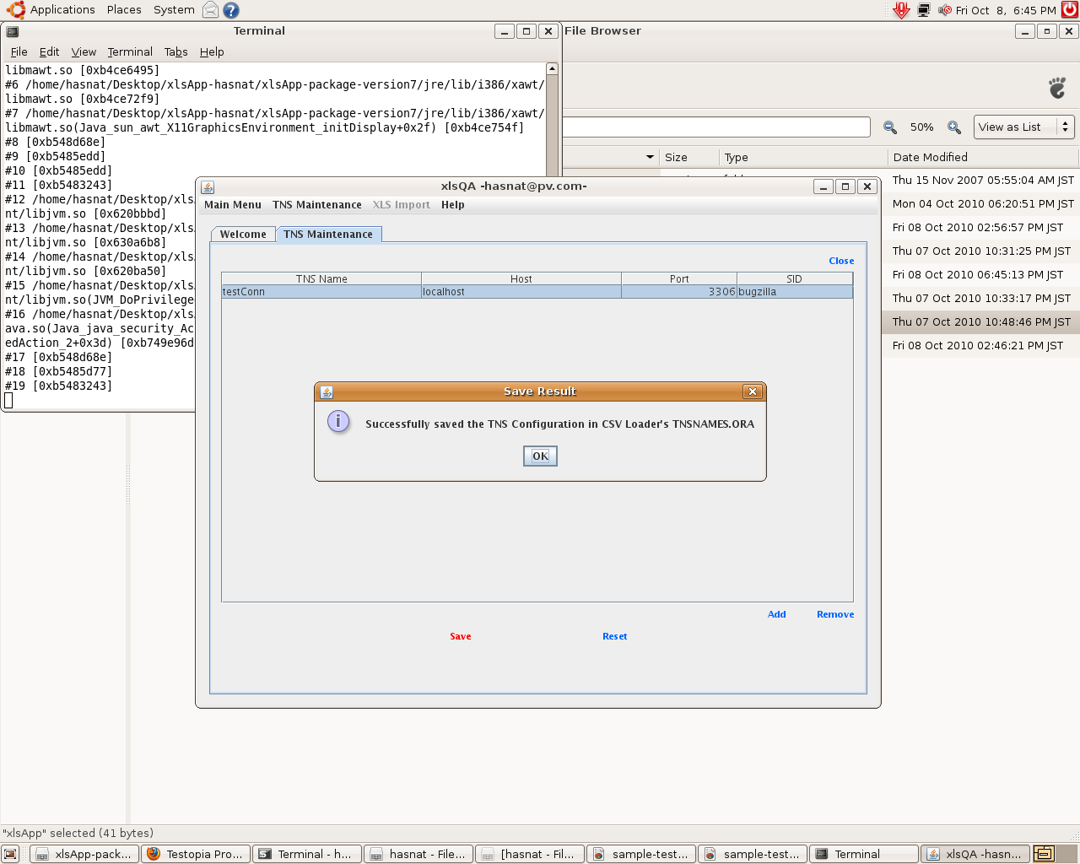

Now log in to the DB system where the testopia (bugzilla) is hosted.
Give input the username and password and then click on login button.
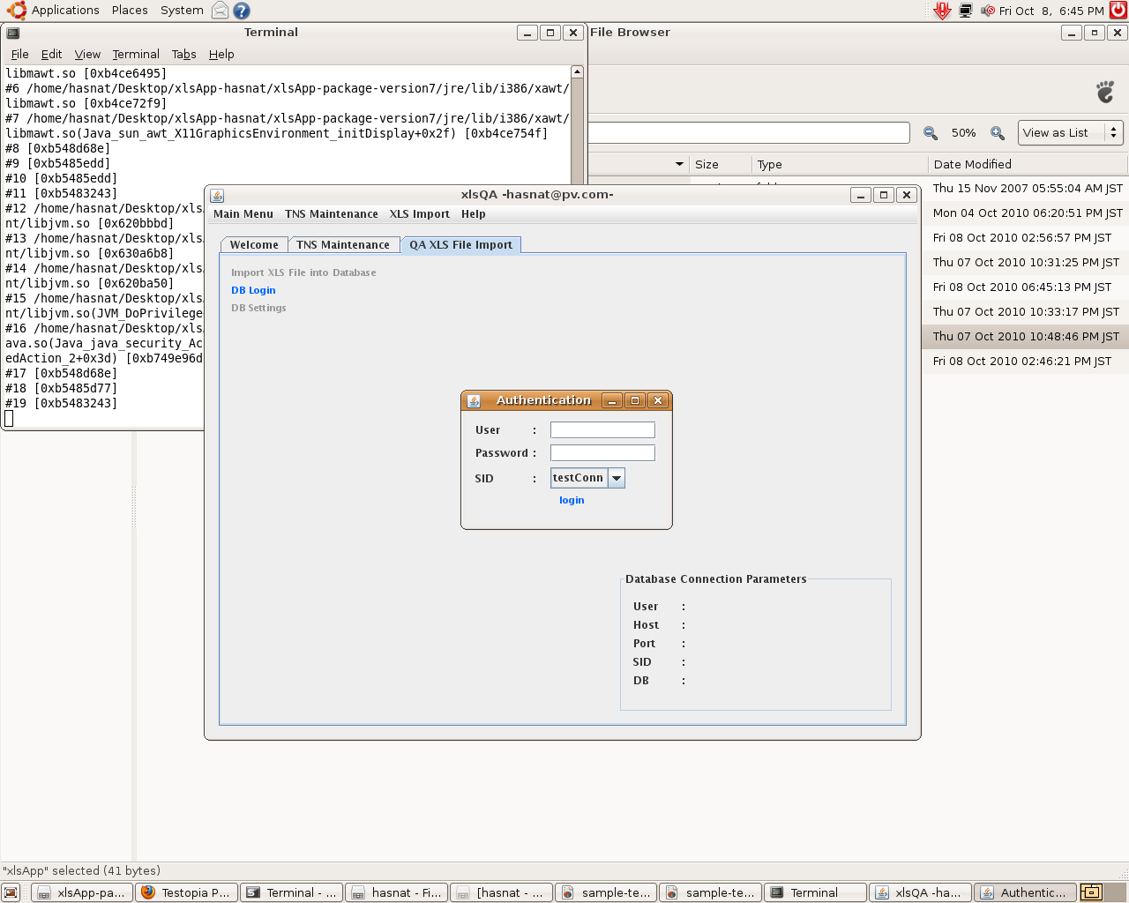

Login

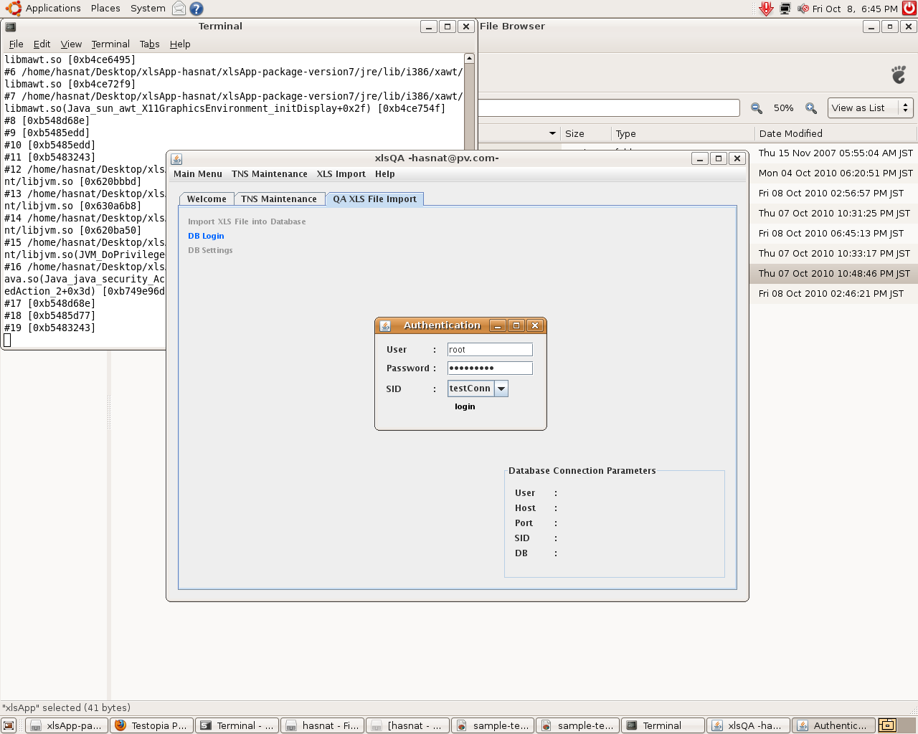

Click the import xls file menu for importing xls test cases in to the databases.

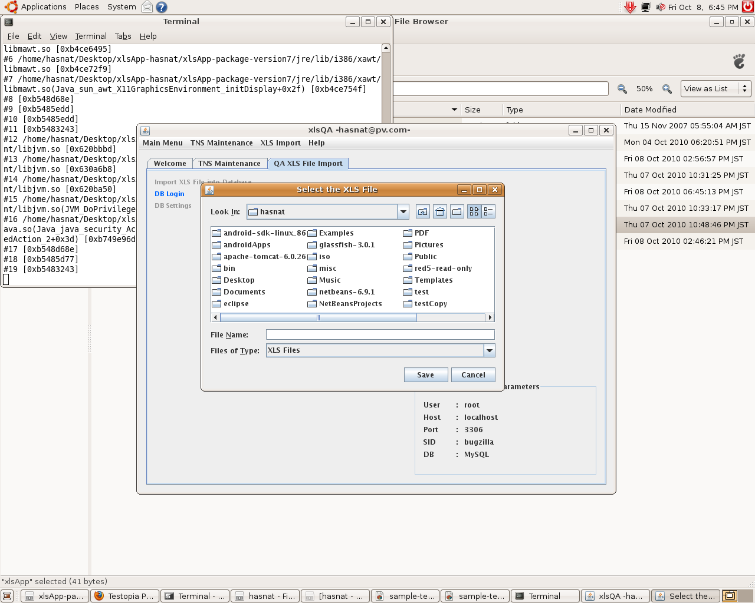

Sample test data entry

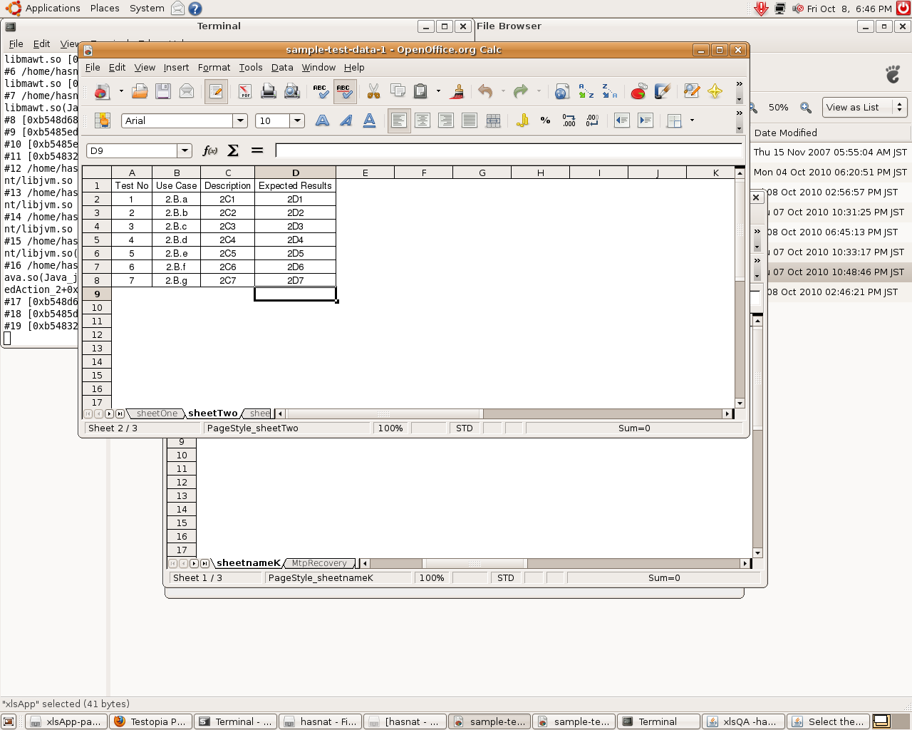

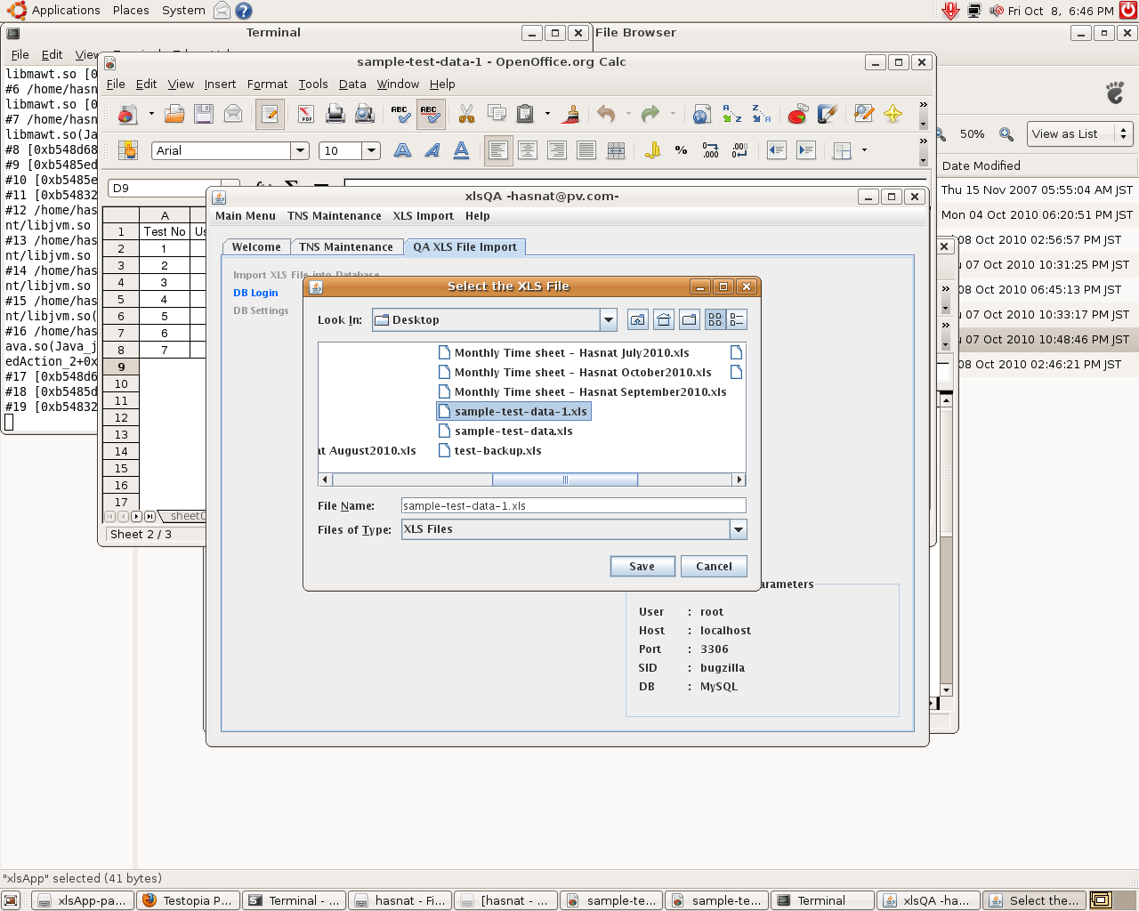

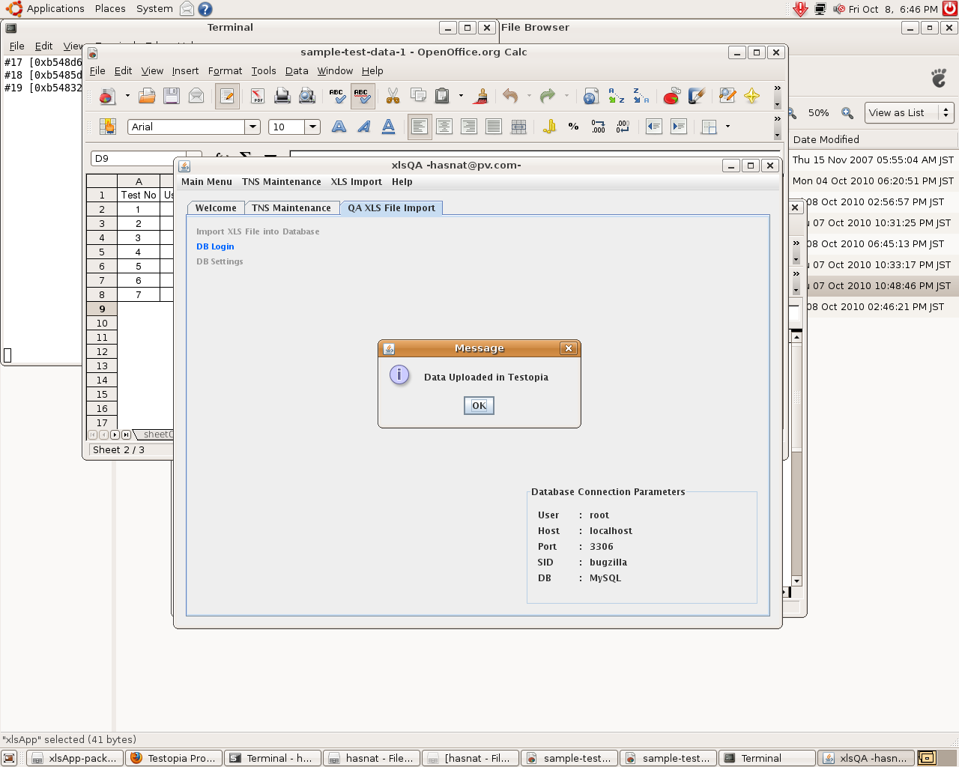

Check from the testopia web front and cross check the xls test cases.

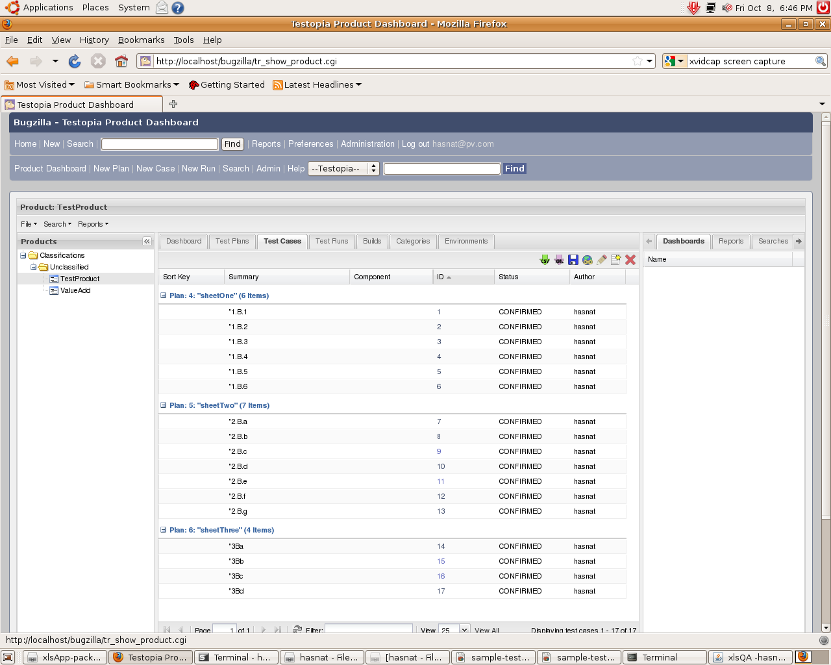

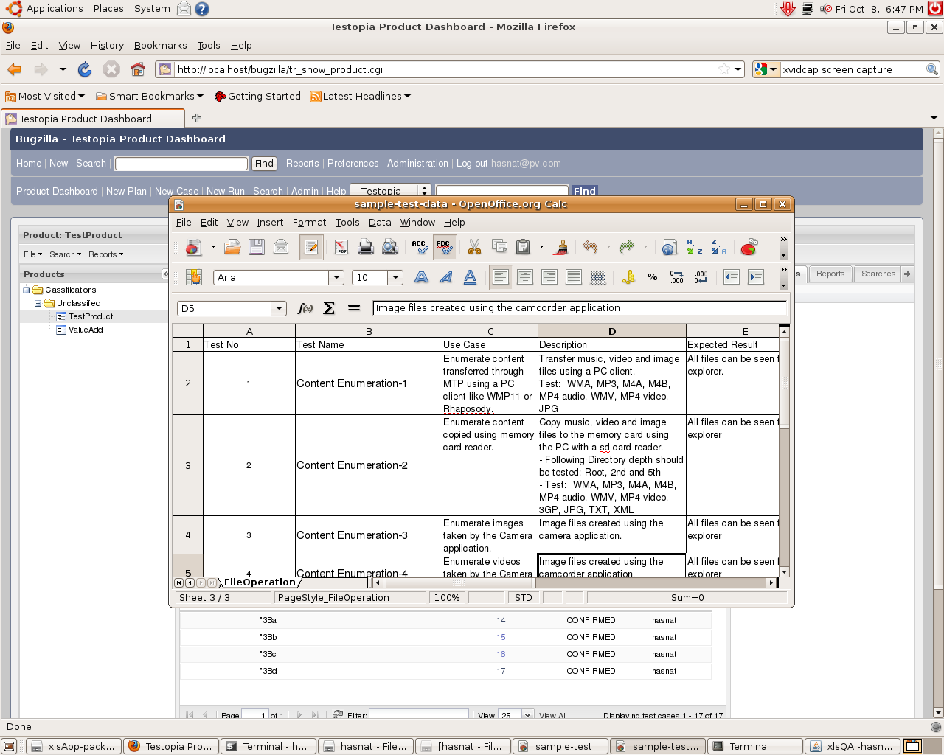

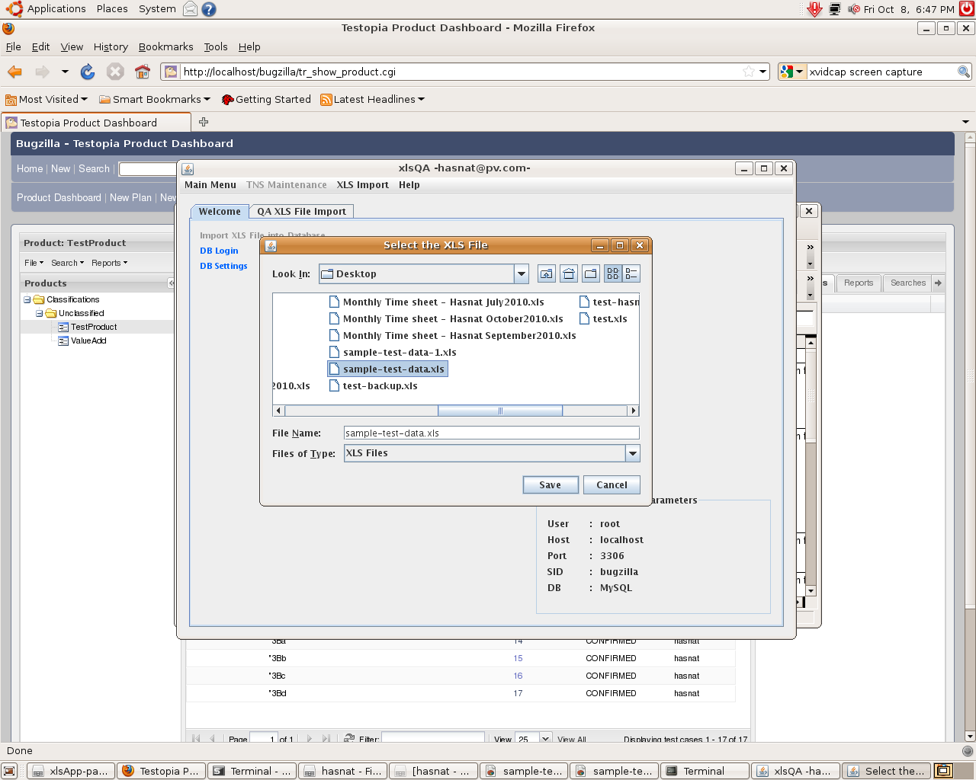

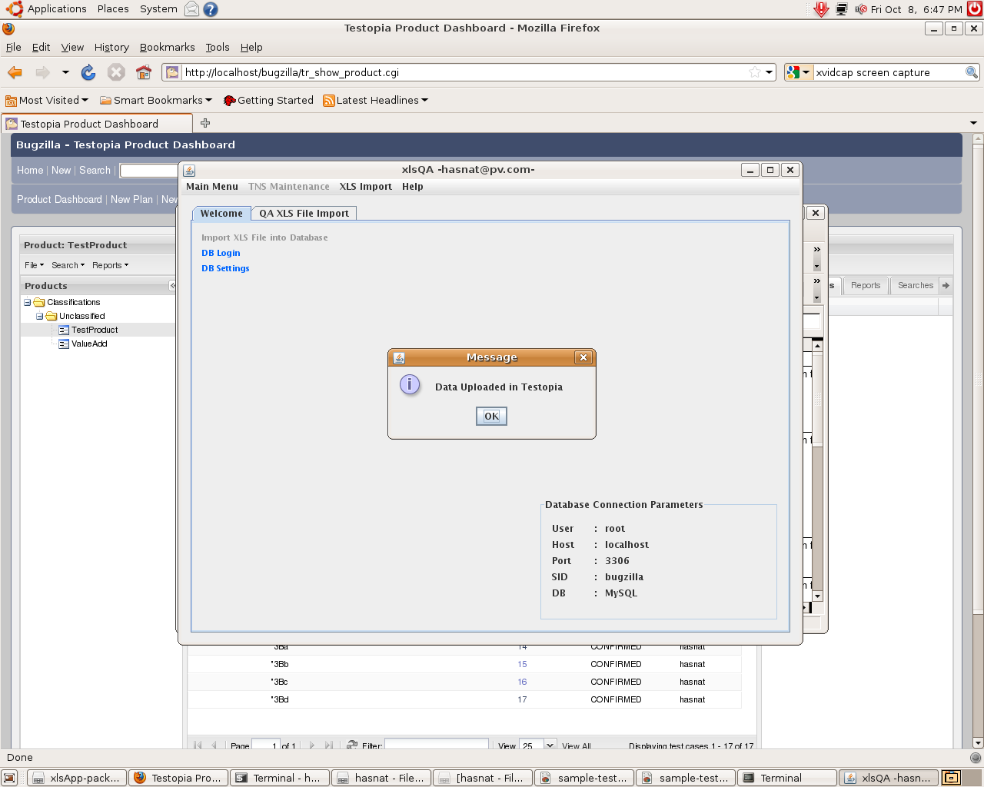

The description and test details data also manipulated from the xls to the testopia.
