INSTRUCTIONS

# Download:

1. Download either the doge or anova folder (should be a zipped folder after downloading)
2. Extract all files

# Install:

1. Go to folder “for redistribution” and double click the .exe
2. Follow the prompts to install the function as well as MATLAB runtime
3. Open Microsoft Excel
4. Go to “File”--> “Options”--> “add ins”-->Manage Excel add in--> “Go”-->”Browse”-->navigate to the folder “for_redistribution_files_only” and select “anova.xla”

# Use the doge formula:

1. Open Microsoft Excel
2. In an empty cell, type “=doge()” (the doge function has no argument)
3. This brings up a doge. Give it a minute, the first time the function calls it takes a little time, using it again should be faster.

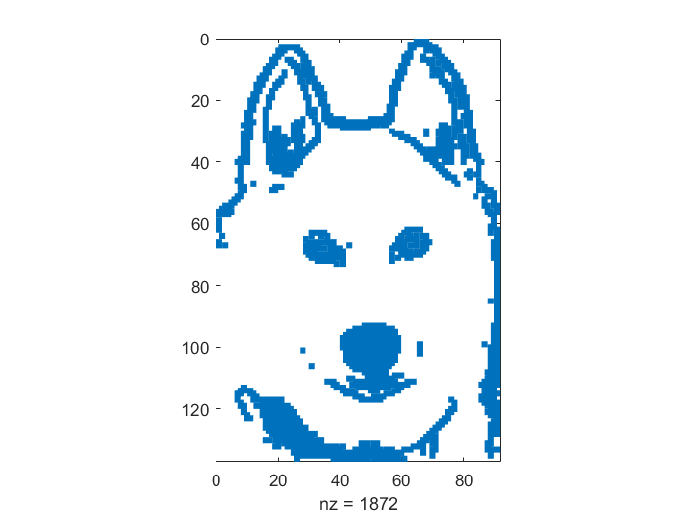

# Use the anova formula:

1. In an empty cell, type “=anova(x),” where “x” is the data that you want to conduct a one way analysis of variance on.
2. The data that is highlighted should be in the following format:

|  |  |
| --- | --- |
| name | value |
| name | value |
| name | value |

For instance, try highlighting the following data (car origins and their MPGs):

|  |  |
| --- | --- |
| USA | 18 |
| USA | 15 |
| USA | 18 |
| USA | 16 |
| USA | 17 |
| USA | 15 |
| USA | 14 |
| USA | 14 |
| USA | 14 |
| USA | 15 |
| USA | 15 |
| USA | 14 |
| Japan | 24 |
| USA | 22 |
| USA | 18 |
| USA | 21 |
| Japan | 27 |
| Germany | 26 |
| France | 25 |
| Germany | 24 |
| Sweden | 25 |
| Germany | 26 |
| USA | 21 |
| USA | 10 |
| USA | 10 |
| USA | 11 |
| USA | 9 |
| LignoLink | 28 |
| Germany | 25 |
| USA | 25 |
| USA | 26 |
| France | 27 |
| USA | 17.5 |
| USA | 16 |
| USA | 15.5 |
| USA | 14.5 |
| USA | 22 |
| USA | 22 |
| USA | 24 |
| USA | 22.5 |
| USA | 29 |
| USA | 24.5 |
| Germany | 29 |
| Japan | 33 |
| USA | 20 |
| USA | 18 |
| USA | 18.5 |
| USA | 17.5 |
| Germany | 29.5 |
| Japan | 32 |
| Japan | 28 |
| USA | 26.5 |
| Sweden | 20 |
| USA | 13 |
| France | 19 |
| Japan | 19 |
| Germany | 16.5 |
| USA | 16.5 |
| USA | 13 |
| USA | 13 |
| USA | 13 |
| USA | 28 |
| USA | 27 |
| USA | 34 |
| USA | 31 |
| USA | 29 |
| USA | 27 |
| USA | 24 |
| USA | 23 |
| Germany | 36 |
| Japan | 37 |
| Japan | 31 |
| USA | 38 |
| USA | 36 |
| Japan | 36 |
| Japan | 36 |
| Japan | 34 |
| Japan | 38 |
| Japan | 32 |
| Japan | 38 |
| USA | 25 |
| USA | 38 |
| USA | 26 |
| USA | 22 |
| Japan | 32 |
| USA | 36 |
| USA | 27 |
| USA | 27 |
| Germany | 44 |
| USA | 32 |
| USA | 28 |
| USA | 31 |

The anova function returns the following figure:

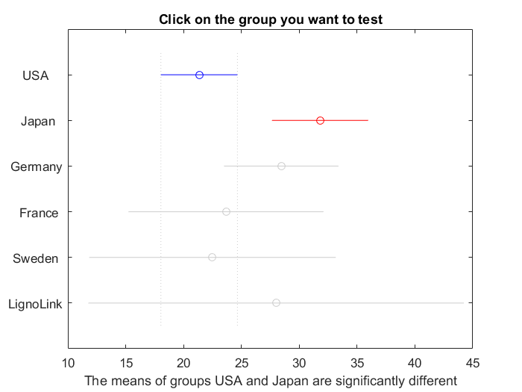  
Try selecting different groups to test the means for statistically significant differences!

# Details:

1. The anova function tests for statistically significant differences between means at the significance level of 95% (alpha = 0.05)
2. The critical value is determined using the Tukey-Kramer honest significant difference criterion
3. The guts of the function are taken from this documentation: <http://www.mathworks.com/help/stats/multcompare.html?refresh=true>
4. The function ignores any missing rows. If there is an empty cell in the leftmost column (the names column) then the data in the cell to the right will be ignored. Likewise, if there is a name with no data point, this row will also be ignored. Basically, empty rows do not trip up the anova function and can be included in the highlighted block. I did this so that blocks of different groups can be separated in the Excel spreadsheet with empty rows to make it easy on the eyes.
5. The function ignores any columns in between the left and rightmost columns that are in the highlighted block. This means that if the following block was highlighted:

|  |  |  |
| --- | --- | --- |
| group | Data type 1 | Data type 2 |
| goup | Data type 1 | Data type 2 |

Then the test would conduct a one way anova on the groups (leftmost column) for Data type 2 (rightmost column). If you want to run it on Data type 1, simply highlight:

|  |  |
| --- | --- |
| group | Data type 1 |
| goup | Data type 1 |

The reason for this is because in spreadsheets I often have data in the form of:

|  |  |  |  |  |
| --- | --- | --- | --- | --- |
| Group | Data 1 | Data 2 | Data 3 | Data 4 |

For instance, maybe something like this:

|  |  |  |  |  |
| --- | --- | --- | --- | --- |
| **Company name** | **return** | **sales** | **income** | **tax** |
| McCormick | 10 | 5 | 2.2 | 1.0993 |
| McCormick | 11 | 5.1 | 2.2 | 1.0994 |
|  |  |  |  |  |
| Ocean Spray | 11 | 4 | 2.21 | 1.1100 |
| Ocean Spray | 11 | 4.1 | 2.20 | 1.0990 |

The way the anova function is set up, you can easily conduct the test on any of the metrics (return, sales, income, or tax) just by highlighting different regions in the spreadsheet. If you want to do income, highlight this part (don’t highlight the table headings)

|  |  |  |  |
| --- | --- | --- | --- |
| McCormick | 10 | 5 | 2.2 |
| McCormick | 11 | 5.1 | 2.2 |
|  |  |  |  |
| Ocean Spray | 11 | 4 | 2.21 |
| Ocean Spray | 11 | 4.1 | 2.20 |

Only the company name and rightmost column (income) will be used in the test, and the blank row will be ignored.