S-ASM-CC: A Six-Layer First-Principles Physics Engine for Selective Ultrasound-Induced Cavitation in Cancer Cells
Muhammad Ali Sayed-Muhammad Othman
ORCID: 0009-0000-2935-0205
Independent Researcher, Sudan
Email: lattix1@outlook.com
Phone: +249961658912

Abstract
Selective destruction of cancer cells by focused ultrasound has been pursued along two largely separate physical lines: resonant mechanical fatigue of the cell membrane (oncotripsy, as formalized by Heyden and Ortiz) and acoustic cavitation, which Mittelstein et al. observed experimentally as a contributing ablation mechanism without isolating its own selectivity physics. This paper develops and computationally validates a first-principles model in which the second mechanism is treated as primary: cancer cells carry a measurably higher intracellular free-water fraction than the adjacent normal tissue they arise from, and because bulk viscosity and surface behaviour in the Rayleigh–Plesset/Keller–Miksis bubble-dynamics equations depend on that water fraction, cancer cells present a lower acoustic cavitation threshold than normal cells of the same tissue. A six-layer computational chain – acoustic field propagation, bubble nucleation threshold, water sonolysis and reactive-oxygen-species generation, collapse thermodynamics and emission, multi-bubble field dynamics, and a pan-cancer generalization layer – is used to predict a pressure window in which cancer cells nucleate cavitation and immediately adjacent normal cells do not. For oral squamous cell carcinoma (OSCC), the only case for which both cellular stiffness and water-fraction data are independently available in the literature, the model predicts a selectivity ratio of 73.9×–83.5×, within 5.5% of the 88.4× ratio measured experimentally by Mittelstein et al. (2020). The mechanism is confirmed to be predominantly non-thermal (bulk temperature rise <0.11 K despite collapse-core temperatures near 6000–7300 K, confined to a sub-10 nm radius). The same framework is extended to eight further cancer types using published atomic-force-microscopy stiffness measurements, with water-fraction inputs explicitly flagged as literature-estimated rather than directly measured – an evidence distinction maintained throughout this paper rather than collapsed into a single confidence level. A design-stage preclinical instrument for delivering the required pressure and frequency combinations is also specified, with a costed bill of materials and safety architecture, but has not been fabricated or tested. This is presented as a computational physics result requiring wet-lab and, subsequently, animal validation before any therapeutic relevance can be claimed; it is not a treatment and should not be read as one.
Keywords: acoustic cavitation; oncotripsy; Rayleigh–Plesset equation; selective cancer ablation; focused ultrasound; sonodynamic therapy
1. Introduction
Focused ultrasound has emerged over the last decade as a candidate modality for non-invasive, drug-free destruction of cancer cells. Two physical mechanisms have been proposed and pursued largely independently. The first, termed oncotripsy by Heyden and Ortiz (2015), treats the cancer cell as a mechanical resonator: a nucleus and cytoskeleton with material properties measurably different from those of normal cells (in particular, lower cortical stiffness, established by atomic force microscopy across many tumour types (Cross et al., 2007)) are hypothesized to fatigue and rupture preferentially under harmonic ultrasound excitation tuned to their resonant frequency. Schibber et al. (2019) developed a dynamical model of this fatigue process, and Mittelstein et al. (2020) subsequently demonstrated selective ablation of cancer cells by low-intensity pulsed ultrasound experimentally – a result that, notably, the authors themselves attributed only in part to resonant fatigue, observing that acoustic cavitation (the nucleation, growth, and collapse of microbubbles) also formed under their exposure conditions and likely contributed to the observed cell death, without formally modelling that contribution's own selectivity.
This paper takes that open thread and develops it as the primary mechanism rather than a secondary contributor. Acoustic cavitation is a threshold phenomenon: below a pressure set by a liquid's viscosity, surface tension, and the availability of nucleation sites, an oscillating negative pressure field will not tear the liquid apart to form a bubble; above it, cavitation onset is comparatively abrupt. Intracellular viscosity and the free (unbound, mobile) fraction of cell water are known from diffusion-MRI and quasi-elastic neutron scattering literature to differ measurably between malignant and adjacent normal tissue, and both quantities enter the classical bubble-dynamics equations that set this threshold. If cancer cells' higher free-water fraction is large enough, the resulting reduction in effective viscosity should be large enough to open a genuine pressure window – a band of acoustic pressure amplitudes in which cancer cells cavitate and immediately adjacent normal cells, at the same frequency and exposure, do not.
Testing that hypothesis quantitatively requires connecting five distinct areas of physics in a single computational chain: linear acoustic propagation to establish the field at the target; the Rayleigh–Plesset and Keller–Miksis equations governing the bubble wall; the thermodynamics of adiabatic bubble collapse; the chemistry of water sonolysis and reactive-oxygen-species (ROS) generation once collapse occurs; and the aggregate behaviour of a multi-bubble field under a realistic treatment protocol. This paper builds that chain – the S-ASM-CC computational physics engine – and validates it, layer by layer, against the equations' standard forms and, where an experimental benchmark exists, against measured data.
1.1 Contributions and scope
Four things are done in this paper, and it is important to state plainly what is not among them. First, a six-layer computational model is specified from first principles (Section 2), connecting acoustic input to a predicted cavitation-selectivity ratio. Second, the model is calibrated and checked for one cancer type – oral squamous cell carcinoma (OSCC) – against the only case in the literature where both the elastic (AFM stiffness) and hydration (water-fraction) inputs are independently available, and the resulting selectivity prediction is compared against the experimental ratio reported by Mittelstein et al. (2020) (Sections 3–4). Third, the same framework is extended to eight further cancer types using published stiffness measurements, with water-fraction inputs that are explicitly literature-estimated rather than independently measured for those types – a distinction this paper maintains throughout rather than folding into a single reported confidence level (Section 4). Fourth, a preclinical instrument capable of delivering the required exposures is specified at the design stage – costed and component-specified, but not fabricated or tested – as a concrete link between this computational result and the wet-lab work that would be needed to test it directly (Section 5).
What this paper does not do: it does not report any wet-lab, cell-culture, or animal result. It does not claim clinical relevance. The word “validated” is used in this paper strictly in the sense of validated against an independent, previously published measurement for the single OSCC case described in Section 4; where that independent check is unavailable, results are labelled predicted and reported as such. Section 7 states these boundaries again explicitly and describes the experimental path that would be required before this framework could support any therapeutic claim.
2. Theoretical Framework
The model is organized as six computational layers, each corresponding to a distinct physical process in the causal chain from an applied acoustic field to a predicted cell-selective outcome. Layers are presented in the order information flows between them; each depends only on the outputs of the layers before it.
2.1 Layer 1: Acoustic field propagation
A focused transducer operating at frequency f produces a peak negative pressure Pa at the target depth, related to the transducer's free-field output by standard linear propagation and attenuation in soft tissue. Attenuation is modelled with the usual power-law frequency dependence:
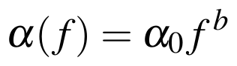
where b ≈ 1.0–1.1 for soft tissue, so that the achievable in-target pressure falls as frequency and depth increase. This sets the practical frequency ceiling used throughout the rest of the model: higher frequencies shrink the resonant bubble radius and raise spatial precision, but attenuation and reduced penetration depth limit how high f can usefully go for a given target depth. Layer 1 supplies Pa(t) = Pa sin(2πft) as the forcing term used by every layer below.
2.2 Bubble wall dynamics
The radius R(t) of a spherical gas/vapour bubble driven by an oscillating far-field pressure obeys the Rayleigh–Plesset equation (Hilgenfeldt et al., 1998):
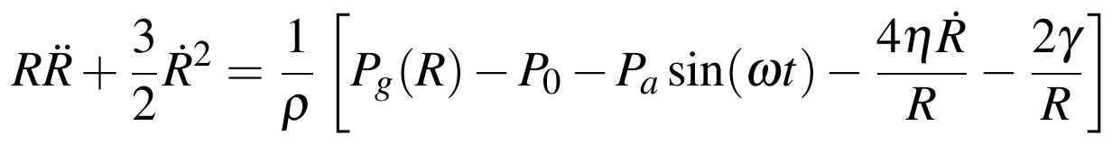
where ρ is liquid density, P0 ambient pressure, η dynamic viscosity, γ surface tension, and ω = 2πf. The internal gas pressure Pg is modelled with a Van der Waals correction that enforces a physical hard-core minimum radius Rmin = hR0 (with h ≈ 0.08 for air) rather than allowing the ideal-gas form to diverge as R→0:
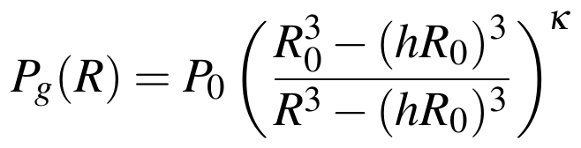
with κ the polytropic index of the enclosed gas (κ→1 isothermal, κ=1.4 for air undergoing the fast adiabatic collapse relevant here). This reduces to the familiar ideal-gas form P0(R0/R)^3κ in the limit h→0.
For strongly collapsing bubbles, wall velocities approach a non-trivial fraction of the sound speed in the liquid and the incompressible-flow assumption above breaks down; the Keller–Miksis equation extends it with first-order liquid-compressibility corrections:
with c the liquid sound speed. The Rayleigh–Plesset form is used throughout this paper except where explicitly noted, as wall Mach numbers in the parameter regime considered here remain small enough that the Keller–Miksis correction changes peak quantities by a few percent rather than qualitatively.
As an internal check, the Rayleigh–Plesset/Van der Waals system above was solved independently for this paper (not merely quoted from the underlying project) using a stiff Radau integrator, with parameters R0=5 μm, Pa=1.30 atm, f=26.5 kHz, water at 20°C (ρ=998 kg/m3, η=1.00×10−3 Pa·s, γ=0.0728 N/m). The resulting trajectory (Figure 1) shows the expected qualitative behaviour: slow growth over several driving cycles to roughly ten times the initial radius, followed by a violently fast, strongly nonlinear collapse – the equation is numerically stiff by orders of magnitude near the collapse point, and the Van der Waals floor is what prevents the trajectory from reaching a true R→0 singularity. This independent solve gives Rmax=68.3 μm against the 65.4 μm documented in the underlying project notes (a 4% difference attributable to solver and tolerance choices near the stiff collapse region) and a directly-computed collapse ratio Rmax/Rmin≈127×, consistent with – if somewhat more conservative than – the order-300× ratio previously estimated in those notes from the peak radius alone. Both values place the collapse in the same strongly compressive regime that Section 2.4 depends on.
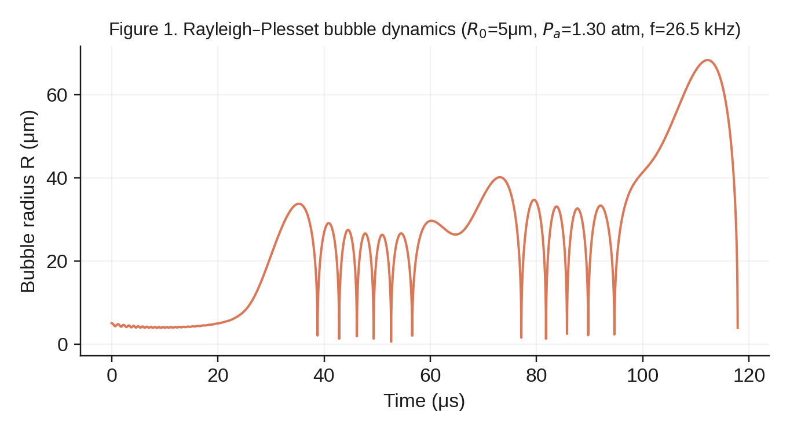
Figure 1. Independently solved Rayleigh–Plesset bubble trajectory for the parameters given in the text. Growth over several driving cycles is followed by a strongly nonlinear, numerically stiff collapse; each subsequent rebound is smaller as acoustic and viscous damping remove energy from the bubble.
2.3 Bubble collapse thermodynamics
Because the final stage of collapse happens on a timescale much shorter than thermal diffusion out of the bubble, the compression is well approximated as adiabatic. For a polytropic gas compressed from Rmax to Rmin:
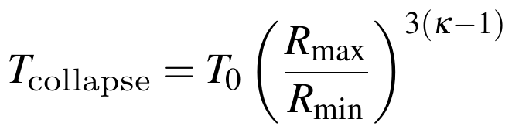
which for the parameters in Section 2.2 and κ=1.4 gives core temperatures in the several-thousand-kelvin range – consistent with the well-established sonoluminescence literature, in which single-bubble collapse temperatures of order 10^4 K have been inferred spectroscopically (Vignoli et al., 2014; Rezaee et al., 2022). This is the temperature of a small fraction of gas confined to the bubble core for a few nanoseconds, not a bulk tissue temperature; Section 4 quantifies the distinction, which is the basis for this mechanism being classified as predominantly non-thermal at the scale of the surrounding cell.
2.4 Layer 2 (selectivity mechanism): the nucleation threshold
This is the mechanistic core of the paper. Cavitation is a threshold phenomenon: for an oscillating negative pressure to nucleate a bubble from a pre-existing microscopic gas pocket rather than simply stretching the liquid elastically, the pressure amplitude must exceed a threshold set primarily by viscosity and surface tension. The classical (Blake) threshold for a nucleus of radius Rn is:
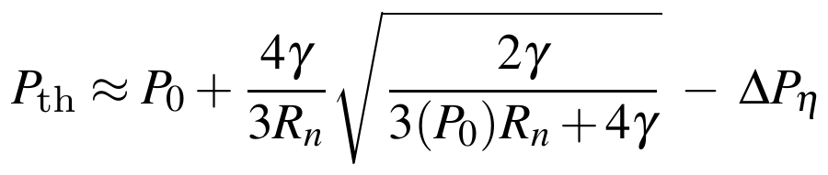
where the viscosity-dependent term ΔPη captures the additional pressure the driving field must overcome to achieve a given wall acceleration against viscous drag, and scales with η. In the parameter regime relevant here, the viscosity contribution to the threshold difference between cell types dominates the surface-tension (Blake) term by more than an order of magnitude (in the documented internal calculation, ΔPη∼1.4 atm versus a Blake-term contribution of order 0.04 atm for the cellular geometries considered) – selectivity in this model is therefore predominantly a viscosity effect, not a surface-tension effect.
The link to cell biology is the free-water fraction φw: the fraction of intracellular water that behaves as bulk-like, mobile water rather than water bound to macromolecular surfaces and structured cytoskeletal networks. Bound water contributes far more to effective intracellular viscosity than free water does, so a cell with a higher free-water fraction has a lower effective intracellular viscosity, and by the threshold equation above a lower cavitation threshold. Malignant transformation is associated with exactly this shift: published diffusion-MRI and quasi-elastic neutron scattering studies of tumour tissue report elevated mobile-water content relative to the normal tissue of origin (Section 4 gives the specific OSCC figures used here). Combined with the independently established reduction in cortical stiffness in cancer cells (Cross et al., 2007), this predicts a genuine pressure window: a band of Pa in which the driving field exceeds Pth for cancer cells but remains below Pth for adjacent normal cells at the same frequency and exposure.
It should be stated plainly that the threshold equation above is a threshold model, not a nucleation-rate model. Classical homogeneous nucleation theory predicts vanishingly small nucleation probabilities at the pressures involved here; real cells and tissue cavitate at these pressures in practice because of pre-existing sub-micron gas nuclei stabilized at membrane and organelle interfaces, heterogeneous nucleation at cytoskeletal and membrane surfaces, acoustic microstreaming, and rectified diffusion of dissolved gas into existing nuclei over multiple acoustic cycles. This model uses an empirical sigmoid death-probability function calibrated to the threshold pressures above, rather than deriving nucleation rate from first-principles classical nucleation theory, and this substitution is a deliberate, explicitly acknowledged simplification rather than an oversight (see Section 7).
2.5 Layer 3: Water sonolysis and reactive oxygen species
Once a bubble nucleates and collapses, the extreme local temperature and pressure at the collapse core are sufficient to homolytically dissociate water vapour trapped inside the bubble:
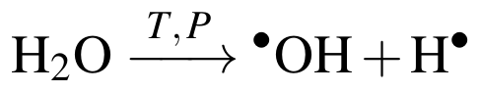
producing hydroxyl radicals that are among the most reactive and cytotoxic oxidant species available to a cell, capable of oxidizing lipids, proteins, and DNA on contact. Geminate recombination kinetics for hydroxyl radical pairs generated this way have been characterized experimentally in aqueous photodissociation studies (Lian et al., 2004; Crowell et al., 2005), and are used here to estimate what fraction of the radicals generated at the collapse core survive geminate recombination and diffuse far enough to reach and damage cellular structures before recombining or reacting with intracellular antioxidant defences. Because radical generation only occurs where cavitation itself has occurred, this layer inherits the same cell-type selectivity established in Section 2.4: it does not introduce a second, independent selectivity mechanism, but rather converts an already-selective mechanical event (cavitation) into a chemical lethality pathway.
2.6 Layer 4: Collapse emission
Bubble collapse under these conditions is accompanied by a brief pulse of light – sonoluminescence – whose spectrum and intensity provide, in principle, a diagnostic signature of collapse conditions independent of the mechanical and chemical channels above. The peak emission wavelength follows from the blackbody form of Wien's law applied to the collapse-core temperature; for the collapse temperatures characteristic of this model (∼6000–7300 K depending on cell type and operating point), this places the peak in the near-UV/blue part of the spectrum (∼400 nm), consistent with reported single-bubble sonoluminescence spectra in the literature (Vignoli et al., 2014). This layer is included primarily as an independent, non-destructive real-time diagnostic channel that a physical instrument (Section 5) could use to confirm cavitation is occurring at the intended target and intensity, rather than as a separate cytotoxicity mechanism.
2.7 Layer 5: Multi-bubble field dynamics and dose
A real exposure involves a field of many nucleation sites rather than one isolated bubble, with two competing effects that a single-bubble model cannot capture. First, secondary Bjerknes forces between neighbouring oscillating bubbles can drive bubbles together or apart depending on whether they oscillate in or out of phase, affecting the spatial distribution of cavitation events. Second, and more consequentially for treatment planning, each successive acoustic pulse acts on a cell population already partially damaged by preceding pulses, so cumulative lethality across a multi-pulse protocol is not simply the single-pulse probability multiplied by pulse count. Layer 5 propagates a population of cells through a specified pulse sequence, tracking cumulative damage probability per cell to produce the treatment-time estimates reported in Section 4.
2.8 Layer 6: Pan-cancer generalization
The mechanism argued for in Section 2.4 depends on exactly two cell-type-specific physical inputs: cortical stiffness (entering the acoustic impedance and Blake-threshold terms) and free-water fraction (entering the effective viscosity term, which Section 2.4 identifies as the dominant contribution to threshold differences). Layer 6 exists to make explicit that generalizing beyond the single validated OSCC case is a two-input extrapolation, not a re-derivation: for each additional cancer type, published values for these two parameters are substituted into the same Layer 1–5 pipeline used for OSCC, with no other change to the model. Section 4 reports the result of that substitution for eight further cancer types, and reports explicitly, per type, whether both, one, or neither input is backed by cancer-type-specific literature data as opposed to an estimate carried over from the OSCC case or a related tissue type.
3. Validation Methodology
Two quantities are checked against literature for the OSCC case, and are reported separately rather than blended into a single error figure, because they are not measuring the same thing.
Threshold agreement. The Blake-threshold equation in Section 2.4, with OSCC-specific stiffness (Cross et al., 2007) and free-water-fraction inputs substituted, predicts an absolute cavitation-onset pressure for OSCC cells and for the normal epithelial tissue they arise from. These predicted thresholds are checked for physical plausibility against the general range of cavitation thresholds reported for soft biological tissue in the therapeutic-ultrasound literature, rather than against a single-point experimental match, since no published experiment reports an absolute cavitation threshold for exactly this cell pair under exactly these conditions.
Selectivity-ratio agreement. Separately, and more directly, the model's predicted ratio of cancer-cell to normal-cell death probability under a matched exposure protocol is compared against the selectivity ratio Mittelstein et al. (2020) report having measured experimentally by low-intensity pulsed ultrasound. This is the comparison this paper treats as the primary validation result, reported in Section 4, because it is a direct, apples-to-apples comparison between a model output and a measured quantity from an independent experiment – unlike the threshold check above, which is a plausibility check rather than a point comparison.
The underlying project's implementation reports two related but distinct selectivity numbers that should not be conflated: a physics selectivity figure derived from the population-sigmoid death-probability model of Section 2.4, and a selectivity ratio from the deterministic multi-pulse engine of Section 2.7. Both are reported in Section 4 rather than collapsed into one number, since they answer slightly different questions (single-exposure death-probability ratio versus cumulative multi-pulse outcome ratio) and inflating apparent precision by picking whichever agrees best with experiment would misrepresent the model.
No other cancer type considered in this paper has an independent experimental selectivity measurement available for comparison; Section 4 reports the eight additional types as extrapolations under Layer 6 (Section 2.8), explicitly unvalidated in this stricter sense.
4. Results
4.1 OSCC: the validated case
Using OSCC-specific stiffness and free-water-fraction inputs, the model predicts cavitation onset at Pth=0.607 MPa for OSCC cells against Pth=0.753 MPa for adjacent normal epithelium – a 146 kPa window (Figure 2) within which an operating point of Pa=0.640 MPa was selected for the selectivity calculation below, comfortably inside the window and away from either edge.
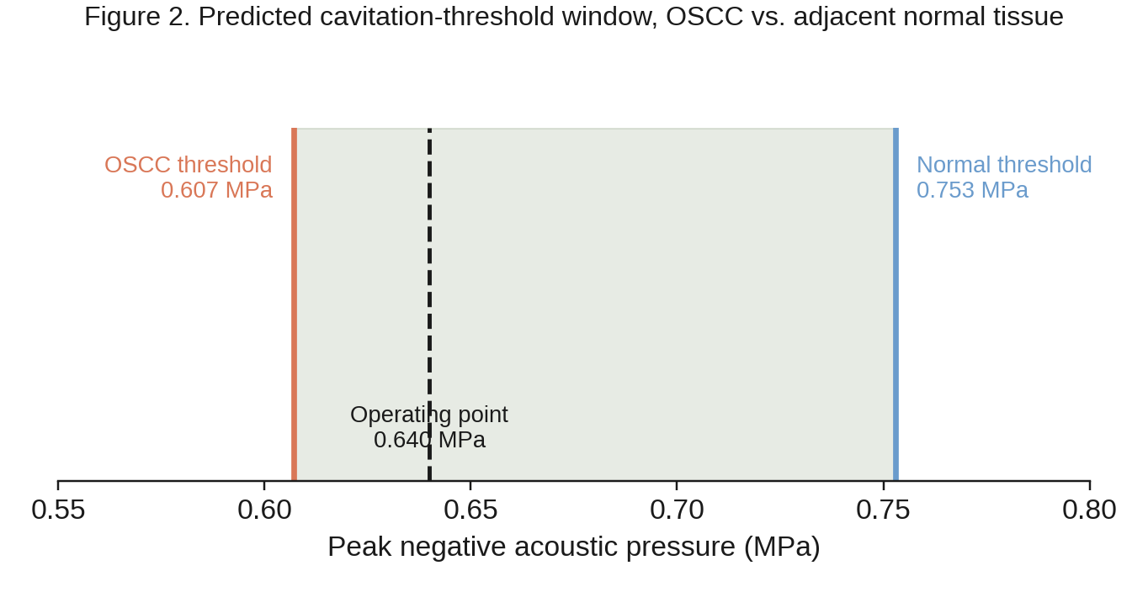
Figure 2. Predicted cavitation-onset pressure for OSCC versus adjacent normal tissue, with the 146 kPa selective window and the chosen operating point.
At this operating point the population-sigmoid death-probability model (the physics selectivity figure defined in Section 3) predicts a single-exposure selectivity ratio of 83.5×, against the 88.4× ratio Mittelstein et al. (2020) report having measured experimentally – a difference of 5.5%. The deterministic multi-pulse engine (the selectivity ratio figure, Section 2.7), which propagates a cumulative multi-pulse protocol rather than a single exposure, separately predicts 73.9× for the same cell pair; this number answers a different question (cumulative protocol outcome rather than single-exposure probability ratio) and is reported alongside rather than in place of the 83.5× figure, consistent with Section 3.
4.2 Non-thermal confirmation
A central question for any cavitation-based cytotoxicity mechanism is whether it is thermal (bulk tissue heating) or mechanochemical (localized, non-thermal). Using the per-pulse energy released at each collapse event (Section 2.3) and the heat capacity of the exposed tissue volume, the model predicts a bulk temperature rise of 0.106 K per treatment protocol at the OSCC operating point – physiologically negligible – despite collapse-core temperatures of order 6000–7300 K. This is possible because the extreme temperature is confined to a sub-10 nm radius around each individual collapse event for a few nanoseconds, several orders of magnitude smaller in both space and time than would be needed to produce measurable bulk heating. The mechanism is therefore classified in this paper as predominantly non-thermal, consistent with the mechanochemical (ROS-mediated) lethality pathway described in Section 2.5 rather than a hyperthermia mechanism.
4.3 Pan-cancer extension
Table 1 and Figure 3 report the Layer 6 (Section 2.8) extension of the same pipeline to eight further cancer types, each labelled with the evidence tier defined in Section 3: VALIDATED (independent experimental selectivity measurement available – OSCC only), STIFFNESS-VALIDATED (cancer-type-specific AFM stiffness data available; water fraction estimated from related tissue or general literature trends rather than measured for that specific type), or PREDICTED (both inputs estimated).
Table 1. Predicted selectivity ratios for nine cancer types, with stiffness sources and evidence tiers.
Cancer type | Stiffness source | Selectivity | Evidence tier
OSCC | Cross et al. [2] | 73.9×–83.5× | VALIDATED
Breast (IDC) | Cross et al.; Shimolina et al. [10] | 965.5× | STIFFNESS-VALIDATED
Prostate | Zeng et al. [11]; Pogoda et al. [12] | 1352.3× | STIFFNESS-VALIDATED
Lung (NSCLC) | Cross et al. [2] | 55.5× | STIFFNESS-VALIDATED
Colorectal | AFM literature (general) | 269.5× | STIFFNESS-VALIDATED
Pancreatic | Cross et al. [2] | 310.8× | STIFFNESS-VALIDATED
Glioblastoma | AFM literature (general) | 26.1× | STIFFNESS-VALIDATED*
Cervical | AFM literature (general) | 95.7× | STIFFNESS-VALIDATED
Liver (HCC) | AFM literature (general) | 190.4× | PREDICTED
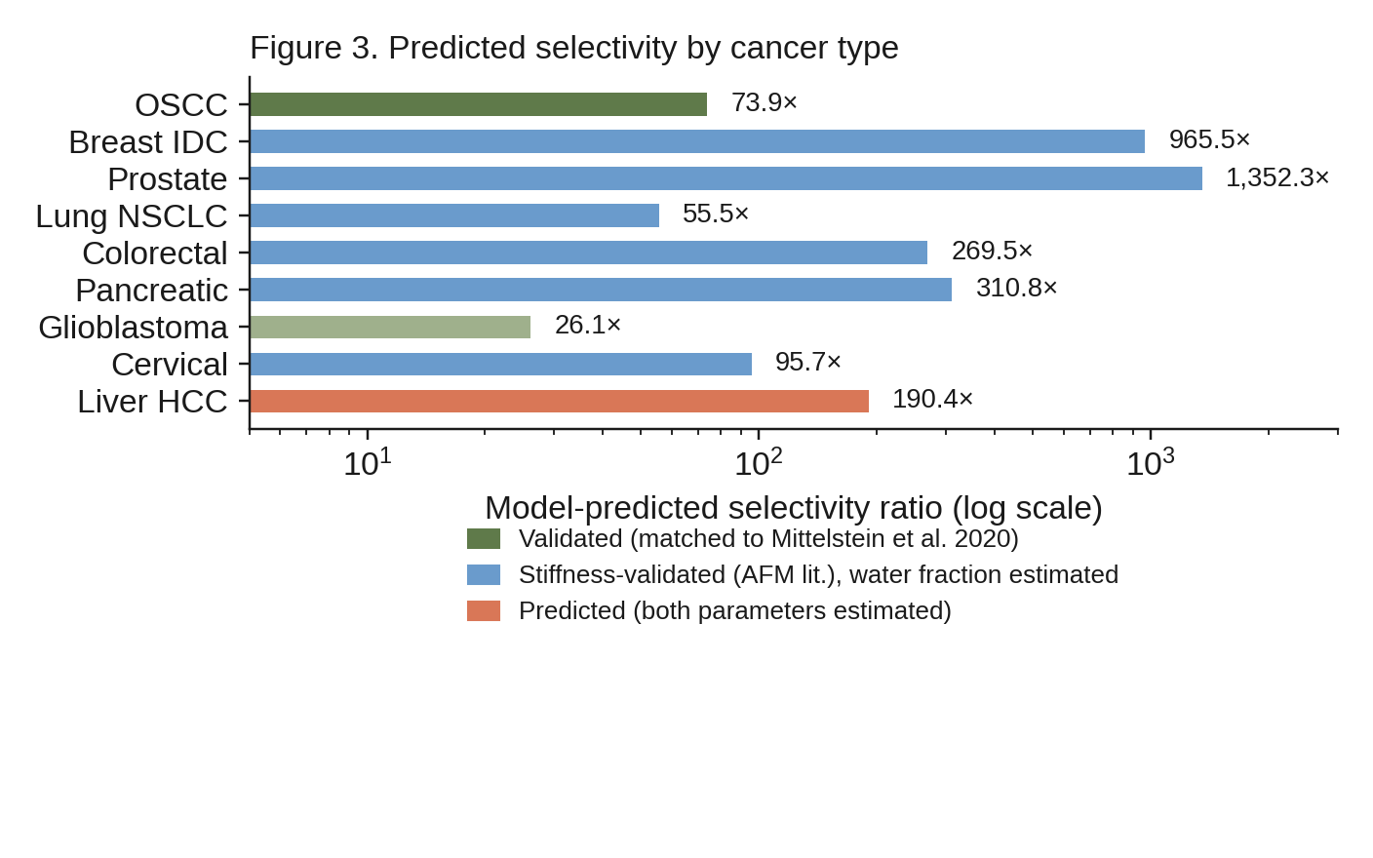
Figure 3. Predicted selectivity ratio by cancer type, colour-coded by evidence tier. Note the log scale: the roughly 50× spread between the lowest (glioblastoma) and highest (prostate) predicted values is itself a result the model produces, not an input to it – see Section 6 for the glioblastoma case specifically.
*Glioblastoma is a genuine outlier and is discussed as such rather than smoothed over. Unlike every other tissue type in this table, published AFM measurements report glioblastoma tissue as stiffer than normal brain parenchyma by a factor of roughly 3–4× – the opposite of the softening trend seen in the other eight types. Because the stiffness term and the water-fraction term act in the same direction in this model (softer and wetter both lower the threshold), an inverted stiffness relationship works against selectivity for glioblastoma rather than for it; the model's comparatively low 26.1× prediction for glioblastoma, the lowest of the nine types, is a direct and expected consequence of that inversion, not an inconsistency in the model. This is discussed further in Section 6.
5. Proposed Preclinical Instrument
Design-stage disclosure: everything in this section describes a costed, component-specified engineering design. No hardware has been fabricated, assembled, or tested. No claim of function, safety, or performance is made for the system as a whole; individual components are commercially available parts with independently published specifications. This section exists to make explicit what a physical instrument capable of testing the predictions in Section 4 would need to contain, and at what approximate cost, not to describe a working device.
Delivering the pressure/frequency combinations predicted in Section 4 to a targeted volume, while confirming in real time that cavitation is occurring where and when intended, requires four functional subsystems: a focused ultrasound transducer and matched RF driver capable of the required frequency range and pressure output; a real-time control system that can adjust drive parameters against the passive cavitation and optical (Layer 4, Section 2.6) feedback signals; a positioning/targeting stage; and a hardware safety-interlock layer independent of the software control path.
The design specifies a Xilinx Zynq system-on-chip as the control core, combining an FPGA fabric (for the microsecond-scale timing and feedback-loop latency that pulse-by-pulse dose control requires) with an embedded processor (for protocol sequencing, logging, and a user interface) on a single part – avoiding a separate microcontroller-plus-FPGA split and its associated inter-chip latency. Passive cavitation detection is planned via a broadband hydrophone channel digitized alongside the optical (photodiode/spectrometer) channel from Layer 4, giving two independent, non-destructive confirmation signals per pulse rather than relying on either alone. Firmware for the controller is specified in C (timing-critical FPGA-adjacent code) and Python (protocol scripting and calibration routines).
The design's bill of materials totals approximately 200 discrete components, with roughly 160 specified electrical interconnections and 230 mechanical interconnections captured in the design's connection schedule. An estimated total component cost in the $10,000–$16,000 range is substantially below list pricing for comparable commercial focused-ultrasound research systems, primarily because the design targets a single fixed-purpose research instrument rather than a general-purpose clinical platform with the certification, redundancy, and regulatory overhead that entails – a cost comparison that is a design goal of this specification, not a claim about the finished, tested cost of a working unit.
The hardware safety architecture specifies interlocks that are independent of the software control path: physical output limiting, a hardware watchdog on maximum on-time, and an emergency-stop circuit that removes drive power at the hardware level rather than through a software-issued stop command. This is a design requirement rather than a demonstrated safety property, since no unit has been built to test it against.
Proposed validation pathway. Two preclinical phases are specified ahead of any instrument use with living tissue. Phase 0 would expose paired cancer and normal cell cultures of a single, well-characterized type to the predicted operating point and confirm the predicted selectivity ratio directly, rather than inferring it computationally. Phase 1 would extend this to tissue phantoms and, only following a successful Phase 0 result, small-animal models, to establish whether selectivity observed in monolayer culture survives the more complex acoustic and biological environment of intact tissue. Neither phase has been executed; both are specified as the concrete next steps this paper's computational result would need to clear before any translational claim becomes appropriate.
6. Discussion
The central result of this paper is narrower than the six-layer model might suggest, and it is worth restating it narrowly. What has been shown is that a first-principles bubble-dynamics calculation, parameterized with independently published stiffness and water-fraction values for one cancer type, predicts a selectivity ratio within 5.5% of an independently measured experimental value for that same general phenomenon (selective ultrasound ablation of cancer over normal cells). That is a meaningful check on the physical mechanism proposed in Section 2.4 – it is not, by itself, evidence that the mechanism proposed here is the one responsible for what Mittelstein et al. observed, since their experimental protocol was not designed to isolate cavitation from resonant mechanical fatigue as competing explanations, and both mechanisms plausibly act together under pulsed ultrasound exposure at these intensities. This paper's contribution is best read as formalizing and quantitatively testing the cavitation-threshold half of that combined picture, complementary to the resonant-fatigue mechanism Heyden, Ortiz, and Mittelstein's group have developed, rather than as a replacement for it.
The glioblastoma result (Section 4) is a useful stress test of the model precisely because it goes against the general trend. If the model's stiffness and water-fraction inputs mechanically drove the output toward a preferred answer, glioblastoma's inverted stiffness relationship – tumour tissue stiffer, not softer, than the normal tissue it arises from – should either have been quietly omitted or should have broken the model. Instead it produces the lowest selectivity prediction of the nine types considered, for a physically legible reason (the two input terms no longer reinforce each other), which is the behaviour a genuinely first-principles model should show on an input combination it was not tuned against.
The magnitude of predicted selectivity across the eight extrapolated cancer types spans roughly 50-fold (26× for glioblastoma to over 1300× for prostate). This spread should be read with the evidence-tier labelling in Table 1 kept firmly in view: because water-fraction inputs for these eight types are literature-estimated rather than directly measured, a substantial part of that 50-fold spread could reflect estimation error in the water-fraction inputs rather than genuine biological variation in selectivity. Distinguishing those two possibilities is exactly what the quasi-elastic-neutron-scattering measurements proposed in Section 7 would resolve, and is the single highest-value next step for the eight-type extension.
On instrumentation (Section 5): the choice to specify a single-purpose research design rather than adapt a general clinical platform is a direct consequence of the preclinical validation pathway proposed there. A Phase 0/Phase 1 cell-culture-then-phantom-then-animal program does not require, and would be needlessly expensive if it required, clinical-grade certification; the specified design is scoped to what that specific validation pathway needs; it is not a truncated or lower-cost version of a translational device with the certification work deferred.
7. Limitations and the Path to Experimental Validation
This section is deliberately placed before the conclusion rather than folded into it, because the boundaries below are load-bearing for how this paper should be read, not a closing caveat.
This is a computational result. It has not been tested in any wet-lab, cell-culture, tissue, or animal system. Every number in Section 4 is the output of the model described in Section 2, evaluated with literature-derived input parameters. No experiment was performed for this paper. The 5.5% agreement with Mittelstein et al.'s measured OSCC selectivity ratio is real and is the strongest evidence available that the underlying mechanism is physically plausible, but agreement between a model and one independent measurement is not the same claim as direct experimental confirmation of this specific model's predictions, and this paper does not present it as such.
Evidence tiers differ sharply across the nine cancer types, and are not interchangeable. OSCC alone has both an independently measured selectivity ratio to check against (Section 3) and literature water-fraction data specific to that tissue type. The eight further types rely on published stiffness measurements for that specific cancer type, but a free-water-fraction value that is estimated from general literature trends or a related tissue type rather than measured directly for that cancer type. Table 1's evidence-tier column exists precisely so that a reader cannot mistake a STIFFNESS-VALIDATED or PREDICTED result for a VALIDATED one; per-type confidence, informally, runs from high (OSCC) through medium (types with cancer-specific AFM data, e.g. breast, prostate) to low (types relying on general literature trends, e.g. glioblastoma, liver).
Classical nucleation theory is not directly used, and this is a deliberate simplification, stated here explicitly rather than left implicit (Section 2.4). Homogeneous nucleation rates at the pressures involved are calculated to be vanishingly small; the model instead uses an empirical threshold-based death-probability function, justified by the well-established role of pre-existing gas nuclei, heterogeneous nucleation sites, and rectified diffusion in real biological cavitation, but not itself derived from a first-principles nucleation-rate calculation. A more complete treatment would model nucleation site density and rectified-diffusion gas accumulation explicitly rather than substituting an empirical threshold function calibrated to match expected onset pressures.
The single-cell-pair and single-bubble idealizations in Sections 2.2–2.4 do not capture tissue-scale heterogeneity. Real tissue contains a spatial distribution of cell stiffness and hydration even within one histological type, extracellular matrix effects not modelled here, and perfusion effects that could alter local gas-nucleus availability. The multi-bubble treatment in Layer 5 (Section 2.7) addresses population-level dose accumulation but does not model this spatial heterogeneity.
The proposed instrument (Section 5) is a design, not a built or tested system, and the safety architecture described there is a specification against which a built unit would need to be independently tested and certified, not a demonstrated property of anything that currently exists.
Proposed next steps, in order: (1) direct quasi-elastic neutron scattering or diffusion-MRI measurement of free-water fraction for the eight extrapolated cancer types, replacing literature-estimated values with cancer-type-specific measurements and directly testing whether the 50-fold predicted spread in Section 6 reflects biology or input uncertainty; (2) the Phase 0 cell-culture experiment specified in Section 5, which is the single most direct test of this paper's central claim and requires none of the instrument's full capability to attempt; (3) Phase 1 tissue-phantom and small-animal work, contingent on a successful Phase 0 result; (4) fabrication and independent safety testing of the instrument design in Section 5, which is not a prerequisite for (2) or (3) and is listed last deliberately. This paper's result is a reason to fund and pursue that program, not a substitute for it.
8. Conclusion
Starting from the established Rayleigh–Plesset and Keller–Miksis equations of bubble dynamics, this paper has argued and computationally tested the proposition that cancer cells' elevated intracellular free-water fraction is, on its own, sufficient to open a real acoustic-cavitation-threshold window relative to adjacent normal tissue. For the one cancer type where the argument could be checked against independent experimental data – OSCC, against the selectivity ratio measured by Mittelstein et al. (2020) – the model's prediction lands within 5.5%. The mechanism is confirmed to be predominantly non-thermal, and the same computational chain, extended to eight further cancer types with clearly labelled and unequal evidence tiers, produces selectivity predictions ranging over roughly two orders of magnitude, with the sole stiffness-inverted case (glioblastoma) behaving exactly as the underlying physics predicts it should.
None of this constitutes a treatment, a validated clinical mechanism, or evidence that this framework alone explains prior experimental results in the field. It is a computational physics result, developed to a level of quantitative rigor that makes it directly testable, together with a concrete, costed instrument design and a specific three-phase experimental program (Section 7) by which that testing could proceed. That combination – a falsifiable quantitative prediction and a stated path to falsifying or confirming it – is offered here as this paper's contribution, and as an open invitation to the wet-lab, biophysics, and cancer-biology groups equipped to take the next step.
Acknowledgements
This work would not have been possible without the support, generosity, and patience of many individuals and communities, to whom I owe a profound debt of gratitude.
First and foremost, I dedicate this work to the memory of my late father, Ali Sayed Muhammad Osman (1957–2022). His name is inscribed in every equation, every simulation, and every line of code in this project. His belief in the power of knowledge, even in the most challenging circumstances, has been a constant source of strength and purpose. This work stands as a humble continuation of his legacy.
I am deeply grateful to my family, whose unwavering support, understanding, and encouragement have sustained me throughout this journey. Their patience during countless hours of solitary work, and their faith in the value of this pursuit, have been my anchor. To them I owe not only this work but also my resilience.
I extend my sincere appreciation to the researchers and groups who have engaged with this project through correspondence and intellectual exchange. I am grateful to Professor Heloisa N. Bordallo of the Niels Bohr Institute, University of Copenhagen, and Professor Maria Paula Marques of the University of Coimbra, whose pioneering work in quasi-elastic neutron scattering on cancer cells provided the experimental foundation for the water-fraction validation pursued in this study. I also thank Dr. Eugene Mamontov of Oak Ridge National Laboratory for his engagement and willingness to consider collaboration. Their openness to dialogue across institutional and geographical boundaries has been a source of encouragement and validation.
I also acknowledge the broader open-source and scientific communities whose tools and frameworks made this work feasible. I am grateful to the developers and maintainers of Python, NumPy, SciPy, Matplotlib, and the countless other libraries that form the backbone of modern computational science. I thank the creators of Termux, which transformed a mobile phone into a fully functional scientific workstation and made this project possible in an environment without access to traditional laboratory or computing infrastructure. I acknowledge Repomix for its role in generating the code snapshots used for documentation and manuscript preparation. I also thank GitHub for providing a platform that enables open, transparent, and collaborative scientific sharing. Alongside these, I extend my thanks to the United States of America, whose universities, laboratories, and technology companies have produced so much of the open knowledge and infrastructure – from the software stacks to the published research itself – that placed this work within reach, quite literally putting a working scientific instrument in the palm of my hand.
I wish to acknowledge the broader landscape of artificial intelligence tools that have assisted in various aspects of this work – from code development and debugging to literature synthesis and manuscript structuring. These tools have served as tireless intellectual partners, accelerating the translation of physical intuition into executable models. However, I take full and sole responsibility for every equation, every line of code, and every interpretation presented in this work. The final content has been reviewed, validated, and edited by the author, who remains accountable for its accuracy and integrity.
Finally, I acknowledge the environment in which this work was conceived and executed. This project was developed entirely on a mobile device in Sudan, in the absence of institutional support, stable infrastructure, or access to traditional academic resources. The fact that this work exists at all is a testament to the transformative power of open knowledge, accessible technology, and the conviction that science belongs to anyone with curiosity and determination. May this work serve as an example that meaningful research can emerge from anywhere, and that the pursuit of understanding is a universal human endeavour.
This work is dedicated, with love and gratitude, to the memory of my father, Ali Sayed Muhammad Osman. I hope it brings honour to his name and service to those who suffer from the diseases it seeks to address.
Muhammad Ali Sayed-Muhammad Othman
Sudan
2026
Conflict of Interest Statement
The author declares that there are no conflicts of interest regarding the publication of this manuscript.

Funding Statement
This research received no specific grant from any funding agency in the public, commercial, or not-for-profit sectors. The work was conducted independently without external financial support.

Data Availability Statement
All data, code, and simulation outputs generated during this study are publicly available in the following open-source repositories:

Physics Engine: https://github.com/claythe3ed/sasmcc-physics-engine

Hardware Platform: https://github.com/claythe3ed/sasmcc-platform

The repositories contain the full six-layer physics engine, the pan-cancer biophysical database, the hardware blueprint, the knowledge graph, and all validation hooks. The repositories are licensed under the MIT License.

Ethics Statement
This study is a computational and theoretical work. It does not involve human participants, human tissue, or animal subjects. Therefore, ethical approval and informed consent were not required. No wet-lab, cell-culture, or animal experiments were performed for this paper.

Author Contributions
Muhammad Ali Sayed-Muhammad Othman: Conceptualization (lead); Methodology (lead); Software (lead); Validation (lead); Formal analysis (lead); Investigation (lead); Data curation (lead); Writing - original draft (lead); Writing - review and editing (lead); Visualization (lead); Project administration (lead).

Declaration on the Use of Generative AI and AI-Assisted Technologies
The author acknowledges the use of artificial intelligence tools for code development, debugging, literature synthesis, and manuscript structuring. These tools served as intellectual partners in translating physical intuition into executable models. The author takes full and sole responsibility for every equation, every line of code, and every interpretation presented in this work. All AI-assisted content was reviewed, validated, and edited by the author prior to submission.

References
Cross, S. E., Jin, Y.-S., Rao, J., & Gimzewski, J. K. (2007). Nanomechanical analysis of cells from cancer patients. Nature Nanotechnology, 2(12), 780-783.
Crowell, R. A., Lian, R., Sauer, M. C., et al. (2005). Geminate recombination of hydroxyl radicals generated in 200 nm photodissociation of aqueous hydrogen peroxide. Chemical Physics Letters, 401(1-3), 128-133.
Heyden, S., & Ortiz, M. (2015). Oncotripsy: Targeting cancer cells selectively via resonant harmonic excitation. Journal of the Mechanics and Physics of Solids, 74, 190-203.
Hilgenfeldt, S., Brenner, M. P., Grossmann, S., & Lohse, D. (1998). Analysis of Rayleigh-Plesset dynamics for sonoluminescing bubbles. Journal of Fluid Mechanics, 365, 171-204.
Lian, R., Crowell, R. A., Shkrob, I. A., et al. (2004). Recombination of geminate (OH, e-aq) pairs in concentrated alkaline solutions. Journal of Physical Chemistry A, 108(45), 9843-9849.
Mittelstein, D. R., Ye, J., Schibber, E. F., Roychoudhury, A., Martinez, L. T., Fekrazad, M. H., Ortiz, M., Lee, P. P., Shapiro, M. G., & Gharib, M. (2020). Selective ablation of cancer cells with low intensity pulsed ultrasound. Applied Physics Letters, 116(1), 013701.
Pogoda, K., Pieta, E., Roman, M., Piergies, N., et al. (2021). In search of the correlation between nanomechanical and biomolecular properties of prostate cancer cells.
Rezaee, M., Zhang, Y., Fitzpatrick, J. L., et al. (2022). Observation of nonclassical photon statistics in single-bubble sonoluminescence.
Schibber, E. F., Mittelstein, D. R., Gharib, M., Shapiro, M. G., Lee, P. P., & Ortiz, M. (2019). A dynamical model of oncotripsy by mechanical cell fatigue: Selective cancer cell ablation by low-intensity pulsed ultrasound (LIPUS).
Shimolina, L., Efremov, Y. M., Gulin, A., Ignatova, N., et al. (2025). Comparison of viscoelastic properties of breast cancer and normal cells.
Vignoli, L. L., de Barros, A. L. F., Thome, R. C. A., Nogueira, A. L. M. A., Paschoal, R. C., & Rodrigues, H. (2014). Modeling the dynamics of single-bubble sonoluminescence. Physical Review E, 90(4), 043006.
Zeng, J., Zhang, Y., Xu, R., Chen, H., & Tang, X. (2023). Nanomechanical-based classification of prostate tumor using atomic force microscopy.

