

BAI12153 Web Programming

Lim Jun Yu (BAI_B2009F- 2601005)

MAY 2026

Student’s Name: | Lim Jun Yu | Student’s ID: | BAI_B2009F- 2601005
Module Code & Name: | BAI12153 Web Programming
Assignment/ Project Title: | Tutor Booking System  A Full-Stack Web Application
Lecturer’s Name: | Dr . Ng Choon ching
Semester/ Year: | MAY 2026

I hereby declare that the work in this assignment/project was carried out in accordance with the regulations of Raffles University. It is original and is the results of my own work, unless otherwise indicated or acknowledged as referenced work.
I certify that the statements I have attested to above have been made in a good faith, true and correct. I acknowledge that any misconduct or violation of academic integrity policies will result in disciplinary action and may affect my academic standing in the institution.
Date: 10/7/2026 Student’s signature: Clayton

Project Description and Objectives
The Tutor Booking System is a full-stack web application that is built to connect students and tutors for one-on-one learning sessions. It addresses a common real-world problem: students struggle to find tutors for particular subjects and to book a session, while tutors need a structured way to manage session requests, accept or reject bookings, and keep track of their upcoming schedule.
The system has two different user roles. Students can browse the list of available tutors filter out tutors by subject and hourly rate and send booking requests. Tutors can design a public profile to describe their subject and rate, review incoming booking requests and accept or decline them. Both roles have a dedicated dashboard that summarizes their most pertinent information at a glance.

Objectives
- Demonstrate a working client-server architecture with well defined separation of frontend, backend and database layers.
- Implement full user authentication with hashed passwords and two distinct user roles with access control.
- Implement full CRUD functionality for a core resource (bookings) (create, read, update, and delete).
- Allow meaningful search and filter capability on at least two criteria on both the student and tutor sides.
- Design a normalized relational database consisting of at least three related tables.
- Use input validation on both the client and server side, and protect the application against common web vulnerabilities (SQL injection, cross-site scripting, CSRF).

System Architecture and Technology Choices
The application uses the classic client-server model. The browser (client) makes http requests to and Express.js server which routes each request through authentication/role middleware, a controller with the business logic and a model layer that communicates with the PostgreSQL database using parameterized queries. The server ten renders and EJS template to HTML and returns that to the browser. Express-session lets us keep state on the server side. And the middleware layer checks who is logged in and what is his role on each request. 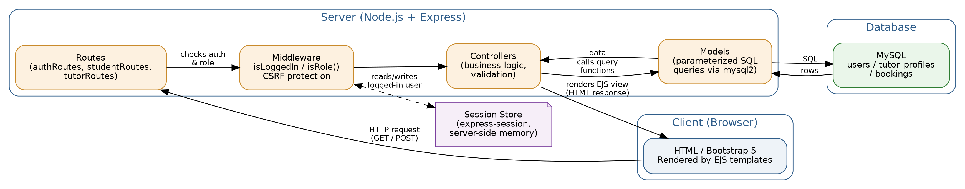
Figure 1 - System architeture: client, serber layers, and database

Technology Choices and Justification
Layer | Technology | Justification
Frontend | EJS + Bootstrap 5 | Server-rendered templates sidestep the build-tooling overhead of a full SPA framework, which is appropriate for the scope of this project.
Backend | Node.js + Express | Express is light-weight and unopinionated with a large middleware ecosystem (sessions, validation) that directly mapped onto the project requirements.
Database | PostgreSQL | Data is always related and a booking always refers exactly one student and one tutor, so a relational database with foreign keys provides a more reliable guarantee of data integrity than a document store. It was originally written with MySQL/MariaDB on a local machine, and then ported to PostgreSQL for deployment.
Auth | Express-session + bcrypt | Session-based auth is easier to integrates cleanly with EJS views via res.locals.

Database Design
The database contains three related tables. The users table has students and tutor, distinguished by a role column, to prevent copying common fields (name, email, password) in two different tables. A tutor who wishes to teach fills in an additional tutor_profiles record with subject, bio and hourly rate – a one-to-one relationship with users. The core resource of the application is the bookings table: each row links exactly one student and one tutor (both foreign keys into users) with the requested subject, date, time and a status flag which tracks the booking through its lifecycle (pending to approved/rejected, or cancelled).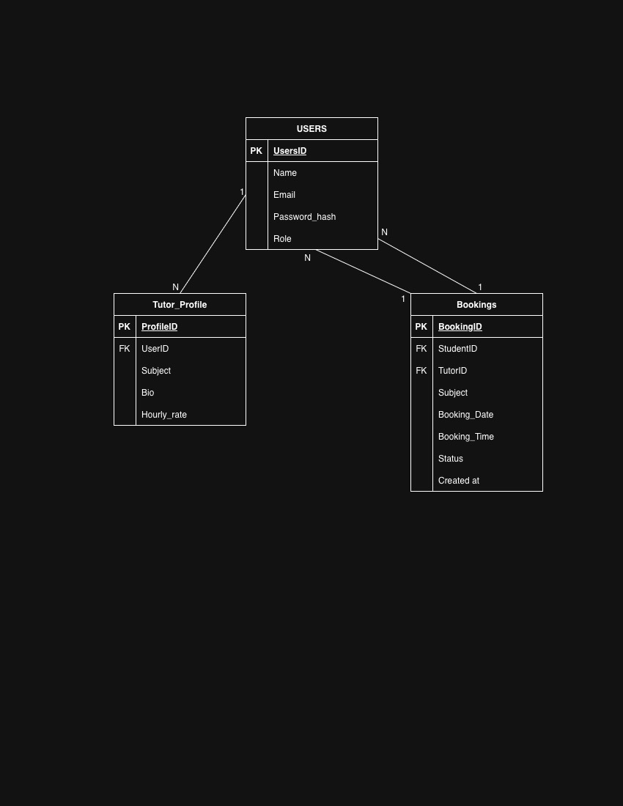
Figure 2 - Entity Relationship diagram
The schema is implemented on PostgreSQL. ENUM-style constraints (user role, booking status) are defined as custom Postgres types, and auto-incrementing primary keys are based on the PostgreSQL type SERIAL (Postgres’s equivalent of MySQL’s inline ENUM columns and AUTO_INCREMENT).

Key Features and How They Were Implemented

User Authentication and Role Management
authController.js is used for registration and login. Passwords are hashed with bcrypt before storage, and never stored in plain text. On successful login a minima user object (id, name, email, role) is pushed into session. Two middleware functions, isLoggedIn and isRole(role), are applied at the top of studentRoutes.js and tutorRoutes.js, so every route under /student and /tutor is automatically protected. A student cannot access a tutor page and vice versa.

Booking CRUD
Bookings are the main resource. Students can create a booking through a form Read all of their bookings on a dedicated page update the date, time, subject of a booking while it is pending delete old cancelled or rejected records permanently to keep their history tidy A tutor can approve or reject a booking from their dashboard, and update its status. This is also an Update, but it’s scoped so that a tutor can only update bookings which are addressed to them.

Search and Filter
Two independent search/filter interfaces are implemented. Students browsing tutors can filter by subject (partial text match) and by maximum hourly rate. Students can filter their own booking lists by status and subject keyword, and tutors can filter theirs by status and date, which satisfies the “at least two criteria” requirement on both sides of the application.

Dashboards
Each role has its own dashboard tailored to what matters most to the. The student dashboard displays a summary of pending requests and a preview of upcoming approved sessions, the tutor dashboard displays the bookings needing a decision and the confirmed sessions for today, with a link to the full filterable schedule.

Input Validation
Every form is validated on two levels. HTML5 attributes required, (type=“email”, minlength, min/max for numbers) give instant feedback in the browser on the client side. On the server-side we use the express-validator library to re-check every field (this is important because client-side checks can be bypassed by disabling JavaScript or sending requests directly, so the server is the authoritative gatekeeper).

Security Hardening
- bcrypt-salted passwords (10 rounds of salt).
- All SQL queries are parameterized using $1, $2, ... placeholders, preventing SQL injection.
- EJS auto-escapes all dynamic output by default, preventing XSS.
- A custom session-based CSRF token is embedded as a hidden field in every state-changing form and verified on the server before the request is processed.
- Role-based middleware prevents privilege escalation between student and tutor areas of the site.
- An email is sent via Nodemailer on booking events.

Challenges Faced and How They Were Resolved
Challenge 1: bcrypt native module blocked by npm’s script policy
The latest version of npm will block install scripts for packages by default as a security measure; bcrypt uses a native addon, which is required to be compiled during installation, meaning the initial npm install looked successful but bcrypt was only partially installed. Running npm approve-scripts –allow-script-pending addressed that problem since, having checked that there was nothing nefarious going on with that specific package, it was approved.
Challenge 2: Local MySQL setup and connection errors
The app has an “Access denied” error when trying to connect to MySQL, but this is before it is actually working. The actual root password of the local MySQL instance was different from the DB_PASSWORD value in the .env file, causing this issue. Double checking the actual value in the .env file with that used in phpMyAdmin, and making sure that the host is not localhost, but rather 127.0.0.1 in order to prevent platform specific hostname resolution problems.
Challenge 3: Formatting dates returned by mysql2
The database driver returns DATE columns as native JavaScript Date objects, which meant that date values had to be formatted conditionally in the EJS template (i.e., check if a.). before they could be safely displayed or pre-filed into HTML date inputs, there was an undefined method named toISOString.
Challenge 4: Add CSRF protection without new dependencies
Instead of fetching an external CSRF library, a fairly concise middleware was developed to set a token into the session and make sure all PUT, POST, PATCH, DELETE requests contain a matching hidden field. This ensured that the dependency list was kept to a minimum while still maintaining the project’s security requirements.

Screenshots of All Major Pages
The following pages illustrate the working application. (Screenshots to be inserted from the local running instance before final submission.)
Login Page
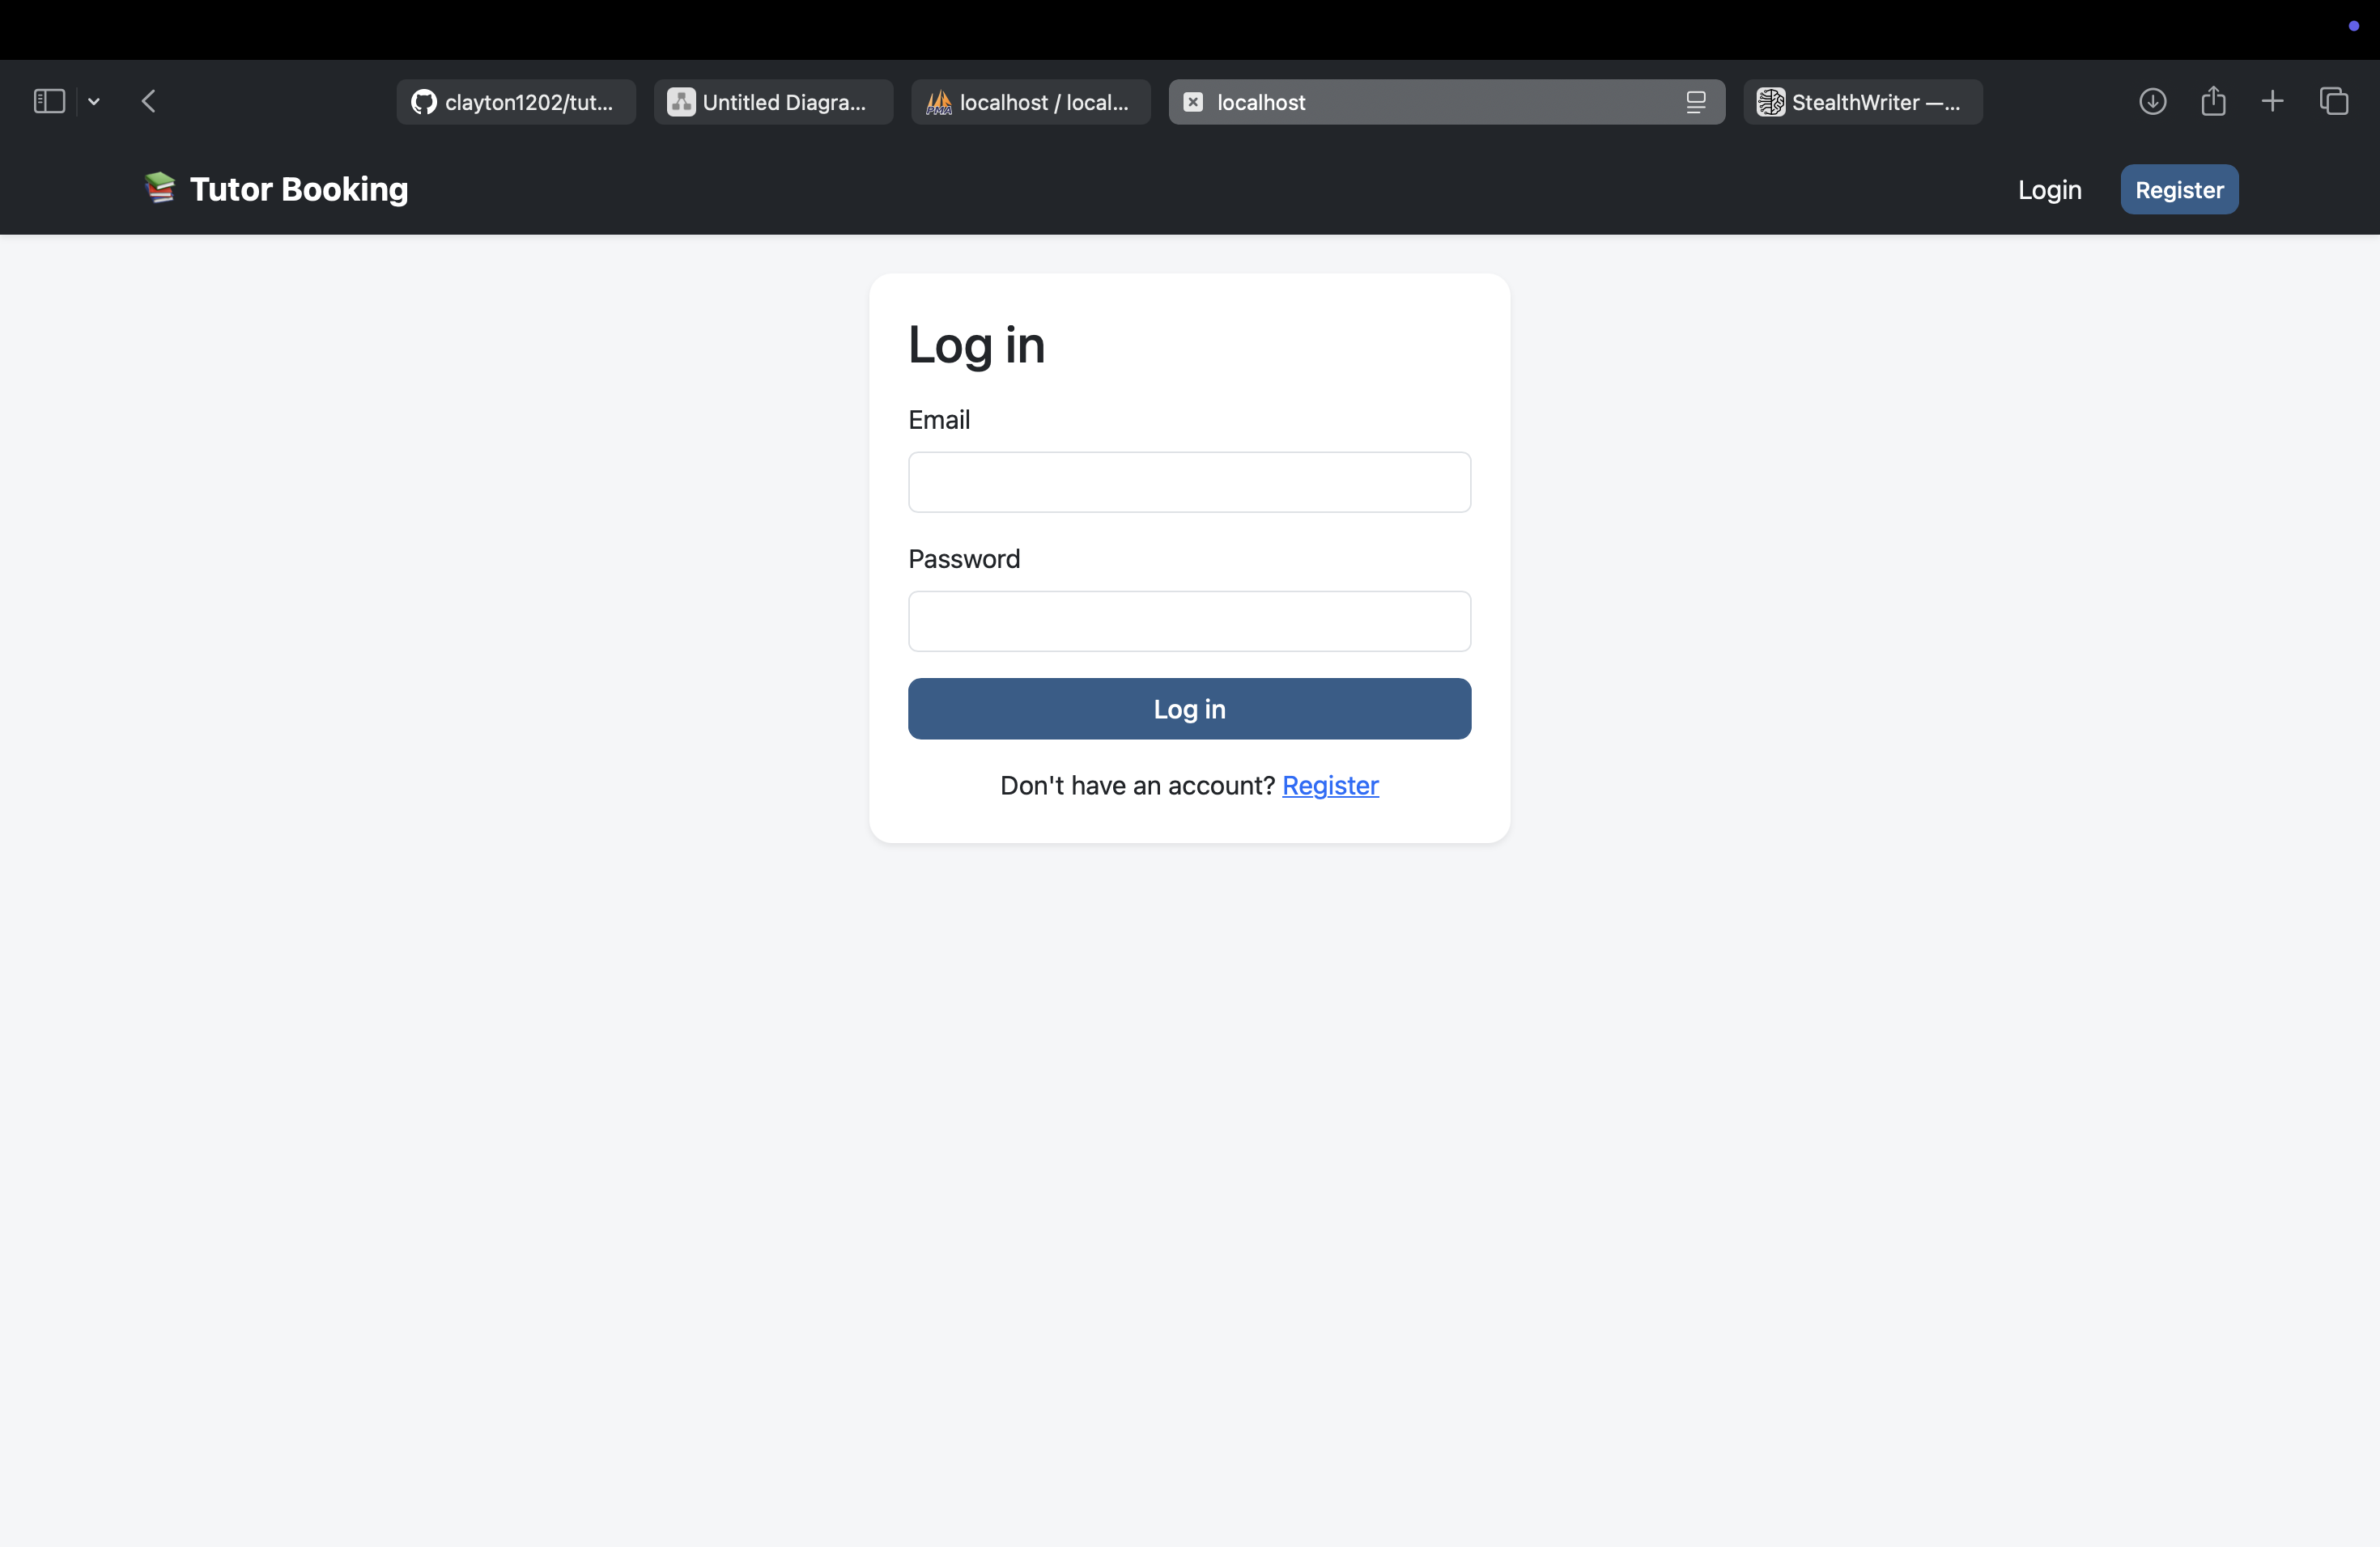
Register Page
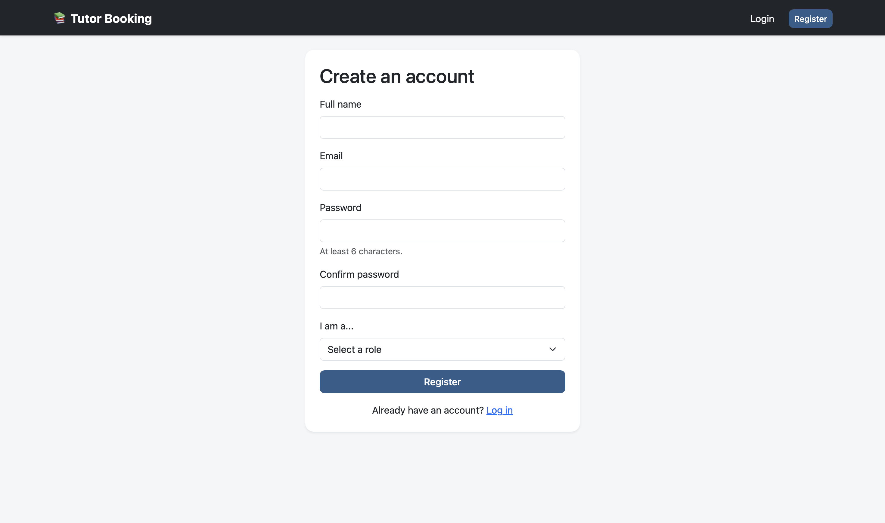

Student Dashboard
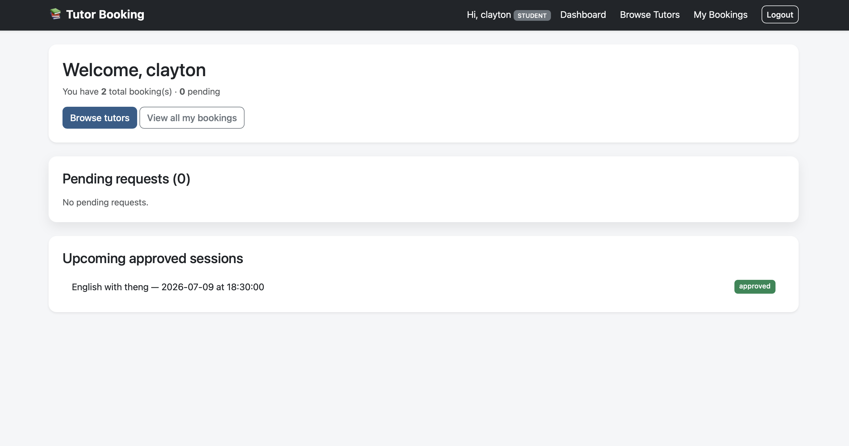
Browse / Search Tutors
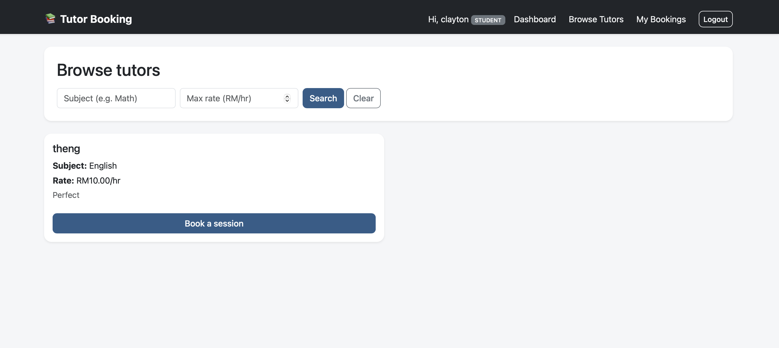

Booking Form
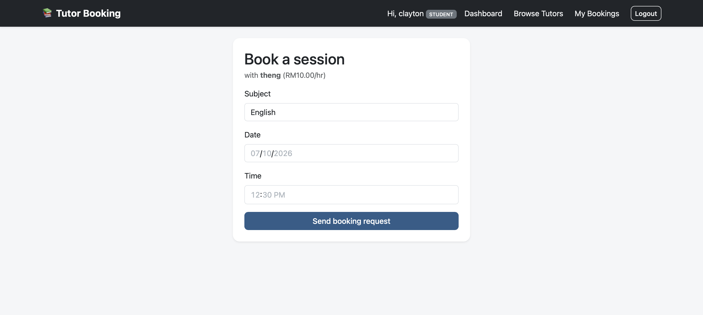
My Bookings (Students)
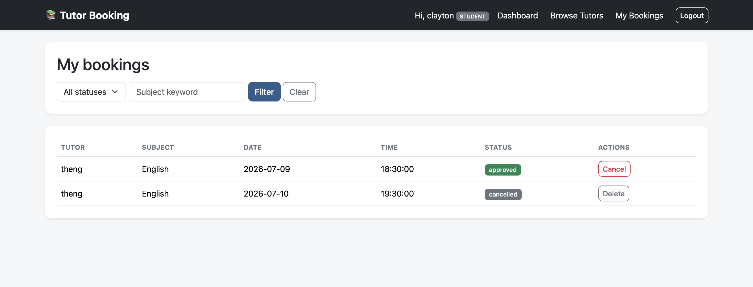
Tutor Profile Setup
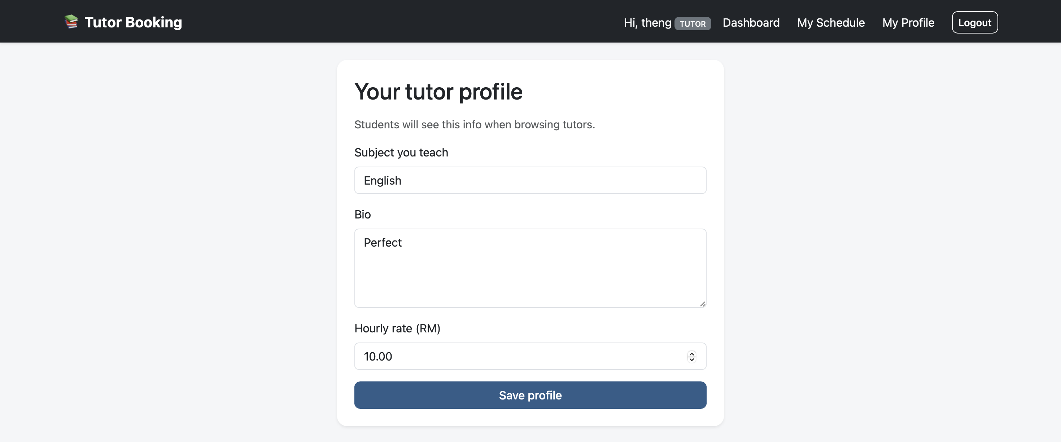
Tutor Dashboard
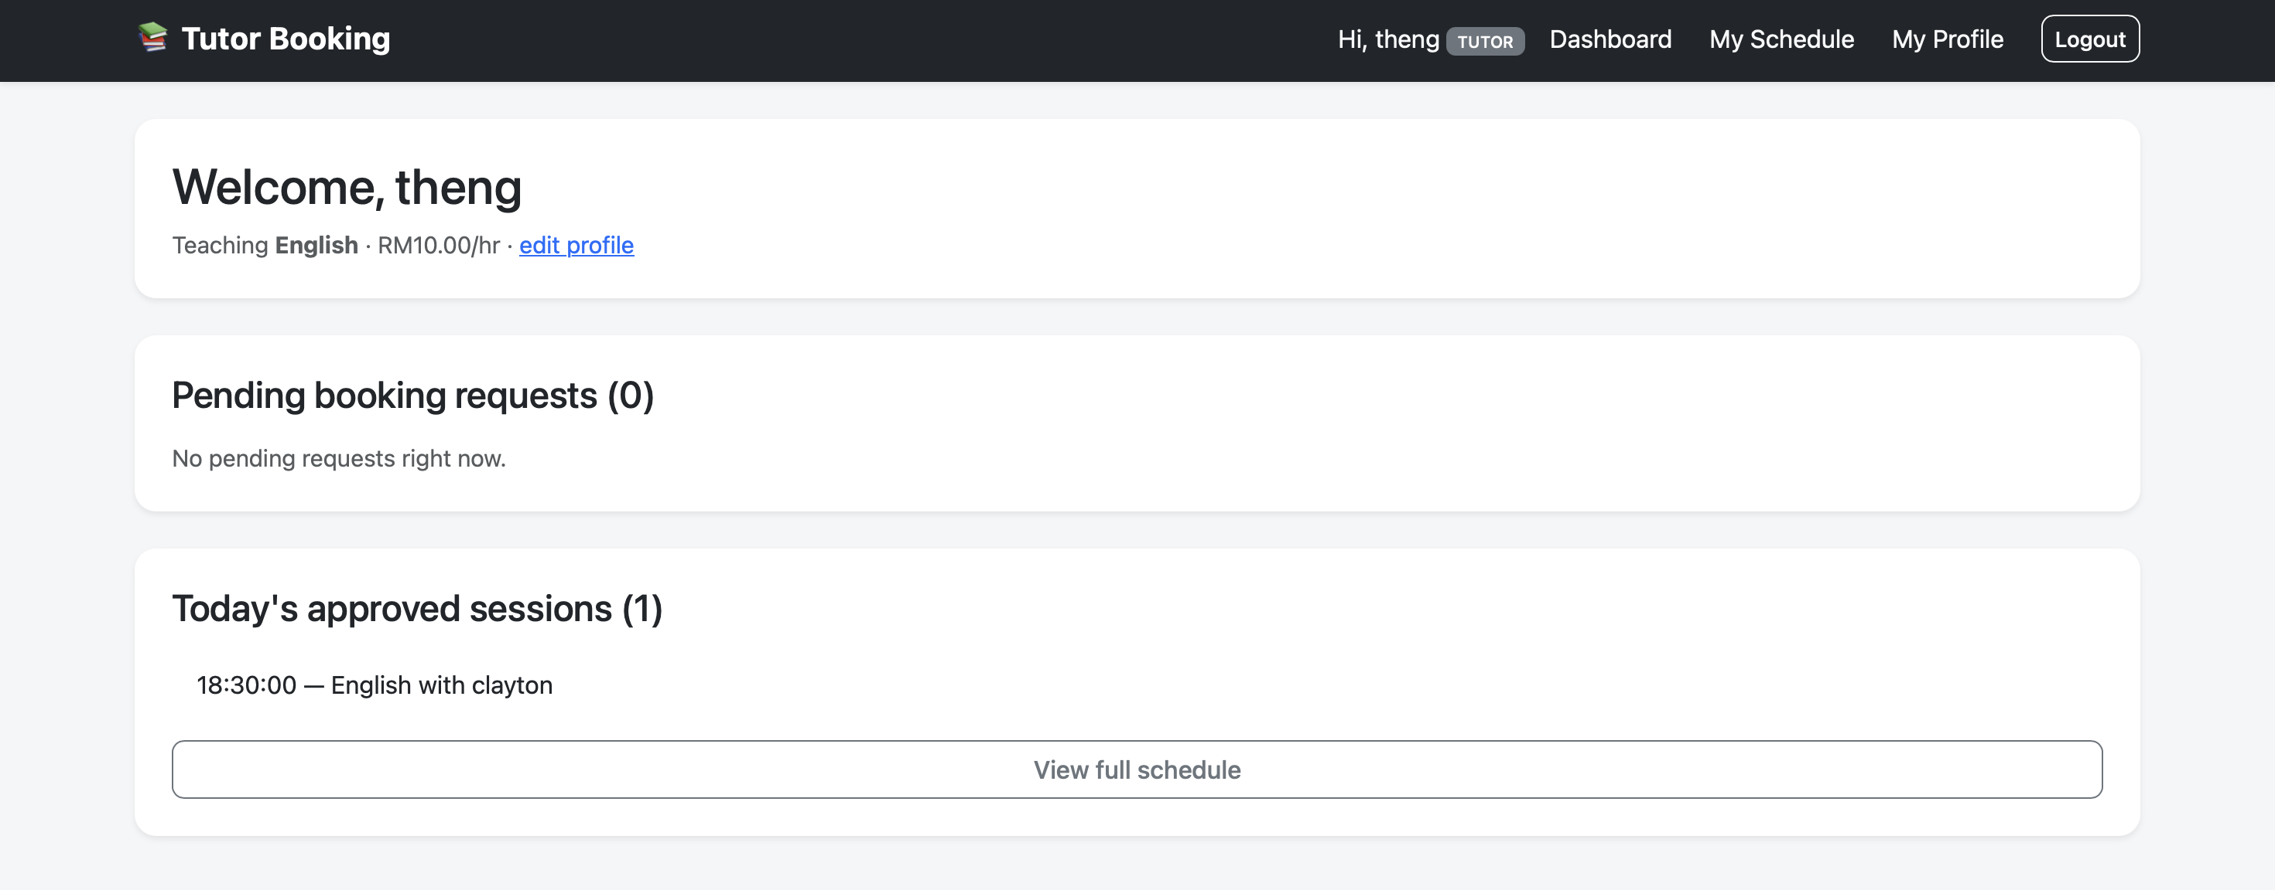
Tutor Schedule
