Alex Owens

CSC 440

JACKN-Wiki

Create User: Design Manual

## **Problem definition**

Being able to create a user is an important feature for a wiki to have. It should definitely exist in the wiki so that everyone can have their own way to access the wiki. It will also be helpful if we end up having roles or administrators because then users can be created to have specific purposes. As it stands now, there are only 2 hard-coded users, which means you have to have some knowledge of those users to even get in to the system.

## **Requirements (User Stories)**

The use case for this feature is actually pretty basic. A user will come to the Wiki and be presented with a login page. From here there will be two cases: either the user has a “user” in the Wiki or they do not have a “user”. In the latter case the user will click some kind of button and fill out a form to create their user.

## **Design**

My feature is designed in a RESTful API style way. It uses the Flask decorator to create a route '/user/create' which is a Python function in routes.py called user_create(). This function is called when the user routes to the specified URL.

On that template, there is a CreateUserForm. This form holds a name, password, and confirm password field. It will do validation upon submission for the name uniqueness and the passwords matching.

When the user submits the form, the routes.py function will call validation, and if that goes through it will call the add_user function on the UserManager for the Wiki. This will be passed a name and password and it writes a user out as JSON data into the users.json file. After this the route redirects to the login page.

Create User: User Manual

Step 1: From the login page, click "Create a User"

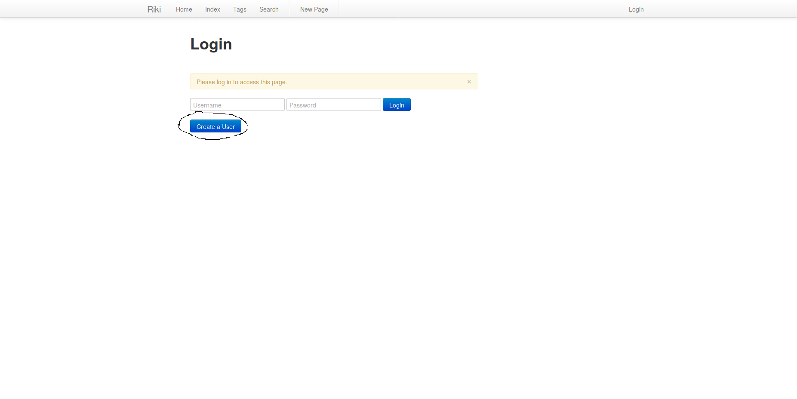

Step 2: Fill in the name, password, and confirm password fields

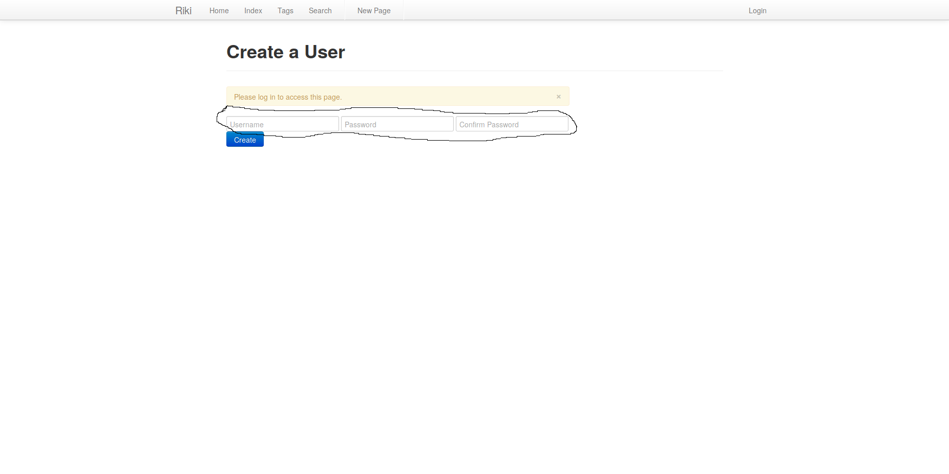

Step 3: Click "Create"

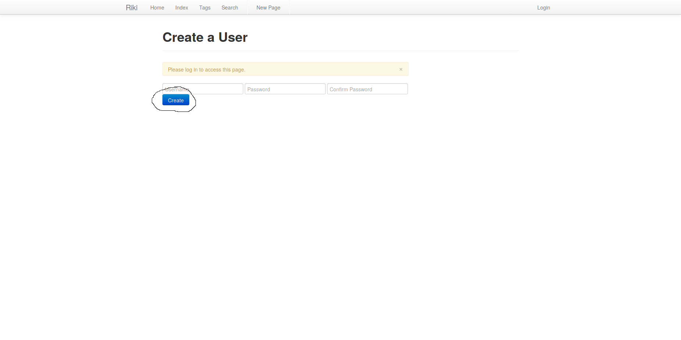

Step 4: Log in with your newly created user