Data Scraping and Collaboration

Katie Clayton with Ian Munoz

2022-11-14

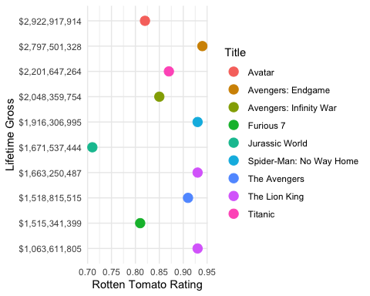

Lifetime Gross vs Rotten Tomato Rating of the Top 10 Highest Grossing Movies

This visualization shows the relationship between the top 10 Highest Grossing Movies and their rating on Rotten Tomatoes. The question that the visualization aims to answer is, is a movie’s rating on Rotten Tomatoes correlated with its lifetime Gross? Given the small sample size of movies, an accurate relationship is hard to confirm. But, a positive relationship between rating and lifetime gross is appearing in this visualization. Meaning that, the higher a movie is rated on Rotten Tomatoes, the higher its lifetime gross is.