West Chester University of Pennsylvania
Department of Computer Science


CSC 402 Undergraduate Capstone Course

Preliminary Design Review
3D Flight Visualization System

17 February 2026

Aramis Hernandez - AH1027406@wcupa.edu
Clayton Lewis - CL1007415@wcupa.edu
Carson Wood - CW1002081@wcupa.edu
Chinemerem Ugwuanyi - CU981828@wcupa.edu
David Shodipe - DS986484@wcupa.edu
Evan Visalli - EV1029477@wcupa.edu
Nicholas Tran - NT1022667@wcupa.edu
Client: SME Solutions, Inc.

Abstract:
This Preliminary Design Review outlines the proposed design for the 3D Flight Visualization System developed for SME Solutions, Inc. The system will ingest real-time telemetry data, including position and 6DOF motion parameters, and render an accurate 3D aircraft model within a virtual environment. It will operate on the NVIDIA Jetson Orin Nano platform while maintaining a minimum performance of 30 frames per second.
The architecture is modular, separating telemetry ingestion, rendering, recording/playback, and user interface components. The system will support real-time visualization, flight path recording and replay, multiple camera modes, and configurable GUI controls without source code modification. This document presents the system architecture, design approach, and implementation strategy to meet SME’s operational and technical requirements.

Table of Contents:
Abstract: 2
Introduction: 5
Concept Development: 6
High-Level Project Concept Map: 6
Rendering Subsystem: 8
Flight Path Rendering Concept 8
Game Engine Justification: 10
Concept Design 11
Data Ingestion 11
Expected Telemetry Fields: 11
Error Handling & Fault Tolerance: 14
1. Error Classification 14
2. Parsing and Schema Faults 15
3. Validation Fault Handling 15
4. Graceful Degradation Policies 15
5. Stream Dropout and Timeout Handling 16
6. Buffering and Backpressure Control 16
7. Logging, Diagnostics, and Debug Support 16
8. Fail-Safe Behavior 17
Rendering 17
Render of 3D Aircraft in flight: 17
Render real-time positional data: 18
Camera angles (chase, fixed, and free camera): 19
Hardware 20
NVIDIA Jetson Orin Nano Board: 20
CloudLab Wisc Servers c240g5: 20
Recording/Playback 21
Telemetry mapping: 21
Display of Flight Path: 21
GUI/Configuration 22
Telemetry tools: 22
Support for Aircraft changes: 22
Start/Stop Playback: 22
Switch Between Playback Modes: 22
Control of Config Without Changing Source Code: 22
Design Hazards 23
1. Telemetry Schema Drift 23
2. Data Integrity and Corruption 24
3. Timing Drift and Replay Desynchronization 24
4. Performance Bottleneck on Jetson Platform 25
5. Memory Growth and Resource Leaks 25
6. Coordinate Conversion Errors 25
7. Integration Coupling Between Subsystems 26
8. Recording / Playback File Compatibility 26
9. Scope Creep and Feature Bloat 26
10. Team Availability and Participation Gaps 27
Conclusion 28

Introduction:
This project is undertaken on behalf of SME Solutions Inc. to develop a real-time air vehicle telemetry visualization system that meets the defined operational and technical requirements. SME has identified the need for a system capable of ingesting live telemetry data, including position, orientation (6DOF), and motion parameters, and accurately rendering a 3D air vehicle model that updates in real time. The system must also support recording and replay functionality to facilitate post-flight review and analysis, while operating efficiently on an NVIDIA Jetson platform at a minimum performance of 30 frames per second.
The proposed solution will deliver a modular software architecture designed to meet both current sponsor requirements and potential future additions. The system will provide a configurable graphical user interface (GUI) that allows users to control data capture, select vehicle models, adjust display parameters, and switch between camera perspectives without requiring modifications to the source code. This approach ensures operational usability and adaptability in dynamic environments.
The development team will employ industry-standard tools, version control practices, and Agile methodologies to ensure traceability from requirements to implementation, reduce technical risk, and provide incremental validation of system functionality. This Preliminary Design Review outlines the proposed architecture, subsystem design, technical approach, and development strategy intended to satisfy SME’s project requirements.

Concept Development:

High-Level Project Concept Map:
The current system design was developed through multiple individual and collaborative brainstorming sessions. The initial objective was to decompose the client’s requirements into discrete functional modules and identify the necessary interactions between them.
The first brainstorming phase focused on:
- Separating high-level requirements into logical subsystems
- Identifying data flow between components
- Determining architectural dependencies
- Clarifying where responsibilities should be isolated
The resulting concept map provided an early structural representation of the proposed software architecture. This model served as a foundation for refining subsystem boundaries and defining interfaces.

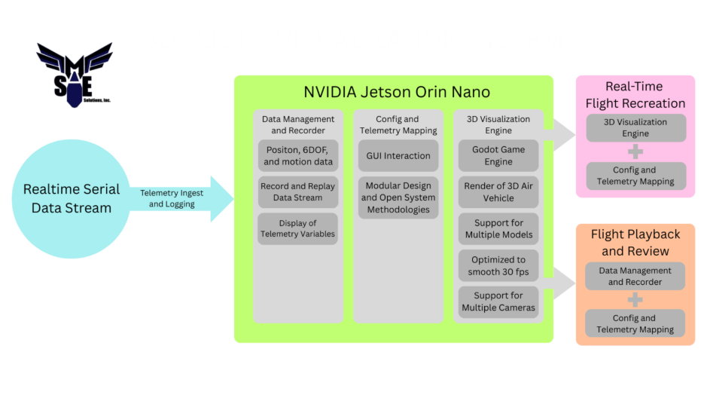

Following the initial concept mapping, the system was divided into three primary architectural domains:
- Hardware
- Data Ingestion
- Rendering
Each domain was analyzed independently to determine:
- Required functionality
- Interface boundaries
- Data dependencies
- Performance considerations
Additional brainstorming sessions were conducted within each domain to further decompose them into smaller, modular components. This iterative breakdown allowed the team to design a scalable architecture while ensuring traceability to the original client requirements.
Based on this structured decomposition and subsequent research, subsystem designs were drafted. The following sections present high-level design diagrams for the rendering components.

Rendering Subsystem:
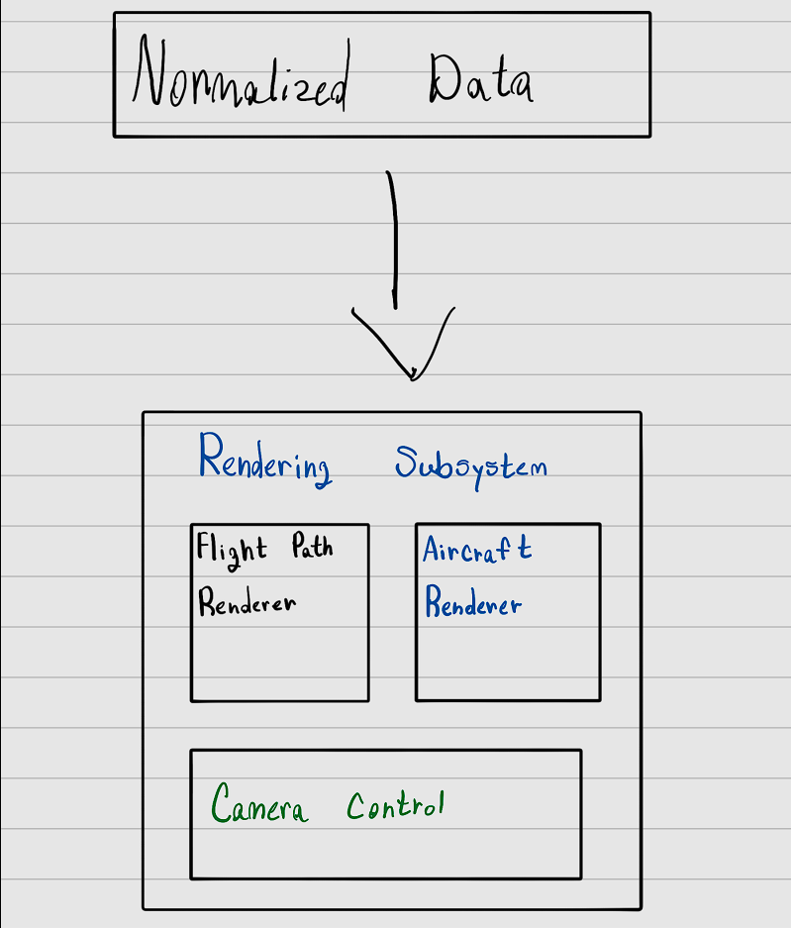

Flight Path Rendering Concept
The following diagram was created during the brainstorming phase specific to flight path visualization.
This conceptual model illustrates:
- The vehicle model receiving pose updates
- The transform pipeline is responsible for updating the position and orientation
- The trajectory rendering mechanism
- The interaction between telemetry-derived variables and visual representation
The diagram also reflects how flight path rendering may be influenced by telemetry parameters (e.g., altitude, velocity, maneuver state), enabling visual encoding such as color mapping, scaling, or density adjustments.
The design ensures that:
- The aircraft model follows pose updates independently of the path visualization
- The trajectory rendering mechanism remains modular
- Playback control can influence both aircraft state and path visualization without modifying underlying data structures

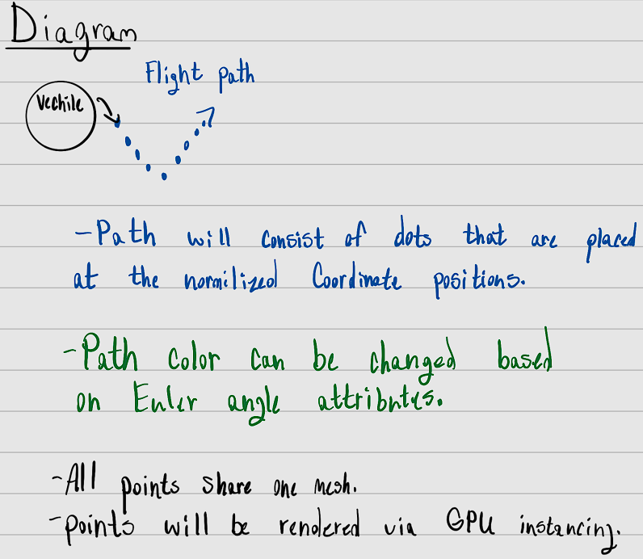

Game Engine Justification:
SME did not mandate a specific game engine or rendering framework for implementation, instead defining functional and performance-based requirements that the final system must satisfy. As a result, we have conducted a structured evaluation of multiple candidate engines and rendering platforms to determine the most suitable solution. The evaluation criteria included compatibility with the NVIDIA Jetson platform, ability to maintain a minimum of 30 frames per second, support for real-time 6DOF updates, flexibility for modular architecture design, ease of integration with C++ and Python-based telemetry processing, and long-term maintainability.

Engines such as Unity, Unreal Engine, and Godot were analyzed for deployment feasibility, performance overhead, tooling support, and system complexity. Based on this comparative analysis, the selected engine was chosen because it best balanced performance efficiency, embedded platform compatibility, and architectural flexibility while minimizing integration risk. This research-driven selection process ensures that the final system aligns with SME’s requirements while remaining scalable and maintainable for future development.

Game Engine: | Positives: | Negatives:
 | - Editor optimized for real-time changes  - Blueprint System  - Advanced Graphics and Simulation | - Large learning curve  - Does not offer ARM/Linux not supported out of the box  - Resource Intensive
 | - Faster to learn  - Rich ecosystem of assets  - Well-designed editor and prefabs | - Sluggish editing of large projects  - Linux is not supported out of the box  - Most assets/plugins would cost money  - Challenging to optimize for Jetson Orin
 | - Linux support out of the box  - Assets and plugins are free with AssetLib  - Easiest for everyone to learn and pick up  - Lightweight - less optimization | - Smaller asset and plugin library  - Weaker physics  - Graphical features are not as good

Concept Design

Data Ingestion
The data ingestion module will act as the intermediary between the drone telemetry source and the rendering engine. The pipeline will follow this structure:

- Telemetry Source (live stream or log file)
- Parser Layer
- Validation & Error Handling
- Data Normalization
- Structured Data Model
- Interface to Rendering Module

Expected Telemetry Fields:
Timestamp: | 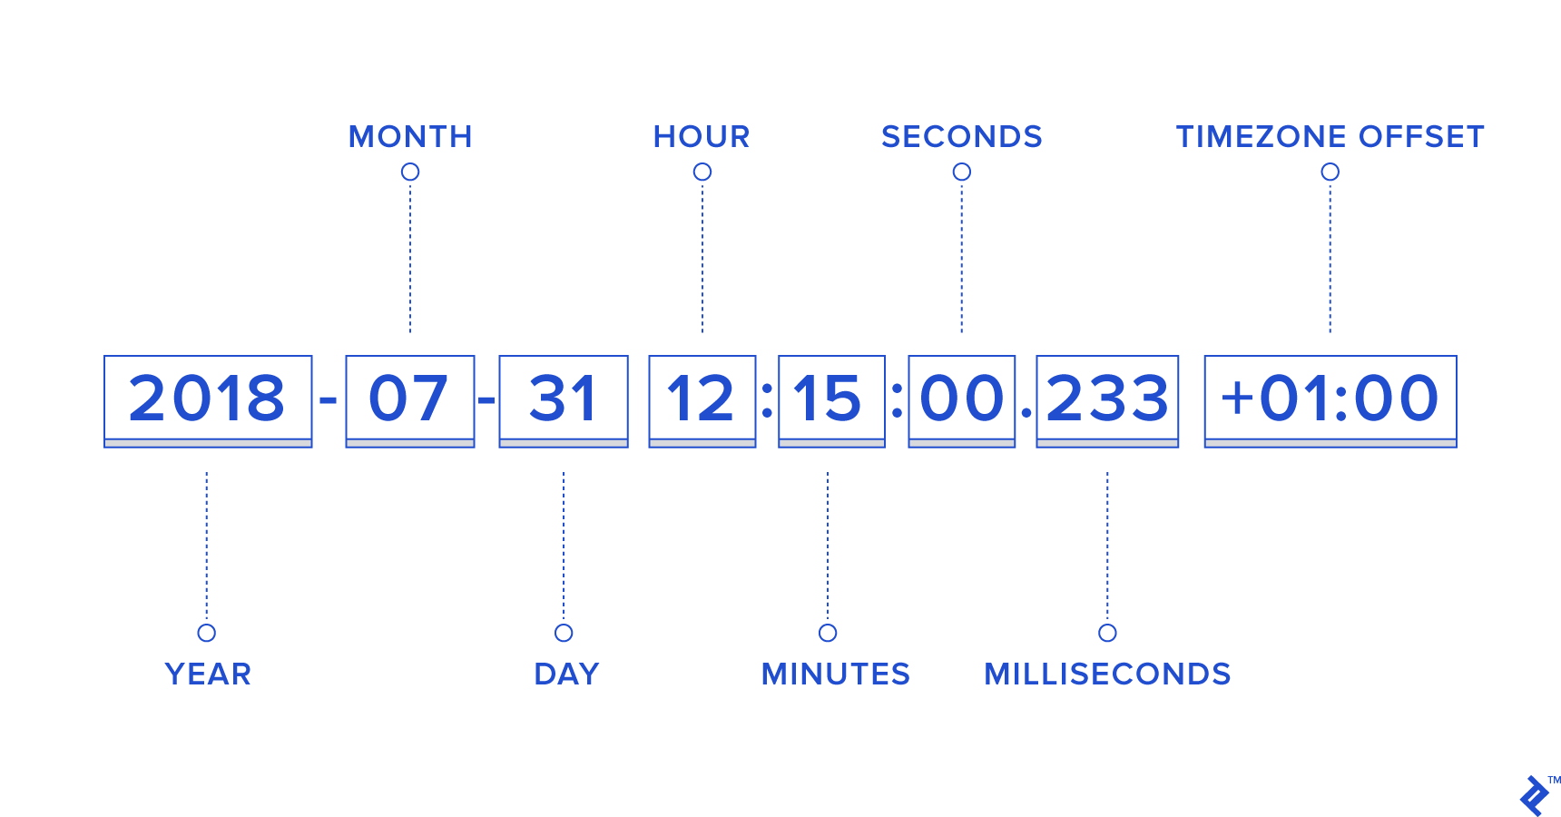
Longitude/Latitude: | 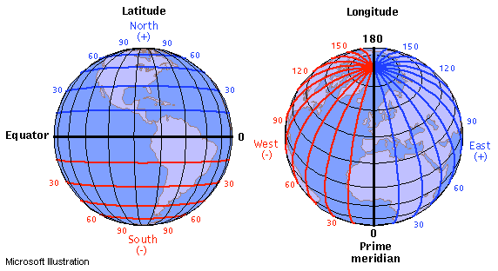
Roll, Yaw, and Pitch: | 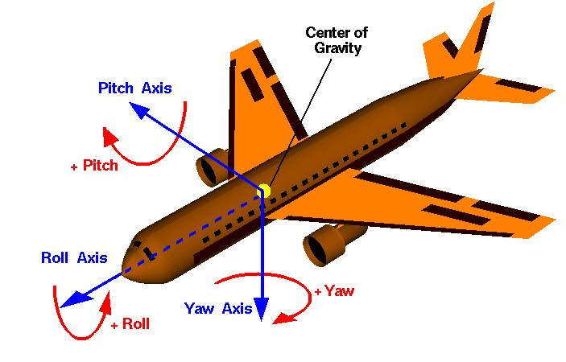
Altitude: | 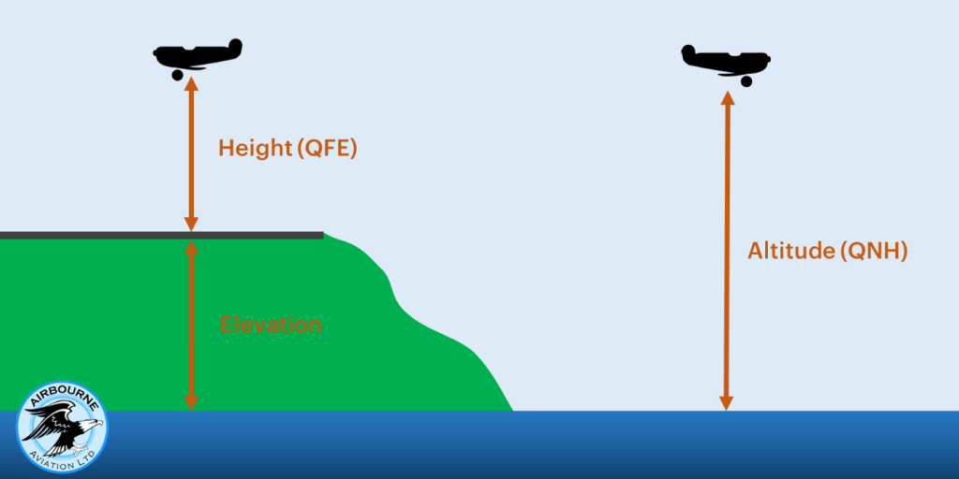
Velocity: | 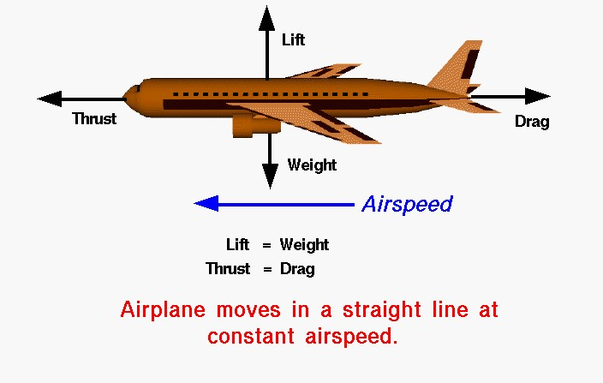

Data Validation Plan
The data ingestion module is responsible for ensuring that all incoming telemetry data is structurally correct, numerically valid, and temporally consistent before it is forwarded to the rendering and recording subsystems. Because telemetry may originate from hardware streams or recorded logs, validation must protect the system from malformed, incomplete, or unrealistic data while preserving real-time performance.
Schema Validation
Each telemetry sample must conform to a predefined schema. At a minimum, the following required fields must be present and correctly typed:
- Timestamp
- Position data (latitude, longitude, altitude, or normalized x, y, z)
- Orientation data (roll, pitch, yaw)
If any required field is missing or improperly formatted, the sample will be rejected and logged. Optional fields such as velocity or acceleration may be accepted when present, but will not prevent processing if absent.
Type validation will ensure that numeric fields are parsed as valid floating-point values and not corrupted strings or null entries.
Range Validation
All numeric fields will be validated against acceptable operational ranges to prevent unrealistic or corrupt telemetry from propagating through the system.
- Latitude must fall between -90 and 90 degrees
- Longitude must fall between -180 and 180 degrees
- Altitude must be within a reasonable operational bound
- Roll, pitch, and yaw must fall within expected angular ranges
Values that exceed defined thresholds will be treated as invalid and discarded. This prevents extreme outliers from producing visual artifacts or unstable rendering behavior.
Temporal Validation
Because replay accuracy and real-time consistency depend on correct timing, timestamp validation is critical.
- Timestamps must increase monotonically
- Duplicate timestamps will be flagged
- Large discontinuities in time intervals will be logged
- Samples that arrive significantly out of order may be rejected
This ensures that playback remains deterministic and that rendering reflects accurate flight progression.
Consistency and Sanity Checks
Beyond simple field validation, ingestion will perform basic sanity checks to detect unrealistic movement patterns.
- Excessive positional deltas between consecutive samples may indicate corruption
- Sudden extreme orientation changes may be flagged for logging
- Invalid transitions may be discarded based on configurable thresholds
These checks help protect against single-sample corruption that passes basic range validation but would otherwise distort the flight path.
Validation Outcome Handling
Validation failures will not cause system crashes. Instead, the following policies will apply:
- Invalid samples are discarded and logged
- The last known valid state may be retained when appropriate
- Validation metrics may be tracked to detect persistent telemetry issues
This layered validation approach ensures that ingestion acts as a protective boundary between hardware input and visualization output, maintaining stability, performance, and replay integrity across the system.

Error Handling & Fault Tolerance:
The system is designed to remain stable and usable even when telemetry input is imperfect. Telemetry streams and logs can contain malformed packets, missing fields, out-of-order timestamps, or temporary dropouts. The error and fault handling strategy focuses on preventing crashes, preserving real-time performance, and providing actionable diagnostics for debugging and integration.

1. Error Classification
Errors will be handled differently depending on severity:
- Non-critical errors: minor validation issues that do not prevent visualization (e.g., missing optional fields like velocity).
Action: continue operation and log a warning.
- Recoverable errors: issues where the sample cannot be used but the stream can continue (e.g., malformed packet, missing required field).
Action: discard the sample, log the reason, and continue processing.
- Critical errors: repeated failures indicating the telemetry stream is unusable, or the parser is misconfigured (e.g., schema mismatch, continuous corruption).
Action: enter a safe degraded state, notify the system via an error event, and avoid uncontrolled crashing.

2. Parsing and Schema Faults
Telemetry may arrive in different formats depending on the hardware interface. The ingestion layer will isolate parsing to a dedicated component so faults do not propagate.
- If a record cannot be parsed (invalid JSON, corrupted line, invalid delimiter):
Action: skip the record, log the failure, and continue.
- If required fields are absent or types are incorrect (e.g., “altitude” is a string):
Action: treat the sample as invalid, discard it, and log the missing/incorrect fields.
- If telemetry schema changes midstream:
Action: detect a mismatch (optionally through schema/version field) and log a high-severity warning. If the failure rate exceeds the threshold, transition to degraded mode.

3. Validation Fault Handling
For numeric and temporal validation failures:
- Range violations (invalid lat/long, impossible angles, unrealistic altitude):
Action: discard the sample and log.
- Timestamp issues (non-monotonic timestamps, duplicates, extreme time gaps):
Action: log the issue, discard if it breaks ordering guarantees, and tag gaps for replay.
- Unrealistic jumps (large positional delta in a single tick):
Action: flag as suspicious and either discard or clamp based on the selected policy. This prevents extreme outliers from creating visual artifacts.

4. Graceful Degradation Policies
To keep the visualization running during partial failures:
- If position is present but orientation is missing:
Action: reuse last known orientation, mark sample as degraded.
- If orientation is present but position is missing:
Action: discard sample (position is required for path updates).
- If optional parameters are missing (velocity, acceleration):
Action: continue without them.
This policy prevents the system from failing due to incomplete but still usable telemetry.

5. Stream Dropout and Timeout Handling
Live telemetry may pause due to connection issues or hardware dropout.
- Ingestion will track the time since the last valid sample.
- If no data arrives within a timeout window:
Action: raise a “telemetry timeout” event, stop advancing the flight path, and avoid freezing/crashing.
When telemetry resumes:
- Ingestion returns to normal processing automatically
- logs the recovery to support debugging

6. Buffering and Backpressure Control
High-frequency telemetry may arrive faster than the rendering loop.
To prevent memory growth and frame drops:
- Ingestion will use a bounded buffer (queue) for incoming samples
- If the buffer reaches capacity, the system applies a drop policy such as:
  - dropping the oldest samples to preserve real-time behavior
  - dropping new samples if preserving continuity is preferred
This ensures the pipeline remains stable and prevents uncontrolled resource usage.

7. Logging, Diagnostics, and Debug Support
All errors will be logged with enough context to troubleshoot integration problems:
- error type (parse, validation, timeout)
- offending field(s) when applicable
- timestamp or sequence number
- count/rate of failures over time
To avoid overwhelming output:
- Repeated errors may be rate-limited
- Summary metrics can be reported periodically (e.g., invalid packets per minute)

8. Fail-Safe Behavior
If telemetry becomes consistently invalid (error rate exceeds threshold), the system will:
- Stop applying new telemetry updates
- preserve the last known valid pose
- continue rendering without crashing
- clearly indicate that data is stale or unavailable through internal status (even if UI messaging is implemented later)
This ensures system stability and improves reliability for demos and sponsor usage.

Rendering

Render of 3D Aircraft in flight:
The aircraft visualization will be rendered as a separate transform-driven entity, allowing orientation (roll, pitch, and yaw) and position updates to occur independently from the flight path rendering process. This modular separation ensures that changes to aircraft representation, camera behavior, or visual effects do not impact the performance or structure of the flight path visualization.

Figure 1: Flight Visualization
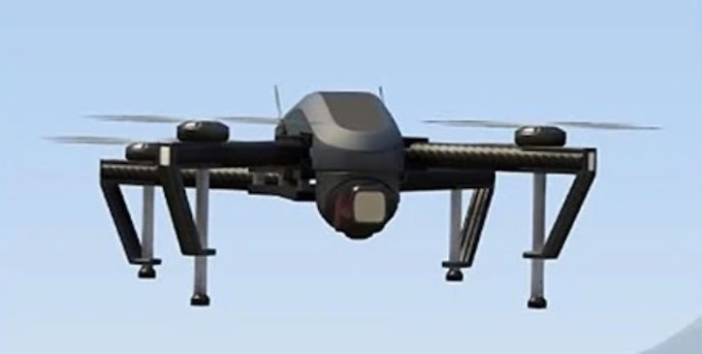

Render real-time positional data:
The application will render a real-time three-dimensional flight path visualization using motion and positional data supplied by the data ingestion layer. Incoming data will include six degrees of freedom (6DOF) orientation information (roll, pitch, and yaw) along with geographic position data consisting of longitude, latitude, and altitude. Additional physical parameters, including velocit y and acceleration, may be used to augment the visualization and improve interpretability.

Figure 2: Longitude and Latitude
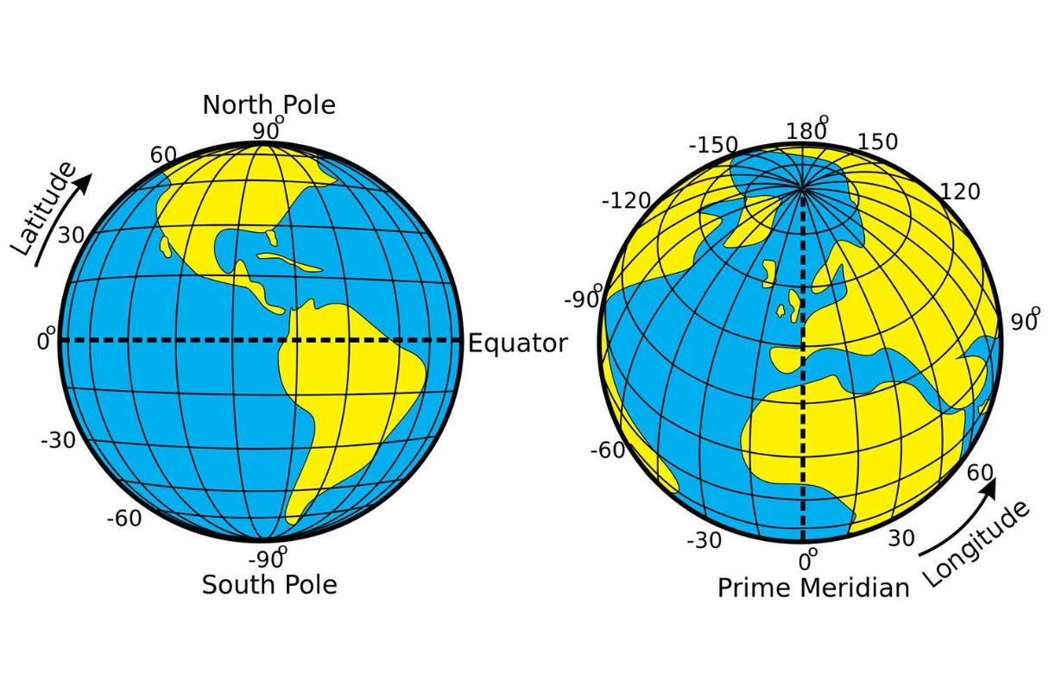

The rendering system is designed to be modular, with a clear separation between data ingestion, coordinate normalization, and visual representation. Geographic position data will be converted into a local Cartesian coordinate space suitable for real-time rendering, while 6DOF orientation data will be applied directly to visual elements. These transformations are handled within the rendering pipeline without requiring external estimation or telemetry logging.

Flight path visualization will be implemented as an independent rendering module that represents each positional update as an instance of a shared mesh. GPU instancing is used to efficiently render large numbers of flight path points while minimizing CPU overhead and draw calls. This approach enables the system to scale effectively with high-frequency data updates, ensuring consistent real-time performance.

Camera angles (chase, fixed, and free camera):
A chase camera would be implemented by attaching a camera rig to the active air vehicle with a fixed offset positioned behind and slightly above the model. The camera’s position would update each frame based on the vehicle’s real-time 6DOF pose, using smoothing to reduce jitter from telemetry data. The camera would continuously orient toward the vehicle to maintain a stable trailing perspective, and users could switch to this mode through the GUI.

A fixed camera would be implemented by placing predefined camera nodes at specific positions within the environment. These cameras would remain stationary while tracking the vehicle’s movement, either by continuously orienting toward the vehicle or maintaining a preset viewing angle. Users could select different fixed viewpoints through the GUI without affecting the simulation state.

A free camera would be implemented as a user-controlled camera that operates independently of the vehicle’s position and orientation. Users would navigate the scene using keyboard and mouse inputs to translate and rotate the camera in real time. This mode would enable unrestricted exploration of the environment and vehicle motion, allowing for detailed observation or analysis.

Hardware

NVIDIA Jetson Orin Nano Board:
GPU: | NVIDIA Ampere Architecture:  - 1024 CUDA cores + 32 tensor cores  - Max Per Core Clock Speed - 625 MHz  - Supported Graphic APIs:  - OpenGL 4.6+  - Vulkan 1.2+  - CUDA 10.2+
CPU: | CPU (Cortex - A78AE v8.2):  - 6-core Arm 64-bit  - 1.5MB L2 + 4MB L3 Cache  - Max Clock Speed - 1510.4 MHz
SDRAM: | SDRAM: 8GB 128-bit LPDDR5  - Max Clock Speed - 2133 MHz
Power Usage: | Around Min 7W up to 15W

CloudLab Wisc Servers c240g5:
GPU: | NVIDIA Tesla P100:  - 3584 cores  - Base Per Core Clock Speed - 1190 MHz  - Max Per Core Clock Speed - 1329 MHz  - Supported Graphic APIs:  - DirectX 12(12.1)  - OpenGL 4.6  - OpenCL 3.0  - Vulkan 1.3  - CUDA 6.0  VRAM:  - 16GB  - Memory Clock Speed - 715 MHz
CPU: | Intel Xeon Silver 4114 Processor:  - 10-core x86-64 (64-bit)  - Base Clock Speed 2.2GHz
RAM: | 192GB ECC DDR4  - Max clock speed - 2666

QEMU EMULATION:
As we are unable to replicate the exact hardware used for the NVIDIA Jetson Orin Nano Board via cloud alternatives available hardware, we will be using QEMU. QEMU is an open source machine emulator and virtualizer, which will allow us to emulate an ARM cpu on a X86/64 64 bit CPU chip. Using the emulator's virtualization, we are also able to choose the specs that the virtual machine has access to, allowing us to get close to the spec performance of the NVIDIA Jetson Orin Nano Board without the equivalent hardware.

Recording/Playback

Telemetry mapping:
Telemetry mapping will be implemented by associating recorded telemetry fields—such as position, orientation, velocity, and altitude—with their corresponding visual and analytical representations within the playback system. During recording, incoming telemetry data will be normalized and stored in a structured format. During playback, this stored data will be read sequentially and mapped back to vehicle state updates, telemetry displays, and flight path visualization in real time. This approach ensures that the replay accurately reproduces the original flight behavior while maintaining synchronization between motion, visual indicators, and recorded parameters.

Display of Flight Path:
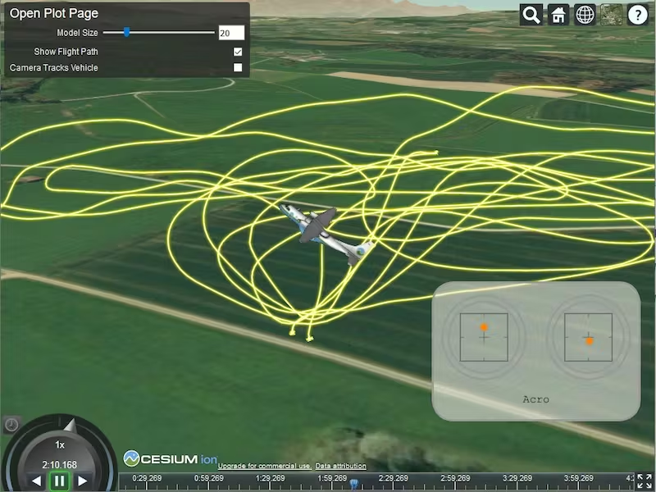
A visual flight path will be implemented by recording the vehicle’s positional data over time and generating a dynamic line or trail within the 3D environment during playback. As telemetry data is replayed, the system will render a continuous path that traces the aircraft’s historical movement through space, allowing users to visually analyze trajectory, maneuvers, and deviations. The flight path visualization will be generated from stored position data and updated frame-by-frame during replay.

GUI/Configuration

Telemetry tools:
The telemetry tools will provide real-time visualization of critical flight parameters, including pitch and roll (attitude), forward velocity (airspeed), altitude (Y-position), and heading (yaw rotation). These instruments will continuously update based on simulation data to give users an accurate and dynamic representation of the aircraft state. By integrating these core indicators into the GUI, the system ensures clear situational awareness and enhances the realism and analytical value of the 3D flight visualization.

Support for Aircraft changes:
The GUI will support dynamic switching between different aircraft models without requiring an application restart. This functionality allows the visualization system to accommodate varying aircraft configurations, flight dynamics, and performance characteristics. The system architecture will separate aircraft data logic from rendering logic to ensure modularity and scalability.

Start/Stop Playback:
A start/stop control will allow users to initiate and terminate flight path logging. When activated, the system will record positional and orientation data over time, creating a stored flight trajectory. Pressing the stop button will end logging and finalize the dataset for later playback or analysis.

Switch Between Playback Modes:
The GUI will allow users to switch between live simulation mode and playback mode. In live mode, telemetry updates occur in real time, while playback mode replays previously recorded flight data. This functionality supports demonstration, debugging, and post-flight analysis use cases.

Control of Config Without Changing Source Code:
A configuration menu will allow users to modify vehicle attributes and environmental parameters without editing source code. Adjustable settings may include aircraft type, terrain characteristics, speed limits, or physics modifiers. This feature enhances usability and ensures flexibility while maintaining a clean separation between interface controls and core system logic.

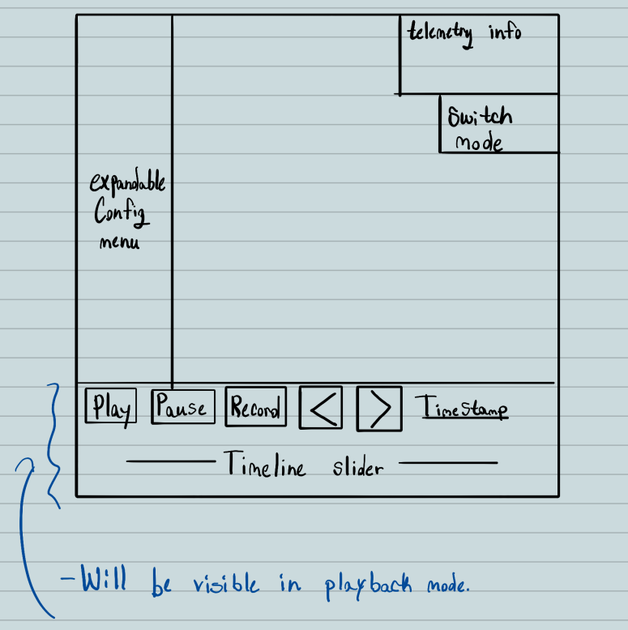

Design Hazards

Telemetry Schema Drift
Risk: Hardware team changes fields, ordering, units, or coordinate systems during development.
Impact: Parsing breaks, rendering becomes incorrect, and replay becomes unreliable.
Detection: Schema/version field in telemetry; ingestion logs unknown/missing fields; unit tests against sample payloads.
Mitigation: Maintain a single shared telemetry schema doc; version telemetry; keep parsing isolated, so updates are localized; add backward-compatible parsing where possible.
Owner: Hardware + Ingestion.

Data Integrity and Corruption

Risk: Packets/log entries arrive malformed, incomplete, duplicated, or out-of-order.

Impact: Flight path artifacts, jitter, crashes, or incorrect analysis during replay.

Detection: Validation rules (required fields, range checks, monotonic timestamps),
checksum if feasible, logging of rejected packets.

Mitigation: Strict validation + graceful discard; “last known good” fallback for orientation; bounded error rate monitoring; robust file parsing that skips bad rows rather than failing the run.

Owner: Ingestion

Timing Drift and Replay Desynchronization

Risk: Irregular timestamps, clock drift, or variable update intervals distort playback timing.

Impact: Replay looks wrong, speed changes, frame pacing issues, and inconsistent demos.

Detection: Compare timestamp deltas to expected Hz; detect gaps/outliers; log discontinuities.

Mitigation: Timestamp normalization; interpolation or resampling for playback; optional fixed-step playback using target frequency (e.g., 30 Hz).

Owner: Ingestion + Recording/Playback

Performance Bottleneck on Jetson Platform

Risk: CPU parsing cost, excessive allocations, or heavy rendering drops below 30 FPS.

Impact: Fails sponsor performance requirement, laggy visualization, unusable real-time mode.

Detection: Profiling on Jetson early; frame time logging; telemetry throughput metrics; memory monitoring.

Mitigation: Batching and buffering; avoid per-frame allocations; sample/decimate telemetry if needed; GPU instancing for path points; reduce draw calls and heavy effects.

Owner: Rendering + Ingestion

Memory Growth and Resource Leaks
Risk: Path points, logs, textures, or scene objects accumulate without bounds.
Impact: FPS degradation, crashes, unstable long runs, and replay failures.
Detection: Long-run soak tests; memory usage tracking; telemetry queue size monitoring.
Mitigation: Cap history size; ring buffers for telemetry; chunked recording files; reuse object pools; limit flight path density with sampling or segmenting.
Owner: Rendering + Recording/Playback.

Coordinate Conversion Errors
Risk: Lat/long → local space conversion mistakes, wrong origin, axis mismatch, degrees vs radians.
Impact: Incorrect path, mirrored movement, wrong altitude, confusing visuals.
Detection: Known test flights/sim inputs with expected path; unit tests for conversion; sanity checks on movement magnitude.
Mitigation: Define a single coordinate convention (ENU/NED or engine space); pick an origin reference; validate with simulated patterns (straight line, circle, climb).
Owner: Ingestion + Rendering.

Integration Coupling Between Subsystems
Risk: Ingestion, rendering, playback, and GUI become tightly coupled and hard to change.
Impact: Integration delays, fragile code, and changes break unrelated features.
Detection: Frequent integration builds, code reviews for boundary violations, and interface contracts.
Mitigation: Keep subsystems modular; define clean data objects; minimize cross-dependencies; add integration tests using recorded telemetry.
Owner: Whole team.

Recording / Playback File Compatibility
Risk: Saved logs become unreadable after schema changes or across environments.
Impact: Replay breaks, demo failures, lost data utility.
Detection: Regression tests loading older logs; schema version checks.
Mitigation: Versioned log format; migration strategy (converter script) if schema changes; store metadata (units, origin, frequency) inside each recording.
Owner: Recording/Playback + Ingestion.

Scope Creep and Feature Bloat
Risk: Extra features (terrain, advanced UI, physics, multiple aircraft modes) expand beyond schedule.
Impact: Missed deadlines, unfinished core requirements.
Detection: Weekly scope review against sponsor requirements; backlog grooming.
Mitigation: Lock an MVP: real-time path + basic 3D model + record/replay + minimal config; defer non-essential features.
Owner: Project management/leadership.

Team Availability and Participation Gaps
Risk: Uneven participation or missing members creates work overload for active contributors.
Impact: Slower progress, reduced quality, missed milestones.
Detection: Task board ownership; meeting attendance; weekly deliverable check-ins.
Mitigation: Assign clear owners; keep tasks small and trackable; redistribute workload early; escalate to the instructor if needed.
Owner: Team leads.

These hazards will be reduced through early profiling on target hardware, strict telemetry validation, modular subsystem boundaries, and frequency integration testing using recorded telemetry.

Conclusion
The goal of the Preliminary Design Review is to showcase careful and thoughtful design for the project to the client SME. The Preliminary Design Review presents a structured, modular, and performance-driven solution for SME Solutiuons Inc.’s real-time air vehicle visualization system. The proposed architecture clearly separates data ingestion, validation, rendering, recording/playback, GUI configuration, and hardware interaction to ensure maintainability, scalability, and fault isolation. By decomposing client requirements into well-defined subsystems and interface boundaries, the team had established traceability from high-level operational goals to specific technical implementation strategies.

In summary, the proposed system design satisfies SME’s functional and performance requirements while establishing a scalable foundation for future expansion. The architecture prioritizes real-time reliability, deterministic playback, modular extensibility, and embedded platform efficiency. Upon approval of this PDR, the team will proceed to detailed implementation and subsystem integration, guided by the defined interfaces, validation policies, and performance benchmarks outlined in this document.

