**Terms to review:**

identifier

variable

constant

declaration

initialization

assignment

argument

data type

block

scope

nesting

truth table

definite loop

indefinite loop

infinite loop

iteration

accumulator

**array**

**array index**

**array element**

**parallel array**

**initializer list**

**linear search (aka. sequential search)**

**range check/match**

**Homework & Labs**

*// Please name your projects LB1, LB2, LB3, etc*

LB1. Complete Naming Conventions Handout

LB2. Complete Data Types Handout

LB3. Complete Prefix/Postfix Handout

LB4. Write a GUI application that calculates delivery charges to 10 different zip codes based on the following table.

*Program must pass all provided unit tests. Program must store this table in a pair of parallel arrays and use an appropriate loop.*

|  |  |
| --- | --- |
| **Zip Code** | **Delivery Charge ($)** |
| 63101 | 20iid |
| 63103 | 12 |
| 63105 | 25 |
| 63109 | 15 |
| 63113 | 10 |
| 63118 | 23 |
| 63130 | 18 |
| 63133 | 20 |
| 63136 | 17 |
| 63137 | 12 |

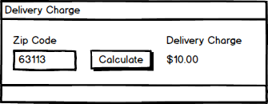

LB5. Write a GUI application that calculates the cost of resort stay based on the number of nights stayed.

*Program must pass all provided unit tests. Program must store this table in a pair of parallel arrays and use an appropriate loop.*

|  |  |
| --- | --- |
| **Nights Stayed** | **Nightly Rate** |
| 1-2 nights | $200 per night |
| 3-4 nights | $180 per night |
| 5-7 nights | $160 per night |
| 8 or more nights | $145 per night |

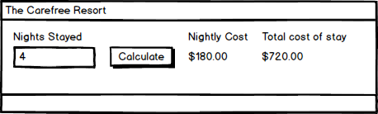

Lb6 GameDatabase

Create a searchable database for a video game store.

**Hint**

Research: String.Contains() & String.ToLower()

* The user can search by either the name of the game or the publisher.
* The user should be able to perform partial keyword searches. “Mario” should return “Super Mario Odyssey”
* If a game is found, then the program will display information about the game.
* The search should be case insensitive
* If a game is not found, then it will display an error message.

|  |  |  |
| --- | --- | --- |
| **Name** | **Publisher** | **Price** |
| Player Unknown's Battlegrounds (PUBG) | Bluehole | $35 |
| League of Legends | Riot Games | $0 |
| Call of Duty: Black Ops III | Activision | $60 |
| Battlefield 4 | Electronic Arts (EA) | $20 |
| Super Mario Odyssey | Nintendo | $60 |

**Screen Mockups**

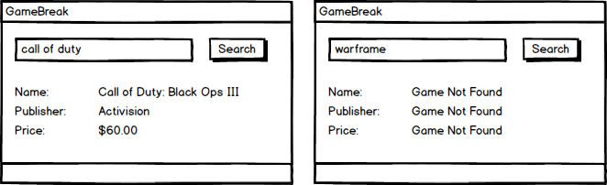

Lb7 MovieDatabase

Create a searchable database for a movie library.

* The user can search by either the name of the movie or the director.
* If a movie is found, then the program will display information about the movie.
* If a movie is not found, then it will display an error message.

**Screen Mockups**

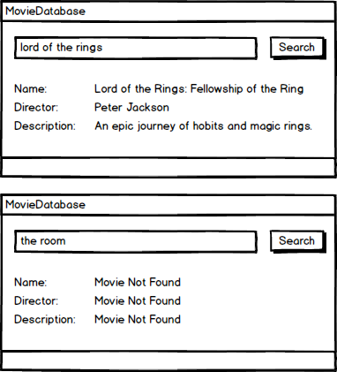

LB8. Write a GUI application that masks all but the last 4 digits of a credit card number with a #

1. The program must support credit card numbers with spaces, dashes, or no separator.
2. Leave the last four digits as is.
3. Leave any spaces or dash as is.
4. Replace any number or letter with a #
5. **The program should work for credit card numbers that are any length (including numbers that are less than four digits long).**

*\*\*Hints\*\**

***A string can be broken into a char array with a subscript***

*String name = “Bob”*

*char letter = name[0] //letter equals B*

*char letter2 = name[1] //letter2 equals o*

*char letter3 = name[2] //letter3 equals b*

*Research Char.IsDigit() and Char.IsWhiteSpace() methods*

