Parity and AD specific neurodegeneration
Clazz
Table of contents

1. Abstract
300 words

2. Introduction
Alzheimer’s disease (AD) is a neurodegenerative disorder characterised by the accumulation of pathophysiological abnormalities leading to neurodegeneration and progressive cognitive and functional decline. Ageing, carring the apolipoprotein E E4 (APOE4) and having female chromosomal sex are three established non-modifiable risk factors for the typical late-onset of this disease [1]. Amongst APOE4 carriers, women exhibit an increased risk of conversion from healthy ageing to MCI, or from MCI to AD dementia between the ages of 65 to 75 compareed to men [2,3]. Factors underlying the interaction between APOE4 and sex are not well understood, warrating a deeper investigation of sex specific events which might interact with this phenomenon. In particular, pregnancy is a female-specific event with far reaching biological impacts on multiple bodily functions, yet its potential effect on senecence has not yet been explored.
In humans, the first pregnancy is associated with drastic increases in sex-steroid levels [4] and a significant hippocampal volume loss [5], which only partially recovers in the post-partum period [6]. Whilst no data has been published regarding hippocampal volume change in second time mothers, Straathof and colleagues [7] recently showed that cortical volume changes that happened during the first preganncy were mirroired in the second, meaning hippocampal changes might also be reproduced. Interestingly, the dynamic volume changes seen during gestation are associated with the change curve seen in in free circulating sex-hormones [8]. In rodents, pregnancy is linked with decreased hippocampal volume during gestation as well as the mid post-partum [9]. Animal models converge towards the idea that cell proliferation is reduced during pregnancy but returns to nulliparous levels after pups have been weaned [9]. Together, these findings suggest that pregnancy and the post-partum period affect hippocampal volume dynamically. Crucially, the hippocampus is one of the first regions affected by AD, and whole hippocampal volume is a hallmark predictor of conversion from MCI to AD [10]. Therefore, this region seems of particular interest given it is affected by parity and is related to AD neurodegeneration.
Few studies have reported associations between parity and hippocampal volume in older adult women. A cross sectional that included 248 women spanning the range from CU to clinically diagnosed with AD found a singificant associaiton between grand multiparity and hippocampal volume. Additionally, preliminary evidence from the UK biobank using 1284 subjects reported that CU postmenopausal women showed lower hippocampal volume compared to nulliparous women, but this difference was not present when comparing multiparous women to nulliparous women [11]. Interestingly, another UK Biobank study using this time 19,787 middle-aged CU women from the UK biobank found that middle-aged parous women exhibited reduced brain age compared with nulliparous women, an effect mainly driven by anatomical components situated in the limbic region [12]. In a secondary analysis, author also found a significant positive linear associations between the Putamen, Hippocampus, Amygdala and Accumbens and number of childbirths. In animal models, nulliparous middle-aged rats show steeper hippocampal neurogenesis decline in compared to their primiparous counterparts [13]. Together, these findings suggest that past reproductive experience influences hippocampal structure in older age, but this association is inconsistent.
These inconsistent findings may be understood through the lens of Brinton’s “healthy cell bias” theory, which posits that estrogen’s neuroprotective effects are contingent upon neuronal metabolic health. Under physiological conditions, estrogen enhances glucose metabolism and mitochondrial bioenergetics, which supports the energy-intensive process of Ca²⁺ homeostasis. However, when metabolic injury is already present and Ca²⁺ regulation has been disrupted, estrogen exposure can paradoxically exacerbate neurodegeneration rather than prevent it. ApoE4 creates precisely this vulnerable metabolic state by impairing glucose metabolism and lysosomal function, essential for Ca²⁺ homeostasis [14]. Consequently, ApoE4 carriers may exist in a state of chronic metabolic compromise, rendering them susceptible to the significant surge in estrogen which occurs during the gestation period. This theory, initially proposed to explain contradictory findings of hormone therapy on dementia risk, may also apply to parity, since parity is not only associated with a significant increase in estradiol, but also an increase in oxidative stress that can accelerate cellular metabolism [15].
Using wildtype and APOE4 models middle aged female rats, Lee and colleagues [16] set-out to specifically test the theory that APOE status modifies the effect of parity on neurogenesis and HV. Results showed that primiparous APOE4 rats displayed decreased neurogenesis in the ventral dentate gyrus of the hippocampus compared to primiparous wildtype rats. In addition to this, parous APOE4 rats showed a spatial solving strategy which indicated a decreased recruitment of the hippocampus. These results confirmed the a-priori hypothesis that in the case of a compromised metabolic state, here due to carrying the APOE4 allele, pregnancy exerts a differencial effect on hippocampal cellular structure in middle-aged rats, with downstream effects on cognition.
Our objective was to understand if parity exerts a differential long-term effect on hippocampal volume and trajectory depending on APOE4 status in postmenopausal CU women. To do so, we aimed to test the interactive effects of parity, APOE4 carriership and time on hippocampal volume. We hypothesized that APOE4 carriers would show a negative relationship between parity and hippocampal volume and trajectory.

3. Methods

3.1 Study population
We included postmenopausal women who completed the baseline and first longitudinal visit (with an average time between visits of 3.32 years) from the ongoing ALFA+ study (Clinicaltrials.gov, NCT01835717). ALFA+ is a research cohort of middle-aged cognitively unimpaired participants, many of whom are offspring of AD patients, who have been deeply characterized by clinical interviews, lifestyle and risk factor questionnaires, cognitive testing, CSF biomarkers, and neuroimaging procedures, including magnetic resonance imaging (MRI), and Aβ positron emission tomography (PET). All of these procedures are repeated every 3 years with the main aim of identifying the earliest pathophysiological changes in the preclinical AD continuum [17]. Briefly, ALFA+ inclusion criteria were: 1) participants who had previously participated in the 45-65/FPM2012 study (ALFA parent cohort); 2) age between 45 and 75 years at the moment of inclusion in the cohort; 3) long-term commitment to undergo all tests and study procedures (MRI, PET, and lumbar puncture). Exclusion criteria at baseline included: 1) cognitive impairment (Clinical Dementia Rating [CDR] > 0, Mini-Mental State Examination [MMSE] < 26, semantic fluency < 12); 2) any significant systemic illness or unstable medical condition which could lead to difficulty complying with the protocol; 3) any contraindication to any test or procedure; 4) family history of monogenic AD. In addition, women with a history of cardiovascular-related gestational disease, such as preeclampsia, were excluded from our sample for analysis. Sex and menopausal status, defined as absence of menstruations for 12 consecutive months, were self disclosed. Women who reported being premenopausal or perimenopausal were not included in our analysis either.
The study was approved by the Independent Ethics Committee “Parc de Salut Mar”, Barcelona, and all participants gave written informed consent. Baseline visits took place between 2016 and 2019, and the follow-up visit between 2019 and 2022.

3.2 Reproductive variables
Parity was defined as the number of biological children and used as a continuous and dichotomous [parous vs nulliparous] variable in the main analyses. Due to the small number of grand multiparous participants, anyone with 4 or more biological children was grouped together. Hormonal Replacement Therapy (HRT) use was defined as a binary variable [currently using vs not currently using]. Cause of menopause was also defined as a binary variable [natural vs non-natural]. Reproductive span was calculated by subtracting age at menarche from age at menopause. Early menopause was defined as a binary variable [age at menopause> 45 vs age at menopause≤ 45]. These informations were self-reported by participants during an interview with a clinician at the baseline visit. When asking about age at menopause, participants were asked to report their age 6(?) months after their last period.

3.3 Cognitive measures
The main cognitive outcome of this study was a modified Preclinical Alzheimer’s cognitive composite (mPACC), including the total immediate recall of the Free and Cued Selective Reminding Test (FCSRT), the total delayed recall of the logical memory subtest in the Wechsler Memory Scale-IV, the Coding subtest of the Wechsler Adult Intelligence Scale-Fourth Edition (WAIS-IV), and the total score of the semantic fluency test (animals category), as defined in previous work [18]. Z-scores were computed for Visits 1 and 2 and used in the linear regressions. When using the longitudinal mPACC score in the mediation analysis, longitudinal cognitive change was computed as the difference between baseline and follow-up standardized scores.

3.4 AD biomarkers
CSF collection, processing, and storage in the ALFA+ study have been described previously [19]. Briefly, CSF Aβ42, Aβ40, sTREM2, YKL40 and GFAP were measured with the exploratory Roche NeuroToolKit immunoassays (Roche Diagnostics International Ltd, Rotkreuz, Switzerland) on a cobas e 601 module. Measurements were performed at the Clinical Neurochemistry Laboratory, Sahlgrenska University Hospital, Molndal, Sweden. Aß accumulation (Aß+, Aß–) was estimated using CSF Aß42/40. Aß status (Aß+, Aß–) was defined using the cutoff of 0.071 for the ratio Aß42/40 [23], where any participant below this cutoff was considered to be Aβ+.

3.5 Imaging data acquisition and preprocessing
Additional information on MRI data acquisition is available in the supplementary materials (eMethods 1).
Automatic Segmentation of Hippocampal Subfields (ASHS) software [20] was used on the T1, T2 and inversion recovery (IR) weighted images to segment the hippocampal formation in the following sub-regions: Brodmann areas 35 and 36, cornu Ammonis (CA) 1, 2 and 3, dentate gyrus (DG), entorhinal cortex (ERC), parahippocampal cortex (PHC), subiculum (SUB), and the hippocampal sulcus (SUL). All segmentations were visually inspected before proceeding with the statistical analyses.
Hippocampal values are reported in cm3 and were obtained at both baseline and follow-up visits.
Total Intracranial volume (TIV) was estimated using deformation fields obtained during the nonlinear registration of each subject’s T1-weighted MRI to a whole-brain template. The FSL Brain Extraction Tool [21] was applied to the template to create an intracranial mask, which was warped into each subject’s MRI at native space to obtain the TIV measurement. TIV is also reported in cm3.
Gray matter volumes were acquired using Freesurfer7’s cortical Desikan-Killiany labeling pipeline on the obtained T1 images.

3.6 Statistical analyses
Linear mixed-effects models were used to explore associations between variables through time. This method was chosen over using simple linear regression and using subject slopes between baseline and follow-up due to its ability to account for within-subject correlation, and accommodate missing data under MAR assumptions.
Hippocampal volume was designated as a primary outcome of interest given the existing literature. Cognitive performance was used as a secondary outcome to provide clinical context to our findings.
Our primary analysis assessed the joint effects of parity and APOE-e4 (exposures), on HV (outcome) over both visits, and test if this association is dependent on time. This model included a three-way interaction term among parity, APOE4, and time (the interval between Visit 1 and Visit 2 in years) as well as all lower-order interactions. Analyses were adjusted for age at baseline visit and scaled total intracranial volume. In addition to this, we also included HRT as a covariate due to reported effect it may have on HV in postmenopausal women (sources). To test specificity of the results with regards to our ROI, we reproduced the 3-way interaction between parity, APOE4 and time on gray matter volume changes in the calcarine cortex. This analysis was also adjusted for age at baseline visit, total intracranial volume and HRT.
To test for potential confounders, sensitivity analyses were performed adding Aβ load as a covariate to disentangle the neuropathological contributions of Aβ accumulation from the phenogenetic contributions of APOE4. Given the high correlation between Aβ load and APOE4 variables, collinearity was tested for each model and can be found in the suppplementary materials. In addition to this, we reproduced the analysis in Aβ-negative participants only. We then conducted another secodary analysis which included additional covariates that reflect estrogen exposure in order to see if these impacted the association at hand.
Our secondary analysis assessed the joint effects of parity and APOE-e4 (exposures) on cognitive performance (outcome). This model included a three-way interaction term among parity, APOE4, and time (the interval between Visit 1 and Visit 2 in years) as well as all lower-order interactions. Analyses were adjusted for age at baseline visit and education.
We conducted exploratory mixed-effect linear regressions to examine the interactives effects of parity APOE-e4 and time on hippocampal subfield volumes across visits. Subfields values were standardized for comparison purposes. Given the exploratory nature of these analyses, results are reported without correction for multiple comparisons.
Lastly, we conducted exploratory mixed-effects linear regressions using inflammatory biomarkers as outcomes to investigate their role in the observed association. CSF inflammatory variables were log-transformed to respect linear model assumptions. They were first tested as simple outcomes, then as ratio over Aß40 since the use of a reference protein may be helpful in improving CSF biomarker clinical relevance [22].
Statistical significance was set at p < 0.05. Analyses were conducted using R software, version 4.5.1 (The R Foundation for Statistical Computing, Vienna, Austria). The package ‘emmeans’ was used to calculate estimated marginal mean for direct group comparison of predicted effects [23]. The package tidiverse was used for data processing and plotting [24]. The package gtsummary was used for formatting tables [25]. The package ggeffects was used to extract predicted values from regression models [26]. The package lme4 was used for performing mixed effect linear regression models [27].
Rates of missing data in exposures or outcome variables at each time point are reported (Table 1).

4. Results

4.1 Descriptive results
Variables | N | Overall N = 189¹ | 0 N = 29¹ | 1 N = 40¹ | 2 N = 91¹ | 3 N = 23¹ | 4+ N = 6¹ | p-value²
Age at first scan, Mean (SD) | 189 | 61.0 (4.6) | 59.7 (4.4) | 60.1 (4.7) | 61.5 (4.5) | 61.6 (4.6) | 64.8 (4.9) | 0.058
Education (years), Mean (SD) | 189 | 13.0 (3.6) | 14.8 (3.8) | 12.8 (3.2) | 12.4 (3.5) | 13.4 (3.9) | 11.8 (3.0) | 0.039
APOE-E4 carriers, Count (%) | 189 | 99 (52%) | 17 (59%) | 16 (40%) | 52 (57%) | 11 (48%) | 3 (50%) | 0.4
CSF Aβ42/40 ratio pg/ml, Mean (SD) | 182 | 0.076 (0.021) | 0.076 (0.024) | 0.078 (0.020) | 0.075 (0.019) | 0.075 (0.022) | 0.079 (0.023) | 0.9
HRT users, Count (%) | 189 | 33 (17%) | 3 (10%) | 8 (20%) | 16 (18%) | 5 (22%) | 1 (17%) | 0.8
Early menopause, Count (%) | 185 | 15 (8.1%) | 1 (3.4%) | 3 (7.9%) | 8 (9.0%) | 2 (8.7%) | 1 (17%) | 0.7
Reproductive span, Mean (SD) | 185 | 37.7 (4.1) | 38.3 (4.5) | 37.8 (4.2) | 37.9 (3.8) | 36.9 (4.5) | 34.8 (4.8) | 0.4
Surgical menopause, Count (%) | 183 | 10 (5.5%) | 3 (10%) | 1 (2.6%) | 5 (5.8%) | 1 (4.3%) | 0 (0%) | 0.7
Baseline Hippocampal volume (cm3), Mean (SD) | 189 | 0.0053 (0.0005) | 0.0053 (0.0005) | 0.0052 (0.0005) | 0.0054 (0.0005) | 0.0054 (0.0006) | 0.0052 (0.0005) | 0.7
Time between scans, Mean (SD) | 189 | 3.36 (0.55) | 3.38 (0.67) | 3.54 (0.58) | 3.26 (0.46) | 3.43 (0.58) | 3.18 (0.53) | 0.091
Baseline composite mPACC score, Mean (SD) | 184 | -0.02 (0.72) | 0.21 (0.84) | -0.09 (0.67) | -0.07 (0.65) | 0.01 (0.89) | 0.07 (0.76) | 0.3
Baseline Total Intracranial Volume (cm3), Mean (SD) | 189 | 1.25 (0.09) | 1.26 (0.07) | 1.23 (0.09) | 1.26 (0.10) | 1.25 (0.11) | 1.27 (0.06) | 0.4
¹Mean (SD); n (%)
²Kruskal-Wallis rank sum test; Fisher's exact test
As shown in Table 1, 29 (X%) participants had no previous childbirths, 40 (X%) had one previous childbirth, 91 (X%) had 2, 23 (X%) had 3, and only 6 (X%) had 4 or more. Education significantly differed depending on parity.

4.2 Primary analysis: Interplay between parity, APOE-E4 and HV decline
Parity, APOE-ε4, and time showed a significant three-way interaction for total HV (β = -0.018, 95% CI [-0.03, -0.007], p = 0.003), indicating that higher parity was associated with steeper decline in HV among APOE-ε4 carriers (Figure X). Stratifying by APOE-ε4 status yielded a significant interaction between parity and time in carriers only (β = -0.013, 95% CI [-0.02, -0.006], p < 0.001) (Figure X).
Reproducing the analysis using parity as a dichotomous variable did not yield any significant associaiton with our 3-way estimate. (p = 0.099).
The 3-way interaction between APOE4 parity and time was not associated with GMV in the calcarine cortical area (p = 0.458).

4.3 Sensitivity analysis: Adjusting for potential confounding factors
To control for other potential confounding factors, the main analysis was first rerun including Aβ load as a covariate. The triple interaction effect was maintained when adjusting analyses by Aβ accumulation (β = -0.026, 95% CI [-0.042, -0.01], p = 0.002). However, Aβ load showed a non-negligeable association with the outcome (β = 1.769, 95% CI [-0.128, 3.666], p = 0.067), indicating it may play a role independently. When reproducing the analysis including only participants with negative Aβ status, the effect was maintained, although attenuated (CSF Aβ<0.071 pg/ml, n = 128) (β = -0.033, 95% CI [-0.058, -0.007], p = 0.014).
- when doing the AB neg model, should I covary by continous CSF AB?
Replicating the analysis by further adjusting for hormonal variables (HRT, reproductive span, early menopause, cause of menopause) still yielded a significant 3-way estimate (β = -0.018, 95% CI [-0.03, -0.006], p = 0.003). Additionally, using anova test to compare this model’s performance with our original model, we did not find that the inclusion of the proxy variables explained the variance in the data any better.

4.4 Secondary analysis: Cognitive trajectory
The interaction between parity, APOE4 and time did not yield a significant association with the cognitive outcome (p = 0.493). However, adjusting the analysis by AB yielded a significant effect of the lower-order interaction between APOE4 and parity (β= -0.186, 95% CI [-0.37, -0.001], p= 0.048), where APOE4 carriers showed worse overall mPACC score with higher parity.

4.5 Exploratory analysis of hippocampal subfields
The 3-way interaction between parity, APOE4 and time was significant in the CA1 (β= -0.034, 95% CI [-0.06, -0.008], p= 0.011), CA2 (β= -0.064, 95% CI [-0.127, -0.002], p= 0.042) and in the DG (β= -0.032, 95% CI [-0.063, -0.002], p= 0.037). Similarly, parity was associated with steeper HV decline in APOE-E4 carriers. When stratifying the analysis by APOE4 status, only the carrier group remained significant in the CA1 (β= -0.024, 95% CI [-0.04, -0.009], p= 0.003), CA2 (β= -0.049, 95% CI [-0.087, -0.01], p= 0.015) and DG (β= -0.023, 95% CI [-0.043, -0.003], p= 0.022).
Adjusting whole group analysis by AB led to a stronger effect in the CA1 (β= -0.053, 95% CI [-0.086, -0.02], p= 0.002), but attenuated significance in the CA2 (p= 0.242). Effects in the DG remained largely unchanged (β= -0.044, 95% CI [-0.084, -0.003], p= 0.034).

4.6 Exploratory analysis for inflammatory biomarkers
No significant effect of the interaction between parity and APOE-e4 was found with any of the tested inflammatory outcomes.

5. Discussion (work in progress)
Our study aimed to investigate the impact of parity and APOE4 allele on hippocampal volume and cgnitive change in CU post-menopausal women at risk of AD. Our results suggest that parity and AD-related genotype interact in women to impact hippocampal volume loss. Specifically, APOE4 carriers showed an association between parity and steeped HV loss, but the opposite was true in non carriers. Stratified analyses revealed that the interactive effects of parity and time were only significant in APOE4 carriers. These interactive effects were not explained by potential confounding factors such as AB accumulation or other reproductive variables. Exploratory analyses of hippocampal subfields showed a significant association between the 3-way interaction and the CA1 and DG after adjusting for AB load. No association with cognition was found. Together, these findings highlight that being a carrier of the APOE4 allele may…
Association between higher parity and steeper HV reduction in APOE4 carriers
The main finding of our study was that APOE4 carriers showed an association between higher parity and steeper hippocampal decline. Our results evoke that previous parity may confer a deleterious effect on HV, a hallmark marker of early AD-related neurodegeneration, in carriers on the APOE4 allele. Although APOE4 carriers showed significantly higher accumulations of AB load, adjusting for this variable did not seem to explain the observed effect. Moreover, this effect was also seen after reproducing the same analysis with AB negative subjects only. Therefore, our results do not seem to reflect amyloid driven neurodegeneration, which can affect the hippocampaus in early stages of the disease (Raffa), but instead an independent pathway specific to APOE4 and parity. These results coincide with our previous hypothesis that the physiological and metabolical stress induced by pregnancy might be mitigated by initial presence of disease risk. Carrying the APOE4 allele is associated with increased inflammation in young adults (Ringman 2012), and this altered inflammatory response might induce greater stress in response to the high neuroplastic demands that occur during pregnancy.
In rodents, decrease in hipocampal neurogeneration mid-gestation till long after weaning (Puri richard Galea 2023)
past reproductive experience effects age dependent decline in neurogenesis in rodents, in a way ahich may attentuate the effects of aging in some hippocampal areas, and translates to better spatial cognition (duarte guzman 2019).
APOE4*parity specific HV changes driven by the CA1 and DG
Exploratory analyses of hippocampal subfields suggested that the CA1 and DG drive the effect seen at whole hippocampal level. Similarly to whole hippocampal analyses, stratified analyses in APOE4 subgroups showed that the effect was driven by carriers of the allele. Interestingly, Lee and colleagues found that primiparity increased neurogenesis in wildtype rats, but reduced it in APOE4 rats. Changes in these areas could be linked with parity related shanges, given the CA1 is among the impacted areas of the hippocampus during pregnancy in humans (Pritschet 2023) and rodents (Puri richard Galea 2023), and parity increases DG volumes in rodents.
- reduction in dendritic branching and increases in dendritic spines is obsevred in the CA1 in late post-partum (Puri richard Galea 2023)
Our findings mirroir the ones found by Lee and colleagues in rodents. Similarly, female APOE4 rodent models showed an association between parity and lower neurogenesis in the ventral hippocampus. In addition to this, the DG was one of the impacted regions in our sample.
Effect of parity increases with each additional child
Unlike in Lee’s study, our sample included multiparous women. Replication of the main analysis usign parity as a dichotomous variable reduced the size of the estimate and its significance. This suggests that parity is a better predictor when used as a continuous variable. Therefore, the interactive effect of parity with APOE4 and time seem to increase with every additional biological child. However, our sample lacked in grand multiparous women, which has been associated with higher AD/cogntive decline. There might be a non linear association between parity and out outcome which might be missed by the limitation of our data.
Possible mechanisms behind the effect
Our data did not find a significant link between inflammation-related CSF biomarkers and the interactive effects of APOE4, parity and time. Inflammatory processes serve essential physiological roles in parutrition (Challis 2009). Long-term consequences remain understudied and several reproductive adjacent variables seem to also impact this long-term association like sex of the child, age at first pregnancy or time between pregnancies (Zavatta 2021). Interestingly, neuroimmune and inflamatory processes see a lesser increase with age in parous rats, compared with nulliparous rats (durate-guzman 2019). In Lee et al., primiparous middleaged hAPOE4 rats showed a greater inflammatory phenotype compared to wildtype rats in the ventral hippocampus, suggesting that APOE4 might also modify parity-related long-term inflammatory responses. However, the ability to directly test presence of these markers in the regions of interest may partly explain the lack of significant relationship in our sample
No effect on cognitive changes
The effects seen on the hippocampus did not trasnlate to an effect on any of the cognitive domains examined. A previous study done with the UK biobank also finds no effect of the interaction between APOE4 and parity on cognitive score (lindseth et al 2023), although their battery of test is limited. In our case, this lack of association might not indicate absence of associaiton but rather reflect the relatively short amount of time between visits, and limited number of follow-ups. Since neurodegeneration typically precedes cognitive symptoms, our window of observation might be capturing early changes which could, in turn, translate into cognitive changes.
The AFLFA+ cohort is an ideal cohort to test this interaction, given the participants are enriched in genetic AD risk, As such, about 40% of our cohort is a carrier of the APOE4 allele, meaning group interactions are very balanced statistically.
Some limitations should be considered. Firstly, the number of follow-up visits is insufficient to observe nonlinear evolution, therefore limiting our understanding of possible mechanisms underlying AD pathogenesis. Future work should include additional time points to better understand the trajectory of these results. Secondly, although our sample’s excellent health record makes it ideal to identify subtle changes in the early AD continuum, the vast majority of ALFA+ study participants are white Caucasians, resulting in an ethnically homogeneous sample primarily from middle to upper-middle class backgrounds. Future work should reproduce these analyses in a more diverse cohort to understand the impact of ethnicity and social background on the present results. Lastly, the absence of direct hormonal measurements limits our ability to draw definitive conclusions about the role of sex steroid hormones in the observed associations. By relying on proxy measures, we can only estimate hormone-related effects, potentially leading to an underestimation of their actual influence.
possible insight into why women who are carriers of APOE4 have a higher elevated risk for AD compared with men? interaction between preg and apoe4 phenotype

6. Figures

6.1 Figure 1
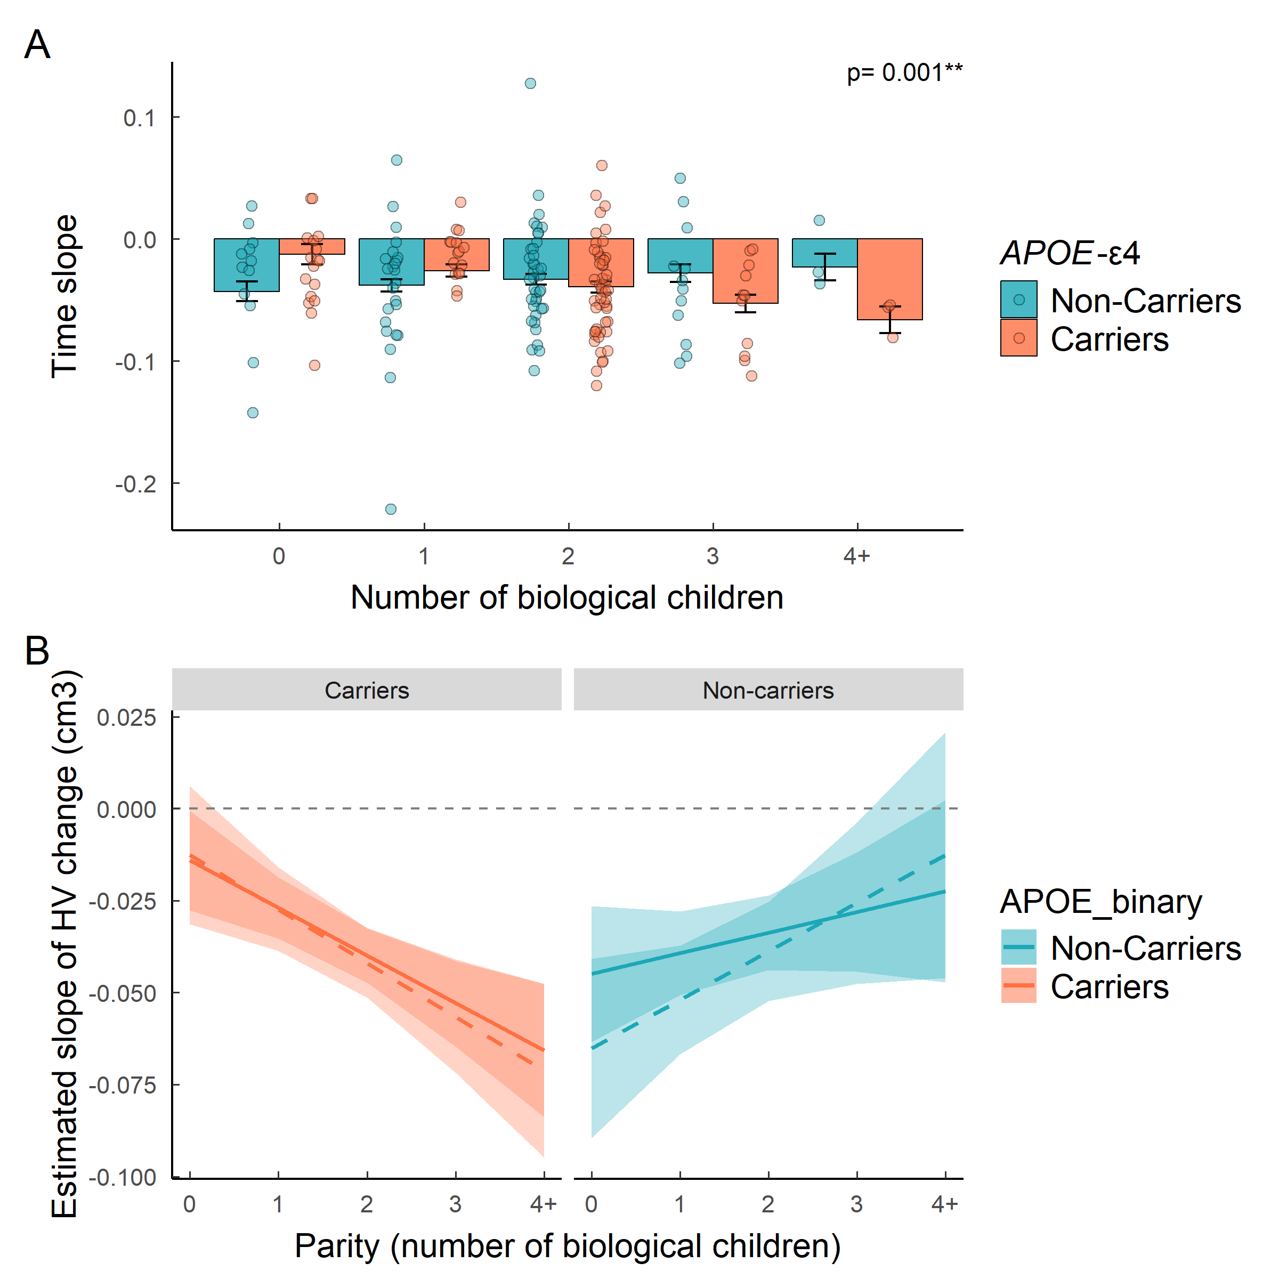

6.2 Figure 2
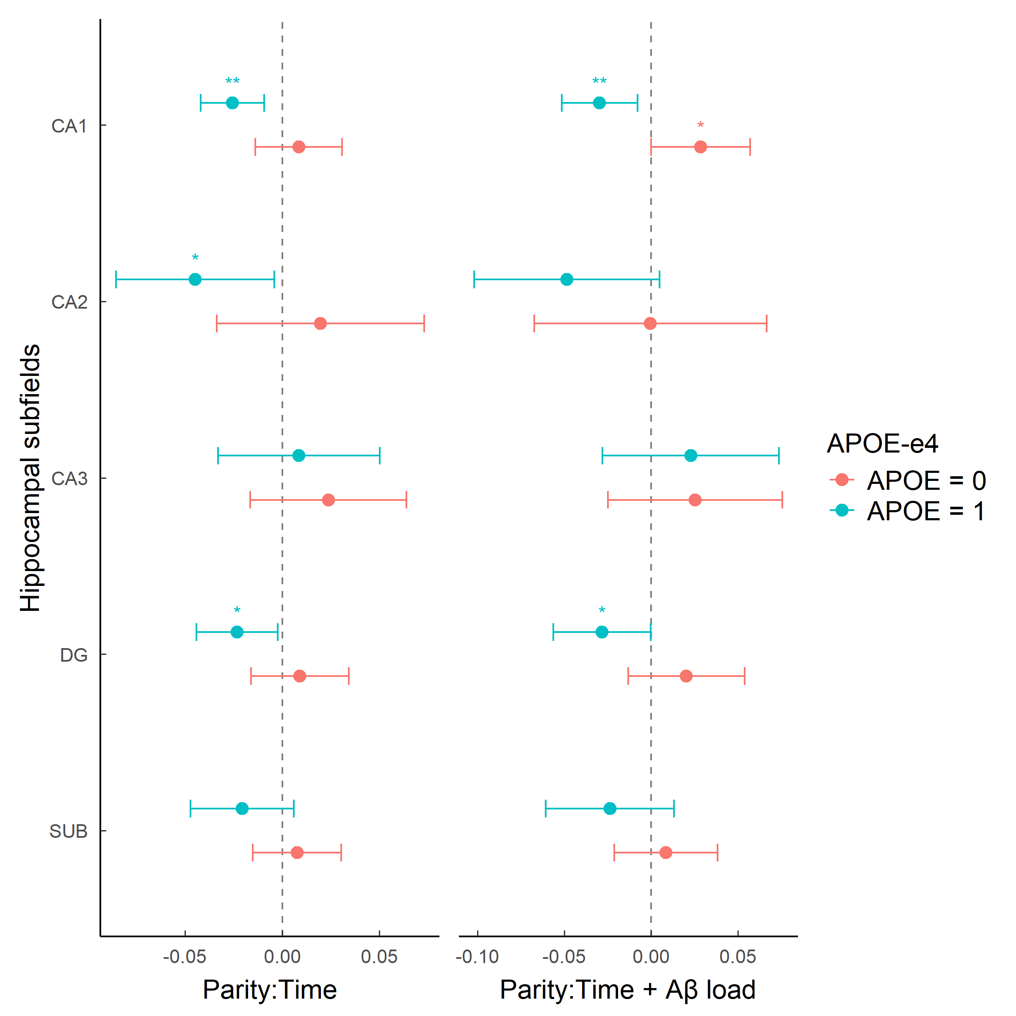

7. Appendix

7.1 MRI data acquisition
MRI scans were acquired on a in-house 3.0 T scanner (GE Discovery MR750 W 3 T) using the same protocol for all participants, which included one T1- and three T2- weighted sequences. The 3D-T1w sequence was designed with an isotropic voxel size of1mm3 and a matrix size of256x256x160 (TR/TE/TI = 8.0/3.7/450 ms, NSA = 1, flip angle = 8°). Three 3D-T2w sequences, with a voxel size of1 mm× 1 mm× 3 mm, were also used: fluid attenuation inversion recovery (FLAIR: TR/TE/ TI = 11,000/90/2600 ms, flip angle = 160°), fast spin echo (FSE: TR/TE = 5000/85 ms, flip angle = 110°) and, gradient echo (GRE: TR/TE = 1300/23 ms, flip angle = 15°). All scans were visually assessed to verify their quality and to detect incidental findings by a trained neuroradiologist and have been reported elsewhere (Brugulat-Serrat et al. 2017). At visit 1, ten participants were excluded due to the presence of a meningioma, as well as 37 participants due to susceptibility, motion artefacts or segmentation problems, resulting in a total of 561 images available for subsequent analysis. At Visit 2, … The medial temporal lobe atrophy was assessed by Medial Temporal Atrophy scale [28].

8.
library(mice)
# Step 1: Set up and run imputation
pred <- make.predictorMatrix(data_ashs_female)
pred[, "subject"] <- -2
pred["subject", ] <- 0
method_vector <- make.method(data_ashs_female)
method_vector[names(data_ashs_female) != "CSF_Abeta_ratio"] <- ""
method_vector["CSF_Abeta_ratio"] <- "pmm"
imp_data <- mice(data_ashs_female,
m = 5,
method = method_vector,
predictorMatrix = pred,
maxit = 50,
seed = 500)
# Step 2: Fit model across all imputations (this is the correct way)
fit <- with(imp_data,
lmer(vol_HIPP ~ kids_total*APOE_binary*diff_mri + CSF_Abeta_ratio+
age_v1 + scale(vol_tiv) + education +
(1|subject)))
# Step 3: Pool results using Rubin's rules
pooled <- pool(fit)
summary(pooled)
# If you want a tidier output
library(broom.mixed)
tidy(pooled, conf.int = TRUE)
[1] Riedel BC, Thompson PM, Brinton RD. Age, APOE and sex: Triad of risk of Alzheimer’s disease. The Journal of Steroid Biochemistry and Molecular Biology 2016;160:134–47. https://doi.org/10.1016/j.jsbmb.2016.03.012.
[2] Altmann A, Tian L, Henderson VW, Greicius MD. Sex modifies the APOE-related risk of developing Alzheimer disease. Annals of Neurology 2014;75:563–73. https://doi.org/10.1002/ana.24135.
[3] Neu SC, Pa J, Kukull W, Beekly D, Kuzma A, Gangadharan P, et al. Apolipoprotein E Genotype and Sex Risk Factors for Alzheimer Disease. JAMA Neurology 2017;74:1178. https://doi.org/10.1001/jamaneurol.2017.2188.
[4] Brett M. Motherhood and memory: A review. Psychoneuroendocrinology 2001;26:339–62. https://doi.org/10.1016/s0306-4530(01)00003-8.
[5] Pritschet L, Taylor CM, Cossio D, Faskowitz J, Santander T, Handwerker DA, et al. Neuroanatomical changes observed over the course of a human pregnancy. Nature Neuroscience 2024;27:2253–60. https://doi.org/10.1038/s41593-024-01741-0.
[6] Hoekzema E, Barba-Müller E, Pozzobon C, Picado M, Lucco F, García-García D, et al. Pregnancy leads to long-lasting changes in human brain structure. Nature Neuroscience 2016;20:287–96. https://doi.org/10.1038/nn.4458.
[7] Straathof M, Halmans S, Pouwels PJW, Crone EA, Hoekzema E. The effects of a second pregnancy on women’s brain structure and function. Nature Communications 2026;17. https://doi.org/10.1038/s41467-026-69370-8.
[8] Servin-Barthet C, Martínez-García M, Paternina-Die M, Marcos-Vidal L, Martín de Blas D, Soler A, et al. Pregnancy entails a U-shaped trajectory in human brain structure linked to hormones and maternal attachment. Nature Communications 2025;16. https://doi.org/10.1038/s41467-025-55830-0.
[9] Duarte-Guterman P, Leuner B, Galea LAM. The long and short term effects of motherhood on the brain. Frontiers in Neuroendocrinology 2019;53:100740. https://doi.org/10.1016/j.yfrne.2019.02.004.
[10] Apostolova LG, Dutton RA, Dinov ID, Hayashi KM, Toga AW, Cummings JL, et al. Conversion of Mild Cognitive Impairment to Alzheimer Disease Predicted by Hippocampal Atrophy Maps. Archives of Neurology 2006;63:693. https://doi.org/10.1001/archneur.63.5.693.
[11] Tucci I, Lacey C, Gawryluk J. The Maternal Brain: Investigating effects of Parity on Brain Structure and Risk for Dementia in Postmenopausal Women. Alzheimer’s & Dementia 2025;21. https://doi.org/10.1002/alz70856_100523.
[12] Lange A-MG de, Barth C, Kaufmann T, Anatürk M, Suri S, Ebmeier KP, et al. The maternal brain: Region-specific patterns of brain aging are traceable decades after childbirth. Human Brain Mapping 2020;41:4718–29. https://doi.org/10.1002/hbm.25152.
[13] Eid RS, Chaiton JA, Lieblich SE, Bodnar TS, Weinberg J, Galea LAM. Early and late effects of maternal experience on hippocampal neurogenesis, microglia, and the circulating cytokine milieu. Neurobiology of Aging 2019;78:1–17. https://doi.org/10.1016/j.neurobiolaging.2019.01.021.
[14] Chen Y, Jin H, Chen J, Li J, Găman M-A, Zou Z. The multifaceted roles of apolipoprotein E4 in Alzheimer’s disease pathology and potential therapeutic strategies. Cell Death Discovery 2025;11. https://doi.org/10.1038/s41420-025-02600-y.
[15] Yu D, Luo L, Wang H, Shyh-Chang N. Pregnancy-induced metabolic reprogramming and regenerative responses to pro-aging stresses. Trends in Endocrinology & Metabolism 2025;36:482–94. https://doi.org/10.1016/j.tem.2024.07.011.
[16] Lee BH, Cevizci M, Lieblich SE, Ibrahim M, Wen Y, Eid RS, et al. Exploring the parity paradox: Differential effects on neuroplasticity and inflammation by APOEe4 genotype at middle age. Brain, Behavior, and Immunity 2024;120:54–70. https://doi.org/10.1016/j.bbi.2024.05.019.
[17] Molinuevo JL, Gramunt N, Gispert JD, Fauria K, Esteller M, Minguillon C, et al. The ALFA project: A research platform to identify early pathophysiological features of Alzheimer’s disease. Alzheimer’s & Dementia: Translational Research & Clinical Interventions 2016;2:82–92. https://doi.org/10.1016/j.trci.2016.02.003.
[18] López-Martos D, Suárez-Calvet M, Milà-Alomà M, Gispert JD, Salvadó G, Brugulat-Serrat A, et al. Longitudinal Associations of Multimodal Core 1 Alzheimer Disease Biomarkers With Cognition in Aging and Preclinical Alzheimer Disease. Neurology 2025;105. https://doi.org/10.1212/wnl.0000000000214308.
[19] Milà-Alomà M, Salvadó G, Gispert JD, Vilor-Tejedor N, Grau-Rivera O, Sala-Vila A, et al. Amyloid beta, tau, synaptic, neurodegeneration, and glial biomarkers in the preclinical stage of the Alzheimer’s continuum. Alzheimer’s & Dementia 2020;16:1358–71. https://doi.org/10.1002/alz.12131.
[20] Yushkevich PA, Pluta JB, Wang H, Xie L, Ding S-L, Gertje EC, et al. Automated volumetry and regional thickness analysis of hippocampal subfields and medial temporal cortical structures in mild cognitive impairment. Human Brain Mapping 2014;36:258–87. https://doi.org/10.1002/hbm.22627.
[21] Smith SM. Fast robust automated brain extraction. Human Brain Mapping 2002;17:143–55. https://doi.org/10.1002/hbm.10062.
[22] Karlsson L, Janelidze S, Barthélemy NR, Horie K, Therriault J, Gaetani L, et al. Reference proteins to improve Core 1 and Core 2 Alzheimer’s disease CSF and plasma biomarkers. Brain 2025;149:1153–67. https://doi.org/10.1093/brain/awaf375.
[23] Lenth RV, Piaskowski J. Emmeans: Estimated marginal means, aka least-squares means 2017. https://doi.org/10.32614/cran.package.emmeans.
[24] Wickham H, Averick M, Bryan J, Chang W, McGowan L, François R, et al. Welcome to the tidyverse. Journal of Open Source Software 2019;4:1686. https://doi.org/10.21105/joss.01686.
[25] Sjoberg Daniel,D, Whiting K, Curry M, Lavery Jessica,A, Larmarange J. Reproducible Summary Tables with the gtsummary Package. The R Journal 2021;13:570. https://doi.org/10.32614/rj-2021-053.
[26] Lüdecke D. Ggeffects: Tidy data frames of marginal effects from regression models. Journal of Open Source Software 2018;3:772. https://doi.org/10.21105/joss.00772.
[27] Bates D, Mächler M, Bolker B, Walker S. Fitting Linear Mixed-Effects Models Usinglme4. Journal of Statistical Software 2015;67. https://doi.org/10.18637/jss.v067.i01.
[28] Scheltens P, Weinstein HC, Leys D. Neuro-imaging in the diagnosis of Alzheimer’s disease I. Computer tomography and magnetic resonance imaging. Clinical Neurology and Neurosurgery 1992;94:277–89. https://doi.org/10.1016/0303-8467(92)90175-3.

