Chapter 1 - Multinational Financial Management: Opportunities and Challenges
Prof. Barker
2026-03-03
Table of contents

1. Introduction
“The best math you can learn is how to calculate the future cost of current decisions.”
This course is about exploring what makes multinational financial management both uniquely challenging and remarkably rewarding.
Think about this: “How often have you have used a product that was made by a company operating in multiple countries?”
This simple exercise demonstrates that we live in a deeply interconnected global economy. The phone in your pocket, the coffee you drank this morning, the streaming service you use - all likely involve multinational enterprises (MNEs) managing complex financial operations across borders.

Chapter Roadmap
Four major section:
- The Global Financial Marketplace - Understanding the players, institutions, and linkages
- Theory of Comparative Advantage - Why international trade and investment make economic sense
- What Makes International Finance Different - The unique challenges MNEs face
- The Globalization Process - How companies evolve from domestic to truly global operations

1.1 The Global Financial Marketplace

1.1.1 The Players
Multinational Enterprises (MNE) are companies or businesses that have operations in more than one country and conduct their business through branches, foreign subsidiaries, or joint ventures with host country firms.

1.1.2 The Playing Field
Think of the global financial marketplace as a complex ecosystem with three fundamental components:

1.1.2.1 Assets (Financial Assets)
These are the debt securities issued by governments. These form the baseline for other forms of financing.
- At the foundation are government debt securities - US Treasury Bonds, UK gilts, German bunds
- These “risk-free” securities form the benchmark for pricing all other assets
- Built upon this foundation: corporate bonds, equities (stocks), bank loans
- More recently: derivatives - financial instruments whose value derives from underlying assets
Critical Point: The health of the global financial system depends on the quality of these securities. When securities fail (remember the 2008 financial crisis with mortgage-backed securities), the entire system suffers.

1.1.2.2 Institutions
These are the governmental, commercial, and private banks. Their health keeps the global financial system stable.
- Central Banks: Create and control money supply (Federal Reserve, European Central Bank, Bank of Japan)
- Commercial Banks: Take deposits and extend loans both domestically and internationally
- Investment Banks & Financial Institutions: Trade securities, facilitate capital flows, create financial products

1.1.2.3 Linkages
These are the interbank networks using currency. Without ready exchange of currencies, the market is hard-pressed to operate efficiently.
- This is the “plumbing” of the global financial system
- Uses CURRENCY as the medium of exchange
- Historically centered on LIBOR (London Interbank Offered Rate)
- Important note: LIBOR is being phased out and replaced (we’ll study this in Chapter 8)
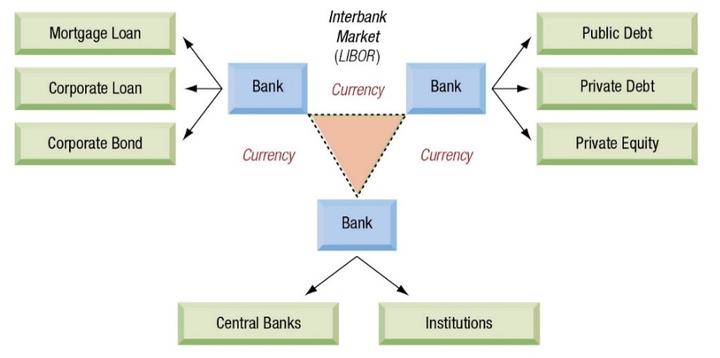
The Global Capital Markets

1.1.3 The Market for Currencies
Key Concept: A foreign exchange rate is simply the price of one currency in terms of another.
Example:
EUR 1.00 = USD 1.1274
or
USD 1.1274 = EUR 1.00

1.1.3.1 Important Terminology Discussion
(Reading exchange rates can be confusing, but it just takes practice.)
There are different ways to express the same exchange rate:
- Traditional notation: $1.1274/€ (read as “1.1274 dollars per euro”)
- ISO (International Organization for Standardization) code format: USD1.1274 = EUR1.00
- Financial press variations:
  - EUR/USD 1.1274
  - EUR-USD 1.1274
  - EURUSD 1.1274
All mean the same thing. The key is understanding which currency is the “base” (the one that equals 1.00) and which is the “quote” (the price).
Convention to Remember (Please note the inconsistency that makes this tricky):
- EUR, GBP (British pound), and some Commonwealth currencies are typically quoted as “dollars per foreign currency”
- Most other currencies quote as “foreign currency per dollar”
Why does this matter? Because when you calculate percentage changes or returns, you need to know which currency is in the numerator and which is in the denominator.

1.1.4 Calculating Percentage Changes in Exchange Rates
Please pay attention to this.
Let’s work through the Argentinian peso example from your textbook:
Question: What happened to the peso’s value?
Scenario: December 16, 2015 - Argentina lifts currency controls allowing its citizens to move money outside of the country.
- Beginning rate (12/16/15): ARG 9.7908 = USD 1.00
- Ending rate: (12/17/15) ARG 13.6160 = USD 1.00

1.1.4.1 Method 1 - Foreign Currency Terms (Foreign currency per USD)
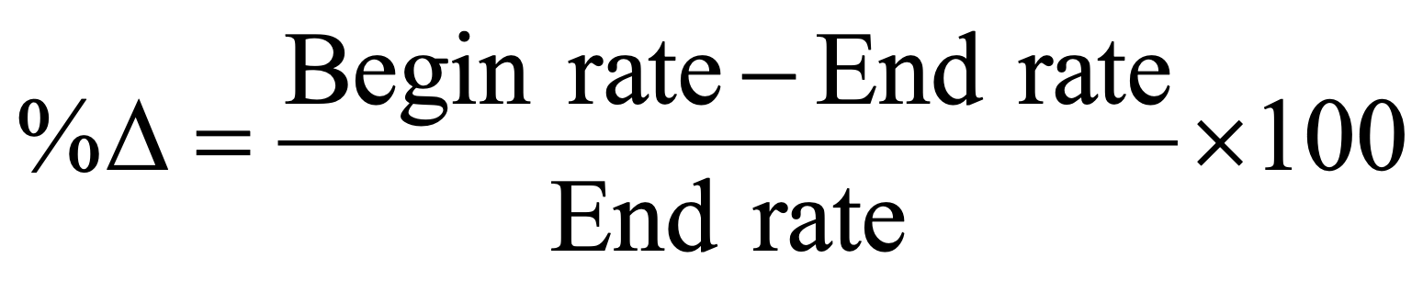
Foreign Currency Terms
Method 1 Calculation:
Beginning rate: ARG 9.7908 = USD 1.00
Ending rate: ARG 13.616 = USD 1.00
Percentage change: -28.09 %
Interpretation: The peso FELL 28.09% in value. Notice:
- It takes MORE pesos to buy one dollar (went from 9.7908 to 13.616)
- The calculation yielded a NEGATIVE number
- Both indicate depreciation

1.1.4.2 Method 2 - Home Currency Terms (USD per foreign currency)
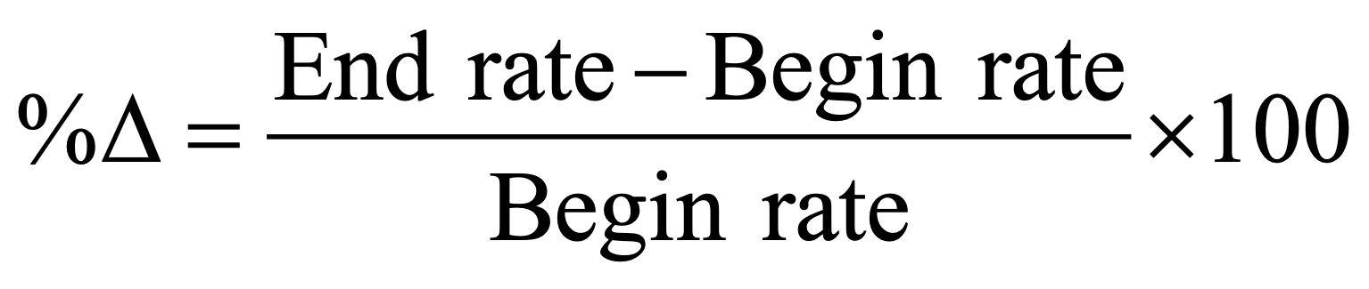
Home Currency Terms
First, we need to flip (take the inverse) of the rates (USD 1/ ARG 9.7908 = 0.10214 and USD 1/ARG 13.6160 = 0.07344).
This tells us how much USD that 1 ARG peso could buy. 1 ARG peso could buy $0.10 on 12/16/15, and only $0.07 on 12/17/15. In 24 hours, the ARG lost purchasing power compared to the USD. A little estimation tells us the ARG lost approximately 30% of purchasing power (from $0.10 to $0.07).
We do this because we are looking at the effect on the “Home” currency, the US Dollar.
Method 2 Calculation:
Beginning rate: USD 0.10214 = ARG 1.00
Ending rate: USD 0.07344 = ARG 1.00
Percentage change: -28.09 %
Both calculations give us the same answer The peso fell 28.09%. (This is very close to our estimation of 30%.)
Teaching Point: Many find Method 2 more intuitive because it follows the standard “end minus beginning over beginning” formula. However, both methods MUST give the same answer.

1.1.4.3 Practice Problem
If the Mexican peso changes from MXN 16.00 = USD 1.00 to MXN 20.00 = USD 1.00, what is the percentage change? Do the calculations using the equations above and see if you get the correct answer.
Mexican Peso Change:
Answer: -20 %
Currency exchange is one of the major themes in International Finance. Please refer back to this section periodically if you need to review.
Now shifting gears back to the bigger picture…

1.1.5 Eurocurrencies and the Eurocurrency Interest Rates
Critical Definition: Eurocurrencies are deposits of a currency held in banks OUTSIDE that currency’s home country.
Examples:
- Eurodollars: US dollars deposited in a London bank
- Euroyen: Japanese yen deposited in a Singapore bank
- Eurosterling: British pounds deposited in a Paris bank
Very Important: The “euro” prefix has NOTHING to do with the European currency. This terminology predates the euro.

1.1.5.1 Historical Origin (Fascinating backstory)
- Born after WWII
- Soviet Union and Eastern European countries held US dollars
- Feared US government might freeze these dollar assets
- Deposited dollars in European banks instead (particularly in London)
- The market grew from there
- A country generally cannot freeze the currency of another country if it is held in an foreign bank, unless the foreign entity agrees to freeze those assets as well. For example, the U.S. cannot freeze the assets of Russia if the funds are held in a Belarus bank, unless Belarus agrees to freeze the funds as well.

1.1.5.2 Eurocurrency Interest Rates - Why Does This Market Exist and Thrive?
- Regulatory Arbitrage: Fewer regulations than domestic banking
  - No reserve requirements
  - No deposit insurance costs (like FDIC in the US)
  - Less bureaucratic overhead
- Narrow Spreads: The difference between deposit and loan rates is often less than 1%
  - Why? Wholesale market (large transactions, $500,000+)
  - Creditworthy borrowers (corporations, governments)
  - Lower overhead costs
- Two Primary Functions:
  - Money market device: Corporations park excess cash, earning higher interest than domestic alternatives
  - Lending source: Companies borrow for working capital, trade finance
LIBOR Connection: The London Interbank Offered Rate (LIBOR) is the benchmark interest rate for the eurocurrency market. It represents the rate at which banks lend to each other in London.
Others currently exist: Paris (PIBOR), Madrid (MIBOR), Singapore (SIBOR), and Frankfurt (FIBOR)
Current Developments: LIBOR is being replaced due to manipulation scandals. We’ll explore this transition in detail in Chapter 8.

**Pre 1.2 - Wayback Machine

Why or how do nations exist?
One theory (by Mancur Olson) supposes that originally people were nomadic clans that finally settled in a certain location. Periodically, roving bandits would ransack and pillage the community leaving them destitute, and riding off into the sunset (or wherever bandits roam). Then the community would rebuild, replant their crops, raise their livestock, and recover.
Just in time for the bandits to return and raid and pillage again.
This happened over and over. Until…
The bandit (and the people) recognized that they could form a mutually beneficial agreement.
The bandit would protect the village from outsiders (other roving bandits), and in return the people would pay the bandit.
During the period while the roving bandit raided the village, there was no incentive for the people to work hard or to invest in building farms or ranches, knowing that, any day, the bandit would return and steal everything they had worked for so hard.
After the bandit became stationary, even though a portion of their produce went to the bandit, there was incentive to invest, growth, and thrive.
And the nation-state was born.
(There are other theories, but this is my favorite.)

Logical Structure
Roving Bandit: Anarchy → Low Investment → Low Output
- Hypothetically, if you knew that your instructor would periodically walk throughout the classroom and confiscate any of your property they chose, would you bring anything of value to class? Of course not.
Stationary Bandit: Protection + Order → Investment + Planning → Higher output + Tax base
Implications for International Finance
- Property rights reduce discount rates (future matters more).
- Capital formation becomes possible.
- Financial intermediation develops because lenders expect repayment.
- States create courts, contract enforcement, currencies.

1.2 Theory of Comparative Advantage

1.2.1 Foundational Economic Theory
Driving question: “Why do countries trade with each other?”
The theory of comparative advantage, developed by David Ricardo in 1817 (building on Adam Smith’s work from 1776), provides the intellectual foundation for understanding international trade and investment.
- Trade makes people better off when preferences differ.
- Trade increases productivity through specialization and the division of knowledge.
- Trade increases productivity through comparative advantage.

1.2.2 Core Concepts

1.2.2.1 Absolute Advantage (Adam Smith)
- A country should specialize in producing goods it can make most efficiently
- Trade these for goods other countries make more efficiently
- Result: More total production, lower prices, higher quality of life
Core definition - Absolute Advantage - A nation has absolute advantage when it produces a good with fewer resources (or lower cost) than others.
Idea: If Country A produces a good with lower unit cost than Country B, specialization and trade reduce prices and raise consumption possibilities.
Mechanisms relevant to finance:
- economies of scale → lower average costs
- capital deepening
- technology diffusion through trade relationships
Why gains emerge:
- Specialize where productivity is highest relative to the alternative uses of resources.
- Smith’s pin factory (famous story from the Wealth of Nations):
  - Specialization increases productivity because of:
    - Learning by doing
    - Reduced switching costs
    - Innovation in task-specific tools
Broad example:
- One worker doing everything → 10 pins/day.
- Ten specialized workers → 48,000 pins/day.
Key takeaway: Productivity is organizational, not merely technological.
Alternative example that is more than just financial:
- One bar of iron costs about $5,
- Or worth about $50 if made into horseshoes,
- Or between $3,500-$5,000 if made into needles,
- Or over $500,000 if made into watch spring.
“Human potential is shaped by effort and skill, not just by inherent qualities.”
What you make of your life is mostly determined by your choices, not your circumstances.
Connection to trade:
- Specialization requires exchange:
  - No reason to specialize unless you can trade for what you lack.
  - Markets expand as specialization deepens.
  - Institutions must support contracts, credit, price systems.
Absolute advantage explains some trade, but not enough. Ricardo’s insight goes deeper.

1.2.2.2 Comparative Advantage (David Ricardo)
- Even if one country has absolute advantage in producing EVERYTHING, both countries benefit from specialization
- Each country should specialize in what it does RELATIVELY better than others
- The key word is “comparative” - relative, not absolute
OPPORTUNITY COST - what do we have to give up to get something?
- This is the relative, or comparative difference between the productive abilities of countries.

1.2.2.3 Simple Example
Imagine two countries - the US and China:
- US: Can produce either 100 computers OR 200 bushels of wheat with the same resources
- China: Can produce either 50 computers OR 150 bushels of wheat with the same resources
Even though the US has absolute advantage in computers, China might still have comparative advantage in wheat production if the opportunity costs differ appropriately.
Who has the comparative advantage in each good? And who should produce computers or wheat?

1.2.3 Modern Reality vs. Theory
The textbook presents important limitations to pure comparative advantage theory:

1.2.3.1 Government Interference
- Tariffs and quotas
- Subsidies to domestic industries
- Political motivations (food security, defense industries, employment goals)
Example: Many countries protect their agricultural sectors even when they’re not the most efficient producers, because food security is considered a national security issue.

1.2.3.2 Factor Mobility
- Classical theory assumed factors of production (land, labor, capital) stayed within countries
- Modern reality: Capital flows freely across borders
- Technology transfers rapidly
- Even labor moves (though less freely than capital, think immigration, both legal and illegal)

1.2.3.3 More Complex Factors of Production
Modern location decisions consider:
- Managerial expertise
- Legal and regulatory environment
- R&D capabilities
- Education levels of workforce
- Infrastructure quality
- Access to capital markets
- Tax differentials
- Political stability

1.2.3.4 Comparative Advantage Shifts Over Time
Example from Textbook:
Cotton textile production comparative advantage has shifted over 150 years:
- United Kingdom (1800s) → United States (early 1900s) → Japan (mid-1900s) → Hong Kong → Taiwan → China (present)
This illustrates how comparative advantage is dynamic, not static.

1.2.4 Relevance Today
Despite limitations, comparative advantage remains highly relevant:
Modern Application: Service outsourcing and the global supply chain
- Financial back offices in Manila (Philippines)
- IT engineering in Hungary and India
- Manufacturing in Vietnam and Bangladesh
- Design and innovation in Silicon Valley
Key Insight: Modern comparative advantage is based on:
- Labor skills and costs
- Access to capital
- Technology and innovation capacity
- Telecommunications infrastructure
Question for Discussion: “Can you think of services or products where the US maintains comparative advantage?”

1.3 What Makes International Finance Management Different?

Framework for Understanding Differences
International financial management differs from domestic finance in six key dimensions:
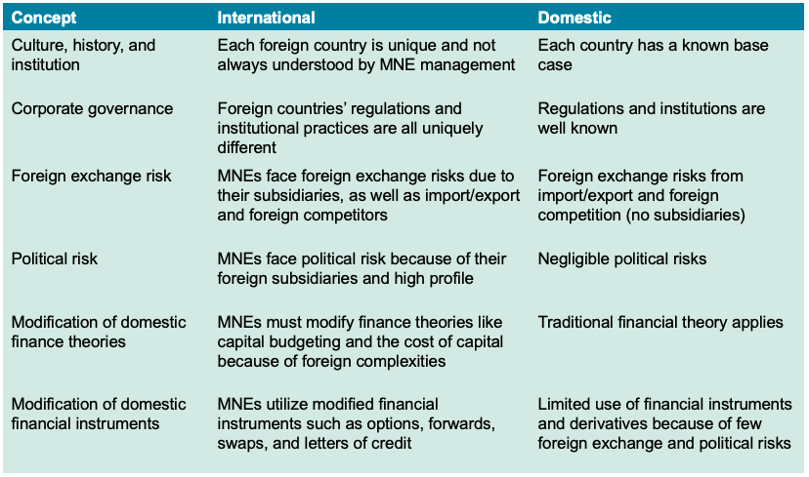
Key Differences

1.3.1 Culture, History, and Institutional Differences
Cultural Challenges
- Business practices vary enormously
- Contract interpretation differences
- Relationship vs. transaction orientation
- Time orientation (short-term vs. long-term)
Example: In many Asian business cultures, building relationships (guanxi in China) is prerequisite to doing business. In the US, contracts often precede relationships.
Historical Context
- Legal systems differ (common law vs. civil law vs. religious law)
- Accounting standards vary (though IFRS is harmonizing some)
- Property rights protection differs dramatically
Institutional Frameworks
- Banking system structures
- Capital market development levels
- Government roles in economy
- Corruption and governance quality
Real World Impact: A company expanding to a new country must understand these differences. What works in New York may fail in Mumbai or Moscow - not because the financial principles are different, but because the operating environment is different.

1.3.2 Corporate Governance Differences
Critical Point: Not all countries have the same ownership structures or governance models.
Three Primary Models
1. Anglo-American Model:
- Dispersed shareholders
- Active stock markets
- Strong shareholder rights
- Goal: Maximize shareholder value
- Examples: US, UK, Canada, Australia
2. Continental European Model:
- Concentrated ownership (families, banks, other corporations)
- Stakeholder orientation (employees, community, shareholders)
- Bank-centered finance
- Examples: Germany, France, Italy
3. Asian Model:
- Often family-controlled (even in public companies)
- Keiretsu in Japan, Chaebol in Korea
- Network relationships important
- State ownership common (especially China)
Why This Matters:
- Affects access to capital
- Influences financial decisions
- Determines accountability structures
- Shapes strategic objectives

1.3.3 Foreign Exchange Risk
This is THE defining characteristic of international finance.
- Domestic firm: All transactions in one currency
- International trading firm: Some transactions in foreign currencies (import/export)
- Multinational firm: Extensive foreign currency exposure through:
  - Foreign sales and revenues
  - Foreign costs and expenses
  - Foreign assets and liabilities
  - Foreign subsidiary operations
Types of Foreign Exchange Exposure
1. Transaction Exposure (Chapter 10):
- Committed but not yet settled foreign currency transactions
- Example: US company sells to German customer, invoice for €1 million due in 90 days
- Risk: Euro value could fall during 90 days
2. Translation (Accounting) Exposure (Chapter 11):
- Converting foreign subsidiary financial statements to home currency
- Even if foreign operations are stable, exchange rate changes affect reported results
3. Economic (Operating) Exposure (Chapter 12):
- Long-term competitiveness effects from exchange rate changes
- Hardest to measure but potentially most significant

1.3.4 Political Risk (Chapter 17)
Definition: Risk that government actions will adversely affect business operations or asset values.
Types of Political Risk
1. Transfer Risk:
- Blocked funds (cannot repatriate earnings)
- Example: Argentina imposing currency controls
2. Expropriation:
- Government seizure of assets
- May or may not include compensation
- Less common today but still occurs
3. Operational Restrictions:
- Local content requirements
- Technology transfer mandates
- Forced joint ventures
- Price controls
4. Regulatory Changes:
- Tax law changes
- Labor law changes
- Environmental regulation
Recent Examples:
- Russia’s actions in Ukraine affecting Western companies
- China’s regulatory crackdowns on tech companies
- India’s changing tax treatment of foreign firms
Key Point: Political risk is hard to quantify, difficult to hedge, but absolutely must be considered in international investment decisions.

1.3.5 Modifications to Financial Theory
Core financial theories remain valid but require adaptation:
Cost of Capital
- Must consider multiple country risk premiums
- Currency risk affects required returns
- Access to global capital markets can LOWER cost of capital
Capital Budgeting
- Project cash flows may be in foreign currency
- Repatriation restrictions must be considered
- Country risk must be incorporated
- Multiple tax jurisdictions complicate analysis
Working Capital Management
- Multiple currencies to manage
- International cash pooling opportunities
- More complex credit analysis for foreign customers
Capital Structure
- Access to foreign debt markets
- Currency matching strategies (financing in same currency as revenues)
- Different optimal leverage ratios in different countries

1.3.6 Modified Financial Instruments
International finance has adapted standard instruments:
Currency Derivatives
- Forward contracts
- Futures
- Options on currencies
- Currency swaps
Interest Rate Instruments
- Cross-currency interest rate swaps
- International bonds (Eurobonds, foreign bonds)
Trade Finance Instruments
- Letters of credit
- Banker’s acceptances
- Documentary collections
Preview: We’ll study many of these in detail in later chapters.

1.3.7 Why Do Firms Go Global?
Strategic Motivations (Five Categories):
1. Market Seekers:
- Produce in foreign markets to serve local demand
- Overcome trade barriers
- Get closer to customers
- Example: US auto manufacturers in Europe
2. Raw Material Seekers:
- Access natural resources where they’re located
- Mining, oil, forestry, agricultural products
- Example: Oil companies drilling in Middle East
3. Production Efficiency Seekers:
- Take advantage of lower-cost factors of production
- Especially labor
- Example: Electronics assembly in Malaysia, Vietnam
4. Knowledge Seekers:
- Access technology, expertise, innovation
- Example: Japanese and German companies buying US tech firms
5. Political Safety Seekers:
- Diversify political risk
- Example: Hong Kong firms investing in Canada, Australia before 1997 Chinese takeover
Each of these strategies should be either Proactive or Defensive:
- Proactive investments are designed to enhance the growth and profitability of the firm itself.
- Defensive investments are designed to deny growth and profitability to the firm’s competitors.
Important Note: These are not mutually exclusive. One investment may serve multiple purposes.

1.4 The Globalization Process

1.4.1 Introducing Ganado Corporation
Ganado is our textbook’s case company we’ll follow throughout the semester.
Background
- Founded 1948 in Los Angeles
- Originally family-owned telecommunications equipment manufacturer
- Went public (IPO) in 1988 - became a publicly traded company
- Now faces decisions about global expansion
Why This Matters: Ganado’s journey mirrors what thousands of real companies experience as they globalize.

1.4.2 Phase 1: Domestic to International Trade
Domestic Phase Characteristics
- All suppliers are domestic (US)
- All customers are domestic (US)
- All transactions in US dollars
- Subject only to US laws and regulations
- Credit assessment under familiar US practices
Simple and low-risk, but limited growth potential.
Catalyst for Change:
NAFTA (North American Free Trade Agreement) created opportunities for trade with Mexico and Canada.
International Trade Phase
- BEGIN importing from Mexican suppliers
- BEGIN exporting to Canadian customers
- NOW dealing with multiple currencies (USD, MXN, CAD)
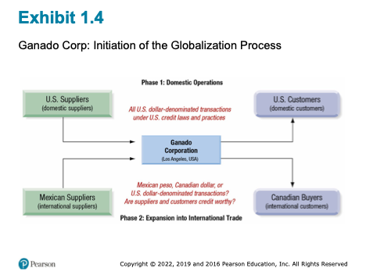
Initiation of the Globalization Process
Two New Major Challenges
- Foreign Exchange Risk:
- Which currency to quote prices in?
- Which currency to accept payment in?
- Which currency to pay suppliers in?
- What if exchange rates change between agreement and payment?
- Credit Risk Assessment:
- How creditworthy is Mexican supplier?
- Will Canadian customer actually pay?
- Different business practices
- Different legal systems
- Different bankruptcy laws
- Less available information
Key Point: Even in this relatively simple international trade phase, financial management complexity increases dramatically compared to purely domestic operations.

1.4.3 Phase 2: International Trade to Multinational Enterprise
Critical Decision Point: At some point, successful international trading leads companies to consider foreign direct investment (FDI).
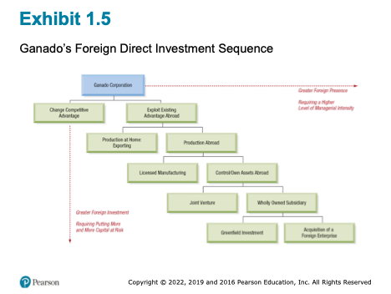
Foreign Direct Investment Sequence

1.4.4 The Foreign Direct Investment Spectrum

1.4.4.1 Increasing Foreign Presence (Low to High)
1. Exporting from Home Production
- Lowest commitment
- Maintain control
- Limited foreign presence
2. Licensing to Foreign Firms
- Foreign company produces under your brand/technology
- Receive royalties
- Low capital investment
- Risk: Creating future competitors, loss of quality control
3. Joint Venture
- Partner with local firm (often 50-50 ownership)
- Share investment, share risks, share rewards
- Common in countries requiring local partners
- Challenge: Potential conflicts with partner
4. Wholly-Owned Subsidiary - Greenfield
- Build new facilities from scratch (“greenfield”)
- Full control
- High investment
- Slow to establish
5. Wholly-Owned Subsidiary - Acquisition
- Buy existing foreign company
- Fastest market entry
- Immediate operations
- Integration challenges
- Potentially very expensive
Key Insight: As you move down this list:
- Foreign presence increases (more physical assets, more employees abroad)
- Managerial intensity increases (more complex to manage)
- Capital at risk increases (more investment)
- Potential returns increase (greater opportunities)

1.4.5 Consolidation Challenges
This is a critical practical issue. Once Ganado has foreign subsidiaries:
- European subsidiary keeping books in euros
- Chinese subsidiary keeping books in yuan
- US parent keeping books in dollars

1.4.5.1 The Problem
Ganado must periodically (quarterly, annually) produce consolidated financial statements in US dollars for:
- Shareholders
- SEC (Securities and Exchange Commission) regulations
- Tax purposes
- Performance evaluation

1.4.5.2 The Process
- Each subsidiary reports in local currency
- Convert to common currency (USD) using appropriate exchange rates
- Sum to create consolidated totals
Critical Issue: Exchange rates change constantly. From one quarter to the next:
- Foreign subsidiary performance may be stable
- BUT exchange rate changes make it look better or worse
- This creates “translation exposure” or “accounting exposure”

1.5 Limits to Financial Globalization

1.5.1 Not All Globalization is Inevitable or Beneficial
Classical economic theory suggests capital should flow freely to its most productive uses globally. Reality is more complex.

1.5.2 The “Twin Agency Problems”
Agency Problem Definition: When someone managing assets (agent) has different interests than the asset owners (principals)
There is a growing debate over whether many of the insiders and rulers of organizations with enterprises globally are taking actions consistent with creating firm value or consistent with increasing their own personal stakes and power.
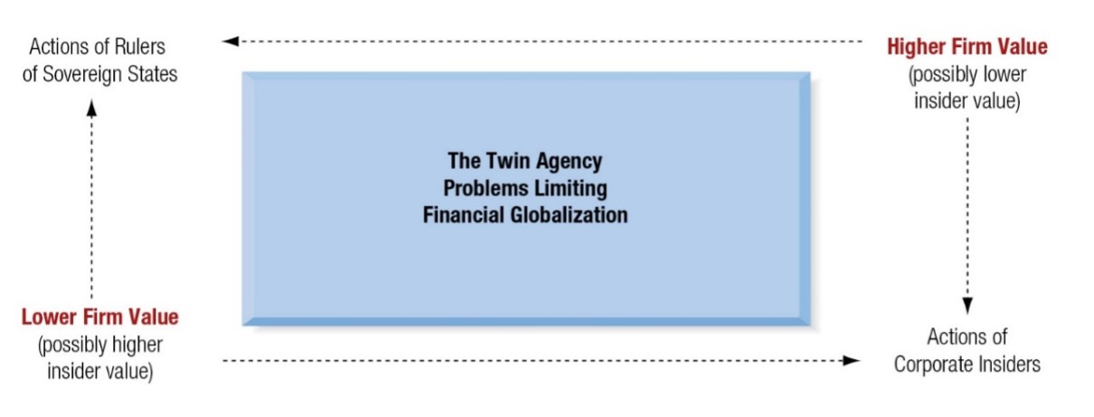
Limits of Financial Globalization
If these influential insiders are building wealth over that of the firm, it will result in preventing the flow of capital across borders, currencies, and institutions to create a more open and integrated global financial community.

1.5.2.1 First Agency Problem - Corporate Insiders
- Do managers/executives pursue firm value maximization?
- OR do they pursue personal wealth/power?
Examples of Value-Destroying Insider Actions:
- Excessive compensation
- Empire building (growth for prestige, not returns)
- Resistance to beneficial takeovers
- Related-party transactions that benefit insiders

1.5.2.2 Second Agency Problem - Government/Sovereign Insiders
- Do political leaders pursue national economic welfare?
- OR do they pursue personal power/wealth?
Examples:
- Corruption
- Expropriation
- Capital controls that harm economy but protect political power
- Regulatory capture

1.5.3 Consequences for Global Capital Flows
IF corporate and government insiders pursue value maximization:
→ Capital flows to these opportunities
→ Financial globalization INCREASES
→ Benefits widely shared
IF insiders pursue personal agendas:
→ Capital avoids these situations
→ Financial globalization LIMITED
→ Creates “winners” and “losers”
→ Segmented markets

1.5.3.1 Real-World Examples
Positive Examples (Attracting Capital):
- Singapore: Strong rule of law, low corruption, excellent governance
- Result: Major financial center despite small size
Negative Examples (Capital Flight):
- Venezuela: Expropriation, corruption, poor governance
- Result: Economic collapse, capital flees

1.5.4 Contemporary Challenges

1.5.4.1 Three Current Issues
1. Inequality:
- Globalization benefits not evenly distributed
- Within-country inequality increasing
- “Left behind” populations creating political backlash
2. Regulatory Arbitrage:
- Companies structure operations to minimize taxes
- “Tax havens” and profit shifting
- Creates political tensions
3. National Security vs. Economic Efficiency:
- Growing restrictions on foreign investment in “strategic” sectors
- Technology transfer concerns
- Supply chain security concerns
Example: US restrictions on Chinese investment in American technology companies, even when economically beneficial.

1.5.5 The Path Forward
“Welcome to the future. This will be a constant struggle. We need leadership, citizenship, and dialogue.”
- Donald Lessard
Key Takeaway: Financial globalization is neither inevitable nor uniformly beneficial. Success requires:
- Strong institutions
- Good governance
- Ethical leadership
- Informed citizenry
- Ongoing dialogue and adaptation

1.6 Conclusion and Synthesis

1.6.1 Connecting the Dots
Let’s bring together these major themes:

1.6.1.1 The Global Financial Marketplace
- Complex ecosystem of securities, institutions, and currency linkages
- Larger and more interconnected than ever
- Creates both opportunities and risks

1.6.1.2 Comparative Advantage
- Still explains why international trade benefits countries
- Modern version focuses on services, skills, technology
- Dynamic, not static - shifts over time

1.6.1.3 What Makes International Finance Unique
- Foreign exchange risk
- Political risk
- Cultural and institutional differences
- Corporate governance variations
- Required modifications to financial theories and instruments

1.6.1.4 The Globalization Journey
- Progression from domestic → international trade → multinational
- Each phase brings new opportunities and new complexities
- Not all firms should fully globalize
- Not all globalization creates value

1.6.1.5 Limits and Challenges
- Agency problems at corporate and sovereign levels
- Potential for value destruction
- Ongoing tension between efficiency and other goals (security, equity, stability)

1.6.2 Looking Ahead
Next chapters will build on this foundation:
- Chapter 2: International Monetary System - How currencies interact, exchange rate regimes
- Chapter 3: Balance of Payments - How we track international flows
- Chapter 4: Corporate Governance in depth - Different models worldwide
- Later: Foreign exchange markets, currency derivatives, international investment, multinational capital budgeting

1.6.3 Why This Matters to You

1.6.3.1 Career Relevance
- Almost every major company operates internationally
- Understanding these concepts makes you more valuable
- Finance, marketing, operations, strategy all require international awareness

1.6.3.2 Citizenship
- Trade policy
- Tax policy
- Immigration
- National security
All involve international finance concepts.

1.6.3.3 Personal Finance
- International diversification
- Currency considerations
- Understanding global markets

1.6.4 Practical Advice for Success in This Course

1.6.4.1 Stay Current
- Read Financial Times, Wall Street Journal, The Economist
- Follow exchange rates
- Track international business news

1.6.4.2 Think Critically
- Don’t just memorize formulas
- Understand the “why” behind concepts
- Question assumptions

1.6.4.3 Connect Concepts
- International finance is integrative
- Links to economics, politics, strategy, culture
- Make connections across chapters

1.6.4.4 Use Real Examples
- Apply concepts to companies you know
- Follow a multinational company throughout semester
- Analyze current events through international finance lens

1.7 Preview Next Section
What’s next:
- The International Monetary System (Chapter 2)
- Fixed vs. floating exchange rates
- The role of the IMF and World Bank
- Major currency crises in history
- The future of the dollar as reserve currency

1.8 Final Thoughts
International finance is one of the most dynamic, challenging, and relevant fields in business today. Every concept we study has real-world application. Every formula we learn represents actual business decisions.
The world is more connected than ever, which creates unprecedented opportunities for those who understand how to navigate the global financial marketplace. It also creates risks for those who don’t.
The goal is to help you develop not just technical competence, but also strategic insight and critical thinking about international finance. This first chapter laid the foundation - now we build.
Please review Chapter 1, work on any assignments, and don’t hesitate to email me with questions.

