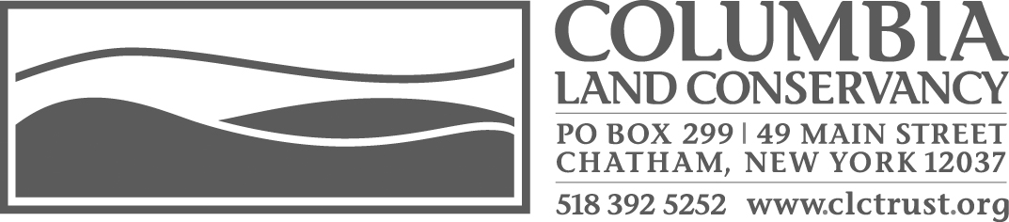
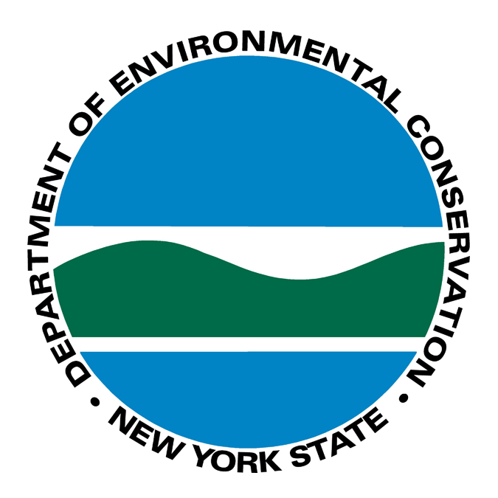
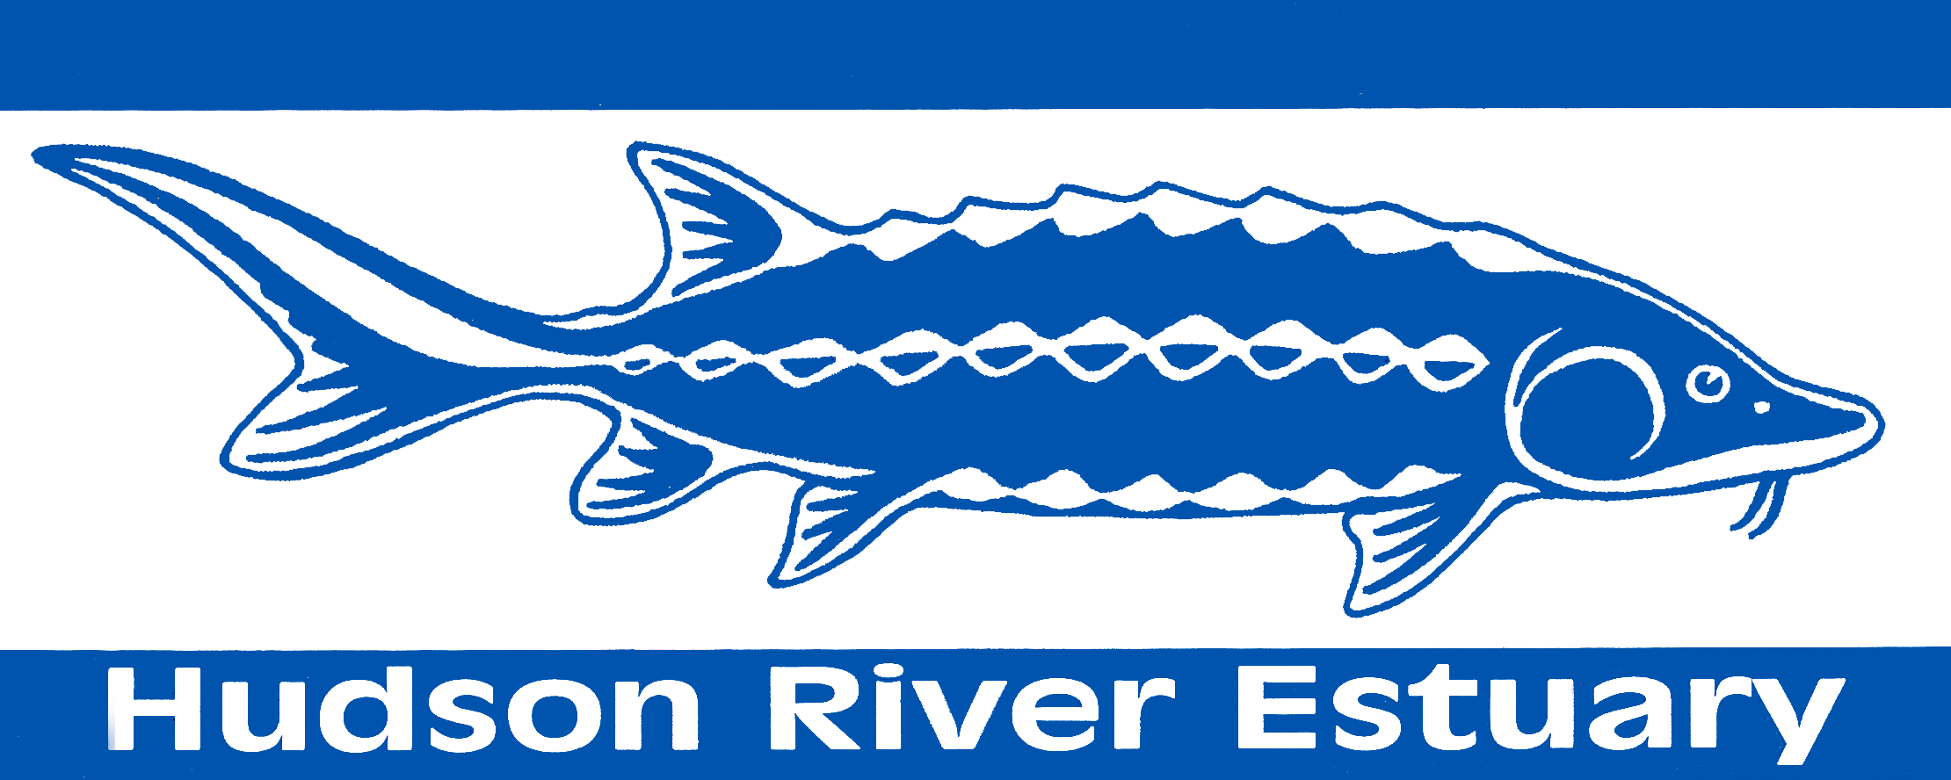

Registration Form

Columbia Land Conservancy with the
Hudson River Estuary Program, NYSDEC/Cornell University
Invite you to the 2013 Land Use Workshop Series

A Better Way to Get There
Two Workshops on Rural Road Design & Management

Part 1: Planning for Better Roads Tuesday, October 1, 5:30 to 7:30 p.m.
Part 2: Better Road Design & Management, Tuesday, October 29, 5:30 to 7:30 p.m

You are encouraged to attend both sessions. Self-certification forms will be provided
for 2.0 credit hours for each session. Credit will be awarded at the discretion of each municipality.

Columbia-Greene Community College
Professional Academic Center/Room 614
4400 State Route 23, Hudson, New York

Free of charge, but please register in advance by mail or fax using this form,
attention to Ellen Jouret-Epstein. Telephone registration after September 1st.

________________________________________ ________________________________________
Name Municipality
I wish to attend: Oct. 1st ________ October 29th _________
________________________________________________________________________________________
Board, committee affiliations (e.g. Planning Board)

____________________________________ ____________________________________________
Email Address Phone No.

________________________________________________________________________________________
Street Address Town State Zip Code

Even if you cannot attend this workshop, we want to hear from you about the kinds of programs that would be helpful to you. Please use the back of this form, or contact Ellen by phone or email: (518) 392-5252, ext. 208, ellen@clctrust.org

Columbia Land Conservancy, 49 Main Street, Chatham, NY 12037, Fax, (518) 392-3099

