**Progress Presentation**

Dashboard and Patient Selection:

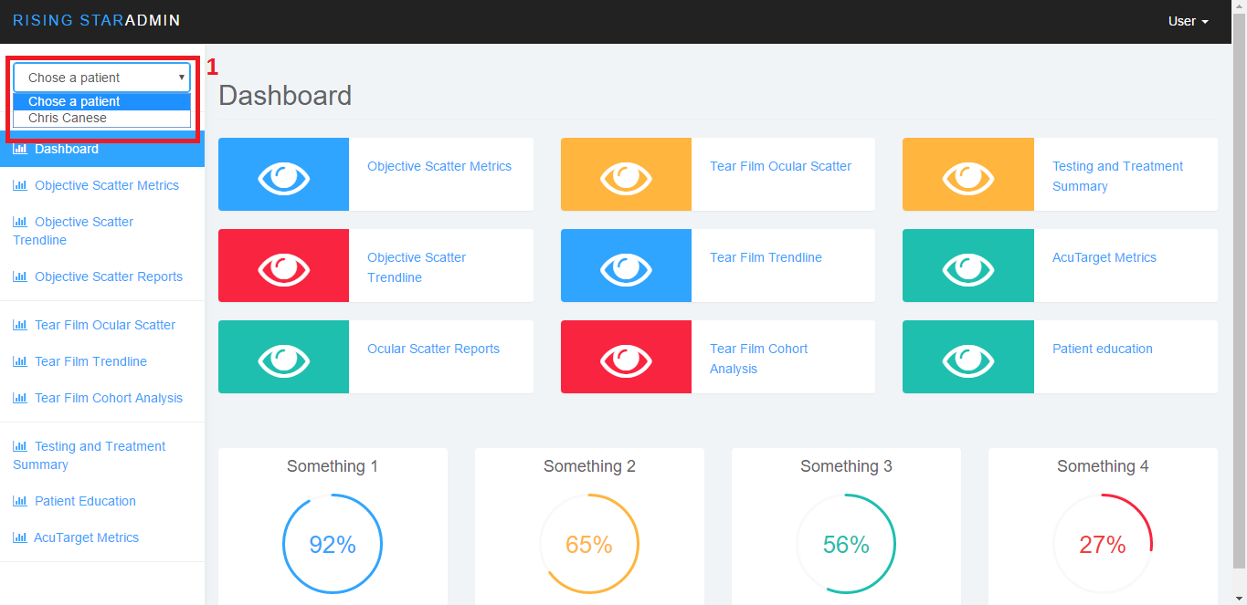

This part is not new but I guess it is worth mentioning. I have already set up to get all the patients, but limited myself to work just with Chris Canese, since he is our subject of study in the Access software.

The dashboard has only links so far, but we can change that to charts later on.

AcuTarget Metrics – OSI

When the user selects AcuTarget Metrics item on the left menu, this is where he’ll end up. The data on the right is presented from the database, with actual data. By clicking on the “Use” button, the values from that row will be transported to the form to the left.

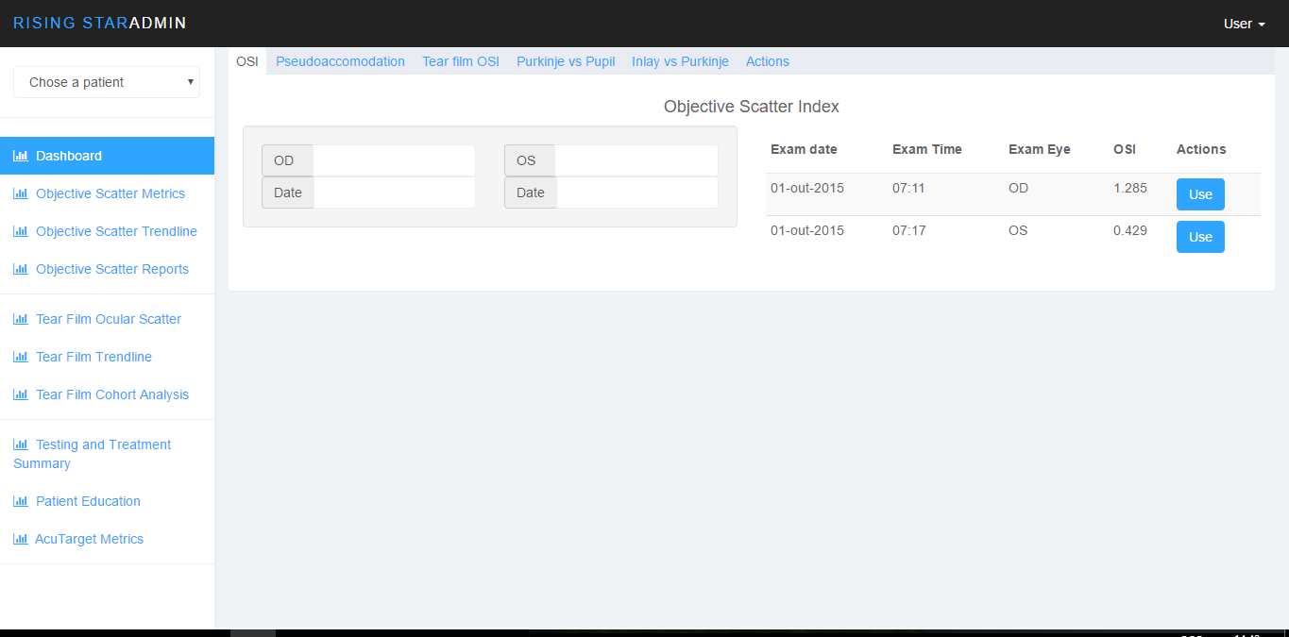

Pseudoaccomodation

This is the Pseudoaccomodation tab, which is pretty much the same as the OSI tab, with different data.

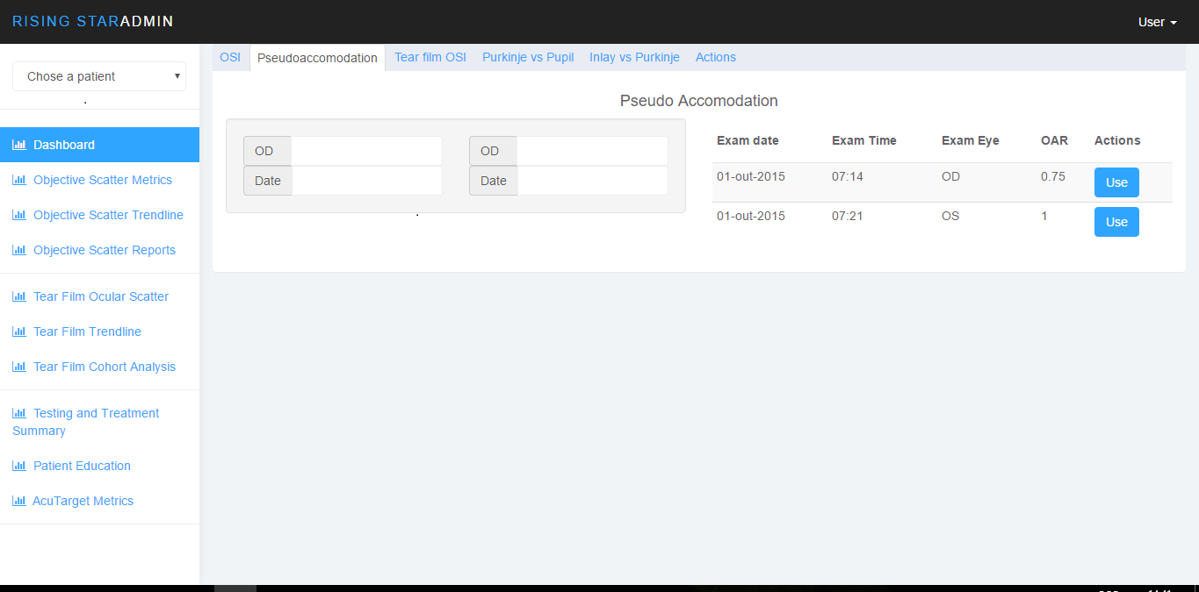

Tear film OSI:

This tab shows the Tear film OSI with its data, also from the real database.

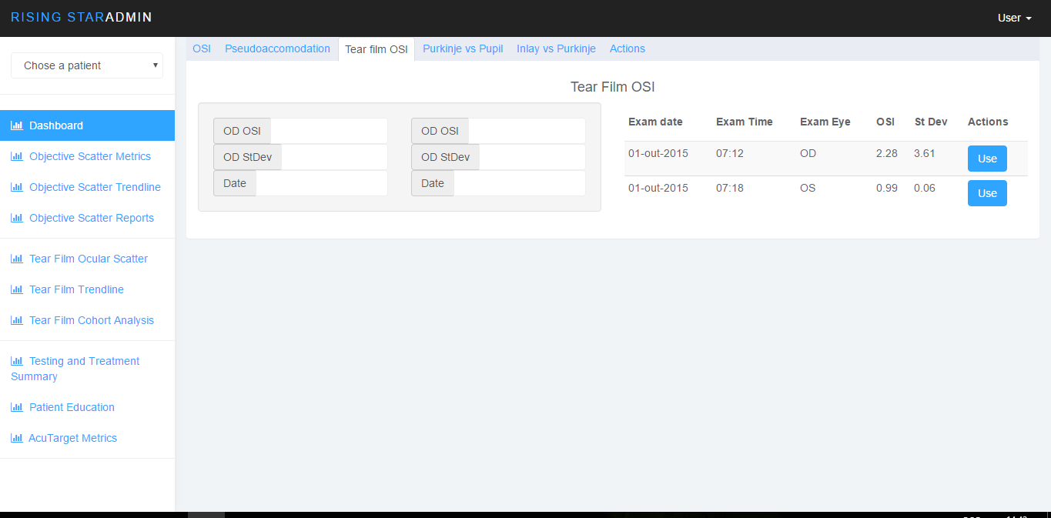

Purkinje vs. Pupil Metrics

This is a more complete tab, that shows information regarding the Purkinje against the pupil metrics. It has data such as the coordinates, angle, X and Y coordinates.

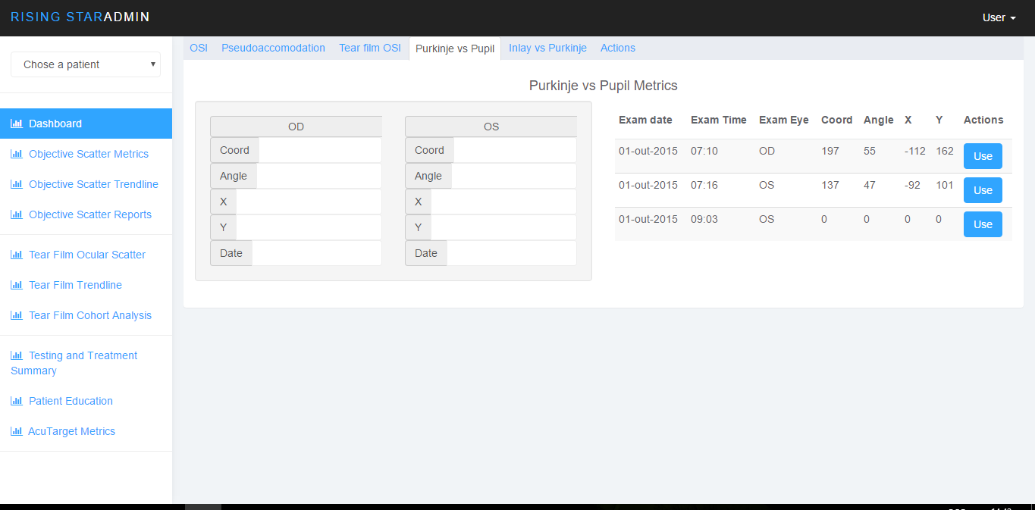

Moving on to the Actions tab, this is where the user will be able to pull up the graph from the selected information.

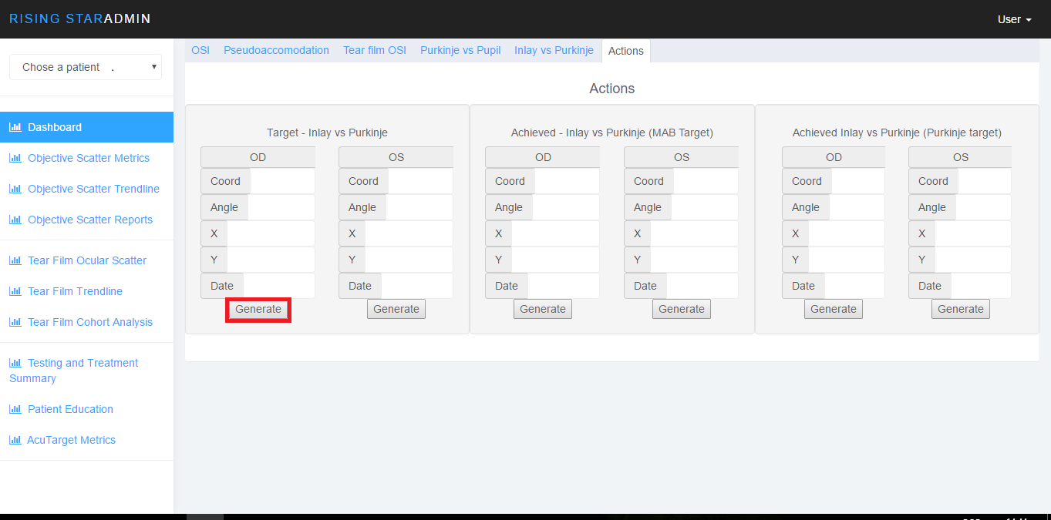

When clicking on any “Generate” buttons, the graph will appear.

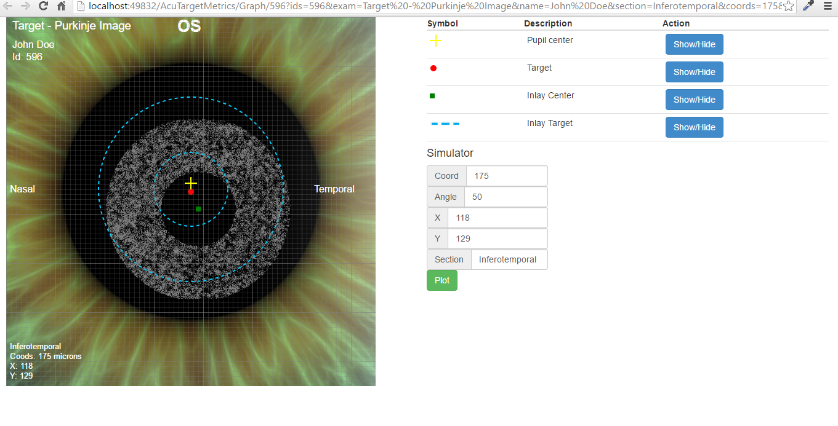

We have the graphic, designed from scratch using HTML5 and javascript. The data is still static, and we are working on getting the simulator working right before retrieving from the forms.

On the upper right side, you will be able to show or hide elements on the graphic.

Right below the table with the options, we are designing a simulator to plot the information on the fly.