Econometric Studies in Brazil

claudio freitas

Saturday, September 12, 2015

## EXECUTIVE SUMMARY

In this project I am using the QUANDL database to analyse some current Brazilian economic data in order to try to predict short term path of inflation and how long should we wait until we can see growth back to the Brazilian economy.

# Data Processing

Dowloading the data from QUAnDL.

library(Quandl)

## Warning: package 'Quandl' was built under R version 3.1.3

## Loading required package: xts  
## Loading required package: zoo  
##   
## Attaching package: 'zoo'  
##   
## The following objects are masked from 'package:base':  
##   
## as.Date, as.Date.numeric

library(tseries)

## Warning: package 'tseries' was built under R version 3.1.3

library(timeSeries)

## Warning: package 'timeSeries' was built under R version 3.1.3

## Loading required package: timeDate

## Warning: package 'timeDate' was built under R version 3.1.3

##   
## Attaching package: 'timeSeries'  
##   
## The following object is masked from 'package:zoo':  
##   
## time<-

library(forecast)

## Warning: package 'forecast' was built under R version 3.1.3

## This is forecast 6.1

library("zoo")  
Quandl.auth("xsPzjKeHjtLjjjEpLgYi")  
PrimeBR<- Quandl("BCB/20019")  
InfBR<- Quandl("BCB/191")  
GDPBRraw<-Quandl("IBGE/ST12_BR_BRASIL_PERC")  
str(GDPBRraw)

## 'data.frame': 77 obs. of 2 variables:  
## $ Date : Date, format: "2015-03-31" "2014-12-31" ...  
## $ Value: num -1.6 -0.2 -0.6 -1.2 2.7 2.1 2.4 3.9 2.6 2.3 ...  
## - attr(*, "freq")= chr "quarterly"

#do not consider inflation befre 1996  
newinf1<- subset(InfBR, InfBR$Date > "2005-03-31")  
newinf<- subset(newinf1, newinf1$Date < "2015-07-31")  
#print(GDPBRraw)  
#print(PrimeBR)  
  
#print(newinf)  
n<- dim(newinf)[1]/3  
  
inf<- data.frame(matrix(0,n))  
i2<- 1  
for (i in 1:n) {  
   
 inf[i,1]<- (((newinf$Value[i2]/100+1)*(newinf$Value[i2+1]/100+1)*  
 (newinf$Value[i2+2]/100+1))-1)*100  
 i2<- i2+3  
 }  
  
#print(inf)  
inf<- apply(inf,2, rev)  
combo1<- merge(InfBR, PrimeBR, by="Date")  
combo<- merge(combo1,GDPBRraw, by="Date" )  
combo<- cbind(combo, inf)  
print(combo)

## Date Value.x Value.y Value matrix.0..n.  
## 1 2005-03-31 0.70 19.79 4.1 1.6261135  
## 2 2005-06-30 -0.05 21.64 4.4 -0.2208515  
## 3 2005-09-30 0.09 21.07 2.1 1.4569590  
## 4 2005-12-31 0.46 21.43 2.1 0.8815171  
## 5 2006-03-31 0.22 19.81 4.3 -0.2512434  
## 6 2006-06-30 -0.40 18.39 2.3 0.4105142  
## 7 2006-09-30 0.19 17.16 4.5 1.0127321  
## 8 2006-12-31 0.63 16.09 4.8 1.5173013  
## 9 2007-03-31 0.48 14.99 5.2 0.9831303  
## 10 2007-06-30 0.42 14.23 6.5 0.9327887  
## 11 2007-09-30 0.23 14.26 5.8 1.1031535  
## 12 2007-12-31 0.70 13.79 6.5 1.4243650  
## 13 2008-03-31 0.45 14.10 6.1 2.3785552  
## 14 2008-06-30 0.77 16.21 6.3 0.5801383  
## 15 2008-09-30 -0.09 17.46 6.9 1.5580017  
## 16 2008-12-31 0.52 21.78 0.9 1.6580976  
## 17 2009-03-31 0.61 19.03 -2.6 0.9828672  
## 18 2009-06-30 0.12 15.27 -2.3 0.7216532  
## 19 2009-09-30 0.18 13.89 -1.3 0.5106741  
## 20 2009-12-31 0.24 13.85 5.3 2.8557894  
## 21 2010-03-31 0.86 13.52 9.2 0.7595556  
## 22 2010-06-30 -0.21 14.52 8.6 0.1688348  
## 23 2010-09-30 0.46 16.53 7.0 2.3273905  
## 24 2010-12-31 0.72 15.53 5.8 2.4887632  
## 25 2011-03-31 0.71 16.80 5.2 1.2822083  
## 26 2011-06-30 -0.18 17.10 4.6 0.8616392  
## 27 2011-09-30 0.50 17.10 3.4 1.5876299  
## 28 2011-12-31 0.79 15.60 2.5 1.6582557  
## 29 2012-03-31 0.60 15.10 1.6 1.1538510  
## 30 2012-06-30 0.11 12.40 0.8 1.2045372  
## 31 2012-09-30 0.54 11.80 2.3 1.5983123  
## 32 2012-12-31 0.66 11.00 2.3 2.0730050  
## 33 2013-03-31 0.72 10.90 2.6 1.1946098  
## 34 2013-06-30 0.35 11.80 3.9 0.3297490  
## 35 2013-09-30 0.30 13.70 2.4 1.9322528  
## 36 2013-12-31 0.69 14.30 2.1 2.5206145  
## 37 2014-03-31 0.85 15.00 2.7 1.6282742  
## 38 2014-06-30 0.33 15.20 -1.2 0.7111986  
## 39 2014-09-30 0.49 15.30 -0.6 1.8409160  
## 40 2014-12-31 0.75 16.00 -0.2 4.1650876  
## 41 2015-03-31 1.41 16.00 -1.6 2.1653340

Test to find out if data is stationary:

#as p value is greater than 0.05 data is non stationary  
test1<-adf.test(combo$matrix.0..n., alternative= "stationary")  
print(test1)

##   
## Augmented Dickey-Fuller Test  
##   
## data: combo$matrix.0..n.  
## Dickey-Fuller = -2.6956, Lag order = 3, p-value = 0.3  
## alternative hypothesis: stationary

plot(combo$matrix.0..n., type="l")

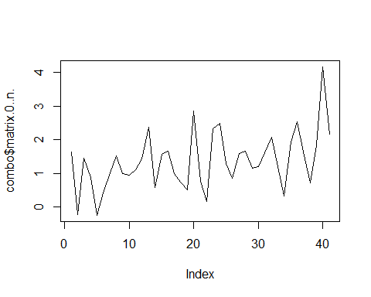

test2<-adf.test(combo$Value.y, alternative= "stationary")  
print(test2)

##   
## Augmented Dickey-Fuller Test  
##   
## data: combo$Value.y  
## Dickey-Fuller = -3.6895, Lag order = 3, p-value = 0.03832  
## alternative hypothesis: stationary

test3<-adf.test(combo$Value, alternative= "stationary")  
print(test3)

##   
## Augmented Dickey-Fuller Test  
##   
## data: combo$Value  
## Dickey-Fuller = -4.0609, Lag order = 3, p-value = 0.01711  
## alternative hypothesis: stationary

As the quarterly inflation data seems to be non stationary, I will differentiate the data.

nd<-ndiffs(combo$matrix.0..n.)  
print(nd)

## [1] 1

primediff<- diff(combo$matrix.0..n., differences=nd)  
combo<- combo[-1, ]  
combo<-cbind(combo, primediff)  
print(combo)

## Date Value.x Value.y Value matrix.0..n. primediff  
## 2 2005-06-30 -0.05 21.64 4.4 -0.2208515 -1.84696504  
## 3 2005-09-30 0.09 21.07 2.1 1.4569590 1.67781053  
## 4 2005-12-31 0.46 21.43 2.1 0.8815171 -0.57544187  
## 5 2006-03-31 0.22 19.81 4.3 -0.2512434 -1.13276056  
## 6 2006-06-30 -0.40 18.39 2.3 0.4105142 0.66175760  
## 7 2006-09-30 0.19 17.16 4.5 1.0127321 0.60221793  
## 8 2006-12-31 0.63 16.09 4.8 1.5173013 0.50456914  
## 9 2007-03-31 0.48 14.99 5.2 0.9831303 -0.53417101  
## 10 2007-06-30 0.42 14.23 6.5 0.9327887 -0.05034155  
## 11 2007-09-30 0.23 14.26 5.8 1.1031535 0.17036475  
## 12 2007-12-31 0.70 13.79 6.5 1.4243650 0.32121154  
## 13 2008-03-31 0.45 14.10 6.1 2.3785552 0.95419023  
## 14 2008-06-30 0.77 16.21 6.3 0.5801383 -1.79841690  
## 15 2008-09-30 -0.09 17.46 6.9 1.5580017 0.97786335  
## 16 2008-12-31 0.52 21.78 0.9 1.6580976 0.10009595  
## 17 2009-03-31 0.61 19.03 -2.6 0.9828672 -0.67523043  
## 18 2009-06-30 0.12 15.27 -2.3 0.7216532 -0.26121398  
## 19 2009-09-30 0.18 13.89 -1.3 0.5106741 -0.21097916  
## 20 2009-12-31 0.24 13.85 5.3 2.8557894 2.34511538  
## 21 2010-03-31 0.86 13.52 9.2 0.7595556 -2.09623379  
## 22 2010-06-30 -0.21 14.52 8.6 0.1688348 -0.59072088  
## 23 2010-09-30 0.46 16.53 7.0 2.3273905 2.15855571  
## 24 2010-12-31 0.72 15.53 5.8 2.4887632 0.16137270  
## 25 2011-03-31 0.71 16.80 5.2 1.2822083 -1.20655490  
## 26 2011-06-30 -0.18 17.10 4.6 0.8616392 -0.42056908  
## 27 2011-09-30 0.50 17.10 3.4 1.5876299 0.72599069  
## 28 2011-12-31 0.79 15.60 2.5 1.6582557 0.07062578  
## 29 2012-03-31 0.60 15.10 1.6 1.1538510 -0.50440469  
## 30 2012-06-30 0.11 12.40 0.8 1.2045372 0.05068625  
## 31 2012-09-30 0.54 11.80 2.3 1.5983123 0.39377503  
## 32 2012-12-31 0.66 11.00 2.3 2.0730050 0.47469274  
## 33 2013-03-31 0.72 10.90 2.6 1.1946098 -0.87839517  
## 34 2013-06-30 0.35 11.80 3.9 0.3297490 -0.86486084  
## 35 2013-09-30 0.30 13.70 2.4 1.9322528 1.60250383  
## 36 2013-12-31 0.69 14.30 2.1 2.5206145 0.58836173  
## 37 2014-03-31 0.85 15.00 2.7 1.6282742 -0.89234033  
## 38 2014-06-30 0.33 15.20 -1.2 0.7111986 -0.91707563  
## 39 2014-09-30 0.49 15.30 -0.6 1.8409160 1.12971737  
## 40 2014-12-31 0.75 16.00 -0.2 4.1650876 2.32417165  
## 41 2015-03-31 1.41 16.00 -1.6 2.1653340 -1.99975360

plot(combo$primediff, type="l")

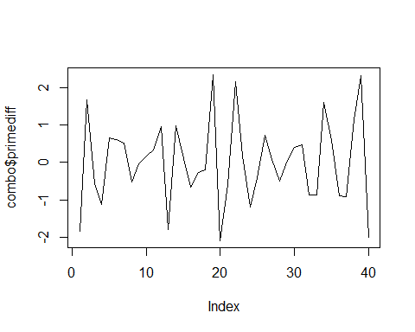

test4<-adf.test(combo$primediff, alternative= "stationary")

## Warning in adf.test(combo$primediff, alternative = "stationary"): p-value  
## smaller than printed p-value

print(test4)

##   
## Augmented Dickey-Fuller Test  
##   
## data: combo$primediff  
## Dickey-Fuller = -6.9717, Lag order = 3, p-value = 0.01  
## alternative hypothesis: stationary

# Econometric models

Lets try the auto arima function to predict inflation based on past behaviour and prime rate:

fit<- auto.arima(combo$primediff, xreg=combo$Value.y, stepwise=FALSE, approximation=FALSE)  
print(fit)

## Series: combo$primediff   
## ARIMA(4,0,1) with non-zero mean   
##   
## Coefficients:  
## ar1 ar2 ar3 ar4 ma1 intercept combo$Value.y  
## -1.5450 -1.7119 -1.3606 -0.7074 0.7714 0.3902 -0.0229  
## s.e. 0.1509 0.1755 0.1789 0.1183 0.2138 0.1925 0.0123  
##   
## sigma^2 estimated as 0.3409: log likelihood=-37.32  
## AIC=90.65 AICc=95.29 BIC=104.16

Forecast inflation differential for the next 6 quarters:

x<-c(17, 17, 17, 17, 17, 17)  
fore6<-forecast(fit, h=6, xreg = x)  
plot(fore6)

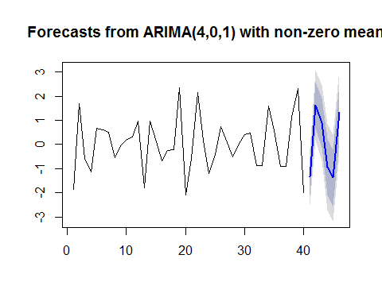

fore6<- data.frame(fore6)  
last<- tail(combo$matrix.0..n.,1)  
print(last)

## [1] 2.165334

print(fore6)

## Point.Forecast Lo.80 Hi.80 Lo.95 Hi.95  
## 41 -1.3378184 -2.0861281 -0.5895086 -2.4822594 -0.1933774  
## 42 1.6323489 0.6862544 2.5784434 0.1854222 3.0792756  
## 43 0.8977306 -0.1243203 1.9197814 -0.6653613 2.4608224  
## 44 -0.9251418 -2.0955321 0.2452484 -2.7150993 0.8648156  
## 45 -1.3767285 -2.5477720 -0.2056850 -3.1676849 0.4142279  
## 46 1.3401159 0.1647118 2.5155201 -0.4575096 3.1377415

Calculating the forecats for the inflation quarter by quarter:

## [1] "Forecast quarterly inflation:"

## [1] 0.8275156

## [1] 2.459865

## [1] 3.357595

## [1] 2.432453

## [1] 1.055725

## [1] 2.395841

Lets try another auto arima function to predict quarterly GDP based on past behaviour and prime rate:

fit<- auto.arima(combo$Value, xreg=combo$Value.y, stepwise=FALSE, approximation=FALSE)  
print(fit)

## Series: combo$Value   
## ARIMA(4,1,1)   
##   
## Coefficients:  
## ar1 ar2 ar3 ar4 ma1 combo$Value.y  
## -0.2111 -0.0606 0.0401 -0.6213 0.5658 -0.1474  
## s.e. 0.1702 0.1412 0.1349 0.1314 0.2076 0.1574  
##   
## sigma^2 estimated as 2.337: log likelihood=-70.88  
## AIC=155.76 AICc=159.37 BIC=167.4

Forecast GDP for the next 6 quarters:

fore62<-forecast(fit, h=6, xreg = x)  
plot(fore62)

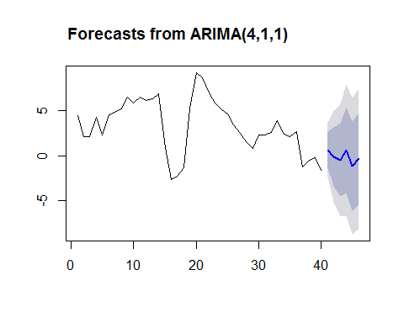

fore62<- data.frame(fore62)  
print(fore62)

## Point.Forecast Lo.80 Hi.80 Lo.95 Hi.95  
## 41 0.6681106 -1.291028 2.627249 -2.328133 3.664354  
## 42 -0.1187052 -3.417576 3.180166 -5.163893 4.926482  
## 43 -0.4678196 -4.540730 3.605091 -6.696799 5.761160  
## 44 0.6203600 -4.148858 5.389578 -6.673529 7.914249  
## 45 -1.1206091 -6.060814 3.819595 -8.676000 6.434781  
## 46 -0.3441971 -5.403694 4.715300 -8.082030 7.393635

# Conclusion

Even thought the confidence intervals are pretty big, we can learn some lessons in this econometric study. First is that the outlook for inflation in Brazil in the following quarters remains still uncertain. Despite the short term good news, inflation could rebound in the endof the year and interest rates will have to remain pretty high during 2016 to prevent new pressures in the following quarters.

Regarding the GDP, the outlook remains negative. Some positive figures can appear in the following months, but recovery seems to be slow and painful. It seems that recession in Brazil will continue throughout 2016.