Development of Web and Mobile POS with Inventory Management System with Forecasting for Banelo Bake and Brew

An Undergraduate Capstone Submitted in Partial Fulfillment of the
Requirements for CAP10-1 Bachelor of Science in Information Systems

Researchers:
Dela Torre, Rommel H.
Dometita, Jethro B.
Ramirez, Jean Noreen E.
Tan, Neil Dominique R.

Richwell Colleges. Incorporated August 2025

Table of Contents
Chapter 1 1
The Problem and Its Background 1
Introduction 1
Statement of the Problem 3
Definition of Terms 5
Significance of the Study 7
Scope and Delimitation of the Study 7
Chapter 2 9
REVIEW OF RELATED STUDIES AND LITERATURE 9
Related Studies and Literature 9
Conceptual Framework 28
Chapter 3 30
METHODOLOGY AND TECHNIQUES OF THE STUDY 30
Developmental Research Design 30
Software Methodology 30
Planning 32
Gantt Chart 32
RACI Matrix 32
Requirements Gathering and Analysis Phase 36
User Story 36
Use Case Diagram 39
Functional Decomposition Diagram (FDD) 40
System Design 41
Data Flow Diagram 41
Data Dictionary 44
Flow Chart(s) 47
Wire Frame 63
Knowledge Discovery in Databases (KDD) Methodology 72
Research Methodology 79
Population and Sample of the Study 80
Research Instrument 82
Data Gathering Procedure 84
Data Processing and Statistical Treatment 85
Ethical Considerations 86
References 87

Chapter 1

The Problem and Its Background
This chapter will present an overview of the study, it will be focusing on the development of a Mobile POS and Inventory Management System with Forecasting and Web Viewing for Banelo Bake and Brew. It will include an introduction to the research problem, the statement of the problem, and the theoretical and conceptual frameworks that serve as the foundation of the study. This chapter will also tackle the significance of incorporating forecasting into the system, alongside the scope and delimitations of the research. Each of the section aims to provide a comprehensive understanding of the study’s context, objectives, and boundaries to guide the design and development of the application.

Introduction
The swift progression of technology has greatly changed and improved the operations of businesses, with point-of-sale (POS) and inventory management systems now essential for enhancing workflows and boosting efficiency. Contemporary POS systems not only allow quicker transactions but also offer immediate sales data and inventory monitoring. These are vital for strategic decision-making and ensuring profitability. In the context of small and medium-sized enterprises (SMEs), these systems have proved beneficial for minimizing errors, fine-tuning stock levels, and improving customer experiences. The pressure of global competition has also compelled businesses in places like Ho Chi Minh City to adopt POS technologies to enhance efficiency and service (Chuanpeng & Yi, 2021). Likewise, Sridhar et al. (2021) point out that digital solutions in retail empower businesses to be able to meet the increasing expectations of consumers while lowering operational costs.
Despite the critical role of inventory as a key business asset, many small enterprises, including Banelo Bake and Brew, continue to face challenges due to reliance on manual operating practices. Inaccurate inventory records, waste from using incorrect components, and errors in pricing are common outcomes of these outdated methods. Such issues often result in discrepancies between actual stock and recorded data, leading to overstocking, stockouts, and misaligned sales reports. Furthermore, the lack of effective control measures and traceability in tracking inventory movement weakens overall inventory management, hindering the business’s ability to safeguard its assets. As highlighted by Wynn and Kuhn Jr. (2021), excessive manual inventory errors negatively affect financial growth, operational efficiency, and executive decision-making. These persistent problems not only disrupt daily operations but also reduce profitability and prevent the business from making timely, data-driven decisions to remain competitive.
The main objective of this study is to create a thorough Mobile POS and Inventory Management System that includes forecasting and web viewing to automate sales processes, improve inventory oversight, and aid predictive decision-making. By reducing human error and avoiding problems such as overstocking or stockouts, the system will allow for real-time monitoring of current sales and anticipated inventory requirements, leading to precise, timely, and data-driven choices regarding inventory replenishment, pricing, and sales strategies. The platform will simplify workflows, enhance financial management, and boost customer satisfaction through quicker and more dependable service, while exclusive administrative controls will guarantee the safe handling of sensitive business information. Ultimately, the combination of mobile POS functionalities, forecasting features, and web-based access will modernize Banelo Bake and Brew’s operations, minimize waste, increase profitability, and prepare the business for sustainable growth and competitiveness within the local market.
This research is anticipated to provide significant benefits to several stakeholders. Automating transactions and inventory management will reduce the staff's workload and decrease the chances of errors, allowing them to concentrate more on providing excellent customer service. For students, the system will be a helpful reference and a practical example in business management, information systems, and similar disciplines, offering concrete insights into the practical use of POS and inventory systems. Researchers may find value in this study as it lays the groundwork for further investigation into digital retail advancements, forecasting methods, and inventory optimization techniques. Moreover, business owners and managers will receive a practical solution to tackle operational inefficiencies, fostering better decision-making, increased profitability, and heightened competitiveness in the market. Lastly, customers will also reap the rewards through an enhanced experience characterized by quicker service, precise pricing, and reliable product availability.

Statement of the Problem
To enhance the efficiency of sales transactions and inventory tracking in a small business setting, this study aims to develop a mobile-based Point of Sale (POS) and Inventory Management System tailored for Banelo Bake and Brew. The existing manual procedures within the business frequently lead to problems such as delayed sales reports, inaccuracies in inventory and sales, inconsistencies in tracking stock levels and sales performance, and inefficient day to day business. Therefore, this study focuses on addressing these issue
- What are the current procedures in the POS and inventory system of Banelo Bake and Brew in terms of:
  - Processing customer transactions and recording sales through manual techniques such as logbooks.
  - Monitoring inventory levels and deducting ingredients based on product recipes
  - Manually generating sales and inventory reports based on the logbook
  - Every user can access every data
  - Making decisions based on the reports on the logbooks
- What essential features should be integrated into the mobile POS and inventory system to address operational inefficiencies, particularly in:
  - Automating order-taking and payment processing (e.g., cash, GCash)
  - Implementing real-time inventory tracking and ingredient deduction
  - Producing accurate and timely sales and stock level reports
  - Enabling role-based access control for administrators, cashiers, and inventory staff
  - Forecasting trends and inventory to support data-driven decision-making
- What software development methodology is most appropriate to ensure adaptability, scalability, and effectiveness in designing the mobile POS and inventory management system?
- What machine learning models are most appropriate for forecasting sales and inventory demand based on the company’s past records and seasonal trends?
- How acceptable is the developed mobile POS and inventory management system for Banelo Bake and Brew based on the ISO/IEC 25010:2015 software quality standards in terms of:
- Functionality
- Performance Efficiency
- Compatibility
- Usability
- Reliability
- Security
- Maintainability

Definition of Terms
The following concepts were operationally or conceptually described for general comprehension of the content of this paper.
- Audit Log – A chronological record of user activities, system events, or changes made within an information system, often used for monitoring security, compliance, and troubleshooting (AWS, 2023).
- Conceptual Framework – A structured model or system of concepts that organizes and guides research, analysis, and interpretation in a study (Adom et al., 2021).
- Data Analytics – The process of examining raw data to uncover patterns, correlations, and insights that support decision-making (Ghasemaghaei, 2020).
- Forecasting – The process of predicting future events or trends by analyzing historical and current data, using mathematical or statistical modeling techniques for decision-making (IBM, 2024).
- ISO/IEC 25010 – An international standard that defines a comprehensive product quality model, outlining essential attributes—such as functionality, reliability, usability, maintainability, and security—for evaluating software and ICT products (Jereb & Kajba, 2023; ISO, 2023).
- Inventory Management System – A software tool that allows businesses to monitor stock levels, track goods movement, and optimize inventory replenishment (Tanaman et al., 2023).
- Machine Learning – A subset of artificial intelligence that enables systems to learn from data, identify patterns, and make predictions or decisions with minimal human intervention (Jordan & Mitchell, 2020).
- Mobile Point of Sale (POS) System – A point-of-sale solution that operates on smartphones, tablets, or other mobile devices, enabling businesses to process payments, manage orders, and track inventory with flexibility and real-time access, unlike traditional fixed POS terminals (TechTarget, 2023)
- Mobile Viewing – The ability to access, interact with, and consume digital content through mobile devices such as smartphones and tablets (Statista, 2022).
- Raw Data – Unprocessed, unorganized data collected from a source before it is cleaned, structured, or analyzed (Sharma et al., 2022).
- SDLC (Software Development Life Cycle) – A systematic process for planning, designing, developing, testing, and deploying software systems (Boehm & Basili, 2021).
- SMEs (Small and Medium-Sized Enterprises) – Businesses with limited scale in terms of employees and revenue, playing a vital role in economic development and innovation (OECD, 2021).
- Software Development – The process of conceiving, designing, programming, testing, and maintaining software applications or systems (Pressman & Maxim, 2020).
- Software Methodology – A framework of structured practices, models, and processes that guide software development activities (Fitzgerald et al., 2020).

Significance of the Study
This Significance of the Study emphasizes the contribution of developing a web and mobile POS and Inventory Management System with forecasting for Banelo Bake and Brew. This section explains how the system affects the operations of every stakeholder in the business.
- Business Owners – Through real-time dashboards and machine learning forecasts, owners can monitor sales and inventory, anticipate needs, and adjust strategies—reducing waste, controlling costs, and improving efficiency.
- Employees – By using a user-friendly POS interface with automated inventory tracking, staff can process transactions more quickly and accurately, which reduces workload and increases productivity.
- Future Researchers – By accessing the findings and methodology of this study, they can build upon its results to develop more advanced mobile POS and inventory solutions.
- The Researchers – By engaging in the design and development of the system, they gain practical experience and apply technical skills to solve real-world business problems

Scope and Delimitation of the Study
This research aims to create a Mobile Point of Sale (POS) and Inventory Management System with Forecasting and Web Viewing specifically designed for Banelo Bake and Brew single-branch operations. The system will allow the owner and employees to handle order creation, sales transactions, and inventory management through a mobile device, facilitating payments via cash and GCash. It includes real-time inventory updates with automatic ingredient deductions based on product recipes, sales reporting, low-stock notifications, and role-based access control for cashiers and owners. Additionally, the system incorporates forecasting models to anticipate sales trends and inventory needs, enabling the business owner to make well-informed decisions regarding stock replenishment and sales strategies. A web viewing feature is available exclusively for the owner or manager, allowing them to remotely observe sales performance, inventory status, and forecasts. Security is maintained through user registration and login processes, while management functions such as account oversight, and forecasting analysis are restricted to the owner only.
The system has specific limitations that outline its scope. It is only compatible with Android mobile devices, leaving out IOS users. Payment methods are confined to cash and GCash, excluding other digital payment options, credit/debit cards, and external payment processors. Inventory management is centered around recipe-related deductions and basic stock oversight. However, it does not consider spoilage, expiration, or manual losses, connect with suppliers, or facilitate automated stock reordering. Forecasting capabilities are restricted to sales and inventory trends. At the same time, role-based access is limited to internal personnel and does not cover customer-facing accounts, loyalty programs, or self-service ordering functionalities. Offline capabilities are minimal, necessitating stable connectivity for the majority of features. Furthermore, the system is intended for a single-branch operation and currently lacks support for multi-branch logistics. User activity tracking is confined to basic functions, limiting the thoroughness of audit trail features.

Chapter 2

REVIEW OF RELATED STUDIES AND LITERATURE
This chapter showcases relevant literature, research, and the conceptual framework that underpins the suggested system. It details current knowledge, associated works, and the framework of the study that connects the issue, objectives, and solution.

Related Studies and Literature
Combining point-of-sale (POS) systems and inventory management is vital to improving efficiency and overall performance in retail operations, particularly in traditional and small- to medium-sized enterprises (SMEs). This review examines four main themes related to this integration: 1) conventional retail operations and inventory management, 2) technological solutions for sales and inventory management via mobile applications, 3) software development life cycle (SDLC) models applied in system development, and 4) Machine Learning for forecasting sales and inventory. Collectively, these themes lay a solid groundwork for understanding how current technologies and development practices enhance retail operations and promote sustainable business growth.
Traditional retail operations and inventory management
Combining point-of-sale (POS) and inventory management systems is essential for an efficient business operation and its overall effectiveness, particularly in the retail industry. Studies have examined the effects of these systems, underscoring the significance of automation in enhancing inventory precision and transaction workflows. Muñoz Macas et al. (2021) discovered that automating POS and inventory management systems diminishes stock discrepancies, making it a this will provide a trustworthy alternative to manual techniques. Similarly, Sridhar et al. (2021) have shown that POS systems make transaction processing efficient and enhance sales tracking, allowing businesses to make better-informed decisions about inventory restocking. This will offer real-time insights enabling businesses to oversee stock levels and refine inventory control more effectively.
There surely are widely recognized benefits, but implementing these systems in small businesses will also come with challenges. Abdulkader et al. (2022) argue that digital POS systems boost operational efficiency by shortening checkout times and enhancing the customer experience. However, Mandviwalla & Flanagan (2021) point out that the steep initial expenses and technological complexities linked to these systems can discourage small businesses from adopting them. Furthermore, Chuanpeng & Yi (2021) say that traditional inventory tracking may still be advantageous to specific retail settings, especially for companies dealing with variable or unpredictable stock levels, where digital systems might lack the flexibility to address these changes. These opinions emphasize that while automated systems present significant advantages, the choice to use or apply them relies on various factors such as the size of the business, budget constraints, and its unique requirements.
Despite these varied viewpoints, many studies validate the efficacy of digital POS and inventory management systems in enhancing retail operations. Gauri et al. (2020) and Moreira et al. (2024) have found that offering a precise demand forecasting automated system would lower the likelihood of stock shortages and excess inventory. Moreover, Setyowati et al. (2021) and ER et al. (2024) observed that mobile POS systems resulted in higher profitability and greater customer satisfaction due to optimized operations. Altogether, these studies reinforce the idea that integrating POS and inventory management systems is crucial for modernizing traditional retail businesses, boosting efficiency, and reducing the risks associated with inventory management.
Technological Approach for Sales and Inventory Management
In recent studies, the importance of efficient inventory management has been widely recognized and noted. Inventory Management for Retail Companies: A Literature Review and Current Trends by Muñoz Macas et al. (2021) highlights the need for proper inventory management in retail businesses, especially Small and Medium-sized Enterprises (SMEs). This finding aligns with Business Process Automation in SMEs: A Systematic Literature Review by Moreira et al. (2024), which stresses that the adoption of automation tools like Enterprise Resource Planning (ERP) and Robotic Process Automation (RPA) is essential to improve efficiency in SMEs. Both studies emphasize that, despite the potential benefits of advanced technologies, many SMEs still rely on basic systems like Excel and manual inventories. Small Business Digital Transformation in the Context of the Pandemic by Mandviwalla and Flanagan (2021) demonstrates that digital transformation has become a lifeline for small businesses, helping them to adapt to new market conditions and manage inventory more effectively during the pandemic. These studies agree that larger systems are beneficial; smaller enterprises often face challenges in adopting such technologies due to cost constraints and a lack of technical expertise. A study on Inventory Management Optimization of Small and Medium-Sized Retail Companies in the Context of New Retail by Chuanpeng and Yi (2021) supports this by showing how New Retail has transformed inventory management.
The study focuses particularly on optimizing factors like delivery methods and management systems, further indicating the need for small retailers to modernize their inventory practices to remain competitive. However, some studies present contrasting views on the level of investment and sophistication needed for effective inventory management. While Inventory Management for Retail Companies: A Literature Review and Current Trends (Muñoz Macas et al., 2021) suggests that SMEs predominantly rely on simple ERP systems and manual inventories due to resource constraints, the Study on Inventory Management Optimization of Small and Medium-Sized Retail Companies in the Context of New Retail (Chuanpeng & Yi 2021) challenges this, arguing that more complex systems are essential to cope with the new dynamics of the "New Retail" landscape. They emphasize the necessity of sophisticated tools for optimizing inventory management in an era where consumer behavior and technology are rapidly evolving. On the other hand, while Simulation of Inventory Management Systems in Retail Stores: A Case Study (Sridhar et al., 2021) presents an innovative approach to inventory optimization using simulation models, it reveals that the use of advanced systems, like the Arena simulation software and OptQuest optimization module, can reduce inventory levels significantly, showing that the cost of implementing such systems is worth the savings. This approach contradicts the notion of simplicity advocated by Muñoz Macas et al. (2021) and Chuanpeng and Yi (2021), which highlights variation in how different studies perceive the applicability of advanced systems in retail businesses.
Nevertheless, some studies support each other in recognizing the pivotal role of digital tools and optimization techniques for enhancing inventory management. Both Inventory Management for Retail Companies: A Literature Review and Current Trends (Muñoz Macas et al., 2021) and Study on Inventory Management Optimization of Small and Medium-Sized Retail Companies in the Context of New Retail (Chuanpeng & Yi, 2021) agree that effective inventory management is increasingly reliant on sophisticated tools that integrate different aspects of supply chain management, though they diverge in their implementation strategies. Both advocate for optimizing processes and using technology to streamline inventory control. Additionally, Simulation of Inventory Management Systems in Retail Stores: A Case Study (Sridhar et al., 2021) complements these studies by offering a more specific model for inventory management that improves store performance. Their simulation model optimizes inventory management processes, reducing inventory levels and lost sales, aligning with the argument that digital tools can dramatically improve operational efficiency, particularly in retail. Meanwhile, Business Process Automation in SMEs: A Systematic Literature Review (Moreira et al., 2024) supports the findings of all the previous studies by emphasizing the need for automation, especially in SMEs, where process automation can lead to better inventory management through improved workflows, fewer manual errors, and a more effective allocation of resources. The findings across these studies highlight the importance of technological advancements, whether automation, optimization models, or ERP systems, for improving inventory management in retail businesses.
Examining Software Development Life Cycle (SDLC) Models
Waterfall Model
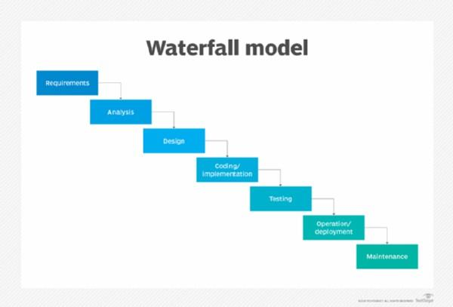
Figure 1. Waterfall Model
The Waterfall model is a sequential and linear method for software development; it requires the completion of each phase before moving on to the next one. In research conducted by Saravanos and Curinga (2023), the Waterfall model was integrated into a simulation-based framework to assess the duration of project and phase completions. By simulating 100 software projects using SimPy, the research uncovered resource bottlenecks—especially in the implementation phase—showing how simulations can improve planning and resource distribution in Waterfall-oriented projects. This organized model is effective for projects with clearly defined requirements and foreseeable workflows.
Agile Model

Figure 2. Agile Model
The Agile methodology promotes iterative development, constant integration, and close collaboration to respond effectively to evolving requirements. As noted by Ranawana and Karunananda (2021), the principles of Agile can be customized for complex projects such as creating machine learning applications. These projects face challenges like dependency on data, model integration, and deployment in real-time. By emphasizing parallel workflows and ongoing evaluation, Agile empowers teams to reduce project risks and minimize technical debt while making incremental improvements. This demonstrates Agile's flexibility and significance in modern software development environments that require rapid adjustments and ongoing feedback.
Spiral Model
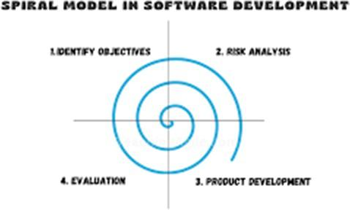
Figure 3. Spiral Model
The Spiral Model is utilized in creating the Mobile POS and Inventory Management System with Forecasting and Web Viewing for Banelo Bake and Brew, highlighting the importance of iterative refinement through planning, risk assessment, prototyping, and evaluation. This methodology guarantees that essential system functionalities such as mobile POS operations, inventory tracking, forecasting integration, and web-based viewing are continuously evaluated and enhanced based on user input. The risk-oriented structure of the Spiral Model facilitates the early identification and resolution of potential challenges. At the same time, incremental testing and prototyping contribute to the system's reliability, adaptability, and overall stakeholder satisfaction during the development cycle (TutorialsArena, 2024).

V-Model
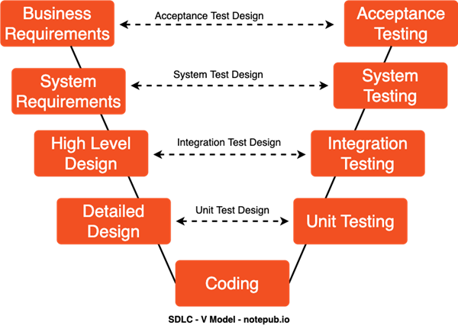
Figure 4. V-Model
The V-Model is a methodical software development life cycle (SDLC) approach that highlights a linear development process, where each stage of development corresponds to a specific testing phase. In their work on creating a real-time analytics system for an innovative campus, Dogan et al. (2021) utilized the V-Model to enhance the system's reliability, monitoring of performance, and facilitate sustainable digital transformation. The model's left side concentrates on establishing system requirements and design, while the right reflects these stages through validation and verification activities. Employing multi-level data flow diagrams (context, parent, and child) enhances thorough system analysis and encourages modular development.

Iterative Model
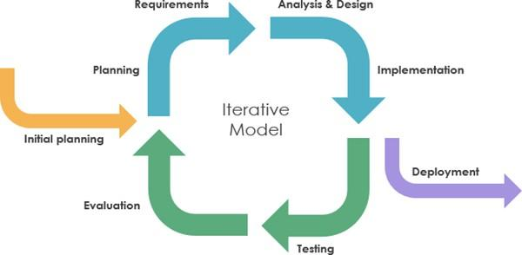
Figure 5. Iterative Model
The Iterative Model focuses on developing a system through multiple cycles of planning, analysis, design, implementation, and maintenance. Ipan and Oktarina (2023) have applied this model to develop an academic e-counseling platform at Bina Darma University for tackling issues in student-thesis guidance stemming from scheduling conflicts and remote learning situations. Each iteration facilitated continuous enhancement, aiding in the documentation of the mentoring process, fostering virtual interactions, and improving accessibility for both students and faculty. The outcome is a strong, online academic support system that adapts to users' and the institution's requirements.

Rapid Application Development (RAD) Model
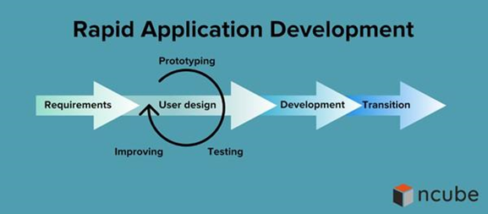
Figure 6. RAD Model
The Rapid Application Development (RAD) model is a software development methodology that emphasizes quick iterations, active user participation, and prototyping. It is particularly well-suited for projects requiring efficient development cycles and ongoing modifications driven by user feedback. In the research conducted by Pratiwi et al. (2022), the RAD methodology was employed to develop a medical record information system for a clinic. This system was created through three key RAD stages to ensure rapid advancement while actively engaging users. Validation was accomplished using Blackbox Testing and User Acceptance Testing (UAT) to verify the system's reliability and ensure it meets user expectations.

Big Bang Model
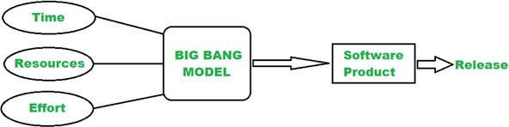
Figure 7. Big Bang Model
The Big Bang model refers to a software development methodology starting with minimal planning and initially allocating substantial resources. This highly adaptable approach enables a quick project kickoff, making it ideal for smaller assignments or experimental projects. However, it frequently results in inconsistent quality, a greater likelihood of bugs, and unpredictable results due to its lack of organizational structure. Ramadha, Wahyuni, and Vannes (2024) noted that the Big Bang method is most appropriate for projects with unclear requirements from the start. Still, it carries risks when applied to complex or large-scale developments. Their comparative analysis with the Waterfall model highlights the necessity of matching the chosen methodology with the project's specific requirements to achieve successful results.

Prototype Model
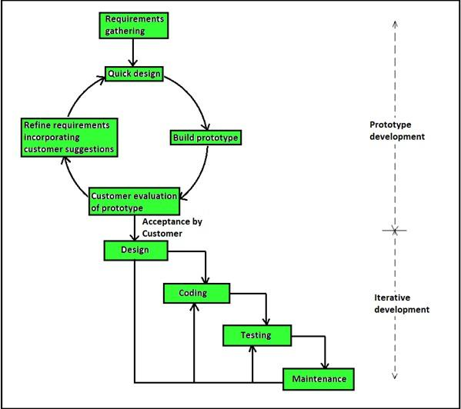
Figure 8. Prototype Model
The research conducted by Wulandari et al. (2021) utilized the prototyping model to create a donation information system for the Al-Ruhamaa Bogor Yatim Center Foundation. This approach allowed developers to efficiently collect user requirements and showcase the functional interfaces for initial feedback. The developed system facilitated donation procedures, automated reporting tasks, and enhanced data storage efficiency. Wulandari et al. (2021) researched using the prototyping model to create a donation information system for the Al-Ruhamaa Bogor Yatim Center Foundation. This approach allowed developers to effectively gather user requirements and present functional interfaces for initial feedback. The resulting system streamlined donation procedures, automated reporting tasks, and improved data storage efficiency. This demonstrates the prototyping model's ability to enhance usability and operational effectiveness. This illustrates the prototyping model's capability to improve usability and operational effectiveness.

DevOps model
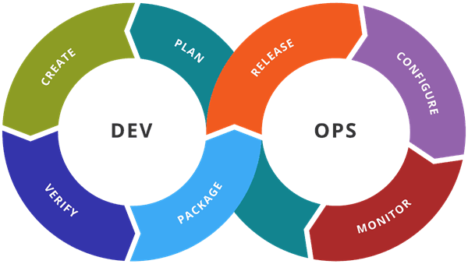
Figure 9. DevOps Model
DevOps is a software development methodology that combines development and operations teams to improve collaboration and streamline the entire software lifecycle, which includes development, deployment, and maintenance. The primary goal is to deliver software and services quickly, reliably, and with better quality by promoting continuous integration and shared accountability among team members. This approach addresses the challenges of rapidly changing requirements and the complexities of modern software systems. The research explores common obstacles faced during DevOps implementation and offers practical solutions to overcome these challenges, providing valuable insights for organizations aiming for successful DevOps practices (Battina, 2021). Overcome these issues, offering valuable insights for organizations seeking successful DevOps implementation (Battina, 2021).
Supervised Machine Learning Algorithms for Forecasting and Prediction
Supervised machine learning algorithms serve as essential tools for making forecasts and predictions, providing dependable methods for examining historical data and predicting future events. These algorithms acquire knowledge from labeled datasets to uncover patterns and relationships, which can be utilized for precise predictions across various domains such as agriculture, energy, finance, and economics. The methods range from straightforward linear models to sophisticated ensemble and hybrid techniques, enabling researchers and practitioners to tackle both simple and intricate data structures. This versatility and ability to predict improve decision-making in fluctuating and uncertain conditions, underscoring their significance in creating efficient forecasting systems that support timely, data-informed strategies.
Linear Regression
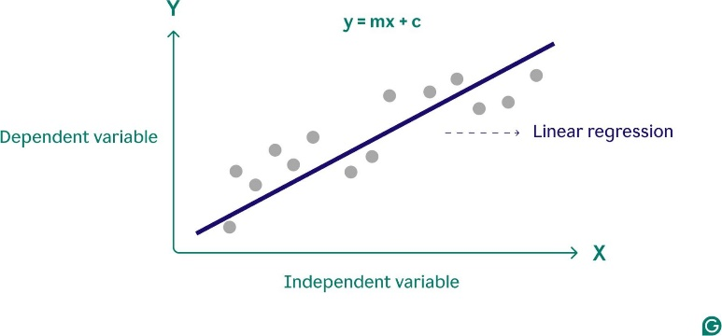
Figure 10. Linear Regression
Regression-based techniques have been extensively used in forecasting because of their ability to illustrate relationships between different variables. In the research conducted by Nazir et al. (2021), Partial Least Squares Regression (PLSR) along with linear regression was utilized to assess rice yield by analyzing vegetation indices derived from Sentinel-II satellite imagery, including NDVI, EVI, SAVI, and REP. The findings indicated a strong predictive capability with an R² value of 0.84, demonstrating that regression models can successfully reflect crop growth trends. These results underscore the potential of regression in forecasting systems where precise and timely predictions are crucial for informed decision-making (Nazir et al., 2021).
Decision Tree
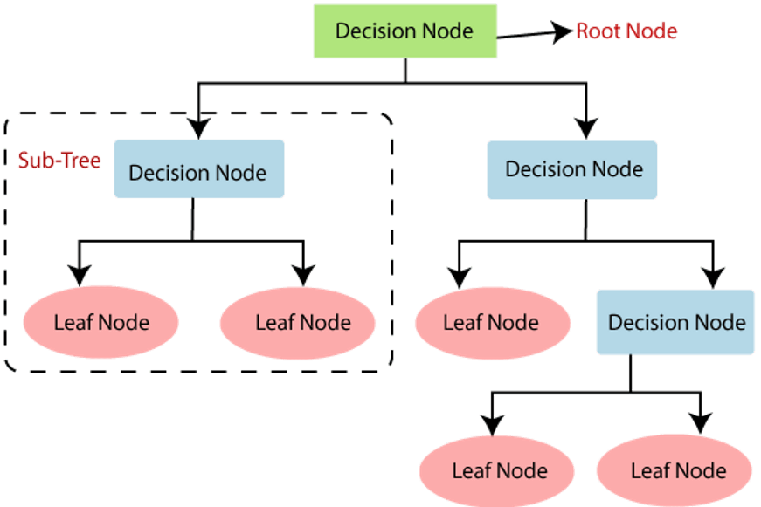
Figure 11. Decision Tree
Supervised learning techniques, such as Decision Trees, are essential for forecasting as they establish the most effective predictive approach under different circumstances. In their study, Ramos, Faria, Morais, and Vale (2022) showcased this by utilizing decision trees to choose between Artificial Neural Networks (ANNs) and k-Nearest Neighbors (k-NN) for predicting electricity usage in an office setting. The decision trees categorized five-minute consumption intervals and pinpointed the most appropriate algorithm for each situation, thus enhancing the precision of short-term energy forecasts. Ramos et al. (2022) highlight that this method underscores the flexibility of supervised algorithms like decision trees in improving prediction accuracy in fluctuating environments.

Random Forest
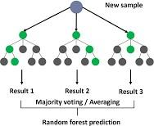
Figure 12. Random Forest
Integrating feature selection with supervised classification improves predictive accuracy in financial scenarios. Abraham et al. (2022) developed a model to forecast daily stock trends that utilized a Genetic Algorithm (GA) for identifying significant features and a Random Forest (RF) classifier for executing the prediction. The model was evaluated on 15 stocks across four international indices, reaching accuracy levels of up to 80% and significantly surpassing traditional models. The genetic algorithm pinpointed the most pertinent lagged features, while the random forest adeptly captured intricate relationships between stock indices and stock price fluctuations. As the research underscores, such combined methods illustrate the flexibility of supervised machine learning strategies in high-uncertainty areas such as stock market predictions (Abraham et al., 2022).

Support Vector Machine (SVM)
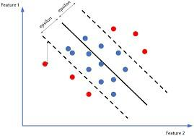
Figure 13. Support Vector Machine
Artificial Neural Networks (ANN) and Support Vector Machines (SVM) are two prominent supervised learning algorithms widely applied in predictive modeling. Kurani, Doshi, Vakharia, and Shah (2023) compared the effectiveness of ANN and SVM in stock market forecasting, highlighting their strengths and limitations. ANN models, particularly when extended into hybrid forms such as ANN-MLP or GARCH-MLP, demonstrated robustness in handling missing data and complex non-linear relationships. Meanwhile, SVMs offered advantages in avoiding overfitting due to their use of simple decision boundaries, with accuracy ranging from 60%–70% and further improvement when integrated with methods like Random Forest or Genetic Algorithms. As noted in the study, both algorithms play significant roles in financial forecasting, and their hybridization with other techniques can yield more powerful predictive models (Kurani et al., 2023).

k-Nearest Neighbors (k-NN)
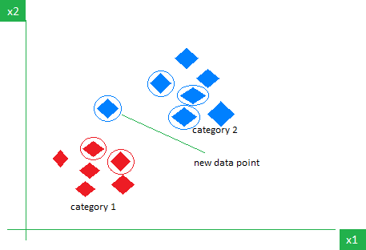
Figure 14. k-Nearest Neighbors
The k-Nearest Neighbors (k-NN) algorithm is straightforward in structure but has shown to be effective for both classification and regression tasks, including forecasting. In their 2024 study, Tajmouati, Wahbi, Bedoui, Abarda, and Dakkon presented two techniques for implementing weighted k-NN in time series forecasting: Classical Parameters Tuning and Fast Parameters Tuning. The first approach involves comparing the latest subsequence with all preceding subsequences, while the latter minimizes the search area for neighbors to enhance computational efficiency. By integrating a cross-validation-inspired method for parameter tuning, these techniques achieved higher forecasting accuracy while reducing computation time. The research validated their efficacy using real-world datasets such as U.S. retail and food services sales as well as U.K. milk production. The authors highlighted that k-NN continues to be an effective supervised learning technique when supplemented with parameter tuning methods for time series forecasting (Tajmouati et al., 2024).

Gradient Boosting
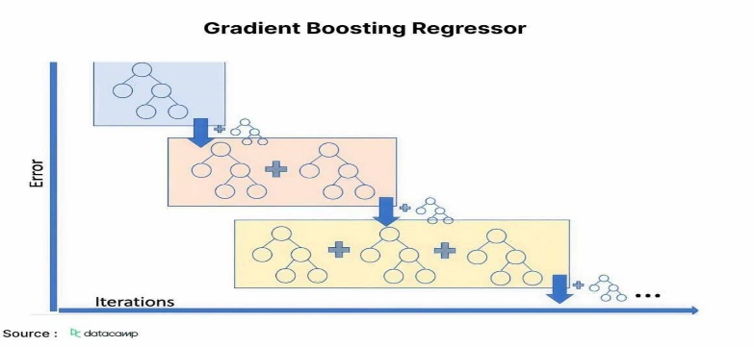
Figure 15. Gradient Boosting
Ensemble learning methods such as Extreme Gradient Boosting (XGBoost) have gained prominence in forecasting tasks due to their ability to reduce overfitting and improve prediction accuracy. Li, Pai, and Lin (2023) applied XGBoost in combination with a Genetic Algorithm (GA) to forecast inflation rates across three-time horizons. The study compared XGBoost’s performance with six other models—Random Forest (RF), Least Square Support Vector Regression (LSSVR), Backpropagation Neural Networks (BPNN), General Regression Neural Networks (GRNN), Deep Belief Networks (DBN), and Long Short-Term Memory (LSTM). Results showed that XGBoost consistently outperformed all competing models, highlighting its robustness and adaptability in economic forecasting. As noted by Li et al. (2023), integrating XGBoost with feature optimization techniques such as genetic algorithms make it a promising approach for reliable inflation prediction and monetary policy support

Conceptual Framework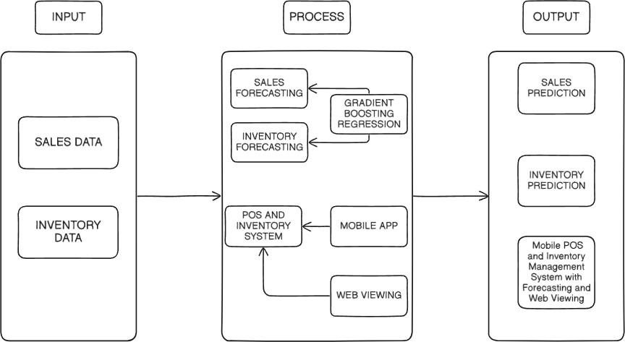
Figure 16. IPO Model
Input:
The system will start with two essential datasets: Sales Data and Inventory Data. Sales data encompasses product quantity, transaction logs, customer purchasing patterns, and pricing information. This data is necessary to be able to take a hold of the demand of consumer trends. Conversely, the inventory data includes stock quantities, product availability, reorder thresholds, and consumption rates. The system compiles the vital information are necessary to be able to monitor the performance of the business and anticipate future demand by combine these two data sources. These inputs are necessary because trustworthy and precise data directly affect the reliability of forecasting and decision-making.

Process:
Once input data is gathered, it will go through several processing stages, the POS and Inventory System is tasked with the live updates of sales transactions and stock levels, this will ensure that each transaction is accurately reflected in the system. This information can be accessed through either a Mobile App or Web Viewing, this will allow the business owners and staff to oversee operations at any time and from any location. For predictive analysis, the system employs Sales Forecasting and Inventory Forecasting using Gradient Boosting Regression, a machine learning technique to enhance prediction accuracy by integrating multiple models. This forecasting phase converts raw data into actionable insights for the future, aiding businesses in anticipating demand, preventing overstock or shortages, and enhancing operational efficiency.
Output:
The concluding phase produces a Sales and Inventory Prediction report, this will present a structured and data-driven forecast regarding the business' future sales activity and inventory needs. For instance, it can predict what products will have a boost in sales in the upcoming weeks or which items may require replenishment soon. Once these are clearly showcased the output will enable decision-makers to plan for procurement, promotions, and staffing more efficiently. Ultimately, this output is a valuable resource for strategic planning, mitigating business risks, and ensuring seamless operations by synchronizing sales patterns with inventory management.

Chapter 3

METHODOLOGY AND TECHNIQUES OF THE STUDY
This chapter outlines the research design, development process, and procedures applied in creating the proposed system. It explains the software methodology used, from planning to system design, as well as the Knowledge Discovery in Databases (KDD) methodology for handling and analyzing data. It also discusses the research methodology, population and sample, research instruments, data gathering and processing procedures, statistical treatments, and ethical consideration.

Developmental Research Design

Software Methodology
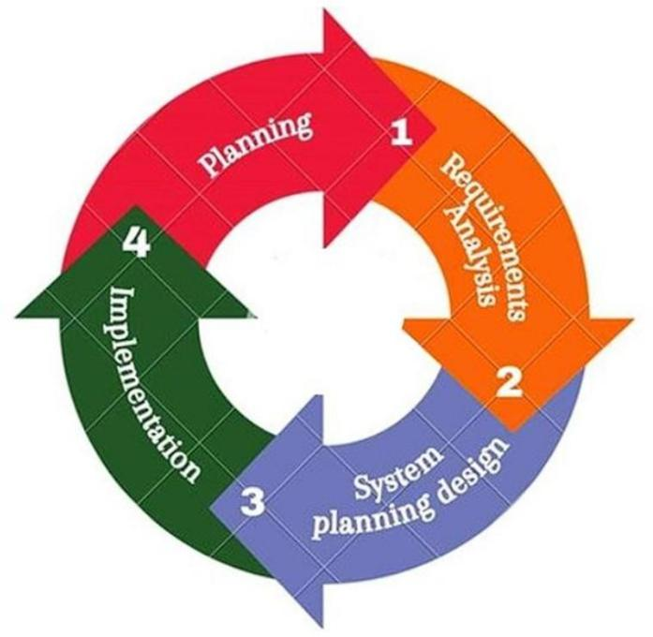
Figure 17. Agile Model
This chapter discusses the software development methodology adopted for the creation of the Mobile POS and Inventory Management System with Forecasting and Web Viewing for Banelo Bake and Brew. To effectively address the dynamic and evolving needs of small to medium-sized enterprises (SMEs), the Agile software development methodology was selected as the foundation of this study. Agile offers a flexible, iterative approach that emphasizes continuous feedback, stakeholder collaboration, and the ability to respond swiftly to changing requirements.
Given the nature of POS and inventory systems—where real-time synchronization, user-friendly interfaces across web and mobile platforms, transaction reliability, and accurate sales forecasting are critical—Agile methodology aligns well with the objectives of this project. Through incremental development, frequent testing, and close user involvement, the system can be continuously refined to improve its functionality, performance, mobile accessibility, and forecasting capabilities. This chapter details how Agile principles were applied throughout the system’s development lifecycle, ensuring that the final product remains adaptable, user-focused, and responsive to the operational demands of SMEs

Planning

Gantt Chart
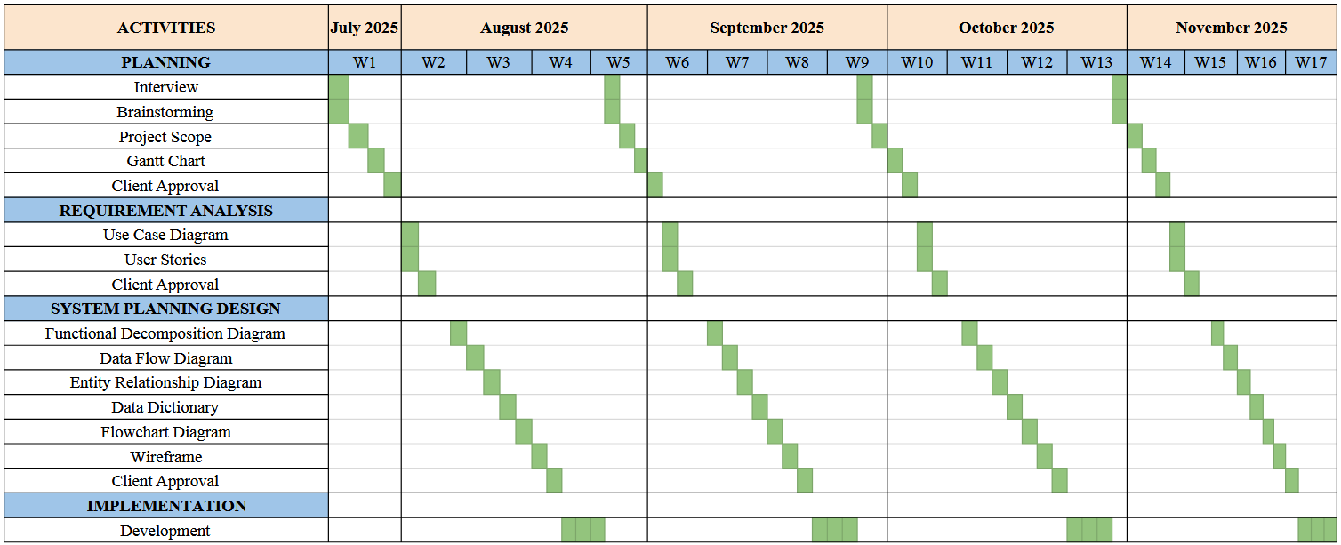
Figure 18. Gantt Chart
The Gantt chart outlines the project timeline for the development of the Mobile POS and Inventory Management System with Forecasting and Web Viewing for Banelo Bake and Brew, spanning an 18-week period from July to November 2025. The development process is structured into four main phases: Planning, Requirement Analysis, System Planning and Design, and Implementation. This timeline ensures systematic progress and timely completion of each phase, facilitating effective coordination and resource management throughout the project lifecycle.

RACI Matrix
Task Description |  | Dela Torre | Dometita | Ramirez | Tan
1. Planning
Client  Acceptance |  | I | R | C | A
Brainstorming |  | C | R | I | A
Project Scope |  | R | C | I | A
Gantt Chart |  | C | A | C | R
RACI Matrix |  | I | A | C | R
Client Approval |  | C | A | I | R
2. Requirements Analysis
Interview |  | A | C | R | C
User Story |  | A | I | R | I
Use Case Diagram |  | R | C | I | C
Client |  | I | R | C | A
Task Description |  | Dela Torre | Dometita | Ramirez | Tan
Approval
 | 3. System Design
 | FDD | I | A | R |  | I
 | DFD | I | R | A |  | C
 | ERD | I | R | A |  | I
 | Data Dictionary | I | R | A |  | C
 | Wireframe | C | A | R |  | C
 | Client Approval | I | R | C |  | A
 | 4. Implementation
 | Development | R | A | R |  | I
 | 5. Testing
 | Client Approval | I | R | C |  | A
Figure 19. RACI Matrix
This RACI defines the roles and responsibilities of team members involved in the project. Dela Torre, Dometita, Ramirez, and Tan are each assigned specific roles based on the RACI framework, which ensures clarity and accountability. One or more members are responsible for executing tasks, while one is accountable for final decisions and overall outcomes. Some are consulted for their input and expertise to support informed decision-making, while others are kept informed about progress and results throughout the project's duration.

Requirements Gathering and Analysis Phase

User Story
Business Owner
- As the owner, I want to be able to create user accounts in the system so I can give access to employees based on their role.
- As the owner, I need the ability to update account details such as usernames, passwords, and assigned roles so that I can manage user access effectively.
- As the owner, I want to delete accounts to remove employees who no longer work at the business or to revoke access for security reasons.
- As the owner, I want to log into my account securely to gain full access to the POS and inventory features.
- As the owner, I want to log out of the system to ensure that all business data remains secure when I am away.
- As the owner, I want the ability to assign specific roles (admin or staff) when creating accounts so that permissions are controlled and limited based on responsibilities.
- As the owner, I need to process customer orders by selecting items, choosing sizes or quantities, and updating the cart before completing the sale.
- As the owner, I want the system to automatically deduct ingredients based on predefined recipes when an order is placed, so that inventory reflects actual usage.
- As the owner, I need the system to process customer payments through both cash and GCash, giving customers flexible payment options.
- As the owner, I want the POS to automatically display an order summary after each transaction for both recordkeeping and customer confirmation.
- As the owner, I need the ability to add new products or ingredients into the inventory database so that all items sold or used are properly tracked.
- As the owner, I want to modify existing products or ingredients in the inventory, including updating prices, names, or stock levels.
- As the owner, I want the option to remove obsolete products or ingredients from the inventory to keep the system up-to-date.
- As the owner, I want inventory quantities to update in real time whenever sales are made to accurately reflect current stock.
- As the owner, I want to view a dashboard that summarizes the current inventory levels, low stock warnings, and recently used items for quick monitoring.
- As the owner, I want to view sales reports to understand performance trends and make informed business decisions.
- As the owner, I want to export sales and inventory reports in formats like CSV, Excel, or PDF for recordkeeping or further analysis.
- As the owner, I need access to the audit log to track user activity, system changes, and transaction history for accountability and security.
- As the owner, I want to be able to know what products I should be restocking in advance based on past sales patterns, so I can prepare for future demand.
- As the owner, I want to anticipate future sales by analyzing historical trends, so I can plan more effectively and make informed business decisions.

Staff
- As a staff, I want to create orders so I can take customer selections and begin the transaction process.
- As a staff, I want to accept payments so I can finalize transactions and ensure accurate billing.
- As a staff, I want the POS to automatically display an order summary after each transaction for both recordkeeping and customer confirmation.
- As the staff, I want to log into my account securely to gain access to the POS features.
- As the staff, I want to log out of the system to ensure that all business data remains secure when I am away.
Inventory Clerk
- As an inventory clerk, I want to add new products so I can keep the inventory up to date.
- As an inventory clerk, I want to edit product details so I can correct or update stock information.
- As an inventory clerk, I want to delete products so I can remove items that are no longer available.
- As an inventory clerk, I want to view the inventory dashboard so I can track stock levels and product availability.
- As the inventory clerk, I want to log into my account securely to gain access to the inventory features.
- As the inventory clerk, I want to log out of the system to ensure that all business data remains secure when I am away

Use Case Diagram
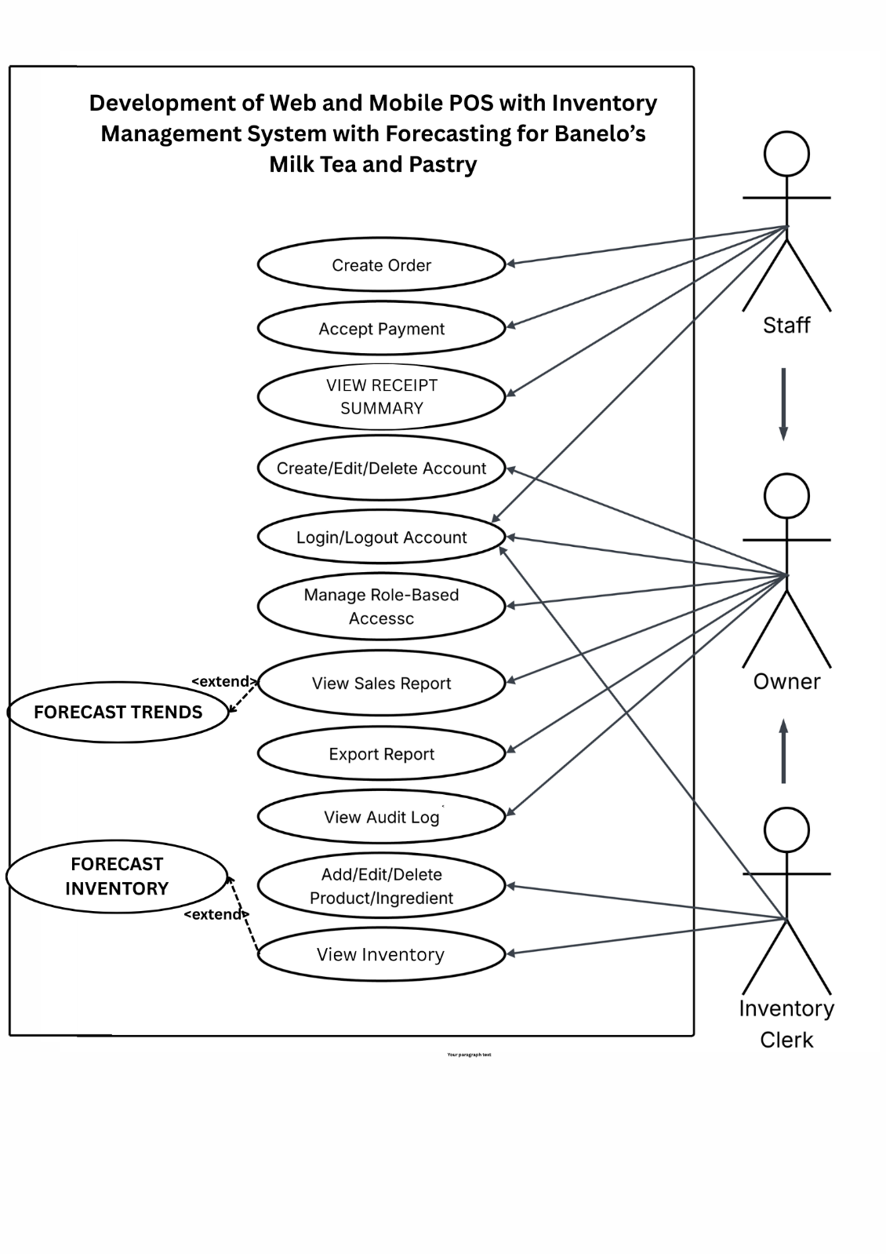
Figure 20. Use Case Diagram
This Use Case diagram shows how users interact with the mobile point of sale (pos) and inventory management system for Banelo Bake and Brew. Users can register accounts, process orders, view reports through web viewing, and manage inventory depending on their role permissions. The owner has access to all the system’s features. Each use case represents a major function user can perform.

Functional Decomposition Diagram (FDD)
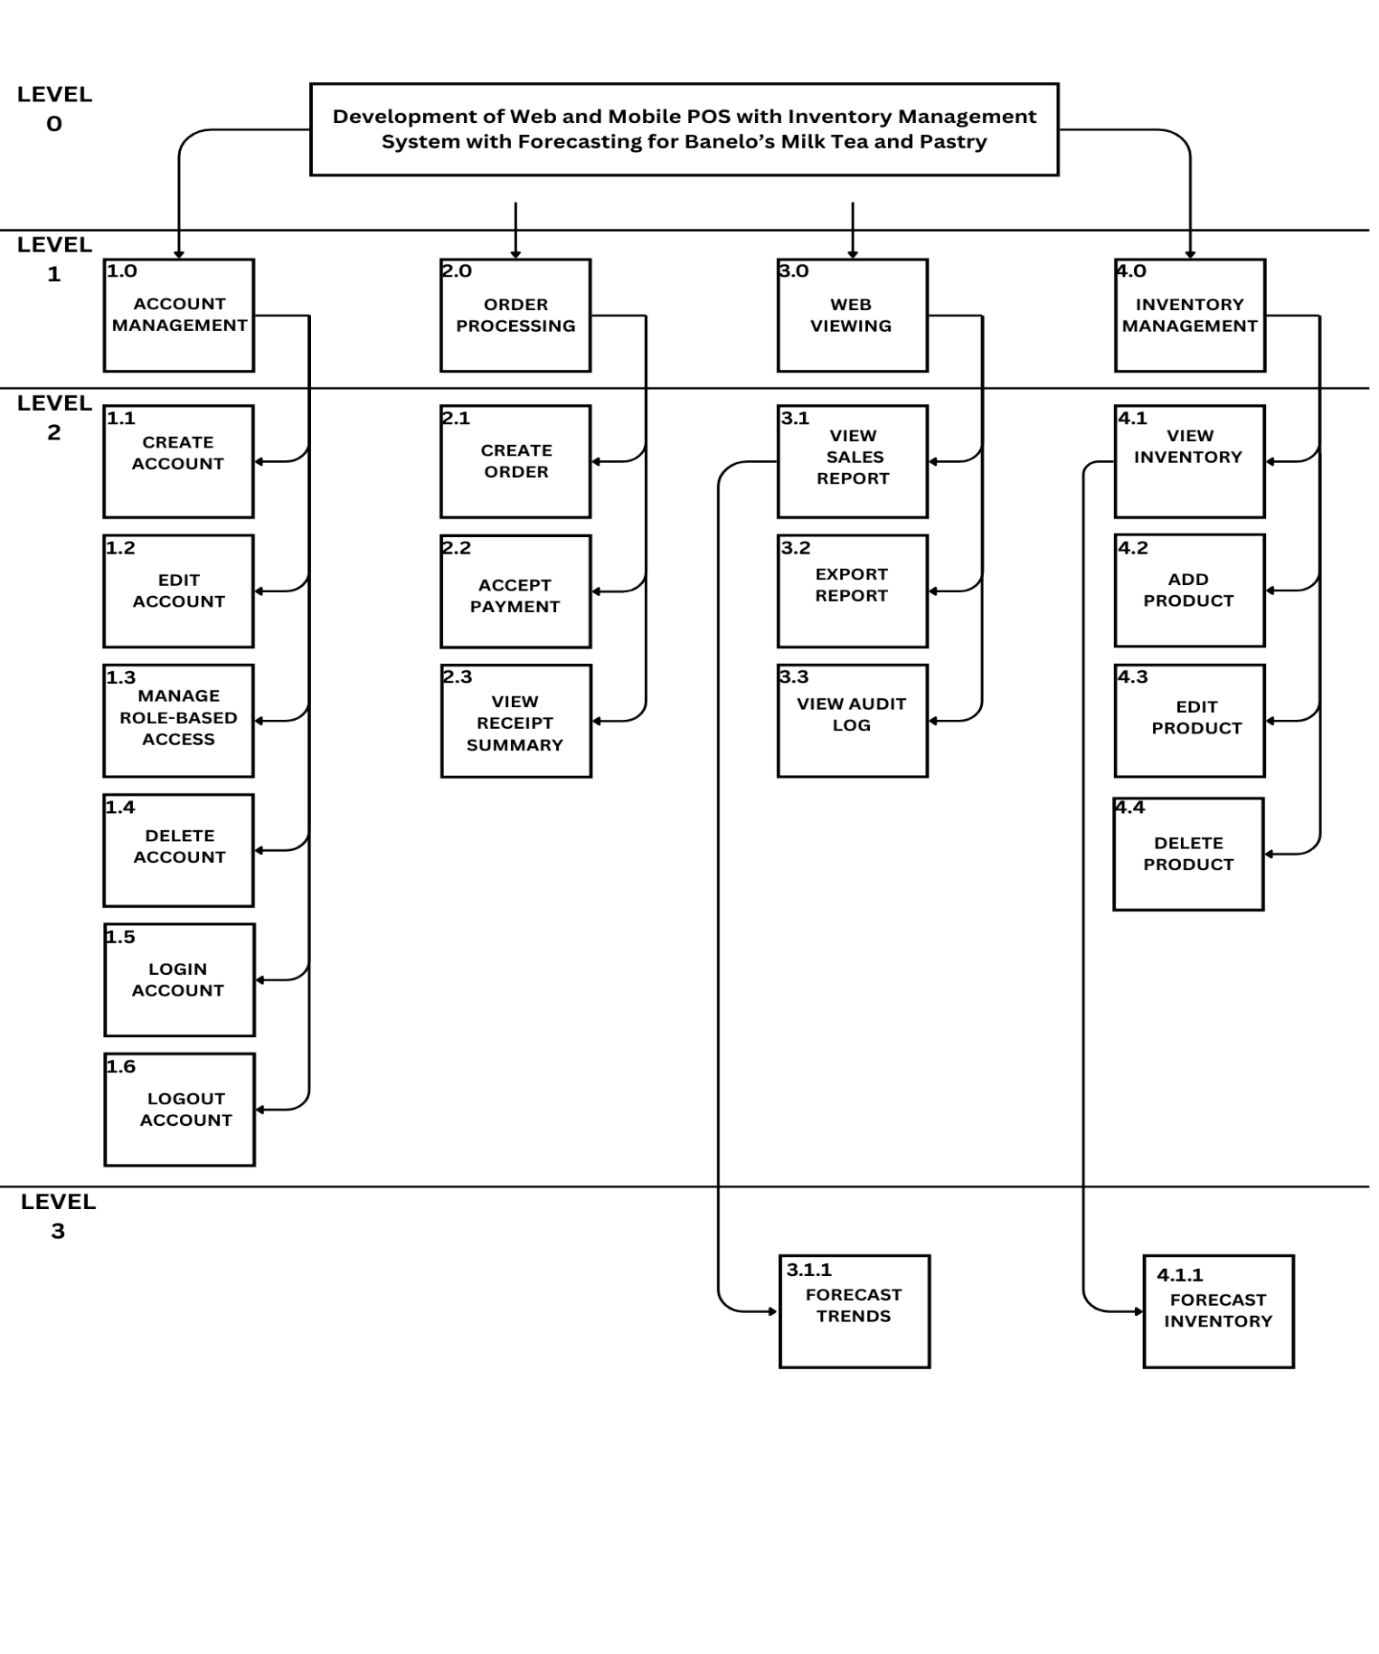
Figure 21. Functional Decomposition Diagram
The Functional Decomposition Diagram (FDD) presents the major functions of the POS and Inventory Management System, including web viewing for forecasting trends and inventory. The main functions are to process sales, manage inventory, manage accounts, and view forecasted data. These major functions are divided into sub-functions as shown in the diagram.

System Design

Data Flow Diagram
Level 0
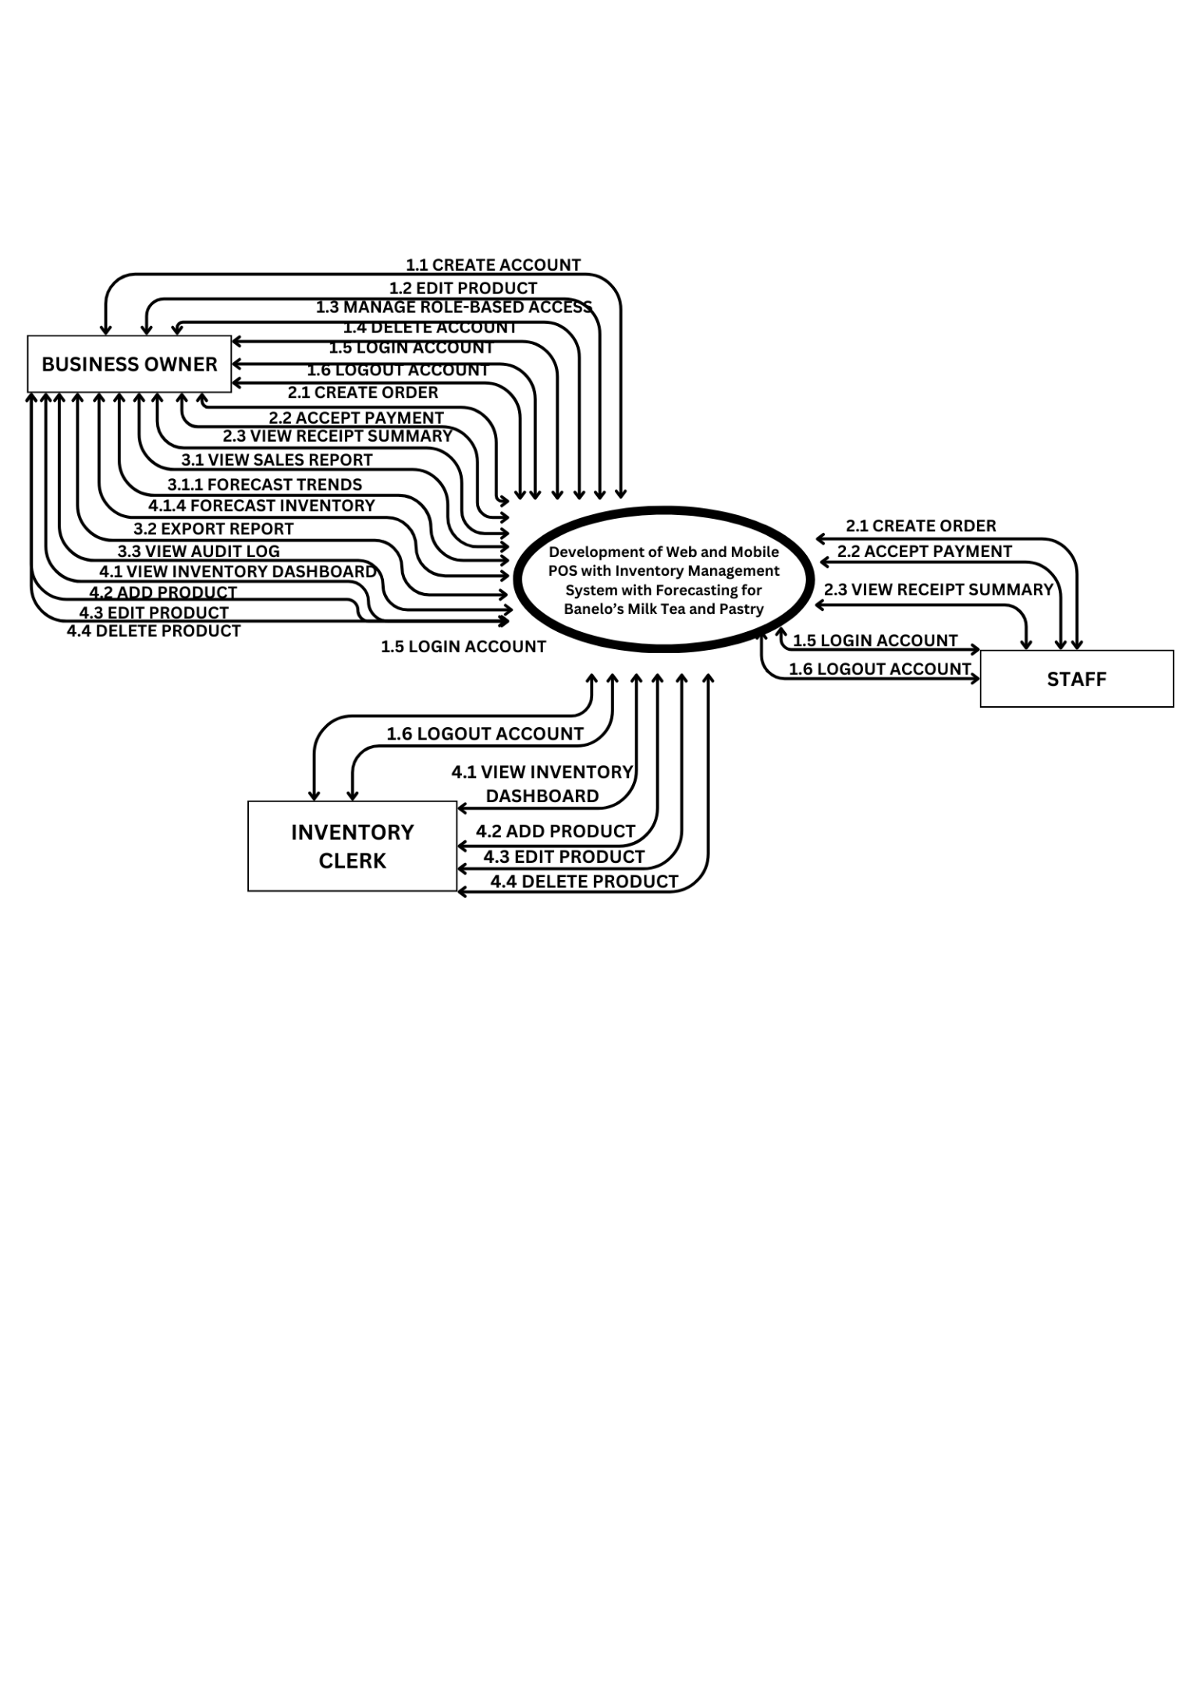
Figure 22. Level 0 Data Flow Diagram

Level 1
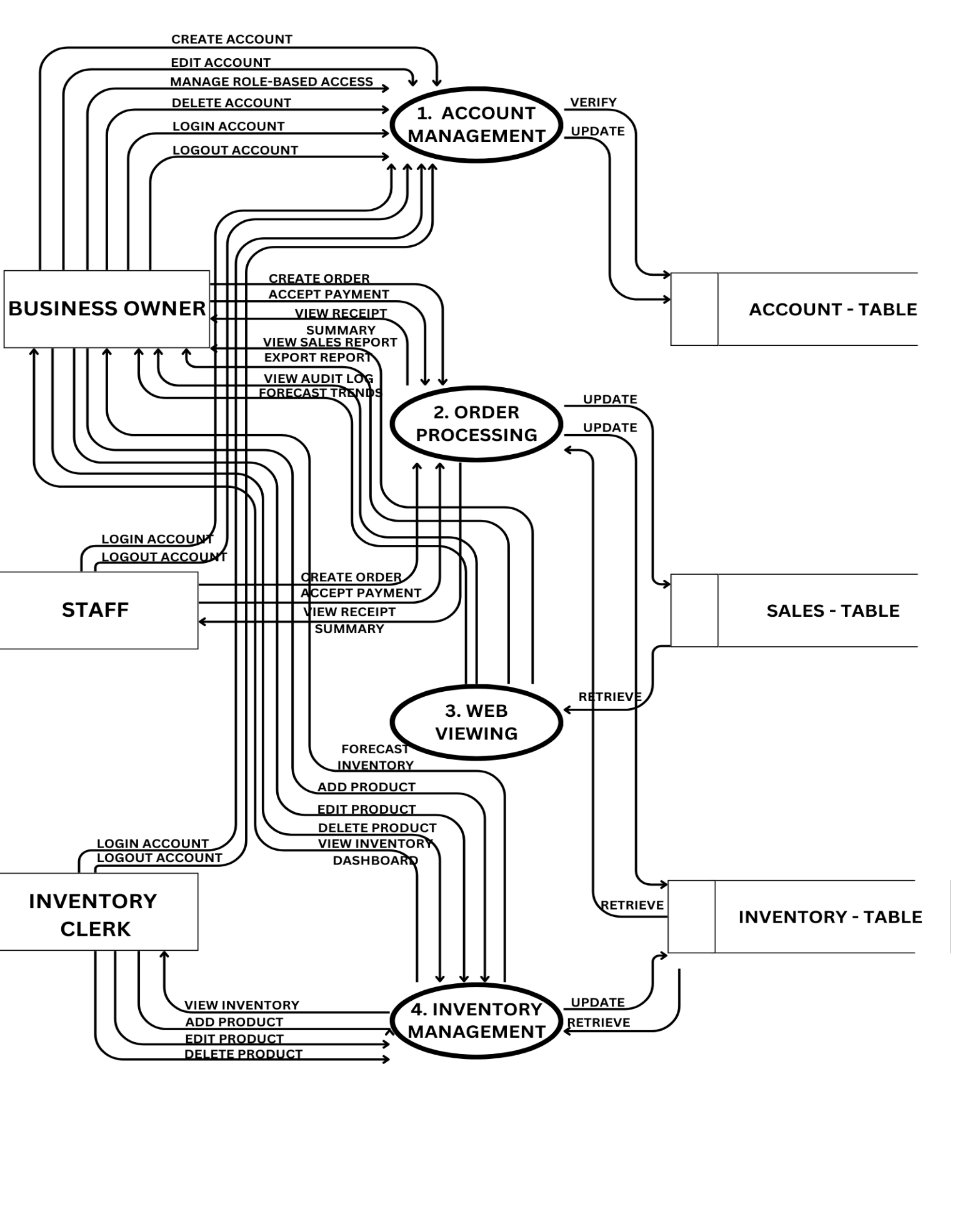
Figure 23. Level 1 Data Flow Diagram

Level 2
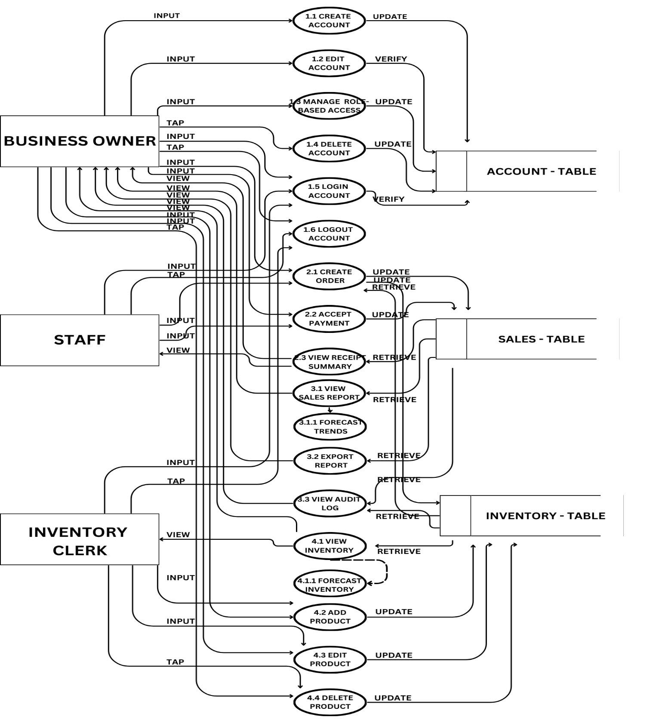
Figure 24. Level 2 Data Flow Diagram
The Data Flow Diagram (DFD) shows how created orders are handled in the POS and Inventory system. The system receives customer orders, checks product availability, and automatically updates the inventory and sales. Data stores include the users, sales and inventory table.

Data Dictionary
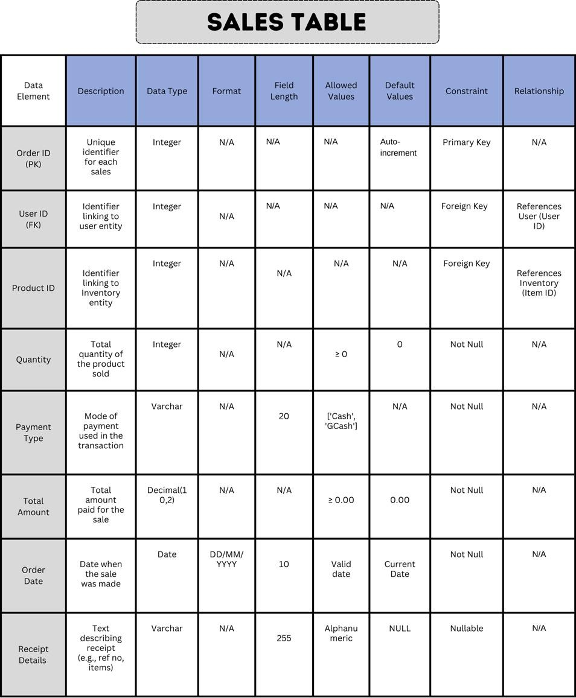
Figure 25. Sales Table Data Dictionary
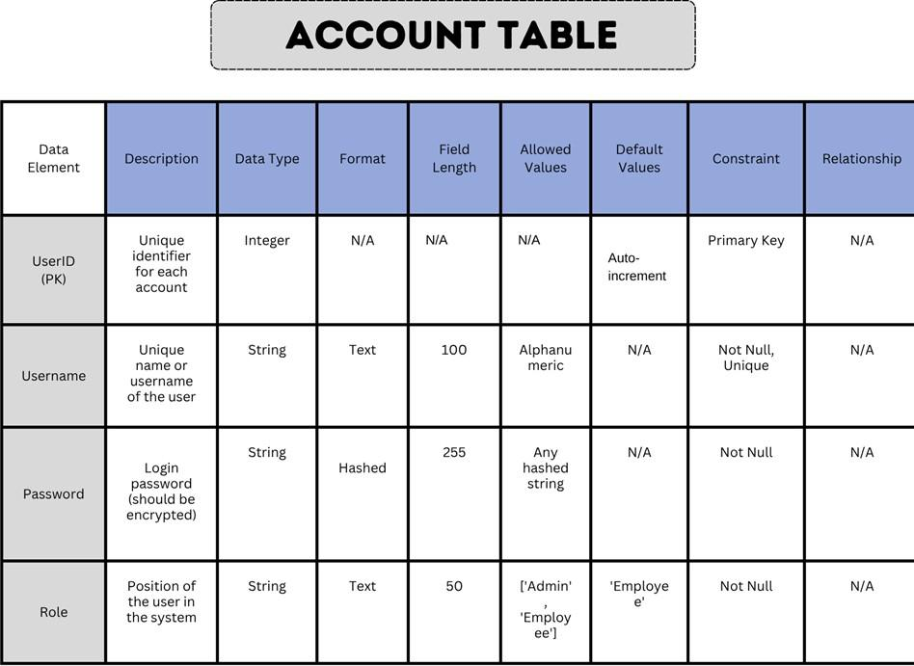
Figure 26. Account Table Data Dictionary
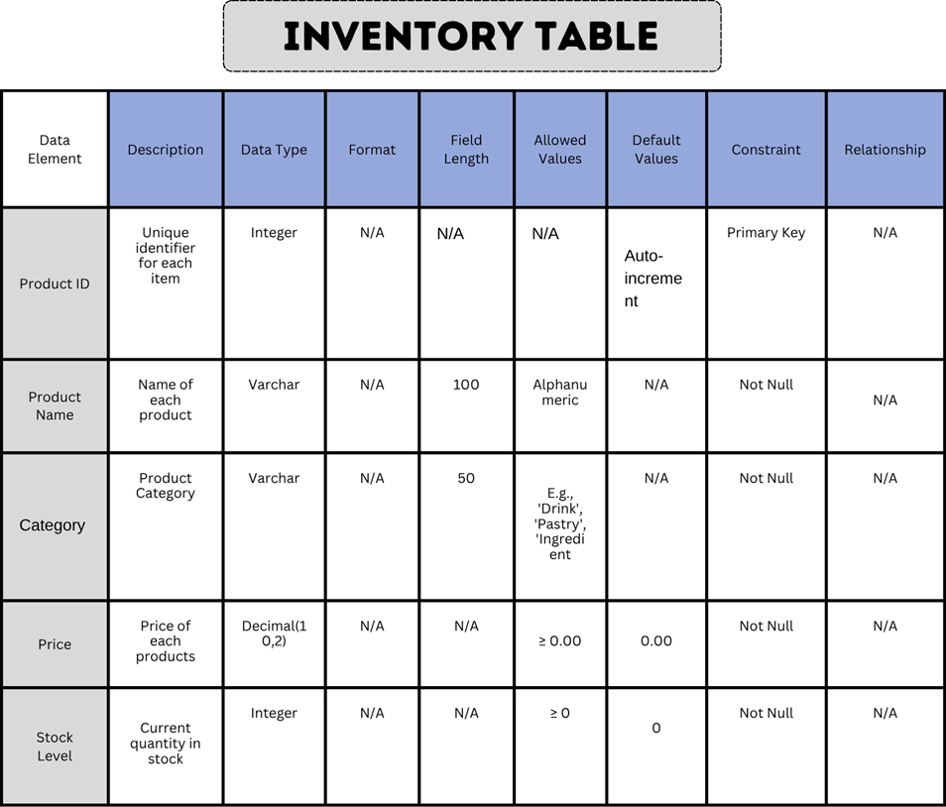
Figure 27. Inventory Table Data Dictionary
The data dictionary provides a comprehensive definition of the data elements used in the system. Each entry includes the data name, type, length, description, and any applicable constraints. This helps ensure consistency in data usage, supports database design, and serves as a guide for developers and analysts. The data dictionary also aids in understanding how data is stored, accessed, and validated throughout the system.

Flow Chart(s)
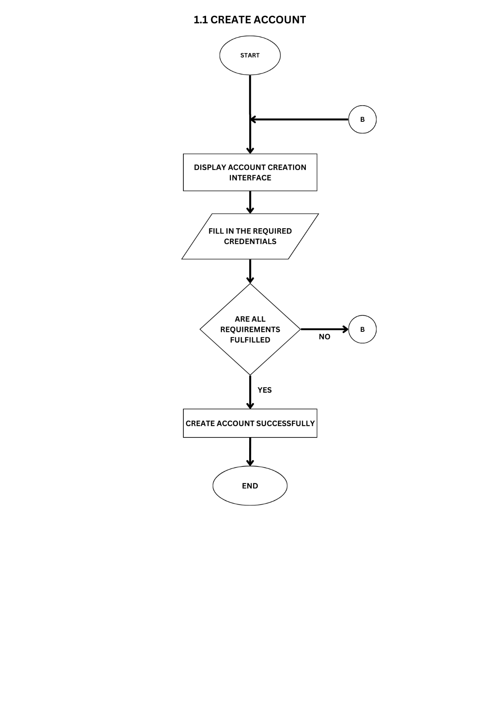
Figure 28Flow Chart: Create Account.
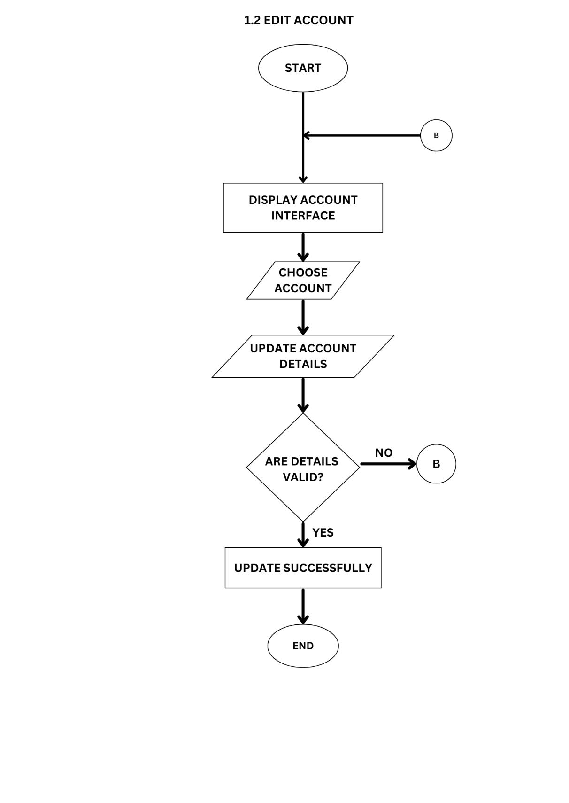
Figure 29Flow Chart: Edit Account.
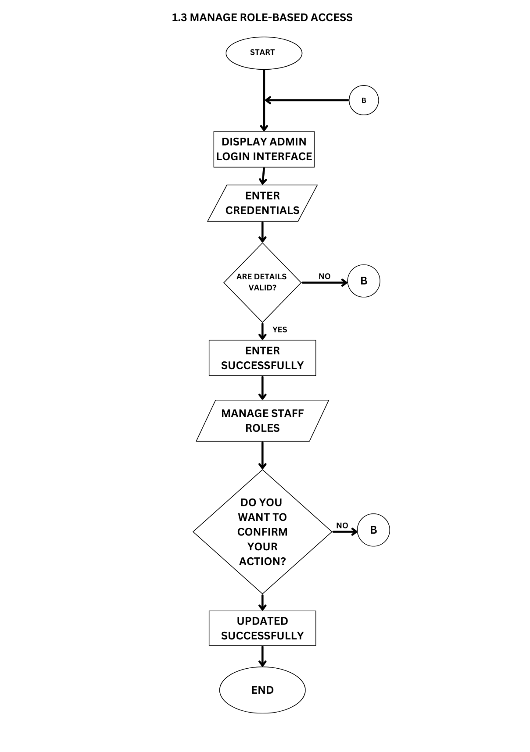
Figure 30 Flow Chart: MANAGE ROLE-BASED ACCESS.
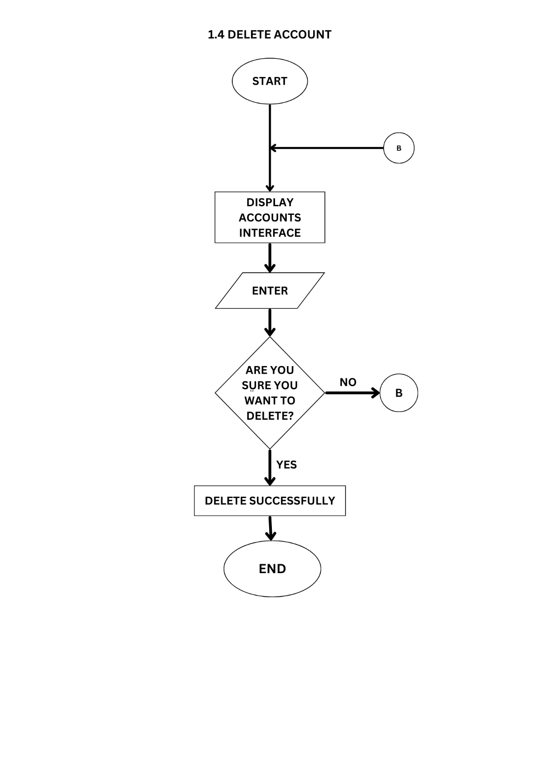
Figure 31 Flow Chart: Delete Account
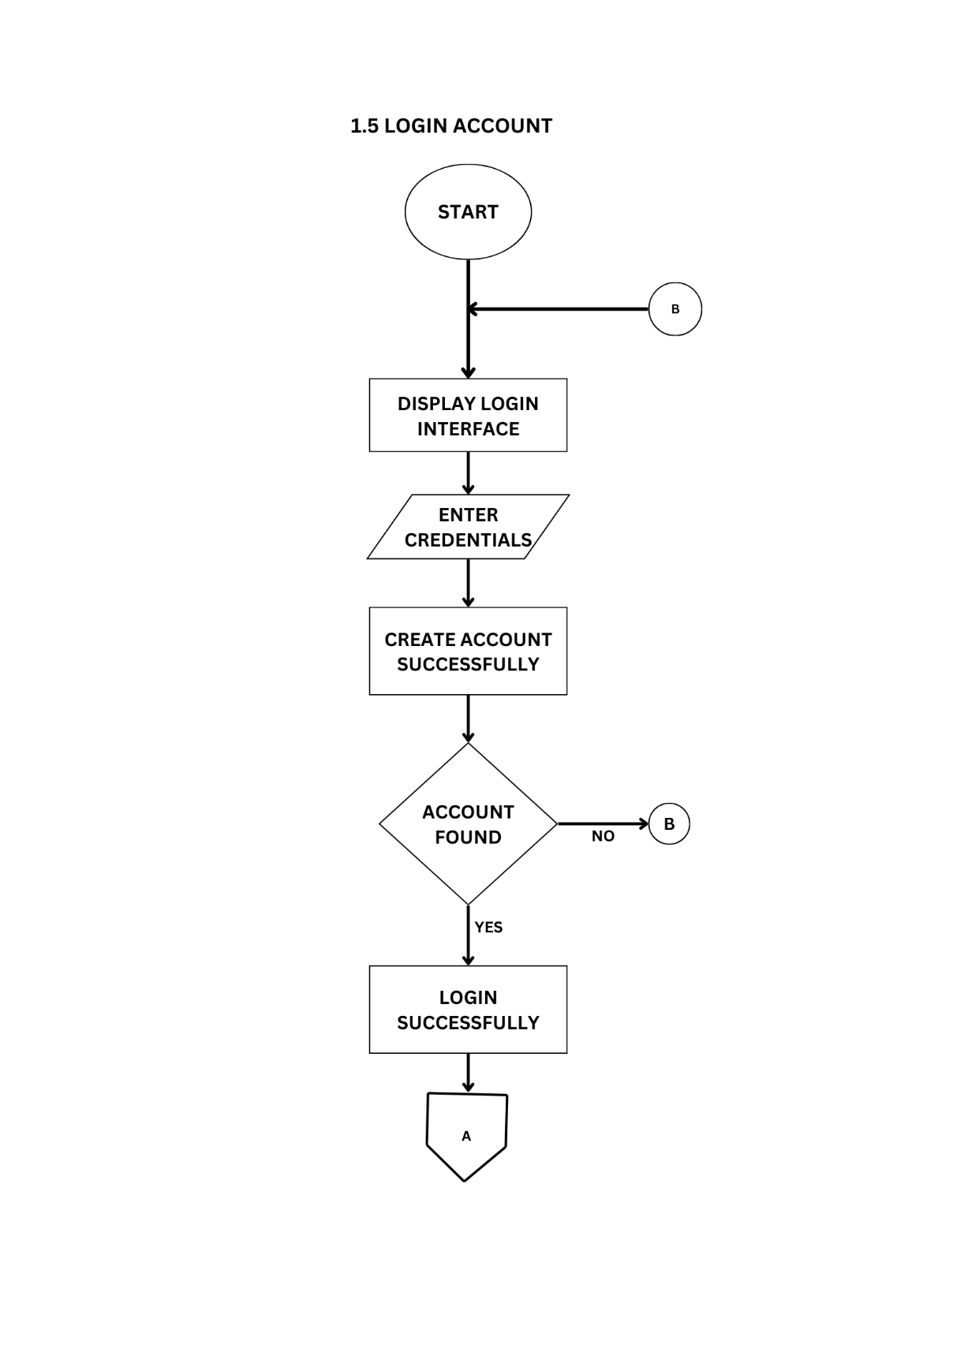
Figure 32Flow Chart: Login Account.
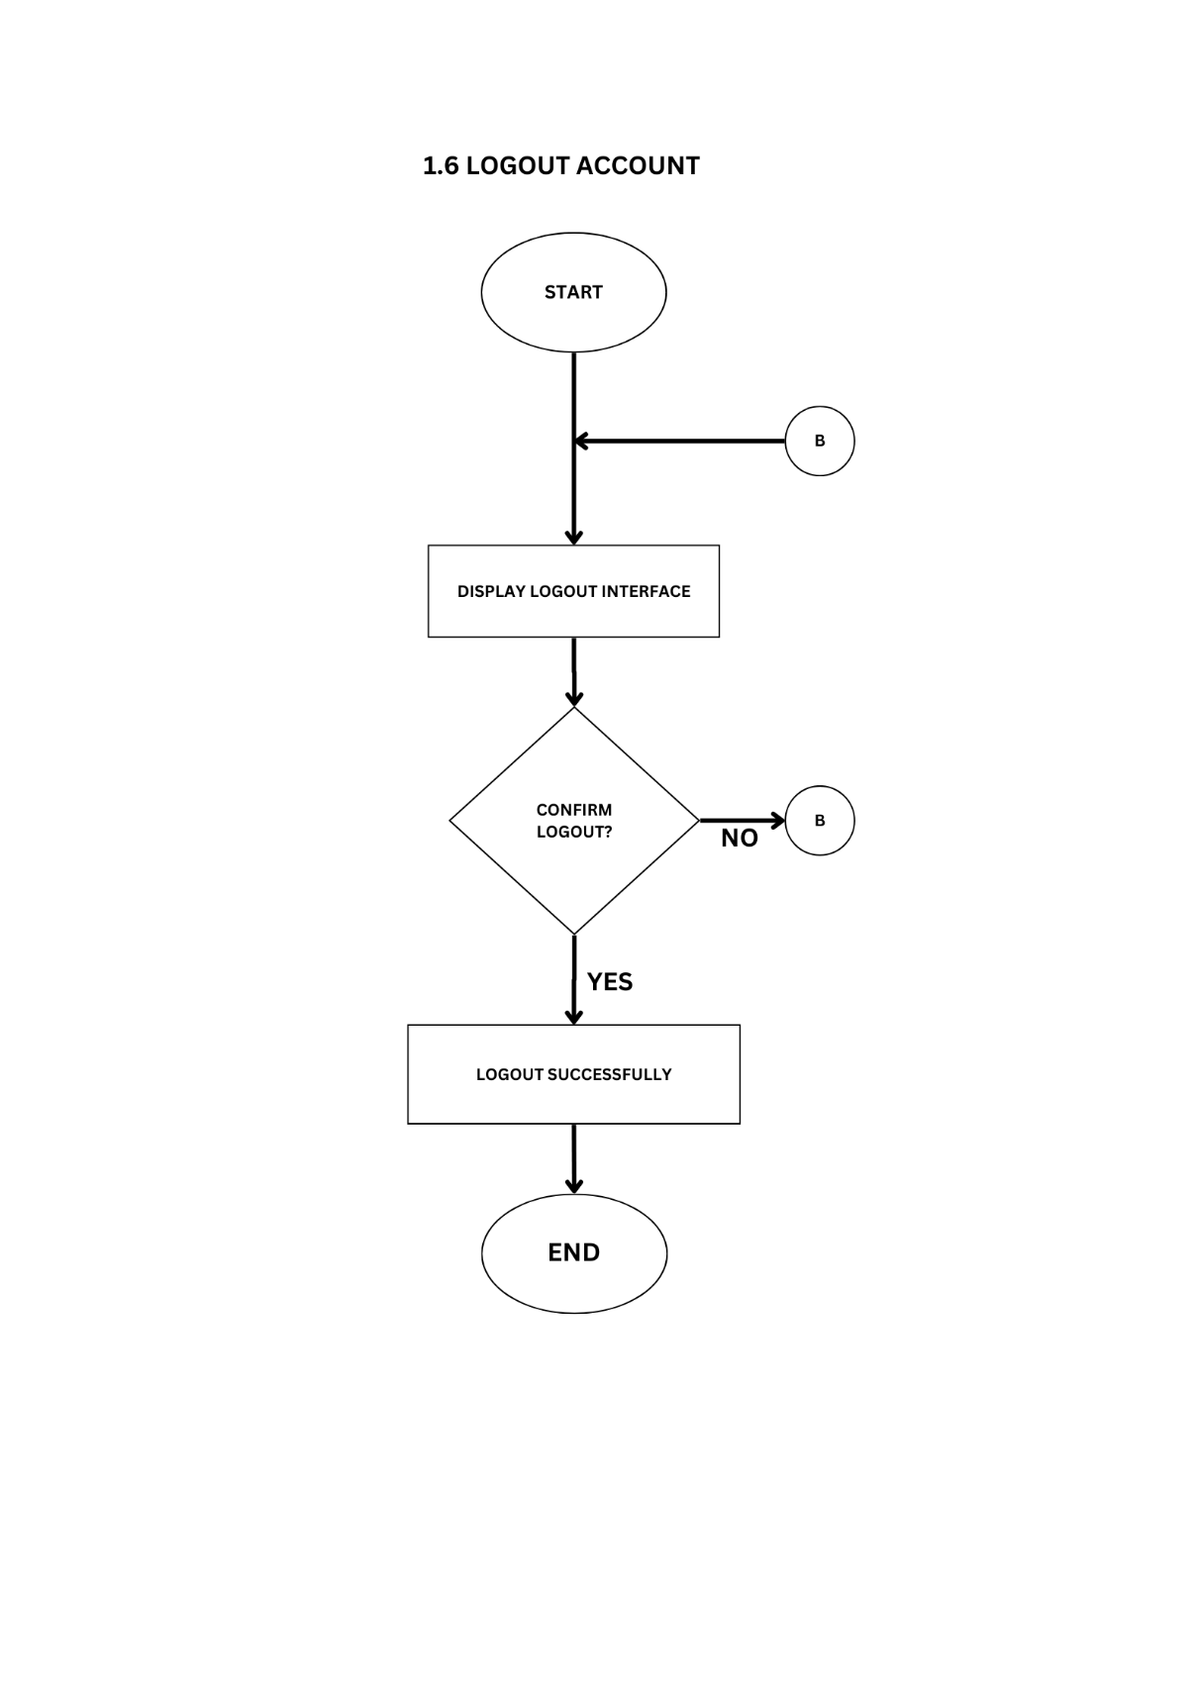
Figure 33. Flow Chart: Logout Account.
The Account Management module is responsible for major user operations such as account creation, modification, and deletion, as illustrated in Create Account, Edit Account, and Delete Account. To maintain secure and role-appropriate access, it incorporates a role-based access control system, shown in Manage Role-Based Access, which ensures that users are granted permissions aligned with their responsibilities. The module includes secure login and logout features, depicted in Login Account and Logout Account, to manage user authentication and protect session integrity. Collectively, this module plays a vital role in efficient user management and reinforces the overall security framework of the system.
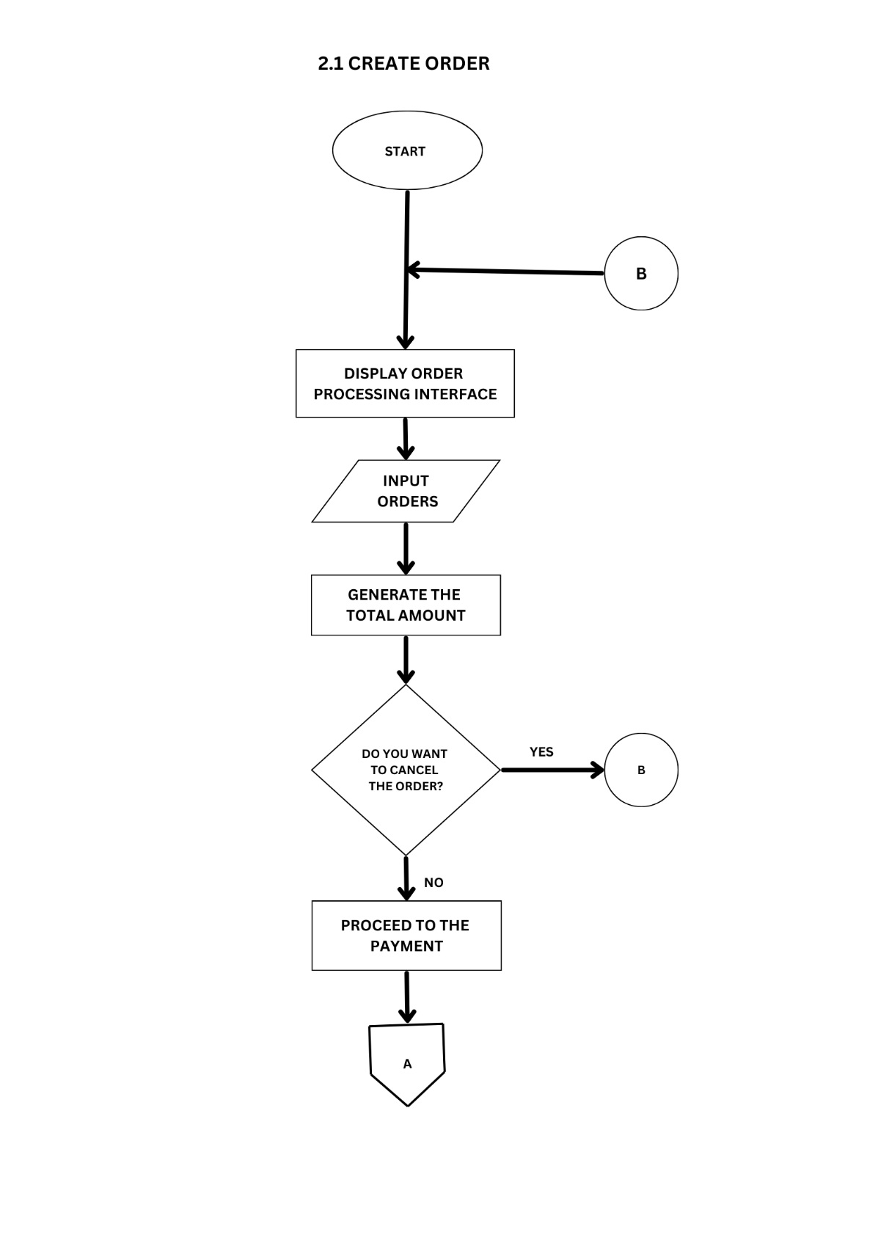
Figure 34. Flow Chart: Create Order
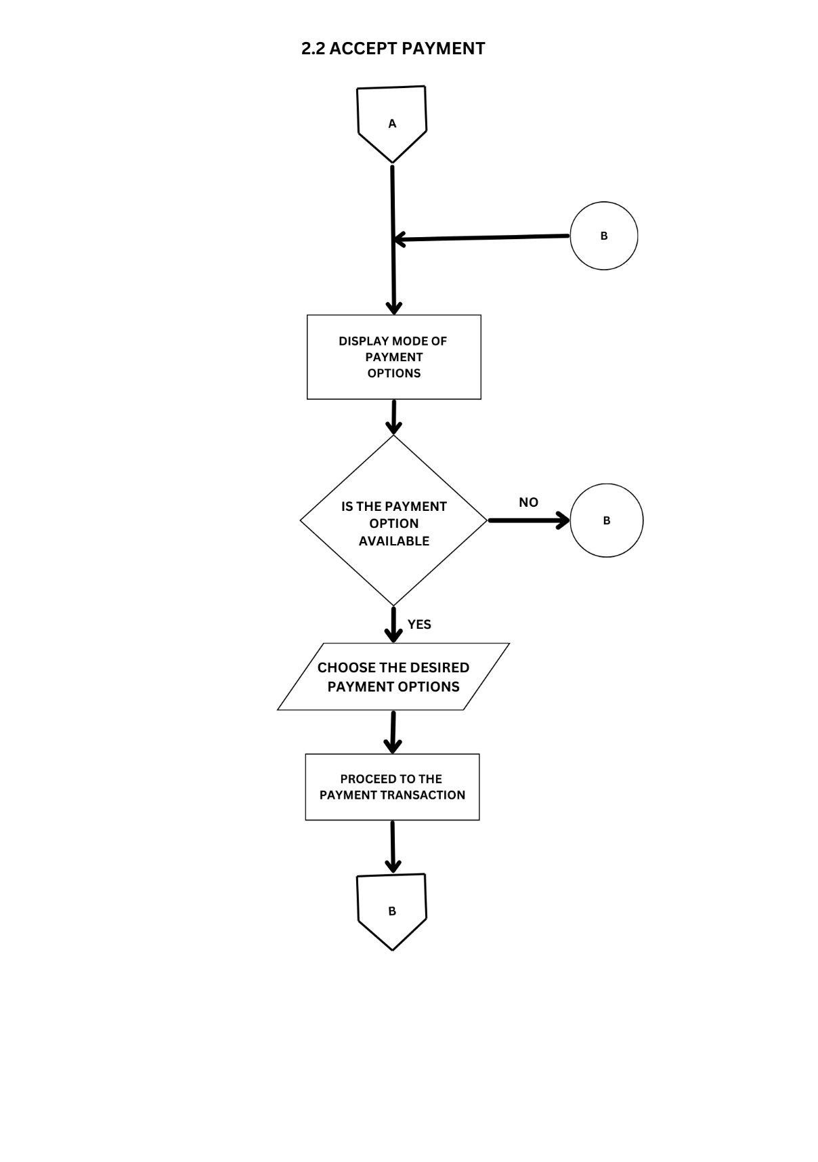
Figure 35. Flow Chart: Accept Payment
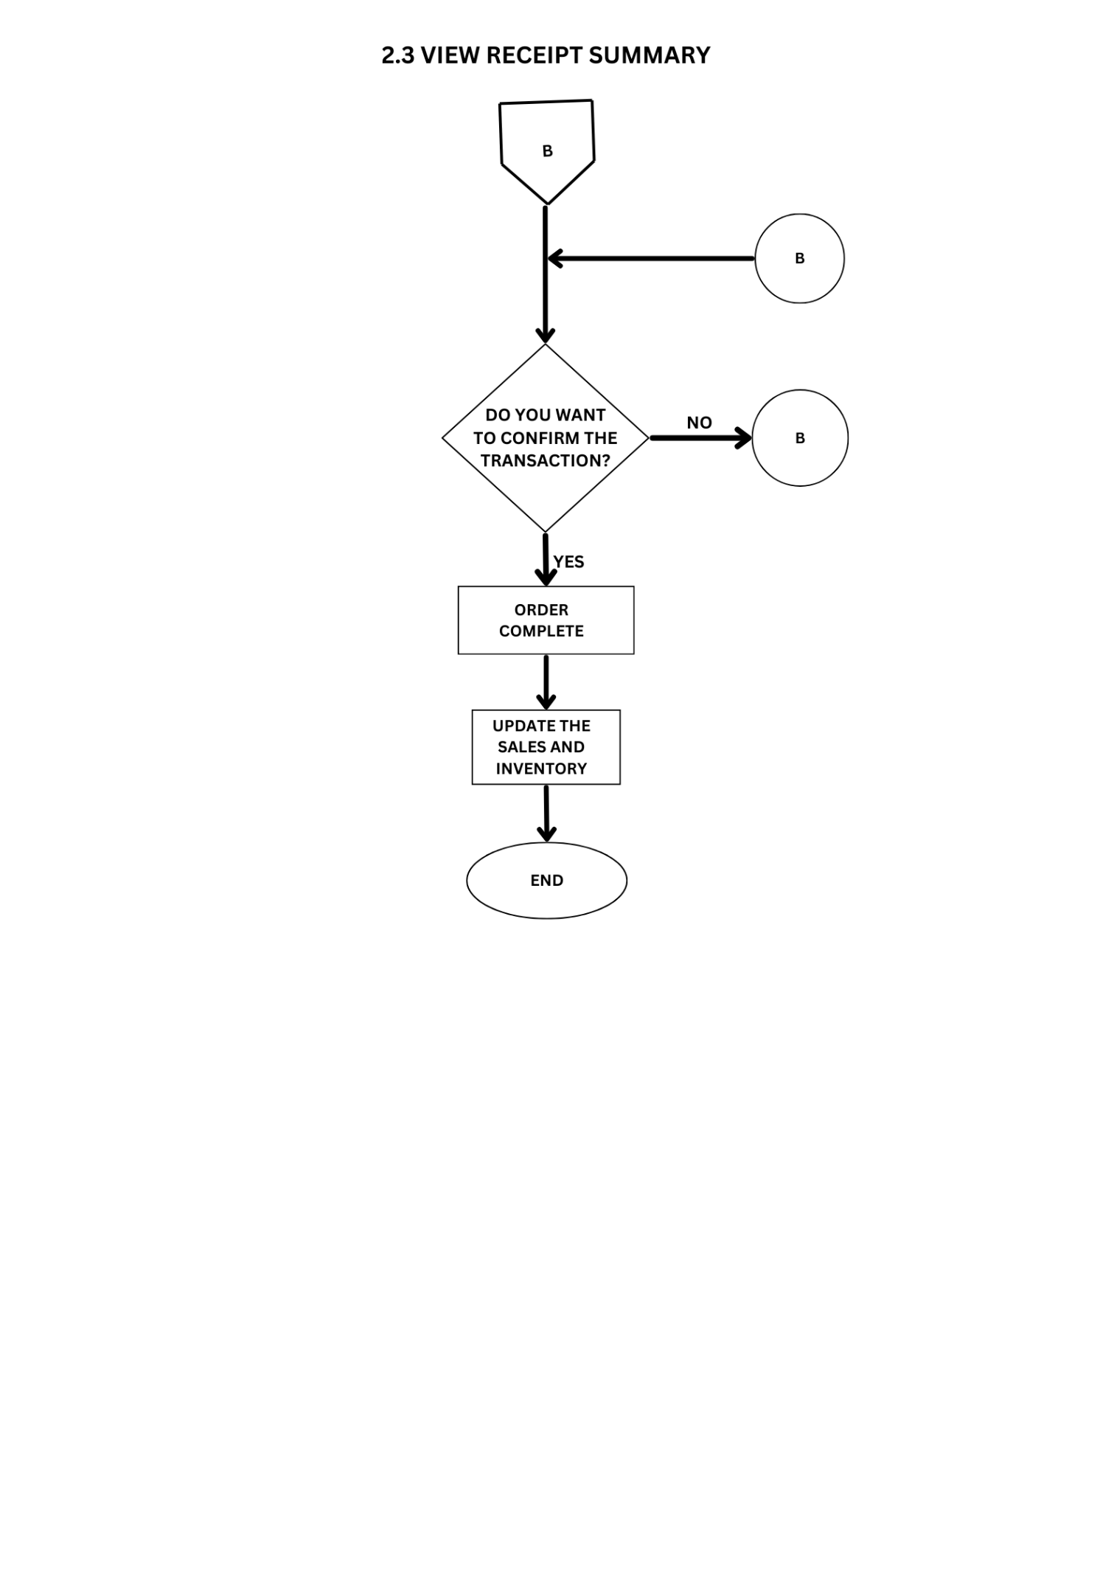
Figure 36. Flow Chart: View Receipt Summary
The Order Processing function manages the system’s core transactions, beginning with order creation, where selected items are recorded for checkout. Once completed, payment is accepted through methods such as cash or GCash, ensuring accurate transaction handling.

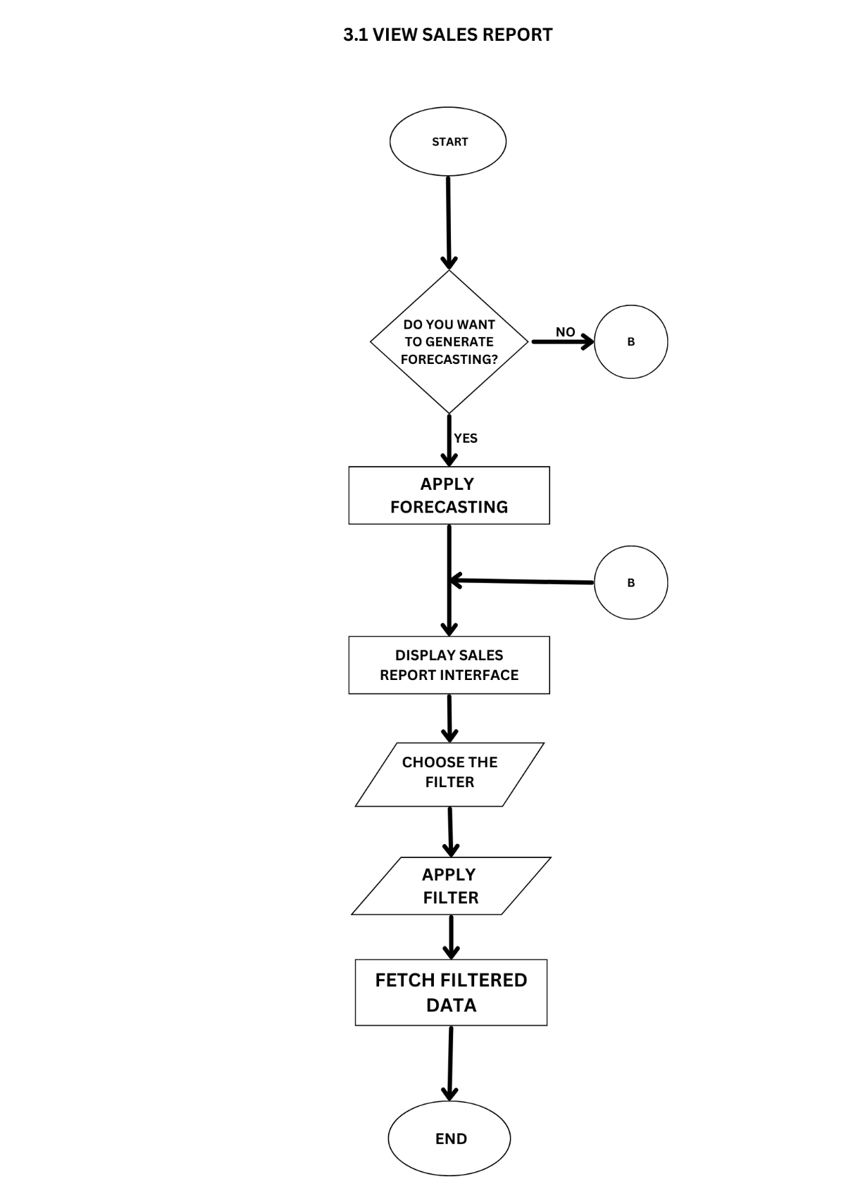
Figure 37. Flow Chart: View Sales Report
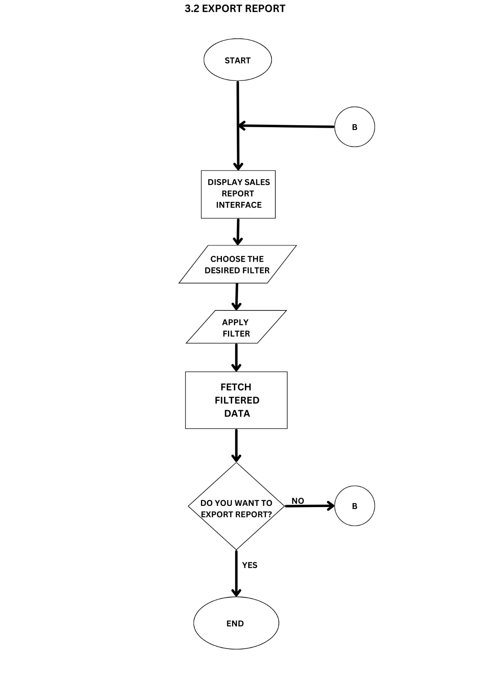
Figure 38. Flow Chart: Export Report
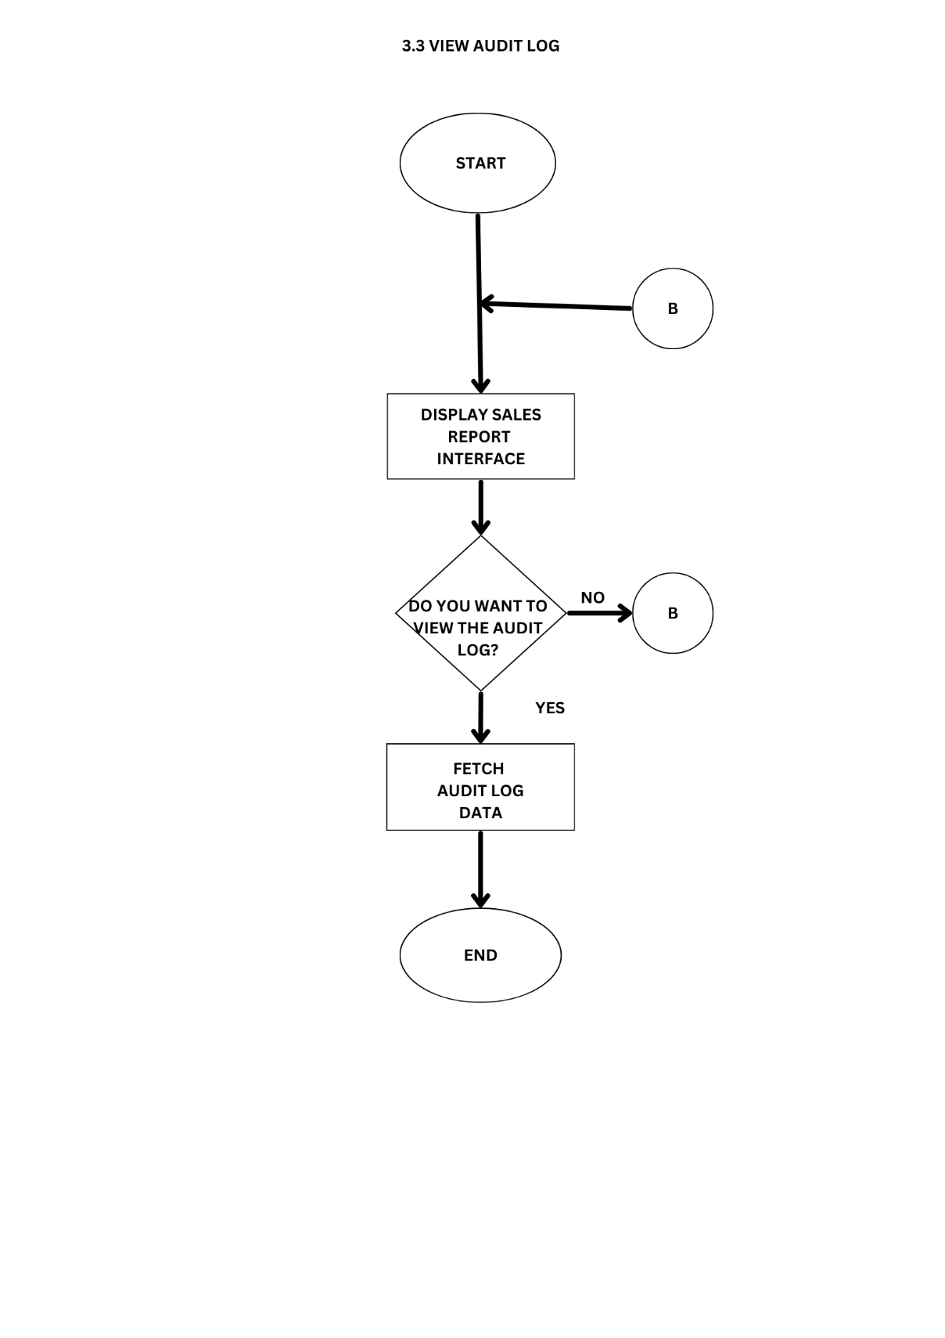
Figure 39. Flow Chart: View Audit Log
The Sales Report function offers key features for tracking business performance. Users can access detailed transaction data and view trends through the sales report interface. With the use of forecasting, users can easily identify sales and inventory trends and export these reports as needed for documentation or analysis. To ensure transparency and accountability, all report-related activities are recorded in the audit log.
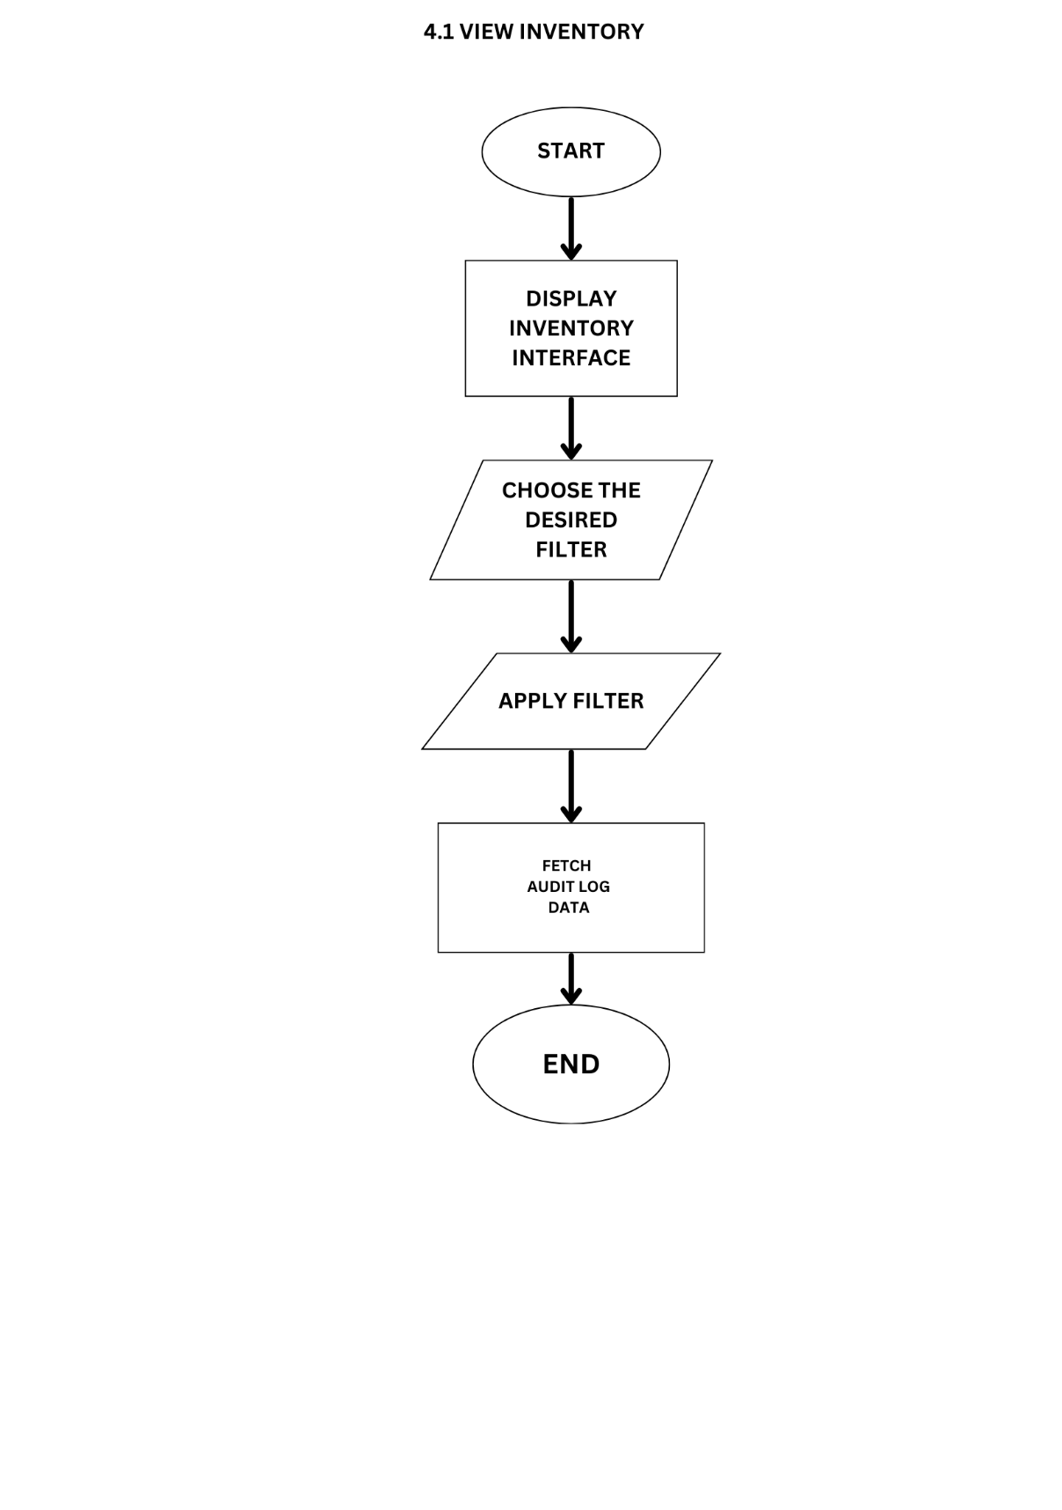
Figure 40. Flow Chart: View Inventory Dashboard
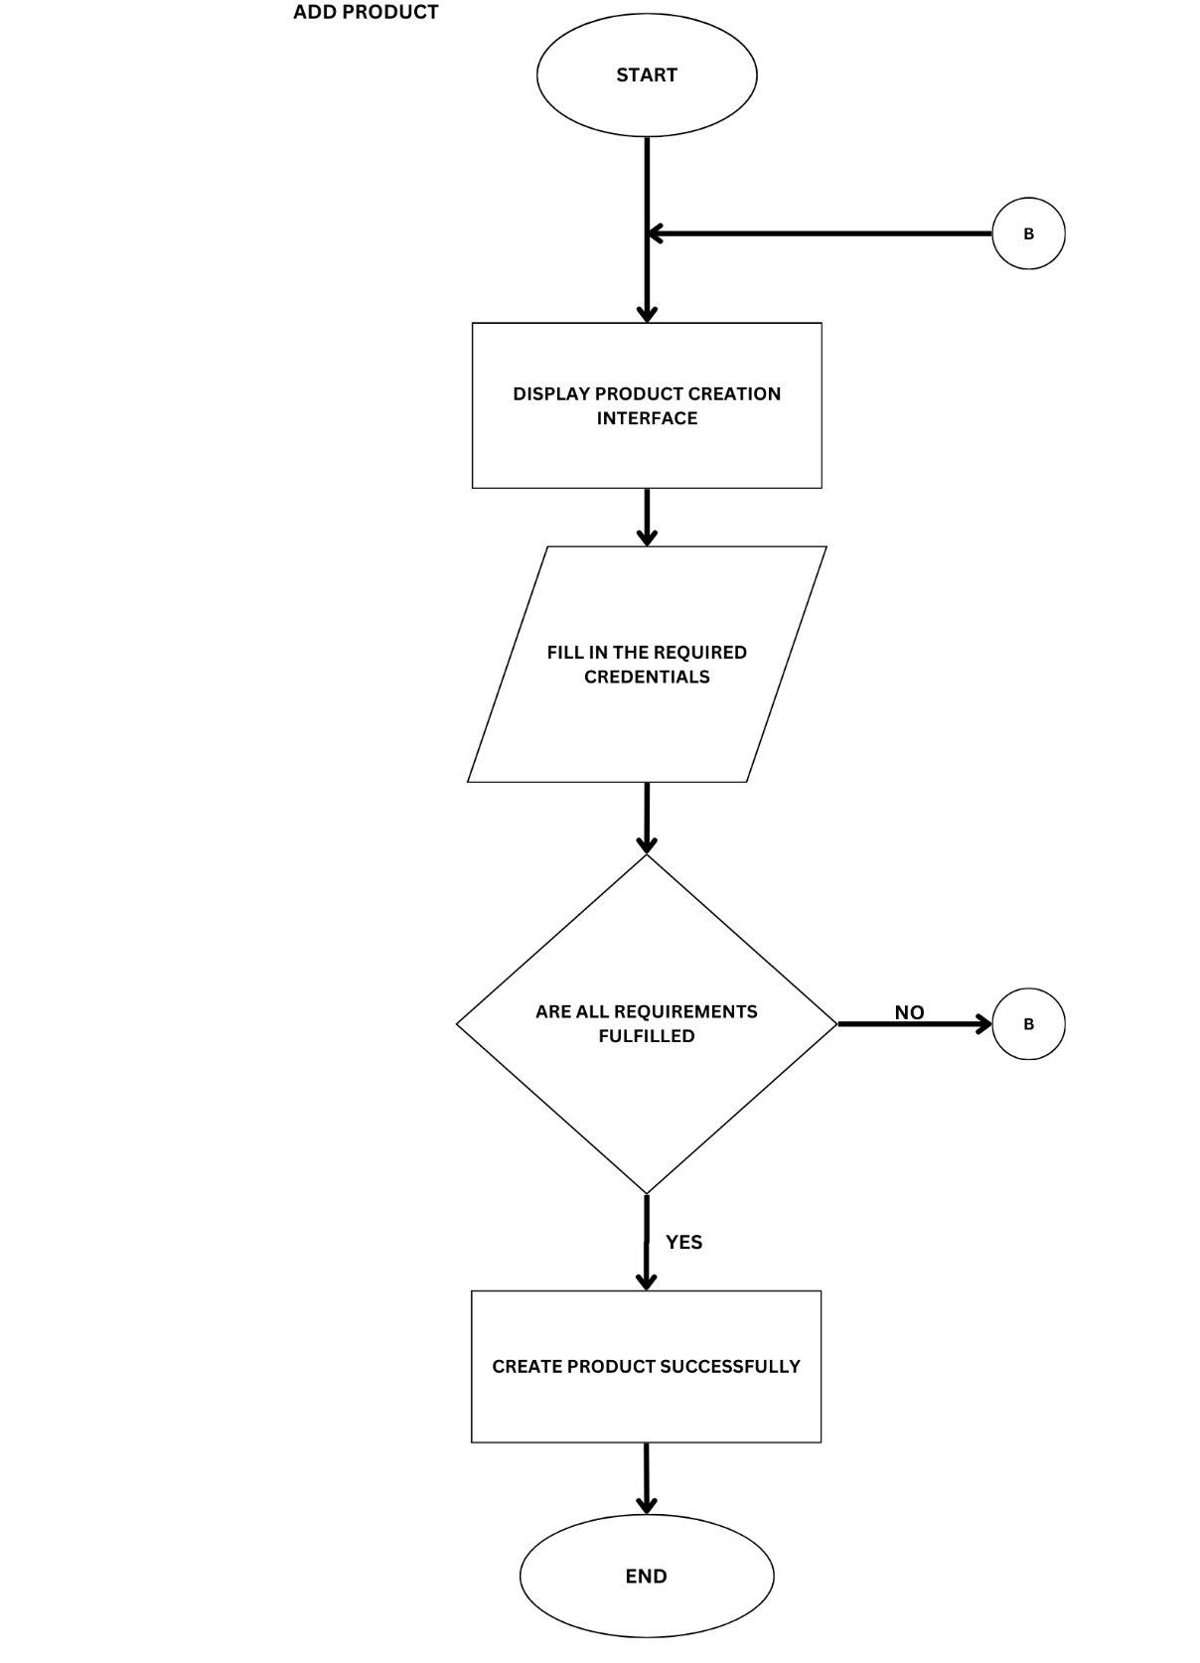
Figure 41. Flow Chart: Add Product
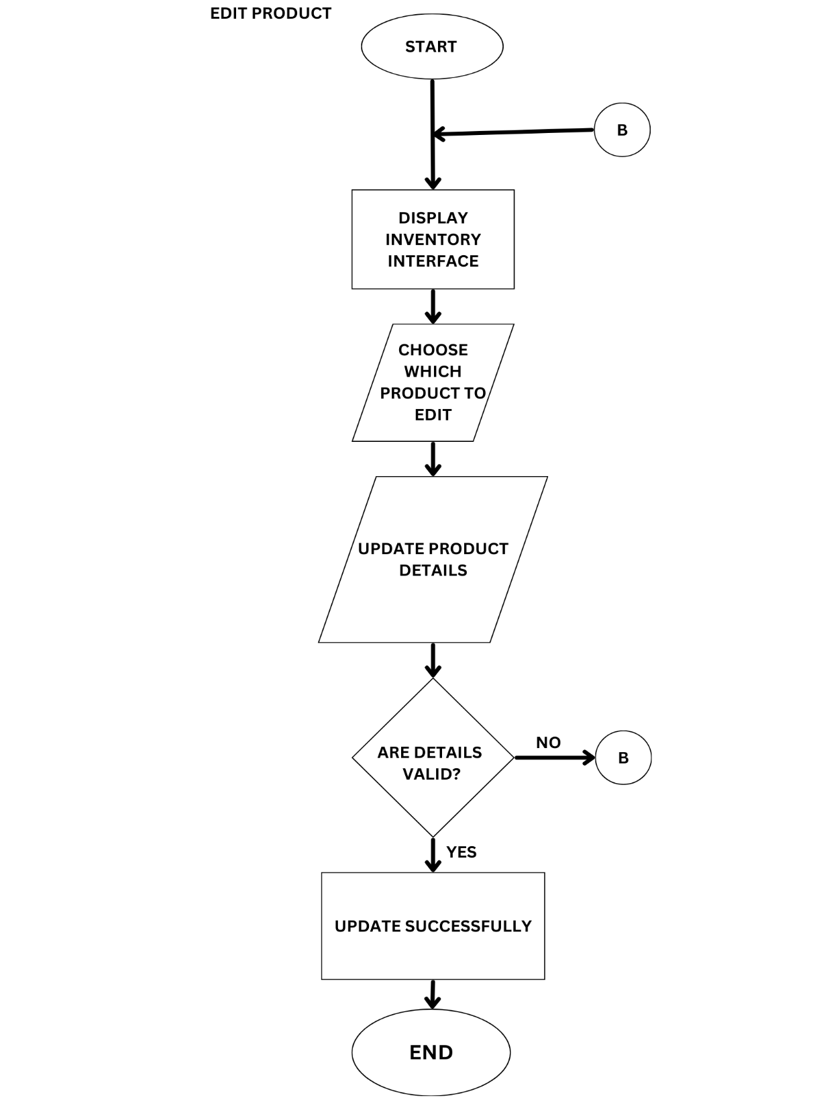
Figure 42. Flow Chart: Edit Product
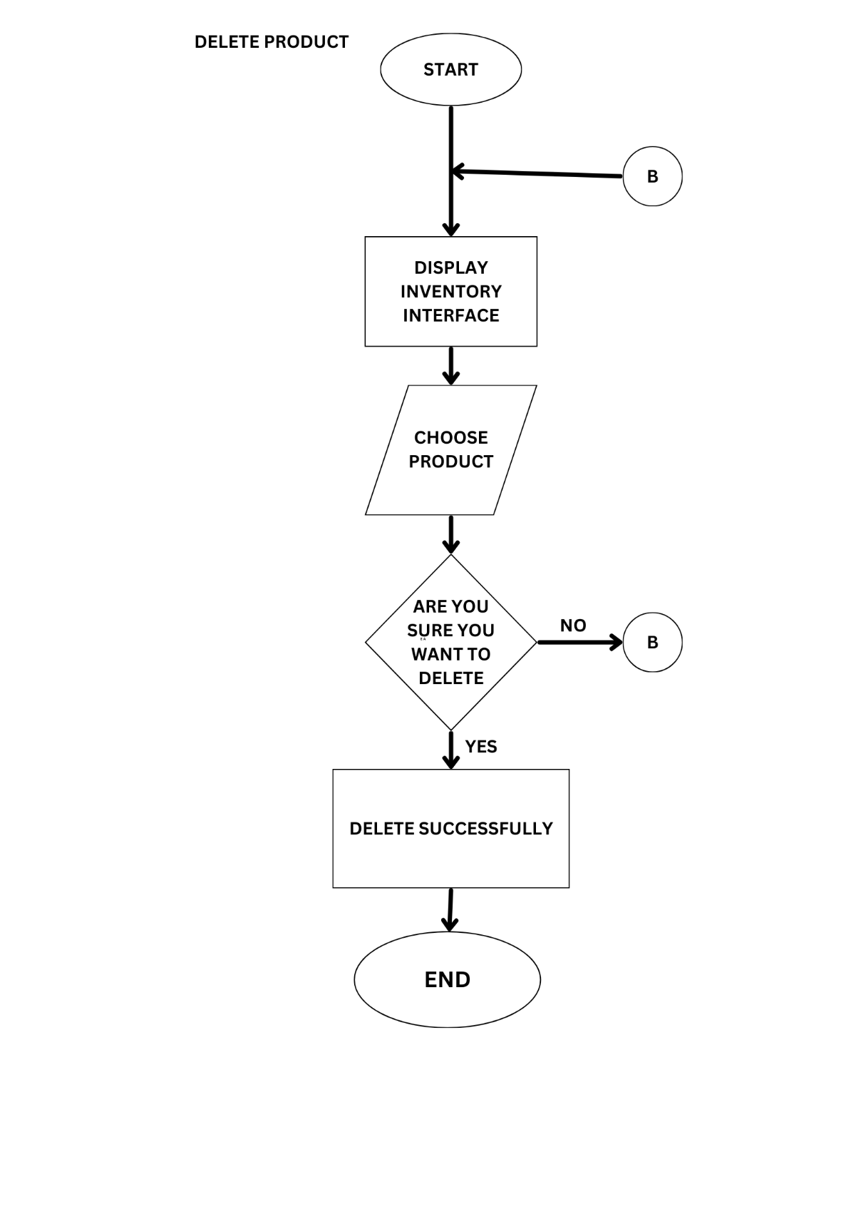
Figure 43. Flow Chart: Delete Product
The Inventory Management function provides efficient tools for tracking and managing product stocks. Users can monitor product availability and stock levels through the inventory dashboard, add new products (Figure 36), update existing product information, and remove outdated items from the system. These capabilities help maintain accurate inventory records and ensure smooth business operations.
Wire Frame
Mobile POS and Inventory
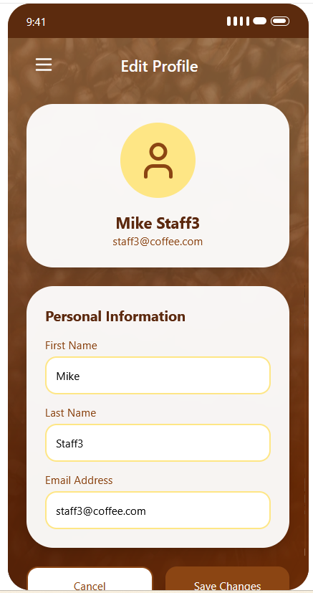
Figure 44. Wire Frame: Edit Account
Figure 45. Wireframe: Create Account

Figure 46. Wire Frame: Account List
Figure 47. Wire Frame: Login


Figure 48. Wire Frame: Logout

The Account Management module provides essential user account functions to ensure secure and efficient access to the system. It includes features for creating new accounts, editing account details, and deleting accounts when necessary. Users can log in securely to access the system and log out when finished. An account list is available for administrators to view and manage all registered accounts, supporting easy monitoring and updates.
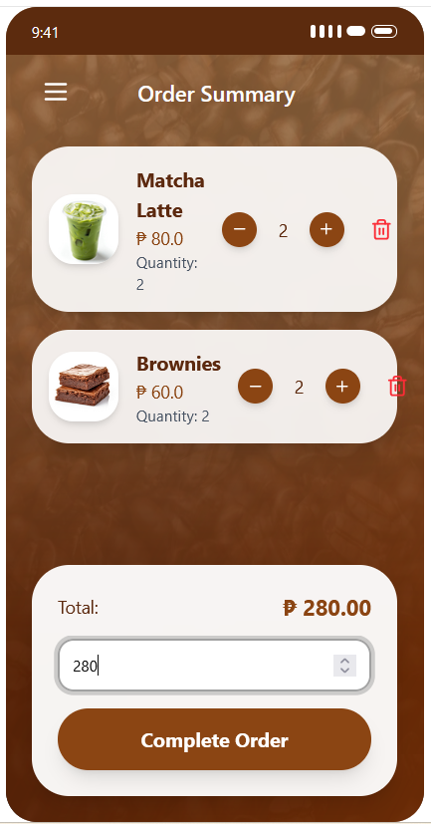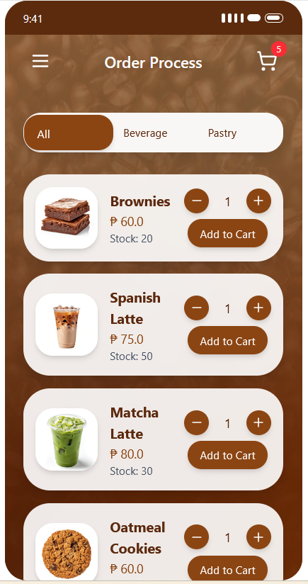
Figure 49Wire Frame: Create Order
Figure 50. Wire Frame: Accept Payment

Figure 51. Wire Frame: View Receipt Summary
The Order Processing module streamlines transaction handling within the POS. It allows users to create new orders by selecting products, quantities, and customizations. Once the order is finalized, the system facilitates secure payment acceptance to complete the transaction. After successful payment, a receipt summary is displayed for both recordkeeping and customer confirmation of purchase.

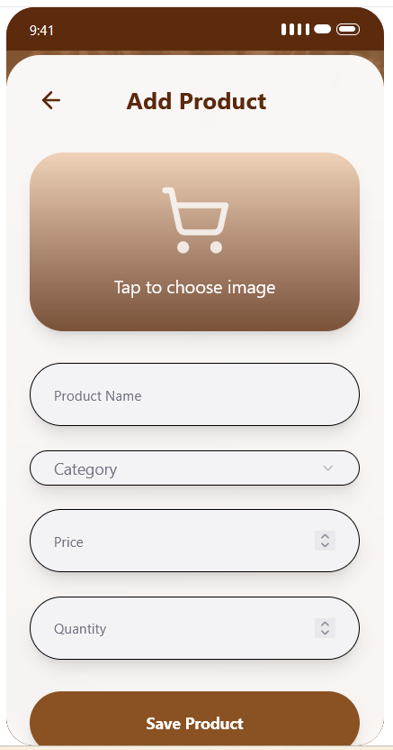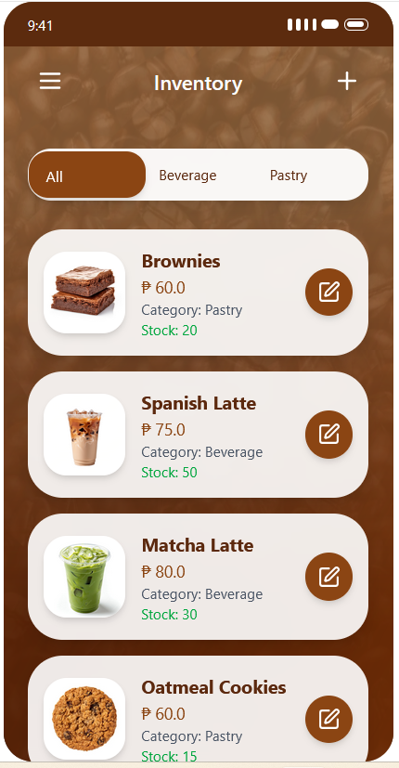
Figure 52. Wire Frame: Inventory Dashboard
Figure 53. Wire Frame: Create Product
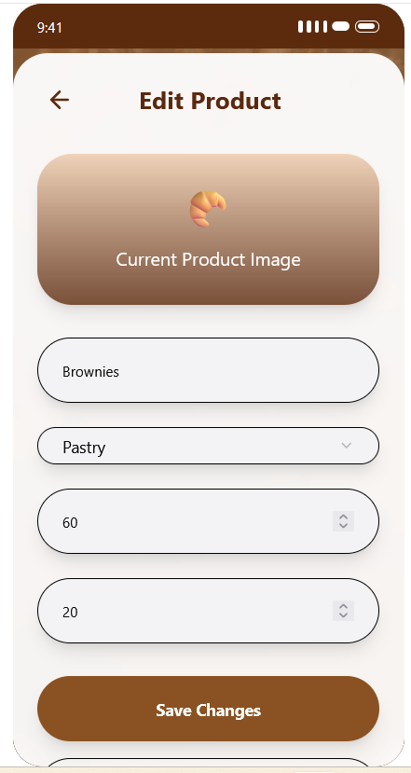
Figure 54. Wire Frame: Edit Product
The Inventory Management module provides tools for maintaining and monitoring product stocks. It enables users to add new products and update existing product details as needed. An inventory dashboard is included to give an overview of available items, stock levels, and product information, helping ensure accurate and efficient inventory tracking.

Web Viewing
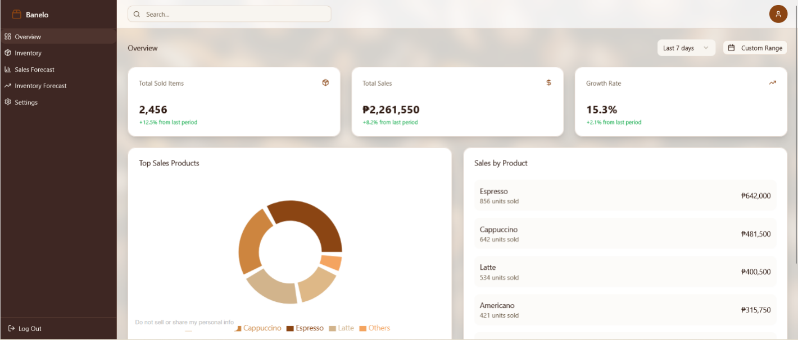
Figure 55. Wire Frame Web: Overview
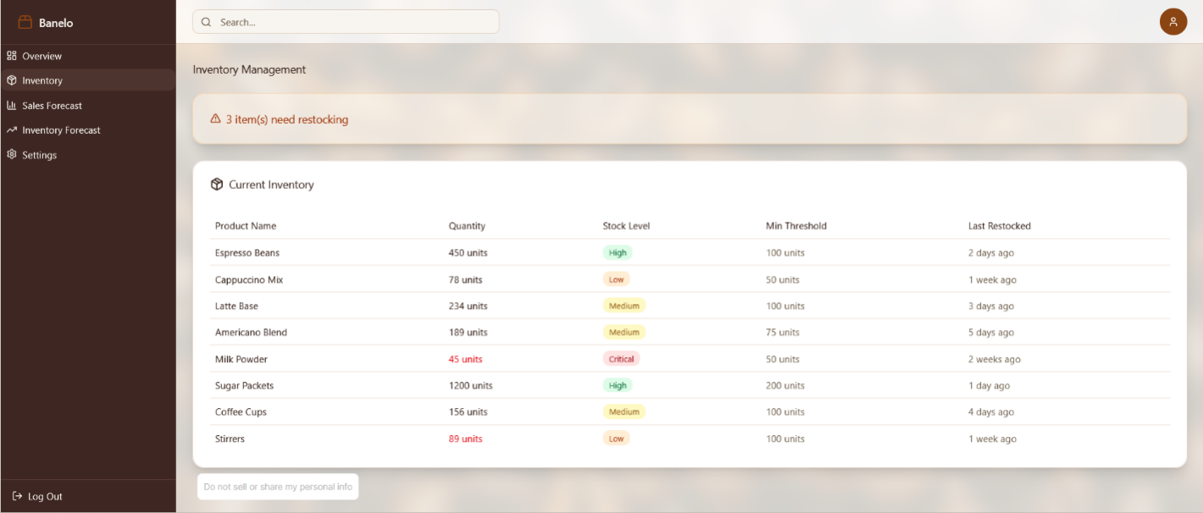
Figure 56. Wire Frame Web: Inventory
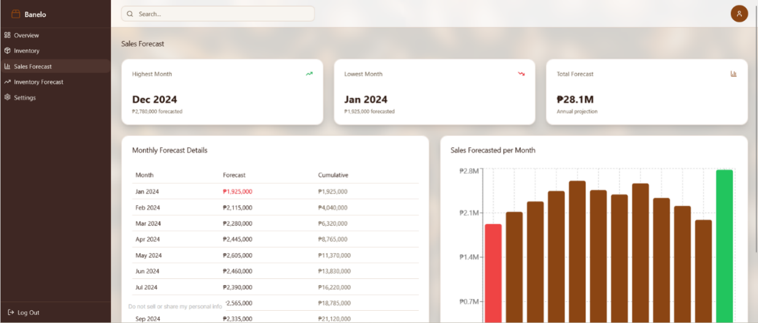
Figure 57. Wire Frame Web: Sales Forecast
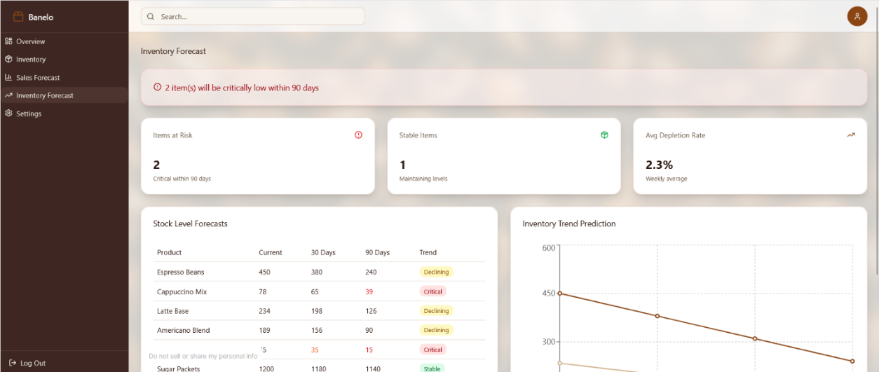
Figure 58. Wire Frame Web: Inventory Forecast
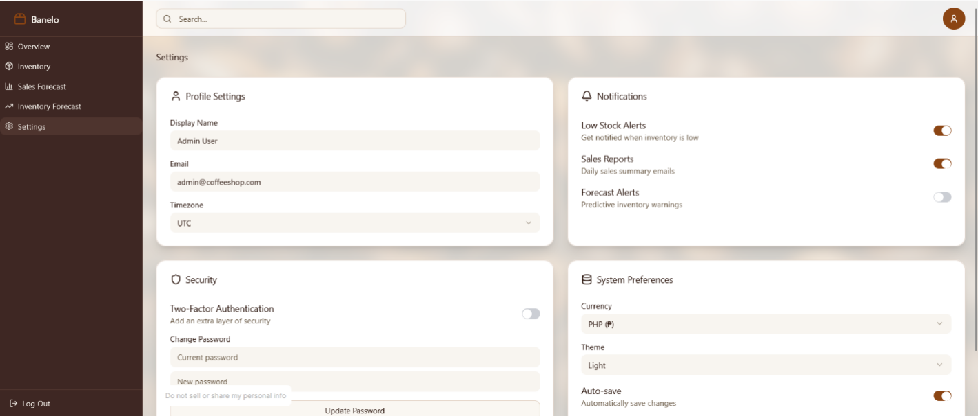
Figure 59. Wire Frame Web: Setting
The Web Viewing module extends system accessibility by providing a browser-based interface for monitoring and analysis. It includes an overview section for tracking sales performance, as well as an inventory view to check current stock levels. Forecasting features are available for both sales and inventory, helping anticipate trends and manage resources effectively. A settings section is also included to configure and customize system preferences.

Knowledge Discovery in Databases (KDD) Methodology
Applied if the system involves data analytics or forecasting. It follows stages from raw data to usable patterns.
  - What data?
The primary dataset for this study consists of historical transaction records obtained from the POS system of Banelo Bake and Brew. The data includes essential fields such as product names, categories, quantities sold, unit prices, total sales per transaction, inventory levels, and transaction timestamps. These attributes were chosen for their direct relevance to sales behavior and forecasting accuracy. Although promotional data is not available, time-based attributes like weekdays, weekends, and months will be considered to capture periodic fluctuations in customer demand.
  - How will I prepare it?
Data preparation will begin with preprocessing, which involves cleaning the raw dataset to ensure consistency, completeness, and accuracy. This includes removing duplicate entries, correcting inconsistent product codes or labels, standardizing date formats, and addressing any missing or null values in key fields. After cleaning, the data will undergo transformation to make it suitable for mining. This involves aggregating daily sales into weekly or monthly totals to smooth short-term noise, generating lag features (e.g., sales from previous days or weeks), and creating rolling averages to highlight trends. Additionally, categorical fields like product categories will be encoded numerically using techniques such as one-hot encoding. Time-based features—such as day of the week, month, or whether the date falls on a weekend—will also be engineered to help the model detect seasonal and behavioral sales patterns.
  - What model will I use?
Multiple Linear Regression
Multiple Linear Regression (MLR) will be applied as the forecasting model to predict sales by examining the combined effect of multiple independent variables on a dependent variable. MLR is widely recognized for its ability to estimate how multiple predictors jointly influence an outcome variable.
According to Dong (2024), multiple linear regression (MLR) proves to be effective for predicting sales since it combines various business components, including pricing, marketing tactics, and consumer spending patterns, to demonstrate fluctuations in sales. Similarly, Lin (2024) showed that MLR is advantageous for retail forecasting, as it considers the impact of external factors such as temperature, holidays, consumer price index (CPI), and unemployment rates on weekly sales. These studies highlight that MLR goes beyond simple regression by incorporating diverse predictors, making it well-suited for real-world applications where multiple factors interact to shape demand. The model assumes a linear relationship, mathematically expressed as:
yi​=β0​+β1​xi1​+β2​xi2​+...+βp​xip​+ϵ
Where:
yi​ = predicted value (e.g., sales)
Bo = intercept
B1, B2,..,Bp = coefficients of predictors
Xi1, Xi2,..,Xip = independent variables
ϵi​ = error term
In the case of Banelo Bake and Brew, the researcher will examine factors like the day of the week, promos, seasonal trends, and available stock, with sales as the main variable to measure. With the use of MLR, we can see how these factors affect the sales performance
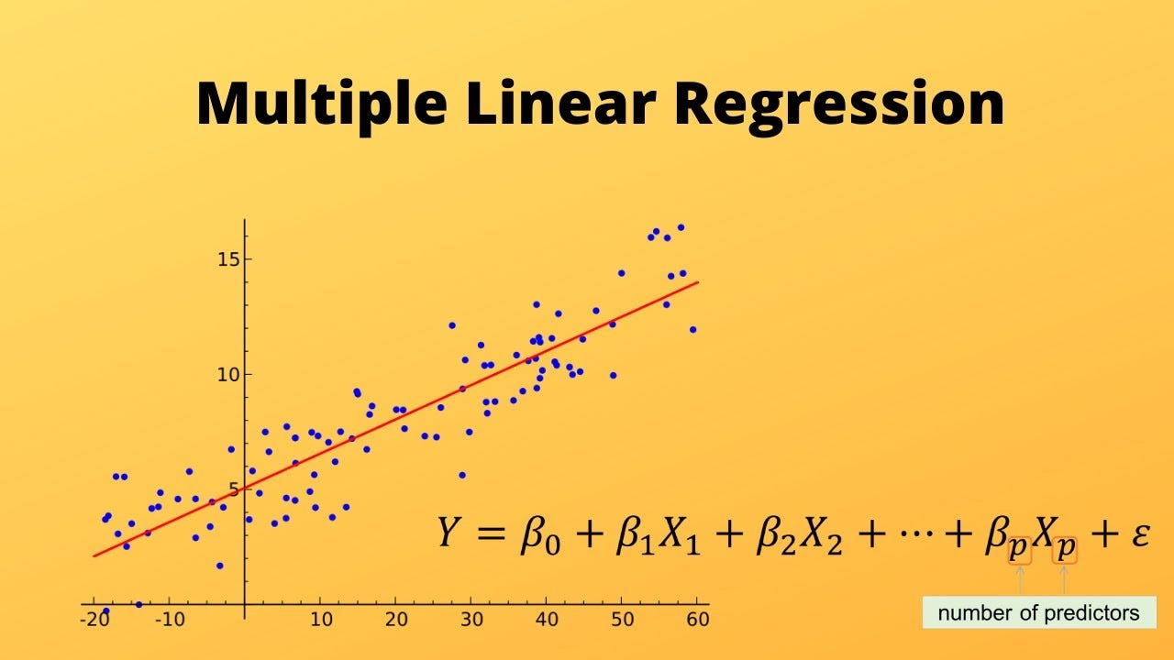
Figure 60. Multiple Linear Regression Model
• How will I measure performance?
The accuracy of the MLR model will be assessed using Root Mean Square Error (RMSE), Mean Absolute Error (MAE), and the R² Score. These metrics will help determine whether the model reliably explains sales patterns and provides consistent predictions. Residual analysis will also be conducted to check whether linearity and other assumptions hold true.
• How will results be shown?
Results will be presented through line graphs comparing actual versus predicted sales values over time, along with residual scatter plots to visualize model performance. These outputs will be integrated into the POS dashboard to give Banelo Bake and Brew practical insights into sales drivers for better inventory planning.

Decision Tree Regression
Decision Tree Regression is a non-parametric machine learning technique that predicts outcomes by splitting data into branches based on decision rules. According to Reddy and Malathi (2022), this model recursively divides the dataset into smaller subsets, creating a tree-like structure that can capture complex, non-linear relationships between predictors and outcomes. Each internal node represents a decision based on a predictor variable, each branch represents the outcome of that decision, and each leaf node provides a predicted value.
Unlike Multiple Linear Regression, which assumes a straight-line relationship between variables, Decision Trees do not require such assumptions. They are especially useful in retail sales forecasting because they can adapt to irregular patterns caused by holidays, customer preferences, and seasonal demand. This flexibility makes the model highly suitable for Banelo Bake and Brew, where demand is influenced by multiple unpredictable factors.
How will I measure performance?
The model will be evaluated using Root Mean Square Error (RMSE), Mean Absolute Error (MAE), and R² Score. These metrics will determine if the predicted data us reliable and accurate. the researcher will also hyperparameters such as maximum tree depth and such.
How will results be shown?
The results of the Decision Tree model will be presented using:
• Line graphs comparing predicted and actual sales values.
• Feature importance charts showing which predictors (e.g., time, promotions, product category) most affect sales.
• Decision tree diagram illustrating how sales predictions are made based on branching rules.
Figure 61 provides an example of a Decision Tree structure. Each split represents a decision rule, and the final leaves represent predicted sales values. Unlike a regression line, the tree captures non-linear jumps in data, making it effective for forecasting irregular sales trends.
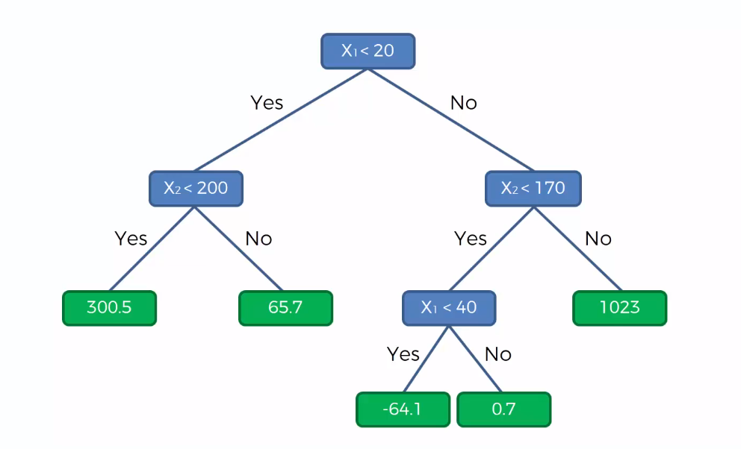
Figure 61. Example of a Decision Tree Regression Model
The use of Multiple Linear Regression and Decision Tree Regression provides a balanced and practical approach to sales forecasting for Banelo Bake and Brew. Multiple Linear Regression offers clear, interpretable insights into how specific factors—such as time, promotions, or stock levels—contribute to sales performance. On the other hand, Decision Tree Regression enhances flexibility by capturing complex, non-linear patterns in customer demand, making it suitable for handling seasonal fluctuations and irregular sales behavior.
Hyperparameter Tuning (for Decision Tree Regression)
To enhance the precision of forecasts using Decision Tree Regression, the researcher will modify several hyperparameters to find the right balance between the complexity of the model and its ability to generalize. As Fan, Xiao, Sun, Zhang, and Xu (2022) noted, careful adjustment of these parameters is critical in tree-based models as it affects the accuracy of predictions and prevents potential overfitting. Similarly, Badrinarayan (2024) emphasizes that Decision Tree Regression significantly relies on parameters that dictate how trees divide and grow, and optimizing these settings can improve the model's performance.
Key hyperparameters for Decision Tree Regression include:
Maximum Depth – limits how deep the tree can grow to avoid overfitting.
Minimum Samples per Split – defines the minimum number of observations required to split a node.
Minimum Samples per Leaf – sets the minimum number of observations in the leaf nodes to promote smoother predictions.
Maximum Features – restricts the number of features considered during splitting to enhance generalization and reduce computational complexity.
By tuning these hyperparameters using cross-validation, the researcher can achieve a more reliable forecast. Fan et al. (2022) emphasized that balancing bias and variance through parameter optimization ensures that the model captures meaningful sales patterns without overfitting historical data. For Banelo Bake and Brew’s POS and inventory management system, this process enables Decision Tree Regression to deliver robust and actionable insights for sales forecasting and inventory planning.
By applying these models, the proposed POS and inventory management system will not only record and track sales but also generate meaningful forecasts that support proactive decision-making. This integration ensures that Banelo Bake and Brew can optimize stock management, reduce waste, and meet customer demand more effectively. Ultimately, the use of machine learning in forecasting strengthens the system’s capability to provide data-driven insights that improve both operational efficiency and business growth.

Research Methodology
This research will employ a quantitative research methodology paired with a developmental descriptive research design to oversee the creation and assessment of the proposed Mobile POS and Inventory Management System with Forecasting and Web Viewing for Banelo Bake and Brew. The aim is to evaluate how the integrated system can resolve operational inefficiencies frequently encountered in traditional sales and inventory methods, especially in small retail establishments.
The quantitative methodology will enable the researchers to collect and analyze numerical data regarding the system’s effectiveness. Metrics such as transaction speed, inventory accuracy, and user satisfaction will be evaluated using structured questionnaires and reports on system usage. As highlighted by Apuke (2020), quantitative research is critical for gathering data that can be subjected to statistical analysis—particularly in technology-related studies where measuring performance and efficiency is vital.
This study employs a developmental-descriptive research design. The developmental aspect focuses on creating the proposed POS and inventory system, while the descriptive aspect evaluates its performance. As Mariani and Wacas (2022) note, descriptive assessment is essential in determining the efficacy, reliability, and accuracy of POS and inventory systems, making this design suitable for the study.
The research development stage will adhere to a structured process comprising analyzing user needs, designing the user interface, establishing backend functionalities, and performing system testing and deployment. Simultaneously, the descriptive component will concentrate on assessing the system's efficacy and its influence on business operations. Data will be gathered from key stakeholders, including shop owners, staff, and customers, to evaluate the system’s usability and tangible benefits.
As Martínez-Borreguero et al. (2020) indicate, integrating developmental and descriptive evaluations is beneficial for understanding both the creation process and the practical impact of ICT-focused solutions. This combined approach guarantees that the study yields not only a functional and dependable system but also valuable insights into its operational contributions to the business.

Population and Sample of the Study
Group | Classification | Frequency | Percentage (%)
End Users | Business Owner | 1 | 10%
 | Staff Member | 1 | 10%
 | Inventory Clerk | 1 | 10%
Subtotal |  | 3 | 30%
IT Experts | IT Instructor | 3 | 30%
 | Industry Worker | 3 | 30%
 | Programmer | 1 | 10%
Subtotal |  | 7 | 70%
Total |  | 10 | 100%

The table above provides an overview of how each group is categorized, along with the frequency and percentage of respondents. The participants in this research were selected based on their direct involvement in business operations or relevant technical expertise.
The first group, End Users, was chosen because they have firsthand experience with daily business tasks, which allows them to share valuable insights into operational challenges. This group consists of a business owner, a staff member, and an inventory clerk, each of whom plays a crucial role in various business functions. Their contributions help the study explore business processes and systems from a practical perspective.
The second group, IT Experts, was selected for their specialized knowledge in information technology, providing a technical viewpoint on system development and application. This group includes three IT instructors, three industry professionals, and a programmer, each bringing a mix of academic and practical experience in IT solutions.
To ensure relevant insights, purposive sampling was used to select participants with the necessary experience for the study's objectives. This approach allows for the careful selection of individuals who can provide meaningful perspectives based on their expertise (Hossan, Dato’Mansor, & Jaharuddin, 2023).

Research Instrument
The researcher will primarily utilize a standardized questionnaire based on the ISO/IEC 25010:2011 Software Product Quality Model, which will be validated by IT professionals and a research advisor to ensure its content validity. This model is globally acknowledged for its effectiveness in assessing software systems, guaranteeing that the quality attributes evaluated are credible and widely recognized. The questionnaire will employ a 5-point Likert Scale of Acceptability, a standard metric for evaluating systems based on users' perceptions of quality and performance. To ascertain the internal consistency and reliability of the questionnaire items, Cronbach’s alpha will be computed. A Cronbach’s alpha score of 0.70 or higher will be considered acceptable, indicating that the instrument adequately measures the constructs associated with the software quality model.
The questionnaire will cover the following software quality characteristics based on ISO/IEC 25010:2011
- Functionality – measures how well the system performs its required functions to meet user needs.
- Usability – assesses how easy, intuitive, and user-friendly the system is.
- Reliability – evaluates the system's ability to operate without failure under specific conditions.
- Efficiency – looks at the system’s response time, resource usage, and overall performance.
- Maintainability – examines how easily the system can be modified to correct faults or improve performance.
- Portability – determines how easily the system can adapt to different environments or platforms.

The Researcher will use the likerts’ scale to have a standardized scale for the respondents. Each item will be rated using the following scale:
Scale | Range | Descriptive Value
5 | 4.20 - 5.00 | Highly Acceptable
4 | 3.40 - 4.19 | Acceptable
3 | 2.60 - 3.39 | Moderately Acceptable
2 | 1.80 - 2.59 | Unacceptable
1 | 1.00 - 1.79 | Totally Unacceptable
We then calculate Cronbach’s alpha to assess the reliability (internal consistency) of the questionnaire using the following scale:
Cronbach’s Alpha | Interpretation
≥ 0.90 | Excellent
0.80 – 0.89 | Good
0.70 – 0.79 | Acceptable
0.60 – 0.69 | Questionable
0.50 – 0.59 | Poor
< 0.50 | Unacceptable
This instrument aims to gather quantifiable feedback from respondents after they interact with the system, helping the researcher evaluate its overall quality, acceptability, and effectiveness based on internationally recognized software standards. However, our respondents consist of only 10 people, so the results may vary and should be treated with caution.

Data Gathering Procedure
The researchers will initiate data collection by creating a mobile point-of-sale and inventory management system with forecasting and web access for Banelo Bake and Brew. In conjunction with system development, a structured questionnaire grounded in the standardized ISO 25010:2011 instrument will be utilized to evaluate the system's usability, functionality, and business impact. To be able to obtain precise and relevant feedback from the selected respondents, these instruments will act as the primary methods.
Before the start of data collection, the researchers will formally request permission and obtain informed consent from the business owner and all participants. The participants consist of the business owner, employees engaging with the system in their daily tasks, and IT experts that will be assessing the application's technical performance. Once consent is secured, the respondents will then be given evaluation forms in person or online, depending on their preferences and availability.
Participants will be asked to utilize the mobile POS and inventory application in their regular operational environments. After using the system, they will then fill out the questionnaires to provide feedback on transaction efiiciency, inventory tracking efficiency, and overall satisfaction as users. The responses will be handled with the utmost confidentiality and will only be utilized for research purposes to assess the effectiveness of the proposed system.

Data Processing and Statistical Treatment
The researchers intend to use Microsoft Excel to quantify, organize, and analyze all data gathered from the participants. According to the type of data, responses from IT instructors and end users will be entered into spreadsheets and given appropriate numerical or categorical values. In order to summarize the findings, the data will be processed using fundamental statistical methods such as frequency counts, percentages, and averages. To aid in interpreting and comparing data across various respondent groups, tables and charts may be created to visually represent the results. This approach will guarantee a systematic evaluation of the data, providing valuable insights that will align with the study's goals and conclusions. Microsoft Excel is selected for its efficiency, ease of use, and ability to conduct accurate data analysis.
The researchers will use the Weighted Mean to assess the responses gathered from the survey questionnaires. The Weighted Mean is a statistical metric that computes the average response while considering the weight or importance assigned to each rating on the Likert scale; this approach is also appropriate for analyzing data obtained from perception-based tools, such as Likert-scale questions, where each response option corresponds to a specific numerical value (Triola, 2020). To ensure the reliability of the research instrument, the researchers will apply Cronbach’s Alpha, a statistical technique that evaluates the internal consistency of the items within the questionnaire. A Cronbach’s Alpha value of 0.70 or higher will be considered acceptable, indicating that the instrument effectively measures the intended constructs. Additionally, Descriptive Statistics, including frequency, percentage, mean, and standard deviation, will be employed to summarize demographic information and assess overall trends in the responses.

Ethical Considerations
This research will follow ethical guidelines to protect all participants' rights, dignity, and well-being. Before data collection, researchers will obtain informed consent from everyone involved, including the business owner, employees, and IT specialists. Participants will be notified of the research goals, methods, potential risks and benefits, and their roles in the study. Participation will only proceed once they confirm their understanding and agreement. The survey will be conducted with strict confidentiality and anonymity. No participant's identity will be shared in any documentation or publications, and all collected data will be securely stored and accessible only to the research team.
Participation is entirely voluntary, allowing participants to join or withdraw at any time without facing any penalties. The research process will prioritize the safety of participants, ensuring no physical, emotional, or psychological harm occurs. All conversations and evaluations will be handled with respect and professionalism. The resulting data will only be used for academic purposes to evaluate and improve the proposed system, managed with integrity according to the institution's ethical standards.

References
- Abdulkader, M., Agatz, N. A., Aksen, D., Alptekinoğlu, A., Arslan, A., Bayram, A., Beck, N., Bendoly, E., Bijmolt, T. H., Boyer, K. K., Boysen, N., Bretthauer, K. M., Cai, Y.-J., Cao, J., DeHoratius, N., Difrancesco, R. M., … Chandon, P. (2022, January 16). The revival of retail stores via omnichannel operations: A literature review and research framework. European Journal of Operational Research. https://doi.org/10.1016/j.ejor.2022.01.016
- Battina, D. S. (2021). The challenges and mitigation strategies of using DevOps during software development. International Journal of Creative Research Thoughts (IJCRT), ISSN 2320-2882.
- Chen, T., & Guestrin, C. (2016). XGBoost: A scalable tree boosting system. In Proceedings of the 22nd ACM SIGKDD International Conference on Knowledge Discovery and Data Mining (pp. 785–794). ACM. https://doi.org/10.1145/2939672.2939785
- Chaudhary, V., Bharadwaja, K., Meena, R. S., Bikash, P., Acharjee, D. N. C. C., & Gopinathan, R. (2023). Exploring the use of machine learning in inventory management for increased profitability. A Journal for New Zealand Herpetology, 12(01), 658–659. https://biogecko.co.nz/admin/uploads/6.pdf
- Chuanpeng, C., & Yi, W. (2021). Research on POS technology adoption in Ho Chi Minh City.
- Chuanpeng, Z., & Yi, Z. (2021, December 5). Study on inventory management optimization of small and medium enterprises. Semantic Scholar. https://pdfs.semanticscholar.org
- Dogan, O., Bitim, S., & Hiziroglu, A. (2021). A V-model software development application for sustainable and smart campus analytics domain. Journal of Network and Innovative Computing, 9, 7–7.
- Etikan, I., Musa, S. A., & Alkassim, R. S. (2016). Comparison of convenience sampling and purposive sampling. American Journal of Theoretical and Applied Statistics, 5(1), 1–4. https://doi.org/10.11648/j.ajtas.20160501.11
- Friedman, J. H. (2001). Greedy function approximation: A gradient boosting machine. Annals of Statistics, 29(5), 1189–1232. https://doi.org/10.1214/aos/1013203451
- Ipan, M., & Oktarina, T. (2023). Application of the iterative model in designing an academic e-counseling system at Bina Darma University. Jurnal Teknik Informatika (JUTIF), 4(1), 117–124.
- Mandviwalla, M., & Flanagan, R. (2021). Small business digital transformation in the context of the pandemic. European Journal of Information Systems, 30(4), 359–375. https://doi.org/10.1080/0960085X.2021.1891463
- Manoharan, G., Sharma, A., Vani, V. D., Raj, V. H., Jain, R., & Nijhawan, G. (2024, May). Predictive analytics for inventory management in e-commerce using machine learning algorithms. In 2024 International Conference on Advances in Computing, Communication and Applied Informatics (ACCAI) (pp. 1–5). IEEE. https://doi.org/10.1109/ACCAI59070.2024.10563639
- Matias, M., & Chatola, F. (2025, May 22). Enhancing SME decision-making and economic growth through a free Android-based point of sale system with cloud-based data analytics. AfriResearch Platform. https://www.afriresearch.com/publication/enhancing-sme-decision-making-and-economic-growth-through-a-free-android-based-point-of-sale-system-with-cloud-based-data-analytics/
- Moreira, S., Mamede, H. S., & Santos, A. (2024). Business process automation in SMEs: A systematic literature review. IEEE Access. https://doi.org/10.1109/ACCESS.2024.3388888
- Pratiwi, M., Mayola, L., Laoli, V. K. H., Arsyah, U. I., & Pratiwi, N. (2022). Medical record information system with rapid application development (RAD) method. Journal of Information Systems and Technology Research, 1(2), 124–130.
- Purnamasari, D. I., Permadi, V. A., Saepudin, A., & Agusdin, R. P. (2023). Demand forecasting for improved inventory management in small and medium-sized businesses. Jurnal Nasional Pendidikan Teknik Informatika (JANAPATI), 12(1), 56–66. https://doi.org/10.23887/janapati.v12i1.57028
- Ramadha, F. N., Wahyuni, E. D., & Vannes, D. D. (2024). SDLC Big Bang dan Waterfall: Perbandingan pendekatan dalam pengembangan perangkat lunak. Nuansa Informatika, 18(2), 41–45.
- Ranawana, R., & Karunananda, A. S. (2021, December). An agile software development life cycle model for machine learning application development. In 2021 5th SLAAI International Conference on Artificial Intelligence (SLAAI-ICAI) (pp. 1–6). IEEE. https://doi.org/10.1109/SLAAI-ICAI52962.2021.9734181
- Schmidt, A., Kabir, M. W. U., & Hoque, M. T. (2022). Machine learning based restaurant sales forecasting. Machine Learning and Knowledge Extraction, 4(1), 105–130. https://doi.org/10.3390/make4010006
- Setyowati, W., Widayanti, R., & Supriyanti, D. (2021). Implementation of e-business information system in Indonesia: Prospects and challenges. International Journal of Cyber and IT Service Management, 1(2), 180–188.
- Sourav, A. I., & Emanuel, A. W. R. (2021). Feasibility study of web-based POS system implementation for SMEs in Bangladesh. IOP Conference Series: Materials Science and Engineering, 1096, Article 012008. https://doi.org/10.1088/1757-899X/1096/1/012008
- Sridhar, P., Vishnu, C. R., & Sridharan, R. (2021). Simulation of inventory management systems in retail stores: A case study. Materials Today: Proceedings, 47, 5130–5134. https://doi.org/10.1016/j.matpr.2021.05.314
- Tanaman, M. T., Baylosis, J. L. A., Abiles, B. J. A., Catungal, M. L. P., & Encarnacion, P. C. (2023). Web-based inventory management system for small enterprises. International Journal of Science and Applied Information Technology, 12(5), 44–48. https://doi.org/10.30534/ijsait/2023/021252023
- TechTarget. (2024, January 11). What is mPOS (mobile point-of-sale)? TechTarget. https://www.techtarget.com/searchcio/definition/mPOS-mobile-point-of-sale
- Triola, M. F. (2020). Elementary statistics (13th ed.). Pearson.
- Wulandari, D. A. N., Bahar, A. A. H., Arfananda, M. G., & Apriyani, H. (2021). Prototyping model in information system development of al-ruhamaa' Bogor Yatim Center Foundation. Jurnal Pilar Nusa Mandiri, 17(2), 127–136.
- Adom, D., Adu-Mensah, J., & Dake, D. A. (2021). Theoretical and conceptual framework: Mandatory ingredients of a quality research. International Journal of Scientific Research, 10(5), 153–158.
- Amazon Web Services. (2023). What is an audit log? AWS. https://docs.aws.amazon.com/whitepapers/latest/aws-overview/audit-logs.html
- Boehm, B., & Basili, V. (2021). Software defect reduction top 10 list revisited. IEEE Software, 38(4), 87–91. https://doi.org/10.1109/MS.2020.2973362
- Fitzgerald, B., Stol, K. J., O'Sullivan, R., & O'Brien, D. (2020). Scaling agile methods: A comparative study. Information Systems Research, 31(2), 547–565. https://doi.org/10.1287/isre.2019.0900
- Ghasemaghaei, M. (2020). Improving organizational performance through the use of big data. Journal of Computer Information Systems, 60(5), 395–407. https://doi.org/10.1080/08874417.2018.1496805
- IBM. (2024). What is forecasting? IBM Think. https://www.ibm.com/think/topics/forecasting
- International Organization for Standardization. (2023). ISO/IEC 25010:2023 Systems and software engineering — Systems and software quality requirements and evaluation (SQuaRE) — Product quality model (2nd ed.). ISO. https://www.iso.org/standard/78176.html
- Jereb, B., & Kajba, M. (2023). Logistics systems digitalisation and software quality: Why it’s important and how it’s related to ISO/IEC 25010. Business Logistics in Modern Management, 23, 413–430. https://ideas.repec.org/a/osi/bulimm/v23y2023p413-430.html
- Jordan, M. I., & Mitchell, T. M. (2020). Machine learning: Trends, perspectives, and prospects. Science, 349(6245), 255–260. https://doi.org/10.1126/science.aaa8415
- OECD. (2021). SMEs and entrepreneurship policy in the post-COVID-19 recovery. OECD Publishing. https://doi.org/10.1787/2db45453-en
- Pressman, R. S., & Maxim, B. R. (2020). Software engineering: A practitioner’s approach (9th ed.). McGraw-Hill Education.
- Sharma, R., Mithas, S., & Kankanhalli, A. (2022). Transforming decision-making with raw data: The role of digital technologies. MIS Quarterly, 46(1), 301–326. https://doi.org/10.25300/MISQ/2022/16622
- Statista. (2022). Mobile internet usage worldwide. Statista Research Department. https://www.statista.com/statistics/617136/digital-population-worldwide
- Wynn, S., & Kuhn, J. R., Jr. (2021). The financial impact of manual inventory record errors. International Journal of Business and Social Science, 12(10), 45–54. doi:10.30845/ijbss.v12n10p2
- Zhu, X., Ninh, A., Zhao, H., & Liu, Z. (2021). Demand forecasting with supply‐chain information and machine learning: Evidence in the pharmaceutical industry. Production and Operations Management, 30(9), 3231–3252. https://doi.org/10.1111/poms.13368
- Hossan, D., Dato’Mansor, Z., & Jaharuddin, N. S. (2023). Research population and sampling in quantitative study. International Journal of Business and Technopreneurship, 13(3), 209–222.
- Mariani, M. J. P., & Wacas, R. U. (2022). Efficacy, reliability, and accuracy of inventory system and point-of-sale service for small-medium enterprises in Tabuk City. International Journal of English, Literature and Social Science, 7(6), 306–311. https://doi.org/10.22161/ijels.76.44
- Dong, C. (2024). Application of Multiple Linear Regression on Sales Prediction. Highlights in Business, Economics and Management, 45, 159–164. https://www.researchgate.net/publication/387477451_Application_of_Multiple_Linear_Regression_on_Sales_Prediction
- Lin, A. (2024). Walmart Sales Prediction Using Multiple Linear Regression. Highlights in Science, Engineering and Technology, 45(2), 1–7. https://drpress.org/ojs/index.php/HSET/article/view/2311
- Riaz, M. (2022, September 16). Multiple linear regression (MLR) explained. Statology. Retrieved September 4, 2025, from https://www.statology.org/multiple-linear-regression/
- Reddy, B. R., & Malathi, D. (2022). A study of decision tree algorithms for predicting student performance. International Journal of Advanced Computer Science and Applications (IJACSA), 13(1), 528–534. https://doi.org/10.14569/IJACSA.2022.0130164
- Shilton, A., Martini, M. C., & Carson, L. (2023). Epochs and generalization: The role of iterative optimization in machine learning forecasting models. Journal of Economic Surveys, 37(4), 1102–1120. https://doi.org/10.1111/joes.12429
- Cordeiro-Costas, D., Troncoso-Pastoriza, J., Muñoz, J., & Fernández-Vilas, A. (2023). Improving load forecasting with optimized epochs in deep learning models. Applied Sciences, 13(13), 7933. https://doi.org/10.3390/app13137933
- Kumar, A. (2025, August 20). What is epoch in machine learning? Simplilearn. https://www.simplilearn.com/tutorials/machine-learning-tutorial/what-is-epoch-in-machine-learning
- Fan, J., Xiao, J., Sun, Y., Zhang, H., & Xu, J. (2022). A survey of hyperparameter optimization methods for machine learning models. Artificial Intelligence Review, 55(8), 5933–5975. https://doi.org/10.1007/s10462-022-10236-3
- Badrinarayan, M. (2024, March 14). Decision trees: Split methods & hyperparameter tuning. Analytics Vidhya. https://www.analyticsvidhya.com/blog/2024/03/decision-trees-split-methods-hyperparameter-tuning/

