**CONFIGURACIÓN ‘REVERSE PROXY’ EN IIS**

1. Cargar IIS Manager y ubicarse en el servidor actual.
2. Seleccionar la opción “Get New Web Platform Components”. Si la aplicación “Web Platform Installer” no se encuentra instalada en el sistema, instalarla desde el link que carga al seleccionar la opción previa.

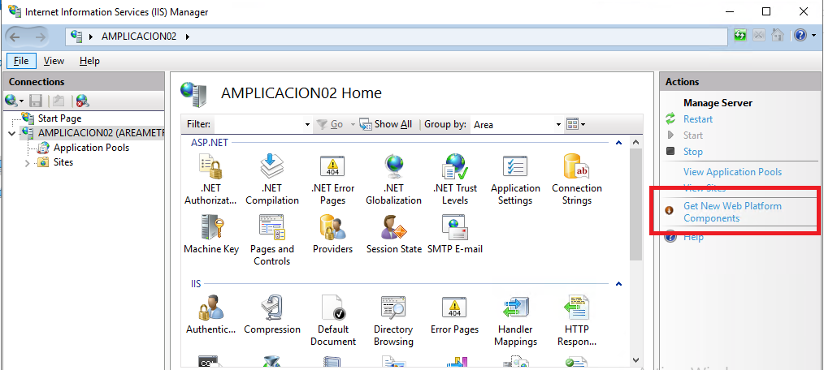

1. En el cuadro de búsqueda, ingresar “Application Request Routing”

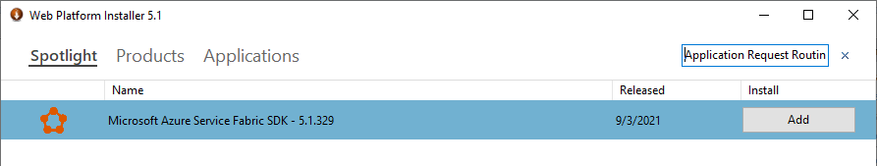

1. Ubicar la aplicación “”, presionar el botón “Add” y luego el botón “Install”:

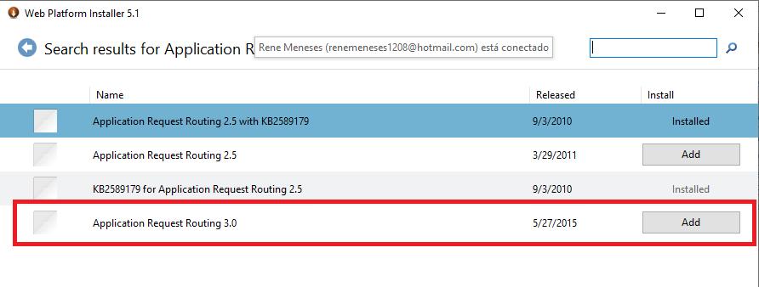

1. Explorar el directorio del Default Web Site.

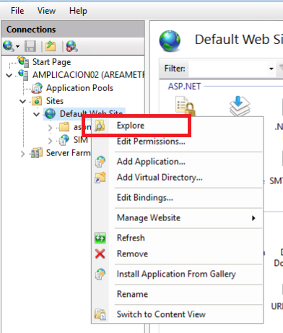

1. Crear en esta ruta el archivo web.config con el siguiente contenido:

<?xml version="1.0" encoding="UTF-8"?>

<configuration>

<system.webServer>

<urlCompression doStaticCompression="true" doDynamicCompression="true" dynamicCompressionBeforeCache="false" />

<rewrite>

<rules>

<rule name="ProxyWorldArcGISImagery" stopProcessing="true">

<match url="^arcgis/rest/services/World_Imagery/(.*)" />

<action type="Rewrite" url="http://server.arcgisonline.com/arcgis/rest/services/World_Imagery/{R:1}" />

<serverVariables>

<set name="HTTP_ACCEPT_ENCODING" value="" />

</serverVariables>

</rule>

<rule name="ProxyArcGISWorldPhysical" stopProcessing="true">

<match url="^arcgis/rest/services/World_Physical_Map/(.*)" />

<action type="Rewrite" url="http://server.arcgisonline.com/ArcGIS/rest/services/World_Physical_Map/{R:1}" />

<serverVariables>

<set name="HTTP_ACCEPT_ENCODING" value="" />

</serverVariables>

</rule>

<rule name="ProxyArcGISWorldStreet" stopProcessing="true">

<match url="^arcgis/rest/services/World_Street_Map/(.*)" />

<action type="Rewrite" url="http://server.arcgisonline.com/ArcGIS/rest/services/World_Street_Map/{R:1}" />

<serverVariables>

<set name="HTTP_ACCEPT_ENCODING" value="" />

</serverVariables>

</rule>

<rule name="ProxyArcGISGeometry" stopProcessing="true">

<match url="^arcgis/rest/services/Geometry/(.*)" />

<action type="Rewrite" url="http://tasks.arcgisonline.com/arcgis/rest/services/Geometry/{R:1}" />

<serverVariables>

<set name="HTTP_ACCEPT_ENCODING" value="" />

</serverVariables>

</rule>

<rule name="ProxySIG" stopProcessing="true">

<match url="^arcgis/rest/(.*)" />

<action type="Rewrite" url="http://amarcgis:8888/arcgis/rest/{R:1}" />

<serverVariables>

<set name="HTTP_ACCEPT_ENCODING" value="" />

</serverVariables>

</rule>

<rule name="ProxyMapGISv5" stopProcessing="true">

<match url="^MAPGISV5_WEB/(.*)" />

<action type="Rewrite" url="http://amarcgis:8888/MAPGISV5_WEB/{R:1}" logRewrittenUrl="true" />

<serverVariables>

<set name="HTTP_ACCEPT_ENCODING" value="" />

</serverVariables>

</rule>

<rule name="ProxyMapGIS5" stopProcessing="true">

<match url="^MAPGIS5_WEB/(.*)" />

<action type="Rewrite" url="http://amarcgis:8888/MAPGIS5_WEB/{R:1}" />

<serverVariables>

<set name="HTTP_X_ORIGINAL_ACCEPT_ENCODING" value="{HTTP_ACCEPT_ENCODING}" />

<set name="HTTP_ACCEPT_ENCODING" value="" />

</serverVariables>

</rule>

<rule name="ProxyGeocode" stopProcessing="true">

<match url="^MapGIS/(.*)" />

<action type="Rewrite" url="http://medellin.gov.co/MapGIS/{R:1}" />

<serverVariables>

<set name="HTTP_ACCEPT_ENCODING" value="" />

</serverVariables>

</rule>

<rule name="ProxyMapRuido" enabled="true" stopProcessing="true">

<match url="^maparuido/(.*)" />

<serverVariables>

<set name="HTTP_ACCEPT_ENCODING" value="True" />

</serverVariables>

<action type="Rewrite" url="http://amarcgis:8888/maparuido/{R:1}" />

</rule>

</rules>

<outboundRules>

<rule name="ReverseProxyArcGISWorldImagery" preCondition="ResponseIsHtml18">

<match filterByTags="A, Form, Img" pattern="^http(s)?://server.arcgisonline.com/arcgis/rest/services/World_Imagery/(.*)" />

<action type="Rewrite" value="http{R:1}://127.0.0.1/arcgis/rest/services/World_Imagery/{R:2}" />

</rule>

<rule name="ReverseProxyArcGISWorldPhysical" preCondition="ResponseIsHtml18">

<match filterByTags="A, Form, Img" pattern="^http(s)?://server.arcgisonline.com/arcgis/rest/services/World_Physical_Map/(.*)" />

<action type="Rewrite" value="http{R:1}://127.0.0.1/arcgis/rest/services/World_Physical_Map/{R:2}" />

</rule>

<rule name="ReverseProxyArcGISWorldStreet" preCondition="ResponseIsHtml18">

<match filterByTags="A, Form, Img" pattern="^http(s)?://server.arcgisonline.com/arcgis/rest/services/World_Street_Map/(.*)" />

<action type="Rewrite" value="http{R:1}://127.0.0.1/arcgis/rest/services/World_Street_Map/{R:2}" />

</rule>

<rule name="ReverseProxyArcGISGeometry" preCondition="ResponseIsHtml18">

<match filterByTags="A, Form, Img" pattern="^http(s)?://tasks.arcgisonline.com/arcgis/rest/services/Geometry/(.*)" />

<action type="Rewrite" value="http{R:1}://127.0.0.1/arcgis/rest/services/Geometry/{R:2}" />

</rule>

<rule name="ReverseProxySIG" preCondition="ResponseIsHtml18">

<match filterByTags="A, Form, Img" pattern="^http(s)?://127.0.0.1//arcgis/rest/(.*)" />

<action type="Rewrite" value="http{R:1}://amgis01:8888/arcgis/rest/{R:2}" />

</rule>

<rule name="ReverseProxyMapGISv5" preCondition="ResponseIsHtml18">

<match filterByTags="A, Form, Img" pattern="^http(s)?://127.0.0.1//MAPGISV5_WEB/(.*)" />

<action type="Rewrite" value="http{R:1}://amgis01:8888/MAPGISV5_WEB/{R:2}" />

</rule>

<rule name="ReverseProxyMapGIS5" preCondition="ResponseIsHtml18">

<match filterByTags="A, Form, Img" pattern="^http(s)?://127.0.0.1/MAPGIS5_WEB/(.*)" />

<action type="Rewrite" value="http{R:1}://amgis01:8888/MAPGIS5_WEB/{R:2}" />

</rule>

<rule name="ReverseProxyGeocode" preCondition="ResponseIsHtml18">

<match filterByTags="A, Form, Img" pattern="^http(s)?://medellin.gov.co/MapGIS/(.*)" />

<action type="Rewrite" value="http{R:1}://127.0.0.1//MapGIS/{R:2}" />

</rule>

<preConditions>

<preCondition name="ResponseIsHtml18">

<add input="{HTTP_X_ORIGINAL_ACCEPT_ENCODING}" pattern="^text/html" />

</preCondition>

<preCondition name="ResponseIsHtml19">

<add input="{RESPONSE_CONTENT_TYPE}" pattern="^text/html" />

</preCondition>

</preConditions>

</outboundRules>

</rewrite>

</system.webServer>

</configuration>

1. Verificar que las reglas estén configuradas en cualquiera de las aplicaciones configuradas:

