Transvaginal laser treatment is a simple non-surgical procedure, mainly aimed to rebuild and restructure damaged tissue of the vagina walls through collagen and elastin recovery stimulation. These fibres play an essential role in sustaining and structuring the vaginal tissue since they are part of its shallower layer.

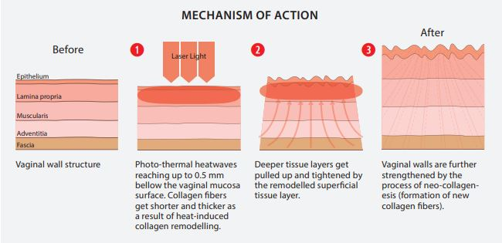

Some factors that can cause weakening of vaginal tone:
Natural ageing: the passing of years inevitably produces collagen loss in every tissue of a woman´s body, including the vaginal wall.
Menopause: the menopause results in a decrease of hormones, especially oestrogen, which have a direct influence on muscles' tone, especially in the genital-urinary tract.
Surgical procedures: Vaginal repair surgery can often result in further scarring of the vagina and may not be appropriate in cases of vaginal laxity.
Childbirth: the vagina is supposed to dilate to allow the baby´s passage, which translates into an extreme expansion from which it may not return to its original structure. Several pregnancies and childbirths are worsening factors.
Obesity: similar to pregnancy, increased weight and fat tissue can affect the expansion of the body tissues. Furthermore, obesity increases the pressure on the abdominal and pelvic organs.
Smoking: among all the harmful consequences of smoking, the decrease in the amount of oxygen supplied to the skin makes it age between 10 and 20 years prematurely. Obviously, this has a negative affect on the muscle tone and the vagina.
Hysterectomy: prior hysterectomy can disrupt the function and support of the urethra and bladder, increasing the chances of developing urinary stress incontinence and other associated conditions.

Possible medical conditions
The stretching of the vaginal wall tissue results in straining of collagen and elastin in this area, which can lead to vaginal relaxation syndrome (VRS), stress urinary incontinence (SUI), and pelvic organ prolapse (POP).
Laser treatment can relieve these conditions or symptoms in women and will restore to the vaginal tissue its original elasticity and contractility. This is especially important for women to maintain a healthy sex life avoiding irritation, lack of lubrication, and/or burning sensation.

Vaginal relaxation syndrome (VRS)
Vaginal relaxation syndrome, also known as vaginal laxity, is when the inner diameter of the vagina's wall increases. This often leads to a loss of friction for both the woman and her partner, which results in a decrease in sexual satisfaction. This can affect both self confidence and body image.
Vaginal relaxation is most often caused because the vaginal wall was overstretched during childbirth. The condition can increase according to the number of births. It can also be caused by ageing, as well as congenital connective tissue weakness.
Until recently, this condition could only be treated effectively by invasive surgery, with procedures such as anterior vaginal plastic surgery and posterior vaginal plastic surgery. These surgical treatments have had many post operative complications associated with them.
Treatment:
IntimaLase® is a unique, Er:YAG laser therapy for incisionless, non-invasive photothermal tightening of the vaginal canal. Clinical studies have shown that IntimaLase is an efficient, easy-to-perform, and safe procedure.

Vaginal Atrophy/GSM (genitourinary syndrome of menopause)
Vaginal atrophy or GSM is quite a common condition, affecting many women after their menopause. Vaginal atrophy is the drying and thinning of the vaginal walls. It often occurs after menopause due to a lack of hydration in the vaginal cells, along with the fact that the woman's body may not be able to produce sufficient oestrogen. It can cause inflammation, drying and thinning of the vagina. This condition can be quite uncomfortable and can cause also result in recurrent urinary tract infections.
Vaginal atrophy may also present during perimenopause (the years that lead up to the menopause). It can be triggered by hormonal cancer treatments, chemotherapy and pelvic radiotherapy. Additionally it may occur after surgical removal of both of the ovaries and smoking. It can also be caused by underlying conditions such as Sjorgen's syndrome and diabetes.
It may happen at any age, although it is estimated that approximately 50% of post-menopausal women experience GSM. As vaginal atrophy is not often discussed, many women accept it as an effect of the menopause, so they don't seek treatment and suffer in silence.
GSM symptoms can include:
- Dryness of the vagina
- Discharge
- Itchy and red genitalia
- Urinary incontinence
- Feeling an urgent need to urinate
- Burning sensation
- Discomfort or bleeding after intercourse
- Pain during intercourse, due to less lubrication
- Shortening and tightening of the vaginal canal
Treatment:
RenovaLase® is an innovative, unique and non-invasive 2940 nm Er:YAG laser therapy to treat the symptoms of vaginal atrophy. It is based on non-ablative photo-thermal treatment of the vaginal canal.
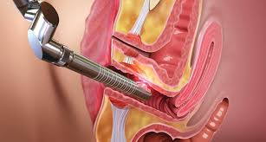

Stress urinary incontinence (SUI)
This condition is characterised by involuntary urine leaks occurring with daily events such as laughing, sneezing, coughing, getting up from a chair or some kind of physical effort like going up and down the stairs, heavy lifting, and jogging.
This problem appears to be due to the loss of strength of the urethral closure mechanism. Being overweight, ageing, and childbirth are factors that increase the probabilities of developing this condition, by putting more pressure on the bladder during simple activities. This condition can impact the patient's daily activities as well as affecting their self-confidence.
Treatment:
IncontiLase® is a non-invasive Er:YAG laser therapy for the treatment of mild and moderate stress urinary incontinence, based on non-ablative photothermal stimulation of collagen neogenesis, shrinking and tightening of vaginal tissue and collagen-rich endopelvic fascia, and subsequently greater support to the bladder.

